A new optical sensor for bubble velocity and size measurements in heterogeneous bubbly flows.
Anthony Lefebvre¹, Stéphane Gluck¹, Yann Mezui², Martin Obligado², Alain Cartellier²
1 A2 Photonic Sensors, 38016 Grenoble, France ; 2 Univ. Grenoble Alpes, CNRS, Grenoble INP**, LEGI, 38000 Grenoble, France.
*Corresponding author: alefebvre@a2photonicsensors.com
** Institute of Engineering Univ. Grenoble Alpes
Highlights
- A new sensor devoted to complex bubbly flows has been developed.
- The sensor combines phase detection and bubble velocity measurements.
- Bubble velocity distributions are measured in homogeneous and heterogeneous regimes.
- Bubble velocity statistics conditioned on local void fraction become accessible.

1. Introduction
Bubble columns are routinely exploited in industry and are often operated in the heterogeneous regime with gas hold-up up to 40%. Despite intense research since the 70’s, the hydrodynamics of these buoyancy driven bubbly flows is still poorly understood. As shown by the numerous correlations proposed in the literature [1], there is no consensus on the influence of the column size or of the gas superficial velocity on key variables. Beside simulations based on two-fluid models still require ad-hoc closures, and the scale-up from lab units to industrial units still relies on empiricism. That situation is evolving thanks to new measuring techniques, to well-controlled experiments and to progress in modelling. For example, the relative velocity in the heterogeneous regime has been shown to widely exceed the bubble terminal velocity [2]. That has prompted the use of a swarm factor that diminishes the drag with void fraction: this correction neatly improves the prediction capability [3]. This relative velocity modification is possibly due to the presence of clusters (with local void fraction up to 10 times the mean gas hold-up) and of voids (with local void fraction down to 0.1 times the mean): such meso-scale structures generate strong concentration gradients and are reminiscent of buoyancy instabilities in turbulent convention [2]. To progress further, there is a crucial need to gather information on bubble velocity. Such measurements are difficult and remain scarce [4-6]. The present contribution deals with the development of a new bubble velocity sensor and with its test in the heterogeneous regime.
2. Sensor development and preliminary measurements
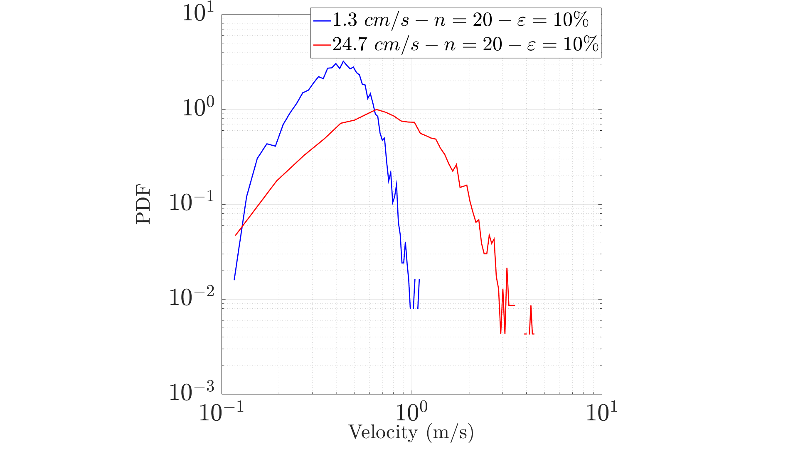
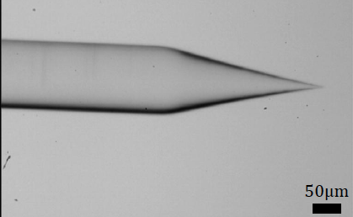
The new sensor combines conical optical probes that are efficient phase detectors [7] with velocity measurements based on Doppler shift. The latter arises from a light wave reflected at the (fixed) probe tip combined with a light wave that exits the probe, interacts with a moving interface and enters back the fiber. The recorded signal is modulated at the Doppler frequency f_{D}=2Vcos(α)/λ where V is the interface displacement velocity, α the angle between the interface velocity and the fiber axis, λ the wavelength in the external medium. The measure of f_{D} directly provides the velocity. That principle has been exploited on gas slugs [8], on micro-bubbles [9], on capillary waves [10] and on solid particles [11]. Yet, all previous works used cleaved fibers that are not adapted to phase detection. Instead, we exploited conical tips whose shape was optimized (Fig.1) to enhance the Doppler amplitude. All prototypes were manufactured from 8.2µm core diameter single mode fibers. A signal processing was implemented to select meaningful Doppler signals detected at the bubble exit (Fig.1) based on the number of successive periods and on their stability. An analysis of the sensor response, including necessary optical conditions for obtaining Doppler signals, indicate that this sensor provides the translation velocity of the bubble mass center projected on the fiber axis with a 10% uncertainty. The sensor was exploited in a bubble column (0.4m I.D., 3m high). Bubble velocity distributions in homogeneous and in heterogeneous regimes gathered at H/D=3.62 above injection are presented Fig.1. For these data sets, 12000 bubbles were detected among which 60% (resp. 30%) provided a velocity in the homogeneous (resp. heterogeneous) regime. Note that bubble’s velocities up to 3m/s are recorded in the latter case: such magnitude is expected as liquid velocities up to 2m/s are observed in the same conditions, and since the actual relative velocities are about 2 to 3 times the terminal velocity [2].
Figure 1. Conical fiber tip (left). Doppler signal collected at an air-water transition (middle). Bubble velocity distributions in homogeneous (blue) and heterogeneous (red) regimes (right).
3. Conclusions
A new sensor has been successfully developed that combines phase detection and bubble velocity measurements. Applied to a bubble column, the sensor indeed provides velocity distributions both in the homogeneous and in the heterogeneous regimes. Future work will be devoted to gather statistics on gas velocity conditioned by the local concentration in order to evaluate the impact of meso-scale structures on the relative velocity.
References
- P. Maximiano Raimundo, A. Cloupet, A. Cartellier, D. Beneventi, F. Augier, Chem. Eng. Sci. 198 (2019) 52-61.
- L. Gemello, V. Cappello, F. Augier, D. Marchisio, C. Plais, Chem. Eng. Research and Design, 136 (2018) 846-858.
- J. Xue, M. Al-Dahhan, M. Dudukovic, R. Mudde, The Canadian Journal of Chemical Engineering 81 (2003) 375-381.
- H. Chaumat, A.M. Billet-Duquenne, F. Augier, C. Mathieu, H. Delmas, Exp. Therm. Fluid Sci. 31(2007) 495–504.
- D.D. McClure, J.M. Kavanagh, D.F. Fletcher, G.W. Barton, Chem. Eng. Sci., 170 (2017) 91-97.
- J. Vejrazka, M. Vecer, S. Orvalho, Ph. Sechet, M. Ruzicka, A. Cartellier, Int. J. Multiphase Flow 36 (2010) 533-548.
- K. Sekoguchi, M. Takeishi, H. Kano, K. Hironaga, T. Nishiura, 2nd Int. Conf. on Laser Anemometry, 2-4 July, Lisbon, Portugal (1984).
- R. Wedin, L. Davoust, A. Cartellier, A. Dahlkild, 10th Int. Symp. on Appl. of Laser Tech. to Fluid Mech., 10-13 July (2000), Lisbon, Portugal.
- L. Davoust, J.-L. Achard , A. Cartellier, Progress in Colloid and Polymer Science 115 (2000) 249-254.
- K.-A. Chang, H.-J. Lim and C.B. Su, Rev. Sci. Instrum. 74 (7) (2003) 3559-3565.

