A conceptual design of Cr(VI)-free anti-corrosion solutions for aerospace applications
Bhavya Goyal¹, Gabriela Hadiwinoto¹, Kleopatra Papamichou¹, Yuyang Tian¹, Zerui Zhang^{1*}, Pieter Swinkels¹
1 Delft University of Technology, Faculty of Applied Science, Van der Maasweg 9, 2629 HZ, Delft, The Netherlands
*Corresponding author: Z.Zhang-9@tudelft.nl
Highlights
- Chromium free anti-corrosive coating for the aerospace industry
- Rare earth metals as corrosion inhibitors and silyl ester as a healing agent

1. Introduction
The high standards of the Aerospace Industry often push the limits of science and one of those times is the protection of aircraft against corrosion. Currently, the coating of an aircraft is made by hand-spraying and the paint itself contains hazardous compounds, with Chromium (VI) to be the most infamous one. This process is not only harmful to the environment but creates major health issues to the painters and raises a lot of concerns. Chromium (VI) salts are very effective and provide a "self-healing" active corrosion inhibition to aluminium substrates. This carcinogenic and toxic compound is banned in the EU and is only permitted in situations where there are no good alternatives, such as in aircraft corrosion prevention. This work provides two Cr-free conceptual designs as the anti-corrosive solutions to be used in the aerospace industry. The two concepts try to mimic the two properties of Chromium (VI) in a safe way: corrosion inhibition and self-healing.
2. Methods
The Delft Design Map (DDM) was systematically followed to frame and organize the designs [1]. Design requirements were identified by translating the needs of stakeholders and the design specifications are generated and evaluated using House of Quality (HoQ) to determine the important features of the final product which were the basis of our design concepts. The corresponding manufacturing process is partially proposed and assessed via safety, health, environment, economic, technology and social (SHEETS) analysis.
3. Results and discussion
The first conceptual design concept proposes the use of rare earth metals as corrosion-inhibitors which work by creating effective protective barriers. Cerium salts, with which researchers have been experimenting for years, oxidize only once and the protective layer they create is not permanent [2]. Long-term protection, therefore, requires the continuous release of these inhibitors. For these, the proposed idea is borrowed from the biomedical community and includes the encapsulation and controlled release of the corrosion inhibitor by macroporous silica particles [3].

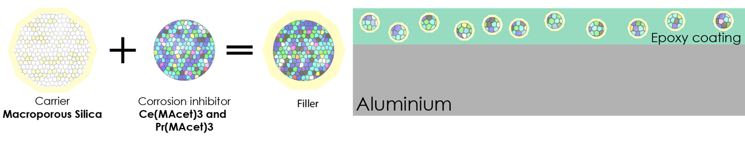Figure 1. Corrosion inhibitors carried by macroporous silica.
The second conceptual design concept is oriented in the direction of actively protecting the surface of the aircraft against any kind of damage, by the use of "self-healing" materials. The idea is to prevent corrosion that is caused by cracks on the coating of the aircraft, by automatic repair of these cracks. The repair of these cracks can be promoted by silyl ester as a healing agent that can form an adhered-to-the-metal hydrophobic barrier system [4]. Relatively similar to the first concept, the self-healing agent is protected in microcapsules until the moment of action [4].
The preliminary analysis of the two designs shows promising results and a lot of margin for completion. This work can be seen as a thoughtful exploration of the alternatives to the problem of Chromium (VI).
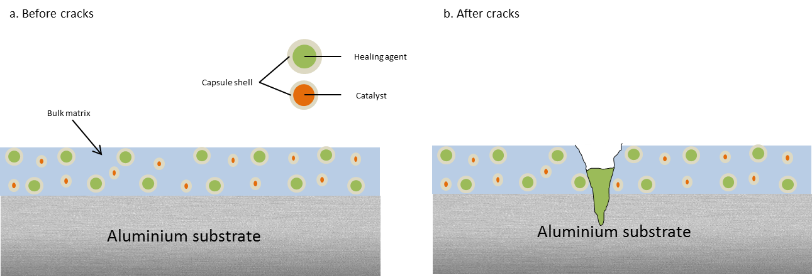
Figure 2. Capsule-based self-healing coating
4. Conclusions
The conceptual designs exhibit possibilities of providing adequate anti-corrosive properties without compromising the structural integrity of an aircraft. In terms of application and maintenance, they facilitate an easier and less hazardous process. However, the thickness of such a coating can exceed acceptable limits and add extra weight, creating issues with the aerospace industry. Therefore, it is proposed to focus on more research in order to combine the two concepts and eliminate their disadvantages.
References
[1] J. Harmsen, A. B. de Haan, P. L. Swinkels, Product and Process Design: Driving Innovation. Walter de Gruyter GmbH & Co KG, 2018.
[2] R. Catubig, A. E. Hughes, I. S. Cole, B. R. W. Hinton, and M. Forsyth, “The use of cerium and praseodymium mercaptoacetate as thiol-containing inhibitors for AA2024-T3,” Corros. Sci., vol. 81, pp. 45–53, Apr. 2014.
[3] J. M. Falcón, F. F. Batista, and I. V. Aoki, “Encapsulation of dodecylamine corrosion inhibitor on silica nanoparticles,” Electrochim. Acta, vol. 124, pp. 109–118, 2014.
[4] S. J. García et al., “Self-healing anticorrosive organic coating based on an encapsulated water reactive silyl ester: Synthesis and proof of concept,” Prog. Org. Coatings, vol. 70, no. 2–3, pp. 142–149, Feb. 2011.

