Mass transfer CFD modeling of biodiesel purification using deep eutectic solvents in a microseparator.
Ana Jurinjak Tušek¹, Davor Valinger¹, Martin Gojun², Anita Šalić², Bruno Zelić^{2*}
¹University of Zagreb, Faculty of Food Technology and Biotechnology, Pierottijeva 6, HR-10000 Zagreb, Croatia; ²University of Zagreb, Faculty of Chemical Engineering and Technology, Marulićev trg 19, HR-10000 Zagreb, Croatia
*Corresponding author: bzelic@fkit.hr
Highlights
- lipase catalyzed biodiesel transesterification
- biodiesel purification in a microseparator
- analysis of the flow patterns
- CFD simulations of biodiesel and DES flow profiles

1. Introduction
Biodiesel is an alternative fuel, similar to classic fossil fuels that can be used in diesel engines. It is a mixture of alkyl esters of fatty acids that can be produced from vegetable oil, micro algal oil or animal fats [1,2,3]. Biodiesel production is mostly achieved through transesterification, using short-chain alcohols (typically methanol or ethanol). This reaction also produces glycerol, which along with unreacted alcohol and oil, has to be removed from the product before it can be used in commercial application. There are several approaches that can be used for biodiesel purification (sedimentation, decantation, water washing, filtration etc.) but all of them are usually characterized as inefficient, non-ecological, expensive, energy consuming etc. In order to resolve some of this disadvantages microseparators coupled with deep eutectic solvents (DESs) were proposed as solution. Microseparators have been widely used to improve the mass and heat transfer processes between two phases due to the high surface-to volume ratio, higher heat and mass transfer rates and short diffusion distance. To achieve the maximum productivity of the biodiesel purification process in a microseparator it is necessary to take into account nature of the components and the operational conditions, such as temperature, volumetric flow rate, dimensions of the used microchannel. All mentioned parameters significantly influence the flow pattern formation. In this work computational fluid dynamics (CFD) analysis was carried out to illustrate and visualize the interactions between two existing phases in separation systems.
2. Methods
Biodiesel production catalyzed by lipase from Thermomyces lanuginosus using edible oil and methanol as the substrates was performed in a batch reactor according to procedure described by Budžaki et al. [4]. After biodiesel was produced, it was placed in a separation funnel (traditional approach for glycerol removal) in order to remove glycerol for 24h. After separation of two phases and analysis of biodiesel content separation efficiency was around 90.37%. In order to remove residual glycerol, microseparator (length: width: depth = 332 mm: 500 μm: 50μm; Micronit Microfluidics B.V. Netherlands) in combination with DES was used. Experimentally obtained data were compared with the CFD simulation results. The CFD simulations of the biodiesel and DES flow profiles in selected microseparator were performed using the finite element software COMSOL Multyphysics v.4.2. A laminar flow model with Lagrangian specification of the field and Ditrich type boundary conditions were used.
3. Results and discussion
In microseparators mass transfer occurs along the interface area between phases so stability of the area is the first necessary condition. The second condition is crucial for phase separation at the exit of microseparator where interface area has to be positioned in the middle of microchannel and flow has to be parallel. Since DES and biodiesel have different physical properties, the input flow rates had to be adjusted so that both phases occupy the same volume in the channel. Therefore, the influence of flow rates on the flow pattern was studied. This was done with the help of a microscope for different flow rates, ranging from 0 to 20 µL min⁻¹ for the biodiesel and from 0.02 to 18 µL min⁻¹ for DES (Figure 1).
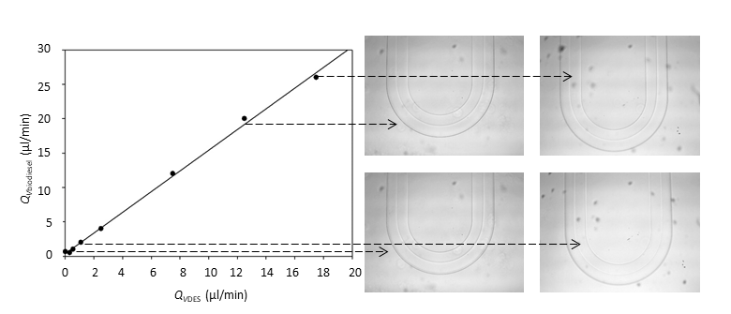
Figure 1. Influence of the velocity on the position of the interphase area
To analyze the hydrodynamics of the selected microseparator system, Re numbers were estimated. The high Re numbers leads to better mixing, and also changes the flow profile. CFD experiments for visualizations of both biodiesel and DES flow profile were carried out by estimating the fluid properties based on assumption of simple mass balance at the beginning and at the end of the microseparator.
4. Conclusions
In this study biodiesel purification using DES in a microseparator was performed. Obtained results indicate that microseparator system is efficient technology for the biodiesel purification. CFD simulations ensure delight insight in the hydrodynamics of biodiesel purification process.
References
[1] T. Issariyakul, A.K. Dalai, Renew. Sust. Energ. Rev. 31 (2014) 446–471.
[2] Z. Yaakob, M. Mohammad, M. Alherbawi, Z. Alam, K. Sopian, Renew. Sust. Energ. Rev. 18 (2013) 184–193.
[3] L. Azocar, G. Ciudad G, H.J. Heipieper, R. Navia, Appl. Microbiol. Biotechnol. 88 (2010) 621–636.
[4] S. Budžaki, A. Šalić, B. Zelić, M. Tišma, Chem. Biochem. Eng. Q. 29 (2015) 329–333.

