Numerical modelling of micromixing in a T-mixer flow at low Reynolds numbers
Cláudio P. Fonte¹, Joelle Aubin², Pierrette Guichardon³, David F. Fletcher^{4,*}
1 ﻿School of Chemical Engineering and Analytical Science, The University of Manchester, Oxford Road, Manchester, M13 9PL, United Kingdom; 2 Laboratoire de Génie Chimique, Université de Toulouse, CNRS, Toulouse, France; 3 Aix Marseille Université, CNRS, Centrale Marseille, M2P2 UMR 7340, Technopôle de Château-Gombert, 38 rue Frédéric Joliot-Curie, 13451 Marseille, France 4 School of Chemical and Biomolecular Engineering, The University of Sydney, Sydney, Australia
*Corresponding author: david.fletcher@sydney.edu.au
Highlights
- CFD simulations are performed to study micromixing in a laminar microfluidic flow.
- Segregation indices are calculated using the Villermaux-Dushman protocol.
- Micromixing is modelled directly with CFD and indirectly with a lamellar model.
- The two solutions are compared in terms of computational cost and analysis times.

1. Introduction
Micromixing, i.e., the full homogenisation of mixtures of two or more components down to the molecular level, is a particularly important phenomenon in systems that involve fast and competitive chemical reactions, since it will directly impact on the achieved conversion and selectivity [1]. Directly modelling micromixing in laboratory or industrial equipment using Computational Fluid Dynamics (CFD) can, however, be computationally expensive. This is due to the need to resolve all the mixing scales down to those at which molecular diffusion becomes the dominant mechanism for the dissipation of concentration gradients. In the past 50 years [2], many efforts have been made to develop sub-grid models capable of describing micromixing in turbulent flows with Reynolds-Averaged Navier-Stokes or Large Eddy Simulations. Laminar flows have, however, received far less attention from the CFD community. In this work, we show that, in spite of their apparent simplicity, direct simulation of micromixing in the laminar regime can still be a challenging task when complex chaotic motions are present in the flow. Micromixing is assessed using the well-known Villermaux-Dushman reaction protocol in a milli-sized T-mixer with square bends. Direct numerical simulations of micromixing from the CFD flow field are compared with the predictions using a lamellar mixing model and previous experimental results.
2. Methods
The mixer geometry and flow conditions used in this work were chosen to replicate the experimental investigation of Commenge and Falk [3]. The flow domain has been discretised with hexahedral meshes with 20 and 40 cells across the duct. The continuity and momentum conservation equations were solved with ANSYS Fluent 19.0 to obtain 3D steady state flow fields in the microchannel at low Reynolds numbers ($60≤Re≤300$). The transport and reaction of the species involved in the Villermaux-Dushman protocol have been directly solved using the built-in Stiff Chemistry solver directly integrated with the CFD flow field. The segregation index, $X_{S}$, has been calculated from the concertation of all the species as described by Commenge and Falk [3] as the metric to assess micromixing.
The flow field obtained from the CFD simulations was additionally used to perform a Lagrangian tracking of the position and deformation of infinitesimal fluid elements injected at the inlets. These results were further processed to obtain an average rate of decay of the striation thickness of laminas of fluid necessary to model micromixing in the microchannel using a lamellar-structure mixing model as described by Ottino et al. [4]. Up to 800 particles were tracked with an adaptive 7th-8th order explicit Runge-Kutta method. The lamellar mixing model equations were solved using the pdepe function in MATLAB. It is worth mentioning that both developed models of micromixing in this work are fully-predictive and have no adjustable parameters, requiring only information on the kinetics of the Villermaux-Dushman reaction scheme found in the literature [3].
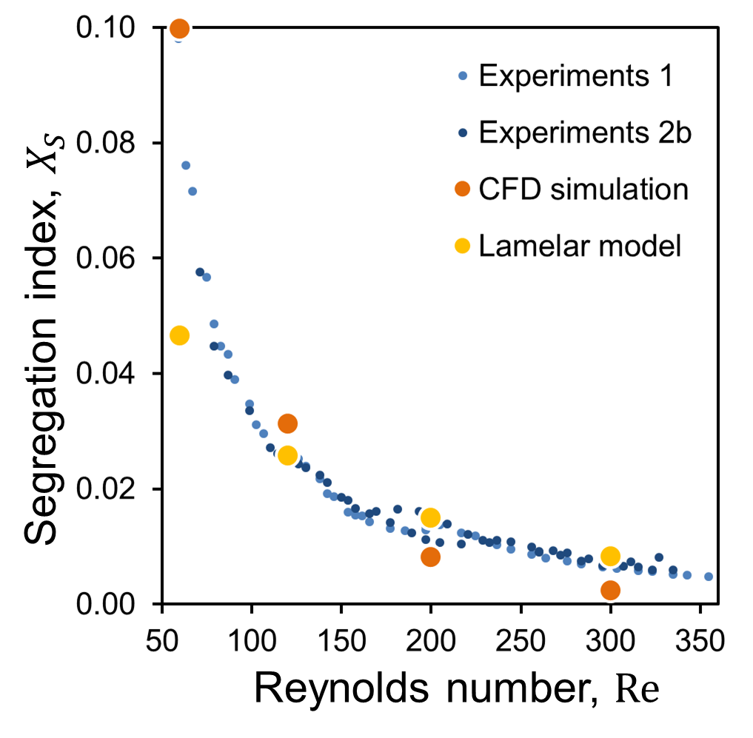
Figure 1. Comparison between the segregation index obtained experimentally by Commenge and Falk [3], the direct CFD simulation of the species transport and reaction, and the simulations using the lamellar mixing model.

3. Results and discussion
The obtained simulation results for both models are in quite good agreement with experimental data of Commenge and Falk [3] (see Figure 1). The lamellar model tends to over predict micromixing at the lower range of Reynolds numbers but predicts well the rate of decay of the segregation index with the increase in $Re$. The direct numerical simulations of the species transport and reaction show quite good agreement with experimental results in the lower part of the $Re$ range but seem to over predict the degree of micromixing in the upper part of the range, indicating that further refinement might still be necessary for those flow conditions.
The direct numerical simulations of micromixing using the CFD flow field have been found to be computationally very costly, requiring very fine meshes (up to 11.5 million elements).
4. Conclusions
CFD simulations have been successfully used in this work to simulate the flow and micromixing in a T-mixer with square bends in the laminar regime. This work shows that, even for simple geometries and low $Re$, the direct simulation of micromixing can be very computationally expensive when chaotic structures are produced by the flow. The use of micromixing models can offer an attractive alternative to direct simulations.
References
- Baldyga J., Bourne J.R., Turbulent Mixing and Chemical Reactions, Wiley-Blackwell (1999)
- Santos R.J., Dias M.M., Lopes J.C.B., Mixing through half a century of chemical engineering, in: Single and Two-phase Flows on Chemical and Biomedical Engineering, Bentham Science, pp. 79–112 (2012)
- Commenge J.-M., Falk L., Villermaux–Dushman protocol for experimental characterization of micromixers, Chemical Engineering and Processing: Process Intensification, 50 (10), pp. 979-990 (2011)
- Ottino J.M., Ranz W.E., Macosko C.W., A lamellar model for analysis of liquid-liquid mixing, Chemical Engineering Science, 34 (6), pp. 877-890 (1979)

