Enhancement of methane non-oxidative coupling performance: from metal incorporation strategies to selective catalyst heating via MW irradiation
Ignacio Julian^{1,2,3}, Jose L. Hueso^{1,2,3,4}, Scott Mitchell³, Reyes Mallada^{1,2,3,4}, Jesus Santamaria^{1,2,3,4}
¹ Department of Chemical and Environmental Engineering, University of Zaragoza, Zaragoza (Spain)
²Institute of Nanoscience of Aragon (INA), University of Zaragoza (Spain)
³Institute of Materials Science of Aragon (ICMA), CSIC-University of Zaragoza (Spain)
⁴Networking Research Centre CIBER-BBN, 28029, Madrid (Spain)
*Corresponding author: jlhueso@unizar.es
Highlights
- Supercritical-solvothermal Mo/ZSM-5 synthesis boosts Mo dispersion and MDA stability
- The use of small polyoxometalates as Mo precursors of Mo/MCM-22 improves MDA performance
- Selective MW-assisted catalyst heating inhibits undesired gas-phase MDA reactions

1. Introduction
Non-oxidative methane coupling (MNOC) is a promising route to directly convert natural gas into more valuable hydrocarbons in one-step catalytic process. However, its industrial implementation is still hindered due to the relative low methane conversion and selectivity towards the products of interest as well as due to the low process stability derived from catalyst coking.
In the frame of the H2020 European Project ADREM (Adaptable Reactors for Resource- and Energy-efficient Methane Valorization), this works reports a multipurpose approach to enhance MNOC performance on the basis of the development of more stable and active catalysts and on the use of alternative heating sources to provide energy-efficient selective heating of the catalysts. The following topics were covered: 1) the development of a novel supercritical solvothermal synthesis for the benchmarking catalyst Mo/ZSM-5 in order to enhance metal dispersion and boost catalyst stability along the time on stream; 2) the use of small polyoxometalates as Mo precursors for the synthesis of Mo/MCM-22 in order to reduce the size of the initial Mo clusters and enhance metal dispersion in comparison to that obtained using the conventional Mo salts; 3) the use of microwave-assisted heating to improve the energy efficiency of the MNOC process while inhibiting the formation of heavy polyaromatics (i.e. hard coke precursors) as it is described by Julian et al. [1].
2. Methods
The supercritical solvothermal synthesis (SC-STS) of 5%Mo/ZSM-5, Si/Al = 23, was carried out using a self-built reactor set-up described elsewhere [2] in which a cold precursor solution containing Mo with added support material (H-ZSM-5) is mixed with a hot solvent inside the reactor. Upon mixing at supercritical conditions, a super-fast precipitation of atomized metal precursor occurs within the zeolite pores.
A selection of polyoxomolybdate anions were employed as Mo precursors of Mo/MCM-22 catalysts under the assumption that the different structural arrangement of their Mo atoms within the polyoxometalate molecules would help to generate repulsion between discrete Mo centres, thereby avoiding the formation of Mo agglomerates on the zeolite surface and enhancing metal dispersion. MCM-22 (Si/Al = 20) was synthesized following the procedure of Corma et al. [3] and employed as support whereas the polyoxometallates were incorporated via incipient wetness impregnation.
All catalytic tests under conventional heating were carried out under benchmarking operational conditions: 700ºC, 1500 mL/g_{cat}h, CH₄:N₂ = 80:20 and fixed bed configuration. Experiments performed under MW-heating were carried out at the same catalyst temperature and methane concentration but different space velocity (3000 mL/g_{cat}h).
3. Results and discussion
Comparing TEM micrographs (Figure 1.a) and MNOC catalytic performance of 5%Mo/ZSM-5 samples prepared by SC-STS and impregnation (Figure 1.b), it is found that both metal dispersion and hydrocarbon productivity are drastically improved using the proposed SC-STS method.
The Mo/MCM-22 catalysts prepared with the precursor [(n-C₄H₉)₄N]₂[Mo₆O₁₉], especially the 5% Mo6/MCM-22 (Si/Al = 20), showed an excellent stability along 22 hours on stream keeping a nearly constant 5.8% benzene yield (>80% selectivity) without apparent catalyst deactivation, which is among the best reported long-term yields in literature for the MNOC process.
The use of MW-heating allowed inhibiting MNOC gas-phase reactions, i.e. polyaromatics production from the pool of methyl radicals and benzene molecules, thus, reducing hard coke deposition on the catalyst and enhancing catalyst stability.
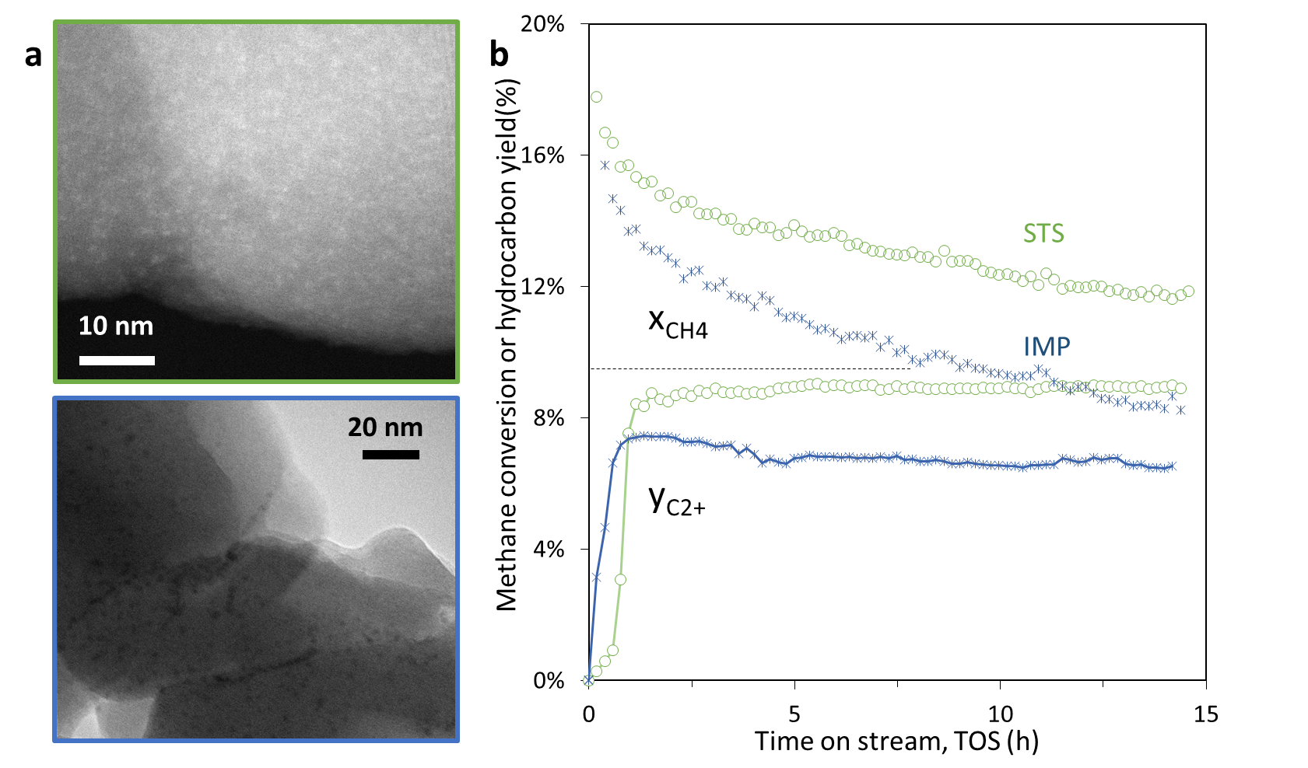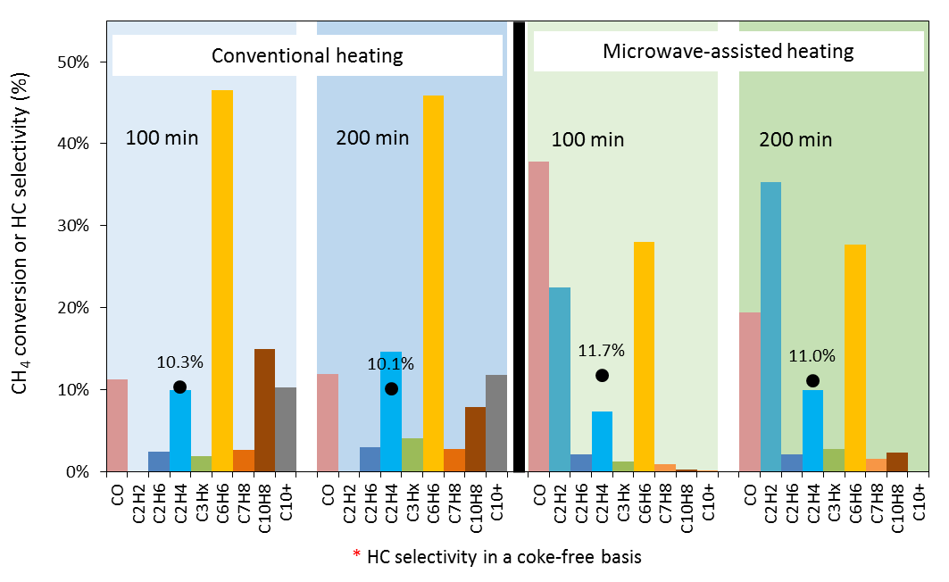
Figure 1. a) TEM micrographs illustrating metal dispersion provided by SC-STS and impregnation methods, b) experimental MNOC performance of 5%Mo/ZSM-5 catalysts prepared by SC-STS and IMP working at 700ºC, 1500 mL/g_{cat}h and 0.5 g_{cat}, c) methane conversion and hydrocarbon products selectivity (coke-free basis) after 100 and 200 min on stream for MNOC on 4%Mo/ZSM-5@SiC operating at 700ºC and 6000 mL/g_{cat}h under CH and MW heating
4. Conclusions
The three proposed approaches helped to enhance both catalyst stability and C₂₊ productivity with respect to conventional procedures, i.e. electrical heating and catalyst synthesis based on impregnation.
References
- I. Julian, H. Ramirez, J.L. Hueso, R. Mallada, J. Santamaria, Chem. Eng. J. (2018). In press.
- C. Kallesøe, H.F. Clausen, L.H. Christensen, EP Patent App. EP 3092067 A1 (2016).
- A. Corma, C. Corell, J. Pérez-Pariente, Zeolites 15 (1995) pp.2-8

