Thermodynamics Based Design Method of Aqueous Two-Phase Systems for Extractive Purification of Biomolecules
Maximilian Wessner¹, Mike Nowaczyk¹, Christoph Brandenbusch¹
1 Laboratory of Thermodynamics, TU Dortmund University, 44227 Dortmund, Germany
*Corresponding author: christoph.brandenbusch@tu-dortmund.de
Highlights
- Thermodynamics based design method for aqueous two-phase systems
- Prediction of biomolecule partitioning in aqueous two-phase systems
- Process tailored purification systems for selective extraction of biomolecules

1. Introduction
The downstream processing of biotechnological products such as therapeutic proteins is a challenging task. It has been shown recently, that Aqueous Two-Phase Systems (ATPS) offer mild processing conditions and a biocompatible environment for the purification of biomolecules due to their high water content of 70-90 wt% [1]. ATPS consist of two hydrophilic components, termed phase formers, (most likely either polymer – polymer or polymer – salt) dissolved in water above a critical concentration, forming two immiscible liquid phases. State of the art identification of ATPS is based on trial-and-error screening methods. In order to circumvent these cost intensive methods, a novel target-oriented method has to be available. This presentation will introduce a thermodynamics based design method [2] dramatically minimizing the experimental effort for ATPS design, and giving rise to a predictive description of the intermolecular interactions between low-molecular components and biomolecules. Based on the knowledge of the interactions of the molecules in solution, the critical concentration of the phase formers, aggregation propensity of the biomolecules, and the partition coefficients of the biomolecules are estimated.
2. Methods
In a first step phase equilibria data, either determined experimentally or modeled applying the ePC-SAFT equation of state [3], is used to determine the minimal concentration of phase formers that allow for the formation of an ATPS. This provides an access to the interactions between the low-molecular components. In order to take the interactions of the biomolecules in the ATPS into account, the osmotic virial coefficients B₂₂ (biomolecule - biomolecule interactions) and B₂₃ (biomolecule - solute interactions) are measured using composition gradient multi-angle light scattering (CG-MALS) for different concentrations of phase formers (polymers, salts) and displacement agents (e.g. neutral salts). Osmotic virial coefficients lower than zero indicate attractive interactions, values higher than zero indicate repulsive interactions. CG-MALS setup comprises of a Calypso II mixing unit, an Optilab T-rEX refractive index and a DAWN HELEOS 8⁺ light scattering detector from Wyatt Technology (Santa Barbara, CA). Subsequently an in-house model [2] is used to predict the partition coefficient of the biomolecules in the ATPS.
3. Results and discussion
In order to identify an optimal ATPS for a given target component, investigations were performed for five phase formers. However, only the results for tri-sodium citrate (Na₃Cit), sodium glutamate (NaGlu) and polyethylene glycol 2000 (PEG2000) are briefly discussed in this abstract. At first, phase equilibria data were measured experimentally (figure 1 left side) and evaluated with respect to the critical concentration of phase formers required to form an ATPS. Furthermore, a model was used to characterize the interactions between the low-molecular components in the ATPS. The measurements show that the critical concentration of phase formers needed is comparable for all combinations investigated. Afterwards B₂₂ values of Immunoglobulin G (IgG) in presence of the respective phase former were measured using CG-MALS to determine the interactions between the biomolecules (figure 1 right side). It is shown that B₂₂ values of IgG in presence of NaGlu are dramatically higher compared the values for Na₃Cit. Based on these results the attractive interactions between IgG molecules in presence of NaGlu are significantly lower and as a consequence, the aggregation propensity of IgG is reduced. Thus, by choosing the NaGlu-PEG2000-ATPS at the respective concentrations indicated in Figure 1 the thermodynamics based design method was successfully applied to identify a process tailored purification of IgG.
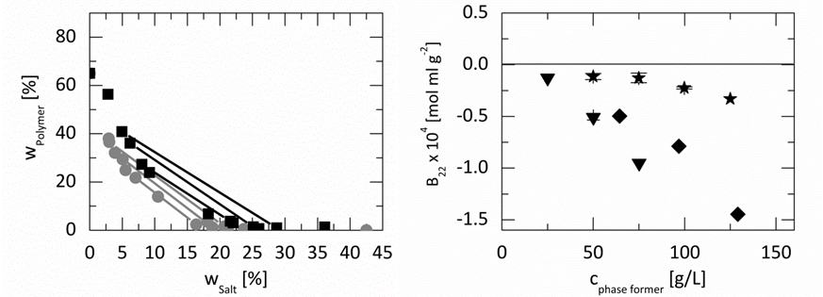
Figure 1. Left: Phase equilibria and binodal curve of ATPS containing sodium glutamate / polyethylene glycol 2000 ( ) and tri-sodium citrate / polyethylene glycol 2000 ( ) at pH of 7 and 298.15 K. Right: B₂₂ values of Immunoglobulin G in presence of the phase former tri-sodium citrate ( ) [4], sodium glutamate ( ) and polyethylene glycol 2000 ( ) in an aqueous 50 mM K₂HPO₄-NaH₂PO₄ solution with pH of 7 and 298.15 K.
4. Conclusions
Within this work, we present a thermodynamics based design method selecting suitable phase former for the extractive purification of IgG. Conventional design approaches fail, due to the fact that knowledge on the interactions between the molecules in an extraction process is limited. It was shown that the description of these interactions is the key factor for establishing a process tailored design of a suitable ATPS. The new method allows for an estimation of the aggregation propensity as well as the partitioning of the biomolecule in the ATPS. It has been proven that the method is a powerful tool and can be used for variety of biomolecular components.
References
- P. Albertsson, Advan. Protein Chem. 24 (1970) 309-341.
- C. Kress, G. Sadowski, C. Brandenbusch, J. Biotechnol. 233 (2016) 151-159.
- C. Held, T. Reschke, S. Mohammad, A. Luza, G. Sadowski, Chem. Eng. Res. Des. 92 (2014) 2884-2897.
- C. Kress, C. Brandenbusch, J. Pharm. Sci. 104 (2015) 3703-3709.

