Novel catalytic distillation processes for a sustainable chemical industry
Anton A. Kiss^{1,2}
1 School of Chemical Engineering and Analytical Science, The University of Manchester, Sackville Street, Manchester, M13 9PL, United Kingdom; 2 Sustainable Process Technology Group, Faculty of Science and Technology, University of Twente, PO Box 217, 7500 AE Enschede, The Netherlands
*Corresponding author: tony.kiss@manchester.ac.uk
Highlights
- Novel reactive distillation processes

1. Introduction
Reactive distillation (RD) is an efficient process intensification technique that integrates catalytic chemical reaction and distillation in one single apparatus acting as a multi-functional reactor. [1] When a heterogeneous catalyst is used, the process is known as catalytic distillation (CD). RD/CD technology has many key advantages such as reduced capital investment and significant energy savings, as it can surpass equilibrium limitations, simplify complex processes, increase product selectivity and improve the separation efficiency.[2] However, reactive distillation is constrained by key thermodynamic requirements (e.g. related to volatility differences and heat of reaction), overlapping of the reaction and distillation operating conditions, and the availability of catalysts that are active, selective and with sufficient longevity to ensure economical operation.

2. Methods
This lecture aims to give an overview of the challenges and opportunities for catalytic distillation processes, the requirements in terms of hardware and catalyst engineering, and it also provides some industrially relevant examples. The potential of reactive / catalytic distillation processes to transform the chemical process industry is assessed from a techno-economic and sustainability perspective. Moreover, the role of the chemical engineering community in enhancing the applicability range of catalytic distillation technology will be addressed and discussed.

3. Results and discussion
The detailed examples presented in this study show that catalyzed RD processes can drastically improve the production of important chemicals such as: acrylic and methacrylic monomers, unsaturated polyesters resins, alkyl ethers (dimethyl ether, di-n-pentyl ether), fatty esters, and other short chain alkyl esters. Various RD configurations can be used, as illustrated in Figure 1. [3]
The main drivers for such novel reactive distillation applications are: economical (large reduction of costs and energy use), environmental (lower CO2 emissions, no or reduced waste) and social (improved safety and health due to lower reactive content, reduced footprint and run away sensitivity). Hence RD technology strongly contributes to all three pillars of sustainability in the chemical process industry.

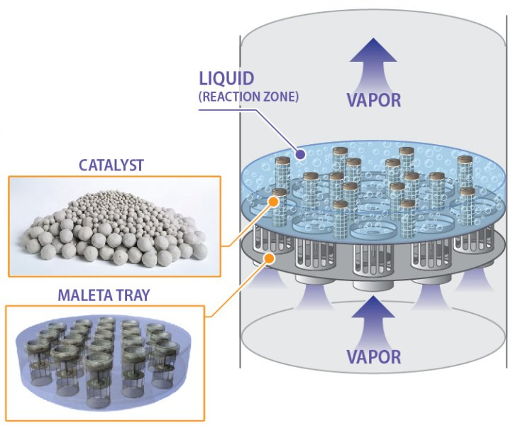
Figure 1: Configurations of reactive distillation processes: classic RD, azeotropic RD, RD with pre-reactors and side-reactors, reactive dividing-wall column (R-DWC), catalytic cyclic distillation internals (Maleta trays).

4. Conclusions
Despite the relatively complex design, control and equipment, RD remains one of the best process intensification technologies that fulfils all the principles of green engineering: design for separation, maximize efficiency, use renewable vs depleting sources, prevent instead of treat, meet need and minimize excess, integrate local material and energy flows, output-pulled vs input-pushed, and design for a commercial afterlife. RD offers key unique features such as: low number of processing units, enhanced overall rates, overcome unfavorable equilibrium, avoid difficult separations, improved selectivity, reduced energy use, less CO2 emissions, low or no solvent use. Considering the outstanding progress in equipment development, modeling and simulation, design and control strategies, real time optimization, and the rapid pace of exploring new applications, RD remains an important PI technique capable to bring green chemistry and sustainable engineering into the chemical process industry.

References
- A. A. Kiss, Topics in Catalysis (2019) DOI: 10.1007/s11244-018-1052-9
- A. A. Kiss, Journal of Chemical Technology and Biotechnology, 89 (2014) 479-498.
- A. A. Kiss, Advanced Distillation Technologies - Design, Control and Applications, Wiley, 2013.

