Supercritical CO₂ impregnation of cotton gauze with bioactive compounds from Olea europea leaves
Lourdes Casas Cardoso, María Teresa Fernández Ponce, Cristina Cejudo Bastante, Casimiro Mantell Serrano, Clara Pereyra López, Enrique Martínez de la Ossa.
Chemical Engineering and Food Technology Department, Wine and Agrifood Research Institute (IVAGRO), University of Cadiz, Cádiz, Spain.
*Corresponding author: lourdes.casas@uca.es
Highlights
- The extract from Olea europea leaf showed antioxidant and antidiabetic capacity.
- Loaded cotton gauze with olive extract was produced by SSI.
- Applying 100 bar and 55 °C favored olive extract impregnation in cotton gauze.

1. Introduction
Food processing generates a substantial volume of solid organic by-products, which are usually used for composting or even discarded in open areas, thus causing potentially environmental problems. The valorization of food industry waste may include several options including extraction and impregnation of bioactive compounds for utilization in the food, cosmetic and pharmaceutical industries.
Supercritical solvent impregnation (SSI), is an efficient and environmentally friendly technique, that is used to the deposition/incorporation of active agents into polymeric matrices. The impregnation of active molecules occurs as a consequence of the interaction balance between the active substance, the matrix and the supercritical phase, which results in an adsorption or a physicochemical attachment of molecules to the polymeric matrix. Furthermore, some of SSI’s advantages are that processes run at moderate temperatures, thus avoiding degradation of thermolabile compounds, and solvent free products can be obtained from the complete desorption of CO₂ gas during the depressurization step.
SSI can be used to develop functional gauze textiles loaded with antioxidant, antimicrobial, anti-inflammatory or antidiabetic agents in order to produce functional textiles with potential applications for instance, in the pharmaceutical field. The main objective of this work was to study the SSI of bioactive leaves extract into cotton gauze. The potential biologically activity of extracts prepared from Olea europea leaves were evaluated.
2. Methods
Firstly, an extract from Olea europea leaf was obtained by Enhanced Solvent Extraction (Thar Technologies, model SF1000) using CO₂+ethanol (1:1 v/v) at 200 bar and 80 ºC, a flow rate of 10 g/min and during 2 h. Results were analyzed according to the global yield, antioxidant activity determined by 2,2-diphenyl-1-picrylhydrazyl assay [1] and inhibition of α-glucosidase evaluated by p-nitrophenyl-a-D-glucopyranoside [2].
Afterwards, the extract was used as active substance in the supercritical impregnation of cotton gauzes using an equipment supplied by Thar Technologies (Pittsburgh, PA, USA, model SF500). The influence of the operating conditions such as pressure (100-400 bar) and temperature (35-55 ºC) were studied.
3. Results and discussion
The use of ethanol as co-solvent in the enhanced solvent extraction of active compounds from Olea europea leaf favored the obtaining of high global yields (12.27 %). The antioxidant activity index of the Olea europea leaf extract labels it as “moderate antioxidant” following the Scherer et al. classification [1]. On the other hand, the pharmaceutical potential of olive extract was evaluated by the α-glucosidase inhibition assay as a determination of the antidiabetic capacity. This extract exhibited a total inhibition against α-glucosidase at 130 ppm.
The results from the experiments carried out at different pressures (100-400 bar) and temperatures (35-55 °C) on the SSI process are displayed in Fig. 1. It can be seen that extract was efficiently impregnated into cotton gauze. The best result was obtained at 100 bar and 55 ºC.
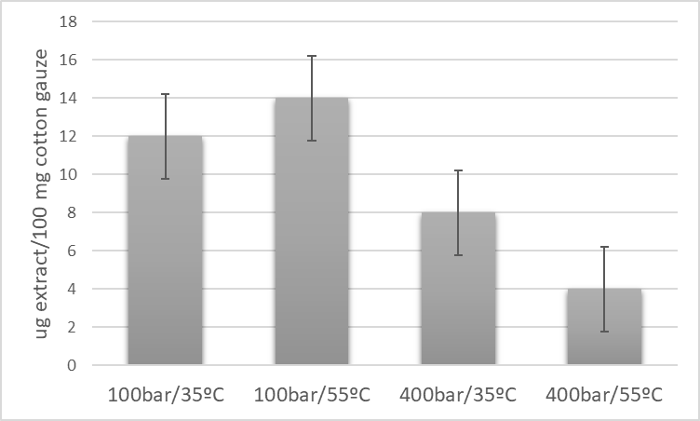
Figure 1. Load of cotton fabrics processed at the different pressures and temperatures.
The impregnation efficiency is governed by the partition coefficient defined as the ratio of equilibrium concentration of the active substance between the polymer matrix and the supercritical phase. In this case, a low solubility of active compounds at 100 bar and 55 ºC favored the impregnation of Olea europea leaf extract due to a higher affinity for the polymer matrix.
4. Conclusions
The use of ethanol as co-solvent favored the obtaining of high global yields and the recovery of antioxidant compounds. The extract exhibited a total inhibition against α-glucosidase with 130 ppm.
SSI process has demonstrated to be a promising alternative for the production of active cotton fabrics. Actually, cotton gauze with a high content in antioxidant and antidiabetic were produced in this study. This is a technology that presents an outstanding potential in pharmaceutical applications.
References
- R. Scherer, H.T. Godoy, Food Chem. 112 (2009) 654-658.
- Y.Li, S.Wen, B. Prasad Kota, G. Peng, G, Qian Li, J. Yamahara, B. Roufogalis. J. of Ethnopharmacology. 99 (2005) 239-244.

