 CHEMICAL ENGINEERING TRANSACTIONS  VOL. xxx, 2025 | A publication of  
The Italian Association
of Chemical Engineering
Online at www.cetjournal.it

Guest Editors: David Bogle, Flavio Manenti, Piero Salatino
Copyright © 2025, AIDIC Servizi S.r.l.
ISBN 979-12-81206-21-2; ISSN 2283-9216

ANN-based hybrid modeling of multicomponent competing adsorption during CO₂ removal from gas mixtures
Katarzyna Bizon*, Marcin Gunia, Mateusz Prończuk
Faculty of Chemical Engineering and Technology, Cracow University of Technology, ul. Warszawska 24, 31-155, Kraków, Poland
*katarzyna.bizon@pk.edu.pl
Sorptive separation is gaining importance as a technique for capturing CO₂ from flue gases. Yet, in numerical simulations of industrial adsorption-based systems, a major difficulty is predicting the equilibrium of multicomponent adsorption. The ideal adsorbed solution theory (IAST) provides a way to determine the isotherms of the mixture components. However, in conjunction with a model of the entire physical system, it appears to be time-consuming and often causes convergence problems.
To handle this problem, this study evaluated the feasibility of using artificial neural networks (ANNs) to describe multicomponent isotherms of a CO₂-N₂ mixture on 5A zeolite. ANN-based surrogate models were then combined with first-principles model and used to simulate the dynamics of CO₂-N₂ adsorption in a fixed-bed adsorptive reactor for performing cyclic CO₂ sequestration-methanation process. The ANNs with a tansig activation function demonstrated very high accuracy in the approximation of multicomponent isotherms, while a hybrid model of the reactor enabled simulation of sorption dynamics and evaluation of the impact of competing sorption phenomena on CO₂ capture.
  - Introduction
In recent decades, separation of gas mixture components based on physical or chemical adsorption have gained considerable attention, mainly for the removal of carbon dioxide from flue gases and atmospheric air (Soo et al., 2024), or as the method for biogas upgrading (Duma et al., 2024). Mathematical modeling and optimization of such processes carried out in classical adsorption columns and adsorptive reactors demands not only information about the process conditions, but also knowledge of the equilibrium of multicomponent adsorption. The reason lies in the fact that, for instance, post-combustion exhaust gases contain, in addition to CO₂, a number of other components that may have a higher or lower affinity towards the adsorbent depending on the sorbent used (Bizon et al., 2022). The co-adsorption of other gas components may negatively affect the efficiency of CO₂ capture. Therefore it should be taken into account when modeling the systems for gas purification based on physical adsorption.
Anyhow, only pure component equilibrium data are usually available due to the complexity of experimental studies of multicomponent adsorption. The methods most commonly used to address this challenge are ideal adsorbed solution theory (IAST) and real adsorbed solution theory (RAST) (Myers and Prausnitz, 1965). They make it possible to determine the isotherms of the components within the mixture, starting from the isotherms of pure components determined experimentally. Unfortunately, solving the IAST/RAST problem on the fly when performing numerical simulations of adsorption columns or adsorptive reactors dynamics usually leads to time-consuming calculations and causes convergence problems for the entire algorithm.
A feasible solution to this problem, analyzed in this study to simulate the dynamics of an adsorptive reactor for the removal of CO₂ from gaseous mixtures, is to use a hybrid model that combines a first-principles model with a data-driven surrogate model. In order to eliminate the computational difficulties resulting from calculating adsorption equilibria using IAST internally within the entire system model, the multicomponent adsorption equilibria were replaced with surrogates based on shallow artificial neural networks (ANNs) with tansig activation function.
  - Mathematical model of adsorptive reactor
    - First principles model
For the construction of the hybrid model and the performing numerical simulations, a one-dimensional model of a fixed-bed isothermal adsorptive reactor for the implementation of cyclic CO₂ sequestration and methanation process was employed. It was assumed that the bed is composed of a homogeneous physical mixture of adsorbent and catalyst particles. The main assumptions of the model are analogous to those of the study by Gunia et al. (2023). In particular, it was assumed that the gas supplied to the apparatus at the adsorption stage (the analysis is limited to this stage) is composed of CO₂, N₂ and inert – from the point of view of adsorption process – gas component.
The mass balance of adsorbable component i in the gas phase can be written as follows:
$$\left({\text{ε}}_{\text{t, ads}}{\text{f}}_{\text{ads}}\text{+}{\text{ε}}_{\text{t, cat}}{\text{f}}_{\text{cat}}\right)\frac{\text{∂}{\text{C}}_{\text{i}}}{\text{∂t}}\text{=}{\text{ε}}_{\text{b}}{\text{D}}_{\text{ax}}\frac{{{\text{∂}}^{\text{2}}\text{C}}_{\text{i}}}{\text{∂}{\text{x}}^{\text{2}}}\text{-u}\frac{\text{∂}{\text{C}}_{\text{i}}}{\text{∂x}}\text{-}{\text{ρ}}_{\text{b,ads}}{\text{f}}_{\text{ads}}\frac{\text{∂}{\text{q}}_{\text{i}}}{\text{∂t}} \text{where i=}{\text{CO}}_{\text{2}}\text{, }{\text{N}}_{\text{2}}$$ | (1)
with the boundary and initial conditions for the adsorption step are defined here as follows:
$${\text{-D}}_{\text{ax}}\frac{\text{∂}{\text{C}}_{\text{i}}}{\text{∂x}}\text{=}\frac{\text{u}}{{\text{ε}}_{\text{b}}}\left({\text{C}}_{\text{f,i}}\text{-}{\text{C}}_{\text{i}}\right)\text{ at x=0 and }\frac{\text{∂}{\text{C}}_{\text{i}}}{\text{∂x}}\text{=0 }\text{at} \text{x}\text{=}\text{L}$$ | (2)
$${\text{C}}_{\text{i}}\left(\text{x,0}\right)\text{=}{\text{q}}_{\text{i}}\left(\text{x,0}\right)\text{=0 for 0≤x≤L}$$ | (3)
Mass transfer in the solid phase is described using linear driving force (LDF) model:
$$\frac{\text{∂}{\text{q}}_{\text{i}}}{\text{∂t}}\text{=k}\left({\text{q}}_{\text{i}}^{\text{*}}\text{-}{\text{q}}_{\text{i}}\right)\text{ where k=}\frac{\text{15}{\text{D}}_{\text{e}}}{{\text{r}}_{\text{p}}^{\text{2}}}\text{ and }{\text{D}}_{\text{e}}\text{=}\frac{{\text{ε}}_{\text{p}}}{{\text{τ}}_{\text{p}}}\frac{{\text{D}}_{\text{K}}{\text{D}}_{\text{m}}}{{\text{D}}_{\text{K}}{\text{+D}}_{\text{m}}}$$ | (4)
The equilibrium concentrations of CO₂ and N₂ in Eq. (4) were described using the Toth isotherm for adsorption on 5A zeolite:
$${\text{q}}_{\text{i}}^{\text{*}}\text{=}{\text{q}}_{\text{sat}}\frac{\text{b}{\text{p}}_{\text{i}}}{{\left[\text{1+}{\left(\text{b}{\text{p}}_{\text{i}}\right)}^{\text{n}}\right]}^{{\text{1}}/{\text{n}}}}\text{ and b=}{\text{b}}_{\text{0}}\text{exp}\left(\frac{\text{-Δ}{\text{H}}_{\text{ads}}}{\text{RT}}\right)$$ | (5)
with the parameters proposed in (Mendes et al., 2017) and reported in Table 1. Other parameters of the model parameter were assumed as in (Gunia et al., 2023).
Table 1: Parameters of the Toth adsorption isotherm on 5A zeolite (Mendes et al., 2017)
Parameter and unit | CO₂ | N₂
q_{sat}, mol/kg | 5.11 | 5.42
b₀, 1/bar | 2.1x10⁻⁵ | 3.3x10⁻⁴
-ΔH_{ads}, kJ/mol | 38.1 | 13.4
n, - | 0.61 | 2.95

The model with associated boundary and initial conditions (Eqs. (1)-(4)) was resolved numerically via the method of lines (MOL) with a prior discretization of the spatial domain using N = 101 equidistant nodes. The system of ordinary differential equations (ODEs) resulting from discretization of the original partial differential equations (PDEs) via MOL was solved in time using ode45 solver from Matlab software. During numerical simulations at each grid node and at each time instant, the equilibrium concentrations of the adsorbed components were calculated using a surrogate model constructed as described in Section 2.2.
    - IAST method and ANN-based surrogate model
Given a K-component gas mixture, finding the concentration of the individual components adsorbed on the solid surface, q_{i}, involves first the solution of the following system of 2K+1 equations (Myers and Prausnitz, 1965; Bizon et al., 2022):
$$\text{p}{\text{y}}_{\text{i}}\text{=}{\text{p}}_{\text{i}}^{\text{o}}{\text{x}}_{\text{i}}\text{, }\int_{\text{0}}^{{\text{p}}_{\text{i}}^{\text{o}}}{{{\text{q}}_{\text{i}}^{\text{o}}\left({\text{p}}_{\text{i}}\right)}/{{\text{p}}_{\text{i}}}}\text{d}{\text{p}}_{\text{i}}\text{-}\text{η}\text{=0, }\sum_{\text{i=1}}^{\text{K}}{{\text{x}}_{\text{i}}}\text{=1, }\text{where}\text{ i=1,2,…K}$$ | (6)
followed by calculation of the solid-phase concentrations of components from the following formulas:
$${\text{q}}_{\text{i}}\text{=}{\text{q}}_{\text{tot}}{\text{x}}_{\text{i}} \text{where} {\text{1}}/{{\text{q}}_{\text{tot}}\text{=}\sum_{\text{i=1}}^{\text{K}}{{{\text{x}}_{\text{i}}}/{{\text{q}}_{\text{i}}^{\text{o}}\left({\text{p}}_{\text{i}}^{\text{o}}\right)}}}$$ | (7)
To construct the surrogate models of multicomponent adsorption isotherms needed to assess the effect of N₂ co-adsorption on CO₂ sequestration, the CO₂-N₂ mixture isotherms were here first calculated using IAST methodology using the pure adsorption isotherms described by Toth model (Eq. (5)).
Specifically, to generate a large amount of data necessary for ANN-based surrogate construction, that is ANN training, the IAST problem (Eqs. (6) and (7)) was solved using fsolve function (with Levenberg-Marquardt algorithm) from Matlab software for 21 temperature values in the range of 293-353 K and 20 partial pressure values of CO₂ and N₂ in the range of 0-4.90 bar (pressure values were distributed logarithmically over the range). Assuming a value of zero of the partial pressure of one of the components of the binary mixture came down to the determination of the isotherm of the pure component directly based on Eq. (5). As a result, a set consisting of 9261 values of CO₂ and N₂ solid-phase concentrations, q_{i}, was obtained.
Based on the available data, two separate neural networks were constructed to predict the solid-phase concentrations of CO₂ and N₂, that is respectively, ${\text{q}}_{{\text{CO}}_{\text{2}}}$ and ${\text{q}}_{{\text{N}}_{\text{2}}}$ (networks output) based on three network inputs, namely temperature, T, and partial pressures, ${\text{p}}_{{\text{CO}}_{\text{2}}}$ and ${\text{p}}_{{\text{N}}_{\text{2}}}$. The networks were trained using the Neural Network Fitting Toolbox from Matlab software, using 70% of the data as training data and the tansig activation function in the hidden layer.
  - Results and discussion
Figure 1a shows an example of adsorption isotherms of pure CO₂ and N₂ on 5A zeolite calculated from Eq. (5) for the two limit temperatures used during the data generation for the construction of surrogate models, that is T = 293 K (solid lines) and T = 353 K (dashed lines). The isotherms shown here illustrate not only the well-known strong influence of temperature on the sorption equilibrium, but also how the value of the affinity coefficient b affects the isotherm shape. For the lower temperature considered here, i.e. T = 293 K, this value for carbon dioxide is as high as b = 130.24 1/bar, while for nitrogen it is merely b = 0.08 1/bar. More than 1000 times higher value of affinity coefficient for CO₂ than the value of b for N₂ has a significant impact on the adsorption equilibrium of the binary mixture. An example of such isotherms is presented in Figure 1b.
The surfaces shown in Figure 1b illustrating ${\text{q}}_{{\text{CO}}_{\text{2}}}\text{(}{\text{p}}_{{\text{CO}}_{\text{2}}}\text{,}{\text{p}}_{{\text{N}}_{\text{2}}}\text{)}$ and ${\text{q}}_{{\text{N}}_{\text{2}}}({\text{p}}_{{\text{CO}}_{\text{2}}}\text{,}{\text{p}}_{{\text{N}}_{\text{2}}})$, respectively, for a single specified temperature (T = 305 K) value were determined numerically using the IAST method given by Eqs. (6) and (7). In the case of a strongly adsorbing compound such as CO₂, the presence of N₂ in the mixture does not significantly affect its adsorption equilibrium. However, for low partial pressures of CO₂, equilibrium solid-phase concentrations of N₂ that is ${\text{q}}_{{\text{N}}_{\text{2}}}$ can exceed (for high values of ${\text{p}}_{{\text{N}}_{\text{2}}}$) even the value of 1 mol/kg. This indicates that under some process conditions, such as the purification of ambient air from CO₂, even N₂ which is weakly adsorbable on 5A zeolite, can compete for sorption sites with CO₂. This confirms the need to take into account multicomponent adsorption and the competitive nature of sorption when modeling adsorption columns and adsorptive reactors.

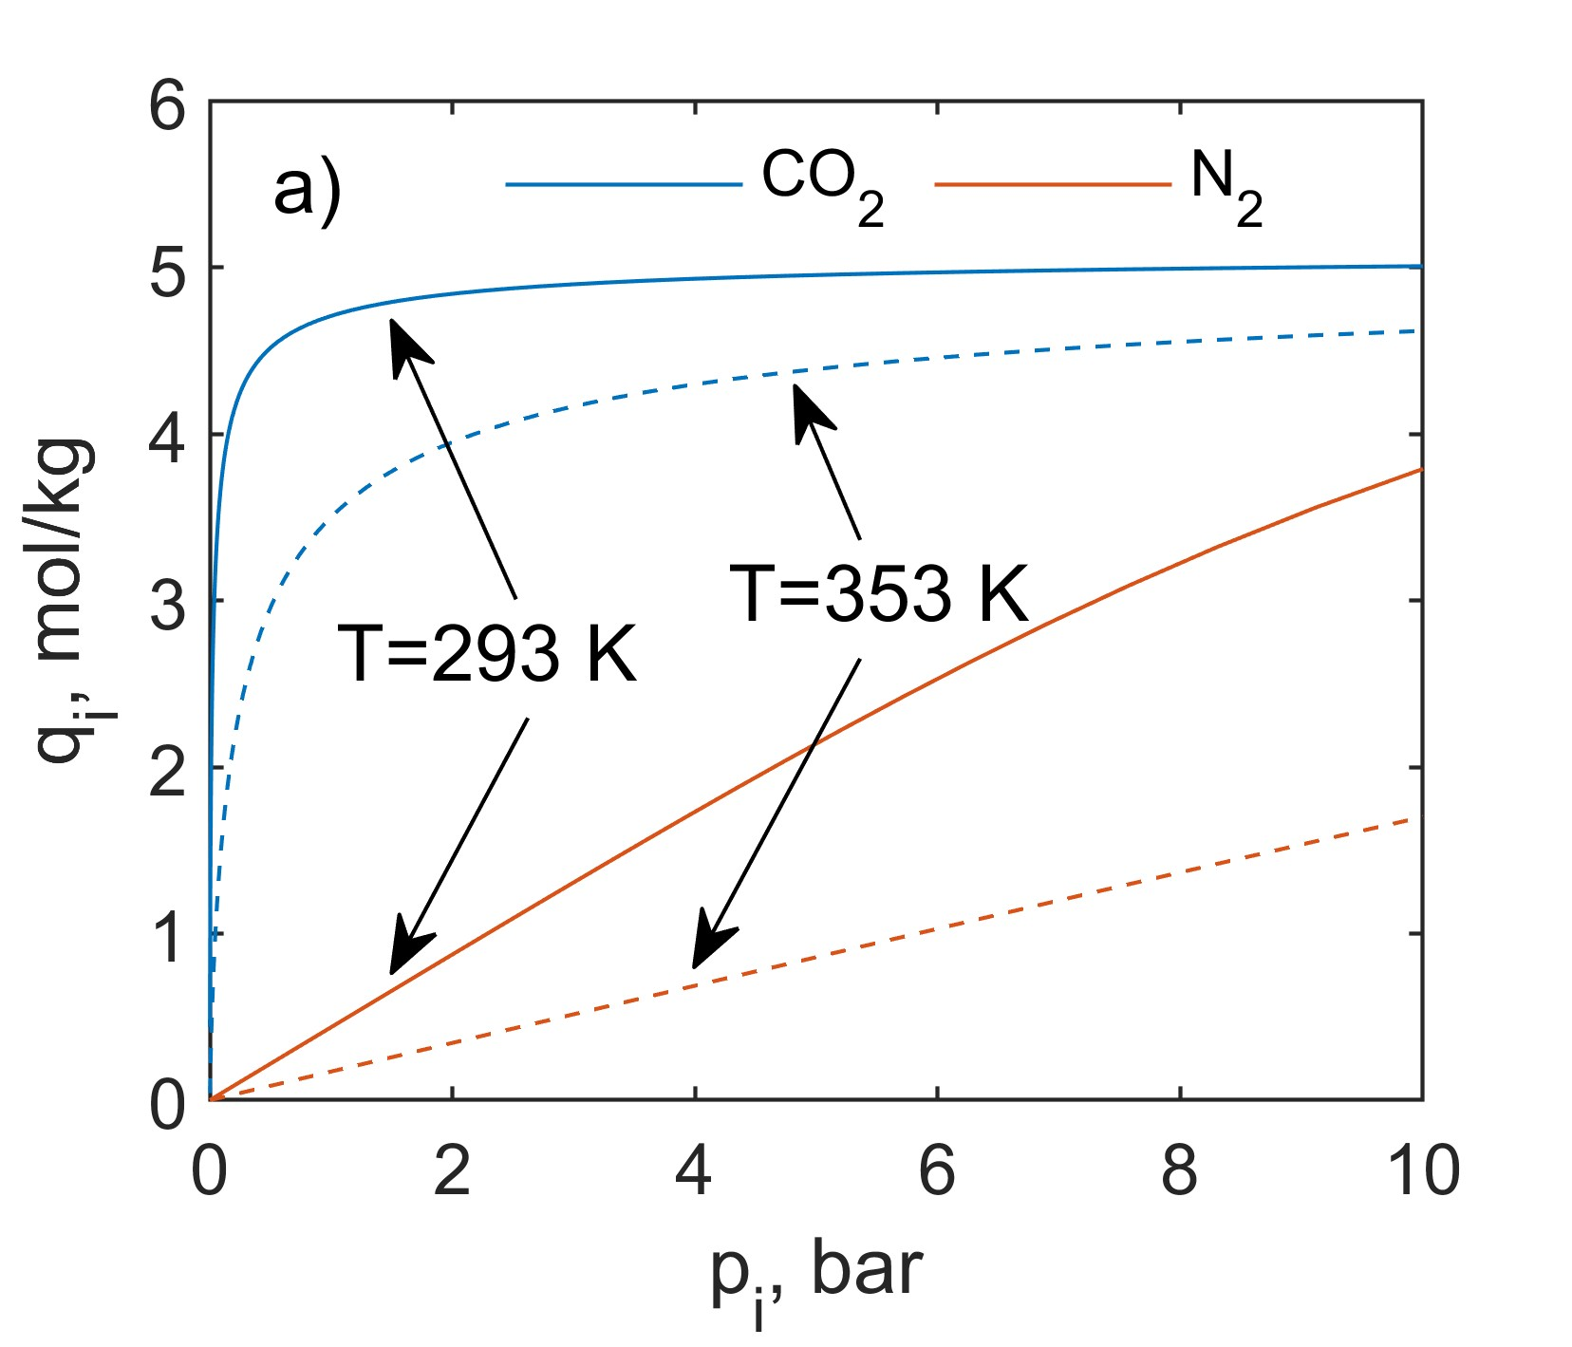 | 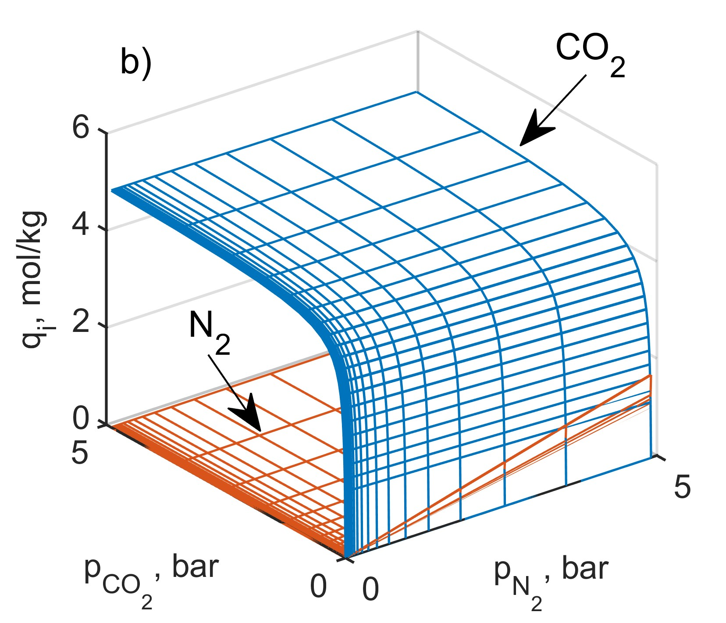
Figure 1: Pure CO₂ and N₂ adsorption isotherms as a function of pressure for two different values of the temperature (a), and CO₂ and N₂ adsorption isotherms in binary mixture for T = 305 K (b) on zeolite 5A as a function of the partial pressures of the individual components in the mixture.
Analogous datasets like the one shown in Figure 1b were numerically determined using IAST for an additional 20 values of the temperature in order to generate the output dataset needed to train the neural network. As mentioned above, two separate neural networks (shallow feed-forward networks with a tansig activation function) were designed for ${\text{q}}_{{\text{CO}}_{\text{2}}}$ and ${\text{q}}_{{\text{N}}_{\text{2}}}$ prediction, respectively, based on three input variables, namely ${\text{p}}_{{\text{CO}}_{\text{2}}}$, ${\text{p}}_{{\text{N}}_{\text{2}}}$ and T.
Figure 2a shows the effect of the number of neurons in the hidden layer of the ANN on its performance, calculated here as a mean-square error. As can be observed, starting from the number of neurons of about 14-15, the accuracy of prediction of the solid-phase concentration of both adsorbed components of the mixture is of the order of 10⁻⁵. Further increasing the number of neurons in the hidden layer of the network no longer improves its performance, so it was decided to adopt ANN-based surrogate models with 15 neurons for further calculations.
Figure 2b shows the CO₂ and N₂ adsorption isotherms in binary mixture determined for T = 305 K using ANNs. As can be visually observed, the resulting ${\text{q}}_{{\text{CO}}_{\text{2}}}$ and ${\text{q}}_{{\text{N}}_{\text{2}}}$ surfaces predicted using ANN-based surrogate models are essentially identical to those shown in Figure 2b.

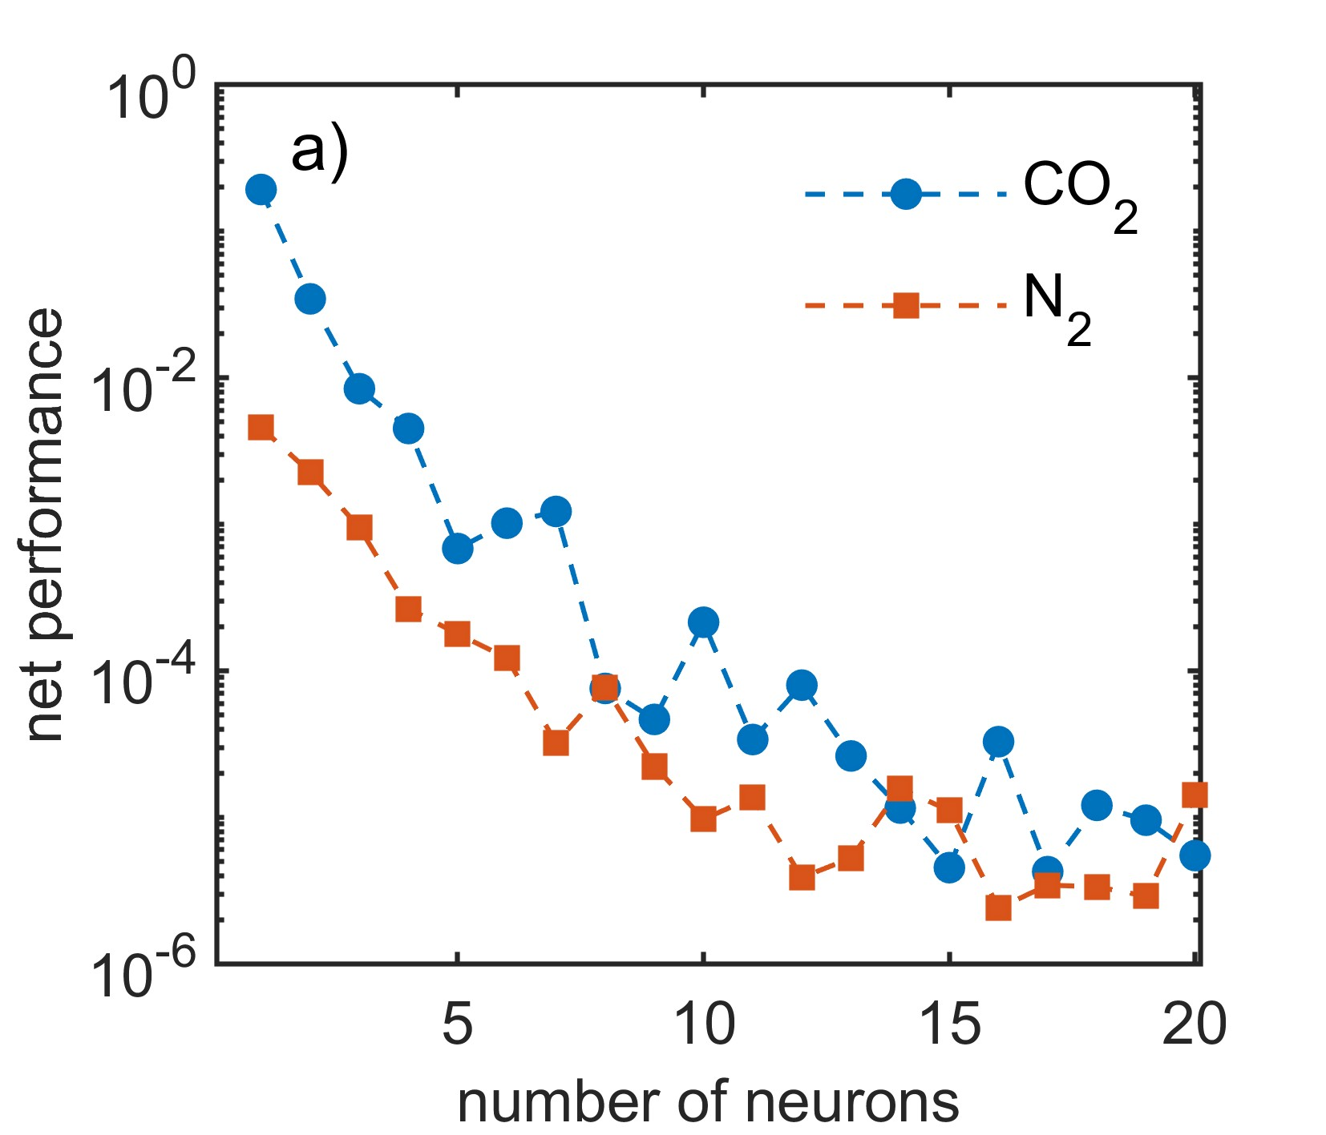 | 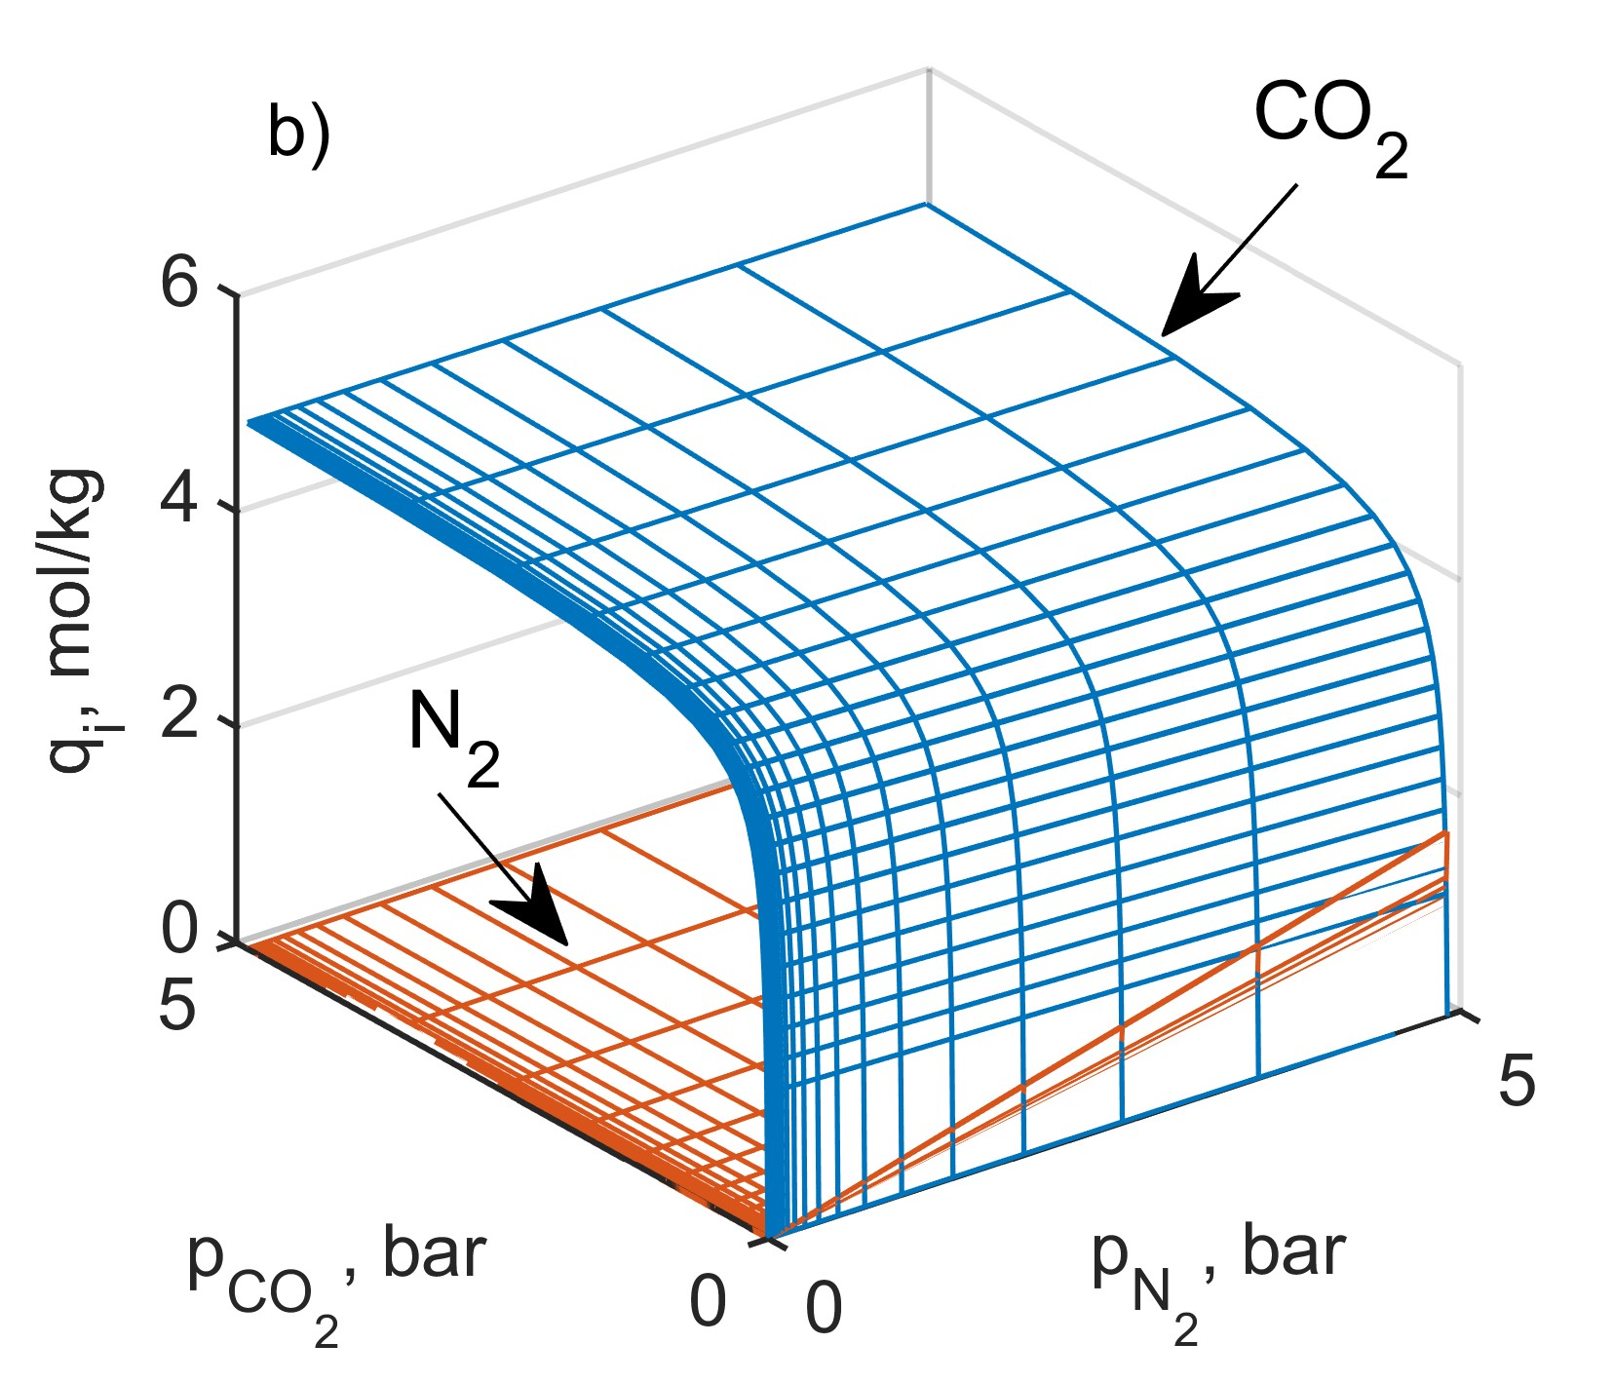
Figure 2: Net performance in the prediction of adsorbed loading of CO₂ and N₂ versus number of neurons (a) and predicted via ANNs (with 15 neurons) CO₂ and N₂ adsorption isotherms in binary mixture for T = 305 K (b) on zeolite 5A as a function of the partial pressures of the individual components in the mixture.
In the next step, the trained ANNs for predicting the solid-phase concentration of adsorbed carbon dioxide and nitrogen based on three input values, that is ${\text{p}}_{{\text{CO}}_{\text{2}}}$, ${\text{p}}_{{\text{N}}_{\text{2}}}$ and T were coupled with the mass balance equations of the adsorptive reactor (Eqs. (1)-(4)). This came down to the construction of a hybrid model also known as a gray model of the physical system under study, which comprises a mechanistic part (based on the first principles) and a data-driven part. To study the dynamics of simultaneous adsorption of CO₂ and N₂, the hybrid model was solved in Matlab software using the ode45 solver. In the simulations, the gas flow velocity was assumed to be u = 0.2 m/s and the temperature was set to T = 305 K. As mentioned in the section describing the model, the gas supplied to the column was composed of CO₂, N₂ and an additional gas component that is inert from the point of view of adsorption. This assumption was made to use the model in which the gas flow velocity is a constant value. In particular, it was assumed that the molar fractions of the components at the inlet are: ${\text{y}}_{{\text{CO}}_{\text{2}}}\text{=} \text{0.05}$, ${\text{y}}_{{\text{N}}_{\text{2}}}\text{=} \text{0.1}$ and ${\text{y}}_{\text{inert}} \text{=} \text{0.85}$. Moreover, given that the process is carried out in a hybrid apparatus, i.e. an adsorptive reactor for cyclic CO₂ sequestration and its methanation, which bed is made of a sorbent and a catalyst, it was assumed that the sorbent and catalyst particles constitute a homogeneous physical mixture and the volume ratio of sorbent to catalyst particles is 2:1. Other parameters were assumed or calculated analogously to the study of Gunia et al. (2023).
Figure 3 shows the results of the simulations. In particular, Figures 3a and 3b illustrate, respectively, the distributions of CO₂ and N₂ concentrations in the solid phase along the bed, namely ${\text{q}}_{{\text{CO}}_{\text{2}}}$ and ${\text{q}}_{{\text{N}}_{\text{2}}}$, at selected time instants. On the other hand Figure 3c shows the bed breakthrough curves; in this figure, the vertical line additionally indicates the time of breakthrough of the bed by CO₂. This time was defined as the time instant at which ${\text{y}}_{{\text{CO}}_{\text{2}}\text{,outlet}}\text{/}{\text{y}}_{{\text{CO}}_{\text{2}}\text{,inlet}} \text{=} \text{0.01}$.
While the solid-phase CO₂ concentration curves shown in Figure 3a are rather classical in shape and illustrate the incremental saturation of the bed by the gas component being sequestered, the shape of N₂ solid-phase concentration distributions along the bed shown in Figure 3b is rather different. This is due to the competitiveness of sorption and the higher affinity value b for CO₂. Given the strongly adsorbable nature of carbon dioxide, it adsorbs initially mainly near the inlet to the apparatus, thus nitrogen flowing through the apparatus adsorbs in its further sections. As the sorbent becomes saturated with CO₂ over time and along the entire bed, N₂ is gradually displaced, yet not completely, by CO₂ also in further sections of the bed. As a result, its local concentration in the solid phase decreases over time from about 0.036 mol/kg to 0.02 mol/kg.

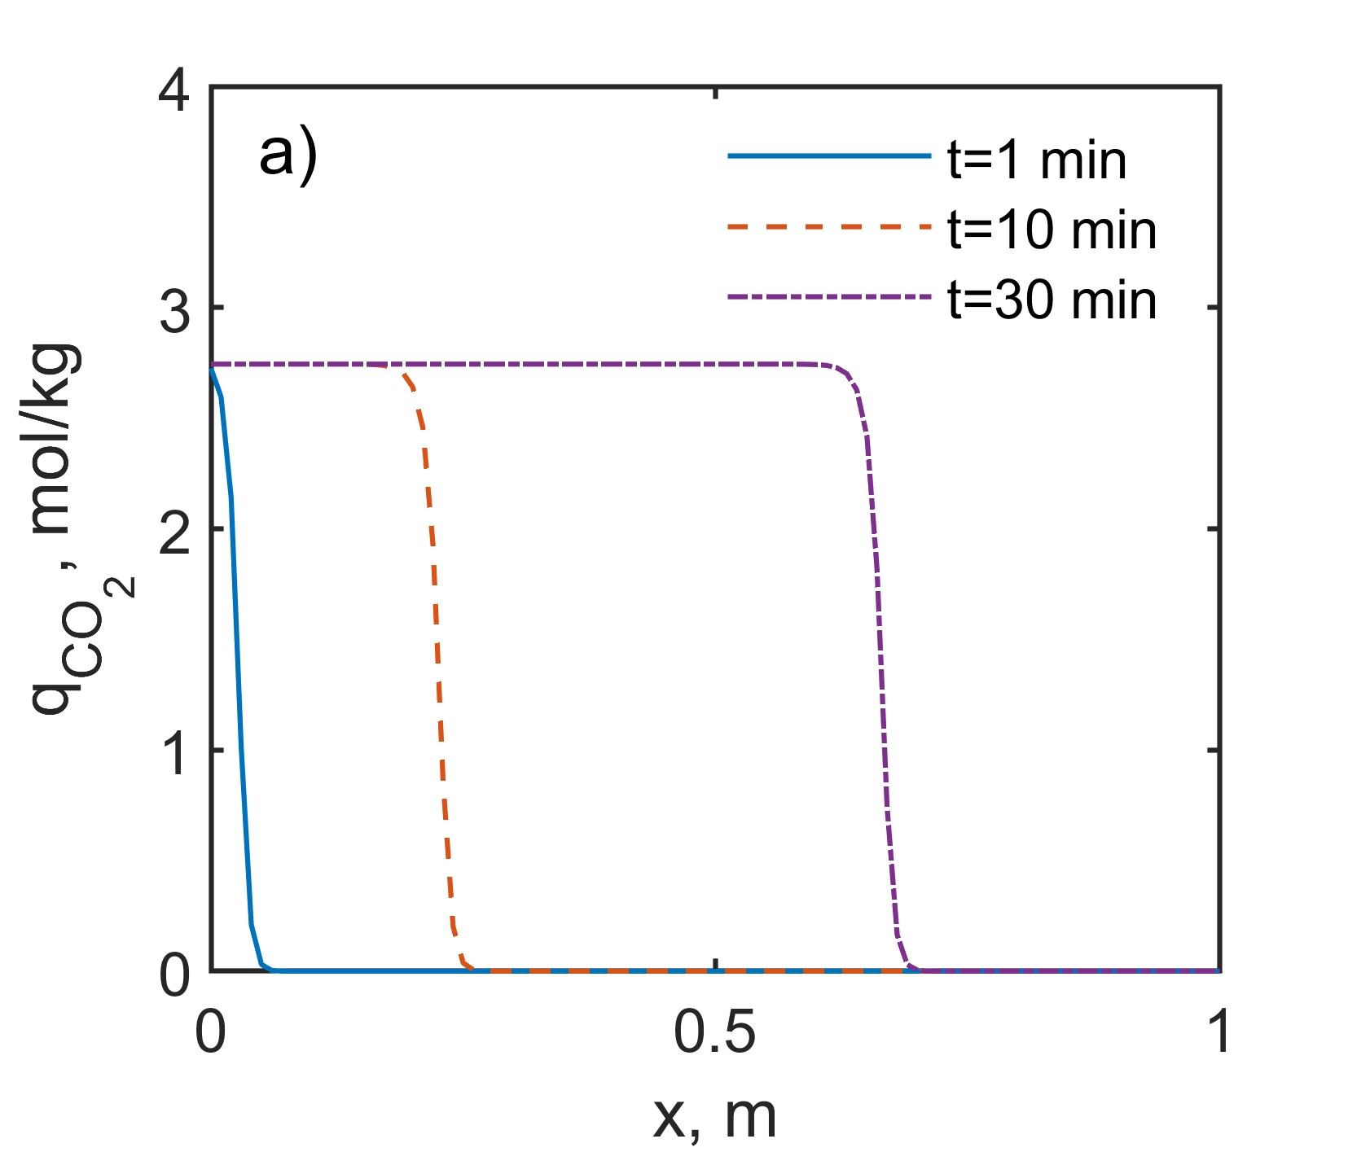 | 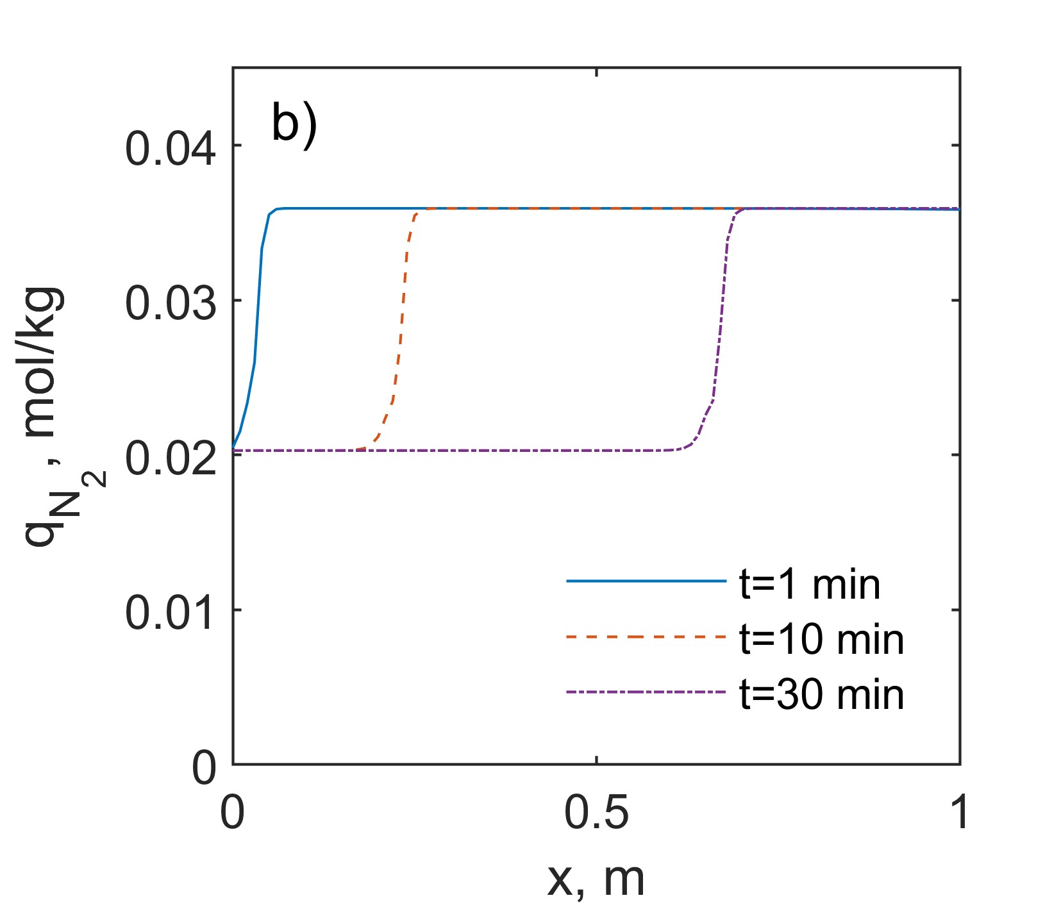
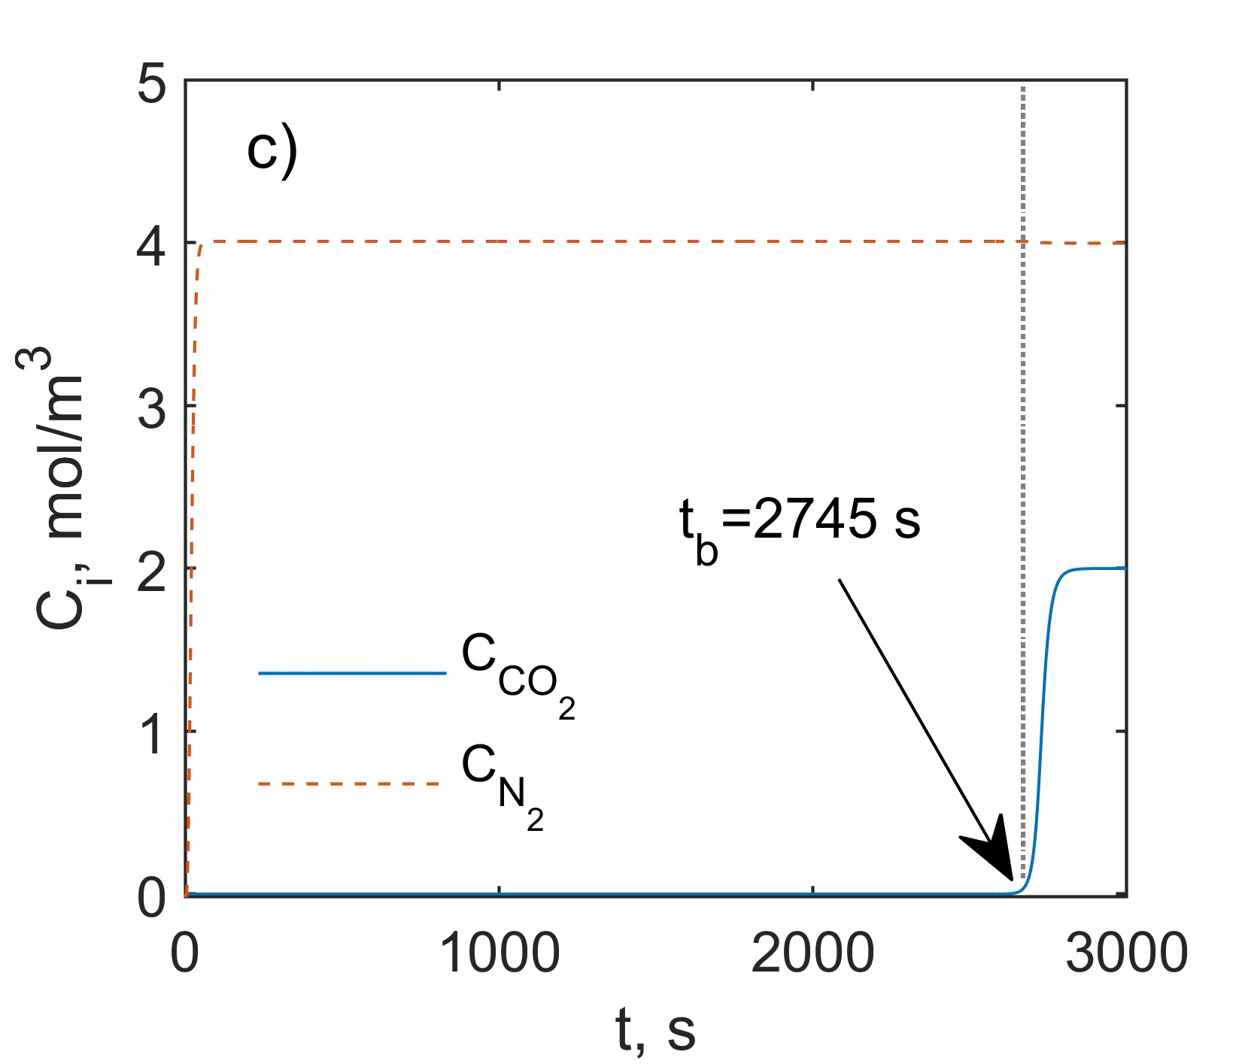
Figure 3: Representative distributions of the solid-phase concentration of CO₂ (a) and N₂ (b) along the bed at different time instants, and the bed breakthrough curves for N₂ and CO₂ (c).
Much stronger adsorption affinity of zeolite 5A towards carbon dioxide than nitrogen is also reflected in the breakthrough curves shown in Figure 3c. Already at the initial stage of the process, the presence of N₂ in the gas phase is observed at the column outlet. The much more strongly adsorbable CO₂ is detected at the bed outlet in the quantity corresponding to the one used in the definition of the breakthrough time only after about 45 minutes. The bed breakthrough indicates that the column is no longer effectively separating CO₂ from N₂, as a result, the regeneration of the bed must be initiated.
  - Conclusions
The study analysed the possibility of using ANN to approximate multicomponent sorption isotherms as an alternative to their calculation based on the IAST method. Shallow feedforward ANNs with tansig activation function and 15 neurons in the hidden layer proved to be very accurate in the approximation of multicomponent isotherms of a CO₂-N₂ mixture on 5A zeolite. Interfacing of ANN-based surrogate models with the model of adsorptive reactor enabled simulation of CO₂-N₂ mixture adsorption on zeolite 5A. In particular, coupling a neural networks (separate ANNs were used to predict solid-phase concentrations of individual components) with a classical first-principles model of mass transport in a fixed bed enabled to study multicomponent sorption dynamics and evaluation of competitive sorption phenomena. It was shown, among other things, that despite the much weaker adsorption of N₂ than CO₂, the former component is also captured by the sorbent particles.
The higher sorption affinity of zeolite 5A towards carbon dioxide than to nitrogen leads to the occurrence of a characteristic N₂ adsorption phenomenon along the bed and its displacement (desorption) by CO₂.
The goal of further research is to develop effective hybrid models based on ANNs for simulating the influence of other components typically present in flue cases onto CO₂ sequestration efficiency. Among others, the approach proposed here based on neural networks will be applied to study the adsorption of CO₂-H₂O mixture in fixed bed. This will involve the use of real adsorbed solution theory (RAST) to determine the isotherms of the real mixture components. Furthermore, for systems with three or more components – which also will be investigated – it is expected that networks with a more complex architecture than those developed in this work will need to be developed.

Nomenclature
b – affinity parameter, 1/bar
b₀ – parameter in Eq. (3), 1/bar
C_{i} – concentration of component i, mol/m³
D_{ax} – axial dispersion coefficient, m²/s
D_{e} – effective diffusivity, m²/s
D_{K} – Knudsen diffusivity, m²/s
D_{m} – molecular diffusivity, m²/s
f_{ads} – adsorbent share in the bed, -
f_{cat} – catalyst share in the bed, -
-ΔH_{ads} – isosteric enthalpy of adsorption, kJ/mol
k – LDF mass transfer coefficient, 1/s
L – length of the fixed bed, m
n – Toth heterogenity parameter, -
p – total pressure, bar
p_{i} – partial pressure of component i, bar
${\text{p}}_{\text{i}}^{\text{o}}$ – pure component i vapor pressure, bar
q_{i} – solid-phase concentration of component i, mol/kg
${\text{q}}_{\text{i}}^{\text{o}}$ – solid-phase concentration of pure component i, mol/kg
${\text{q}}_{\text{i}}^{\text{*}}$ – equilibrium solid-phase concentration of pure component i, mol/kg
r_{p} – particle radius, m
R – universal gas constant, kJ/(K·mol)
t – time, s
t_{b} – breakthrough time, s
T –temperature, K
u – superficial gas velocity, m/s
x – longitudinal coordinate in the reactor, m
x_{i} – molar fraction in adsorbed phase of component i, -
y_{i} – molar fraction in gas phase of component i, -
ε_{b} – bed void fraction, -
ε_{p} – particle porosity, -
ε_{t,ads} – total void fraction of the bed (including particle pores), -
η – reduced spreading pressure, mol/kg
ρ_{b,ads} – bulk density of the bed, kg/m³
τ_{p} – tortuosity factor, -

Acknowledgments
The research was financed by the Polish National Science Centre, under research project ”Experimental and numerical analysis of mass and heat transport in “tailormade” fixed beds for gas-solid processes”, no. UMO-2021/42/E/ST8/00313, and aligns with the CYPHER networking project – “Cyber-Physical systems and digital twins for the decarbonisation of energy-intensive industries”, COST Action no. CA22151.
References
Bizon K., Boroń D., Tabiś B., 2022, Practical issues concerning two-component equilibria of strongly adsorbing species in porous solids, Chemical Engineering Research and Design, 187, 290-298.
Duma Z, Makgwane P.R., Masukume M., Swartbooi A., Rambau K., Mehlo T., Mavhungu T., 2024, A comprehensive review of metal-organic frameworks sorbents and their mixed-matrix membranes composites for biogas cleaning and CO₂/CH₄ separation, Materials Today Sustainability, 27, 100812.
Gunia M., Ciećko J., Bizon K., 2023, Assessment of bed macro-structuring and thermal wave impact on carbon dioxide adsorption efficiency in a hybrid fixed-bed reactor, Chemical and Process Engineering: New Frontiers, 44, e13.
Mendes P.A.P, Ribeiro A.M., Gleichmann K., Ferreira A.F.P., Rodrigues A.E., 2017, Separation of CO₂/N₂ on binderless 5A zeolite, Journal of CO₂ Utilization, 20, 224-233.
Myers A.L., Prausnitz J.M., 1965, Thermodynamics of mixed-gas adsorption, AIChE Journal, 11, 121–127.
Soo X.Y.D., Lee J.J.C., Wu W.-Y., Tao L., Wang C., Zhu Q., Bu J., 2024, Advancements in CO₂ capture by absorption and adsorption: A comprehensive review, Journal of CO₂ Utilization, 81, 102727.

