|  |  |
| --- | --- |
| cetlogo ***CHEMICAL ENGINEERING TRANSACTIONS***  ***VOL. xxx, 2025*** | A publication of  aidiclogo_grande |
| The Italian Association  of Chemical Engineering  Online at www.cetjournal.it |
| Guest Editors: David Bogle, Flavio Manenti, Piero Salatino  Copyright © 2025, AIDIC Servizi S.r.l. **ISBN** 979-12-81206-21-2; **ISSN** 2283-9216 | |

Predictive Modelling and Economic Analysis for Enhanced Efficiency in Electrochemical Hydrogen Compressors

Elisa Zanella, Giacomo Tondelli, Alessio Ferlin, Nicola Bernareggi, Mariangela Longhi, Carlo Pirola\*

Università degli Studi di Milano, Dipartimento di Chimica – via Golgi, 19, 20133 Milano (MI), Italy

\* carlo.pirola@unimi.it

Hydrogen is a promising energy carrier, but efficient separation and compression are crucial for its transport via natural gas pipelines. This study focuses on electrochemical hydrogen compression as a combined purification and compression solution. A predictive model was developed using experimental data to analyse system performance, simulating key phenomena such as gas permeation, hydrogen back-diffusion and membrane hydration. The model also incorporates the current-potential relationship, considering membrane properties and operational parameters. Using this model, the optimal parameters for maximizing system efficiency were identified. Different Nafion® membranes (N-117, N-115, N-212), natural gas:hydrogen mixtures, and output pressures (350 and 700 bar) were evaluated. A techno-economic analysis based on the data obtained from the model assessed CAPEX, OPEX, and H2 cost, identifying the best configurations to enhance overall performance.

* 1. Introduction

In today's world, when concerns about climate change are growing and energy demand is constantly rising, hydrogen stands out as a promising energy vector for long-term storage (International Energy Agency (IEA), 2024). Surplus electricity from renewable sources can be used to produce hydrogen through electrolysis, which can then be stored and later converted back into electricity or utilized as a fuel for industrial processes and transportation. This flexibility makes hydrogen an essential component in the quest for a reliable and sustainable energy system powered by renewables. Exploiting the gas pipelines currently used for natural gas can be a concrete and immediate solution to its transport problems (EU Monitor, 2020). However, blending hydrogen with natural gas presents problems with separation, purification, and storage after grid transportation.

In this work, the Electrochemical Hydrogen Compressor (EHC) is taken into consideration for the separation and compression of hydrogen in low amount in a natural gas-hydrogen mixture. In this device, impure hydrogen undergoes oxidation, generating protons at the anode, which can selectively migrate through a proton exchange membrane (PEM) to the cathode side, where are then reduced to produce pure, compressed hydrogen. Other gases, in this case methane, can only pass through the membrane by means of the slow solution-diffusion mechanism that are characteristic of the type of membrane used. The literature already includes several studies exploring the use of this device for hydrogen purification from methane or natural gas (NG). These studies investigate its effectiveness, operating conditions, and potential advantages compared to conventional separation technologies. Nordio et al. (2021) have investigated the separation of low-concentration hydrogen from the natural gas grid, analysing various hybrid configurations with EHC coupled with membranes or vacuum pumps, identifying the optimal setup for purity (99.9997%) and energy efficiency. Jeckson et al. (2024) investigated the use of EHC for hydrogen deblending from natural gas grids to supply refuelling stations meeting ISO 14687-2019-D purity standards. Mrusek et al. (2024) also studied hydrogen separation from methane blends, focusing on both hydrogen recovery and removal, demonstrating the feasibility of separating and compressing hydrogen from a 5% H2:CH4 mixture, achieving 6 bar at the cathode. In our previous studies, we investigated the efficiency of purification of different methane:hydrogen molar ratio, underlying the feasibility of the process (Zanella et al., 2023). We evaluated three different types of Nafion® membrane (N-117, N-115 and N-212) and, on the basis of the experimental setup configuration and data obtained, we constructed a mathematical model to well represent the behaviour and performances of the EHC with respect to the operative conditions (Zanella et al., 2025). In the present work, the model was used to perform an efficiency assessment and as a base for a successive economic evaluation for an industrial scale plant in different case studies for both purification from a 10:90 hydrogen:natural gas mixture and compression up to 700 bar with all the three evaluated membranes. The case studies of 350 bar and 700 bar were selected as they represent the standard storage pressures for hydrogen cylinders used in heavy- and light-duty fuel cell vehicles. The aim is to assess the feasibility of using an electrochemical hydrogen compressor to separate and compress hydrogen from natural gas mixtures in pipelines, making it suitable for use in hydrogen refuelling stations.

* 1. Methodology
     1. EHC System Design

The EHC is a divided electrochemical cell in which the anodic and cathodic chambers are separated by a membrane electrode assembly (MEA). The MEA consists of a PEM pressed between two gas diffusion electrodes (GDEs), each made up of a gas diffusion layer (GDL) coated with a catalyst. In this study, a carbon cloth GDL is used, with a Pt/C catalyst applied at a loading of 0.2 mg·cm⁻² on both the anode and cathode. The choice of the PEM is one of the most impacting factors in the optimization of the EHC, being the main contributor to the cell capital expenditures (CAPEX) and overpotentials of the system, determining the electrical consumption (Badgett et al., 2024). Moreover, the physiochemical characteristics of the membrane are strictly correlated to the permeation of gases, influencing the product purity and the production efficiency due to back-diffusion of hydrogen (Marciuš et al., 2022). In this work three commercial Nafion® membranes (N-117, N-115 and N-212) are considered, as they are widely studied and employed for many electrochemical processes and were experimentally tested in our previous works (Zanella et al., 2025). The main characteristics of the three membranes are reported in Table 1.

*Table 1: Comparison of the Nafion® membranes considered in this work (Nafion, 2025).*

|  |  |  |  |  |
| --- | --- | --- | --- | --- |
| Membrane | Thickness (μm) | EW\* (kg mol-1) | Water uptake (%) | \* (kg m-3) |
| Nafion® 117 | 183 | 1.1 | 38 | 1970 |
| Nafion® 115 | 127 | 1.1 | 38 | 1970 |
| Nafion® 212 | 50.8 | 1.0 ± 0.5 | 50 ± 5.0 | 1980 |

*\*EW = equivalent weight and $ρ_{dry}$ = dry membrane density*

In industrial plants, cells are stacked with bipolar plates, allowing current to flow in series and gas streams in parallel. This design lowers capital costs by integrating multiple cells into a single unit with shared components. An effective stack design is crucial for ensuring uniform gas flow distribution across all cells and withstanding significant mechanical stresses at high pressures. The most effective approach is to use circular cells and reduce their size as operating pressure increases (Moton et al., 2014). An EHC system for hydrogen purification and compression requires power supply units and gas humidification to maintain membrane hydration and minimize resistance. Temperature control is crucial, as excess heat affects membrane humidification and increases resistance, while low temperatures lower efficiency (Yadav and Fedkiw, 2012). These operations constitute the main balance of plant (BOP), essential for system performance.

* + 1. Model development

In this work, a mathematical model developed to describe EHC behavior is used to evaluate the efficiency of the device and the energy consumption in many scenarios of both compression and purification using N-117, N-115 and N-212 and varying cathode pressure (1 bar, 350 bar, 700 bar), temperature (298.15 K, 313.15 K, 328.15 K) and inlet gas composition (100:0 and 10:90 H2:NGmolar ratio). The model was developed in the C++ programming language starting from literature equations and experimental data fitting on the setup previously studied (Zanella et al., 2025). The model calculates the material balance between the anodic and cathodic chambers considering the hydrogen chemical conversion, directly correlated to the current density (Eq 1) as no other parasitic reactions are considered, the passage of gasses (Eq 2) and the water transport by electroosmotic transport and diffusion in the polymeric membrane (Eq 3). The correlation between current density and potential applied to the cell was obtained considering the Nernst potential (Eq 4), the reaction activation energy by Butler-Volmer equation (Eq 5), and the ohmic resistances (Eq 6). The total cell potential ($U_{cell}$) is the sum of all the other contributions (Eq 7) (Marciuš et al., 2022). All symbols used in the equations are defined in the Nomenclature section at the end of the article.

|  |  |  |  |
| --- | --- | --- | --- |
| ${\dot{n}}_{H_{2}}^{theor}=\frac{j}{2F}A$ | (1) | ${\dot{n}}_{i}^{perm}= k_{p, i}∆p_{i}\frac{A}{L}$ | (2) |
| ${\dot{n}}_{H_{2}O}^{ }=EOD∙A\frac{j}{F}+D_{H_{2}O}\frac{ρ_{dry}}{EW}\frac{A}{L}$ | (3) | $E^{eq}=E^{0}+\frac{RT}{2F}\ln\left(\frac{P_{H_{2}, cat}}{P_{H_{2}, an}}\right)$ | (4) |
| $j=j_{0}p_{H_{2}}^{α}\left[\exp\left(\frac{2αF}{RT}η_{act}\right)-\exp\left(-\frac{2αF }{RT}η_{act}\right)\right]$ | (5) | $η_{Ω}= σ_{(λ, T)}\frac{L}{A} j$ | (6) |
| $U_{cell}= E^{eq}+η_{act}+η_{Ω}$ | (7) |  |  |

To simulate the cell, a partial integration approach was used, dividing the total active area into sections calculated sequentially. The output conditions of each section served as the input for the next, allowing for a step-by-step analysis of the system. The parameters for membrane resistivity and permeability were obtained from our previous experimental studies that were conducted in a bench scale plant (Zanella et al., 2025). Considering a current efficiency of 100%, since no side reactions are taken into account, the energy efficiency ($ϕ_{energ}$), the production efficiency ($ϕ_{prod}$), total efficiency ($ϕ_{tot}$), and the energy consumption ($W$) were calculated by means of equations 8, 9, 10 and 11, respectively.

|  |  |  |  |
| --- | --- | --- | --- |
| $ϕ_{energ}=\frac{2FE^{eq}}{2FU_{cell}}=\frac{E^{eq}}{U_{cell}}$ | (8) |  | (9) |
|  | (10) |  | (11) |

* + 1. Economic assessment

A cost analysis was carried out under optimized operating conditions to evaluate the total cost of the EHC, CAPEX and operational expenditure (OPEX). CAPEX includes the costs associated with the stack (CStack), installation (CInstallation), and balance of plant (CBOP) (Eq 12). Given that the electrochemical hydrogen compressor operates with a PEM, its expected lifespan is comparable to that of a PEM electrolyser, therefore a lifetime of 40000 hours is assumed in this study (Choi et al., 2024).

The number of stacks is calculated to achieve the total number of cells required to meet the daily hydrogen production target (Eq 13 and Eq 14), set at 250 kg/day, and it was decided to limit it to a maximum of 60. The stack cost depends on the number of cells (n°cell) and on their costs (Ccell) (Eq 13). The ncell was fixed at 150 to simulate a possible industrial device. The MEA cost was calculated considering the membrane material, the GDL material and Pt amount. Based on the values provided in Table 2, a cost of 0.27 € cm-2, 0.32 € cm-2 and 0.34 € cm-2 was calculated for N-212, N-115 and N-117. In a typical configuration this cost represents the 50% of the total Ccell (Badgett et al., 2024; Moton et al., 2014). The BOP cost was calculated considering that in literature the power supply count for the 73% of the total BOP costs (Moton et al., 2014). Considering this assumption, it was decided to calculate only the power supply cost (CPower Supply). Three different power supplies with power ratings of 500 kW, 1 MW and 5 MW were considered and selected based on the total power consumption of the plant. Finally, the CInstallation were calculated using Eq 15 (Prokopou et al., 2024).

|  |  |  |  |
| --- | --- | --- | --- |
| $$CAPEX=\frac{C_{Stack}+C_{installation}+C_{BOP}}{Life Time}$$ | (12) | $C_{Stack}=C_{cell}∙{n°}_{cell}= C_{cell}∙{\dot{m}}_{H_{2}}/{\dot{m}}_{H_{2},cell}$ | (13) |
| ${\dot{m}}_{H_{2},cell}=M_{H2}∙ {\dot{n}}_{H_{2},cell}=M_{H_{2}}∙\left({\dot{n}}_{H_{2}}^{theor}-{\dot{n}}_{H_{2}}^{perm}\right)$ | (14) | $C_{installation}=\left(C_{Stack}+C_{BOP}\right)∙0.12$ | (15) |

For the OPEX evaluation only electricity consumption was considered and the operating costs normalized for kg of hydrogen were calculated using Eq 16.

|  |  |
| --- | --- |
| $OPEX=\left(\frac{2{FU}_{cell}}{3600∙M_{H_{2}}∙ϕ_{prod}}\right)∙C_{electricity}$ | (16) |

The final total normalized costs were calculated using the following equation:

|  |  |
| --- | --- |
| $Cost H_{2}=\frac{CAPEX}{{\dot{m}}_{H_{2}}}+OPEX$ | (17) |

*Table 2: Materials and resources costs considered for the economic assessment.*

|  |  |  |
| --- | --- | --- |
| Materials and resources | Cost | Ref. |
| Pt cost | 29.07 € g-1 | (StoneXBullion, 2025) |
| Nafion® 212 membrane | 960 € m-2 | (h2planet 2025; Nafion® 2025) |
| Nafion® 115 membrane | 1255 € m-2 | (h2planet 2025; Nafion® 2025) |
| Nafion® 117 membrane | 1330 € m-2 | (h2planet 2025; Nafion® 2025) |
| Carbon cloth | 250 € m-2 | (Badgett et al., 2024) |
| Cost of power supply | 0.05 € W-1 | (Badgett et al., 2024) |
| Cost of electricity | 0.11835 € kWh-1 | (TradingEconomics, 2025) |

*Table 3: Case studies evaluated in the economic assessment.*

|  |  |  |  |
| --- | --- | --- | --- |
| Case Study | | Starting mix | Outlet pressure |
| Compression | C, 350 bar | 100% H2 | 350 bar |
| Compression | C, 700 bar | 100% H2 | 700 bar |
| Purification | P, 1 bar | 10% H2 in NG | 1 bar |
| Purification & Compression | P+C, 350 bar | 10% H2 in NG | 350 bar |
| Purification & Compression | P+C, 700 bar | 10% H2 in NG | 700 bar |

For the economic assessment the case studies listed in Table 3 were evaluated. To account for the mechanical strength limitations due to high pressure differences, the design of the cell was considered as circular, with a diameter decreasing with the enhance in pressure: 400 cm2 for ambient pressure, 260 cm2 for 350 bar and 220 cm2 for 700 bar (Moton et al., 2014).

* 1. Results and discussion

Using the mathematical model presented in Section 2.2, the energy consumption and efficiency of the EHC system were analysed under various operating conditions. All simulations were conducted assuming ambient pressure as the initial condition and constant membrane humidification of 100%. Three different Nafion® membranes, namely N-212, N-115, and N-117, were evaluated by comparing their performance under varying final output pressures, temperatures, and inlet gas compositions.

The first analysis focused on the impact of output pressure on energy consumption, considering 1 bar, 350 bar, and 700 bar. The operating temperature was set to 298.15 K, and the feed gas composition consisted of a 10% hydrogen in natural gas mixture. As shown in Figure 1a, at 1 bar, energy consumption increases linearly with current density, with N-212 exhibiting the lowest values due to its lower resistance. Previous studies have correlated this behaviour with its reduced thickness and lower equivalent weight (see Table 1) (Zanella et al., 2025, 2023). At high pressures, the energy consumption curve exhibits a minimum as a result of two competing effects. At low current densities, hydrogen back-diffusion from the cathode to the anode reduces the net hydrogen transfer, leading to a decrease in overall efficiency. Conversely, at high current densities, ohmic losses become the predominant factor, causing an increase in energy consumption. This minimum shifts toward higher current densities for thinner membranes, as their greater hydrogen permeability intensifies back-diffusion effects. Specifically, the optimal current density for minimum energy consumption was found at 0.97 A cm-2 for N-212, 0.38 A cm-2 for N-115, and 0.27 A cm-2 for N-117.

The second analysis examined the influence of temperature, considering three values: 298.15 K, 313.15 K, and 328.15 K. The output pressure was maintained at 700 bar, with a 10% H2 in NG mixture as the feed. An overall reduction in energy consumption was observed as temperature increased (Figure 1b). For the N-212 membrane, the minimum energy consumption decreased from 29.2 kWh kg-1 at 298.15 K to 25.4 kWh kg-1 at 313.15 K and further to 22.7 kWh kg-1 at 328.15 K. This trend is attributed to the reduction in ohmic resistance and improved proton conductivity at higher temperatures (Yadav and Fedkiw, 2012).

The final study evaluated the effect of hydrogen concentration in the feed. The final output pressure was maintained at 700 bar, and the operating temperature at 298.15 K. Feed compositions ranged from pure hydrogen to 10% H2 in NG. No significant variations in energy consumption were observed across different compositions (Figure 1c). This can be explained by the dominance of compression energy over purification energy, indicating that separation efficiency does not substantially impact on energy consumption at high pressures.

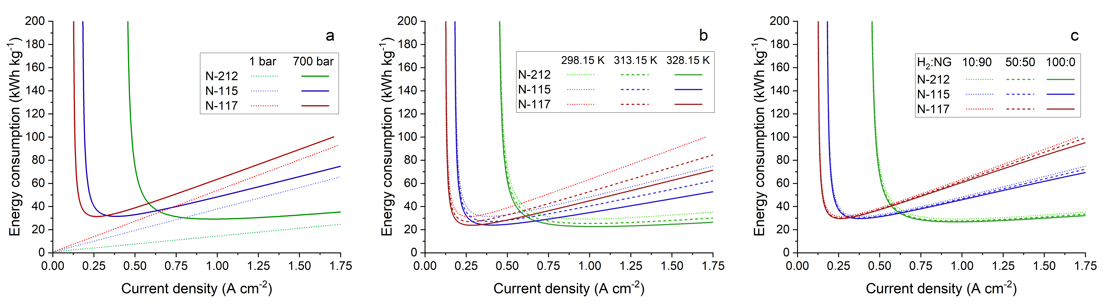

Figure 1: Energy consumption curves against current density for the three different membranes (N-212, N-115 and N-117) at different operating conditions: a) final pressure, b) temperature, c) initial feed composition.

A detailed analysis was conducted to evaluate the influence of both production efficiency and energy efficiency on overall system performance. At low current densities, production efficiency is equal to zero, as all the hydrogen generated diffuses back from the cathode to the anode side. Contrarily, at higher current densities, energy efficiency becomes the dominant factor, as the cell voltage (*U*cell) is affected by elevated ohmic overpotentials, leading to higher energy losses. In Figure 2 is reported the efficiency evaluation for the three different Nafion membranes considering as starting mixture 10% of hydrogen in natural gas, a temperature of 298.15 K and a final output pressure of 700 bar. The maximum total efficiency is comparable for the three membranes, but it shifts at higher current densities for thinner membranes, with higher energetic efficiency and lower production efficiency.

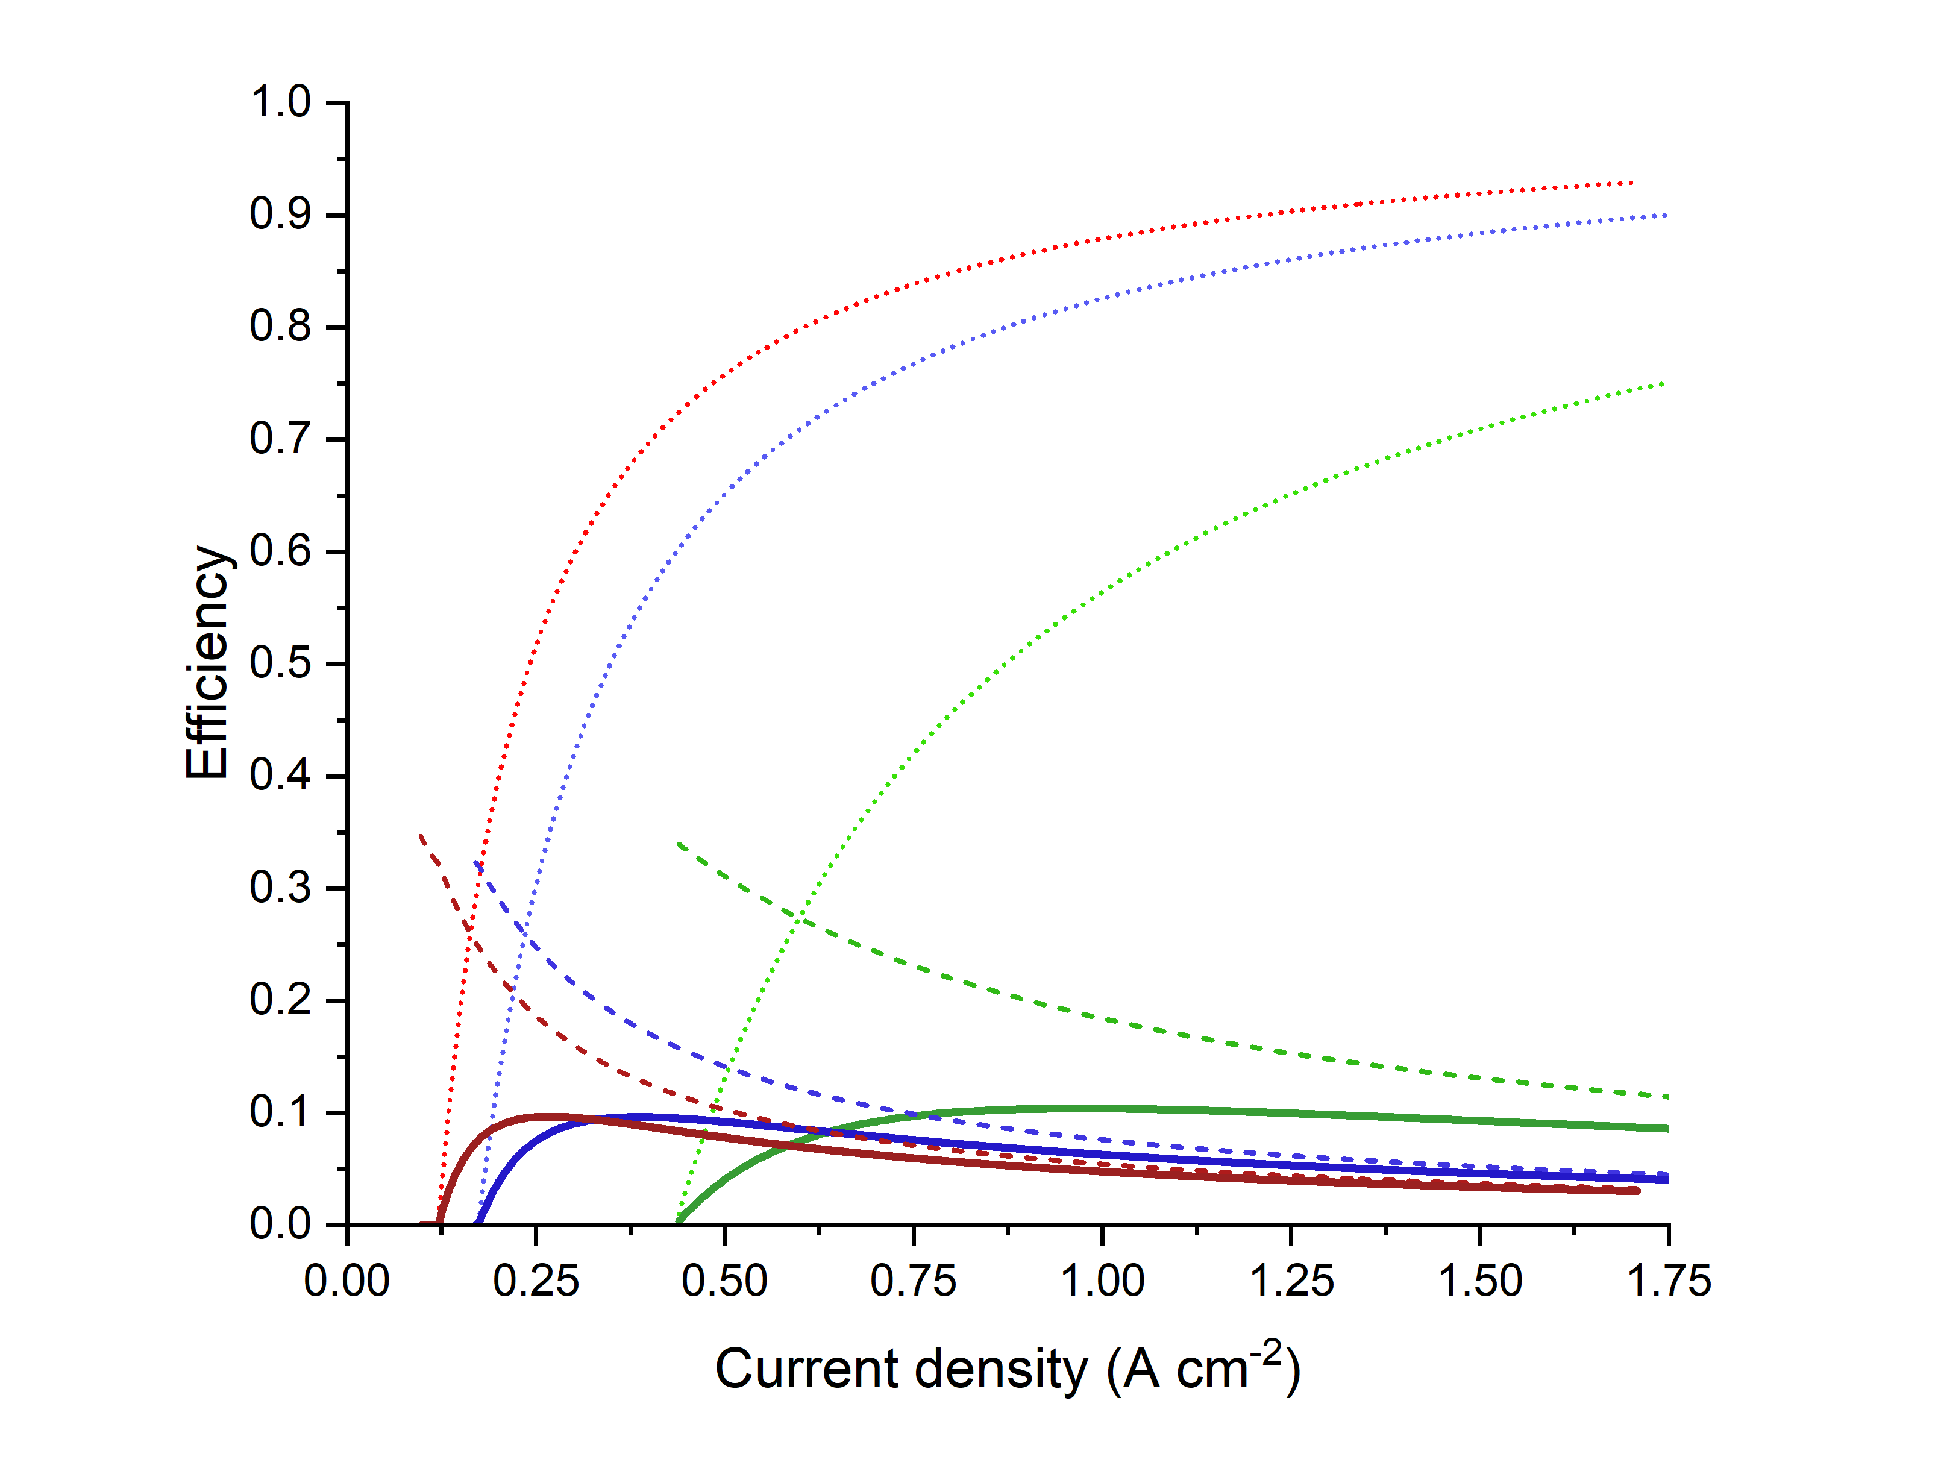

Figure 2: Efficiency contributions for the three different Nafion membranes considering as starting mixture 10% of hydrogen in natural gas, a temperature of 298.15 K and a final output pressure of 700 bar.

Once the optimized parameters for the three membranes were found the cost analysis assessment was performed. CAPEX, OPEX and the normalized hydrogen cost were evaluated considering a productivity of 250 kg of H2 per day. The optimized used operative condition, and the results are presented in Table 4 and Figure 3. The economic analysis reveals that utilizing the N-212 membrane allows operations at higher current densities, when minimizing energy consumption, which remains comparable across the three membranes, as observed by the efficiency comparison presented in Figure 2. Still a slight reduction in energy demand and therefore OPEX is observed for N-212. Furthermore, the ability to operate at higher current densities enables the design of more compact systems, which in turn reduces CAPEX, making the system more cost-effective.

*Table 4: Optimized operative conditions, CAPEX and OPEX resulting from the economic assessment.*

|  |  |  |  |  |  |  |
| --- | --- | --- | --- | --- | --- | --- |
| Membrane | Case study | Cell Area (cm2) | N° Stack | Current density (A cm-2) | CAPEX (103 €) | OPEX (€ kg-1) |
| N-212 | C, 350 bar | 260 | 22 | 0.55 | 294 | 1.66 |
| C, 700 bar | 220 | 16 | 0.98 | 196 | 2.93 |
| P, 1 bar | 400 | 26 | 0.18 | 503 | 0.44 |
| P+C, 350 bar | 260 | 21 | 0.57 | 282 | 2.10 |
| P+C, 700 bar | 220 | 15 | 1.00 | 186 | 3.57 |
| N-115 | C, 350 bar | 260 | 47 | 0.24 | 706 | 1.82 |
| C, 700 bar | 220 | 38 | 0.40 | 495 | 3.21 |
| P, 1 bar | 400 | 47 | 0.10 | 1065 | 0.58 |
| P+C, 350 bar | 260 | 45 | 0.25 | 677 | 2.25 |
| P+C, 700 bar | 220 | 34 | 0.42 | 459 | 3.83 |
| N-117 | C, 350 bar | 260 | 60 | 0.18 | 959 | 1.85 |
| C, 700 bar | 220 | 50 | 0.29 | 666 | 3.22 |
| P, 1 bar | 400 | 56 | 0.08 | 1318 | 0.66 |
| P+C, 350 bar | 260 | 57 | 0.19 | 885 | 2.29 |
| P+C, 700 bar | 220 | 51 | 0.29 | 679 | 3.81 |

Regarding the normalized cost per kg of hydrogen produced, thinner membranes exhibit lower costs, particularly in the case of purification at low pressures. Nonetheless in the separation of hydrogen from a 10% H₂ in NG, combined with compression up to 700 bar, the N-212 membrane demonstrates a lower normalized cost of 3.64 € kg-1, compared to 4.03 € kg-1 and 4.10 € kg-1 for the N-115 and N-117 membranes, respectively. This further highlights the economic advantage of employing thinner membranes in electrochemical hydrogen compression and purification processes. Also in terms of hydrogen purity, the N-212 membrane enables the attainment of purity levels that comply with the limits set by regulatory standards (ISO 14687:2019, 2019).

Figure 3: Normalized cost per kg of hydrogen produced and purity obtained for the different case studies.

* 1. Conclusions

This study evaluates the feasibility of using an EHC for hydrogen separation and compression from natural gas mixtures. A mathematical model was used to perform an efficiency assessment and a successive economic evaluation. Different case studies were evaluated, with a focus on the comparison of the behaviour of three different commercial Nafion® membranes (N-212, N-115 and N-117) at different final pressure, temperature and initial composition. The results highlight the N-212 as the best performing membrane, with a major reduction of the CAPEX without compromising the product yield, purity and normalized cost of compression and purification. These results highlight the potential of using EHC to extract and compress hydrogen directly from natural gas grids, enabling decentralized supply to hydrogen refuelling stations.

Nomenclature

|  |  |  |
| --- | --- | --- |
| $j$- current density, A cm-2  - Faraday constant  A - active surface area, cm2  - the molar flow of the species i $k_{p,i}$ - permeability coefficient, barrer $p_{i}$ - partial pressure, bar $L$ - membrane thickness, μm | $EOD$- electroosmotic coefficient $D_{H_{2}O}$ - diffusion coefficient of water $ρ_{dry}$ - dry membrane density $EW$ - equivalent weight $E^{eq}$ - Nernst potential, V $E^{0}$ - cell standard potential, V $R$ - gas constant | $T$- temperature, K $j_{0}$ - exchange current density, A cm-2  - symmetry coefficient $η_{act}$ - activation overpotential, V $η_{Ω}$ - ohmic overpotential, V $σ$ - membrane resistivity, Ω cm $λ$ - membrane water content |

References

Badgett, A., Brauch, J., Thatte, A., Rubin, R., Skangos, C., Wang, X., Ahluwalia, R., Pivovar, B., Ruth, M., 2024. Updated Manufactured Cost Analysis for Proton Exchange Membrane Water Electrolyzers.

Choi, Y., Sera, D., Mishra, Y., Love, J., 2024. Degradation Modelling of PEM Electrolysers under Fluctuating Input Power for Long-Term Performance Optimisation. In: 2024 IEEE 9th Southern Power Electronics Conference (SPEC). pp. 1–6.

EU Monitor, 2020. Communication COM/2020/301: A hydrogen strategy for a climate-neutral Europe. Ommunication From the Commission To the European Parliament, the Council, the European Economic and Social Committee and the Committee of the Regions 53.

h2planet, 2025. Nafion Membranes. URL https://www.h2planet.eu/it/products/ (accessed 3.5.25).

International Energy Agency (IEA), 2024. World Energy Outlook 2024.

ISO 14687:2019, 2019. Hydrogen fuel quality - Product specification.

Jackson, C., Smith, G., Kucernak, A.R., 2024. Deblending and purification of hydrogen from natural gas mixtures using the electrochemical hydrogen pump. Int J Hydrogen Energy 52, 816–826.

Marciuš, D., Kovač, A., Firak, M., 2022. Electrochemical hydrogen compressor: Recent progress and challenges. Int J Hydrogen Energy 47, 24179–24193.

Moton, J.M., James, B.D., Colella, W.G., 2014. Advances in electrochemical compression of hydrogen. In: International Conference on Fuel Cell Science, Engineering and Technology. American Society of Mechanical Engineers, p. V001T01A002.

Mrusek, S., Blasius, M., Morgenroth, F., Thiele, S., Wasserscheid, P., 2024. Hydrogen extraction from methane-hydrogen mixtures from the natural gas grid by means of electrochemical hydrogen separation and compression. Int J Hydrogen Energy 50, 526–538.

Nafion, 2025. Nafion Membranes. URL https://www.nafion.com/en/ (accessed 3.5.25).

Nordio, M., Wassie, S.A., Van Sint Annaland, M., Pacheco Tanaka, D.A., Viviente Sole, J.L., Gallucci, F., 2021. Techno-economic evaluation on a hybrid technology for low hydrogen concentration separation and purification from natural gas grid. Int J Hydrogen Energy 46, 23417–23435.

Prokopou, G.I., Mödden, M.L., Mitsos, A., Bongartz, D., 2024. Optimal sizing and operation of electrochemical hydrogen compression. Chem Eng Sci 293, 120031.

StoneXBullion, 2025. URL https://stonexbullion.com/en/charts/platinum-price/gram/ (accessed 3.5.25).

TradingEconomics, 2025. Italy - Electricity Price URL https://it.tradingeconomics.com/italy/electricity-price (accessed 12.20.24).

Yadav, R., Fedkiw, P.S., 2012. Analysis of EIS Technique and Nafion 117 Conductivity as a Function of Temperature and Relative Humidity. J Electrochem Soc 159, B340–B346.

Zanella, E., Longhi, M., Tondelli, G., Minguzzi, A., Comite, A., Vertova, A., Pirola, C., 2025. Separation of hydrogen-methane mixtures by electrochemical hydrogen compressor: Experimental and modelling investigation on the influence of different Nafion membranes and operative conditions. Int J Hydrogen Energy 126, 439–449.

Zanella, E., Tonsi, G., Grainca, A., Jamoletti, F., Longhi, M., Pirola, C., 2023. Hydrogen Purification and Odorization to Evaluate the Distribution of This Energy Carrier Through the Gas Pipelines. Chem Eng Trans 105, 61–66.