|  |  |
| --- | --- |
| cetlogo ***CHEMICAL ENGINEERING TRANSACTIONS***  ***VOL. xxx, 2025*** | A publication of  aidiclogo_grande |
| The Italian Association  of Chemical Engineering  Online at www.cetjournal.it |
| Guest Editors: David Bogle, Flavio Manenti, Piero Salatino  Copyright © 2025, AIDIC Servizi S.r.l. **ISBN** 979-12-81206-21-2; **ISSN** 2283-9216 | |

Recovery of aragonite calcium carbonate from acid mine drainage of the three mines in the Witwatersrand basin, Gauteng, South Africa: A kinetic study

Recardo D.S. Khumaloa\*, German Montes-Hernandezb, Hendrik G. Brinka, Evans M.N. Chirwaa

aWater Utilisation and Environmental Engineering Division, Department of Chemical Engineering, University of Pretoria, Hatfield Campus, Pretoria, 0002, South Africa

bUniversité Grenoble Alpes, Université Savoie Mont Blanc, CNRS, IRD, Université Gustave Eiffel, ISTerre, 3800 Grenoble, France

rds.khumalo@outlook.com

In South Africa, over the last few decades, gold mining has seen a steep decline due to various factors, like depletion of the reserves, the decline in ore quality, superior extraction technologies of other producing nations, geopolitical issues, to name but a few. As a result, a significant number of gold mining operations have since ceased to exist in the area, with most mines left unattended and without proper remediation strategies, thus allowing the acid mine drainage to accumulate in the mine voids to the level of decanting on the surface. An environmentally benign method for the acid mine drainage remediation has been proposed where calcium carbonate (aragonite polymorph) and water that can be used possibly for agricultural irrigation were recovered from the polluted mine wastewater of the three Witwatersrand basins. To get better insights on the recovery of aragonite from mine wastewater of the three basins when subjected to urea hydrolysis under hydrothermal conditions, *in situ* Raman Spectroscopy was used to investigate the reactions. The morphologies of the recovered particles were determined using Field Emission Gun Scanning Electron Microscopy. The samples displayed different reaction profiles as shown by the aragonite asymmetric stretching Raman shift peak evolution at 1084 cm-1. The Avrami model was used to determine the kinetic parameters where the nucleation/growth rate and dimensionality of growth constants were estimated on the uncalibrated Raman spectroscopy data, which were in good agreement with the observed resulting particle morphologies.

* 1. Introduction

Calcium carbonate (${CaCO}_{3}$) is one of the most abundant and versatile minerals on earth that is renewable (Niu et al., 2022). In nature, the biomineralisation of ${CaCO}_{3}$ occurs in soils (Chaparro-Acuna et al., 2018); caves (Banks et al., 2010); animals (Wilson, 2017); marine sediments (Sun et al., 2017); and fresh water (Tone & Koga, 2021), to name but a few. The mineral occurs naturally in three crystalline polymorphs (same chemical composition but different crystal structures), which are, in the order of thermodynamic stability, trigonal calcite, rhomboid aragonite and hexagonal vaterite, with the first two polymorphs being the ubiquitous forms on the earth’s crust (Liendo et al., 2022). Even though the polymorphism of ${CaCO}_{3}$ was first presented almost a century ago (Saylor, 1928), it is still a subject of active research academically and industrially, more so because of the functional nature of the mineral and its importance for vast number of applications (Boon et al., 2020; Jimoh et al., 2018; Kirboga & Oner, 2013). To this effect, synthesis strategies have been the focus of research since controlling purity, morphology, particle size and distribution have a significant impact on mineral applications and economics. Understanding the crystallization kinetics of the mineral is crucial as they play a significant role in controlling these parameters (Chang et al., 2017). As such, there has been significant development in technology that enables researchers to achieve better understanding of crystallisation kinetics of ${CaCO}_{3}$ by using state of the art *in situ* investigation techniques where the reactions are monitored in real time, some to millisecond time scale (Li & Deepak, 2022). Among these advanced techniques, *in situ* Raman Spectroscopy has demonstrated to be a robust and valuable technique especially in studying the carbonates and other systems in aqueous medium as the signal is not affected by pressure and temperature of the reaction (Prigiobbe, 2018). That is, the technique captures the molecular fingerprint of the mineral formation during the reaction. In the carbonate systems, the conformation of the carbonate ions in their crystal lattice are different and this in turn directly affects the Raman vibration modes. The technique can detect the differences between and within carbonate mineral groups (Alves et al., 2023). For example, the nucleation and growth of calcite group minerals (siderite, magnesite and calcite) were investigated using *in situ* Raman Spectroscopy which revealed detailed insights and nuances in the reaction mechanisms and kinetics of these minerals (Montes-Hernandez & Renard, 2016). It has been reported that aragonite was recovered from acid mine drainage (AMD) of three mine basins in the Witwatersrand region (Gauteng, South Africa) when the wastewater was subjected to urea hydrolysis under hydrothermal conditions (Khumalo & Chirwa, 2024). With the chemistry and physical properties of these mine wastewater samples being different, it was interesting that aragonite was recovered from all three basins. In this work, we attempt to understand the reaction kinetics of aragonite formation when the AMD of the three basins are subjected to urea hydrolysis. This was investigated using *in situ* Raman spectroscopy and morphologies of the resulting particles were determined using the Field Emission Gun Scanning Electron Microscopy.

* 1. Experimental
     1. Materials

The mine wastewater samples were sourced from the three basins in Gauteng (South Africa), Eastern (EB) Springs, Central (CB) Germiston and Western (WB) Randfontein, at the collection points of the mine shafts before the stream enters the treatment plants into 50 Lt High Density Polyethylene (HDPE) containers. Urea ($CO{({NH}_{2})}_{2}$), analytical grade with purity >99.9%, was purchased from Sigma-Aldrich South Africa. The water samples were decanted to remove the suspended solids, and the urea was used as is without any pre-treatment.

* + 1. In situ Raman spectroscopy

The experimental setup is presented in Figure 1 where (1) is the reactor, (2) temperature controller and, (3) Raman Spectrometer (RAMAN RXN1, Kaiser Optical Systems Inc., USA) and a computer for data visualisation and storage. Predetermined amount of urea was dissolved into 300 ml of the AMD sample in a 500 ml beaker (Khumalo & Chirwa, 2024). The solution was transferred into a 600 ml reactor. Stirring at 300 rpm was started when the reactor was closed, open to ambient pressure. The reactor was then heated and kept at 90 °C for the duration of the experiment. The formation of aragonite was tracked over 4 hours (hrs) per reaction using a Raman probe (infrared laser of 785 nm) with a sapphire window immersed in the rection solution with data acquisition intervals of 1 minute (min.) for the first 2 hrs of the reaction, then increased to 5 min. intervals for the last 2 hrs of the reaction. A minimum of duplicate runs per sample of each basin were performed after optimising the reaction setup.

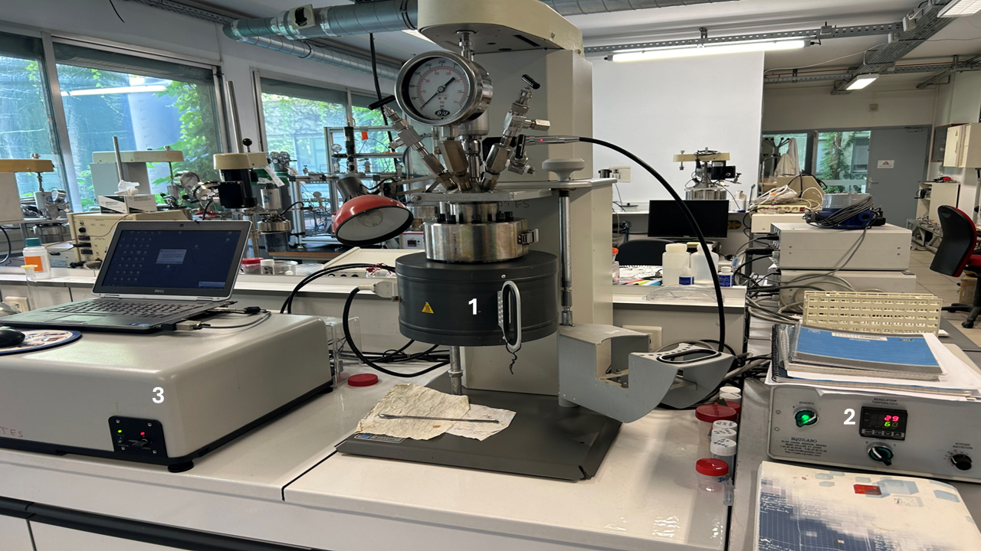

Figure 1: Experimental setup (1) Reactor, (2) Temperature controller, and (3) Raman Spectrometer

* + 1. Sample characterization

The morphologies of the resulting precipitates were determined *ex situ* using images taken on the Zeiss Gemini Ultra Plus Field Emission Gun Scanning Electron Microscope (FEG-SEM) (Germany) at different magnifications. The powders were suspended in ethanol and sonicated for 15 min, then the solution drop placed onto the aluminium SEM stub to evaporate the solvent over night before taking the images.

* 1. Results and Discussion

During the optimisation of the experiments, it was confirmed that the resulting precipitate consists of aragonite as shown by the Raman shift characteristic peaks at 154 and 183 cm-1 (Translational mode double peak), 210 cm-1 (Librational mode), 1084 cm-1 (Symmetric stretch mode) and 704 cm-1 (Asymmetric bending mode) as shown in Figure 2a (Veneranda et al., 2022). The other prominent peaks that were not assigned belonged to the laser probe’s sapphire window (three) and urea (one). The 1084 cm-1 symmetric stretch peak was used to track the mineral formation as a function of peak intensity evolution, shown in Figure 2b. The EB sample displayed the shortest onset of crystallisation at about 24 min, followed by CB sample at about 27 min and lastly WB sample at about 36 min. The final peak intensities displayed a different trend to the induction times where the EB sample had the highest while the CB sample had the lowest. Interestingly, the crystallisation induction times in these experiments were not influenced by the initial pH of the AMD samples, while the final peak intensities displayed a relationship with the initial reaction solution pH (Khumalo & Chirwa, 2024). That is, higher initial pH resulting in higher final peak intensities, with the trend EB>>WB>CB which was also related to the crystallinities of the recovered minerals from the X-Ray Diffraction (XRD) results (Khumalo et al., Submitted). On the other hand, the onset of crystallisation appeared to be a function of the AMD’s chemical composition beyond the *Ca2+/Mg2+* ratio (WB>>EB>CB for this study), which continues to be a subject of debate in the ${CaCO}_{3}$ crystallisation research (Chang et al., 2017).

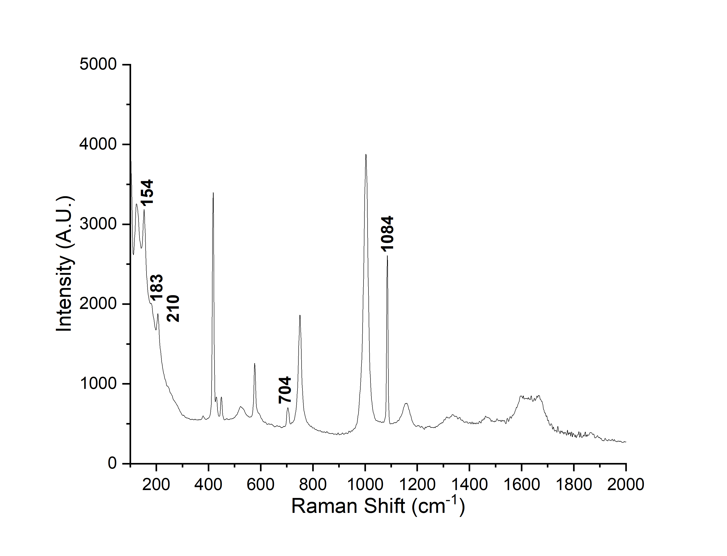 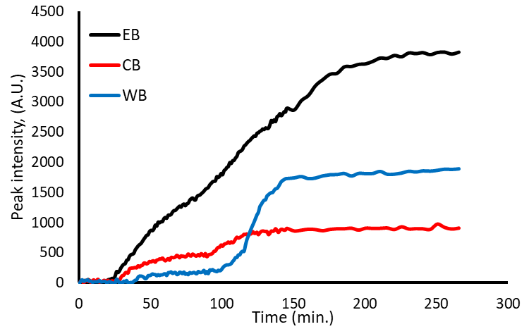

**b**

**a**

Figure 2: Raman spectrum of the recovered precipitate post reaction (a) and an overlay of the 1084 cm-1 peak evolution for the samples over the reaction time (b).

Generally, the reactions of all three basins displayed sigmoidal (S curve) profiles. Time dependent transformations under isothermal conditions have been extensively expressed using the Avrami equation (Avramov & Sestak, 2014). Since the measurements of the peak heights were not calibrated, the Avrami equation (Eq.1) was used to model the data as

|  |  |
| --- | --- |
| $$f\left(t\right)=1-exp(-{kt}^{n})$$ | (1) |

where $f(t)$ is the fraction of aragonite precipitated over time, $k$ is the nucleation and growth rate constant, and $n$ is a dimensionality of growth constant that obtained from the model (Shirzad & Viney, 2023). The data and simulations done on Microsoft Excel are shown in Figure 3 and the parameters extracted from the model are presented in Table 1. On average, the simulations gave the lowest sum of squares regression (SSR) for each data set after five iterations of the model (minimum of 97.5 % SSR reduction from the original values).

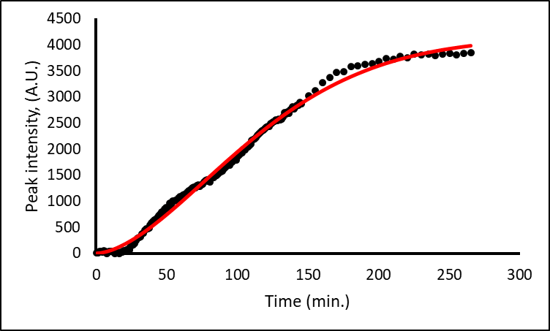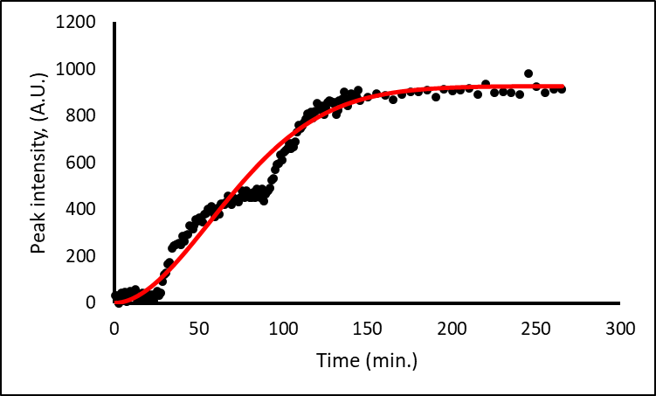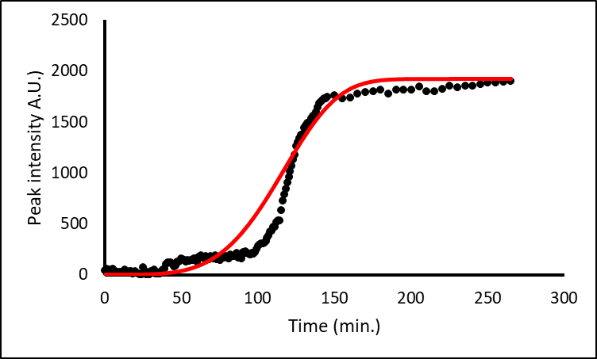

**c**

**b**

**a**

Figure 3: Raman peak intensities measured (•) and simulated (**-**) for (a) EB, (b) CB and (c) WB.

The estimated model parameters are presented in Table 1. The value of $k$ for the EB sample was the smallest indicating a faster nucleation and growth rate of aragonite for this basin when compared to the other basins while the WB sample was the slowest, in agreement with the observed crystallisation induction times. The $n$ values of all the samples were > 1 indicating firstly, that the nucleation in the reactions was sporadic (homogenous) and that the nucleation rates increased with time (interface-controlled crystal growth). Secondly, the $n$ values obtained from the model were in good agreement with the theoretical Avrami exponent with regards to explaining the crystal growth dimension of the obtained particles (Shirzad & Viney, 2023). This was augmented by the morphologies of the precipitates as shown by the SEM images in Figure 4. The EB sample (Figure 4a and d) and to a lesser extent CB sample (Figure b and e) were characterised by needle-like aragonite particles, while the WB sample (Figure 4c and f) was dominated by three-dimensional aragonite structures.

Table 1: Estimated model parameters

|  |  |  |  |
| --- | --- | --- | --- |
| Sample | *k* | *n* | *Dimensionality of growth\** |
| EB | 2.85 x10-4 | 1.67 | (2) needle-like/one-dimensional growth |
| CB | 2.38 x 10-4 | 1.88 | (2) needle-like/one-dimensional growth |
| WB | 8.65 x 10-10 | 4.33 | (4) three-dimensional growth |

\*Theoretically based on the *n* values in the parenthesis (Shirzad & Viney, 2023).

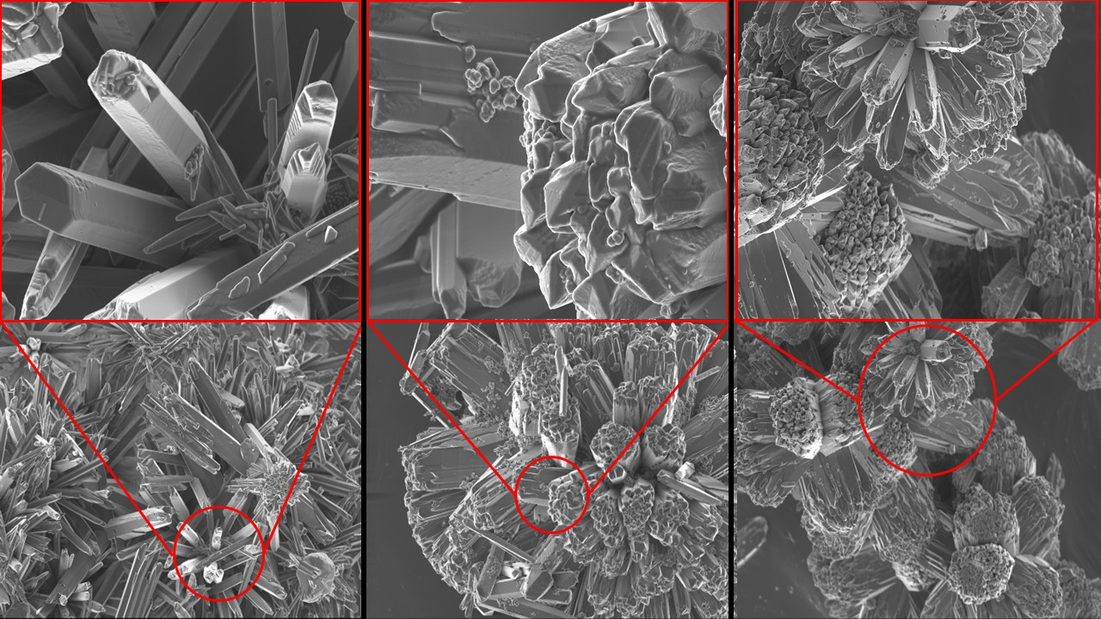

**f**

**e**

**d**

**c**

**b**

**a**

Figure 4: SEM images of the samples at different magnifications, EB (a, d), CB (b, e) and WB (c, f).

* 1. Conclusions

The use of *in situ* Raman Spectroscopy revealed significant insights about the reaction kinetics of aragonite recovered from the mine wastewater of the three Witwatersrand basins. The samples displayed different reaction profiles with their onset crystallisation times following the trend EB>CB>WB. This was influenced by the overall chemical compositions of the AMD samples. The initial pH of the reaction solutions had a significant influence on the final peak intensities of the reaction profiles related which was related to the crystallinities of the resulting particles with the trend EB>>WB>CB. The Avrami equation, though generally considered a “rough approximation, gave a good fit for the experiments. The model’s nucleation and growth constant parameters agreed with the observed crystallisation times where the EB sample had the largest *k* value and shortest crystallisation induction time while the WB sample had the lowest *k* value and the crystallisation induction time. The samples showed different morphologies which were in congruence with the Avrami exponent (*n*) where the EB and to a lesser extent CB aragonite particles displayed needle-like/one-dimensional growth, while the WB aragonite particles displayed three-dimensional growth. The model also confirmed that the crystallisation of aragonite from the reactions for all three basins were homogenous and the crystal growth mechanism is interface-controlled.

Acknowledgments

The authors would like to extend their gratitude to the management of the Institute of Earth Sciences (ISTerre) Université Grenoble Alpes (France), for affording the opportunity to collaborate on this work and to Dr X.L. Dyosiba (University of Pretoria) for performing the FEG-SEM experiments. The authors would also like to express gratitude to Safripol (PTY) LTD management for making it possible to travelling to France for the experimental work.

# References

Alves, J. F., Edwads, H. G., Korsakov, A., & de Oliveira, L. F. (2023). Revisiting the Raman Spectra of Carbonate Minerals. *Minerals, 13*, 1358. https://doi.org/10.3390/min1311358

Avramov, I., & Sestak, J. (2014). Generalized kinetics of overall phase transition explicit to crystallization. *Journal of Thermal Analysis and Calorimetry, 118*, 1715-1720. https://doi.org/10.1007/s10973-014-4144-1

Banks, E. D., Taylor, N. M., Gulley, J., Lubbers, B. R., Giarrizzo, J. G., Bullen, H. A., . . . Barton, H. A. (2010). Bacterial Calcium Carbonate Precipitation in Cave Environments: A Function of Calcium Homeostasis. *Geomicrobiology Journal, 27*(5), 444-454. https://doi.org/10.1080/01490450903485136

Boon, M., Rickard, W. D., Rohl, A. L., & Jones, F. (2020). Stabilization of Aragonite: Role of Mg2+ and Other Impurity Ions. *Crystal Growth & Design, 20*(8), 5006-5017. https://doi.org/10.1021/acs.cgd.0c00152

Chang, R., Kim, S., Lee, S., Choi, S., Kim, M., & Park, Y. (2017). Calcium Carbonate Precipitation for CO2 Storage and Utilization: A Review of the Carbonate Crystallization and Polymorphism. *Frontiers in Energy Research, 5*(17), 1-12. https://doi.org/10.3389/fenrg.2017.00017

Chaparro-Acuna, S. P., Becerra-Jimenez, M. L., Martinez-Zambrano, J. J., & Rojas-Sarmiento, H. A. (2018). Soil bacteria that precipitate calcium carbonate: mechanism and applications of the process. *Acta Agronomica, 67*(2), 277-288. https://doi.org/10.15446/acag.v67n2.66109

Jimoh, O. A., Ariffin, K. S., Hussin, H. B., & Temitope, A. E. (2018). Synthesis of precipitated calcium carbonate: a review. *Carbonate Evaporites, 33*, 331-346. https://doi.org/10.1007/s13146-017-0341-x

Khumalo, R. D., & Chirwa, E. M. (2024). Witwatersrand Basin Acid Mine Drainage (AMD) Softening via Urea Hydrolysis: Part 1 Experimental . *Chemical Engineering Transactions, 110*, 463-468. https://doi.org/10.3303/CET24110078

Khumalo, R., Brink, H., & Chirwa, E. (Submitted). Hydrothermal synthesis of Aragonite from Acid Mine Drainage (AMD) of the Witwatersrand basin in Gauteng, South Africa. *Minerals Engineering*.

Kirboga, S., & Oner, M. (2013). Effect of the Experimental Parameters on Calcium Carbonate Precipitation. *Chemical Engineering Transactions, 32*, 2119-2124. https://doi.org/10.3303/CET1332354

Li, J., & Deepak, F. L. (2022). In Situ Kinetic Observations on Crystal Nucleation and Growth. *Chemical Reviews, 122*(23), 16911-16982. https://doi.org/10.1021/acs.chemrev.1c01067

Liendo, F., Arduino, M., Deorsola, F. A., & Bensaid, S. (2022). Factors controlling and influencing polymorphism, morphology and size of calcium carbonate synthesized through the carbonation route: A review. *Powder Technology, 398*, 1-22. https://doi.org/10.1016/j.powtec.2021.117050

Montes-Hernandez, G., & Renard, F. (2016). Time-Resolved in Situ Raman Spectroscopy of the Nucleation and Growth of Siderite, Magnesite, and Calcite and Their Precursors. *Crystal Growth & Design, 16*(12), 7218-7230. https://doi.org/10.1021/acs.cgd.6b01406

Niu, Y.-Q., Liu, J.-H., Aymonier, C., Fermzni, S., Kralj, D., Falini, G., & Zhou, C.-H. (2022). Calcium carbonate: controlled synthesis, surface functionalization, and nanostructured materials. *Chemical Society Reviews, 51*(18), 7883-7943. https://doi.org/10.1039/d1cs00519g

Prigiobbe, V. (2018). Estimation of nucleation and growth parameters from in situ Raman spectroscopy in carboante systems. *Journal of Environmental Chemical Engineering, 6*, 930-936. https://doi.org/10.1016/j.jece.2017.12.024

Saylor, C. H. (1928). Calcite and Aragonite. *The Journal of Physical Chemistry ABC, 32*(10), 1441-1460. https://doi.org/10.1021/j150292a001

Shirzad, K., & Viney, C. (2023). A critical review on applications of the Avrami equation beyond materials science. *Journal of the Royal Society Interface, 20*(203), 20230242. https://doi.org/10.1098/rsif.2023.0242

Sun, C.-Y., Marcus, M. A., Frazier, M. J., Giuffre, A. J., Mass, T., & Gilbert, P. U. (2017). Spherulitic Growth of Coral Skeletons ans Synthetic Aragonite: Nature's Three Dimensional Printing. *ACS Nano, 11*, 6612-6622. https://doi.org/10.1021/acsnano.7b00127

Tone, T., & Koga, N. (2021). Thermally Induced aragonite-Calcite Transformation in Freshwater Pearl: A Mutual Relation with the Thermal Dehydration of Included Water. *ACS Omega, 6*, 13904-13914. https://doi.org/10.1021/acsomega.1c01683

Veneranda, M., Sanz-Arranz, A., Manrique, J. A., Siaz, J., Garcia-Priet, C., Pascual-Sanchez, E., . . . Lopez-Reyes, G. (2022). Analytical database of Martian minerals (ADaMM): Project synopsis and Raman data overview. *Journal of Raman Spectroscopy, 53*(3), 364-381. https://doi.org/10.1002/jrs.6215

Wilson, P. B. (2017). Recent advances in avian egg science: A review. *Poultry Science, 96*, 3747-3754. https://doi.org/10.3382/ps/pex187