|  |  |
| --- | --- |
| cetlogo ***CHEMICAL ENGINEERING TRANSACTIONS***  ***VOL. xxx, 2025*** | A publication of  aidiclogo_grande |
| The Italian Association  of Chemical Engineering  Online at www.cetjournal.it |
| Guest Editors: David Bogle, Flavio Manenti, Piero Salatino  Copyright © 2025, AIDIC Servizi S.r.l. **ISBN** 979-12-81206-21-2; **ISSN** 2283-9216 | |

Analytical studies on the functional effect of sulfur-containing extreme pressure additives

Roland NAGYa,\*, Gábor NAGYa

aUniversity of Pannonia, Faculty of Engineering, Department of MOL Hydrocarbon and Coal Processing; Egyetem u. 10., Veszprém, H-8200, Hungary

[nagy.roland.dr@mk.uni-pannon.hu](mailto:nagy.roland.dr@mk.uni-pannon.hu)

Proper maintenance of machine components exposed to high pressure and temperature is essential for efficient and safe operation. One of the most important additives in these lubricants is the extreme pressure (EP) additive, which allows lubricants to perform effectively under high-stress conditions by forming a protective film that prevents metal-to-metal contact. Traditionally, EP additives are derived from sulfur-based raw materials, but there is an increasing shift towards using environmentally friendly, plant-based alternatives. Sulfurized vegetable oils, in particular, are gaining attention as renewable, biodegradable, and high-performing alternatives.

This study focuses on the synthesis and evaluation of sulfurized EP additives derived from various vegetable oils, analysing their effects on lubricant properties. The goal is to understand how different vegetable oil sources influence the functionality of lubricants, particularly in terms of their molecular weight distribution and wear protection efficiency. The analysis utilized Gel Permeation Chromatography (GPC) to assess molecular weight distribution and polydispersity, revealing that additives synthesized from vegetable oils with higher molecular weights and broader distributions provided superior protection against wear. The study highlights the significance of sulfur content and molecular structure in optimizing lubricant performance under extreme conditions, providing insights into the development of environmentally friendly EP additives from renewable sources.

* 1. Introduction

Lubricants are essential for any moving device, machine or system used for an industrial process. Lubricants reduce friction by creating a film between two surfaces and prevent machine wear. Lubricant additives are used to add tribological functions to the lubricating oils.

One of the key additives for lubricants is the Extreme Pressure (EP) additive. It enables lubricants to function effectively under high temperatures and pressures, forming a protective film to prevent metal-to-metal contact (Azarhoushang, 2022). These additives are vital for preventing load and score of abrasive tool layers, ensuring lubricants possess key qualities like lubricity and high film strength (Kishore, 2000).

EP additives, typically derived from sulfur-based raw materials, are increasingly sourced from environmentally friendly vegetable oils due to industry trends (Bart et al., 2013). Ensuring these raw materials meet technical standards is crucial for producing high-quality lubricants, particularly focusing on the fatty acid composition of vegetable-based materials (Abdulrahman et al., 2019). Vegetable oils are favoured for synthesizing EP additives, with options such as rapeseed oil and sunflower oil being common choices in Europe. (Gabor et al., 2022) However, their natural form lacks adequate oxidative stability for direct use in lubricants, necessitating modification through sulfurization to enhance properties like viscosity index and metal adherence (Frank et al., 1979).

The experimental phase aims to evaluate selected vegetable oils as raw materials for EP additive synthesis and assess their effect on lubricating oil properties in relation with molecular weight, using different analytical methods.

* 1. Materials

The data of the raw materials (raw materials to be sulfurized and sulfur donor) used for the EP additives synthesis are indicated in Tables 1-2.

Table 1: Characteristics of the raw materials to be sulfurized

|  |  |  |  |  |  |
| --- | --- | --- | --- | --- | --- |
| Raw material | Appearance | Density at 20°C, g/cm3 | Kinematic viscosity at 40°C, mm2/s | Kinematic viscosity at 100°C, mm2/s | Iodine number, gI2/100g |
| Rapeseed oil | Yellow, clear liquid | 0.9166 | 35.44 | 8.11 | 108.0 |
| Sunflower oil | Yellow, slightly opal liquid | 0.9195 | 33.21 | 7.81 | 122.0 |
| Used cooking oil | Brown, clear liquid | 0.9202 | 41.40 | 8.84 | 85.4 |
| Olive pomace oil | Yellow, clear liquid | 0.9141 | 40.42 | 8.45 | 72.0 |
| C14-C16 α-olefin | Colourless, clear liquid | 0.7789 | 2.28 | 1.04 | 122.6 |
| C12-C14 α-olefin | Colourless, clear liquid | 0.7634 | 1.44 | 0.74 | 145.7 |
| Fatty acid methyl ester (FAME) | Brownish yellow, clear liquid | 0.8797 | 4.36 | Not  measurable | 95.9 |

The raw material mixture of the fatty acid methyl ester used for the synthesises contains average 30 wt% used cooking oil (UCO) raw material fraction. Used cooking oils contain water, organic matters and food residues produced during the food frying process. Therefore a purification process has to be executed before the employment of used cooking oils for avoiding operational problems (Miguel et al., 2024).

Table 2: Characteristics of the sulfur donor used for the synthesis

|  |  |
| --- | --- |
| Properties | Sulfur |
| Consistency | solid |
| Colour, appearance | yellow, powder |
| Density at 25°C, kg/m3 | 2 070 |
| Flashpoint, °C | > 200 |

Considering both their application scope and purity, the tested raw materials were found appropriate for further research.

* 1. Methods

The sulfurized samples were made with the reaction of the above described raw materials, and elemental sulphur. The first step was the homogenization of the reagents in a 2 hours mixing process at 125 °C. The reaction was taken place at about 140 °C and at 1 bar. To maximize the reaction yield, 5 hours holding is necessary at the reaction temperature (Donald and John, 1979).

What is certain for all the sulfurized samples is that the sulfur donor was elemental sulfur, and the synthesis method was dark sulfurization. The synthesises were executed in a five-necked spherical flask with propeller stirrer and temperature regulator. The ratio of the sulfur in the reaction mixtures are indicated in Table 3.

For the detailed physical and physico-chemical investigation of the examined raw materials, the following international standard methods were applied:

* Appearance [Visual]
* Density 20 °C [EN ISO 12185], g/cm3
* Kinematic viscosity at 40 °C [EN ISO 3104], mm2/s
* Kinematic viscosity at 100 °C-on [EN ISO 3104], mm2/s
* Iodine value [EN ISO 3961], g I2/100g

In addition to the above listed methods, the following measurements were used to determine the amount and type of incorporated sulfur content in the synthesized additive samples (Leslie, 2017):

* Total sulphur content [ASTM D 5185], wt%
* Active sulphur content [ASTM D 1662], wt%

For the measurement of the functional effect of synthesized additives, the following two methods were used to evaluate the extreme-pressure and anti-wear properties of the samples:

* Four-ball test – weld load [DIN 51350-4], N
* Four-ball test – wear scar diameter [DIN 51350-5], mm
* Copper corrosion test (100 °C, 3 h) [ASTM D 130]

For obtaining meaningful measurements that would allow a good evaluation of the sulfurized samples’ synthesis, performing a Gel Permeation Chromatography (GPC) / Size Exclusion Chromatography (SEC) on the samples and the raw materials was chosen as the most appropriate method.

Different methodologies and instrumentation are employed to confirm and control the properties and quality of a lubricant such as NMR, FTIR, and GPC/SEC. If a certain batch of lubricant’s molecular size falls out of the desired range, it will fail specification and be rejected for the coating process.

The average molecular weight and its distribution were measured by Gel Permeation Chromatography (Waters 2414GPC system fitted with RI detector, Ultrastyragel 1000Å, 500Å, 100Å columns). A basic schematic about the GPC system was used is indicated on Figure1. Samples were dissolved in tetrahydrofuran (THF), then filtered with 0.2 μm Millipore (Millex filter) membrane. 1.0 cm3/min eluent flow rate was used and 100 μl of 0.1% sample solution was injected. The calibration was carried out by using polystyrene standards, and a 3th order polynomial calibration curve was described.

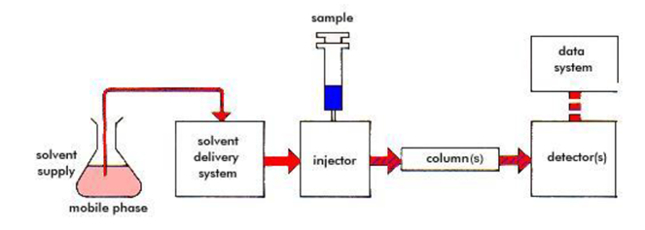

*Figure 1: Basic schematic of a GPC system*

* 1. Results

The investigations had begun by determining the physico-chemical properties of the raw materials than the synthesized additive samples were examined. The synthesized additive samples were marked with “EP” abbreviation. In Table 3, their physico-chemical properties are shown. All samples had a dark appearance.

Table 3: Physico-chemical properties of the sulfurized samples (EP)

|  |  |  |  |  |  |  |  |
| --- | --- | --- | --- | --- | --- | --- | --- |
| Sulfurized sample | Raw material | Amount of sulfur in the reaction mixture, wt% | Density at 20°C,  g/cm3 | Kinematic viscosity at 40°C, mm2/s | Kinematic viscosity at 100°C, mm2/s | Total sulfur content, wt% | Active sulfur content, wt% |
| EP-1 | Rapeseed oil | 10 | 0.9892 | 734.00 | 75.65 | 10.82 | 1.37 |
| EP -2 | Sunflower oil | 10 | 0.9929 | 917.50 | 100.70 | 10.91 | 1.18 |
| EP -3 | Used cooking oil | 10 | 0.9893 | 498.10 | 56.20 | 9.71 | 3.48 |
| EP -4 | Olive pomace oil | 10 | 0.9807 | 392.40 | 44.67 | 10.93 | 3.78 |
| EP -5 | 15 | 0.9980 | 1 035.97 | 99.82 | 15.76 | 6.86 |
| EP -6 | C14-C16 α-olefin | 10 | 0.8435 | 4.54 | 1.74 | 11.04 | 7.89 |
| EP -7 | C12-C14 α-olefin | 10 | 0.8353 | 2.86 | 1.18 | 11.87 | 9.37 |
| EP -8 | FAME | 10 | 0.9531 | 14.11 | 3.89 | 10.95 | 4.72 |
| EP -9 | 15 | 0.9884 | 24.72 | 5.46 | 16.39 | 7.89 |
| EP -10 | 20 | 1.0257 | 44.95 | 7.82 | 19.21 | 17.47 |
| EP -11 | 25 | 1.0484 | 63.48 | 9.61 | 22.76 | 22.03 |

Once the sulfurized additives had been synthesized and their properties had been measured, these additive samples were blended into Group I dilution oil in a concentration of 3 wt%. These lubricating oil samples were marked with “LO” abbreviation. Their key-performance properties were measured and evaluated by comparing them with the industrial standards. The physico-chemical and functional properties of the lubricating oil samples are described in Table 4.

Table 4: Physico-chemical and functional properties of the lubricating oil samples (LO)

|  |  |  |  |  |  |  |  |
| --- | --- | --- | --- | --- | --- | --- | --- |
| Lubricating oil sample | The used sulfurized sample | Appearance | Kinematic viscosity at 40°C, mm2/s | Kinematic viscosity at 100°C, mm2/s | Four-ball weld load,  N | Four-ball scar diameter,  mm | Copper corrosion test, level |
| LO-1 | EP-1 | Brown, clear liquid | 35.70 | 5.90 | 2 300 | 0.50 | 3a |
| LO -2 | EP -2 | Brown, clear liquid | 36.12 | 5.91 | 2 300 | 0.44 | 1b |
| LO -3 | EP -3 | Brown, clear liquid | 34.72 | 5.70 | 2 300 | 0.49 | 4b |
| LO -4 | EP -4 | Brown, clear liquid | 35.12 | 5.79 | 2 400 | 0.40 | 4b |
| LO -5 | EP -5 | Brown, clear liquid | 34.45 | 5.74 | 2 800 | 0.52 | 4b |
| LO -6 | EP -6 | Brown, clear liquid | 29.39 | 5.118 | 2 300 | 0.52 | 4b |
| LO -7 | EP -7 | Brown, clear liquid | 28.37 | 5.016 | 2 600 | 0.56 | 4b |
| LO -8 | EP -8 | Brown, clear liquid | 32.00 | 5.39 | 2 100 | 0.56 | 4b |
| LO -9 | EP -9 | Brown, clear liquid | 31.58 | 5.33 | 2 300 | 0.56 | 4b |
| LO -10 | EP -10 | Brown, clear liquid | 31.89 | 5.41 | 3 000 | 0.64 | 4b |
| LO -11 | EP -11 | Brown, clear liquid | 32.04 | 5.46 | 3 000 | 0.70 | 4c |

To understand how different vegetable oil sources and sulfur content in the additive samples influence the molecular weight distribution Gel Permeation Chromatography analyses was performed. In Figure 2. an example of a distribution curve obtained from the GPC measurement related to EP-4 sample can be observed.

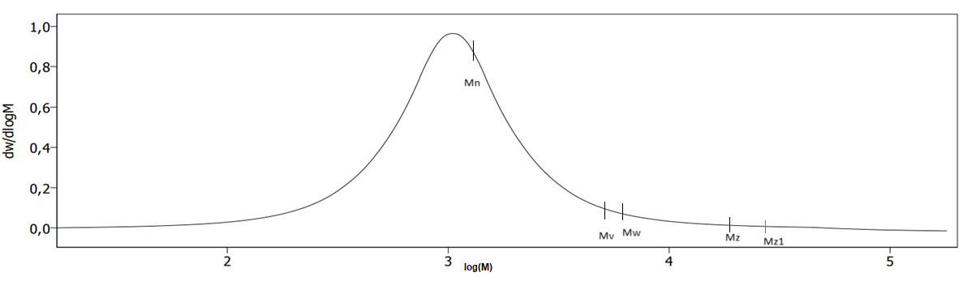

*Figure 2: An example of a distribution curve (EP-4 sample)*

Each sample that was subject of the GPC analysis was run for 40 minutes in the equipment and the chromatogram peaks are graphed on the comparison of time and voltage.

The values in Table 5 indicate the different molecular weights and the polydispersity index of each samples, observed after the GPC measurement. Knowing these molecular weight values and the polydispersity index is helpful when doing the corresponding analysis regarding the tribological properties of the synthesized additives and lubricating oils.

Table 5: Results of the GPC analysis of the sulfurized samples

|  |  |  |  |  |  |  |
| --- | --- | --- | --- | --- | --- | --- |
| Sulfurized sample | Mp | Mn | Mw | Mz | Mz+1 | PD |
| EP-1 | 5054 | 7390 | 25191 | 59751 | 86159 | 3.4089 |
| EP -2 | 4479 | 4559 | 22781 | 58996 | 85728 | 4.9982 |
| EP -3 | 4929 | 3724 | 18342 | 53862 | 87374 | 4.9254 |
| EP -4 | 4506 | 3826 | 17066 | 50094 | 84351 | 4.4617 |
| EP -5 | 4381 | 4760 | 21416 | 58023 | 85923 | 4.4992 |
| EP -6 | 661 | 813 | 2353 | 5467 | 8393 | 2.8954 |
| EP -7 | 1830 | 2154 | 3040 | 4268 | 5535 | 1.4113 |
| EP -8 | 508 | 498 | 1175 | 2491 | 3994 | 2.3608 |
| EP -9 | 815 | 1034 | 2597 | 4994 | 7164 | 2.5117 |
| EP -10 | 2934 | 1476 | 3582 | 6340 | 8556 | 2.4271 |
| EP -11 | 3714 | 1537 | 4708 | 7038 | 9437 | 3.0637 |

From Table 5, the values written in the first row correspond to the following concepts: Mp – molecular weight of the highest peak, Mn – number average molecular weight, Mw – weight average molecular weight, Mz – size average molecular weight, Mz+1 – z+1 average molecular weight, PD: polydispersity index.

It was determined that the applied GPC system is suitable for the examination of sulfurized vegetable oil-based EP additives. Based on the analysis of the results of the GPC tests, it was determined that sulfur was not incorporated in the samples EP-6, EP-8 and EP-9 based on the molecular weight values. Furthermore, it was found that the tested samples basically have a broad molecular weight distribution, except additive EP-7.

The active sulfur content is the amount of sulfur in a sulfurized additive that easily chemisorbs to the metal surface under the test conditions. Typically, additives whose molecules contain a higher amount of sulfur atoms linked to polysulfide chains have higher active sulfur content (Wilfried and Theo, 2017).

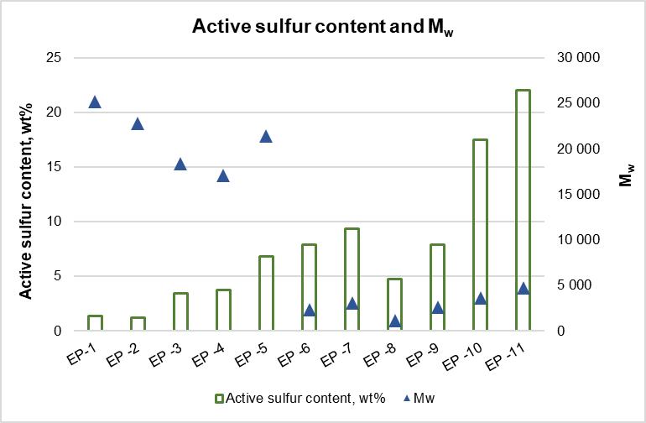

*Figure 3: The active sulfur content and the weight average molecular weight of the synthesized additives*

Figure 3 shows that in the case of triglyceride-type raw materials, the active sulfur content is lower, and the weight-average molecular weight of the sulfurized additives produced using them is in a higher range. Based on these phenomena, it can be concluded that in the case of vegetable oil raw materials, mono- and disulfide chains are mostly formed in the molecules of the sulfurized additive, and these intermolecular sulfur chains also form connections between several triglyceride molecules. As a result, the molecular weight of these molecules increases compared to the used raw materials molecular weight, and their active sulfur content will be lower.

In the case of alpha-olefin and FAME raw materials, a significant increase in the average molecular weight is not observed. Based on this, it can be concluded that a smaller number of molecules are connected by sulfur bridges. In addition, the additives synthesized from these types of raw materials have higher active sulfur content than the additives that formed from vegetable oil raw materials have. This implies that the number of sulfur atoms in the intermolecular sulfur chains connecting their molecules is 3 or higher.

The four-ball wear scar diameter measurements were determined from the base oil solution of the synthesized additive samples. The diameter of the wear scar is affected by the chain length and active sulfur content of the molecules that build up the additive molecule. Additive molecules containing longer carbon chain compounds have a positive effect on the extent of wear. Also, additives with a lower active sulfur content also have a better anti-wear effect. (Endre, 1983).

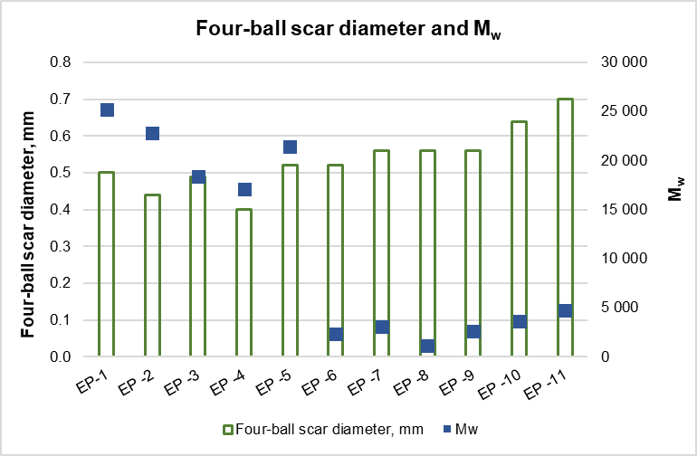

*Figure 4: The four-ball wear scar diameter results of the base oil solutions of the synthesized additives and the weight average molecular weight of the synthesized additives*

Figure 4 shows that the wear scar diameter is lower for larger additive molecules with higher weight average molecular weight than for additives with lower weight average molecular weight. Based on this, it can be concluded that both the higher weight average molecular weight and the lower active sulfur content have a positive effect on the wear scar diameter.

* 1. Conclusions

Our experiments showed that the primary physicochemical properties and functional characteristics of the synthesized samples are closely linked to the composition of the vegetable oils used. Additives derived from olive pomace oil provided the most desirable functional effects, yet for broader applicability, the use of sunflower and rapeseed oils proves more advantageous.

* Additives containing molecules with longer carbon chains have a beneficial impact on wear resistance. Additionally, those with lower active sulfur content demonstrate superior anti-wear properties.
* It was identified that the most favourable wear scar diameter results were obtained for additive samples synthesized from triglyceride raw materials.
* The Gel Permeation Chromatography system employed in this study was found to be highly suitable for the analysis of sulfurized vegetable oil-based EP additives.
* Analysis of the Gel Permeation Chromatography results revealed that sulfur was not incorporated into the EP-6 and EP‑9 samples, as indicated by their molecular weight values.

References

Abdulrahman A.S., Lawal S.A., Ojapah, M.M., Olutoye M.A., Woma T.Y., 2019, Vegetable Oil Lubricants: Challenges and Prospects, Japanese Society of Tribologists, Vol. 14, No. 2, 60-70.

Azarhoushang B., 2022, Tribology and Fundamentals of Abrasive Machining Processes, Third Edition, Chapter 17, 615-652.

Bart J., Gucciardi S., Cavallaro S., 2013, Biolubricants, Science, and Technology, Woodhead Publishing Series in Energy, Chapter 7, 351-395.

Donald A.L., John A.B., 1979, Extreme pressure additives for lubricants, US4149982, USA.

Endre V., 1983, Tribological Handbook, Friction, Wear and Lubrication of Machines and Machine Parts, Technical Publishing House, Budapest, Hungary, 36-116.

Frank L.E., Phillip S.L., Robert E.A., 1979, Vegetable oil derivatives as lubricant additives, EP0353872A1, USA.

Gábor Z.N., Nikoletta L., Roland N., 2022, Investigation of vegetable oil raw materials for sulfurized vegetable oil-based lubricant additives, Technical Scientific Publications, 17.

Kishore N., 2000, Determination of Sulfur in Petroleum Products and Lubricants: A Critical Review of Test Performance, American Laboratory, November.

Leslie R.R., 2017, Lubricant Additives. Chemistry and Applications, Third Edition, CRC Press, Boca Raton, FL, 211-278.

Miguel A., Karla E., José J., Salvador H., Fabricio O., 2024, Simulation of the Purification Process of Waste Cooking Oil as a Feedstock for Biodiesel Production, Chemical Engineering Transactions, 110, 55-60.

Wilfried D., Theo M., 2017, Lubricants and Lubrication, Third Edition, Wiley, Weinheim, 138-144.