|  |  |
| --- | --- |
| cetlogo ***CHEMICAL ENGINEERING TRANSACTIONS***  ***VOL. xxx, 2025*** | A publication of  aidiclogo_grande |
| The Italian Association  of Chemical Engineering  Online at www.cetjournal.it |
| Guest Editors: David Bogle, Flavio Manenti, Piero Salatino  Copyright © 2025, AIDIC Servizi S.r.l. **ISBN** 979-12-81206-21-2; **ISSN** 2283-9216 | |

Study on the catalytic synthesis of sulfurized vegetable oil type extreme pressure additives

Gábor Zoltán NAGYa\*, Roland NAGYa

aUniversity of Pannonia, Faculty of Engineering, Department of MOL Hydrocarbon and Coal Processing; Egyetem u. 10., Veszprém, H-8200, Hungary

[gznagy@phd.uni-pannon.hu](mailto:gznagy@phd.uni-pannon.hu)

The development of extreme pressure (EP) additives is increasingly important for improving the performance of lubricants under high temperature and pressure. Due to the growing focus on environmental sustainability, sulfurized vegetable oils are being studied as renewable sources for EP additive production. These bio-based alternatives have a smaller environmental impact compared to traditional synthetic additives. The success of the synthesis depends on key factors such as reaction temperature, sulfur content, and the natural composition of the used vegetable oil. These parameters need to be carefully controlled to achieve better lubricating properties. The use of appropriate catalysts can help improve product stability and quality.

In the current phase of the research, additive samples were produced in catalytic synthesises using the selected sulfur donor and technology. The physico-chemical properties of the samples were investigated and standard testing procedures were executed, including application-specific tests. Based on the results of the physico-chemical and application tests, it was found that the synthesized bio-based additives are suitable for use in modern industrial lubricants.

* 1. Introduction

The lubricant industry plays a crucial role in optimizing machine performance within the global industrial sector. Lubricants always contain functional additives that give them new properties or improve their existing properties. Key additives include dispersants, viscosity index improvers, detergents, anti-wear (AW) agents, antioxidants, corrosion inhibitors, friction modifiers, and emulsifiers. EP additives are used to extend the lifespan of mechanical equipment (Leslie, 2017).

The effectiveness of sulfur compounds as EP additives in lubricants has long been recognized and proven. Sulfur-containing additives are employed in gear oils, metalworking fluids, greases, and engine oils as EP/AW additives. Most of these additives consist of modified triglycerides, esters, or olefins (Nicole and Xavier, 2018). Although sulfur-based EP additives derived from vegetable oils are environmentally friendly and biodegradable, their oxidative stability and corrosiveness remain unsatisfactory (Wilfried and Theo, 2017).

The sulfurization reaction requires a sulfurizable raw material containing a double bond and a sulfur donor, which can be elemental sulfur, hydrogen sulfide, mercaptan, sulfide, etc. In industrial applications, batch technologies are used. Usually, the amount of sulfur donor is calculated based on the total olefinic unsaturation of the raw material mixture (Kirk, 1980). The literature distinguishes three types of processes based on the colour of the product: the dark sulfurization process, the lighter sulfurization process and the light sulfurization process (Leslie, 2017). The sulfurization reaction can also be carried out in the presence of various catalysts, which can be ammonia, but amines, metal dithiocarbamates, sulfides or transition metal oxides are more commonly used. In addition, the use of acid catalyst is also known in the literature (James, 1990).

The current phase of the research is aimed at exploring the array of catalysts that can be employed for the production of sulfurized vegetable oil additives. Furthermore, a primary objective is to identify those catalysts that are most effective for synthesizing EP additives derived from vegetable oils.

* 1. Materials

The data of the raw materials to be sulfurized, the sulfur donor and the applied catalysts used for the synthesis of the EP additives are indicated in Tables 1-3.

Table 1: Characteristics of the raw materials to be sulfurized

|  |  |  |  |  |  |
| --- | --- | --- | --- | --- | --- |
| Raw material | Appearance | Density at 20°C, g/cm3 | Kinematic viscosity at 40°C, mm2/s | Kinematic viscosity at 100°C, mm2/s | Iodine number, gI2/100g |
| Used cooking oil | Brown liquid | 0.9195 | 40.24 | 8.71 | 75.7 |
| Olive pomace oil | Yellow-green liquid | 0.9137 | 39.54 | 8.36 | 73.3 |

Used cooking oils comprise water, organic impurities, and food-derived residues accumulated during the frying process. Consequently, a purification step is essential prior to their utilization to mitigate potential operational complications (Miguel et al., 2024).

Table 2: Characteristics of the sulfur donor used for the synthesis

|  |  |
| --- | --- |
| Properties | Sulfur (orthorhombic) |
| Consistency | solid |
| Colour, appearance | yellow, powder |
| Density at 25°C, g/cm3 | 2.07 |
| Flashpoint, °C | > 200 |

Table 3: Characteristics of the catalysts used for the synthesis

|  |  |  |  |  |  |
| --- | --- | --- | --- | --- | --- |
| Properties | Acid | Organic peroxide | Amine 1 | Sulfide | Amine 2 |
| Consistency | liquid | liquid | liquid | solid | solid |
| Colour | transparent | transparent | transparent | white | white |
| Purity | ≥95% | ≥98% | ≥99% | ≥98% | ≥97% |
| Density at 20°C, g/cm3 | 1.84 | 0.79 | 0.74 | n.a. | 0.81 at 25°C |

All of the tested raw materials were found appropriate for further research in accordance with the objectives of the synthesises.

* 1. Methods

In order to define the results in a more precise and uniform way, the below listed international standards were applied during the tests. To investigate the physico-chemical properties of the vegetable origin raw materials, the following methods were used.

* Appearance [Visual]
* Density 20 °C, [EN ISO 12185], g/cm3
* Kinematic viscosity at 40 °C [EN ISO 3104], mm2/s
* Kinematic viscosity at 100 °C-on [EN ISO 3104], mm2/s
* Iodine value [EN ISO 3961], g I2/100g

To determine the amount and type of incorporated sulfur content in the synthesized additive samples, the relevant ASTM standard methods have been used (Kishore, 2000). In addition, the colour shade of the synthesized samples was also measured with an ASTM standard method.

* Total sulphur content [ASTM D 5185], wt%
* Active sulphur content [ASTM D 1662], wt%
* ASTM Color Scale [ASTM D 1500]

To assess the functional parameters of the synthesized additives, two distinct methods were employed. Four-ball weld load measurement evaluates the extreme-pressure property of the samples under high-load conditions. The wear scar diameter measurement focuses on the anti-wear characteristics of the additive samples. Additionally, an examination was conducted to explore the additives' effects on copper corrosion, determining what extent this influences their application (Theo et al., 2011).

* Four-ball test – weld load [DIN 51350-4], N
* Four-ball test – wear scar diameter [DIN 51350-5], mm
* Copper corrosion test (100 °C, 3 h) [ASTM D 130]
  1. Results

The sulfurized samples were produced by reacting the previously listed vegetable origin raw materials with elemental sulfur (Frank et al., 1979). Initially, the reagents were homogenized through a mixing process lasting 1–2 hours at approximately 120–130 °C (Emile, 1974). While the temperature was raised to the reaction temperature, the catalyst was added into the reaction mixture in equal portions (Roger, 1995). The reaction was carried out at around 140–150 °C under a pressure of maximum 2 bar, with a holding time of 1–3 hours (Davis et al., 1988). In the case of the samples synthesized without catalyst, the holding time at reaction temperature was 2-4 hours (Donald and John, 1979). Then the samples were cooled to 60-70°C. The applied reaction parameters have been previously optimized to maximize the connection rate of the sulfur. If precipitation was observed, the sample was filtered through a 5 micron filter paper using vacuum. In such cases, all tests and further steps were performed with the filtered sample.

In the current phase of the research, the primary goal was to identify catalysts those could be effectively employed for producing EP additives derived from vegetable oils. Another aim was to investigate the possibility of reducing the reaction time of the sulfurization process. The minimum achievable weld load was fixed at 2 200 N, while the maximum of the scar diameter was set at 0.60 mm. We also expected a copper corrosion rate lower than 4b and ASTM colour lower than 8.0. These values were determined based on the performance level of EP additives with similar sulfur content available on the market.

The investigation started with the analyzation of the raw materials and the synthesized additive samples. In Table 4, physico-chemical properties for the sulfurized samples (EP) based on used cooking oil are indicated. Based on the observation that the colour grade of UCO-4 and UCO-6 samples was slightly brighter, it can be concluded that using amine type catalyst is advantageous in terms of lighter colour. In the case of UCO-2 and UCO-3 samples, crystal precipitation was observed during cooling. This was filtered out of the samples, and then identified as unreacted sulfur by using X-Ray fluorescence spectrometry.

Table 4: Physico-chemical properties of the sulfurized samples (EP) based on used cooking oil

|  |  |  |  |  |  |  |
| --- | --- | --- | --- | --- | --- | --- |
| Sulfurized sample | Catalyst type | ASTM colour grade | Kinematic viscosity at 40°C, mm2/s | Kinematic viscosity at 100°C, mm2/s | Total sulfur content, wt% | Active sulfur content, wt% |
| UCO-1 | - | 8.0 | 271.6 | 32.55 | 8.78 | 6.00 |
| UCO-2 | Acid | 8.0 | 202.6 | 26.60 | 7.22 | 3.42 |
| UCO-3 | Organic peroxide | 8.0 | 267.5 | 33.30 | 8.36 | 3.64 |
| UCO-4 | Amine 1 | 7.5 | 494.2 | 52.58 | 8.92 | 2.14 |
| UCO-5 | Sulfide | 8.0 | 583.9 | 58.82 | 9.65 | 5.04 |
| UCO-6 | Amine 2 | 7.5 | 501.3 | 53.15 | 8.95 | 2.55 |

The kinematic viscosity of the samples is directly proportional to the total sulfur content incorporated into their structure. The reason for this is that the more sulfur forms intermolecular bonds between triglyceride molecules, the larger molecules are formed. The two lowest active sulfur content values were determined for UCO-4 and UCO-6. In both cases, an amine type catalyst was used. The lower total sulfur content of UCO-2 and UCO-3 was caused by the previously mentioned filtering process. On Figure 1, the kinematic viscosity, the total and the active sulfur content of the sulfurized used cooking oil additive samples are shown.

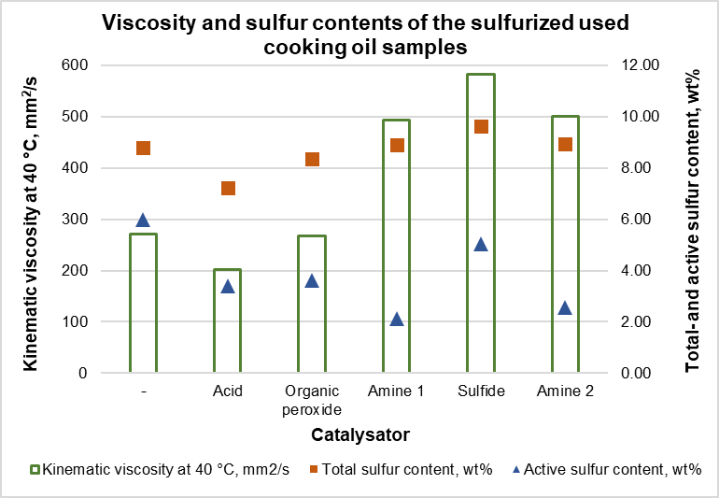

*Figure 1: The kinematic viscosity, the total sulfur content and the active sulfur content of the sulfurized used cooking oil additive samples*

In Table 5, physico-chemical properties for the sulfurized samples based on olive pomace oil are shown. In the case of OPO-4 and OPO-6 samples, the colour grade was significantly brighter than the other ones. In the case of these samples, amine type catalyst was employed. This confirms that amine type catalysts have favorable effect on the colour. Crystal precipitation was observed in the case of OPO-1, OPO-2 and OPO-3 samples. These samples were filtered after cooling.

Table 5: Physico-chemical properties of the sulfurized samples (EP) based on olive pomace oil

|  |  |  |  |  |  |  |
| --- | --- | --- | --- | --- | --- | --- |
| Sulfurized sample | Catalyst type | ASTM colour grade | Kinematic viscosity at 40°C, mm2/s | Kinematic viscosity at 100°C, mm2/s | Total sulfur content, wt% | Active sulfur content, wt% |
| OPO-1 | - | 8.0 | 67.3 | 12.14 | 4.70 | 2.40 |
| OPO-2 | Acid | 8.0 | 59.8 | 11.09 | 3.04 | 1.80 |
| OPO-3 | Organic peroxide | 7.5 | 348.4 | 40.08 | 8.97 | 3.60 |
| OPO-4 | Amine 1 | 7.0 | 76.0 | 13.13 | 5.09 | 2.90 |
| OPO-5 | Sulfide | 7.5 | 378.1 | 43.70 | 8.59 | 2.90 |
| OPO-6 | Amine 2 | 7.0 | 288.8 | 34.48 | 8.88 | 4.20 |

In the case of sulfurized additive samples produced on the basis of olive pomace oil, the highest viscosity was achieved by those whose total sulfur content was also among the highest. These were the OPO-3, OPO-5 and OPO-6 samples. The low total and active sulfur content measured in the case of the OPO-2 sample was due to the significant amount of precipitate that was filtered out. The two samples with the lowest active sulfur content were produced using amine and sulfide type catalysts. Favorable results were also achieved when using the organic peroxide catalyst. On Figure 2, the kinematic viscosity, the total and the active sulfur content of the sulfurized olive pomace oil additive samples are shown.

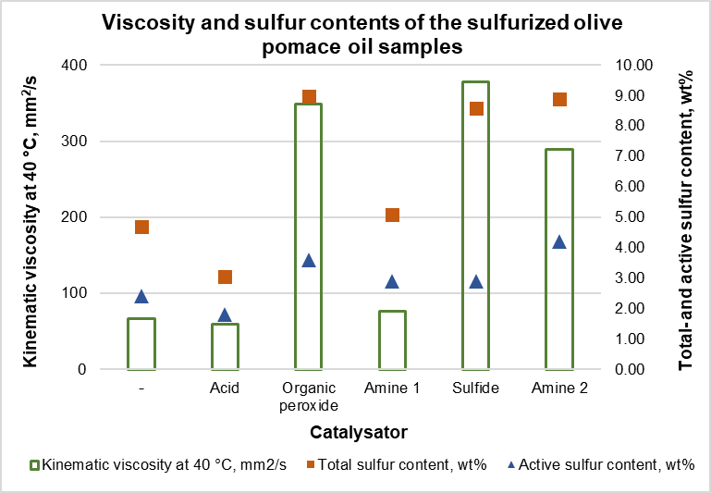

*Figure 2: The kinematic viscosity, the total sulfur content and the active sulfur content of the sulfurized olive pomace oil additive samples*

After the sulfurized additives were synthesized and investigated, the lubricating oils were made by adding the synthesized additives in 3 wt% into Group I dilution oil. Finally, the key performance properties evaluation of the lubricating oil samples were executed for the purpose of assessing their compliance with the objectives set.

In Table 6, the physico-chemical and functional properties of the lubricating oil solutions made with the sulfurized used cooking oil additive samples are described. Since the colour of the used cooking oil is darker than crude or refined vegetable oils, the additive samples synthesized using it had also darker colour. This is noticeable in the colour of the lubricating oil samples as well, which ranged from dark brown to reddish brown.

Table 6: Physico-chemical and functional properties of the lubricating oil solutions (LOS) of the sulfurized used cooking oil additive samples

|  |  |  |  |  |  |  |  |
| --- | --- | --- | --- | --- | --- | --- | --- |
| Lubricating oil sample | Sulfurized sample | Appearance | Kinematic viscosity at 40°C, mm2/s | Kinematic viscosity at 100°C, mm2/s | Four-ball weld load,  N | Four-ball scar diameter,  mm | Copper corrosion test, level |
| LOS-1 | UCO-1 | Dark brown liquid | 34.9 | 5.70 | 2 300 | 0.62 | 4c |
| LOS -2 | UCO-2 | Dark brown liquid | 34.5 | 5.66 | 2 300 | 0.49 | 4c |
| LOS -3 | UCO-3 | Dark brown liquid | 34.8 | 5.70 | 2 300 | 0.52 | 4b |
| LOS -4 | UCO-4 | Reddish brown liquid | 35.3 | 5.72 | 2 200 | 0.52 | 3b |
| LOS -5 | UCO-5 | Dark brown liquid | 35.1 | 5.74 | 2 300 | 0.52 | 4a |
| LOS -6 | UCO-6 | Reddish brown liquid | 35.2 | 5.74 | 2 400 | 0.53 | 4a |

The weld load measurements revealed no significant differences among the samples; each sample achieved the set target, with some even surpassing it. Wear scar diameters conformed to expectations for all samples, except for LOS-1 which was synthesized without a catalyst. Additionally, when amine and sulfide-type catalysts were employed (LOS-4, LOS-5, LOS-6), the copper corrosion rates were favourably low, exceeding the established target. The four-ball weld load and wear scar diameter results of the lubricating oil solutions made with the sulfurized used cooking oil additives are shown on Figure 3.

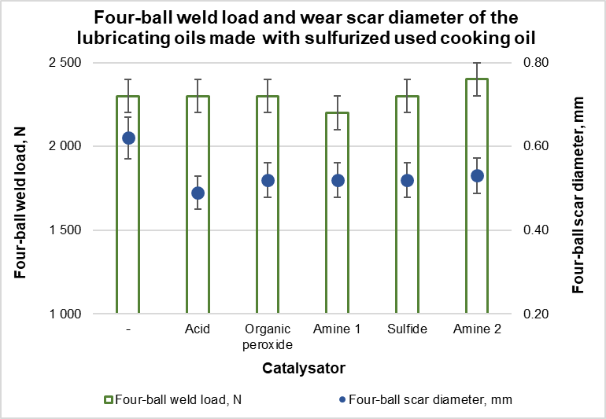

*Figure 3: The four-ball weld load and wear scar diameter results of the lubricating oil solutions of the sulfurized used cooking oil additive samples*

In Table 7, the physico-chemical and functional properties of the lubricating oil solutions made with the sulfurized olive pomace oil additive samples are presented. These lubricating oil samples had slightly brighter shade, except the solution of the samples made without catalyst and with acid type catalyst. The primary reason of this phenomenon was the lighter colour of the raw material, and it was also influenced by the type of catalyst used.

Table 7: Physico-chemical and functional properties of the lubricating oil solutions (LOS) of the sulfurized *olive pomace oil* additive samples

|  |  |  |  |  |  |  |  |
| --- | --- | --- | --- | --- | --- | --- | --- |
| Lubricating oil sample | Sulfurized sample | Appearance | Kinematic viscosity at 40°C, mm2/s | Kinematic viscosity at 100°C, mm2/s | Four-ball weld load,  N | Four-ball scar diameter,  mm | Copper corrosion test, level |
| LOS-7 | OPO-1 | Dark brown liquid | 33.7 | 5.55 | 2 100 | 0.61 | 4c |
| LOS -8 | OPO-2 | Dark brown liquid | 33.6 | 5.52 | 2 100 | 0.56 | 4c |
| LOS -9 | OPO-3 | Reddish brown liquid | 35.0 | 5.72 | 2 200 | 0.51 | 4a |
| LOS -10 | OPO-4 | Brown liquid | 33.9 | 5.55 | 2 100 | 0.50 | 3b |
| LOS -11 | OPO-5 | Reddish brown liquid | 35.3 | 5.72 | 2 200 | 0.53 | 3b |
| LOS -12 | OPO-6 | Brown liquid | 34.8 | 5.67 | 2 300 | 0.50 | 4a |

The best weld load result was occurred in the case of “Amine 2” type catalyst (LOS-12), in addition each sample achieved the set target. The lowest wear scar diameter results were measured in the case of amine type catalysts (LOS-10, LOS-11), which outcomes exceed the set target. Moreover, when organic-peroxide (LOS‑9), amine (LOS-10, LOS-12) and sulfide-type (LOS-11) catalysts were applied, the copper corrosion levels were low, significantly surpassing the established target. The four-ball weld load and wear scar diameter results of the lubricating oil solutions made with the sulfurized olive pomace oil additives are shown on Figure 4.

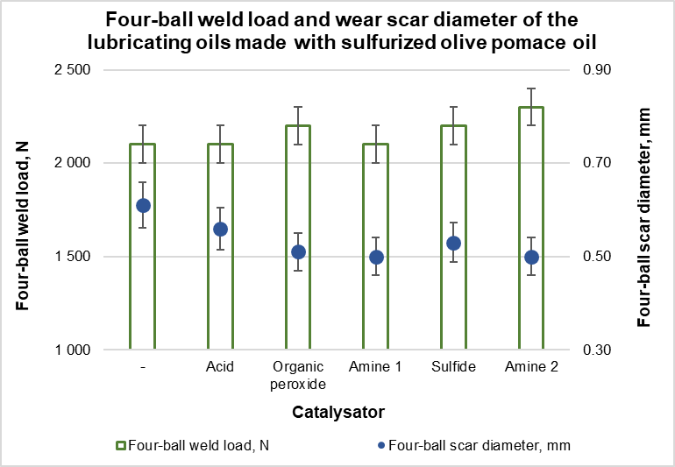

*Figure 4: The four-ball weld load and wear scar diameter results of the lubricating oil solutions of the sulfurized olive pomace oil additive samples*

* 1. Conclusions

It can be stated, that additives derived from olive pomace oil with the use of amine- and sulfide-type catalysts provided the most favorable physico-chemical properties and the most desirable functional effects. The results demonstrate that additives exhibiting a lower degree of copper corrosion than those commercially available with similar sulfur content can be produced by employing suitably selected catalyst and reaction conditions.

* With appropriately selected catalyst, it is feasible to produce EP additives whose functional parameters exceed the established targets, even when using waste cooking oil as the raw material.
* The application of amine-type catalysts is advantageous in terms of both physico-chemical properties and functional performance.
* The use of a carefully chosen catalyst can reduce the reaction time by half, thereby economic benefits can be realized through lower production costs.
* Employing amine- and sulfide-type catalysts results in additives with lower viscosity, lighter colour and favorable tribological performance that allows their application in modern lubricating oils.
* Furthermore, the use of amine- and sulfide-type catalysts achieves a lower level of copper corrosion, thereby broadening the range of applications for these additives; concurrently, the weld load and wear scar diameter values are either comparable to or exceed to those of the reference.

References

Davis K., Frank Z., Reed W., 1988, Sulfurized compositions and lubricants, EP0289548B1, EU.

Donald A.L., John A.B., 1979, Extreme pressure additives for lubricants, US4149982, USA.

Emile N.H., 1974, Novel sulfur-containing compositions, US3926822, USA.

Frank L.E., Phillip S.L., Robert E.A., 1979, Vegetable oil derivatives as lubricant additives, EP0353872A1, EU.

James J.S., 1990, Mixtures of partial fatty acid esters of polyhydric-alcohols and sulfurized compositions and use as lubricant additives, US4,957,651, USA.

Kirk E.D., 1980, Sulfurized compositions, US4,191,659, USA.

Kishore N., 2000, Determination of Sulfur in Petroleum Products and Lubricants: A Critical Review of Test Performance, American Laboratory, November.

Leslie R.R., 2017, Lubricant Additives, Third Edition, CRC Press, Boca Raton, FL, 211-278.

Guerrero-Muñoz M.A., Mares-Molina K.E., Tovar-Negrete J.J., Hernández S., Barroso-Muñoz F.O., 2024, Simulation of the purification process of waste cooking oil as a feedstock for biodiesel production, Chemical Engineering Transactions, 110, 55-60.

Nicole G., Xavier B., 2018, Grease composition, US9,951,292 B2, USA.

Roger S., 1995, Sulfurized fatty acid or ester and olefin mixtures, lubricants, and methods of making the same, EP0656414A2, EU.

Theo M., Kirsten B., Thorsten B., 2011, Industrial Tribology. Tribosystems, Friction, Wear and Surface Engineering, Lubrication, Wiley, Weinheim, 320-335.

Wilfried D., Theo M., 2017, Lubricants and Lubrication, Third Edition, Wiley, Weinheim, 138-144.