|  |  |
| --- | --- |
| cetlogo ***CHEMICAL ENGINEERING TRANSACTIONS***  ***VOL. xxx, 2025*** | A publication of  aidiclogo_grande |
| The Italian Association  of Chemical Engineering  Online at www.cetjournal.it |
| Guest Editors: David Bogle, Flavio Manenti, Piero Salatino  Copyright © 2025, AIDIC Servizi S.r.l. **ISBN** 979-12-81206-21-2; **ISSN** 2283-9216 | |

Exploiting dynamic simulation in sustainability-based scheduling optimization for biomethanol production

Ghida Mawassi, Alessandro Di Pretoro\*, Ludovic Montastruc

Laboratoire de Génie Chimique, Université de Toulouse, CNRS/INP/UPS, Toulouse, France

alessandro.dipretoro@ensiacet.fr

During the last decade, the sustainability targets set by the EU within 2050 (Communication from the commission of the European Parliament, 2024) have resulted in a need for substantial reconsiderations in the process and energy industry setup. For the effective achievement of this goal, indeed, several solutions have been proposed from the production, utility and logistics perspectives. In particular, from a quantitative point of view, the decarbonization of the energy sector appears to be the most critical step due to the difficulty of keeping a stable production by using intermittent sources, such as renewables. For this reason, an alternative approach could be based on the productivity modulation according to renewables availability over time in order to minimize the use of non carbon-free backup energy sources. In order to test the potential of renewable energy-based demand response for large scale processes (Bruns et al., 2021), a case study related to the biogas-to-liquid technology was set up due to its promising performance in terms of CO2-to-molecule conversion (Fedeli and Manenti, 2022). In particular, biomethanol production was selected because of the high versatility and energy density of this species.

Based on the steady state estimations obtained in previous works (Di Pretoro et al., 2024), this study aims then at testing the process dynamic response to the process to the variation on input flowrate. Based on the result, the best control loop configurations providing the optimum yield and purity for the product were chosen. The outcome of this study confirmed the potential of dynamic simulation and control strategies when dealing with fluctuating input that aligns with availability of renewable energy.

* 1. Introduction

In chemical engineering, steady-state simulation is essential for process design and optimization, especially when utilizing advanced software such as Aspen Plus® and Aspen HYSYS®. By modelling and analysing chemical processes under continuous working settings, these technologies give engineers important information on the viability, effectiveness, and performance of industrial systems. Engineers can assess critical process parameters, such as flow rates, pressures, temperatures, and compositions, across various unit activities, such as reactors, distillation columns, heat exchangers, and separators, by modelling steady-state circumstances. This makes it possible to do precise material and energy balance calculations, which are essential for creating processes that are both economical and ecologically benign. Additionally, steady-state simulation is an effective tool for diagnosing current systems, assisting in the detection of bottlenecks, inefficiencies, or possible malfunctions prior to their development into operational problems. Engineers may rapidly evaluate various process configurations and situations by utilizing simulation software, thus, reducing the time and expense involved in experimental testing or physical prototyping.

With the growing demand for electricity, carbon dioxide emissions due to energy generation is a main contributor to global warming specially in chemical industries (Ritchie., 2020). Hence, the industry sector needs to be a key player in this continuous transition to renewable energy. The idea of continuously available energy, as in the case of fossil fuel or hybrid generation, is eliminated when a production facility or other system is powered solely by renewable energy. Instead, intermittent energy with varying intensities across time is used. This suggests that the production capacity must be adjusted to match the energy supply, resulting in ongoing disruptions and departures from steady conditions. In this situation, steady state simulation—which is modelled to create stationary processes—will not yield reliable results about how the system reacts to instability. Dynamic simulation will be used to solve this problem. The latter clearly depicts the time lag between the start of the perturbation and the steady state, accounting for the time-dependent behaviour of variables. To put it another way, raw material inlet flow—in will be regulated by adjusting its setpoint (SP) in accordance with renewable energy, and dynamic simulation will enable the monitoring of the control of flow rates, temperatures, pressures, and other parameters from their current state to their new SP.

* 1. Case Study

To align this study with the main goal of using renewable energy, mitigating CO2 emissions, the process that should be selected as a case study should help in reaching this target. The most effective way to mitigate CO2 and stop further global warming is to convert CO2 into long-lasting products and use renewable energy sources to generate electricity. Through the use of these complementary techniques, chemical processes can be converted into negative emission processes, preventing CO2 emissions while also using carbon dioxide to create products that will permanently prevent its re-emission.

Methanol (MeOH) appears to be an attractive application in this work due to its wide range of uses and high demand. It is frequently utilized as a feedstock for the synthesis of methyl methacrylate, acetic acid, and formaldehyde in addition to being an excellent fuel for transportation applications. A variety of environmentally friendly techniques and bio-based resources, involving gasification, reforming, stripper-off gas, and power-to-liquid, can be used to produce green MeOH. In this article, biomethanol production from biogas will be examined. Prior conversion, the biogas needs to be purified to get rid of impurities that can obstruct the conversion process. Following purification, the methane is reformed to produce syngas, a blend of H₂ and CO, which is the feedstock needed to synthesise methanol. Steam methane reforming is the most often used technique for methane reforming (Zhang et al., 2012). Then, syngas conversion to methanol occurs through a catalytic process at high pressures and temperatures. Lastly, the methanol is separated and refined by distillation to make sure it satisfies the purity requirements for the applications for which it is designed. This purification is divided into two steps; removal of unreacted components or off gas, and water removal. The whole process is illustrated in Figure 1 below. In this article, dynamic simulation of biomethanol production from syngas and the separation of unreacted component and products will be discussed.

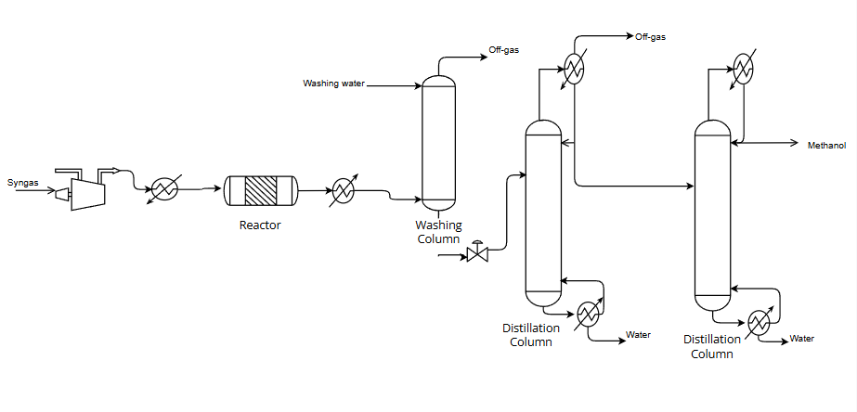

Figure 1: PFD of biomethanol production

* 1. Methodology

The biomethanol production process is simulated on Aspen PLUS® as a steady state simulation then converted to dynamics. The simulation includes the process from syngas conversion to off gas removal only, the biogas reforming will not be included in this study as stated earlier.

The main objective is to find the optimum control loops for each unit of the process in case the production capacity is not constant and depends on the availability renewable energy, therefore many control loops will be configured and the optimal one will be selected. The quantity of syngas to be processed is variable and depends on the renewable energy available, and the SP of the syngas entering the process follows the trend of energy.

The forms of energy considered are wind and solar energy, two forms of highly fluctuating energy throughout the day and the season. The selection criteria will be the speed of adjustment of the system with the high variation in the SP of the input. In order to proceed, the SP will be modified regularly to check how the system will react to this variation.

This procedure is intended to determine the ideal control configuration as well as whether it differs from the default or typical configuration that is usually employed in case of constant production rate.

Finally, Figure 3 illustrates the dynamic simulation and the control loops chosen for the process by scheduling the biomethanol production based on renewable energy, availability in January in Toulouse as shown in Figure 2. The choice of these control loops configuration is detailed in section 4.

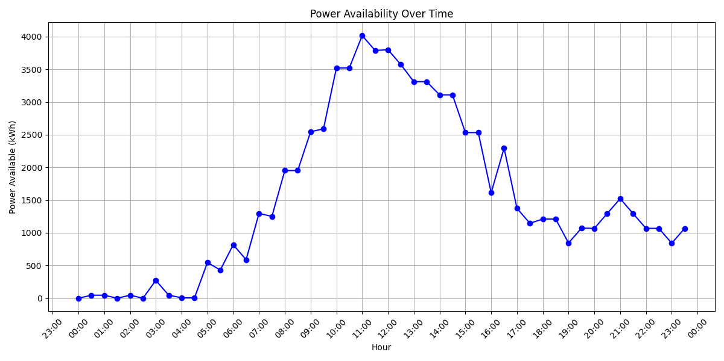

Figure 2: Power availability from renewable energy during the day

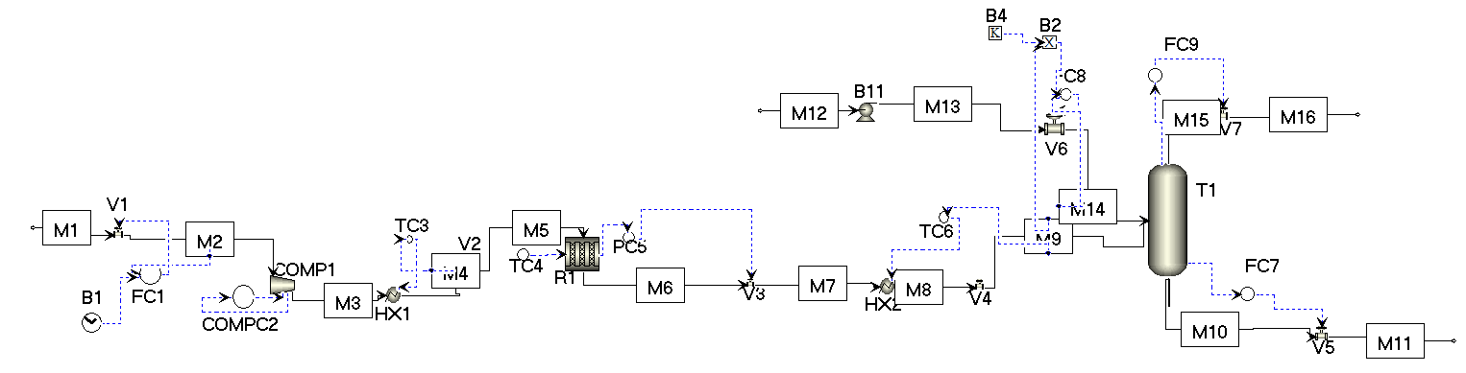Figure 3: Reaction section dynamic simulation and control loops

* 1. Results
     1. Inlet flow control

Firstly, the SP for the syngas flowrate entering the process is scheduled on an hourly basis. Following the availability of renewable energy-solar and wind-during each hour and ensuring that the energy supply aligns with operational requirements. The flowrate is then regulated using a control valve V1, enabling precise adjustment to meet the desired SP.

* + 1. Compressor

When considering the control of the compressor, several strategies were evaluated. An intuitive approach is to control the pressure immediately downstream of the compressor, by regulating its brake power. However, this method (configuration 1) poses challenges due to its close interaction with the flow control system. Such proximity can lead to pressure instabilities during regulation, and the inlet flowrate can't be varied on all the desired range. These instabilities could disrupt process efficiency and operational stability.

Three other configurations were tested to overcome these challenges.

The first approach (configuration 2) is to regulate the pressure at the reactor inlet. By shifting the control point to the reactor inlet, the system can better manage pressure variations, allowing greater flexibility in adjusting the inlet flowrate.

Another approach (configuration 3) is done by calibrating the temperature of the flow leaving the compressor leads to an automatic adjustment of the pressure entering the reactor. It will oscillate between 53 and 55 bars, an acceptable range for production of biomethanol reactions (Adil et al., 2022). When the temperature is regulated, the brake power automatically shifts and realigns depending on the inlet flowrate.

The last configuration (configuration 4) is based on controlling the suction volume flowrate by regulating the brake power**.** If the suction volume flowrate is chosen carefully, this control layout ensures that the pressure of the flow entering the reactor is maintained 53 and 55 bars, in this case brake power varies according to the inlet flowrate scheduled.

This form guarantees a good manipulation of the flowrate of syngas, starting from 0 kg/h and going to the maximum capacity and an outlet temperature that varies in a restricted range (197 to 450°C) compared to the configuration 2 where the temperature can reach more than 1000°C, from when the flowrates vary between the desired range (600 to 3000 kg/h).

Configurations 4 offers a better response to fluctuations than configuration 3 as in Figure 5**.** The controller reacts rapidly to any change in the SP based on the schedule in Figure 5 and the flowrate is never surpassed when the SP increases, the overshoot is equal to 0. Figure 5b illustrates the control process for adjusting the flow rate from an initial value of 600 kg/h to a SP of 3000 kg/h representing the maximum and minimum values possible. It shows that for reaching 90% of the desired SP, 2700 kg/h, it takes about 1 hour (more precisely 0,9) only knowing that it will be the maximum delay between 2 SPs.

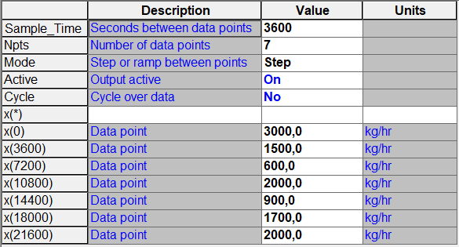

Figure 4: Example of scheduling during 5 hours

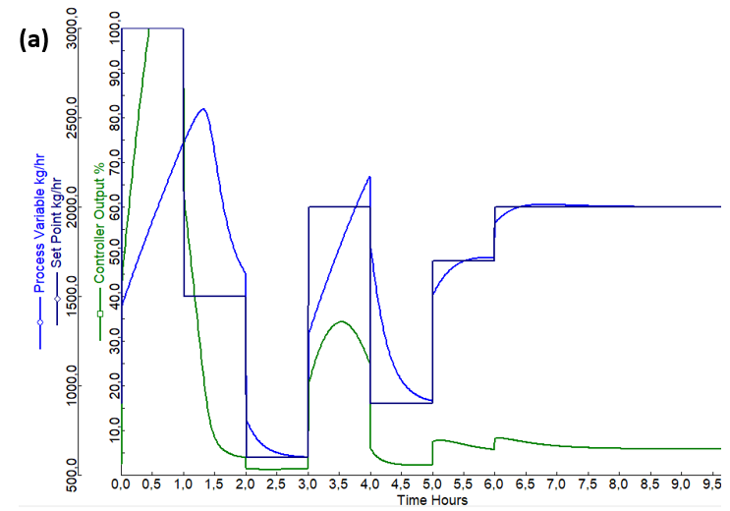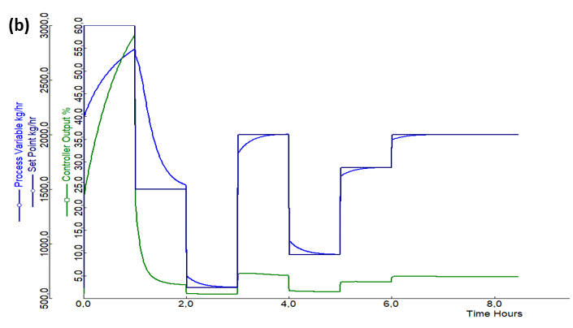

*Figure 5: Example of syngas flowrate controller response for: a) configuration 3, b) for configuration 4*

Compressor type

To translate the control and simulation of the compressor into practical use, a variable speed drive compressor is chosen. Traditional fixed speed air compressors operate at constant always at full-throttle. They have many benefits if the needed capacity is constant but if it's variable, and not all the output is always required energy will be wasted. On the other hand, variable speed drive compressor continuously modifies the motor speed to fit the inlet demand. This drive adjusts the unit's speed (RPM) in response to demand, varying the power consumption to precisely match the output needed. The compressed air system will lower the motor speed and, thus, the power usage when the demand decreases and inversely when it increases improving energy efficiency.

The volume of this equipment is wisely selected to ensure acceptable performance on all the range of syngas flowrate.

* + 1. Reactor

The control of the reactor should be based on two critical operating conditions affecting the conversion of syngas into biomethanol; the temperature and the pressure. These parameters should not only be controlled at the entrance of the reactor but should also be monitored inside the equipment. CO2 hydrogenation and water-gas shift reactions are exothermic, generating heat that raises the temperature inside the reactor, potentially destabilizing the reaction. To maintain optimal conditions, it is necessary to regulate the temperature by continuously cooling the reactor. This is achieved by adjusting the flow rate of the cooling fluid, ensuring the temperature remains at the desired level.

Similarly, the pressure is fixed at a desirable level by controlling the valve opening at the reactor's outlet.

* + 1. Washing column

Water flow

The washing column removes unreacted syngas from the water-methanol mixture before distillation, the optimal removal is achieved by maintaining a constant water to feed flowrate ($W/F$) ratio equal to 3.5 during the process. Considering that the syngas flowrate (FS) is variable and adapted to the energy availability, the flowrate of washing water (FW) should also accommodate on that basis. The first attempt was to schedule the water flow in accordance to syngas flow Figure 3 as illustrated in Table 1,

$F_{W}={3.5 F}_{S}$ (1)

However, the simulation is dynamic and based on fluctuating conditions, so this setup option was associated with a delay between both states because the flowrate is adjusting itself to be compatible with the syngas entering the process (M1) but did not yet enter the column. Therefore, ($W/F$) ratio will deviate from the optimal value identified causing variation in less efficient separation that will affect the whole process.

To address this challenge, the water flowrate is calculated and scheduled directly onsite. The flowrate of the feed entering the column is continuously tracked, then automatically multiplied by the optimal ($W/F$) ratio. The resulted flowrate is assigned as the remote SP of the controller managing the washing water, and calibrating its corresponding valve opening (Figure 6a). To thoroughly validate this configuration, the same quantity of syngas scheduled in Figure 1 was used with both control strategies to ensure comparability. For the first method, the flow rate of methanol in the stream proceeding to the next distillation column exhibits relatively limited quantity 75 to 175 kg/hr. Similarly, its mass fraction is observed to fluctuate within low but wide range between 0.0075 and 0.0175 having a fluctuation of 130%. In contrast, the alternative method shows a markedly different performance. The flow rate of methanol is considerably higher, varying more widely between 140 and 210 kg/hr, and the mass fraction also experiences narrow fluctuation, ranging from 0,0188 to 0,0219 (Figure 6b).

This analysis underscores a critical drawback of the first control strategy, it leads to a significant loss of methanol, which represents a major inefficiency. The loss of such a high quantity of methanol not only impacts the overall process yield but also increases material waste and potentially raises operational costs.

Moreover, fluctuations in the composition of the stream can introduce inefficiencies into the subsequent stages of the process, as they necessitate adjustments to operating conditions to accommodate the variability.

In conclusion, the second strategy has proven to be the optimal choice for this process, as it outperforms the first approach in several key aspects, including efficiency and stability. Its ability to maintain better control over the flow rate and composition, while minimizing losses, makes it the most suitable option for achieving the desired operational goals. Consequently, the second strategy will be adopted as the preferred method for implementation in the process.

Table 1: Washing column water control

|  |  |  |  |  |  |
| --- | --- | --- | --- | --- | --- |
| Hour | 1 | 2 | 3 | 4 | 5 |
| FW in kg/h | 10500 | 5250 | 7000 | 2450 | 3500 |

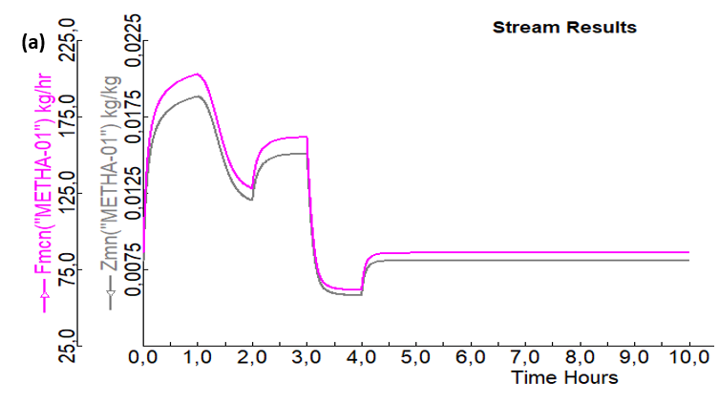 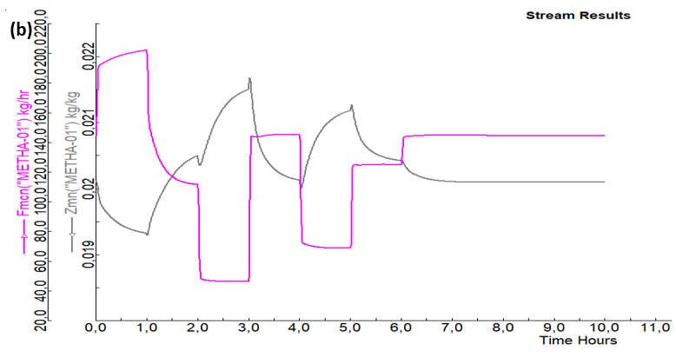

Figure 6: Results of the water methanol mixture leaving the washing column: a) on the left for scheduling water strategy, b) on the right for the final control strategy

* + 1. Scheduling

Once the control loops were adjusted, scheduling the process can begin. As seen in Figure 2, the process's scheduling is carefully adjusted with Toulouse's solar and wind power availability in January in order to assess how well these control loops are performing. The available power is used to calculate the syngas input while accounting for the specified limitations, which include both minimum and maximum capacities, 600 and 3000 kg/h respectively (Figure 7a). When the minimum limitation is not satisfied by the solar and wind energy, backup energy will be supplied from biomass cogeneration if more energy is needed. This calculated input is added in B1 and serves as a variable SP for FC1.

Finally, the resulting biomethanol production shows a constant link between energy availability and biomethanol output, closely matching the trends shown in the syngas input curve (Figure 7b). This biomethanol is obtained after the purification stage that is not discussed in this article.

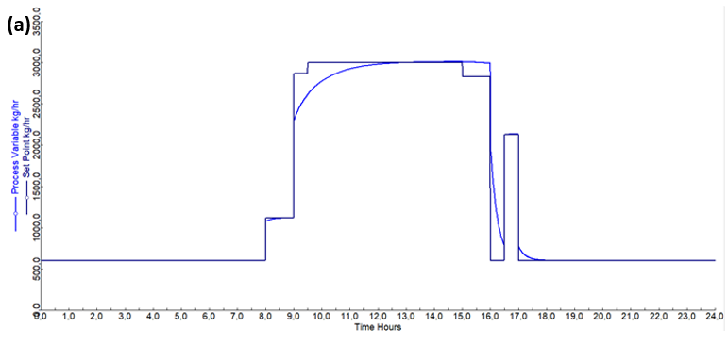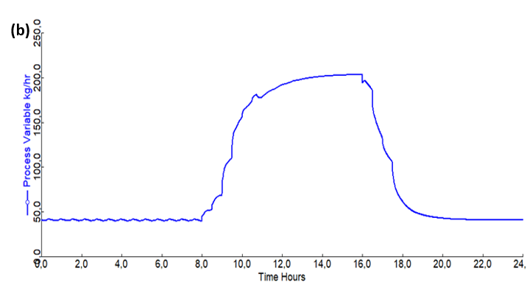

Figure 7: a) Syngas scheduling, b) Biomethanol obtained at the end of the process during the day

* 1. Conclusions

The impact of the energy transition on process scheduling and related control strategy was analysed in depth. In particular, by means of a dynamic simulation, it was proved that the alignment of process capacity and energy availability by exploiting appropriate and optimal control strategies can substantially impact the efficiency of the process in terms of renewables exploitation. This syngas-to-methanol case study showed many aspects of this control on different units and highlighted different point:

* Control loops in industrial and process systems that permit a wide range of flowrate changes are essential because it enhances the flexibility of the process to accommodate with the energy availability (like in the case of the compressor design);
* While controlling it is crucial to take into consideration the delay between each unit operation and consider the fact that not all units are processing the same flowrate at the same moment. Overlooking this fact may affect the yield and the quality of the product (like in case of the washing column);
* The key parameter to account for when implementing an emissions-oriented process scheduling is the overall energy demand, which should be as much compliant as possible with the characteristic profile of the selected utility source.

To further validate the suggested methodology, future research will address the comparison between renewable energy sources with different characteristic cycle times and their adaptability to chemical processes with different dynamics and unit operations.

Acknowledgments

This work benefited from State aid managed by the Agence Nationale de la Recherche under the Investissements d'Avenir programme, reference ANR-18-EURE-0021.

References

Adil A., Rao L., 2022, Methanol production from biomass: Analysis and optimization, Materials Today: Proceedings, 57, 1770-1775, 10.1016/j.matpr.2021.12.450.

Bruns B., Di Pretoro A., Grünewald M., Riese J., 2021, Indirect demand response potential of large-scale chemical processes, Industrial & Engineering Chemistry Research, 61(1),605-620, [10.1021/acs.iecr.1c03925](http://dx.doi.org/10.1021/acs.iecr.1c03925).

Communication from the commission of the European Parliament, the European Council, the Council, the European Economic and Social Committee and the Committee of the Regions, 2019. “The European Green Deal”. <https://eur-lex.europa.eu/legal-content/EN/TXT/?uri=COM%3A2019%3A640%3AFIN> accessed 10.07.2024.

Di Pretoro A., Tageldin I., Montastruc L., 2024, Emission oriented scheduling optimization for sustainable processes, Computer Aided Chemical Engineering, 1567–1572, 10.1016/B978-0-443-28824-1.50262-3.

Fedeli M., Manenti, F. 2022 Assessing process effectiveness with specific environmental and economic impact of heat, power & chemicals (HPC) option as future perspective in biogas. Cleaner Chemical Engineering 2, 10.1016/j.clce.2022.100016.

Ritchie H., 2020, Sector by sector: where do global greenhouse gas emissions come from? OurWorldinData<https://ourworldindata.org/ghg-emissions-by-sector> accessed 18.09.2020.

Zhang H., Sun Z., Hang Hu Y., 2021, Steam reforming of methane: Current states of catalyst design and process upgrading, Renewable and Sustainable Energy Reviews,1364-0321, [10.1016/j.rser.2021.111330](http://dx.doi.org/10.1016/j.rser.2021.111330).