 CHEMICAL ENGINEERING TRANSACTIONS  VOL. xxx, 2025 | A publication of  
The Italian Association
of Chemical Engineering
Online at www.cetjournal.it
Guest Editors: David Bogle, Flavio Manenti, Piero Salatino
Copyright © 2025, AIDIC Servizi S.r.l.
ISBN 979-12-81206-21-2; ISSN 2283-9216
Evaluation of ammonia cracking catalysts far from optimal conditions for application in energy systems
Chiara Anfossoª, Antonio Barbucci^{b}, Davide Clematis^{b}*, Daria Bellottiª
ªTPG – Thermochemical Power Group, Dipartimento di Macchine Sistemi Energetici e Trasporti, University of Genoa, Via Montallegro 1, 16145 Genova, Italy
^{b}DICCA – Department of Civil, Chemical and Environmental Engineering, University of Genoa, Via Opera Pia, 15 – 16145 Genova, Italy
davide.clematis@unige.it
Ammonia cracking is a promising method for carbon-free hydrogen production, crucial for sustainable energy applications. This study investigates the catalytic performance of two commercially available catalysts—ruthenium-based (3% wt. Ru/Al₂O₃) and nickel-based (20% wt. Ni/Al₂O₃)—under varying operational conditions to determine their efficiency and long-term stability. While ruthenium catalysts exhibit high intrinsic activity at lower temperatures, their performance is hindered under high-pressure conditions. Nickel catalysts, though requiring higher activation energy, demonstrate greater robustness and cost-effectiveness, making them viable for industrial applications. Unlike conventional plug flow reactor (PFR) studies, this research utilizes a batch reactor configuration to examine catalyst behavior, mass transfer limitations, and material degradation under extended reaction times. Experiments conducted between 450–650 °C and up to 9 barg provide insights into the impact of operating conditions on catalytic efficiency. A physically based model incorporating reaction kinetics and mass transport phenomena further aids in interpreting the results. Findings indicate that Ru-based catalysts perform best at lower temperatures and pressures, while Ni-based catalysts exhibit superior performance under harsher conditions. These results contribute to optimizing ammonia cracking for industrial hydrogen production, emphasizing the importance of catalyst selection and reactor design in advancing hydrogen energy solutions.
  - Introduction
The global transition toward sustainable energy systems necessitates efficient hydrogen production methods that minimize carbon emissions (Osman et al., 2022). Ammonia cracking has emerged as a promising solution due to its ability to generate hydrogen in a carbon-free manner, making it highly relevant for applications in energy production, transportation, and industrial processes (Clematis et al., 2023; Richard et al., 2024). However, the efficiency of ammonia decomposition heavily depends on the presence of effective catalysts that can facilitate the reaction under varying operational conditions (Asif et al., 2023; Spatolisano et al., 2023). Given the increasing interest in scaling up ammonia cracking for industrial use, it is crucial to understand how catalysts perform under realistic process conditions, including elevated temperatures and pressures.
A key challenge in ammonia cracking lies in the reaction’s dependence on operating pressure. Thermodynamically, the decomposition of ammonia into hydrogen and nitrogen is favored at low pressure, yet many practical applications, such as gas turbines and fuel cells, require a pressurized hydrogen feed (Su et al. 2023). This discrepancy poses significant challenges for integrating ammonia cracking into industrial hydrogen supply chains. As such, studying catalyst performance under conditions deviating from the thermodynamic optimum is essential for optimizing reactor design and ensuring process efficiency. Catalytic performance in ammonia cracking is influenced by several factors, including reaction kinetics, catalyst composition, and reactor configuration. Traditional approaches have primarily focused on plug flow reactors (PFRs), which allow for continuous operation and high conversion rates (Di Carlo et al., 2014). However, batch reactors provide unique advantages for fundamental studies by offering greater control over reaction parameters, extended contact time between reactants and catalysts, and an ability to assess long-term stability. While batch configurations may not always reflect industrial-scale conditions, they serve as valuable tools for investigating catalyst deactivation, mass transfer limitations, and material durability under varying operational stresses.
This study investigates the performance of two commercially available catalysts, ruthenium-based (3% wt. Ru/Al₂O₃) and nickel-based (20% wt. Ni/Al₂O₃), to determine their suitability for ammonia cracking under varied conditions. Ruthenium catalysts are known for their high intrinsic activity at relatively low temperatures, but their performance can degrade under high-pressure conditions. Conversely, nickel-based catalysts, though requiring higher activation energy, offer robustness and cost-effectiveness, making them attractive for large-scale applications. The comparative assessment of these catalysts provides a deeper understanding of their operational strengths and limitations. Unlike conventional studies that employ PFR configuration, this research utilizes a batch reactor setup to provide insights into catalyst behavior, long-term stability, and material degradation. By examining catalyst activity across a temperature range of 450–650 °C and pressures up to 9 barg, this study aims to enhance the understanding of ammonia cracking catalysts and their potential for industrial-scale hydrogen production. Additionally, the impact of prolonged exposure to ammonia and hydrogen on catalyst microstructure it has been considered, shedding light on potential embrittlement and compositional changes that could affect performance over time. Furthermore, the study employs a physically based model tailored for batch reactors, incorporating diffusion and reaction phenomena to better interpret the experimental results. This approach ensures that key reaction mechanisms and mass transfer effects are adequately accounted for, allowing for a more comprehensive evaluation of catalyst efficiency and degradation trends. By integrating experimental data with modelling insights, the study contributes to the optimization of ammonia cracking processes for industrial hydrogen generation, to bridge the gap between laboratory-scale catalyst assessments and real-world operational requirements. By identifying the optimal conditions for each catalyst and evaluating their long-term stability, the findings can guide the development of more efficient and durable catalytic materials for ammonia cracking. The results underscore the importance of catalyst selection and reactor design in advancing hydrogen production technologies, paving the way for more sustainable and economically viable hydrogen energy solutions.
  - Materials and methods
Based on literature and market analysis two catalysts with distinct behaviors were selected. Specifically, a 3% wt. Ru/Al₂O₃ was chosen as reference catalyst with high performance at low temperatures (T < 550 °C), while a 20% wt. Ni/Al₂O₃ was selected as reference material for operating at higher temperatures. The Ru/Al₂O₃ required a preliminary activation step, that has been carried out at 450 °C for 2 hours, with a flow of 100 ml/min (10%H₂/90%N₂). Both catalysts were tested in a temperature and pressure range of 450 – 650 °C and 0 – 9 barg, respectively, by using a batch reactor. All the experiments have been carried out based on a tailored protocol before injecting NH₃ into the system, and the main stages are here summarized. Firstly, purging the system is performed using nitrogen to remove any eventual residual ammonia inside the reactor and avoid any release into atmosphere during the vacuum phase. Then, a vacuum stage is required to remove the nitrogen which remains inside the reactor zone, followed by the heating of the reactor to the desired temperature. Before the injection of ammonia for the test, a second vacuum step is performed once the target temperature is reached. Finally, NH₃ is fed to the reactor to achieve the desired pressure. At the end of each test, the test-rig is discharged exploiting a scrubber system to prevent the release of unreacted ammonia into the atmosphere. Both the catalysts undergo such catalytic characterization as well as a morphological (Scanning Electronic Microscopy – SEM) and compositional (Energy Dispersive Spectroscopy – EDS) investigations before and after the experimental campaign.
The analysis of the results has been carried out developing a tailored model which considers both mass transport and reactive contributions. Specifically, the system has been modeled with a finite element method in a 3D domain made of two overlapped volumes as reported in Figure 1. The bottom domain (D_{CTZ}) represents the catalytic bed, while the upper domain (D_{GAS}) represents the volume occupied by the gas within the reaction chamber above the catalyst.
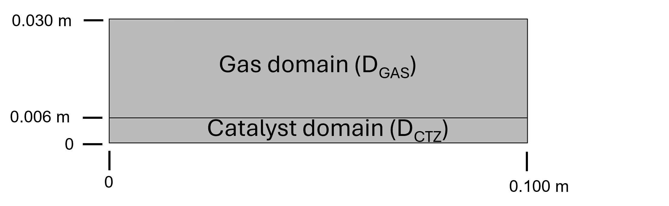
Figure 1: Representation of the two domains considered in system modelling.

The model considers the presence of three species (NH₃, H₂, N₂), and the selected physics describes a diffusion process within the gas phase (D_{GAS}), while in the catalytic bed, the diffusion within the porous structure is coupled with a reactive process:
$\frac{∂c_{i}}{∂t}+∇∙J_{i}+u∙∇p=R_{i}$ (1)
$J_{i}=-D_{i}∇c_{i}$ (2)
$\ln\left(D_{i}\right)=A_{i}+\frac{B_{i}}{T}+C_{i}∙ln⁡(T)$ (3)
where $c_{i}$ is the concentration, $J_{i}$ is the diffusive flux, $u∇p$ is the forced component of mass transport, and $R_{i}$ is the reactive term. This last term is neglected in D_{GAS}. The diffusion coefficients 𝐷𝑖 [cm²/s] have been considered temperature-dependent and the parameters $A_{i}$, $B_{i}$, $C_{i}$ have been obtained from (National Institute of Standards and Technology, 2025).
Within the reaction zone (D_{CTZ}), the diffusion is influenced by the interaction between the molecules in the gas phase and the catalytic bed, which is characterized by porosity (𝜀) and tortuosity (𝜏). To account for the specific characteristics of this domain, the diffusion coefficient 𝐷𝑖 has been replaced by an effective diffusion coefficient $D_{eff,i}$ defined as:
$D_{eff,i}=\frac{ε}{τ}D_{i}$ (4)
$τ=ε^{-1/2}$ (5)
The parameters 𝜀 and 𝜏 have been defined based on the literature and by applying the Bruggeman model (BM, Eq 5) (Tjaden et al., 2016). The porosity ranges between 30-40% for a bed composed of spheres, and then it has been set at 35%.
  - Results and discussion
To fully characterise both catalysts several experiments at different temperatures and pressure have been carried out. Both catalysts have been tested at 450 °C, 550 °C, 600 °C and 650 °C varying the pressure from 0 to 9 barg. For each test the pressure variation is described by three sections with different rates. The first one is linear and faster than other two, and it is related to the feeding of NH₃ in the reactor. The slope of the pressure in this section is an index of catalyst activity and can be used for a preliminary comparison of their performance as a function of pressure and temperature. After a transitory (2nd phase), the pressure increases with a lower linear trend which is only related with the conversion. Indeed, the ammonia cracking reaction (2NH₃ 3H₂ + N₂) occurs with an increase in number of moles followed by a pressure growth.

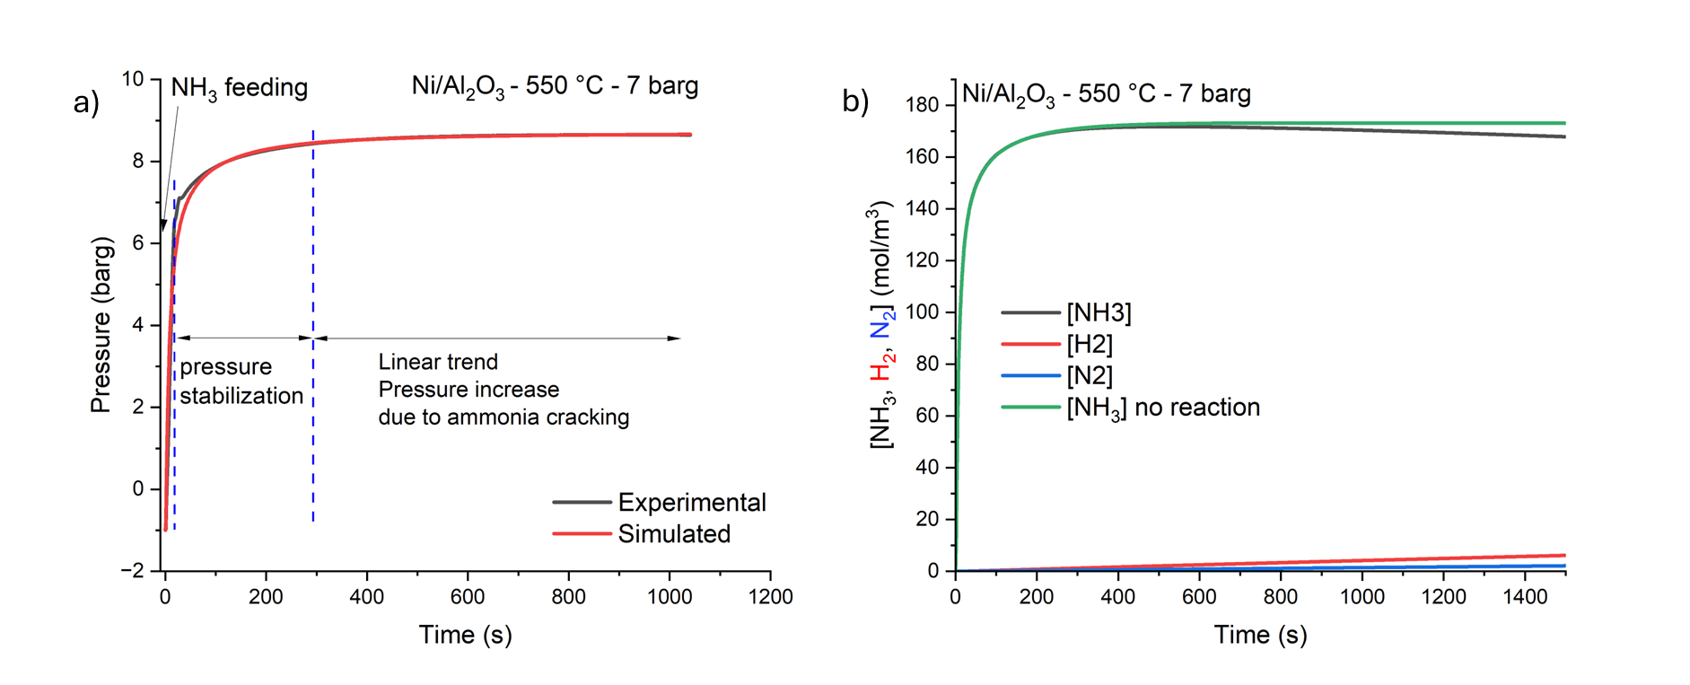
Figure 2: a) Example of experimental (black line) and simulated (red line) pressure trends during the ammonia cracking testing in a batch reactor b) Corresponding NH₃, H₂ and N₂ concentration profiles obtained by using the model described.

Nevertheless, it is reasonable to assume that the conversion starts since the first ammonia reaches the catalyst bed during the ammonia loading. Then, to estimate the conversion obtained in the full experiment the model described in section 2 has been applied following the scheme here described. Firstly, a simulation that models the overall pressure inside the reactor since the ammonia injection and its cracking reaction has been performed (Figure 2a). From this simulation, it is also possible to evaluate the concentration profiles for the reagent and products (Figure 2b). Subsequently, a second simulation is performed, excluding the reactive contribution (green curve in Figure 2b), and the difference between the two cases (e.g. ΔNH₃ = 5.2 mol/m³) is representative of the cracked ammonia. Then, it is possible to calculate the ammonia conversion at any time (e.g. after 1500 s X_{NH3} = 3%) and the corresponding H₂ e N₂ produced (e.g. after 1500 s [H₂] = 7.8 mol/m³ and [N₂] = 2.6 mol/m³). This approach has been applied to all the experiments and the obtained conversions as function of temperature and pressure are summarised in Figure 3a and 3b, respectively. The results clearly show that at low temperature (450 °C) and pressure (0 barg) Ru/Al₂O₃ has higher performance than Ni/Al₂O₃, as expected from the literature (Medina et al. 2024; Peters et al. 2023).
Nevertheless, the temperature increase has a beneficial effect on Ni/Al₂O₃ that is reported to enhance its activity over 600 °C (Zheng et al., 2008). On the contrary, the Ru/Al₂O₃ has a lower improvement in its performance with temperature, and the ammonia conversion oscillates close to 11% for T ≥ 550 °C. This effect of the temperature can be explained by considering the following microkinetic model with the elementary steps for ammonia cracking and the rate-determining step:
1) Ammonia adsorption: NH₃ (g) + * ↔ NH₃* (ads) (6)
2) 1st N-H cleavage: NH₃* (ads) + * → NH₂* (ads) + H* (ads) (7)
3) 2nd N-H cleavage: NH₂* (ads) + * → NH* (ads) + H* (ads) (8)
4) 3rd N-H cleavage: NH* (ads) + * → N* (ads) + H* (ads) (9)
5) H₂ recombination: 2H*(ads) → H₂ (g) + 2* (10)
6) N₂ recombination: 2N* (ads) → N₂ (g) + 2* (11)
where * is the active surface site (Trangwachirachai et al., 2024).
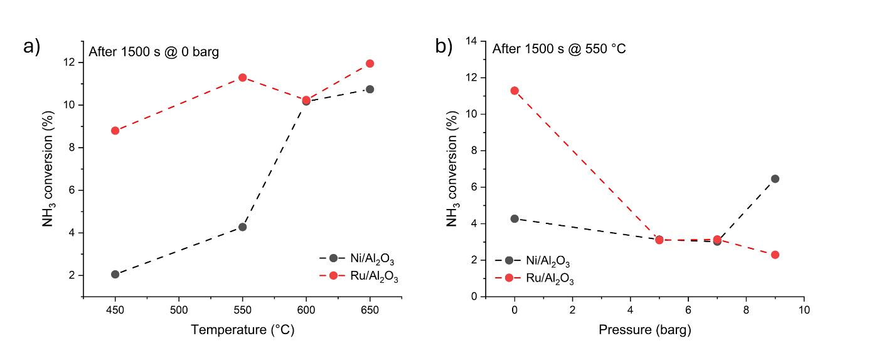
Figure 3: a) Calculated ammonia conversion at 0 barg and different temperature for Ni/Al₂O₃ and Ru/Al₂O₃ and b) at 550 °C and different initial ammonia pressure.

At temperatures below 550 °C, the rate-determining step for Ru/Al₂O₃ is assumed to be the N-N recombination to form N₂. In contrast, at higher temperatures, the desorption of H* (as H₂) hinders the cracking kinetic due to the low dissociation barrier of hydrogen. This change in the rate-determining step negatively affects the overall reaction rate because the affinity of H* with Ru surface is higher than that of N*. Moreover, for each cracked NH₃ molecule, the hydrogen atoms released are more than nitrogen ones, and then they occupy more active sites, and a slowdown of their desorption has a more negative impact than those linked with the desorption of nitrogen. A similar detrimental effect has been identified for the Ru/Al₂O₃ at 550 °C, increasing the NH₃ initial pressure. The conversion drops from an average of 11.2% at 0 barg to values lower than 4% for pressure higher than 5 barg. The literature ascribes such a trend to the same phenomenon just introduced to explain the low impact of temperature increase by using a Ru-based material, with the adsorbed atomic hydrogen that remains on the catalyst surface inhibiting the desired cracking reaction.
The SEM analysis has been used to evaluate the impact of ammonia cracking on catalyst morphology by comparing images of pristine and tested materials (Figure 4 a-d). Ni/Al₂O₃ particle shows no relevant surface modification with a stable behaviour. On the contrary, the testing activity has a negative impact on the reduced Ru/Al₂O₃ visible from Figure 4 d), where at least three cracks are well visible over the catalyst surface. The presence of such defects can explain the enhanced brittleness observed in the Ru-based particles compared to both the Ni/Al₂O₃ (pristine and tested) and the Ru/Al₂O₃ catalysts, which have only undergone the reduction process in 10% H₂ at 450 °C for 2 hours. The reduction in mechanical properties can be explained by the different interactions between the adsorbed hydrogen, produced during ammonia cracking, and the Ru-catalyst surface, which changes from 450 °C (temperature of the reduction process) to 650 °C (maximum operating temperature used). Indeed, at 450 °C, the atomic hydrogen is weaker adsorbed than at 650 °C, as previously discussed. This stronger interaction at 650 °C not only slow-down the turnover frequency at reactive sites, penalising ammonia conversion, but can promote the catalyst hydrogen embrittlement. Specifically, the lower turnover frequency increases contact time between the catalyst surface and the reactants, acting as an accelerated test to reveal material property changes that would require extended testing in a PFR configuration.
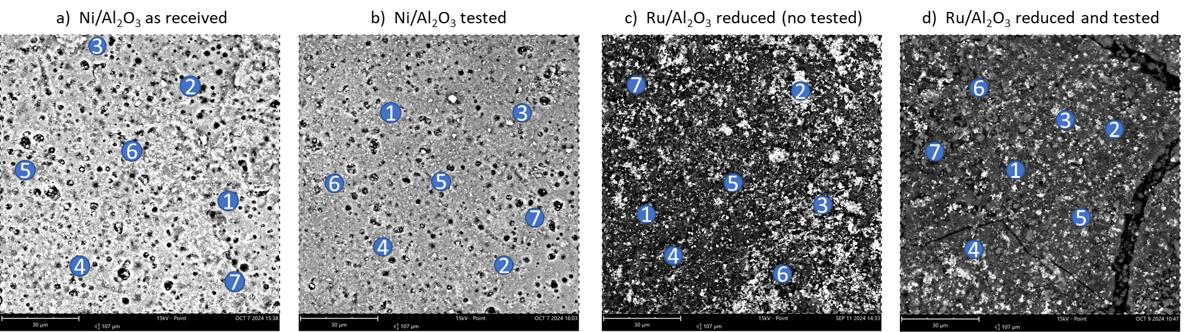
Figure 4: Scanning Electron Microscopy (SEM) for a) Ni/Al₂O₃ as received b) Ni/Al₂O₃ after test c) Ru/Al₂O₃ after the pretreatment in 10% H₂ at 450°C and d) Ru/Al₂O₃ after test. The numbers are referred to the point used for EDS analysis and reported in Table 1 and Table 2.

The EDS analyses for Ni/Al₂O₃ (Table 1) and Ru/Al₂O₃ (Table 2) show that the metal concentration remains close to the nominal one, suggesting a good adhesion with the alumina support. The main difference between the two catalysts is the dispersion of the metal phase. Indeed, 20% Ni/Al₂O₃ has a narrow Ni concentration range, while the Ru/Al₂O₃ has a less homogenous distribution.

Table 1 EDS analysis for Ni/Al₂O₃ catalyst as received and after testing
 | Ni/Al₂O₃ as received |  |  | Ni/Al₂O₃ tested
 | Elements concentration (%wt)
EDS Point | O | Al | Ni | O | Al | Ni
1 | 43.10 | 37.68 | 19.22 | 44.01 | 33.18 | 22.81
2 | 45.06 | 38.97 | 15.97 | 43.55 | 34.18 | 22.27
3 | 43.38 | 38.03 | 18.59 | 42.14 | 34.82 | 23.04
4 | 45.68 | 38.00 | 16.32 | 45.20 | 34.23 | 20.57
5 | 44.62 | 38.15 | 17.23 | 43.31 | 33.71 | 22.98
6 | 43.91 | 38.12 | 17.97 | 44.92 | 32.58 | 22.50
7 | 45.36 | 38.23 | 16.41 | 41.91 | 34.62 | 23.47
Area | 45.23 | 37.54 | 17.23 | 42.93 | 33.42 | 23.65

Table 2 EDS analysis for Ru/Al₂O₃ catalyst after reduction and after testing
 | Ru/Al₂O₃ after reduction |  |  | Ru/Al₂O₃ tested
 | Elements concentration (%wt)
EDS Point | O | Al | Ru | O | Al | Ru
1 | 67.61 | 30.51 | 1.88 | 56.22 | 41.89 | 1.89
2 | 59.99 | 29.66 | 10.35 | 57.74 | 40.18 | 2.08
3 | 66.41 | 25.45 | 8.14 | 55.35 | 27.76 | 16.89
4 | 65.38 | 32.13 | 2.49 | 57.62 | 33.96 | 8.42
5 | 52.83 | 41.13 | 6.04 | 48.07 | 30.97 | 20.96
6 | 72.17 | 22.68 | 5.15 | 62.88 | 33.75 | 3.37
7 | 63.48 | 34.06 | 2.46 | 68.19 | 31.03 | 0.78
Area | 65.17 | 31.32 | 3.51 | 59.78 | 36.34 | 3.88

  - Conclusions
This study provides a comparative analysis of ruthenium-based and nickel-based catalysts for ammonia cracking, offering critical insights into their performance under varied operating conditions. The findings highlight the superior catalytic activity of Ru/Al₂O₃ at lower temperatures and pressures, making it an ideal choice for applications where these conditions are maintained. However, the study also demonstrates that Ni/Al₂O₃ exhibits greater resilience and efficiency under high-temperature and high-pressure conditions, suggesting its suitability for industrial-scale applications where harsher environments are expected. The batch reactor configuration proposed here allows for a detailed examination of catalyst behaviour, including long-term stability and structural degradation. While this approach may not fully replicate industrial plug flow reactor conditions, it provides valuable data on catalyst deactivation mechanisms, mass transfer effects, and microstructural changes. The physically based model developed further aids in interpreting experimental results by accounting for both diffusion and reaction kinetics. Overall, these findings contribute to the optimization of ammonia cracking for hydrogen production, demonstrating that catalyst selection should be tailored to specific operational demands. By improving the understanding of catalyst performance under non-ideal conditions, this research supports the development of more efficient and robust hydrogen production technologies, ultimately advancing sustainable energy solutions.

References
Asif M., Sidra Bibi S., Ahmed S., Irshad M., Shakir Hussain M., Zeb H., Kashif Khan M., Kim J., 2023. Recent advances in green hydrogen production, storage and commercial-scale use via catalytic ammonia cracking. Chemical Engineering Journal 473, 145381. https://doi.org/10.1016/j.cej.2023.145381
Clematis D., Bellotti D., Rivarolo M., Magistri L., Barbucci A., 2023. Hydrogen Carriers: Scientific Limits and Challenges for the Supply Chain, and Key Factors for Techno-Economic Analysis, Energies 16, 6035. https://doi.org/10.3390/en16166035
Di Carlo A., Vecchione L., Del Prete Z., 2014. Ammonia decomposition over commercial Ru/Al₂O₃ catalyst: An experimental evaluation at different operative pressures and temperatures. International Journal of Hydrogen Energy 39, 808-814. https://doi.org/10.1016/j.ijhydene.2013.10.110
Medina E., Fernàndez C., Karelovic A., Jiménez R., 2024. A review: rational design of catalysts for catalytic decomposition of ammonia, International Journal of Hydrogen Energy, 90, 1435-1466. https://doi.org/10.1016/j.ijhydene.2024.09.152
National Institute of Standards and Technology (NIST), 2024. Self-Diffusion and Binary-Diffusion Coefficient in Gases, NIST TN 2279.
Osman A.I., Mehta N., Elgary A.M., Hefny M., Al-Hinai A., Al-Muhtaseb A., Rooney D.W., 2022. Hydrogen production, storage, utilisation and environmental impacts: a review. Environmental Chemistry Letters 20, 153-188. https://doi.org/10.1007/s10311-021-01322-8
Peters S., Abdel-Mageed A.M., Wohlrab S., 2023. Thermocatalytic Ammonia Decomposition – Status and Current Research Demands for a Carbon-Free Hydrogen Fuel Technology, ChemCatChem, 15, e202201185. https://doi.org/10.1002/cctc.202201185
Richard S., Ramirez Santos A., Oliver P., Gallucci F., 2024. Techno-economic analysis of ammonia cracking for large scale power generation, International Journal of Hydrogen Energy, 71, 571-587. https://doi.org/10.1016/j.ijhydene.2024.05.308
Spatolisano E., Pellegrini L.A., de Angelis A.R., Cattaneo S., Roccaro S., 2023. Ammonia as a Carbon-Free Energy Carrier: NH₃ Cracking to H₂. Industrial & Engineering Chemistry Research 62, 10813-10827. https://doi.org/10.1021/acs.iecr.3c01419
Su B., Huang Y., Wang Y., Huang Z., Yuan S., Huang Q., Xu Z., Lin F., 2023. Novel ammonia-driven chemically recuperated gas turbine cycle based on dual fuel mode. Applied Energy 343, 121184. https://doi.org/10.1016/j.apenergy.2023.121184
Tjaden B., Cooper S.J., Brett D.J.L., Kramer D., Shearing P.R., 2016. On the origin and application of the Bruggerman correlation for analysing transport phenomena in electrochemical systems, Current opinion in Chemical Engineering, 12, 44-51. https://doi.org/10.1016/j.coche.2016.02.006
Trangwachirachai K., Rouwenhorst K., Lefferts L., Faria Albanese J.A., 2024. Recent progress on ammonia cracking technologies for scalable hydrogen production, Current Opinion in Green and Sustainable Chemistry, 49, 100495. https://doi.org/10.1016/j.cogsc.2024.100945
Zheng W., Zhang J., Ge Q., Xu H., Li W., 2008. Effects of CeO₂ addition on Ni/Al₂O₃ catalysts for the reaction of ammonia decomposition to hydrogen, Applied Catalysis B. Environmental, 80, 98-105. https://doi.org/10.1016/j.apcatb.2007.11.008

