 CHEMICAL ENGINEERING TRANSACTIONS  VOL. xxx, 2025 | A publication of  
The Italian Association
of Chemical Engineering
Online at www.cetjournal.it

Guest Editors: David Bogle, Flavio Manenti, Piero Salatino
Copyright © 2025, AIDIC Servizi S.r.l.
ISBN 979-12-81206-21-2; ISSN 2283-9216

Index Method for the Assessment of Natech Risk from Storms
Antonino Muratore^{a,}*, Giovanni Grillone^{b}, Maurilio Bellissimo^{b}, Giuseppe Giannelliª, Vincenzo Nastasi^{b}
ªInail, UOT Como, Via Petrarca 4 - 22100 Como, Italy
^{b}Inail, UOT Palermo, Viale del Fante 58/D - 90146 Palermo, Italy
a.muratore@inail.it
Climate change has an impact on both urban and industrial environments. In the industrial environment, the plants that require the most attention are those that handle hazardous chemicals.
In this work we consider the effects of meteorological climate changes such as storms, with their accompanying (Necci et al., 2022):
- Heavy precipitation, which can lead to flash floods
- Storm surges
- Strong winds
- Lightning
Such effects can cause, in industrial plants with the presence of hazardous substances: fires, explosions, releases of hazardous substances into the environment which often lead to plant and production shutdowns for a long time. According to the recent approach of the IPCC (Intergovernmental Panel on Climate Change of the United Nations) the concept of risk associated with climate change is based on three fundamental components: hazard, exposure and vulnerability. There is a risk if in a certain place and at a certain time a vulnerable receptor is exposed to a source of danger of a climatic nature (IPCC, 2022).
The aim of this work is to introduce, for the Italian production reality, a simplified index method for determining the level of natech risk from storms in industrial activities with presence of dangerous substances. The level of storm natech risk is identified through the index I_{Rns} which depends on: the storm hazard index I_{Hs} (function of lightning, floods, strong wind); the storm vulnerability index, I_{Vs} and the storm exposure index, I_{Es}. After having calculated the level of risk natech from storms I_{Rns} it is possible to predict the main adaptation actions with the aim of increasing the resilience of the plant containing hazardous substances against storms.
  - What are storms
Storms are extreme weather events, characterized by a very low pressure area (depression), which are more intense the lower the pressure minimum. These are disturbances often associated with a cyclone. In the Mediterranean these events also bring very heavy rainfall, strong thunderstorms with violent gusts of wind, tornadoes or hail. A significant example is the storm called Vaia in October 2018, associated with a pressure minimum of 975 hPa, which caused winds so strong that they knocked down millions of trees in the Dolomites, and exceptional storm surges in Liguria with waves over 10 meters high. In 2015 EUMETNET (Network of European Meteorological Services), a European intergovernmental organization whose objective is to ensure and facilitate cooperation between the national meteorological and hydrological services of Europe, established the “Storm naming” project, to name the most intense storms as already happens in the United States of America for hurricanes. For this program, Europe has been divided into several groups of countries (Fig. 1) (Canessa, 2021). Italy belongs to the Central Mediterranean group, which includes Slovenia, Croatia, North Macedonia, Montenegro and Malta. Since 28 September 2021, the Italian Air Force Meteorological Service has been naming the most intense storms affecting Italy, in coordination with the countries of the “Central Mediterranean Group”, consisting of ARSO METEO (Slovenia), DHMZ (Croatia), YXMP (North Macedonia), Malta Meteorological Office (Malta) and IHMS (Montenegro).


Figure 1: Storm naming project
  - Impact of storms on industries with major accident hazards
Industrial activities are not normally perceived as sectors vulnerable to climate change. In particular, the increase in frequency and intensity of extreme weather events such as storms significantly impact industries and plants that contain dangerous chemical substances, causing Natech (Natural Hazard Triggering Technological Disaster) events that involve fires, explosions and releases into the environment. All this leads to involving not only the workers of plants but also the citizens who live in their vicinity. The authors introduce an index method for the Italian production reality to determine the level of natech risk induced by storms in industrial activities with the presence of dangerous chemical substances that fall within the scope of the European Directive 2014/18/EU (Seveso Directive). According to the recent approach of the IPCC (Intergovernmental Panel on Climate Change of the United Nations, 2022) in general the concept of meteorological risk from storms associated with climate change is based on three fundamental components: hazard, exposure and vulnerability. We therefore speak of risk if in a certain place and at a certain time a vulnerable receptor, that is, one that can suffer the consequences triggered by the danger, is exposed to a source of danger. In this work we consider the effects of meteorological climate changes such as storms, with their accompanying (Necci et al., 2022): a) Heavy precipitation, which can lead to floods; b) Storm surges; c) Strong winds; d) Lightning. The level of storm natech risk is identified through the index “I_{Rns}” which depends on: the storm hazard index “I_{Hs}” (function of lightning, flash floods, strong wind); the storm vulnerability index “I_{Vs}” and the storm exposure index “I_{Es}”: I_{Rns =} f (I_{Hs,} I_{Vs,} I_{Es}). Since determining the function “f” is quite complex in terms of time and resources, the simplified index method proposed by the authors is:

I_{Rns =} I_{Hs} * I_{Vs} * I_{Es} (1)
To determine the level of natech risk from storms “I_{Rns}” it is necessary to determine the values of I_{Hs,} I_{Vs} , I_{Es}. After having calculated the level of risk natech from storms I_{Rns} it is possible to predict the main adaptation actions with the aim of increasing the resilience of the plant containing hazardous substances against storms. This method allows to perform a preliminary assessment of the Natech risk from Storm, in order to identify the critical elements of a plant. Any further investigations, in cases of non-linear interactions between the three indices, can be performed subsequently.
  - How to determine the storm hazard index, I_{Hs}
The storm hazard index “I_{Hs}” depends on weather events: a) Heavy precipitation, which can lead to flash floods; b) Storm surges; c) Strong winds, d) Lightning. This index “I_{Hs}” is given an increasing value between 1 and 4. Therefore, considering an equal contribution from the previously reported weather events, we obtain:

I_{Hs} = (I_{Hsp} + I_{Hsw} + I_{Hsl}) / 3 (2)
Where: A) “I_{Hsp}” is an index with a value from 1 to 4, which depends on heavy precipitation (in the presence of flash floods or storm surges, one unit is added to the value obtained); B) “I_{Hsw}” is an index with a value from 1 to 4, which depends on strong winds; C) “I_{Hsl}” is an index with a value from 1 to 4, which depends on the density of lightning to the ground (average number of lightning strikes per km² per year; value detectable from lightning location networks located throughout the territory).
    - How to determine the precipitation storm hazard index, I_{Hsp}
According to the recent report n 42/2024, presented by SNPA (Italy, National System for the Protection of the Environment) concerning the climate in Italy in 2023, regarding precipitation, Figs. 2 and 3 are shown below (SNPA Report, 2024).

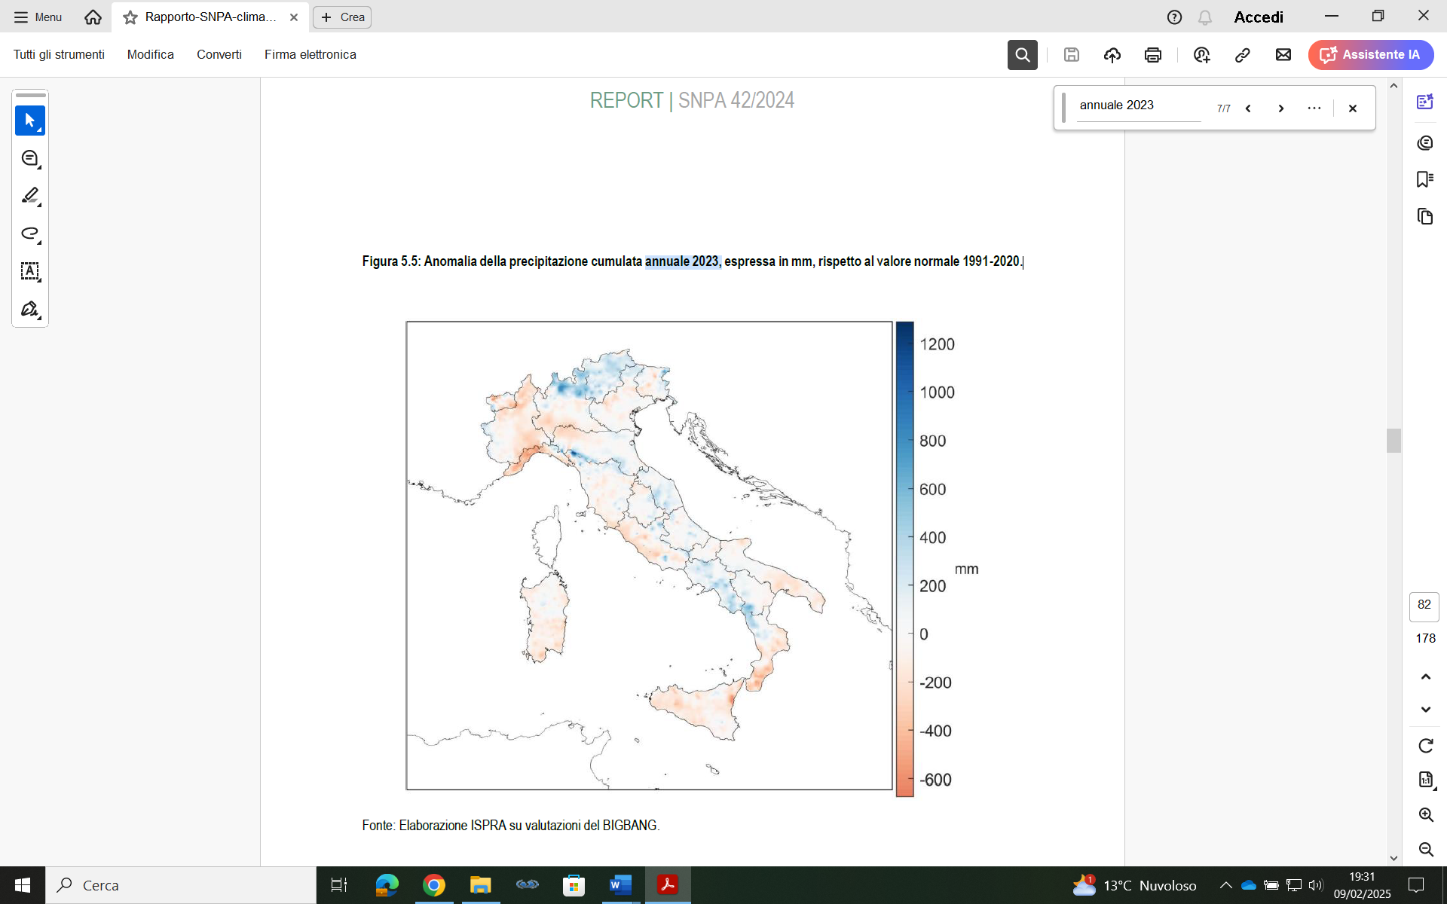  Figure 2. Anomaly of the cumulative annual precipitation 2023, expressed in mm, compared to the normal value 1991-2020. | 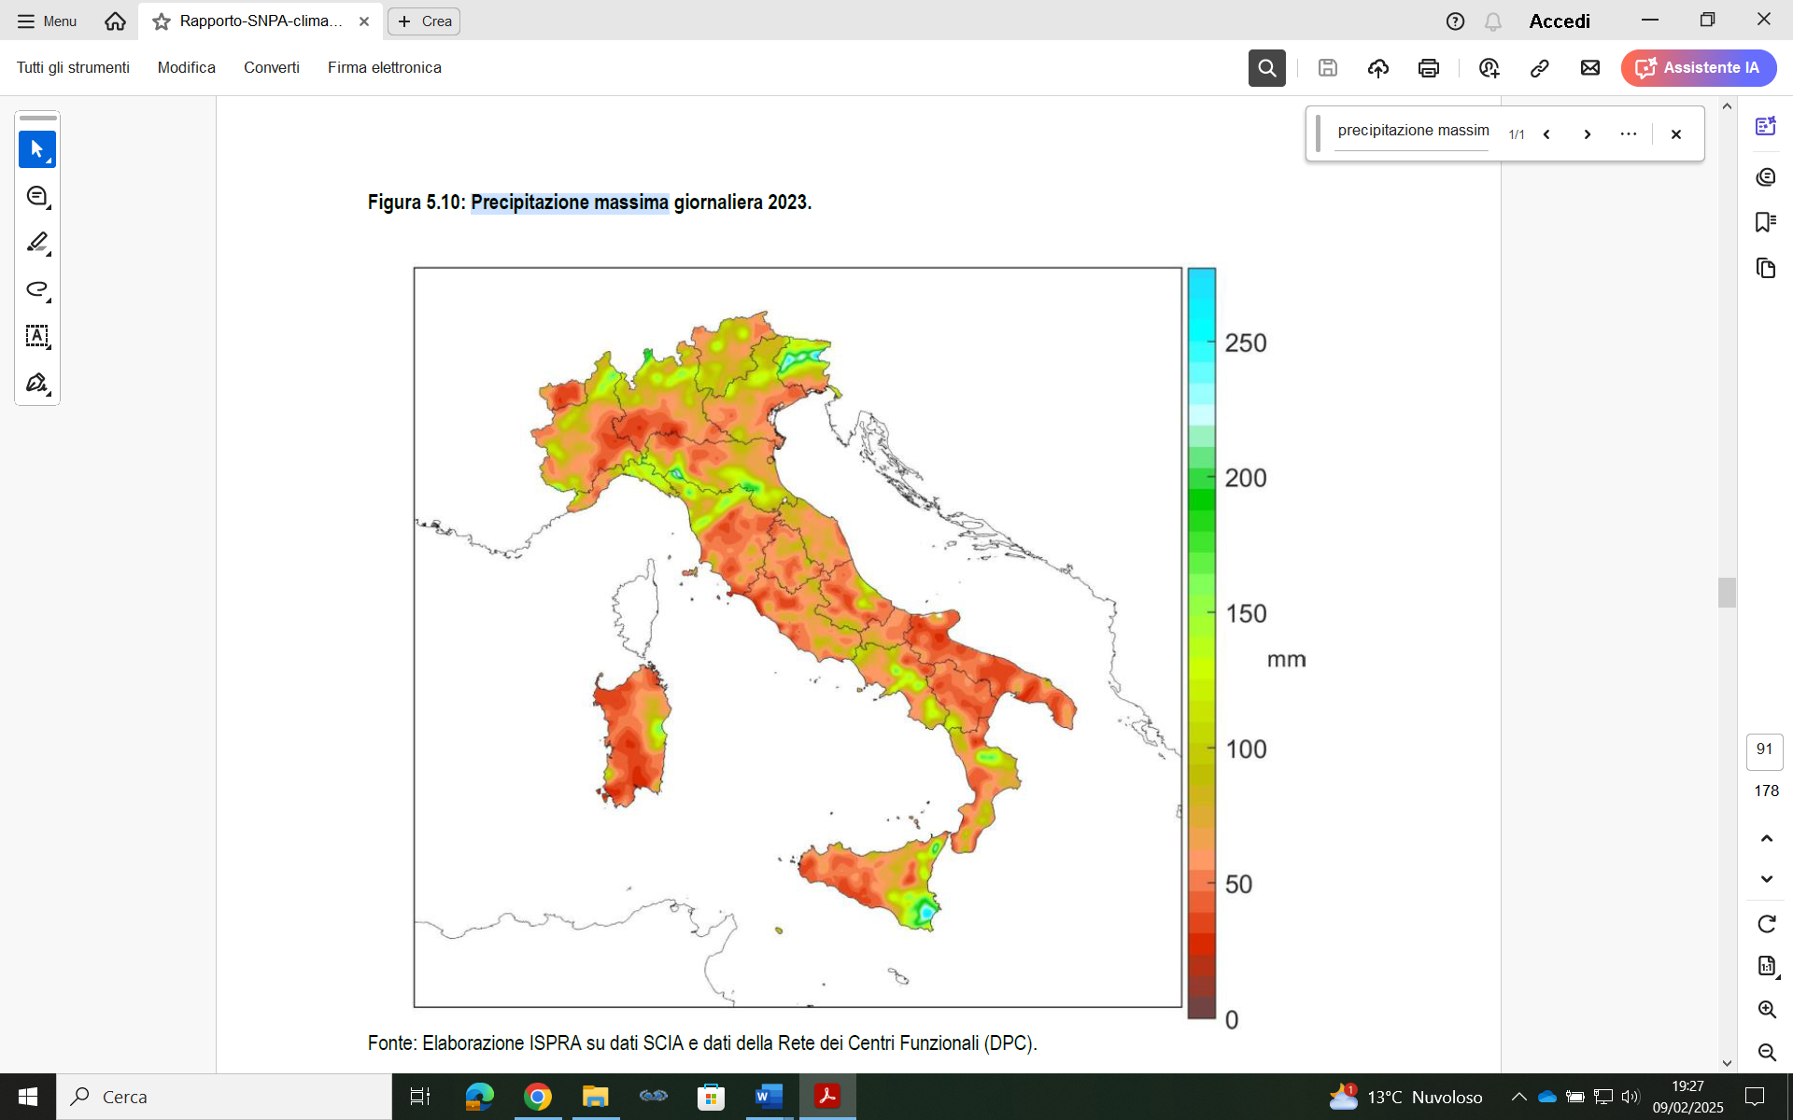  Figure 3. Maximum daily precipitation 2023.

Using Fig. 3 where the maximum daily precipitation in mm is reported for Italy, it is possible to determine the precipitation storm hazard index, I_{Hsp}. To calculate the value of this index, the authors, based on their experience, propose the following table 1:
Table 1. Relationship between daily maximum precipitation in mm and precipitation storm hazard index, I_{HsP}.
Maximum daily precipitation in mm | I_{Hsp}
< 50 | 1
≥ 50 < 100 | 2
≥ 100 < 150 | 3
≥ 150 | 4
Heavy rainfall impacts the safety of equipment containing hazardous substances, whether they work under pressure (vessels, reactors, etc.) or not under pressure (fuel storage tanks, etc.). It is necessary to identify and analyse equipment in order to define which are the critical elements of certain industrial plants (Muratore et al., 2022). Finally, it is necessary to define the vulnerability of critical elements that are at the basis of incidental events such as fires, explosions and releases into the environment (Muratore et al., 2024).
    - How to determine the wind storm hazard index, I_{Hsw}
To determine the index relating to strong wind, reference is made to the Italian Wind Atlas. It is a very useful resource resulting from the collaboration between ERSE (ENEA-Electrical System Research) and the University of Genoa, and can be easily viewed in interactive form. For Italy is reported below: the ground measurement stations of the wind atlas anemological database (Fig. 4) and the map of the average wind speed (Fig. 5),

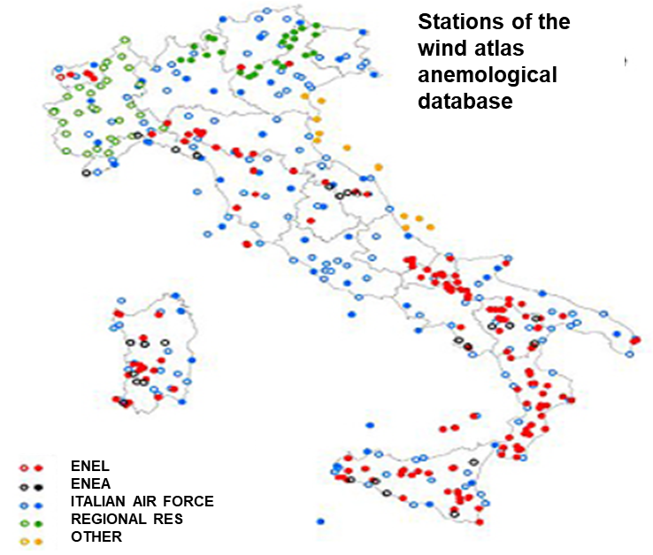  Figure 4. The ground measurement stations of the wind database of the Wind Atlas. | 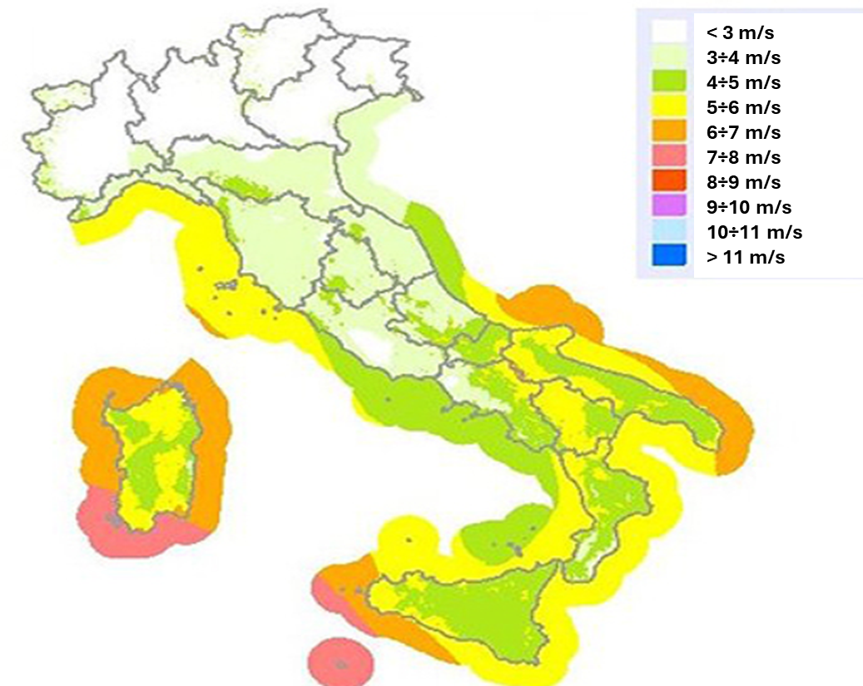  Figure 5. Map of the average wind speed at 25 meters above sea level and up to 40 km from the coast. (source: ERSE/University of Genoa).

Where ERSE means ENEA-Electrical System Research and ENEA means Italian National Agency for New Technologies, Energy and Sustainable Economic Development.
For a first preliminary evaluation of the wind index I_{Hsw}, it can be related to the average wind speed found in figure 5. To calculate the value of this index, the authors, based on their experience, propose the following table 2:
Table 2. Relationship between wind speed and the wind storm hazard index, I_{Hsw}.
Wind speed [m/s] | I_{Hsw}
< 3 | 1
≥ 3 < 5 | 2
≥ 5 < 7 | 3
≥ 7 | 4
    - How to determine the lightning storm hazard index, I_{Hsl}
Among the countries in the world that receive the most lightning strikes in absolute terms are Brazil and the United States, while Italy is among the European countries that receive the most lightning strikes per square kilometres on average. Today in Italy it is possible to determine the point of impact of a lightning strike with a precision of about 500 meters thanks to the SIRF (Italian Lightning Detection System) lightning detection system. For the analysis of the chronology of lightning events, you can refer to the CEI ProDisTM online application which is structured on data acquired from the SIRF monitoring network. This application provides information (indicated by the symbol Ng) that represents the average number of lightning strikes to the ground per year per Km² calculated using a grid with square cells with sides equal to 5 Km, based on lightning data collected in over ten years of observations throughout Italy. In relation to this, the manufacturer is able to determine the value of Ng for his establishment. The higher the Ng value, the greater the probability that lightning strikes the industrial site being assessed.
Using CEI ProDisTM online application it is possible to determine the lightning storm hazard index, I_{Hsl}. To calculate the value of this index, the authors, based on their experience, propose the following table 3:
Table 3. Relationship between Ng and lightning storm hazard index, I_{Hsl}.
Ng | I_{Hsl}
< 1 | 1
≥ 1 < 2.5 | 2
≥ 2.5 < 4 | 3
≥ 4 | 4
  - How to determine the storm vulnerability index, I_{Vs}
In industrial plants it is important to identify the vulnerability of critical equipment that is the basis for triggering natech events from storms. The risk analysis methodology used by the Seveso industry often resulted in scenarios related to Natech (Castro Rodriguez et al., 2023). Among the equipment with greater criticality in this work are considered those containing hazardous substances present in the process and storage industry: pressurized equipment, built according to Directive 2014/68/EU (PED – Pressure Equipment Directive) (spheres, columns, reactors, exchangers, tanks, ovens), atmospheric storage tanks (fixed or floating roof) and piping systems containing or conveying hazardous substances (pressurized or not). In Table 4 we relate the type of equipment containing hazardous substances with the storm vulnerability index "I_{Vs}". The latter is determined in a range from 1 to 4 in the light of the authors' experience in the field. The values must take into account the maintenance status of said critical equipment.
Table 4. Relationship between equipment containing hazardous substances and storm vulnerability index, I_{Vs}
Equipment type | Filling level | Construction features | I_{Vs}
Floating Roof Tanks | ≥50% / < 50% |  | 4 / 3
Fixed Roof Tank | ≥50 % / < 50% |  | 3 / 2
Pressure equipment (Spheres, columns, reactors, ovens, etc.) |  | before PED / according to PED | 3 / 2
Pipes under pressure  Pipes not under pressure |  | before PED / according to PED | 2 /1  1
  - How to determine the storm exposure index, I_{Es}
Exposure means the extent and severity of damage to receptors potentially affected by the effects of incidental events caused by storms (workers, population, environment, assets, infrastructures). As regards industrial structures (intended as buildings, parts of plants, equipment, pipelines, etc. or power lines connecting industrial plants). The analysis of Natech incidents triggered by storms can cause loss of containment, with the possibility of fire and/or explosion, if they contain combustible, flammable or explosive substances; due to alterations in processes caused by interruptions in electrical power and voltage drops and impacts on electrical and electronic control and safety systems, plants and devices. The consequences of damage and failures can extend to the surroundings, affecting other parts of the plant and in certain cases also affecting the surrounding environment (Domino Effects). In relation to the above, the authors propose to give the exposure index I_{Es} from storms the following values shown in table 5:
Table 5. Relationship between storm exposure type and storm exposure index, I_{Es}
Storm exposure type | I_{Es}
Only possible impacts that lead to the failure of equipment without loss of content of hazardous substances | 1
Possible impacts in the vicinity of the affected unit. There is no possibility of a domino effect (for example, a tank adjacent to other tanks) | 2
Possible impacts that may involve the entire plant | 3
Possible impacts that may involve the outside of the plant with the possibility of a domino effect | 4
  - Level of acceptability of natech risk from storms
Once the three factors that influence the level of natech risk from storms have been identified through the respective I_{Hs}, I_{Vs} and I_{Es} indices, it is possible to determine the natech risk index from storms I_{Rns} as per report (1) of paragraph 2 of this article. For I_{Rns} values up to 8, the risk is acceptable but appropriate prevention and protection actions must be planned over time. For values of I_{Rns} higher than 8 and lower than 32, the natech risk from storms must provide for urgent prevention and/or protection interventions such as to make it acceptable. For values of I_{Rns} greater than 32, the natech risk from storms is not acceptable.
  - Interventions in order to reduce the vulnerability of critical elements of natech risk from storms
In the case of newly built industrial plants, it is important to identify the installation site. In this way, you are able to manage the three factors that influence natech risk from storms: I_{Hs}, I_{Vs} and I_{Es}, bringing them to the lowest possible values. In the case of existing establishments, for the purposes of managing the natech risk from storms, only one factor can be acted upon, which is vulnerability I_{Vs}, while little can be done about the other two factors I_{Hs} and I_{Es} which depend on the location of the industrial site and the neighboring urban planning. The following are some (non-exhaustive) examples of how to reduce the vulnerability of Critical Industrial Plants from storms:
- Technical interventions: In this regard, place generators, pumps and control rooms above the hydrometric level that can normally be found from the time series that affect the plant. Provide for the installation of devices to ensure electrical continuity or to limit overvoltages, adopting protective measures to ensure that the path of lightning strikes is kept away from flammable and explosive substances, through preferential low-impedance routes, taking advantage of the characteristic of metals to be good conductors. Provide: a) appropriate anchoring of equipment and systems taking into account the wind speed of the site; b) special walls and diaphragms in order to prevent water from entering the production site from outside; c) special tanks for the collection of water coming from the yards and basins of the plant; etc.
- Maintenance, control and verification interventions: Appropriate maintenance and inspection of the protection systems from lightning risks must be provided, which includes the carrying out of tests and electrical continuity measurements; in fact, systems against atmospheric discharges tend to lose their effectiveness over time due to corrosion and damage due to environmental conditions, mechanical shocks and lightning strikes. Systematically clean any ducts that are located near the production site.
- Organisational interventions: Activate suitable weather alert systems. In this regard, prepare suitable procedures to be activated in time in order to make people and plants safe.
The above-mentioned interventions improve the resilience of individual industrial activities, both in terms of vulnerability of critical elements and in terms of exposure for settlements near the establishment.
  - Conclusions
The increase in the frequency and intensity of extreme weather events such as storms have a significant impact on industries and plants that contain hazardous chemicals, with the possibility of causing Natech events that involve fires, explosions and releases into the environment. All this leads to the involvement not only of the workers of these plants but also of the citizens who live in the vicinity of them. In the light of what has been highlighted in this article, a preliminary index method is introduced for the Italian production reality to determine the level of natech risk induced by storms in industrial activities. The purpose of this work is to give managers/employers indications regarding the adaptation to storms that are often accompanied by heavy precipitation, which can lead to flash floods, storm surges, strong wind and lightning. The proposed method can be applied to all geographical areas, provided that it is possible to determine the storm hazard index, I_{Hs} for the single area. This is possible if are available: a) Maximum daily precipitation in mm, b) Wind speed in m/s, c) The average number of lightning strikes to the ground per year per Km², for each single area. The other two indices storm vulnerability index, I_{Vs} and storm exposure index, I_{Es} are not influenced by the geographical area.
References
Canessa A., 2021, Storm naming, Rivista di Meteorologia Aeronautica Militare N.4 OTT/DIC 2021, p. 34-43.
Castro Rodriguez D.J., Pilone E., Camuncoli G., Demichela M., 2023, Implementation of a Natech Vulnerability Index in a Seveso Plant, Chemical Engineering Transactions, 100, 43-48 DOI:10.3303/CET23100008.
European Union, 2012, Directive 2012/18/EU of the European Parliament and of the Council of 4 July 2012 on the control of major-accident hazards involving dangerous substances, amending and subsequently repealing Council Directive 96/82/EC (SEVESO III), Official Journal of the European Union, L197, p.1-37.
European Union, 2014, Directive 2014/68/EU of the European Parliament and of the Council of 15 May 2014 on the harmonization of the laws of the Member States relating to the making available on the market of pressure equipment (recast), Official Journal of the European Union, N. 189, 27.6.2014, p. 164–259.
IPCC, 2022: Climate Change 2022: Impacts, Adaptation and Vulnerability. Contribution of Working Group II to the Sixth Assessment Report of the Intergovernmental Panel on Climate Change [H.-O. Pörtner, D.C. Roberts, M. Tignor, E.S. Poloczanska, K. Mintenbeck, A. Alegría, M. Craig, S. Langsdorf, S. Löschke, V. Möller, A. Okem, B. Rama (eds.)]. Cambridge University Press. Cambridge University Press, Cambridge, UK and New York, NY, USA, 3056 pp., DOI:10.1017/9781009325844.
Muratore A., Giannelli G., Nastasi V., Sferruzza G., Grillone G., Delle Site C., 2022, Flood risk identification and analysis for pressure equipment. Proceedings of 32nd European Safety and Reliability Conference, Dublin, Ireland, 28 August - 1 September 2022, ESREL2022 Organizers, pp. 885-890. Published by Research Publishing, Singapore. ISBN: 978-981-18-5183-4. DOI: 10.3850/978-981-18-5183-4_R17-03-059-cd.
Muratore A., Grillone G., Delle Site C., Giannelli G., Nastasi V., 2024, Natech Risk from Floods. Vulnerability of Critical Technical Systems Containing Hazardous Substances, Chemical Engineering Transactions, 111, 559-564 DOI:10.3303/CET24111094.
Necci A., Krausmann E., Natech risk management – Guidance for operators of hazardous industrial sites and for national authorities, EUR 31122 EN, Publications Office of the European Union, Luxembourg, 2022, ISBN: 978-92-76-53493-8. DOI: 10.2760/666413, JRC129450.
SNPA Report 42/2024, The climate in Italy in 2023, ISBN 978-88-448-1217-1.

