|  |  |
| --- | --- |
| cetlogo ***CHEMICAL ENGINEERING TRANSACTIONS***  ***VOL. xxx, 2025*** | A publication of  aidiclogo_grande |
| The Italian Association  of Chemical Engineering  Online at www.cetjournal.it |
| Guest Editors: David Bogle, Flavio Manenti, Piero Salatino  Copyright © 2025, AIDIC Servizi S.r.l. **ISBN** 979-12-81206-21-2; **ISSN** 2283-9216 | |

**Dark fermentation process by *Thermotoga neapolitana*: effect of sugar substrates**

Fabiana Lanzillo, Genadi A. Atanasov, Francesca Raganati\*, Piero Salatino, Antonio Marzocchella

Università degli Studi di Napoli Federico II, P. le V. Tecchio 80, 80125 Napoli, Italy

francesca.raganati@unina.it

Significant efforts have been made in recent years to develop alternative energy vectors to reduce fossil fuel resource use, greenhouse gas emissions, and the release of harmful particulates. Among the alternative vectors, hydrogen (H2) is a promising option for achieving carbon neutrality because its combustion produces only water. Moreover, H2 is considered an excellent candidate for energy applications owing to its high heating value and high-octane number. H2 production can occur through dark fermentation, a biotechnological process that uses anaerobic bacteria to generate H₂ and by-products (such as volatile fatty acids and CO₂) from organic substrates. Specifically, the bacterium Thermotoga neapolitana efficiently converts carbohydrates into biogas, producing approximately four molecules of H2 and acetic acid per mole of consumed glucose. This study focuses on optimizing the dark fermentation process with T. neapolitana, analysing the effects of various substrates (monosaccharides and disaccharides) on bacterial growth and the production of H₂ and acetic acid. The results indicated that T. neapolitana grew on all tested substrates, with fructose yielding the highest amount of H2 and mannose yielding the highest amount of acetic acid.

* 1. Introduction

Recently, significant efforts have been made to develop energy vectors as alternatives to fossil-based energy vectors. The shift from fossil fuels to alternative resources is driven by the progressive energy independence of countries and awareness of environmental risks related to the exploitation of fossil resources. Fossil resource exploitation is the primary cause of increased greenhouse gas (GHG) emissions. The release of carbon dioxide (CO₂) and harmful particulates into the environment poses serious environmental and health risks (Yasin et al., 2014). The exploitation of alternative resources has gained increasing attention, with H2 emerging as one of the most promising options for achieving carbon neutrality goals (Zehao et al., 2023).

H2 is widely considered to be an ideal energy source because of its clean combustion properties. The only theoretical by-product of H2 combustion is non-polluting water, which can be electrolyzed to produce additional H2. Furthermore, H2 has a high calorific value and octane number (Zehao et al., 2023).

Several methods are currently available for H2 production. The most widely used method is steam methane reforming (SMR), which involves extraction, treatment (compressed and purified), and conversion into H2 and CO2 (Zhang et al., 2021). Another technique is coal gasification (CG), which involves processing raw materials with air and steam at high temperatures (700–900°C) to produce syngas mainly composed ofH2, CO, and CO₂. Electrolysis is the process of splitting water into H2 and oxygen by pumping electrical power.

Dark fermentation (DF) is a promising biological process for H2 production. This technique converts organic substrates under anaerobic conditions into H2 and other by-products such as volatile fatty acids, alcohols, and gases (including CO₂) (Saravanan et al., 2021). Unlike photofermentation, dark fermentation does not require light (Liu et al., 2020) but uses carbon as an energy source. One microorganism of particular interest for biological H2production is Thermotoga neapolitana, which is found in Lucrino (Italy). It is a Gram-negative, rod-shaped, non-sporulating, facultative anaerobic, thermophilic bacterium with an optimal growth temperature of 75°C (Belkin et al., 1986).

The choice of the carbon source significantly influences the efficiency of dark fermentation, affecting bacterial growth, substrate utilization, and product yields (Ngo et al., 2012; Pradhan et al., 2015). Although *T. neapolitana* is known for its ability to metabolize various sugars, a systematic comparison of its fermentation performance across multiple substrates is still lacking. Understanding these effects is essential for optimizing hydrogen production and bioprocess sustainability (Dipasquale et al., 2014).

This study addressed this gap by evaluating the growth kinetics, hydrogen yield, and acetic acid production of *T. neapolitana* using six different sugar substrates under identical conditions. The presented findings provide insights into the substrate-specific performance and contribute to the development of more efficient biohydrogen production strategies.

* 1. Materials and methods
     1. Microorganism and culture media

*Thermotoga neapolitana* DSM 4359 was supplied by Deutsche Sammlung von Mikroorganismen und Zellkulturen -DSMZ- (Braunschweig, Germany). Cultures were stored in a refrigerator at 4°C in bottles of 100 mL loaded with 50 mL of anaerobic medium, according to d’Ippolito et al. (2010). The strain was then transferred to a static oven at 75°C for 24 h for acclimation. Acclimated pre-cultures were used to inoculate batch reactors. The tests were performed in triplicates (biological replicates) to ensure reproducibility.

The composition of the standard fermentation medium is listed in Table 1. The chemicals were obtained from Merck KGaA (Darmstadt, Germany).

Table 1: Fermentation medium

|  |  |  |  |  |  |
| --- | --- | --- | --- | --- | --- |
| **Fermentation medium** | | **Vitamin solution\*** | | **Metal solution\*** | |
| **Compound** | **Concentration**  **g/L** | **Compound** | **Concentration,**  **mg/L** | **Compound** | **Concentration,**  **g/L** |
| NaCl | 10 | Biotin | 2 | Nitrilotriacetic acid | 1.5 |
| KCl | 0.1 | Folic acid | 2 | MgSO4 x 7 H2O | 3 |
| MgCl2 6H2O | 0.2 | Pyridoxine hydrochloride | 10 | MnSO4 x H2O | 0.5 |
| NH4Cl | 1 | Thiamine HCl | 5 | NaCl | 1 |
| K2HPO4 | 0.3 | Riboflavin | 5 | FeSO4 x 7 H2O | 0.1 |
| KH2PO4 | 0.3 | Nicotinic acid | 5 | CoSO4 x 7 H2O | 0.18 |
| CaCl2 2H2O | 0.1 | Calcium D-(+)-pantothenate | 5 | CaCl2 x 2 H2O | 0.1 |
| Cysteine HCl | 1 | Vitamin B12 | 0.1 | ZnSO4 x 7 H2O | 0.18 |
| Yeast extract | 2 | p-Aminobenzoic acid | 5 | CuSO4 x 5 H2O | 0.01 |
| Tryptone | 2 | (DL)-alpha-Lipoic acid | 5 | AlK(SO4)2 x 12 H2O | 0.02 |
| Vitamin solution | 10\* |  |  | H3BO3 | 0.01 |
| Metal solution | 10\* |  |  | Na2MoO4 x 2 H2O | 0.01 |
| Sugar | 5 |  |  | NiCl2 x 6 H2O | 0.03 |
|  |  |  |  | Na2SeO3 x 5 H2O | 0.0003 |
|  |  |  |  | Na2WO4 x 2 H2O | 0.0004 |

\*mL/L for the vitamin and metal solutions.

* + 1. Batch tests

Fermentation tests were carried out in 100 mL serum bottles. The medium (50 mL) was loaded into the bottles and boiled for 10 min. During cooling, N2 was sparged into the bottles to provide an anaerobic environment. The pH was tuned to 7.5 with 1 M NaOH or 0.5 M HCl. The bottles were sealed with Viton caps, capped with aluminium crimpers, and autoclaved for 20 min at 121°C. Vitamin, metal, and sugar substrate solutions were supplemented before inoculation and the cultures were incubated at 75°C.

The sugars used as carbon/energy sources during the fermentation tests were hexose monosaccharides (glucose, fructose, and mannose), pentose monosaccharides (xylose and arabinose), and disaccharides ( sucrose). The sugar concentration was set at 5.0 ± 0.5 g/L.

Fermentation tests were carried out under pH control for two weeks. The pH was adjusted periodically to approximately 6 to ensure optimal conditions for microorganism growth. Tests were also carried out with sucrose in the fermentation medium without T. neapolitana under the typical operating conditions set for the fermentation tests. The aim was to assess the spontaneous hydrolysis of sucrose.

* + 1. Analytical methods

1 mL of the culture was sampled daily from the fermentation bottles. Each culture was characterized in terms of cell concentration, acetic acid production, and sugar consumption.

The optical density (ODλ) of the samples was measured at 600 nm using a UV–visible spectrophotometer (SPECORD 50 UV-VIS; Analytik Jena, Jena, Germany). The biomass concentration (gDM/L) was assessed by processing the measured absorbance according to a calibration curve (1 OD = 0.4 gDM/L).

The samples were centrifuged (13,000 rpm, 10 min) using a centrifuge (MiniSpin®, Eppendorf Italia, Milan, Italy) before measuring the concentration of the water-soluble products. The concentrations of acetic acid and sugars were measured using an HPLC system (HP1100, Agilent Co., Santa Clara, CA, USA), equipped with Rezex™ RHM-Monosaccharide H+ (8%), 300 × 7.8 mm, and a RID detector at room temperature. The mobile phase was water, fed at 0.6 a flow rate.

Gas samples (3 mL) were periodically collected from the batch bottles to monitor the H2 and CO2 concentrations. The gas composition was measured using a gas chromatograph (GC, HP6890, Agilent Co., Santa Clara, CA, USA) equipped with a thermal conductivity detector (TCD). The GC was fitted with a 15-mHP-PLOT Molecular Sieve 5A column (Internal Diameter, 0.53 mm; film thickness, 50 μm) (Sigma Aldrich, Milan, Italy). The pressure in the fermentation bottles was measured using a pressure manometer (Keller), before and after each gas sampling.

* + 1. Fermentation performances

Tests were performed in triplicate to support reproducibility. The results presented in the figures/tables and throughout the paper are mean values ± standard deviation.

Batch performance was assessed in terms of the sugar conversion degree (ƐS), maximum biomass concentration (X), final acetic acid concentration, yield metabolite on the substrate (YPi/S), fraction of H2 in the reactor headspace, amount of H2 produced, and specific growth rate (μ). The total amount of produced H2 by *T. neapolitana* was assessed by considering the H2 concentration and pressure of the gaseous phase in the fermentation vessel.

* 1. Results

The aim of the present study was to assess the effects of different types of substrates on *T. neapolitana* growth and on the production of acetic acid and H2. Batch fermentations were conducted in 100 mL bottles filled with 50 mL of culture media.

* + 1. Fermentation performances using sucrose

The fermentation of *T. neapolitana* with sucrose as substrate exhibited immediate microbial growth without a detectable lag phase, indicating efficient adaptation to the medium (Figure 1A). However, sucrose consumption did not begin immediately; instead, its conversion into glucose and fructose was observed after approximately 50 h (Figure 1B). This suggests that *T. neapolitana* primarily metabolizes the hydrolysis products rather than sucrose itself, likely due to limited expression or activity of extracellular sucrose-hydrolyzing enzymes under the tested conditions.

Figure 1: Data measured during T. neapolitana batch fermentation in standard medium supplemented with sucrose (nominal initial concentration: 5 g/L), A) concentration of cells and pH; B) concentration of sugars.

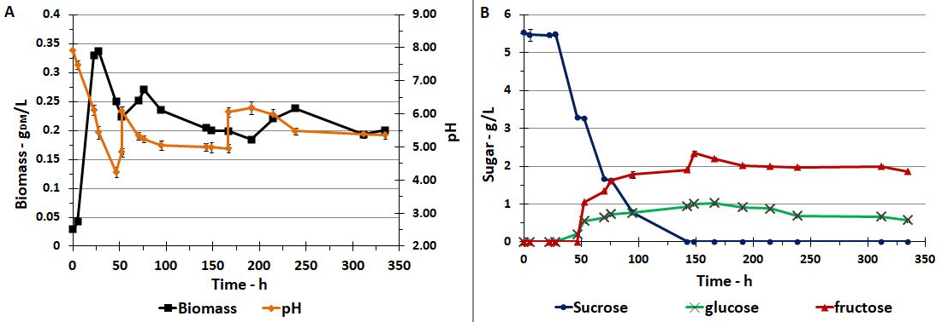

A rapid decrease in pH was observed during fermentation, coinciding with the accumulation of acetic acid (data not shown) and the onset of cell aggregation (Figure 1A). The formation of aggregates at low pH suggests a microbial stress response, which may enhance survival by protecting cells from acidic conditions, a phenomenon previously reported in other fermentative bacteria (Dipasquale et al., 2014). The immediate resumption of cell growth following pH adjustments further supports this hypothesis, indicating that *T. neapolitana* remains viable but experiences temporary metabolic inhibition under acidic conditions.

Figure 1B shows that fructose accumulated in the medium in higher concentrations than glucose after sucrose hydrolysis. This suggests that *T. neapolitana* preferentially uptakes glucose, a trend consistent with previous studies on thermophilic anaerobes, where glucose transport systems exhibit higher affinity compared to those for fructose (Ngo et al., 2012). Since glucose and fructose enter metabolic pathways differently, this differential uptake could influence fermentation performance, particularly H2 and acetic acid production. As previously reported for extreme thermophiles, carbon source availability can alter the metabolic flux distribution, leading to variations in hydrogen yields (Pradhan et al., 2015).

To confirm whether hydrolysis occurred spontaneously or was enzymatically driven, additional tests were performed by incubating sucrose-supplemented medium under sterile conditions at different pH levels (Figure 2). The results indicated that spontaneous hydrolysis was negligible at pH 7.0, but became significant at pH 4.5, reaching approximately 78% conversion after 188 h. By comparing these findings with Figure 1B, it can be inferred that at the beginning of fermentation (when the pH remained between 7 and 6), hydrolysis was primarily enzymatic, driven by glycosidic enzymes secreted by *T. neapolitana*. However, at lower pH levels, spontaneous hydrolysis likely contributes to sucrose breakdown, further altering the substrate composition.

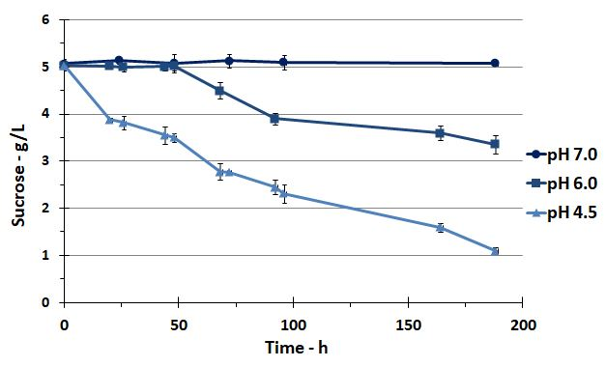

Figure 2: Natural hydrolysis of sucrose at high temperature (75°C) and at different pH (4.5, 6.0, 7.0)

* + 1. Fermentation performances using fructose

The results of typical fermentation of *T. neapolitana* using fructose as the substrate are shown in Figure 3. The analysis of Figures 3A and 3B indicates that microorganism growth begins upon inoculation: no lag phase was present. The maximum biomass concentration was achieved within the initial 50 h of fermentation. The reduction in pH induces the formation of cell aggregates responsible for multiple peaks in the microbial growth profile. Indeed, the free cell concentration was underestimated when the aggregates were formed.

The synthesis of H₂ by *T. neapolitana* was strongly associated with acetic acid formation (Pradhan et al., 2019), as evidenced by the immediate onset of gas generation following inoculation (data not shown). The microorganism produced H₂ throughout the batch fermentation process, and the concentration in the reactor headspace was 44.7% H₂ at the end of the test (Table 2). The production of H₂ was 0.0024 mol.

Figure 3: Data measured during T. neapolitana batch fermentation in standard medium supplemented with fructose (nominal initial concentration: 5 g/L), A) concentration of cells and pH; B) concentration of acetic acid and fructose.

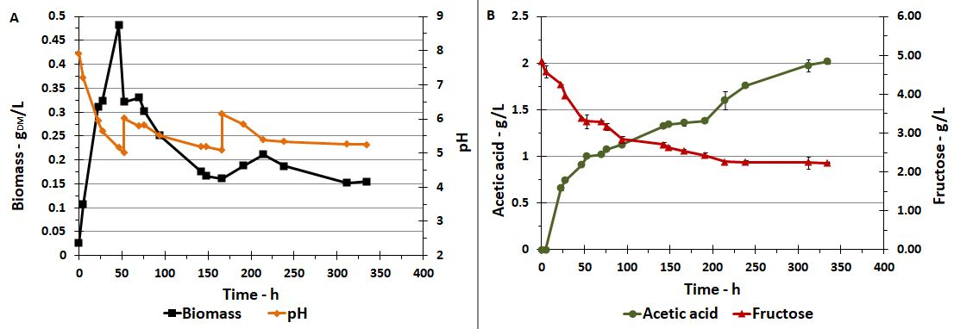

* + 1. Substrate effects on the growth and production

Table 2 reports the fermentation performance of *T. neapolitana* assessed for fermentation tests carried out with the investigated sugars. Analysis of the data in Table 2 confirmed that the microorganism grew and produced acetic acid and H2when the investigated sugars were used as substrates. Scientific papers in the literature have documented the versatility of other species within the *Thermotogales* family and their capacity to grow using several sugars as substrates. Chhabra et al. (2003) reported the ability of *Thermotoga maritima* to utilize monosaccharides, disaccharides, and polysaccharides. Furthermore, Ngo et al. (2012) reported the ability of *T. neapolitana* to utilize pentose sugars.

The production of acetic acid exhibited comparable maximum concentrations when glucose and xylose were used as substrates. In contrast, fructose and sucrose yielded approximately 13% higher concentrations, whereas arabinose and mannose showed substantial increases of 27% and 40%, respectively. Regarding cellular growth, fructose emerged as the most effective substrate, promoting the highest cell density, whereas sucrose resulted in the lowest cellular density among the substrates examined.

The specific growth rate (μ) was almost independent of the sugar (approximately 0.7 h-1), which was slightly lower than that of arabinose.

H2 production was characterized by a more pronounced disparity. Glucose and xylose yielded the highest H2 concentrations, 66.4% and 63.0% of the batch reactor gas content, respectively. When fructose and sucrose were used, the H2 concentration of the disaccharide substrates decreased to 32 %. Among the substrates examined, arabinose yielded the highest H2 production (0.0026 mol).

Table 2: Maximum cell concentration (XMAX), acetic acid and H2 concentrations, production yield, and specific growth rate ($μ$). The experiments were performed in batches at 75 °C using different sugar substrates at a concentration of 5 g/L.

|  |  |  |  |  |  |  |  |  |  |  |
| --- | --- | --- | --- | --- | --- | --- | --- | --- | --- | --- |
| **Sugar (5 g/L)** | **XMAX**  **gDM/L** | **Acetic acid mg/L** | **H2**  **%** | **h-1** | **ƐS**  **%** | **Tot H2**  **mol** | **YAA/S**  **g/g** | **YH2/S**  **g/g** | **YX/S**  **g/g** |  |
| **Glucose** | 0.38 | 1810 | 66.4 | 0.76 | 75.8 | 0.0022 | 0.44 | 0.021 | 0.091 |  |
| **Xylose** | 0.35 | 1830 | 64.0 | 0.72 | 94.1 | 0.0014 | 0.42 | 0.013 | 0.084 |  |
| **Fructose** | 0.43 | 2010 | 44.7 | 0.70 | 53.8 | 0.0024 | 0.82 | 0.036 | 0.17 |  |
| **Sucrose** | 0.34 | 2060 | 58.5 | 0.66 | 56.0 | 0.0022 | 0.66 | 0.028 | 0.11 |  |
| **Arabinose** | 0.36 | 2300 | 49.8 | 0.51 | 85.9 | 0.0026 | 0.74 | 0.031 | 0.12 |  |
| **Mannose** | 0.38 | 2540 | 50.7 | 0.68 | 67.8 | 0.0024 | 0.93 | 0.035 | 0.14 |  |

The analysis of the data reported in Table 2 also indicates that fructose consistently outperformed the other substrates in many performance indicators. Among the tested substrates, fructose exhibited the highest biomass production and one of the highest H2 yield. This can be attributed to the efficient transport and metabolism of *T. neapolitana*. Unlike glucose, which is typically internalized via a phosphotransferase system (PTS), fructose may be taken up through facilitated diffusion or a different transport mechanism that reduces ATP consumption, allowing for more energy-efficient conversion into cellular components (Ngo et al., 2012). Additionally, fructose metabolism in thermophilic bacteria has been reported to follow a slightly different glycolytic pathway, potentially optimizing electron flux toward hydrogenogenesis rather than alternative fermentation products (Pradhan et al., 2015).

Nevertheless, this behavior is not in agreement with the results reported by De Vrije et al. (2009). They reported divergent results in their investigation of *T. neapolitana* and *Caldicellulosiruptor saccharolyticus* fermentative capabilities when utilizing Miscanthus crop hydrolysates containing glucose and fructose. They observed more favorable outcomes in terms of H₂ and acetic acid production when only glucose was present. This discrepancy could be attributed to the different fermentation conditions. The bacteria were cultured at higher temperatures (80°C) with sugar concentrations twice as high as those used in the present study. Therefore, further investigation is required.

* 1. Conclusions

The effects of different substrates on the growth and fermentation performance of *T. neapolitana* were also tested. Experiments were successfully carried out using hexose monosaccharides (glucose, fructose, and mannose), pentoses (xylose and arabinose), and disaccharides (sucrose). The tests were performed at an initial concentration of 5 g/L. The results indicated that *T. neapolitana* could grow and produce acetic acid and H2 using all substrates investigated. The highest biomass concentration was obtained in the presence of fructose, with a value of 0.43 gDM/L. However, 2540 g/L of acetic acid was obtained only with mannose, while the maximum amount of H2 produced using arabinose was 0.0026 mol.

No sugar was able to maximize all fermentation parameters of growth and production. However, fructose emerged as the most interesting substrate, as it allowed for the highest yields of biomass and H2 production, with values of 0.17 and 0.036 g/g, respectively.

Acknowledgments

This study has been funded by INAIL: Progetto “Processi innovativi biologici e bio-elettrochimici per la produzione di idrogeno da matrici organiche di scarto”, Bando BRiC-INAIL, 2022, Convenzione per la realizzazione del progetto di cui alla tematica ID 64 “Salute e sicurezza nella produzione di biocombustibili dalle biomasse mediante modelli di economia circolare”, Repertorio n. 159/2023, Prot n. 102738 del 03/05/2023, CUP H73C22001670005.

References

Belkin S., Wirsen C.O., Jannasch H.W., 1986, A new sulfur-reducing, extremely thermophilic eubacterium from a submarine thermal vent, Appl Environ Microbiol. 51(6):1180-1185.

Chhabra S.R., Shockley K.R., Conners S.B., Scott K.L., Wolfinger R.D., Kelly R.M., 2003, Carbohydrate-induced differential gene expression patterns in the hyperthemophilic bacterium Thermotga martima. Journal of Biological Chemistry, 278(9): 7540-7552.

Dipasquale L., d'Ippolito G., Fontana A., 2014, Capnophilic lactic fermentation and hydrogen synthesis by Thermotoga neapolitana: An unexpected deviation from the dark fermentation model, International Journal of Hydrogen Energy, 39(10): 4857-4862.

de Vrije T., Bakker R.R., Budde M.A.W., Lai M.H. Mars A.E., Claassen P.A.M., 2009, Efficient hydrogen production from the lignocellulosic energy crops Miscanthus by the extreme thermophilic bacteria Caldicellulosiruptor saccharolyticus and Thermotoga neapolitana. Biotechnology for Biofuel, 2(12)

d'Ippolito G., Dipasquale L., Vella F.M., Romano I., Gambacorta A., Cutignano A., Fontana A., 2010, Hydrogen metabolism in the extreme thermophile Thermotoga neapolitana, Int. J. Hydrogen Energy 35: 2290-95.

Liu Y., Min J., Feng X., He Y., Liu J., Wang Y., He J., Do H. Sage V., Yang G., 2020, A Review of Biohydrogen Productions from Lignocellulosic Precursor via Dark Fermentation: Perspective on Hydrolysate Composition and Electron-Equivalent Balance. Energies 13(10): 2451.

Ngo T.A., Kim M.S., Sim S.J., 2011, Thermophilic hydrogen fermentation using Thermotoga neapolitana DSM 4359 by fed-batch culture, International Journal of Hydrogen Energy, 36(21): 14014-14023.

Ngo T.A., Nguyen T.H., Viet Bui H.T., 2012, Thermophilic fermentative hydrogen production from xylose by *Thermotoga neapolitana* DSM 4359. Renewable Energy 37(1): 174-179.

Pradhan N., D’Ippolito G., Dipasquale L., Esposito G., FontanaA., 2015, Hydrogen production by the thermophilic bacterium Thermotoga neapolitana. International Journal of Molecular Sciences, 16(6): 12578-12600.

Saravanan A., Senthil Kumar P., Khoo K.S., Show P.L., Femina Carolin C., Fetcia Jackulin C., Jeevanantham S., Karishma S., Show K.Y., Lee D.J., Chang J.S.,2021, Biohydrogen from organic wastes as a clean and environment-friendly energy source: Production pathways, feedstock types, and future prospects. Bioresour Technol., 342: 126021.

Yasin M., Jeong Y., Park S., Jeong J., Lee E.Y., Lovitt R.W., Kim B.H., Lee J., 2014, Chang I.S., Microbial synthesis gas utilization and ways to resolve kinetic and mass-transfer limitations. Bioresource Technology, 177: 361-374.

Zehao S., Jichao H., Tiezhu Z., Binbin S., Binbin Y., Liqun L., Lin L., Kaiwei W., 2023, Hydrogen engine operation strategies: Recent progress, industrialization challenges, and perspectives. International Journal of Hydrogen Energy, 48(1): 366-392.

Zhang H., Sun Z., Hu Y.H., 2021, Steam reforming of methane: Current states of catalyst design and process upgrading. [Renewable and Sustainable Energy Reviews](https://www.sciencedirect.com/journal/renewable-and-sustainable-energy-reviews), [149](https://www.sciencedirect.com/journal/renewable-and-sustainable-energy-reviews/vol/149/suppl/C): 111330.