|  |  |
| --- | --- |
| cetlogo ***CHEMICAL ENGINEERING TRANSACTIONS***  ***VOL. xxx, 2025*** | A publication of  aidiclogo_grande |
| The Italian Association  of Chemical Engineering  Online at www.cetjournal.it |
| Guest Editors: David Bogle, Flavio Manenti, Piero Salatino  Copyright © 2025, AIDIC Servizi S.r.l. **ISBN** 979-12-81206-21-2; **ISSN** 2283-9216 | |

Techno-economic analysis of cryogenic carbon capture for cement decarbonisation

Leonardo Varnier, Davide Rubinaccio, Fabrizio Bezzo, Federico d’Amore\*

CAPE-Lab – Computer-Aided Process Engineering Laboratory, Department of Industrial Engineering, University of Padova, via Marzolo 9, 35131 Padova PD (Italy)

federico.damore@unipd.it

The increasing concern over climate change due to global warming has intensified efforts to reduce CO2 emissions into the atmosphere, with a particular emphasis on carbon removal technologies, including carbon capture. While much of the current research and applications focus on well-established methods, such as solvent-based capture, cryogenic CO2 separation techniques present several advantages. These include the ability to operate solely on electricity, ideally supplied by renewables, along with high capture rates and CO2 purity. This study assesses a cryogenic carbon capture process for separating the CO2 from the flue gases of a coal-fired cement plant. The process is investigated from a techno-economic standpoint by evaluating the capital and operative costs, and by calculating its key performance indicators. Simulation results estimate an energy penalty of 1.14 MJel/kgCO2 and a CO2 avoidance cost of 118.2 €/tCO2, which would make cryogenic capture less energy-intensive and potentially more cost-effective than conventional solvent-based methods.

* 1. Introduction

The accumulation of greenhouse gases in the atmosphere, particularly carbon dioxide (CO2), has a detrimental effect on climate change. Cement production is responsible for 7 % of global CO2 emissions, making this sector the second largest industrial emitter after steel (Marmier, 2023). The carbon footprint of cement averages 0.59 tons of CO2 per ton of cement, varying by production technologies, fuel mixes, efficiency measures and cement types (Ferrario et al., 2023). As most of the CO2 emissions derive from the calcination process for producing clinker, i.e., the main constituent of cement, the implementation of decarbonisation strategies other than carbon capture is insufficient to mitigate the environmental impact of these plants. Therefore, carbon capture technologies are key for addressing the process-related emissions of cement plants (Varnier et al., 2024). Among the various options to abate such CO2 (e.g., chemical absorption, membranes, calcium-looping), cryogenic capture is gaining scientific interest due to the following potential advantages (Asgharian et al., 2025): (*i*) low energy consumption; (*ii*) high capture rate (potentially larger than 95 %) and purity (greater than 99.5 %), indicating that this process can meet stringent CO2 requirements without additional downstream equipment; and (*iii*) high flexibility and retrofittability to (small-to-large) existing plants.

Cryogenic separation is based on capturing CO2 from flue gases in the solid phase through direct contact with a low-vapour-pressure hydrocarbon. This process exhibits a good performance in terms of energy requirements due to its high potential for heat integration. Jensen et al. (2015) evaluated the performance of cryogenic CO2 capture from a 550 MW coal-fired power plant, reporting an energy penalty between 0.71 and 0.92 MJel/kgCO2. This result was confirmed by Hoeger et al. (2021), who demonstrated that cryogenic capture could abate the CO2 from coal-fired power plants with an energy penalty of 0.89 MJel/kgCO2, significantly lower than other technologies investigated in their study. In the cement sector, Asgharian et al. (2025) investigated the integration of cryogenic capture with a water-ammonia absorption refrigeration cycle, achieving an energy penalty below 0.70 MJel/kgCO2. Despite the potential benefits, cryogenic CO2 capture is still in the early stages of development and faces several technical challenges. Furthermore, limited data are available on its techno-economic feasibility for cement plant decarbonisation. To address these aspects, this work proposes a techno-economic analysis of cryogenic carbon capture applied to cement plant flue gas, benchmarking its performance (i.e., energy demands and costs) against conventional carbon capture options.

* 1. Materials and methods

The cryogenic CO2 capture plant, illustrated in Figure 1, was simulated in Aspen Plus V14.0 (AspenTech, 2025) according to the following assumptions: (*i*) pollutants such as SOx, NOx, HCl, CO and H2S are excluded; (*ii*) the inlet flue gas composition aligns with Varnier et al. (2025) for a coal-fired cement plant producing 1 Mt clinker annually (Table 1); (*iii*) a baseline 90 % CO2 capture rate is set, to facilitate the comparison with other capture technologies; (*iv)* compressors and blowers operate at 90% and 85% polytropic efficiency, respectively, while pumps have an isentropic efficiency in the range of 70-85%; (*v*) electrical-to-mechanical efficiency is 95%; (*vi*) minimum pinch temperatures are 5 °C (intercoolers, liquid-liquid exchangers), 10 °C (gas-liquid exchangers), and 2 °C (multi-stream heat exchanger); and (*vii*) cooling water is available at 25 °C and returns at 35 °C. Accurate prediction of solid CO2 formation requires robust solid-vapour equilibrium calculations. For this purpose, the Peng-Robinson cubic equation of state was selected due to its proven accuracy and effectiveness in solid-vapour equilibrium predictions for CO2 (Jensen et al., 2015).

*Table 1: Inlet flue gas properties and composition.*

|  |  |  |  |  |  |  |
| --- | --- | --- | --- | --- | --- | --- |
| **Properties** | **Unit** | **Value** |  | **Composition** | **Unit** | **Value** |
| Flow rate | kg/s | 91.79 |  | CO2 | %mol | 22.2 |
|  | kmol/h | 10759 |  | N2 | %mol | 58.1 |
| Temperature | °C | 110 |  | O2 | %mol | 6.9 |
| Pressure | bar | 1 |  | H2O | %mol | 12.1 |
|  |  |  |  | Ar | %mol | 0.7 |

The flue gas leaving the cement plant at 110 °C (stream #1, Figure 1) is used in the distillation column reboiler before being pressurised by a blower to offset pressure losses throughout the process. After cooling to ambient temperature, the gas (stream #4) enters a dehydration section, where water is removed via chilled water absorption (DRY1) and a molecular sieve. Before entering the desublimation column (DES), the dehydrated gas (stream #6) is further cooled near the freezing point (-93 °C) within the multi-stream heat exchanger (MSHX) via heat integration with cold streams, including the CO2-lean stream (stream #23). Additionally, the CO2-lean stream is utilised to produce the chilled water required for flue gas dehydration. In the desublimation column, the CO2 is separated from the gas mixture into liquid and solid phases via direct heat transfer with cold isopentane. The resulting CO2/isopentane slurry (stream #27) is pressurised above the CO2 triple point and further cooled to increase the solid CO2 content before entering the solid-liquid separator. Here, liquid isopentane is removed with an efficiency of 95 % (Asgharian et al., 2025) and recycled to the desublimation column, resulting in a CO2 mass fraction of 0.66 (stream #30).



*Figure 1: Cryogenic CO2 capture process flow diagram.*

The concentrated slurry is melted by condensing the second refrigerant, pumped to 30 bar (stream #32) and reheated to 25 °C in MSHX, yielding a liquid-vapour stream (stream #33), which is fed to the final distillation stage. In the distillation column, CO2 is recovered as a vapour from the column top with a purity of 99.9 % by mass (stream #40). It is compressed to 80 bar, condensed, and further pressurised to 110 bar through a pump (stream #42) to meet transportation requirements. Isopentane is collected as the distillation residue (stream #34), cooled in HX2, further chilled to -80 °C in the MSHX, and recycled to the desublimation column.

Cooling is provided by two refrigeration loops. The first refrigerant (stream #13) consists of a hydrocarbon mixture comprising 45.2 % methane, 18.0 % ethane, 19.3 % propane, and 17.5 % butane by mass. This mixture is compressed to 37 bar in an 8-stage compressor with intercooling (stream #14), condensed, and expanded to 4.6 bar at -130 °C (stream #16) to cool the CO2/isopentane slurry. The second refrigeration loop (stream #18) uses a different hydrocarbon mixture, consisting of 25.2 % methane, 71.1 % ethane, 1.9 % butane, and 1.8 % isopentane by mass. The refrigerant is compressed to 13.1 bar, condensed by melting the CO2 slurry, and used to operate the distillation condenser. It is then expanded to 10 bar to provide additional duty in the MSHX.

The economic analysis of the cryogenic capture plant includes the calculation of capital and operative expenses, expressed in €2024 currency. The bare module cost (*CBM*) of the plant, which includes equipment purchase and installation costs, is determined using the methodology described in Turton et al. (2018). Total capital costs are evaluated according to the procedure of Rubin et al. (2013) and summarised in Table 2, alongside the main assumptions regarding the calculation of operative expenditures. The number of operators is based on values reported for CO2 capture projects of comparable scale in the cement sector (Gardarsdottir et al., 2019).

*Table 2: Cost structure for capital and operative costs calculation.*

|  |  |
| --- | --- |
| **Capital costs (CAPEX) calculation** |  |
| Bare module cost (*CBM*) | Turton et al. (2018) |
| Process contingencies (*PC1*) | 40 % *CBM* |
| Total direct cost (*TDC*) | *CBM* + *PC1* |
| Engineering service (*EPC*) | 14 % *TDC* |
| Project contingencies (*PC2*) | 20 % *TDC* |
| Total plant cost (*TPC*) | *TDC* + *EPC* + *PC2* |
| Owner’s and Start-up costs (*OS*) | 10 % *TPC* |
| Total overnight cost (*TOC*) | *TPC* + *OS* |
| **Operative costs (OPEX) calculation** |  |
| Personnel (*PER*) | 20 operators (Gardarsdottir et al., 2019) |
| Operating labour (*OL*) | 60000 €/y ∙ *PER* (Gardarsdottir et al., 2019) |
| Total maintenance (*TM*) | 2.5 % *TPC* |
| Administrative and support labour (*ASL*) | 30 % (*OL* + 40% *TM*) |
| Insurance (*INS*) | 2 % *TPC* |
| Fixed OPEX (*FO*) | *OL* + *TM* + *ASL* + *INS* |
| Utilities - Electricity | 100 €/MWhel (Eurostat, 2025) |
| Utilities - Cooling water | 0.02 €/ton of H2O |
| Utilities - CO2 transport and storage | 35 €/ton of CO2 (d’Amore et al., 2024) |
| Variable OPEX (*VO*) | Sum of utilities |

The technical and economic performance of the cryogenic carbon capture process was assessed using the key performance indicators (KPIs) outlined in the following. The energy penalty *γ* is the primary metric to quantify the process energy efficiency, given its fully electrified nature:

|  |  |
| --- | --- |
| $$γ\left(\frac{{MJ}_{el}}{{kg}_{{CO}_{2}}}\right)=\frac{\dot{W}}{{\dot{m}}_{{CO}_{2},capt}}$$ | (1) |

where $\dot{W}$ (MWel) represents the total power consumed in the cryogenic capture process by compressors, pumps and the blower, while ${\dot{m}}_{{CO}_{2},capt}$ (kg/s) is the mass flowrate of captured CO2.

The equivalent CO2 avoidance rate (*ACeq* [%]) evaluates CO2 reduction based on the equivalent CO2 emissions (eeq [kgCO2,eq/tclinker]), accounting for both direct and indirect emissions. *ACeq* is defined as follows:

|  |  |
| --- | --- |
| $${AC}_{eq}\left(\%\right)= \left(1-\frac{e_{eq}^{decarb}}{e_{eq}^{ref}} \right)∙100$$ | (2) |

In Eq(2), the superscripts “decarb” and “ref” denote the decarbonised and reference plants, respectively. The reference plant equivalent emissions are set at 860.8 kgCO2,eq/tclinker (Varnier et al., 2025), based on the EU-27 energy mix scenario with an electricity carbon intensity of 210 kgCO2,eq/MWhel (EEA, 2025). The cost of avoided CO2 (*CAC*) is the primary economic KPI. Since cryogenic capture is a post-combustion technology, only the additional cost of clinker (Δ*COC* [€/tclinker]) due to capture implementation is considered. Δ*COC* is derived from the sum of fixed and variable operating expenses, along with the annualised total overnight cost (*TOC*) normalised by the annual clinker production rate ( ${\dot{m}}_{clinker}$ [tclinker/y]). The annualisation assumes a 91.3 % plant capacity factor, a 25-year operational lifespan, and an 8 % discount rate. The cost formulations are as follows:

|  |  |
| --- | --- |
|  | (3) |
|  | (4) |

* 1. Results

Table 3 summarises the technical results of the cryogenic capture plant. The process captures 90 % of the CO2 in the flue gas, relying solely on electrical energy. The total power demand amounts to 29.89 MWel, resulting in an energy penalty of 1.14 MJel/kgCO2. This is promising when compared to MEA-based carbon capture, which incurs both a thermal energy penalty of 3.76 MJth/kgCO2 and an electrical energy penalty of 0.52 MJel/kgCO2 for a flue gas with a similar CO2 concentration (Voldsund et al., 2019). With more conservative assumptions for the polytropic efficiency of compressors and blowers, reduced to 85% and 75% respectively, the total power consumption would increase to 32.01 MWel, resulting in an energy penalty of 1.22 MJel/kgCO2 (+7 %).

*Table 3: Electrical power consumption and key performance indicators for the cryogenic capture process.*

|  |  |  |  |
| --- | --- | --- | --- |
| **Variable** | **Unit** | **Value** |  |
| Power consumption blower | MWel | 4.14 | 13.8 % |
| Power consumption refrigerant 1 compressor | MWel | 23.24 | 77.8 % |
| Power consumption refrigerant 2 compressor | MWel | 0.59 | 2.0 % |
| Power consumption CO2 compressor | MWel | 1.27 | 4.2 % |
| Power consumption pumps | MWel | 0.66 | 2.2 % |
| **Total power consumption** | **MWel** | **29.89** | **100.0 %** |
| **Energy penalty (*γ*)** | **MJel/kgCO2** | **1.14** |  |
| Equivalent CO2 emissions | kgCO2,eq/tclinker | 160.9 |  |
| Carbon capture rate | % | 90.0 |  |
| **Equivalent CO2 avoidance rate (*ACeq*)** | **%** | **81.3** |  |

The compression power for the first refrigeration cycle represents the main contributor to overall power consumption, accounting for 77.8 % of the total. Additionally, the blower contributes almost 14 %, primarily to offset the pressure drop of the gas throughout the drying section. Considering the substantial increase in electrical demand, capturing 90 % of the direct CO2 emissions results in an equivalent CO2 avoidance rate of 81.3 %, due to the higher indirect emissions.

The sensitivity of the energy penalty to the molar concentration of CO2 in the flue gas was analysed across a range between 10 % and 31 % in order to assess process efficiency under variable flue gas concentrations (Figure 2). The overall process design was maintained, including key parameters such as flue gas mass flow rate, refrigerant composition, and distillation column configuration. However, minor adjustments were made to meet pinch temperature constraints in heat exchangers and ensure process feasibility on CO2 product purity.

Within the 10-31 % mol CO2 range, the energy penalty exhibits a decreasing trend, varying from 1.70 to 1.07 MJel/kgCO2. The process performs particularly well at CO2 concentrations above 19 %, with an energy penalty below 1.20 MJel/kgCO2, while for concentrations below this threshold, performance deteriorates. Also, it should be noted that at CO2 inlet concentrations between 10 % and 13 %, the trend of energy penalty slightly deviates due to the high N2 and O2 content in the flue gas. This results in a significant portion of these gases dissolving in isopentane, which prevents achieving the same product purity as for CO2 concentrations greater than 13 % (99.9 % by mass).

Figure 3a presents the total plant cost (*TPC*) breakdown, estimated in 203.2 M€. The first refrigerant compressor dominates capital expenses, accounting for approximately 50 % of the total cost, followed by heat exchangers, including the multi-stream unit, and the blower, accounting for 16.7 % and 9.5 % of the total cost, respectively.

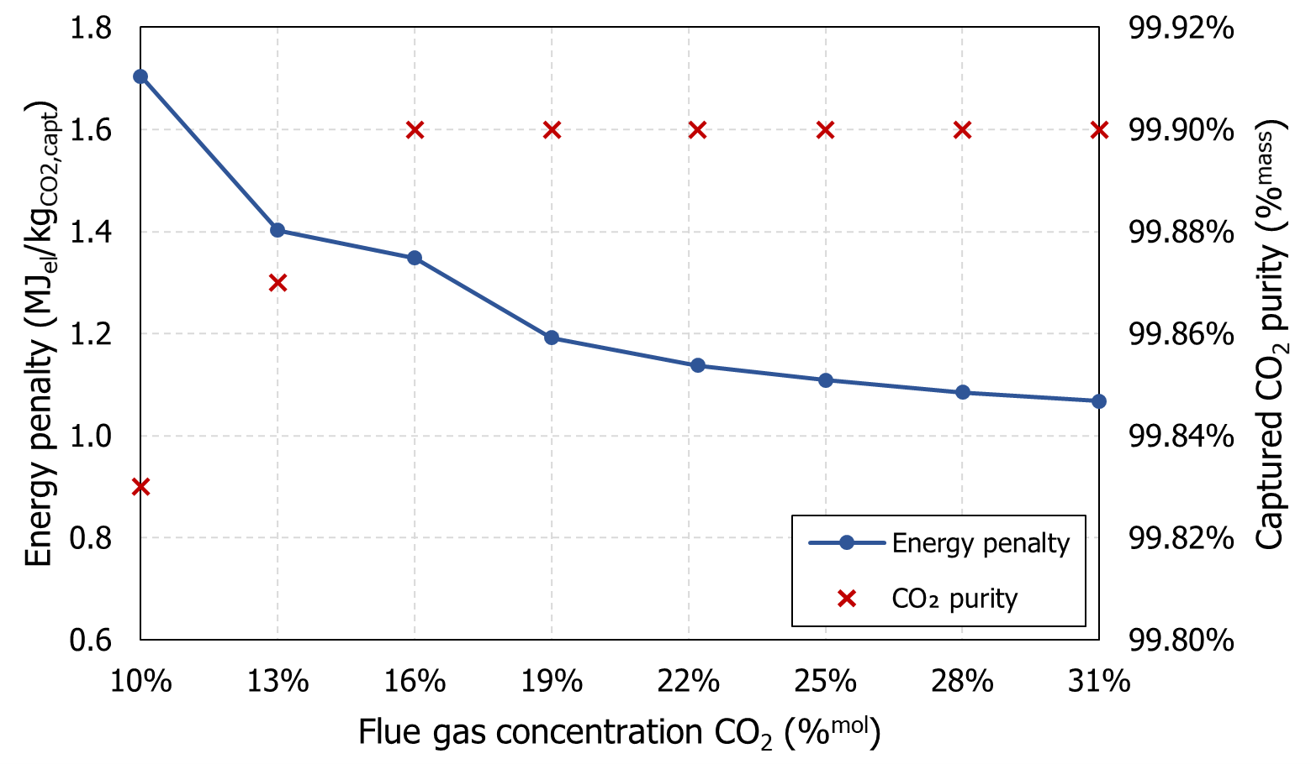

*Figure 2: Sensitivity analysis of process energy penalty and CO2 purity against CO2 concentration in flue gas.*

Figure 3b illustrates the cost of avoided CO2 for the cryogenic capture process, estimated at 118.2 €/tCO2. The main cost drivers are variable OPEX, including electricity, cooling water and transportation and storage, which together constitute nearly 61 % of the overall cost, while the annualised CAPEX accounts for 25 %. Notably, transport and storage (31.8 %) and electricity (28.7 %) are the largest contributors to the CO2 avoidance cost.

The economic performance of cryogenic capture was benchmarked against MEA-based capture, oxyfuel process, and tail-end calcium looping. The cost values were sourced from Gardarsdottir et al. (2019) and Voldsund et al. (2019) and recalculated using the same economic assumptions outlined in Section 2. Transport and storage costs were included to ensure a consistent comparison, particularly with tail-end calcium looping, which produces and captures more CO2 and incurs higher associated costs.

Cryogenic capture outperforms MEA-based capture being significantly less OPEX-intensive, but it shows a CO2 avoidance cost 16 % larger than oxyfuel technology due to greater CAPEX and electricity expenses. It also exhibits comparable CO2 avoidance costs to tail-end calcium looping, which, despite higher CAPEX and CO2 transport/storage costs, benefits from electricity export. However, it is important to note that both oxyfuel and calcium looping technologies generate a lower purity CO2 outlet stream.

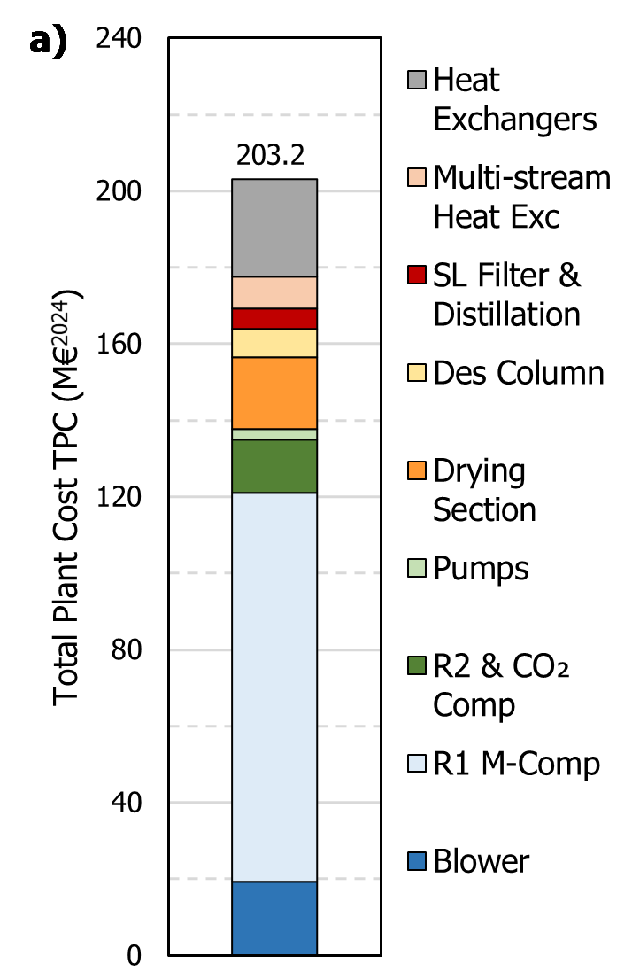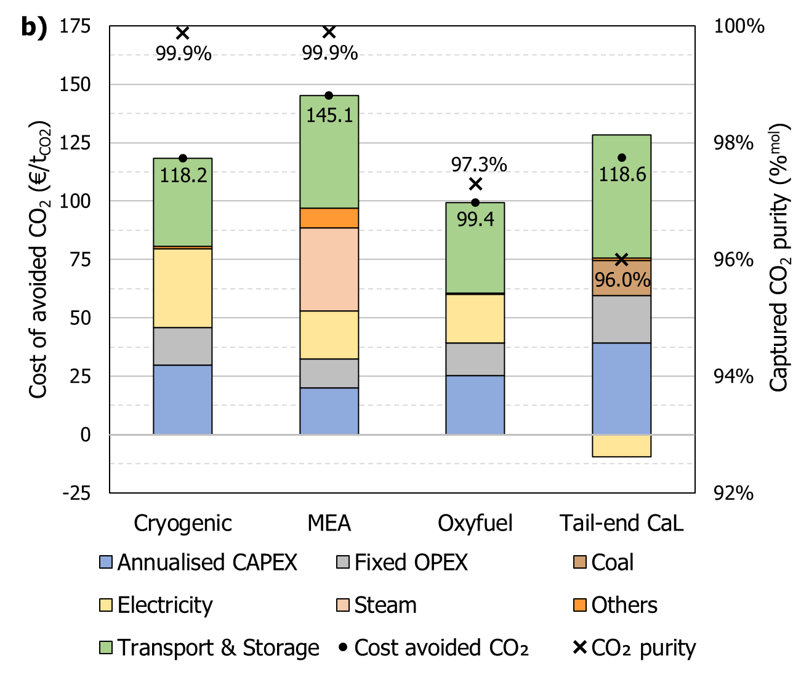

*Figure 3: (a) Breakdown of total plant cost (TPC) for the cryogenic capture process and (b) comparison of cost of CO2 avoided between cryogenic capture, MEA-based capture, oxyfuel cement process, and tail-end calcium looping. Results are adapted from Voldsund et al. (2019) and Gardarsdottir et al. (2019) recomputed using the same economic assumptions as this study.*

* 1. Conclusions

This study presented a techno-economic analysis of cryogenic CO2 capture applied to a coal-fired cement plant, highlighting its potential as a viable alternative to more established capture technologies. The simulations demonstrated competitive performance from both an energy and economic perspective, exhibiting an energy penalty of 1.14 MJel/kgCO2 and a cost of avoided CO2 of 118.2 €/tCO2. While the economic performance of cryogenic capture is less favourable than oxyfuel and comparable to tail-end calcium looping, it offers the advantage of a higher purity in the captured CO2. These results provide a benchmark for future research aimed at enhancing process design and efficiency. Future studies should prioritise optimisation of the refrigeration cycles and drying section to improve energy performance and reduce both capital and operating costs.

Acknowledgements

This work has been funded by the European Union’s Horizon Europe under the Marie Skłodowska-Curie Grant Agreement No. 101073547 “CO2Valorize”. FdA and FB acknowledge the support of the National Recovery and Resilience Plan (NRRP), Mission 4 Component 2 Investment 1.4 - Call for tender No. 3138 of December 16, 2021 of the Italian Ministry of University and Research, funded by the European Union - NextGenerationEU [Award Number: CNMS named MOST, Concession Decree No. 1033 of June 17, 2022, adopted by the Italian Ministry of University and Research, CUP: C93C22002750006, Spoke 14 ‘‘Hydrogen and New Fuels’’].

References

Asgharian H., Iov F., Nielsen M. P., Liso V., Burt S., Baxter L., 2025, Cryogenic Carbon Capture Process Combined with Absorption Refrigeration Cycle for Cement Plants - A Danish Case Study, Separation and Purification Technology, 353, 128419.

AspenTech, 2025, Aspen Plus V14.0, <aspentech.com/en/products/engineering/aspen-plus> accessed 29.01.2025.

d’Amore F., Natalucci L., Romano M.C., 2024, Optimisation of ship-based CO2 transport chains from Southern Europe to the North Sea, Carbon Capture Science and Technology, 10, 100172.

EEA, 2025, Greenhouse gas emission intensity of electricity generation in Europe <eea.europa.eu/en/analysis/indicators/greenhouse-gas-emission-intensity-of-1> accessed 29.01.2025.

Eurostat, 2025, Electricity prices for non-household consumers - bi-annual data (from 2007 onwards) <doi.org/10.2908/NRG\_PC\_205> accessed 29.01.2025.

Ferrario D., Stendardo S., Verda V., Lanzini A., 2023, Solar-driven calcium looping system for carbon capture in cement plants: Process modelling and energy analysis, Journal of Cleaner Production, 394, 136367.

Gardarsdottir S.O., De Lena E., Romano M., Roussanaly S., Voldsund M., Pérez-Calvo J.F., Berstad D., Fu C., Anantharaman R., Sutter D., Gazzani M., Mazzotti M., and Cinti G., 2019, Comparison of technologies for CO2 capture from cement production-Part 2: Cost analysis, Energies, 12(3), 542.

Hoeger C., Burt S., Baxter L., 2021, Cryogenic Carbon Capture™ Technoeconomic Analysis, Proceedings of the 15th GHGT Conference <https://dx.doi.org/10.2139/ssrn.3820158> accessed 14.11.2024.

Jensen M.J., Russell C.S., Bergeson D., Hoeger C.D., Frankman D.J., Bence C.S., Baxter L.L., 2015, Prediction and validation of external cooling loop cryogenic carbon capture (CCC-ECL) for full-scale coal-fired power plant retrofit, International Journal of Greenhouse Gas Control, 42, 200-212.

Marmier A., 2023, Decarbonisation options for the cement industry, Publications Office of the European Union <data.europa.eu/doi/10.2760/174037> accessed 14.11.2024.

Rubin E., Short C., Booras G., Davison J., Ekstrom C., Matuszewski M., McCoy S., 2013, A proposed methodology for CO2 capture and storage cost estimates, International Journal of Greenhouse Gas Control, 17, 488-503.

Turton R., Bailie R., Whiting W., Shaeiwitz J., 2018, Analysis, Synthesis, and Design of Chemical Processes (5th ed.), Prentice Hall.

Varnier L., d’Amore F., Clausen K., Bezzo F., 2024, Assessment of Different Carbon Capture and Electrification Configurations for Low-Carbon Cement, Proceedings of the 17th GHGT Conference <https://dx.doi.org/10.2139/ssrn.5058552> accessed 29.01.2025.

Varnier L., d’Amore F., Clausen K., Melitos G., de Groot B., Bezzo F., 2025, Combined electrification and carbon capture for low-carbon cement: techno-economic assessment of different designs, Journal of Cleaner Production, 498, 145029.

Voldsund M., Gardarsdottir S.O., De Lena E., Pérez-Calvo J.F., Jamali A., Berstad D., Fu C., Romano M., Roussanaly S., Anantharaman R., Hoppe H., Sutter D., Mazzotti M., Gazzani M., Cinti G., Jordal K., 2019, Comparison of technologies for CO2 capture from cement production - Part 1: Technical evaluation. Energies, 12(3), 559.