 CHEMICAL ENGINEERING TRANSACTIONS  VOL. xxx, 2025 | A publication of  
The Italian Association
of Chemical Engineering
Online at www.cetjournal.it

Guest Editors: David Bogle, Flavio Manenti, Piero Salatino
Copyright © 2025, AIDIC Servizi S.r.l.
ISBN 979-12-81206-21-2; ISSN 2283-9216

On the Path to Efficient CO₂ Liquefaction: Overcoming Limits for Large-Scale CCS Projects
Disarò E.*, Felici P., Orsetti A., Ferrari. F.
NEXTCHEM, Milano
e.disaro@nextchem.it
The Liquefaction of captured CO₂ is a critical step for efficient transport within Carbon Capture and storage (CCS) systems, enabling the connection of locations lacking CO₂ pipeline infrastructure. This work provides a techno-economic comparison of two CO₂ Liquefaction technologies applied to post-combustion Carbon Capture: Ammonia-Refrigerated and Self-Refrigerated CO₂ Liquefaction.
Ammonia-Refrigerated CO₂ Liquefaction has become the industry standard for small-scale applications thanks to its high efficiency and the extensive knowledge behind Ammonia refrigeration cycles. However, due to limitations in compression technology, its application to large-scale CO₂ Liquefaction projects—essential to meet the growing demands of energy transition—is less efficient and less viable.
Conversely, advancements in CO₂ compression technology have enabled Self-Refrigerated Liquefaction to effectively address the challenges of large-scale projects, overcoming the constraints of Ammonia refrigeration. On the other hand, traditional Self-Refrigerated systems face limitations in achieving high efficiencies due to the thermodynamic properties of CO₂. Recent advancements, such as those developed by NEXTCHEM, have successfully overcome these limitations through innovative process design and highly efficient heat integration strategies. These advancements enable the deployment of Self-Refrigerated systems with significantly improved performance, delivering high efficiency with fewer rotating machines, thereby reducing capital expenditures and operational complexity.
  - Introduction
The CO₂ Liquefaction process involves compressing and cooling CO₂ gas to condense it into a liquid state, essential for efficient transport and storage, while also reducing impurity levels to meet the stringent transport specifications (Northern Lights, 2024). Liquefaction is particularly valuable for long-distance transport where pipelines are impractical, enabling ship-based transportation and offering flexibility in connecting emission sources with storage sites (Cha, 2024). Historically, CO₂ Liquefaction has been utilized across various industries, including beverage carbonation, chemical manufacturing, and pharmaceuticals, primarily relying on the NH₃-Refrigerated technology. However, its role has expanded significantly within the Carbon Capture and Storage (CCS) value chain, where projects operate at scales reaching millions of tons of CO₂ annually. This shift demands highly efficient, large-scale liquefaction units—making them crucial for CCS project feasibility.
Traditional NH₃-Refrigerated systems are unsuitable for large-scale CO₂ Liquefaction due to inherent capacity limitations of CO₂ screw compressors. To meet high throughput demands, multiple parallel Liquefaction units are required, which undermines economies of scale and leads to higher capital and operational expenditures. This configuration also adds system complexity, increases maintenance and coordination efforts, and reduces overall efficiency and reliability. Moreover, due to its flammability and toxicity, NH₃ presents additional safety hazards compared to CO₂. In contrast, Self-Refrigerated Liquefaction systems can overcome scalability limitations by employing Integrally Geared (IG) centrifugal compressors instead of screw compressors. These systems exploit the Joule-Thomson effect, where high-pressure CO₂ expands through a valve or expansion device, cooling and partially liquefying in the process, without the need of an external refrigerant. A typical example is the Linde-Hampson cycle, where liquefaction occurs by compressing, cooling, and expanding the gas to a lower pressure, allowing the cold gas to absorb heat from the incoming compressed gas (Linde, 1903).
However, using CO₂ as a refrigerant poses additional challenges compared to NH₃, particularly due to its low critical temperature (31°C), which prevents conventional condensation and necessitates the use of a gas cooler. This makes CO₂ cycles inherently transcritical, requiring higher operating pressures to operate efficiently (Liao and Jakobsen, 1998), and leading to more complex and costly equipment, especially for compressors. CO₂ refrigeration cycles may also exhibit a lower coefficient of performance compared to NH₃-based systems, with studies indicating an efficiency penalty of around 20%, primarily due to thermodynamic losses during throttling (Cavallini and Zilio, 2007). Another challenge is the risk of CO₂ solidification, as operating temperatures near the triple point (-56.6°C) can lead to dry ice formation, potentially causing system blockages. Previous comparisons in the literature (Jackson and Brodal, 2019) have consistently shown that NH₃-refrigerated Liquefaction offers superior energy efficiency under industrially relevant conditions, compared to CO₂-based refrigeration. These findings are largely based on variations of the Linde-Hampson process for Self-refrigerated systems. NEXTCHEM has successfully implemented an innovative Self-Refrigerated Liquefaction design that leverages nested CO₂ refrigeration and advanced heat integration. This approach minimizes the performance losses typically associated with transcritical CO₂ cycles and achieves energy efficiencies that exceed those of NH₃-based systems, particularly at large scale. This work provides a comprehensive overview of NH₃-Refrigerated and NEXTCHEM Self-Refrigerated CO₂ Liquefaction technologies, examining their main features and providing a detailed comparison to assess key indicators, including energy efficiency, capital costs, scalability, and safety aspects, to determine the most suitable solution for large-scale CO₂ Liquefaction systems.
  - Technologies Description
    - Ammonia-Refrigerated CO₂ Liquefaction
In Ammonia-Refrigerated CO₂ Liquefaction, raw CO₂ gas from the Carbon Capture plant is initially compressed in a screw compressor to reach the required outlet pressure. Since this CO₂ stream is typically saturated with water, it is first dried to prevent ice formation in the cold downstream sections of the plant, which could lead to operational disruptions and equipment damage. The dried CO₂ vapor stream is then directed into the stripping column where non-condensable impurities—such as nitrogen, oxygen—are reduced to levels that meet the product specifications. The heating medium for the stripping process is the CO₂ vapor feedstock to the column, thus reducing the condensation load and leading to improved overall energy efficiency. At the top of the stripping column, most of the CO₂ vapors are condensed using Ammonia refrigerant as the cooling medium and recycled to the column, while a small fraction is lost as vent. In the condenser, Ammonia refrigerant absorbs heat from the CO₂ stream, vaporizes, and is then recompressed via a dedicated compressor for reuse in the Ammonia Refrigeration cycle. The process scheme for Ammonia-Refrigerated CO₂ Liquefaction is well-established, with numerous references available in industrial practice. Unlike more complex systems, this approach leverages an external refrigeration cycle, simplifying process control and reducing the need for extensive heat integration.
    - Self-Refrigerated CO₂ Liquefaction
In Self-Refrigerated CO₂ Liquefaction, CO₂ acts as both the refrigerant fluid and the process fluid to be liquefied, with all compression duties handled by a single compressor. The raw CO₂ gas is first fed into the CO₂ compressor, where its pressure is increased above the critical value. This compressor also manages recycle streams from the downstream refrigeration cycle, therefore acting as the compressor for both the process fluid and the refrigerant fluid. In this setup, the CO₂ compressor is an Integrally Geared Centrifugal type, optimized for handling the high compressibility of CO₂ while maintaining high efficiency. The compressed CO₂ is then sent to a drying unit to reduce its water content and prevent ice formation in the colder sections of the plant. Drying occurs at an intermediate compression stage before reaching supercritical conditions, which would hinder desiccant performance. At the compressor outlet, supercritical CO₂ is split into two streams: process CO₂, which is subsequently liquified, and refrigerant CO₂, which is flashed to a lower pressure level to generate a liquid phase in the CO₂ refrigeration section. Therefore, unlike the Linde-Hampson process, which relies solely on the vapor generated during expansion for refrigeration, this process uses a dedicated liquid CO₂ stream as a refrigerant. Process CO₂ is first cooled in the Heat Recovery System, which exploits frigories from CO₂ recycle streams to lower the Liquefaction duty and maximize heat integration and is then flashed and fed at the top of the Stripping Column, where it is purified to remove impurities similarly to the Ammonia-Refrigerated process. The stripped vapors are cooled down via evaporation of the refrigerant CO₂ in the column condenser and sent back to the column as reflux, while a small fraction is lost as vent. Evaporated refrigerant CO₂ is subsequently recycled to the CO₂ Compressor through the Heat Recovery System, therefore closing the Refrigeration cycle. To enhance flexibility, the Liquefaction column pressure is decoupled from the final product pressure. This allows the system to deliver CO₂ at different pressure levels, making it particularly suitable for large-scale CCS projects where different CO₂ specifications may be required.
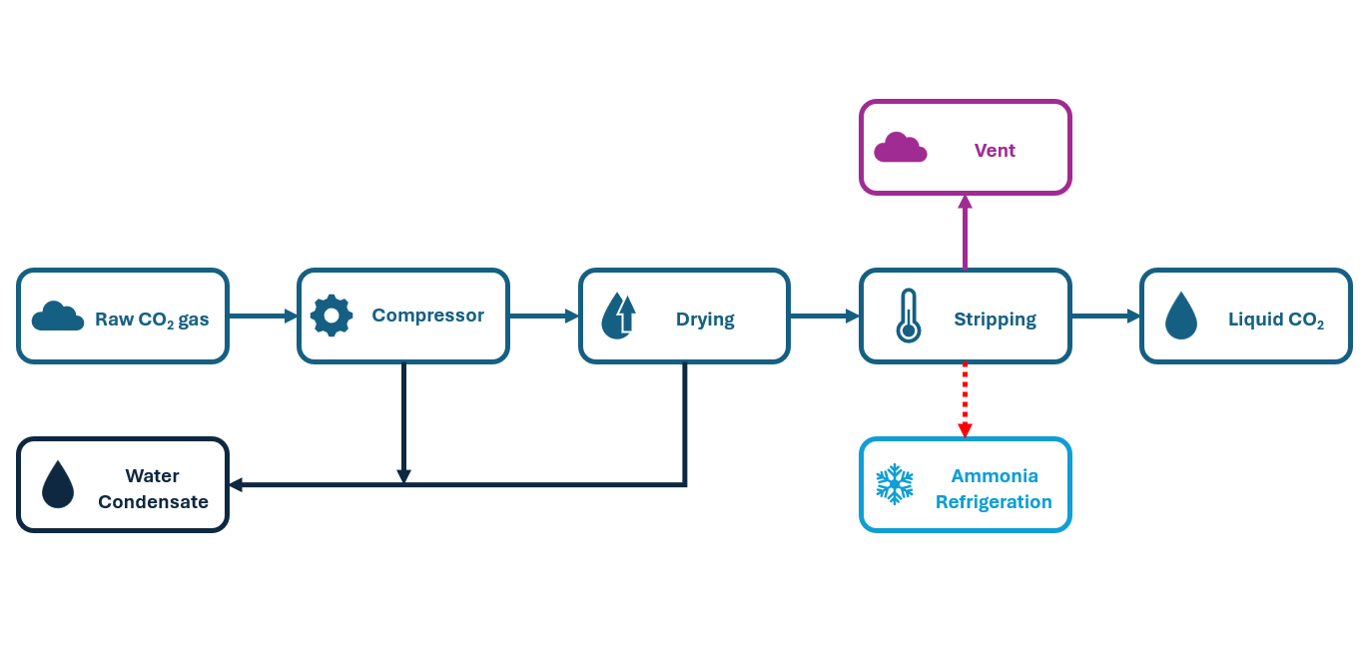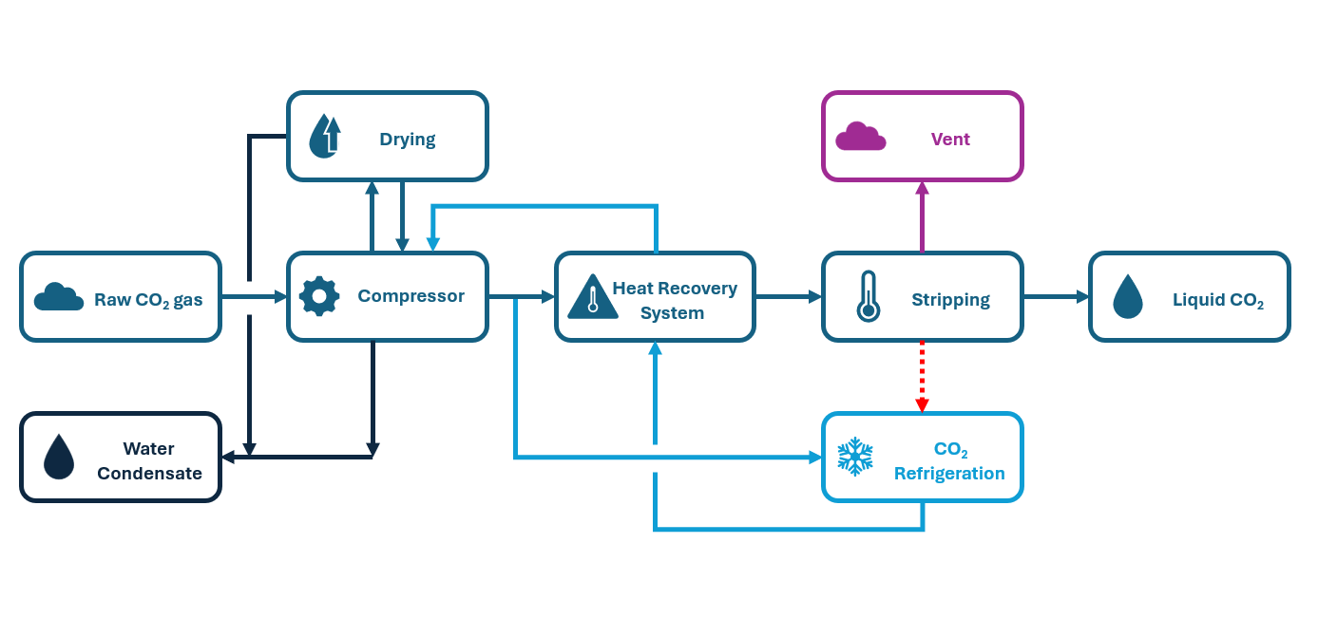
(b)
(a)
Figure 1 - Schematic representation of (a) Ammonia Refrigerated Liquefaction and (b) NEXTCHEM Self-Refrigerated CO₂ Liquefaction
  - Comparison
The comparison for the two CO₂ Liquefaction technologies is carried out for a capacity of 1,500 MTPD, a typical scale found downstream of cement and power plants. Two scenarios are analyzed, each targeting a different liquid CO₂ delivery pressure: 7 bar(g) and 15 bar(g). In the first case, CO₂ is liquefied at approximately -45°C, a temperature commonly associated with long-distance transport via ship. The second case is more typical for bulk storage tanks used in industrial applications and distribution, as it offers a practical balance between temperature and pressure, facilitating easier storage and handling.
Table 1 presents the quality of the raw CO₂ gas entering the Liquefaction process, along with the minimum required purity for the resulting liquid CO₂ (Northern Lights, 2024). Any additional impurities in the raw CO₂ stream may necessitate dedicated purification systems. However, since these purification steps can be integrated into both Liquefaction technologies with comparable cost and efficiency, they fall outside the scope of this technology comparison. As a result, only the most common impurities typically found downstream of an amine-based Carbon Capture process have been considered.
Table 1: CO₂ quality
 | Unit | Raw CO₂ gas | Liquid CO₂
Temperature | °C | 40 | -26/-45
Pressure | bar(g) | 0.5 | 15/7
N₂ | ppmvol-dry | 300 | <50
O₂ | ppmvol-dry | 50 | <10
H₂O | ppmvol-dry | Sat. | <30
The performance of the two processes was evaluated using an Aspen HYSYS V14 simulation. Table 2 presents the assumptions used in both simulations. The comparison is carried out under a typical cooling temperature of 40 °C, where the NH₃-based process is commonly regarded as more efficient (Jackson and Brodal, 2019).
Table 2: Input data for the Aspen HYSYS Simulation
Item | Value | Unit
Isoentropic efficiency Screw Compressor | 70 | %
Isoentropic efficiency IG Compressor | 80 | %
Heat Exchanger Pressure Drop | 10 | kPa
Cooling Water Coolers Outlet Temperature | 40 | °C

    - Maximum Capacity
The maximum capacity of the Ammonia-Refrigerated Liquefaction is constrained by the available screw compressor technology, which is limited to a throughput of CO₂ of a maximum of 15-20 t/h. For the capacity considered in this work, a minimum of 4 Liquefaction Trains - and therefore 8 compressors- shall be considered to achieve the indicated capacity. Increasing the number of rotating machines impacts maintenance efforts and operational complexity, as each compressor requires lubrication and monitoring. Moreover, with limited maximum capacity, economies of scale cannot be leveraged. On the other hand, Self-Refrigerated CO₂ Liquefaction enables large-scale CO₂ Liquefaction by utilizing IG compressors. These compressors support high-capacity processing, reaching suction volumetric flow rates up to 500000 m³/h, ensuring they are not a bottleneck in the system.
    - Operational Flexibility
A key advantage of Ammonia-Refrigerated Liquefaction is its high degree of operational flexibility, largely due to the use of screw compressors for Ammonia and CO₂ compression. Screw compressors are well-suited for variable load conditions, provide continuous operation, and require lower maintenance compared to other types of compressors. Additionally, the decoupling of the CO₂ liquefaction and Ammonia refrigeration allows for independent operation, making this approach particularly robust in fluctuating process conditions, and, compared to more integrated refrigeration cycles, an external Ammonia refrigeration system offers easier start-up procedures. Since the Ammonia-Refrigerated CO₂ Liquefaction process does not rely on complex heat integration, it can reach operational stability faster, reducing downtime. Conversely, the IG compressors used in the Self-Refrigerated Liquefaction operate optimally within a specific load range. While they are highly efficient at full capacity, they are less flexible, which may limit adaptability when CO₂ supply fluctuates, and decrease performance efficiency at lower loads.
    - Liquid CO₂ Quality Range
Delivery conditions, including pressure and temperature, determine the system’s adaptability to varying market demands and its integration with downstream transport and storage. In an emerging market like CO₂ Liquefaction, where there is no globally accepted standard yet that defines the precise conditions for liquid CO₂ transport, ensuring flexibility in production is a key factor in de-risking any project. Different industries and regions may adopt varying specifications based on infrastructure, regulatory requirements, or end-use applications. A Liquefaction unit capable of adjusting delivery conditions across a range of pressures and temperatures allows operators to respond to evolving standards and market demands without requiring costly retrofits or process modifications. For these reasons, the flexibility in the output of Self-Refrigerated Liquefaction is a high-value advantage. Moreover, since the pressure of the Liquid CO₂ is decoupled by that of the stripping column, Self-Refrigerated Liquefaction can achieve lower temperatures and pressure levels than the minimum values reached for the Ammonia-Refrigerated solution while maintaining high efficiency and CO₂ recovery.
    - Energy efficiency
Energy efficiency in CO₂ liquefaction—typically measured in kWh per ton of CO₂ liquefied—is a critical factor in operational cost optimization, especially given the fully electrified nature of the process. In the 15 bar(g) case, NEXTCHEM’s Self-Refrigerated Liquefaction achieves an energy consumption of 111.9 kWh/tCO₂, compared to 125.9 kWh/tCO₂ for the ammonia-refrigerated alternative—a 12% improvement. The difference is even more pronounced at 7 bar(g), where the Self-Refrigerated system consumes 123.5 kWh/tCO₂ versus 142.5 kWh/tCO₂ for the ammonia-based solution. One of the key contributors to efficiency is compressor technology: Self-Refrigerated Liquefaction systems developed by NEXTCHEM utilize integrally geared (IG) centrifugal compressors, which typically offer superior isentropic efficiency compared to the screw compressors commonly used in Ammonia-refrigerated systems. This mechanical advantage alone contributes to lower energy consumption, but it is further amplified by the process design itself. The ammonia-refrigerated system would be penalized if it adopted IG compressors, as it would require multiple rotating machines to manage both the CO₂ and NH₃ cycles, increasing capital costs, operational complexity, and maintenance demands. Moreover, the ammonia-based process operates as a separate external refrigeration unit, limiting opportunities for heat integration and resulting in lower overall thermodynamic efficiency. In contrast, the Self-Refrigerated Liquefaction system integrates refrigeration and liquefaction into a single train, enabling advanced heat recovery and internal energy reuse. This design not only reduces the number of rotating machines but also enhances process efficiency beyond what is achievable with conventional multi-stage CO₂ depressurization schemes. Indeed, as shown in the study by Jackson et al. (Jackson and Brodal, 2019), even optimized multi-stage CO₂ cycles only manage to match the performance of ammonia-based systems under a cooling temperature of 40 °C —whereas NextChem Tech’s configuration consistently exceeds it.
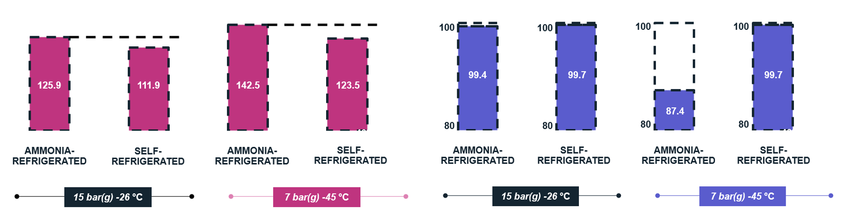 Figure 2 – Comparison for Energy Efficiency (a) and CO₂ Recovery (b) between Ammonia-Refrigerated and Self-Refrigerated Technology
(b)
(a)
    - CO₂ Recovery
The CO₂ recovery rate, or the proportion of captured CO₂ successfully liquefied, is a key factor in determining the system’s efficiency. Any CO₂ lost at the top of the stripping column may be recycled back to the upstream CO₂ Capture unit for recovery, but this incurs a significant energy penalty, as CO₂ Capture is highly energy intensive. Therefore, maximizing recovery is crucial for the overall efficiency of the CCS project. Both Self- and NH₃-refrigerated Liquefaction can achieve high CO₂ recovery values; however, their performance is influenced by temperature constraints. NH₃-based systems are limited by the evaporation temperature of NH₃ at atmospheric pressure (-33°C). This limitation prevents the system from reaching the lower temperatures necessary for full CO₂ condensation, leading to higher CO₂ losses at the top of the stripping column. The difference becomes especially pronounced at lower pressure targets of the CO₂ product. In the 7 bar(g) case, the CO₂ recovery rate of the NH₃-Refrigerated system drops to 87.43%, whereas the Self-Refrigerated solution maintains its performance, since using CO₂ as a refrigerant allows for lower condensation temperatures.
    - Refrigerant Characteristics and Safety
NH₃ is toxic and flammable, posing both safety and regulatory challenges. Depending on site-specific regulations, NH₃ refrigeration systems may require area classification, enhanced ventilation, and leak detection. In contrast, CO₂ is inherently safe and inert. It does not require area classification, which simplifies plant design and safety measures. CO₂ is non-flammable, non-toxic and eliminates refrigerant costs, as it is already present in the system. In NEXTCHEM’s Liquefaction, CO₂ is used as a refrigerant before being purified in the stripping stage, meaning it must maintain a relatively high level of purity. Downstream Post-Combustion Carbon Capture, this is generally not a concern, as contaminants such as N₂ and O₂ are typically present only in trace amounts.
    - Operational Costs
Operational costs in CO₂ liquefaction are primarily driven by electricity consumption, as the process is fully electrified. At 15 bar(g), the Self-Refrigerated Liquefaction process developed by NEXTCHEM achieves an energy consumption of 111.9 kWh/tCO₂. Considering other utilities and assuming an electricity price of 100 €/MWh, this translates to an operational cost of approximately 11.5 €/tCO₂, which accounts for around 88% of the operational cost of the NH₃-refrigerated process. In contrast, at 7 bar(g), ammonia-refrigerated systems suffer from reduced CO₂ recovery, with around 13% of the captured CO₂ lost in the vent stream. Recapturing this loss—typically via an aminic post-combustion capture unit—would incur an additional cost of roughly 5.6 €/tCO₂, assuming a typical capture cost of 40 €/tCO₂. This further increases the operational advantage of the Self-Refrigerated solution, which displays a 35% reduction in operational costs, as it maintains high recovery rates even at lower pressures, avoiding the energy penalty and the added cost of reprocessing vented CO₂.
    - Investment Costs
Investment costs are a critical factor in the feasibility of CCS projects. Given the early-stage adoption of these technologies, securing financing is often challenging, making cost efficiency essential. Unlike traditional revenue-generating ventures, CCS projects typically depend on government incentives, carbon pricing mechanisms, or corporate sustainability commitments to justify expenditures. As a result, investors and stakeholders evaluate capital requirements against expected savings, regulatory frameworks, and potential revenue streams such as carbon credits. High upfront costs without a clear financial return can delay or even prevent project deployment—making cost-effective, scalable design a prerequisite for success. In this context, a technology that effectively leverages economies of scale, such as Self-Refrigerated CO₂ Liquefaction, provides a significant competitive advantage for large-scale CCS projects by reducing costs at high capacities. According to Table 3, the investment cost for the Self-Refrigerated Liquefaction system, as estimated using a Class III AACE approach, is approximately 45% lower than that of the Ammonia-Refrigerated Liquefaction system. This cost reduction is primarily driven by the possibility of managing the required capacity in a single unit, without the need to use multiple trains in parallel, and by the integration of refrigeration and Liquefaction within a single system, which reduces the number of rotating machines and the footprint of the installation.
  - Conclusions
Historically, Self-Refrigerated Liquefaction has been regarded as a less efficient alternative compared to NH₃-Refrigerated Liquefaction, primarily due to the thermodynamic challenges of using CO₂ as a refrigerant. However, this paper demonstrates that with the innovative process design developed by NEXTCHEM—featuring advanced heat integration, internal refrigeration loops, and high-performance IG compressors—this paradigm is reversed. The comparison between NH₃-Refrigerated and Self-Refrigerated CO₂ Liquefaction highlights the significant advantages of the Self-Refrigerated approach, particularly for large-scale CCS projects. While Ammonia-Refrigerated Liquefaction offers operational flexibility and is an established technology, its limitations in maximum capacity, energy efficiency, and CO₂ recovery in a range of conditions present challenges for large-scale applications. Self-Refrigerated CO₂ Liquefaction, as developed by NEXTCHEM, emerges as the preferred solution due to its ability to handle high processing capacities with fewer rotating machines, reducing complexity and improving energy efficiency, which translates into lower operational costs. Additionally, the ability to achieve lower operating temperatures ensures higher CO₂ recovery rates, minimizing losses and maximizing the effectiveness of carbon management efforts. From a safety and regulatory perspective, using CO₂ as a refrigerant eliminates the hazards associated with NH₃, simplifying plant design and reducing compliance costs. Furthermore, the scalability of Self-Refrigerated Liquefaction allows for significant capital cost reductions, leveraging economies of scale that make large CCS projects more financially viable. Given these advantages, NEXTCHEM’s Self-Refrigerated CO₂ Liquefaction stands out as the optimal choice for large-scale CCS projects, ensuring high performance and improving economic viability.
Table 3: Comparison Summary
Item | Unit | Ammonia-Refrigerated  Liquefaction | NEXTCHEM Self-Refrigerated Liquefaction
Maximum Capacity | MTPD | 400 | 5000
Case Study Capacity | MTPD | 1500 | 1500
Number of Liquefaction Trains | - | 4 | 1
Number of Compressors | - | 8 | 1
CO₂ Recovery @15 bar(g) LCO₂ pressure | % | 99.42 | 99.68
CO₂ Recovery @7 bar(g) LCO₂ pressure | % | 87.43 | 99.68
Energy Efficiency @15 bar(g) LCO₂ pressure | kWh/t_{CO2} | 125.9 | 111.9
Energy Efficiency @7 bar(g) LCO₂ pressure | kWh/t_{CO2} | 142.5 | 123.5
Operational Costs @15 bar(g) LCO₂ pressure | €/t_{CO2} | 13.0 | 11.5
Operational Costs @7 bar(g) LCO₂ pressure | €/t_{CO2} | 20.0 | 13.0
Investment Costs | % | 100% | 55%

Nomenclature
CCS – Carbon Capture and Storage
LCO₂ – Liquid CO₂
IG – Integrally Geared
MTPD – Metric Tons Per Day
References
Cavallini A., Zilio C., 2007, Carbon dioxide as a natural refrigerant, International Journal of Low-Carbon Technologies, 2(3), 225–249.
Cha D., 2024, Development of long-distance and large-scale Carbon Capture and storage (CCS) value chain using liquefied CO₂ ship transportation, Australian Energy Producers Journal, 64(S1), S119-S124.
Jackson S., Brodal E., 2019, Optimization of the CO2 Liquefaction Process-Performance Study with Varying Ambient Temperature, Appl. Sci. 2019, 9(20)
Liao S., Jakobsen A., 1998, Optimal Heat Rejection Pressure in Transcritical Carbon Dioxide Air-conditioning and Heat Pump Systems, Natural Working Fluids ’98, IIR Gustav Lorentzen Conference, 346–355
Linde C., 1903, Process of producing low temperatures, the liquefaction of gases, and the separation of the constituents of gaseous mixtures, United States.
Northern Lights, 2024, Liquid CO₂ (LCO2) Quality Specifications, <norlights.com/wp-content/uploads/2024/06/NorthernLights-GS-co2-spec2024.pdf>

