|  |  |
| --- | --- |
| cetlogo ***CHEMICAL ENGINEERING TRANSACTIONS***  ***VOL. xxx, 2025*** | A publication of  aidiclogo_grande |
| The Italian Association  of Chemical Engineering  Online at www.cetjournal.it |
| Guest Editors: David Bogle, Flavio Manenti, Piero Salatino  Copyright © 2025, AIDIC Servizi S.r.l. **ISBN** 979-12-81206-21-2; **ISSN** 2283-9216 | |

Life Cycle Assessment of NiFeP electrodes: a case study

Alberto Affranchi\*a, Sonia Longob, Maurizio Celluraa,b, Rosalinda Inguantab, Roberto Luigi Oliverib

aCenter of Sustainability and Ecological Transition, University of Palermo, Piazza Marina 61, 90133 Palermo, Italy

bDepartment of Engineering, Università degli Studi di Palermo, Viale delle Scienze, 90128 Palermo, Italy

alberto.affranchi@unipa.it

Global hydrogen production increased by 2.5% in 2023, reaching 97 Mt, but the sector is still largely dependent on fossil fuels. Projections indicate a significant rise in green hydrogen production to 49 Mt by 2030. This increase is considered fundamental for achieving the Paris Agreement’s goal of limiting global temperature rise. Alkaline electrolysers, while less efficient than Proton Exchange Membrane electrolysers, are currently the most commercially mature technology for hydrogen production. To improve the efficiency of alkaline cells, recent research has focused on the development of electrodes using nanostructured materials. Specifically, this study aims to evaluate the life cycle energy and environmental impact of experimental NiFeP nanowire electrodes for alkaline electrolysers. Additionally, the analysis assesses the environmental impact resulting from varying sodium hypophosphite concentrations during electrode fabrication. The results show minimal differences (< 0.4%) for all impact categories. This study also identifies critical hot spots within the system providing valuable insights for reducing the environmental footprint of hydrogen production technologies at laboratory scale. Optimizing electrode production from the preliminary stages of design, is crucial for enhancing the sustainability of electrolysers, supporting the transition toward renewable energy systems and net-zero emissions by 2050.

* 1. Introduction

Despite a 2.5% increase in global hydrogen production in 2023, reaching 97 Mt, the industry continues to be heavily reliant on fossil fuels (IEA, 2024). Green hydrogen production remains below 1 Mt, with electrolysis contributing less than 100 kt, primarily concentrated in China. However, future projections indicate a significative expansion, with announced projects potentially scaling green hydrogen production to 49 Mt by 2030, covering up to 75% of the Net Zero Emissions (NZE) scenario target. By 2050, low-emission hydrogen is expected to account for over 95% of total production under the NZE scenario, driven by advances in water electrolysis and carbon capture technologies. Consequently, hydrogen is increasingly integrated into national strategies as a critical component in achieving the Paris Agreement’s goal of limiting global temperature rise to 2°C or lower (Kouchaki-Penchah et al., 2024). Specifically, hydrogen produced from renewable electricity plays a crucial role as an energy carrier contributing to the stabilization of the energy grid by facilitating the integration of intermittent energy sources (Franco and Giovannini, 2023). Among electrolysers technologies, alkaline electrolysers are the most widespread and commercially mature (Li et al., 2020). These electrolysers consist of two nickel-based electrodes, a separator, and an electrolyte, which is a potassium hydroxide solution with a concentration between 20% and 30% (Arsad et al., 2023). Proton Exchange Membrane (PEM) electrolysers exhibit higher efficiency compared to alkaline electrolysers (Hu et al., 2022).In addition, the latter offer significant advantages, including lower hydrogen production costs, longer operational lifespans, and enhanced safety (Yang et al., 2023). PEM electrolysers rely on catalysts made from precious materials, such as platinum group metals, whereas alkaline electrolysers utilize more cost-effective alternatives like nickel alloys (Arsad et al., 2023).

To enhance the efficiency of alkaline electrolysers, recent research has focused on innovative electrode designs, such as “nanowire” electrodes. These electrodes consist of conductors with average diameters on the order of a few hundred nanometers made from nickel alloys derived from simple, cost-effective, and easily scalable processes (Buccheri et al., 2021). In this context, the present study focuses on the production process of “nanowire” prototype electrodes based on a nickel-iron-phosphorus (NiFeP) alloy developed at laboratory scale with a low Technology Readiness Level (TRL). In particular, the study aims to assess the environmental impacts and identify the hot spots associated with experimental NiFeP nanowire electrodes for alkaline electrolysers. Furthermore, it examines the effects on environmental performances caused by varying the concentration of sodium hypophosphite within the international recognised framework of Life Cycle Assessment (LCA). This methodological approach offers valuable insights for optimizing the process at the laboratory scale, thereby establishing a foundation for its future upscaling.

* 1. Methodology

LCA provides a comprehensive methodology to evaluate the energy and environmental impact of a service or a product across its whole life cycle, from raw material supply to the end of life. This approach, recognized by international standards of UNI EN ISO 14040 (ISO 14040, 2021) and 14044 (ISO 14044, 2021), highlights the most impactful life cycle stages or components in an eco-design perspective. In this study, the methodology is applied to an emerging technology at the laboratory scale, allowing for the early identification of environmental impacts and hotspots in the design phase. These insights are crucial for minimizing the environmental footprint, both at the lab scale and during future scale-up processes.

The system boundaries are considered “from cradle to gate”, from raw materials extraction to the end of manufacturing stage while the functional unit is the production of one electrode. The impact categories assessed in this analysis, indicated in Table 1, are based on the EPD method (The International EPD System, 2018).

Table 1 Impact categories

|  |  |
| --- | --- |
| Impact category | Unit |
| Acidification | kg SO2 eq |
| Eutrophication | kg PO43-eq |
| Global warming | kg CO2 eq |
| Photochemical oxidation | kg NMVOC |
| Abiotic depletion of elements | kg Sb eq |
| Abiotic depletion of fossil fuels | MJ |
| Water scarcity | m3 eq |
| Ozone layer depletion | kg CFC-11 eq |

* + 1. The case study of the electrode

The "nanowire" electrodes under investigation consist of nanowires composed of a NiFeP alloy, with average diameters on the order of a few hundred nanometres. These electrodes are fabricated using a Cyclopore track-etched polycarbonate membrane, which serves as a matrix to guide the formation of the conductive nanowires. The fabrication process, conducted at a laboratory scale, aims to optimize the alloy composition by varying the concentration of sodium hypophosphite, that is the phosphorus precursor. The production process is diagrammed in Figure 1 and it is characterized by three stages: sputtering, electrodeposition, and trichloromethane etching.

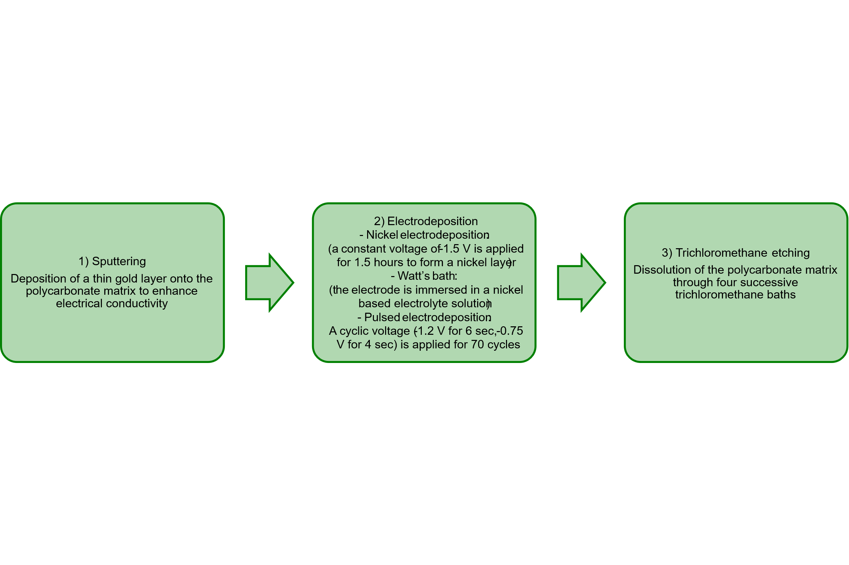

Figure 1 Description of the production process of the electrode

In the following section, the data collection process is examined in relation to the three stages of production.

* + 1. Data

Primary data related to the inputs and outputs of the various processing steps are collected experimentally, using an electrode prototype with a surface area of 17.35 cm². The study examines three different experimental conditions by varying the sodium hypophosphite concentration in the Watt’s bath, specifically 0.6 g/L, 0.9 g/L, and 1.2 g/L (considering the use of 300 mL of solution in the process). The primary data collected for the prototype are indicated in Table 2. Secondary data employed for the development of eco-profiles for all materials and energy sources are extracted from the Ecoinvent database (Wernet et al., 2016) and are referenced within the European context.

Table 2 Primary data of the electrodes

|  |  |  |
| --- | --- | --- |
| Stage production | Input | Amount |
|  | Electricity | 6.2 Wh |
| Sputtering | Gold | 1.6 mg |
|  | Polycarbonate | 28.1 mg |
|  | Deionised water | 0.03 L |
|  | FeSO4 | 0.1 g/L |
| Electrodeposition | H3BO3 | 1.35 g/L |
| NaH2PO2 | 0.6-0.9-1.2 g/L |
|  | NiCl2 | 1.35 g/L |
|  | NiSO4 | 9 g/L |
| Trichloromethane etching | Trichloromethane | 0.1 L |

* 1. Results

In this section, the results for the functional unit of one electrode are calculated using the professional LCA software Simapro 9.6 (“PRé Sustainability, Simapro,” 2024). The analysis reveals negligible differences among the three scenarios, both in terms of absolute values (with variations below 0.4%, as in Table 3) and when examining the percentage contribution of each process phase to the total impact. These findings suggest that the variation in sodium hypophosphite concentration has a minimal effect on the overall environmental performance of the electrodes. The results of this study are based on a system developed at the laboratory scale and the aim is to explore how the process can be optimized at this level, thereby laying the groundwork for future scale-up process. This process will enable comparisons with existing industrial technologies in subsequent research.

Table 3 Results for the three electrodes

|  |  |  |  |  |
| --- | --- | --- | --- | --- |
| Impact category | Unit | Electrode 1 | Electrode 2 | Electrode 3 |
| Acidification | kg SO2 eq | 3.29E-03 | 3.30E-03 | 3.30E-03 |
| Eutrophication | kg PO43-eq | 1.42E-03 | 1.42E-03 | 1.43E-03 |
| Global warming | kg CO2 eq | 6.30E-01 | 6.31E-01 | 6.31E-01 |
| Photochemical oxidation | kg NMVOC | 1.63E-03 | 1.64E-03 | 1.64E-03 |
| Abiotic depletion of elements | kg Sb eq | 1.19E-04 | 1.19E-04 | 1.19E-04 |
| Abiotic depletion of fossil fuels | MJ | 5.34E+00 | 5.34E+00 | 5.34E+00 |
| Water scarcity | m3 eq | 5.80E-01 | 5.81E-01 | 5.82E-01 |
| Ozone layer depletion | kg CFC-11 eq | 1.09E-04 | 1.09E-04 | 1.09E-04 |

The contribution analysis in Figure 2 illustrates the assessment for electrode 2, selected as a representative example, given that the differences across the three electrodes are less than 1%. Specifically, trichloromethane etching is the main contributor to global warming (78%), photochemical oxidation (42%), abiotic depletion of fossil fuels (68%), and ozone layer depletion (nearly 100%). In contrast, sputtering is identified as the main contributor to eutrophication (66%) and abiotic resource depletion of elements (87%). Similarly, electrodeposition is the dominant factor for acidification (56%) and water scarcity (77%), primarily due to the use of nickel-based compounds.

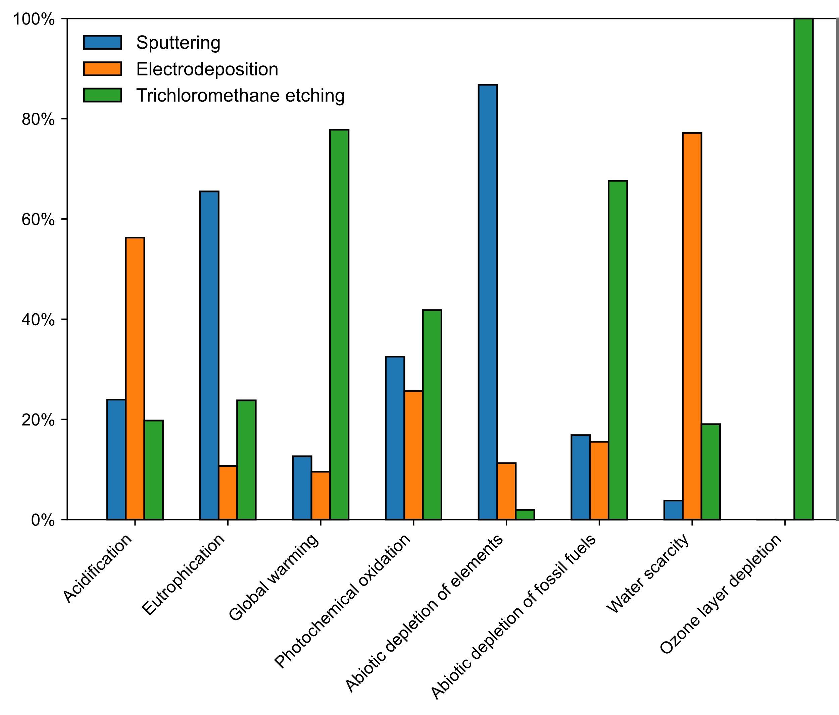

Figure 2 Contribution analysis of the electrode 2: percentage incidence of each step on the total impact

Figure 3 presents the contribution analysis for the sputtering process, which remains consistent across all three electrodes. Within this process, gold emerges as the primary hot spot, contributing between 93% (water scarcity) and nearly 100% (abiotic depletion of elements) across all impact categories. In contrast, the maximum impact caused by electricity is 7% for water scarcity, while polycarbonate contributes minimally, with its highest impact reaching approximately 1% for ozone layer depletion.

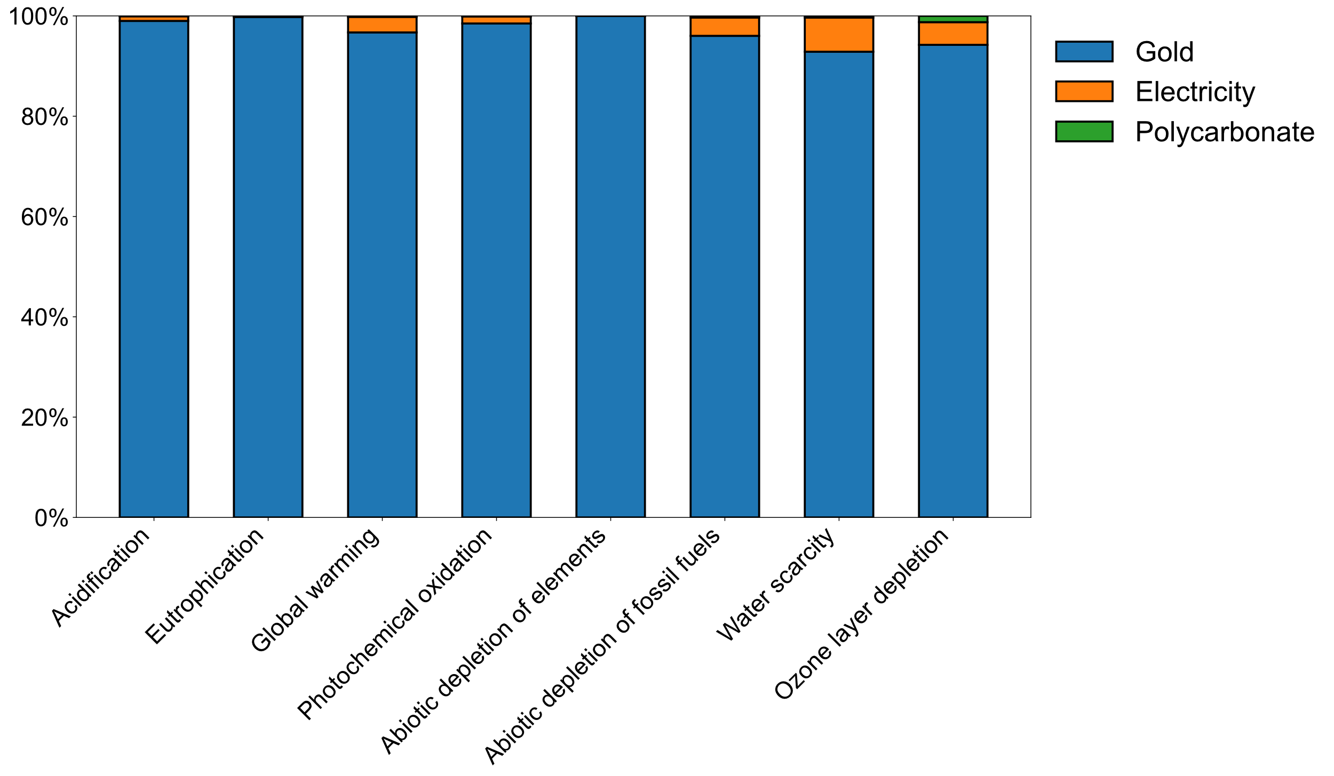

Figure 3 Contribution analysis of Sputtering process: percentage incidence of each input in the process

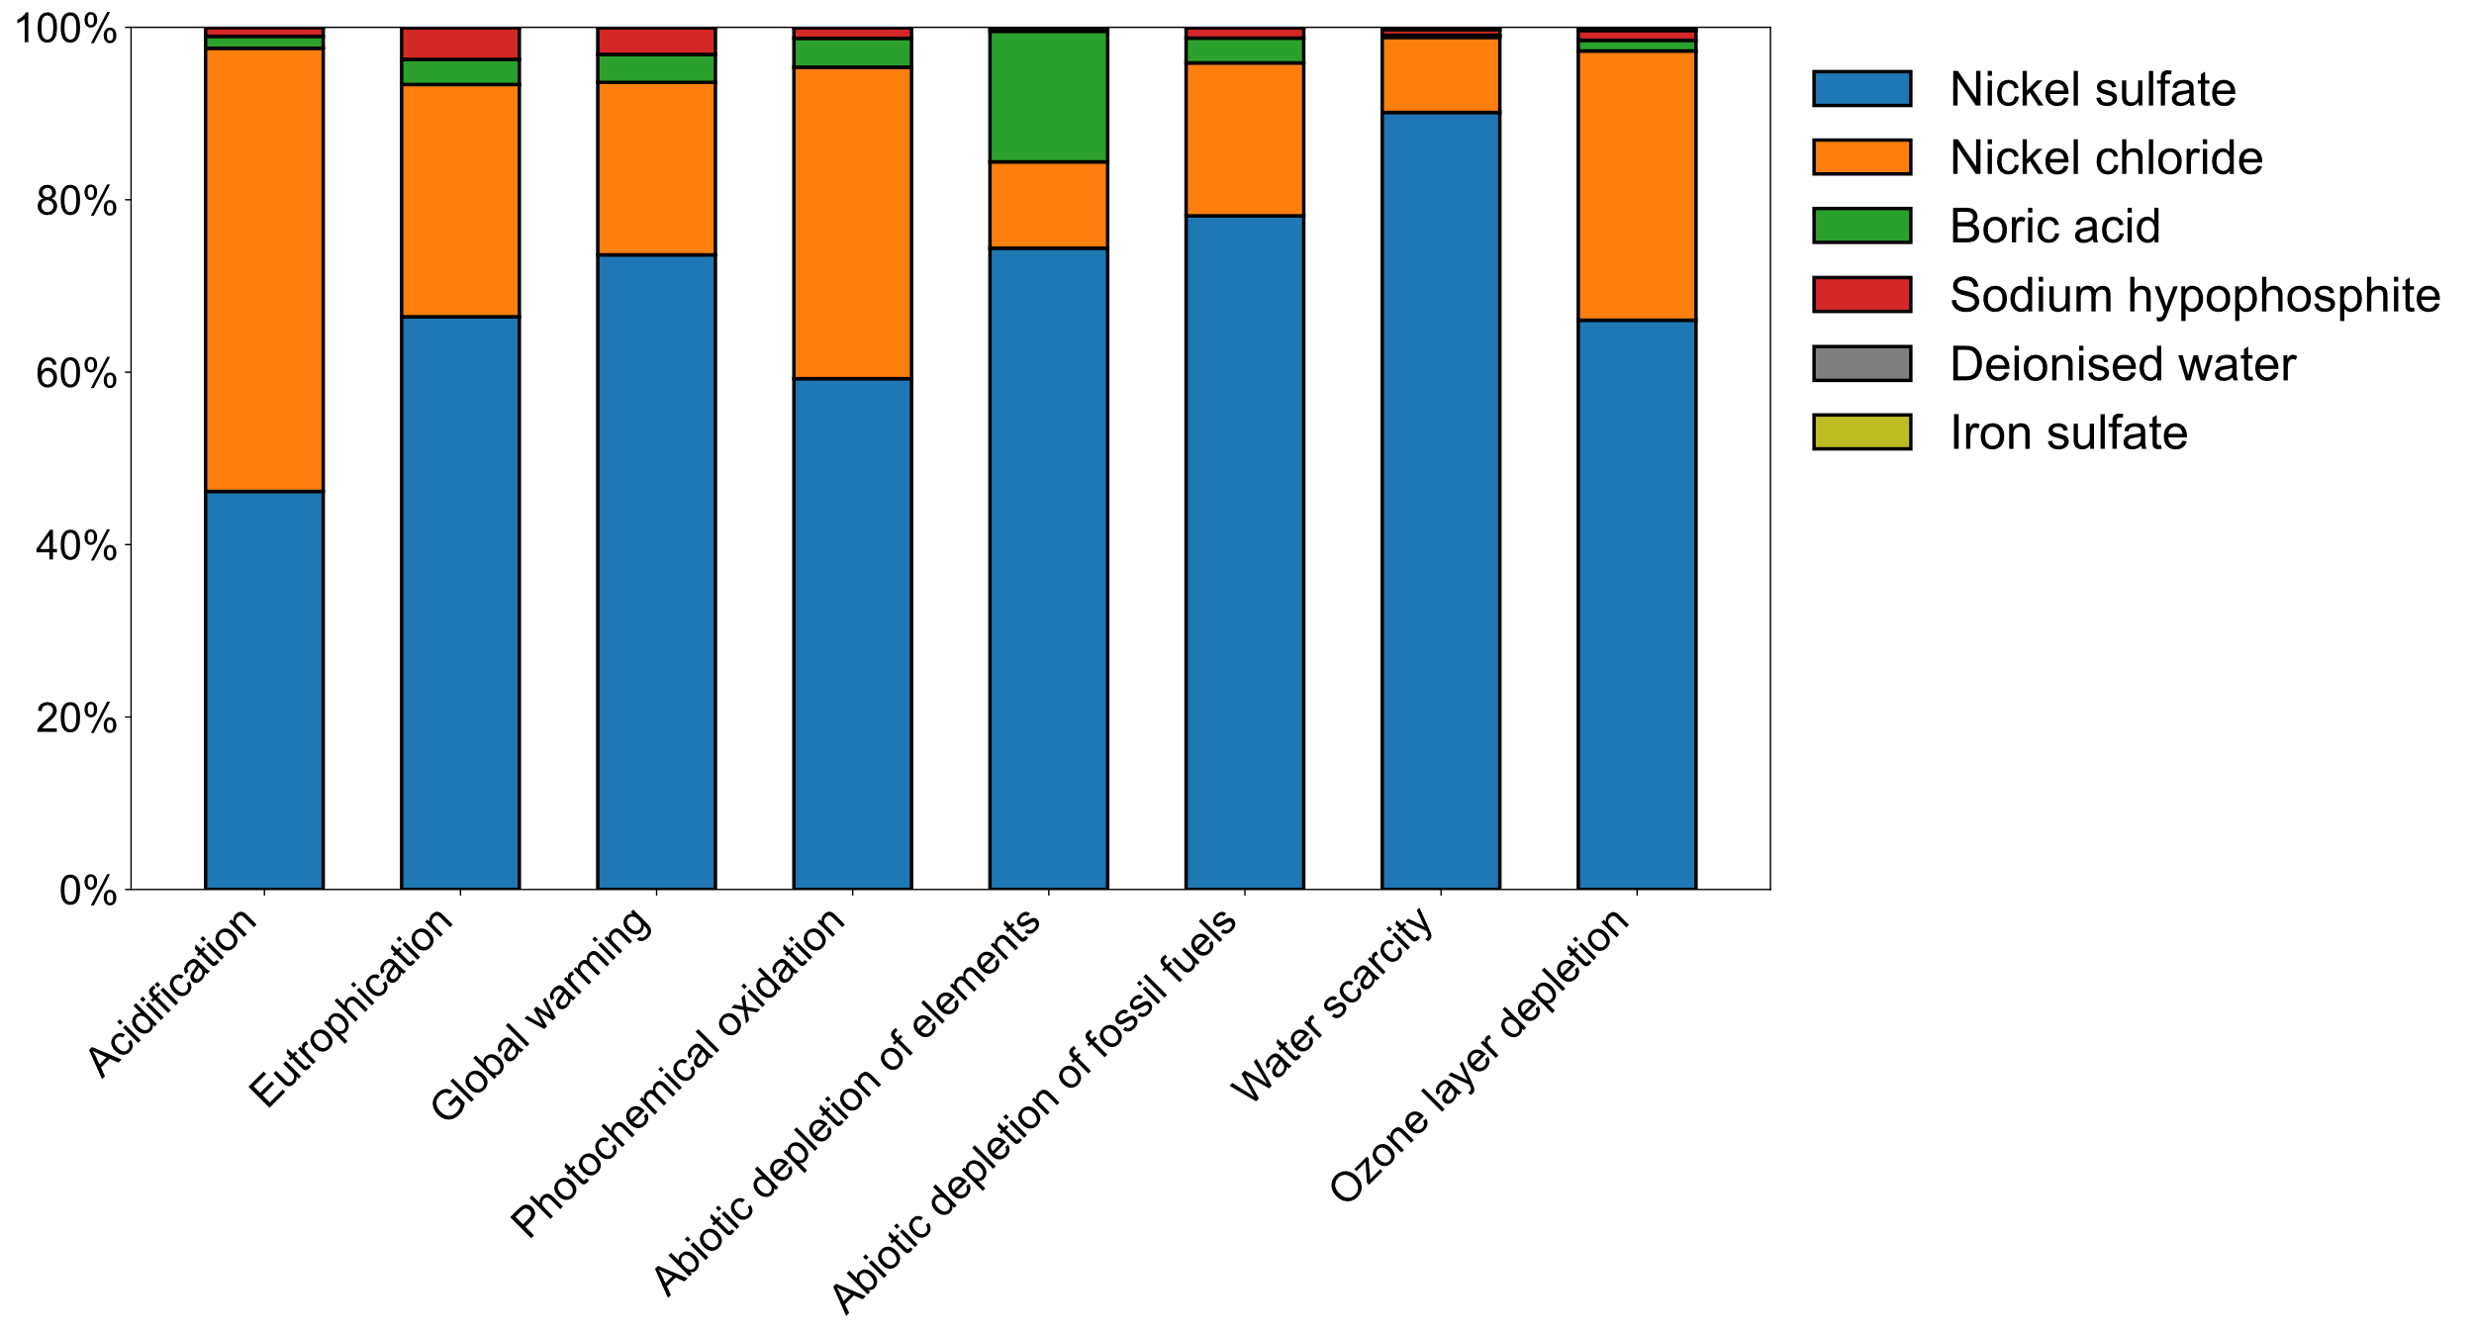

Figure 4 Contribution analysis of Electrodeposition of Electrode 2: percentage incidence of each input in the process

Further contribution analyses are conducted on the electrodeposition process of the three prototypes. Figure 3 illustrates, as an example, the results for the electrodeposition of Electrode 2 (with a sodium hypophosphite concentration of 0.9 g/L). Specifically, nickel sulfate accounts for a variable contribution ranging from 46% (acidification) to 90% (water scarcity). Similarly, nickel chloride causes impacts between 9% (water scarcity) and 51% (acidification). Boric acid reveals a minor contribution, with its impact ranging from 0.2% (water scarcity) to 15% (abiotic depletion of elements). Sodium hypophosphite is responsible for an impact between 0.4% (abiotic depletion of elements) and 4% (eutrophication). Deionised water and iron sulfate have negligible impacts, each contributing less than 1% across all impact categories.

* 1. Conclusions

In this LCA study, the energy and environmental impacts of prototype electrodes for electrolysers made from NiFeP alloy were assessed by considering three different scenarios, which were defined by varying the concentration of sodium hypophosphite. The results demonstrated that the three electrodes reveal negligible percentage differences in their environmental impacts. This lack of significant variation can be attributed to the minimal contribution of sodium hypophosphite across nearly all impact categories, with its maximum contribution reaching only 4% for eutrophication (in the case of Electrodeposition 2).

Furthermore, the contribution analysis of the electrodeposition process identifies nickel sulfate (46%-90%) and nickel chloride (9%-51%) as the main hotspots. In addition, a contribution analysis was conducted for the sputtering process highlighting that gold was the component with the highest impact across all categories, with contributions reaching a minimum of 93%.

This study provides a foundation for future LCA research of electrodes for electrolysers and for identifying eco-design strategies. Given the critical role these technologies will play in achieving decarbonization goals, the findings underscore the importance of optimizing the environmental performances particularly at low TRL. Although the results are referred to lab-scale electrodes and may not be directly comparable to established commercial technologies, they can provide important insights into the environmental impacts of the prototypes and constitute a foundational basis for future research aimed at scaling up the process. Thereby, Integrating LCA into the research and development phase, prior to the advancement of technologies to higher TRL, can facilitate informed design decisions and material selections, thereby promoting more sustainable technological pathways.

Acknowledgments

This work was financed by the project "SiciliAn MicronanOTecH Research And Innovation CEnter "SAMOTHRACE" (MUR, PNRR-M4C2, ECS\_00000022), spoke 3 - Università degli Studi di Palermo "S2-COMMs - Micro and Nanotechnologies for Smart & Sustainable Communities

References

Arsad, A.Z., Hannan, M.A., Al-Shetwi, A.Q., Hossain, M.J., Begum, R.A., Ker, P.J., Salehi, F., Muttaqi, K.M., 2023. Hydrogen electrolyser for sustainable energy production: A bibliometric analysis and future directions. International Journal of Hydrogen Energy 48, 4960–4983. https://doi.org/10.1016/j.ijhydene.2022.11.023

Buccheri, B., Ganci, F., Patella, B., Aiello, G., Mandin, P., Inguanta, R., 2021. Ni-Fe alloy nanostructured electrodes for water splitting in alkaline electrolyser. Electrochimica Acta 388, 138588. https://doi.org/10.1016/j.electacta.2021.138588

Franco, A., Giovannini, C., 2023. Recent and Future Advances in Water Electrolysis for Green Hydrogen Generation: Critical Analysis and Perspectives. Sustainability 15, 16917. https://doi.org/10.3390/su152416917

Frischknecht, R., Jungbluth, N., 2007. Implementation of Life Cycle Impact Assessment Methods.

Hu, K., Fang, J., Ai, X., Huang, D., Zhong, Z., Yang, X., Wang, L., 2022. Comparative study of alkaline water electrolysis, proton exchange membrane water electrolysis and solid oxide electrolysis through multiphysics modeling. Applied Energy 312, 118788. https://doi.org/10.1016/j.apenergy.2022.118788

I IEA (2024), World Energy Outlook 2024, IEA, Paris https://www.iea.org/reports/world-energy-outlook-2024, Licence: CC BY 4.0 (report); CC BY NC SA 4.0 (Annex A)

ISO 14040, 2021. Environmental Management: Life Cycle Assessment; Principles and Framework.

ISO 14044, 2021. Environmental Management: Life Cycle Assessment; Requirements and Guidelines.

Kouchaki-Penchah, H., Bahn, O., Bashiri, H., Bedard, S., Bernier, E., Elliot, T., Hammache, A., Vaillancourt, K., Levasseur, A., 2024. The role of hydrogen in a net-zero emission economy under alternative policy scenarios. International Journal of Hydrogen Energy 49, 173–187. https://doi.org/10.1016/j.ijhydene.2023.07.196

Li, X., Zhao, L., Yu, J., Liu, X., Zhang, X., Liu, H., Zhou, W., 2020. Water Splitting: From Electrode to Green Energy System. Nano-Micro Lett. 12, 131. https://doi.org/10.1007/s40820-020-00469-3

PRé Sustainability, Simapro, 2024. https://simapro.com/

The International EPD System, 2018. EPD Environmental Performance Indicators [WWW Document]. URL https://www.environdec.com/pcr/env-perf-indic/gpi4 (accessed 2.10.25).

Wernet, G., Bauer, C., Steubing, B., Reinhard, J., Moreno-Ruiz, E., Weidema, B., 2016. The ecoinvent database version 3 (part I): overview and methodology. Int J Life Cycle Assess 21, 1218–1230. https://doi.org/10.1007/s11367-016-1087-8

Yang, B., Zhang, R., Shao, Z., Zhang, C., 2023. The economic analysis for hydrogen production cost towards electrolyzer technologies: Current and future competitiveness. International Journal of Hydrogen Energy 48, 13767–13779. https://doi.org/10.1016/j.ijhydene.2022.12.204