|  |  |
| --- | --- |
| cetlogo ***CHEMICAL ENGINEERING TRANSACTIONS***  ***VOL. xxx, 2025*** | A publication of  aidiclogo_grande |
| The Italian Association  of Chemical Engineering  Online at www.cetjournal.it |
| Guest Editors: David Bogle, Flavio Manenti, Piero Salatino  Copyright © 2025, AIDIC Servizi S.r.l. **ISBN** 979-12-81206-21-2; **ISSN** 2283-9216 | |

Technical Assessment of a Cascade Avocado Waste Biorefinery Based on Water, Energy and Product Evaluation (WEP)

Stefany A. Valdez-Valdes, Alejandra V. Fontalvo-Morales, Ángel Darío González-Delgado\*

Chemical Engineering Department, Nanomaterials and Computer-Aided Process Engineering Research Group (NIPAC), Universidad de Cartagena, Cartagena 130014, Bolívar, Colombia.

[\*agonzalezd1@unicartagena.edu.co](mailto:*agonzalezd1@unicartagena.edu.co)

The rising global population is driving significant changes in climate and environmental conditions, emphasizing the urgent need for sustainable practices across all sectors. This study evaluates the technical performance of a cascade biorefinery for processing avocado waste from Colombia. This waste can be transformed into value-added products such as starch and bioplastic films. The assessment was conducted using the Water-Energy-Product (WEP) framework, analyzing key metrics on water and energy consumption along with product outputs. Eight critical process parameters and eleven technical indicators were calculated. Results indicate efficient resource use, with a 61.93 % fractional water consumption and an energy-specific intensity of 89.22 MJ/t. However, challenges remain, including a 46.93 % wastewater production ratio and high energy costs (50.38 %). Scenario analysis suggests that integrating renewable energy sources and enhancing material recirculation could further optimize efficiency. These findings highlight the potential of cascade biorefineries to support circular economy principles and sustainable waste management, providing a scalable model for agricultural residue valorization.

* 1. Introduction

The increasing demand for sustainable solutions in agro-industrial waste management has driven the exploration of biorefineries to valorise residues and reduce environmental impact. Avocado (*Persea Americana Mill.*), a widely cultivated fruit in Latin America, generates substantial waste, particularly from its seed, which accounts for approximately 20 % of the total fruit weight (Charles et al., 2022). Although rich in bioactive compounds, starch, and fiber, avocado seeds are largely discarded, contributing to organic waste accumulation. Implementing cascade biorefineries offers an opportunity to transform these residues into value-added products while optimizing resource use through water and energy efficiency strategies.

Colombia has experienced a significant expansion in Hass avocado cultivation, particularly in the Putumayo region, where production plays a crucial role in the local economy (García et al., 2021). Despite this growth, the avocado supply chain remains primarily focused on fresh fruit commercialization, neglecting the potential of by-products such as seeds and peels (Fajardo, 2023). To address this gap, a cascade biorefinery model has been proposed to process Hass avocado wastes into starch and biofilms, employing computer-aided process engineering for technical evaluation.

Water and energy management are critical in biorefineries, as these factors directly influence economic feasibility and environmental sustainability. The Water-Energy-Product (WEP) assessment methodology provides a structured approach to evaluating process efficiency by analyzing key indicators such as fractional water consumption, production yield, energy-specific intensity, and material recirculation (García-Maza et al., 2024). This approach allows for an in-depth examination of resource optimization and potential areas for improvement, ensuring sustainable and economically viable process development (Caporusso et al., 2022).

This study focuses on the technical assessment of a Hass avocado waste cascade biorefinery in the south of Colombia, with a particular emphasis on water and energy efficiency. Using computer-aided simulation, the cascade biorefinery process was modelled to determine material and energy balances, evaluate resource consumption, and assess the efficiency of key performance indicators. The analysis includes best- and worst-case scenarios to benchmark process performance and identify strategies to enhance sustainability. By integrating the WEP evaluation framework, this research provides valuable insights into the feasibility of implementing cascade biorefineries for avocado waste valorization. Unlike previous research, which primarily focuses on single-product valorization, such as Araújo et al. (2020) on the process optimization of microwave-assisted extraction of bioactive molecules from avocado seeds, this study examines a multi-product strategy that integrates starch extraction and biofilm production, while assessing water and energy efficiency. Additionally, process simulation was used to model resource consumption under a specific operational scenario, offering a more comprehensive technical assessment compared to prior works. The findings contribute to the advancement of circular economy strategies in the agro-industrial sector, supporting the transition toward more sustainable and efficient resource utilization practices.

* 1. Materials and methods
     1. Modelling of the cascade biorefinery topology

The cascade biorefinery consists of three main sections: starch extraction and bioplastic film production. These sections were designed to maximize raw material utilization while minimizing waste generation through material recirculation. The process begins with the washing and size reduction of avocado wastes, followed by starch extraction using wet milling, decantation, and drying (Tesfaye et al., 2018). The extracted starch is used in biofilm production, where it undergoes gelatinization with glycerol to produce biofilm1. To obtain biofilm 2, part of the incoming waste is converted into polylactic acid (PLA) through hydrolysis, fermentation, and polymerization steps (Heo et al., 2019).

The Non-Random Two-Liquid (NRTL) model with the Redlich-Kwong (RK) equation of state was selected on the simulator Aspen Plus® V14 to describe liquid and vapor phase behavior, ensuring accurate thermodynamic modeling of the biorefinery process (Smith et al., 2021). Operating conditions, such as pressure, temperature, and reaction kinetics, were determined based on experimental data and literature values. The raw material input was set at 2645.4 tons per year, corresponding to 50 % of the estimated avocado waste availability in the selected region (South of Colombia). In Figure 1, a process flow diagram illustrates the integration of different processing units and material flows within the system of the cascade biorefinery topology.

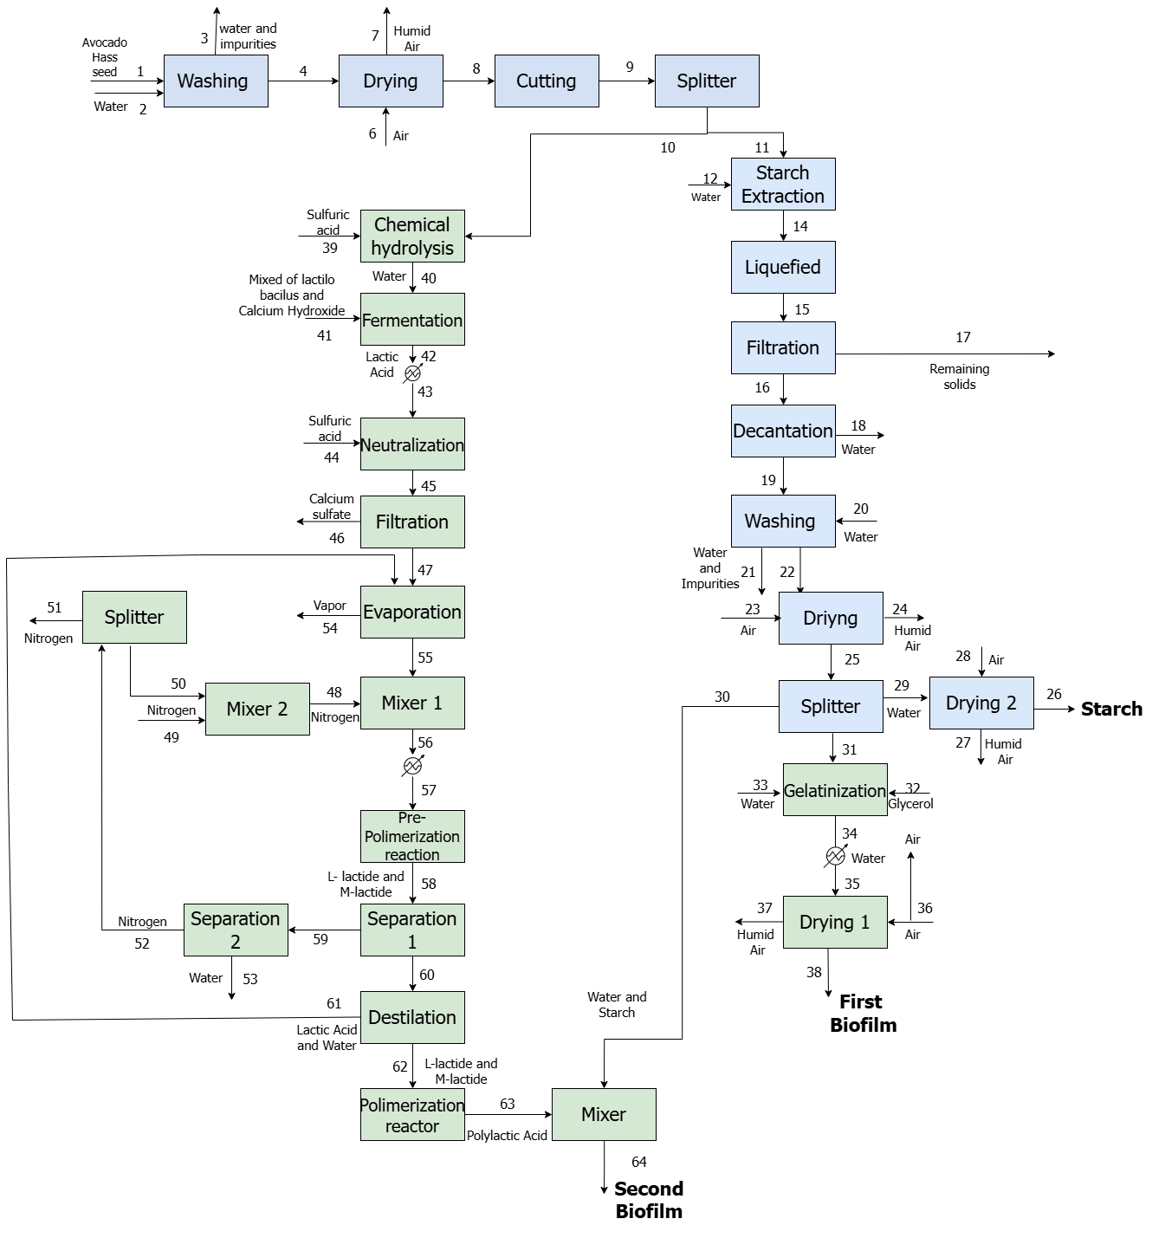

Figure 1: Process Flow Diagram of the Hass Avocado Waste Cascade Biorefinery.

* + 1. Water-Energy-Product (WEP) Technical Assessment

The sustainability and efficiency of the cascade biorefinery were evaluated using the Water-Energy-Product (WEP) assessment methodology (Aguilar-Vazquez et al., 2024), which quantifies process performance based on key indicators related to water consumption, energy efficiency, and material utilization. The WEP assessment framework has been previously used to evaluate biorefinery efficiency; however, this study expands its application by incorporating a multiproduct set of process indicators tailored to an avocado waste cascade biorefinery. The assessment included the following metrics described in Table 1.

Table 1: Technical indicators, descriptions and equations.

|  |  |  |
| --- | --- | --- |
| **Variable** | **Description** | **Equation** |
| Production yield (%) | Amount of product obtained per unit of raw material. | $$γ_{i}=\frac{Product flow}{Raw material flow}×100\%$$ |
| Fractional water consumption (m3/t) | The volume of water consumed during product manufacturing. | $$FWC=\frac{Volumetric flow of freshwater}{Product mass flow}$$ |
| Total cost of freshwater ($/day) | Overall cost of freshwater usage per unit of time. | $$TCF=Fresh water flow consumed×cost of freshwater$$ |
| Wastewater production ratio (%) | The net freshwater consumption, calculated as the required input minus the wastewater produced. | $$WPR=\frac{Wastewater volumetric flow }{Volumetric flow of freshwater}×100$$ |
| Solvent reuse index (%) | The proportion of solvent recovered and reused relative to the total solvent consumed in the process. | $$SRI=\frac{Mass flow of reused solvent}{Mass flow of used solvent}×100\%$$ |
| Total cost of energy ($/day) | Overall expenditure on energy consumption per unit of time. | $$TCE=Total energy consumed×Energy cost$$ |
| Energy specific intensity (MJ/t) | Energy usage per ton of product obtained | $$R_{ESI}=\frac{Total energy consumed}{Product mass flow}$$ |
| Net Energy ratio (Dimensionless) | The ratio of the energy content of the products to the energy input into the process. | $$NER=\frac{ {HHV}_{p}×Product mass flow}{Total energy consumed+({HHV}_{rm}×rm mass flow)}$$ |
| Energy utilization index (Dimensionless) | Shows the ratio between the energy that could be gained from the product as fuel and the energy needed. | $$EUI=\frac{ {HHV}_{product}×Product mass flow}{Total energy consumed}$$ |
| Natural gas consumption index (m3/t) | Amount of gas used per ton of product obtained. | $$NGCI=\frac{Total natural gas consumed}{Product mass flow}$$ |
| Electric energy consumption index | Amount of kilowatt-hours consumed per ton of product obtained. | $$EECI=\frac{Total electricity consumed}{Product mass flow}$$ |

The best- and worst-case scenarios were established to benchmark process efficiency by analyzing variations in key performance indicators such as energy consumption, production yield, and material recirculation. In the best-case scenario, the cascade biorefinery achieved optimal efficiency, with a production yield of 100 %, while in the worst-case scenario, the production yield dropped to 0 %. Fractional water consumption was 0.35 m³/t in the best-case scenario, reflecting efficient water use, whereas in the worst-case scenario, it increased to 0.88 m³/t due to ineffective water recycling. Wastewater generation was minimal in the best-case scenario, but in the worst-case scenario, the wastewater production ratio reached 75 %. The total cost of freshwater was reduced to 0.48 per day in the best−case scenario, but it rose significantly to 15.60 per day in the worst-case scenario, indicating excessive reliance on external water sources. Energy-specific intensity was 40.41 MJ/t in the best-case scenario, reflecting efficient energy utilization, whereas in the worst-case scenario, it increased dramatically to 240.82 MJ/t. Similarly, the electric energy consumption index was 6.9 kWh/t in the best-case scenario but doubled to 27.6 kWh/t in the worst-case scenario. Natural gas consumption was fully optimized in the best-case scenario, contributing to an improved net energy ratio, but in the worst-case scenario, its efficiency dropped to only 25.15 %, highlighting significant inefficiencies in energy utilization.

* 1. Results and discussion
     1. WEP Technical Evaluation Parameters of the Hass Avocado Waste Cascade Biorefinery

The performance of the Hass avocado waste cascade biorefinery was assessed using the Water-Energy-Product (WEP) methodology to quantify the sustainability and efficiency of the process. The evaluation considered key operational parameters, including raw material input, product yield, water consumption, and energy utilization. The biorefinery processed 27.40 kg/h of avocado waste, generating 21.46 kg/h of final products, with a total of 1.01 kg/h of recirculated material. Unconverted material was measured at 3.52 kg/h, indicating a high conversion efficiency. The cascade biorefinery had a freshwater consumption of 0.31 m³/h, while wastewater generation was up to 0.13 m³/h. In terms of energy consumption, the total energy demand for the process was 728.04 MJ/h, distributed across the different production stages, including starch extraction and biofilms production.

* + 1. WEP Technical Evaluation Indicators of the Cascade Biorefinery

Table 2 shows the summary of the WEP technical indicators obtained for the Hass avocado waste cascade biorefinery to obtain starch and biofilms.

Table 2: Results of the technical evaluation of the cascade biorefinery from Hass avocado waste.

|  |  |  |
| --- | --- | --- |
| **Indicator** | **Units** | **Value** |
| Production Yield | % | 78.34 |
| Fractional Water Consumption (FWC) | m3/t | 0.55 |
| Total Cost of Freshwater (TCF) | USD/day | 3.02 |
| Wastewater Production Ratio (WPR) | % of water utility | 39.80 |
| Index of Reused Unconverted Material (IRUM) | % of material not converted | 28.80 |
| Total Cost of Energy (TCE) | USD/day | 1,013.52 |
| Energy Specific Intensity (ESI) | MJ/t | 62,004.30 |
| Natural Gas Consumption Index (NGCI) | % | 50.29 |
| Electric Energy Consumption Index (EECI) | % | 13.78 |
| Net Energy ratio (NER) | Dimensionless | 0.18 |
| Energy Usability Index (EUI) | Dimensionless | 0.24 |

The parameters evaluated in the process highlight the technical efficiency achieved in the cascade biorefinery. The total mass of Hass avocado waste processed is 27.40 kg/h, from which 21.46 kg/h of products are generated, equivalent to a mass yield of 78.34 %. This shows a significant utilization of the raw material, with only 3.52 kg/h of unconverted material. In addition, the flow of recirculated material (1.01 kg/h) suggests that the integration of the process optimizes the use of resources, reducing losses and promoting internal reuse. In terms of resource consumption, the process uses a moderate volume of fresh water (0.31 m³/h) and generates a low volume of wastewater (0.13 m³/h), indicating efficient water management in line with sustainability principles. However, total energy consumption is 728.04 MJ/h, underscoring the need to explore energy integration strategies to reduce operating costs and improve environmental performance. These parameters provide a solid basis for assessing the viability of the process, highlighting both its strengths and opportunities for improvement.

* + 1. Efficiency of Technical Evaluation Indicators

To further assess the effectiveness of the cascade biorefinery, the technical evaluation indicators were compared against best- and worst-case scenarios to determine their efficiency. Figure 2 illustrates the effectiveness of the nine metrics evaluated in the production process of starch and biofilms derived from Hass avocado wastes. It is important to note that the NER and EUI metrics were excluded from this analysis due to their specific nature and calculation methods, which do not yield values suitable for normalization into percentages. Consequently, these metrics did not contribute to the overall evaluation. The remnant indicators, however, provide insight into the efficiency of the process concerning energy consumption, mass utilization, and output. Additionally, it highlights potential areas where optimization alternatives could enhance performance. The efficiency evaluation highlights both strengths and areas for improvement in the cascade biorefinery process. The Production Yield (78.34 %) reflects effective conversion of avocado waste into valuable products, underscoring the robustness of the process design. However, the Index of Reused Unconverted Material (IRUM, 28.80 %) suggests a missed opportunity to optimize material recirculation. Enhancing resource efficiency could involve refining extraction parameters (e.g., pH, temperature, solvent ratio) or employing advanced separation methods such as ultrafiltration and supercritical fluid extraction (Poveda-Giraldo et al., 2021). Additionally, secondary valorization of unconverted residues, such as fermentation for bioethanol or biochar synthesis (Trinca et al., 2024), could further reduce waste and enhance sustainability.

Figure 2: Performance of the technical indicators for the Hass avocado wastes cascade biorefinery.

Water and wastewater management indicators present a controlled but improvable performance. The Fractional Water Consumption (FWC, 61.93 %) and Total Cost of Freshwater (TCF, 83.23 %) indicate good efficiency, but the Wastewater Production Ratio (WPR, 46.93 %) suggests that nearly half of the water used becomes wastewater. Implementing advanced water treatment and reuse strategies, such as membrane filtration (ultrafiltration, reverse osmosis) and electrocoagulation, could improve process sustainability (Radelyuk et al., 2023). A closed-loop water system, where wastewater is treated and reused, would further enhance efficiency, particularly in regions with limited water resources. Energy-related indicators highlight mixed performance. While the Energy-Specific Intensity (ESI, 89.22 %) demonstrates high efficiency, the Total Cost of Energy (TCE, 50.38 %) and Natural Gas Consumption Index (NGCI, 33.59 %) indicate a need for better energy cost management. The Electric Energy Consumption Index (EECI, 66.67 %) suggests a higher reliance on electricity compared to natural gas. To improve energy efficiency, heat recovery systems such as waste heat exchangers and cogeneration using biogas from process residues could be explored (Stampfli et al., 2019; Potrc et al., 2021).

A comparison with the extractive-based biorefinery studied by García-Maza et al. (2024) reveals notable differences in process performance. The extractive-based biorefinery, which utilizes the entire Creole-Antillean avocado (pulp, peel, and waste), had a lower production yield (61.63 %) than the cascade biorefinery (78.34 %), likely due to differences in feedstock optimization. Water efficiency was significantly higher in the cascade biorefinery, with an FWC of 0.55 m³/t compared to 2.45 m³/t in the extractive-based system. Additionally, WPR efficiency was 94 % in the extractive-based biorefinery versus 46.94 % in the cascade, indicating greater wastewater challenges in the former. Energy performance also varied: TCE efficiency was higher in the extractive-based biorefinery (95 %) compared to 50.38 % in the cascade system, reflecting higher energy intensity. The ESI efficiency was 74 % in the extractive-based system and 89.22 % in the cascade biorefinery, demonstrating lower energy consumption per ton of product in the latter. The NGCI efficiency (77 %) in the extractive-based biorefinery was more than twice that of the cascade system (33.59 %), indicating a higher dependency on natural gas. Conversely, EECI efficiency was 90 % in the extractive-based biorefinery, compared to 66.67 % in the cascade, suggesting greater reliance on electricity. These performance differences are largely due to variations in process design and feedstock selection. The extractive-based biorefinery operates at a higher processing capacity, while the cascade biorefinery focuses solely on avocado waste, affecting resource utilization and efficiency. This comparison underscores the importance of tailored process configurations to optimize energy, water, and material flows in biorefinery systems.

* 1. Conclusions

The technical assessment of the Hass avocado waste biorefinery in the south of Colombia demonstrated the feasibility of implementing a cascade biorefinery model to optimize resource utilization and minimize waste. The Water-Energy-Product (WEP) evaluation framework provided key insights into process efficiency, highlighting the importance of water and energy management in sustainable bioprocessing. The cascade biorefinery achieved a production yield of 78.34 %, demonstrating efficient conversion of avocado waste into value-added products. Efficiency indicators revealed the strengths and challenges of the process. Water usage was relatively efficient, with a Fractional Water Consumption (FWC) of 61.93 %, but the Wastewater Production Ratio (WPR) of 46.93 % indicates a need to enhance water recycling systems. Energy analysis showed an Energy Specific Intensity (ESI) of 89.22 %, reflecting high-energy efficiency, but costs related to energy consumption (Total Cost of Energy, 50.38 %) and reliance on non-renewable sources (Natural Gas Consumption Index, 33.59 %) underscore opportunities for integrating renewable energy systems. By comparing best- and worst-case scenarios, the study identified key opportunities to enhance process efficiency, particularly in reducing natural gas and electricity consumption. The findings underscore the potential of cascade biorefineries in the circular economy, providing a foundation for further research and industrial application of sustainable bioprocesses for agricultural residues.

Acknowledgments: The authors gratefully acknowledge the financial support provided by the Universidad de Cartagena and the Colombian Ministry of Science, Technology, and Innovation (Minciencias). This work was funded under the project SIGP 100307 and contract 442-2023.

References

Aguilar-Vásquez, E., Ramos-Olmos, M., & González-Delgado, Á. D., 2023, A joint Computer-Aided Simulation and Water-Energy-Product (WEP) approach for technical evaluation of PVC production. Sustainability, 15(10), 8096.

Araújo, R. G., Rodriguez-Jasso, R. M., Ruiz, H. A., Govea-Salas, M., Pintado, M. E., & Aguilar, C. N., 2020, Process optimization of microwave-assisted extraction of bioactive molecules from avocado seeds. Industrial Crops and Products, 154, 112623.

Caporusso, A., Giuliano, A., Liuzzi, F., & De Bari, I., 2022, Techno-economic analysis of a lignocellulosic biorefinery producing microbial oils by oleaginous yeasts. Chemical Engineering Transactions, 92, 637-642.

Charles, A. C., Dadmohammadi, Y., & Abbaspourrad, A., 2022, Food and cosmetic applications of the avocado seed: a review. Food & Function, 13(13), 6894-6901.

Fajardo Aguirre, L., 2023, Business proposal for the reduction of environmental impacts associated with solid waste in Hass avocado (*Persea americana*) crops, case study, La Aurora farm, Sibundoy-Putumayo (in Spanish). Universidad Tecnológica de Pereira. Available in: https://hdl.handle.net/11059/14524

García, J. S. A., Hurtado-Salazar, A., & Ceballos-Aguirre, N., 2021, Current overview of Hass avocado in Colombia. Challenges and opportunities: a review. Ciência Rural, 51(8). https://doi.org/10.1590/0103-8478cr20200903

García-Maza, S., Herrera-Rodríguez, T. C., & González-Delgado, Á. D., 2024, Process Simulation and Technical Evaluation Using Water-Energy-Product (WEP) Analysis of an Extractive-Based Biorefinery of Creole-Antillean Avocado Produced in the Montes De María. Sustainability, 16(21), 9575.

Heo, S., Park, H. W., Lee, J. H., & Chang, Y. K., 2019, Design and Evaluation of Sustainable Lactide Production Process with an One-Step Gas Phase Synthesis Route. ACS Sustainable Chemistry & Engineering, 7(6), 6178–6184.

Potrc, S., Nemet, A., Cucek, L., & Kravanja, Z., 2021, Energy Integration within Sectors to improve the Efficiency of Renewable Energy System within the EU. Chemical Engineering Transactions, 88, 1153-1158.

Poveda-Giraldo J.A., Piedrahita-Rodríguez S., Cardona-Alzate C.A., 2021, Life Cycle Analysis of Biotechnological Processes based on the Composition of the Raw Material. Eucalyptus, Avocado, and Plantain cases in a Biorefinery System, CET Journal-Chemical Engineering Transactions, 83.

Radelyuk, I., Klemeš, J. J., Jia, X., & Yelubay, M., 2023, Implementation of Circular Economy in the Water Sector in the Industrial Region of Kazakhstan. Chemical Engineering Transactions, 103, 13-18.

Smith, J. M., Van Ness, H. C., Abbott, M. M., & Swihart, M. T., 2021, Introduction to Chemical Engineering Thermodynamics.

Stampfli, J. A., Lucas, E. J., Olsen, D. G., Krummenacher, P., & Wellig, B., 2019, Batch Process integration: Management of Capacity-Limited thermal energy storage by optimization of heat recovery. Chemical Engineering Transactions, 76, 1027-1033.

Tesfaye, T., Gibril, M., Sithole, B., Ramjugernath, D., Chavan, R., Chunilall, V., & Gounden, N., 2018, Valorisation of avocado seeds: extraction and characterisation of starch for textile applications. Clean Technologies and Environmental Policy, 20(9), 2135–2154.

Trinca A., Di Palma L., Verdone N., 2024, Innovative Solutions for a Circular Economy: a Review on Waste to Chemicals Valorization Plants, Chemical Engineering Transactions, 109, 391-396.