|  |  |
| --- | --- |
| cetlogo ***CHEMICAL ENGINEERING TRANSACTIONS***  ***VOL. xxx, 2025*** | A publication of  aidiclogo_grande |
| The Italian Association  of Chemical Engineering  Online at www.cetjournal.it |
| Guest Editors: David Bogle, Flavio Manenti, Piero Salatino  Copyright © 2025, AIDIC Servizi S.r.l. **ISBN** 979-12-81206-21-2; **ISSN** 2283-9216 | |

Dynamic simulation and Residence time Optimization of an Autohydrolysis Reactor for the Valorization of Lignocellulosic Waste

Mattia Vallerioa, Giorgia Spignob, Flavio Manentia, Andrea Bassanib,\*

aDipartimento di Chimica, Materiali e Ingegneria Chimica “Giulio Natta”, Politecnico di Milano, Piazza Leonardo Da Vinci, 32, Milan, 20133, Italy

bUniversità Cattolica del Sacro Cuore, Department for Sustainbale Food Process (DiSTAS), Via Emilia Parmense 84, 29122 Piacenza, Italy

[andrea.bassani@unicatt.it](mailto:andrea.bassani@unicatt.it)

Lignocellulosic residues from agricultural and food-processing activities are increasingly recognized as promising feedstocks for the development of bio-based materials and sustainable energy carriers. In this framework, the Cyclevit project investigates a hybrid valorization approach combining autohydrolysis and organosolv treatments to extract cellulose and lignin, which are precursors for vitrimers—recyclable polymer networks. This study had two primary goals: to carry out a dynamic simulation in the Pomodoro toolkit of the autohydrolysis process using a previously established kinetic model, and to optimize the residence time in the reactor. The kinetic model accounts for heat and mass transfer and simulates the thermal degradation of hemicellulose and cellulose. Regarding optimization, the results showed sigmoidal degradation trends and stressed the need to fine-tune residence time to enhance hemicellulose solubilization while minimizing cellulose loss. These results lay the groundwork for a full dynamic optimization of the investigated reactor, including a possible extension to multi-objective optimization to explore the trade-offs with energy consumption with a systematic approach.

* 1. Introduction

Biomass and agro-food waste byproducts can be valuable resources for energy and/or value-added compound production through thermochemical and fractionation processes. In recent times, numerous pretreatment and fractionation methods for lignocellulosic biomass have been investigated to improve the production of biofuels or chemicals (Prasad et al., 2023). Additionally, these techniques have been utilized to extract antioxidants, phenolic compounds, cellulose, and lignin from residues such as wheat straw and rice husk, thereby enhancing environmental sustainability. One example is the use of potentially eco-friendly autohydrolysis processes, which are being researched both as a promising pretreatment to improve the production of chemicals (e.g., butanol or ethanol) from woody materials (Amiri and Karimi, 2015) and as an alternative to traditional mild acid hydrolysis for recovering antioxidants and/or lignin and cellulose for biofuel/energy production or as a polymer base. The latter is the focus of the Cyclevit project, which aims to explore the transformation of lignocellulosic agro-industrial residues into valuable materials, with a particular emphasis on producing vitrimers, a class of recyclable and adaptable polymer networks (Cipriani et al., 2024). In brief, one of the project's steps is to develop and optimize combined autohydrolysis and organosolv treatments to recover cellulose and lignin (i.e., the basic compounds for vitrimers production) from different residues. In this context, creating kinetic and reactor models that can accurately represent and simulate autohydrolysis pretreatment is essential for fully utilizing the potential of biomasses or agricultural residues. Scientific literature has explored various mathematical models related to autohydrolysis, such as the severity factor model, response surface methodology, and kinetic model. However, the first two models have several limitations, like inadequate consideration of heating and cooling phases and the need for a large amount of experimental data to calibrate the model, while the kinetic models, despite overcome some of these issues, they have been little investigated and therefore still present lack of flexibility for reuse model itself with different kind of biomass. Nevertheless, such models could be used to optimize the process, for example, by identifying the optimal temperature profile to reduce or separate a specific compound, reducing at the same time the energy consumption. Therefore, the main objective of this work was to carry out an initial dynamic optimization of the autohydrolysis treatment using the kinetic model developed by Bassani et al. (2021), implemented through the Pomodoro software (Bhonsale et al., 2018).Specifically, the autohydrolysis process is optimized to identify the operating conditions that maximize hemicellulose solubilization while minimizing cellulose dissolution, to preserve as much cellulose as possible in the solid residue at different temperature. Finally, using these optimal conditions, the potential recovery yield of cellulose and lignin will be estimated by combining the autohydrolysis and organosolv processes.

* 1. Material and Methods

This section briefly describes both the kinetic model and the dynamic optimization framework used and presents the parameter estimation methodology developed and validated to enable the application of the kinetic model to different types of biomass.

* + 1. Kinetic model

As previously mentioned, the kinetic model used for the autohydrolysis treatment is the one developed by Bassani et al. (2021). This model is based on mass and energy balances, which allows the simulation to include both the heating and cooling phases. Moreover, it incorporates an initial approach to predict the degradation of cellulose and hemicellulose as a function of the amount of water used. The kinetic scheme adopted is relatively simple and essentially simulates the degradation of cellulose and hemicellulose through the formation of their respective oligosaccharides, followed by the production of the corresponding monosaccharides (glucose and xylose) and sugar degradation products. The kinetic laws are pH-dependent and follow the traditional Arrhenius equation.

* + 1. Optimal-control problem (OCP) formulation and solution

The batch autohydrolysis simulation and optimization is posed as a parametric optimal-control problem (Bhonsale et al., 2018):

|  |  |
| --- | --- |
|  | (1) |

Where, *x* represents the state variables, *u* the control variable, *p* the fixed parameters, *f* is the system of ODEs or DAEs, *J* is the objective function – both Lagrange and Mayer terms can be defined. All functions are assumed twice differentiable, fulfilling the regularity conditions required by the optimisation algorithms used in the backhand.

Following the methodology outlined by Biegler (2007), the continuous optimal control problem (OCP) is reformulated as a sparse nonlinear programming (NLP) problem using orthogonal collocation on third-order Radau points. This process begins by dividing the integration interval into a finite number of elements (50 in this work). Within each of these elements, the state and control trajectories are approximated using high-order polynomials. The coefficients of these polynomials then serve as the decision variables in the NLP. To ensure that the system dynamics are accurately captured, collocation residuals are used to enforce the differential equations (specifically, Eq. 1b) at the Radau points. Meanwhile, the remaining equations (1c through 1e) are directly translated into algebraic constraints within the NLP formulation. Unlike single or multiple-shooting methods, this fully discrete collocation approach eliminates the need for an external ODE solver. All decision variables are handled internally by the optimizer, which is particularly beneficial when dealing with stiff reaction networks, such as those encountered in autohydrolysis.

The numerical solution of the resulting NLP is handled using a combination of *CasADi* and *Pomodoro*. CasADi provides algorithmic differentiation in both forward and reverse modes, enabling the generation of exact sparse Jacobians and Hessians (Andersson et al., 2019), while Pomodoro offers a high-level interface that automates the construction of collocation meshes, implements normal-boundary-intersection scalarization for multi-objective problems, and facilitates the transfer of the problem to an NLP solver (Hashem et al., 2017). The solver used is IPOPT, which operates within an interior-point framework and can be seamlessly replaced by BONMIN for mixed-integer problems without requiring code modifications. Thanks to the use of exact derivatives and the exploitation of sparsity, large scale dynamic optimization problems can be solved with an efficient use of computational resources and time. This direct-collocation, derivative-rich strategy closely follows the dynamic optimization framework described by Bhonsale et al. (2016) and serves as the foundation for all simulations and optimizations presented in this article.

* + 1. Preliminary Estimation of Energy Consumption in the Auto-Hydrolysis Process

The assessment of energy consumption during the auto-hydrolysis process requires consideration of several factors, including the heating capacity of the jacketed fluid or electric resistance, the thermal isolation of the system from the external environment (which is particularly critical during the isothermal phase), and the design of the equipment, especially the available heat exchange surface. Although the current kinetic model includes an equation capable of estimating temperature variations during the heating and cooling phases, it does not account for all these potential variables. Nevertheless, even a rough estimate of energy consumption can be valuable for identifying optimal operating conditions. Therefore, as a preliminary approximation, the empirical formula proposed by Zhang et al. (2020) was adopted, as reported below:

|  |  |
| --- | --- |
| $$EC\left(kWh\right)=\frac{\left[\frac{T-20}{5\frac{°C}{min}}\left(590W+210W\right)+\left(150W+210W\right)t\right]}{60000}$$ | (2) |

where *t* is the time in min of the isothermal phase, the heating speed was 5 °C/min, 590 W and 150 W are the power of heating and temperature control phase (i.e isothermal phase) respectively and 210 W is the power consumed by the agitator. It is important to emphasize, as previously mentioned, that the energy consumption and heating rates derived from the empirical formula are specific to the reactor used by Zhang et al. (2020). Moreover, this formula does not account for the energy consumption associated with the cooling phase. However, this omission can be considered negligible, as cooling is often achieved using cold water, which can potentially be recycled within the system.

* 1. Results and Discussions
     1. Autohydrolysis Simulation and Optimization

Using the proposed kinetic model, implemented in the dynamic simulation and optimization software (CasADi and Pomodoro), it was first possible to simulate an autohydrolysis treatment on wheat straw under the operating conditions reported by Sidiras et al. (2011). These authors conducted autohydrolysis experiments with a solid-to-liquid ratio of 1:20 (g/mL), reaching four different final temperatures (160 °C, 180 °C, 200 °C, and 240 °C), each maintained for six different residence times (0, 10, 20, 30, 40, and 50 minutes). Additionally, both the heating and cooling ramps were replicated based on the experimental data provided by Sidiras et al. (2011). The software, integrating and coupling mass- and energy-balance ODEs and returns the time profile of each component, including the degradation of cellulose and hemicellulose, as reported in Figure 1, where x0 and x1 are the hard and easy to dissolve hemicellulose concentrations (w/w%), while x4 and x5 are the hard and easy to dissolve Cellulose concentrations.

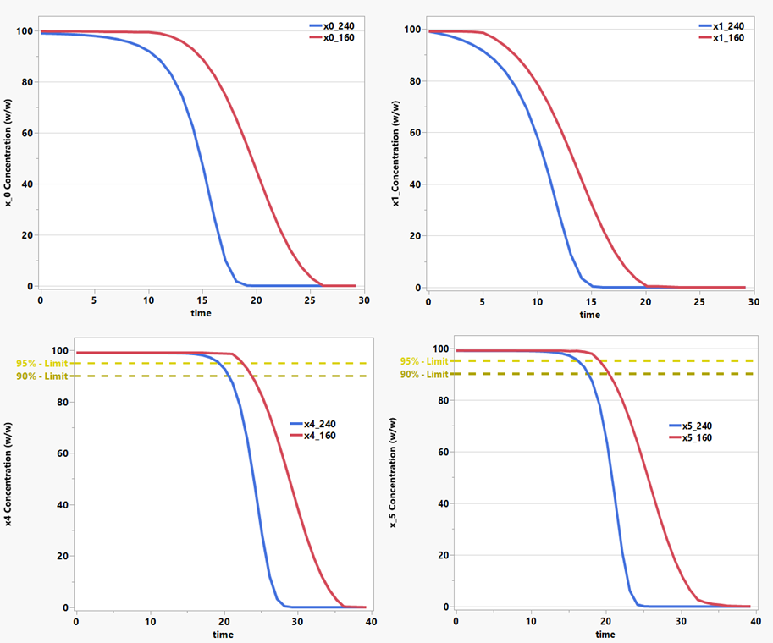

*Figure 1: The figure plots the residual cellulose and hemicellulose in the recovered solid (%) versus residence time (τ).* x0 and x1 are the hard and easy to dissolve hemicellulose concentrations (w/w%), x4 and x5 are the hard and easy to dissolve Cellulose concentrations

The results obtained exhibit a sigmoidal-like behavior for both hemicellulose and cellulose degradation. In fact, these trends show a specific residence time in the reactor beyond which a rapid degradation of the target compound occurs. The following table summarizes some residence times that may be relevant for this study.

Table 1: Inflection time and time need for complete degradation of Hemicellulose and Cellulose at different temperatures

|  |  |  |  |  |  |  |  |  |  |  |
| --- | --- | --- | --- | --- | --- | --- | --- | --- | --- | --- |
|  |  |  | *Hemicellulose x0* | | | | *Cellulose x4* | | | |
|  |  |  | 160°C | 180°C | 200°C | 240°C | 160°C | 180°C | 200°C | 240°C |
| Inflection time [min] | | | 20.1 | 18.9 | 16.4 | 15.1 | 29.2 | 28.1 | 26.6 | 24.2 |
| Time to have ∼0% of residual component | | | 28.2 | 26.6 | 23.5 | 20.3 | 38.2 | 35.7 | 33.1 | 30.3 |

The objective of the autohydrolysis treatment, as defined within the Cyclevit project, is to remove as much hemicellulose as possible while minimizing cellulose degradation. The cellulose is intended to be subsequently separated from lignin through an organosolv process. As shown in Table 1, the time required for complete hemicellulose degradation increases as the temperature decreases. However, higher temperatures may lead to increased energy consumption and require tighter control over processing times, since even small variations in residence time could promote cellulose degradation. For example, residence time in the 22–25 min window at 240°C (i.e. 2 to 5 minutes after the inflection point to have 0% of Hemicellulose), corresponds to a degradation of cellulose from 78% to 26%, thus resulting in a about 70% loss of cellulose in only 5 minutes. Considering this aspect, Table 2 reports the cellulose and hemicellulose conversion rates at the four temperatures under investigation, based on an optimal residence time range within the auto-hydrolysis reactor. This range was defined using an optimal range for the remaining cellulose 95% to 90% as the lower and upper limit of residence time, beyond which cellulose degradation becomes excessively rapid. It can be seen how optimal control of temperature and residence time will be critical to achieve the desired performance in this first reactor.

Table 2: Comparison at different temperatures of the residual hemicellulose in the solid after autohydrolysis and of the relative energy consumption considering a range of residence time to recover 95-90% of cellulose.

|  |  |  |  |  |  |  |  |  |  |  |  |
| --- | --- | --- | --- | --- | --- | --- | --- | --- | --- | --- | --- |
|  |  |  | *160°C* | | | *180°C* | | *200°C* | | *240°C* | |
|  |  |  | *min* | *max* | *min* | | *max* | *min* | *max* | *min* | *max* |
| Range of Optimal Residence Time for a range of 95%-90% residual cellulose [min] | | | 21.34 | 24.7 | 20.23 | | 23.45 | 19.8 | 22.4 | 19.10 | 21.20 |
|  | | |  |  |  | |  |  |  |  |  |
| Range of residual hemicellulose [%] | | | 22.3 | 7.4 | 15.50 | | 4.30 | 4.30 | 0.40 | 0.10 | 0.0 |
| Energy Consumption [kW\*h] | | | 0.50 | 0.52 | 0.55 | | 0.57 | 0.60 | 0.61 | 0.70 | 0.71 |

As previously discussed, both hemicellulose and cellulose degradation remain more stable at lower temperatures within the optimal residence time range, thereby enabling better process control. In this context, the condition at 200 °C appears to be the most favorable, as it allows for greater cellulose preservation while achieving near-complete hemicellulose removal. However, when energy consumption is also taken into account, a slightly decreasing trend is observed up to 240 °C This “slightly decrease” can be attributed to the higher heating energy demands at elevated temperatures, which is mitigated by the longer treatment times required at lower temperatures. Consequently, the consumption at 180°C and 200°C is quite similar, validating the choice of 200°C as the optimal conditions for this work. Indeed, this temperature offers a favorable balance between minimal cellulose degradation and reduced energy consumption. It is important to note that the optimization was conducted by evaluating each of the four temperatures (i.e., 160 °C, 180 °C, 200 °C, and 240 °C) independently. A more comprehensive optimization would require identifying the optimal operating temperature itself. This aspect will be addressed in future studies, which will aim to introduce generalized equations adaptable to different reactor configurations and heating profiles, rather than relying on an empirical formula tailored to a specific reactor type, as done in the present work.

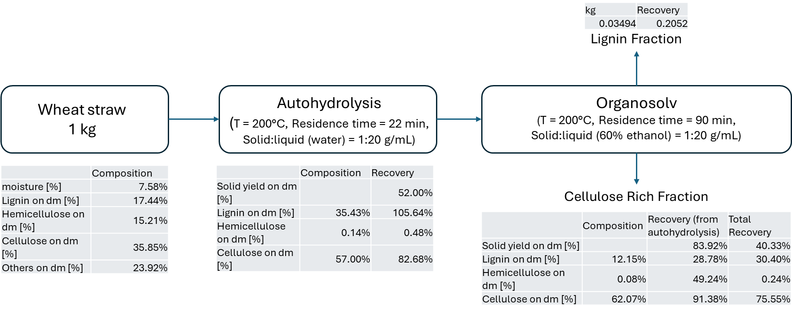

*Figure 2: Estimation of Lignin and Rich-Cellulose solid fraction obtained with a combined treatment of autohydrolysis and organosolv from wheat straw*

Finally, Figure 2 presents an estimate of the production of lignin and a cellulose-rich solid fraction obtained from wheat straw through a combined autohydrolysis and organosolv process. The optimal conditions for the autohydrolysis step were taken from the present study, while those for the organosolv process were adopted from Cipriani et al. (2024), although they were not optimized. As shown, the final solid yields are not particularly high, especially in the case of lignin. However, it is expected that by applying the same optimization approach used in this study to the organosolv process, the overall yield could be further improved.

* 1. Conclusions

This work shows a preliminary study for the dynamic optimization of an autohydrolysys reactor for for the valorization of lignocellulosic Waste. The developed dynamic model was used to perform a dynamic optimization in which the residence time was optimized to achieve the optimal residual concentration of cellulose between 90% and 95% while completely dissolving the hemicellulose for different temperature profiles. This analysis is a first step towards complete dynamic optimiztion of the autohydrolysys reactor and the organosolv reactor. This work is open to different interesting future develpments like: (i) CSTR modeling of autohydrolysis, where continuous liquor withdrawal is expected to enhance xylan removal at shorter residence times; (ii) developing a kinetic model for the organosolv delignification step, enabling optimization of dissolution time to maximize residual lignin in the solid phase; (iii) Training artificial neural networks (ANNs) on expanded datasets to improve predictive accuracy and deliver real-time uncertainty quantification; (iv) Linking the optimized process outputs to the CORO (Capex/Opex Robust Optimizer) (Bozzini et al., 2023) framework to provide a preliminary assessment of the economic feasibility of the proposed system. Overall, the developed framework marks a significant step toward the flexible and sustainable optimization of bio-based value chains, supporting the transformation of agro-industrial residues into high-value materials such as vitrimers.

Acknowledgments

This research was supported and funded by Fondazione Cariplo through the project “CYCLEVIT - Closing the loop: Green process for transforming highly heterogeneous biomasses into novel bio-based vitrimer composites” (2021-0757 grant) and by National Research Centre for Agricultural Technologies (Agritech)” CN00000022. PNRR-M4C2, Investment 1.4 - Funded by the European Union - NextGenerationEU” - CUP: J33C22001160007.

References

Andersson J. A., Gillis J., Horn G., Rawlings J. B., Diehl, M, 2019, CasADi: a software framework for nonlinear optimization and optimal control, Mathematical Programming Computation, 11, 1-36.

Amiri H., Karimi K., 2015, Autohydrolysis: A promising pretreatment for the improvement of acetone, butanol, and ethanol production from woody materials, Chemical Engineering Science, 137, 722-729.

Bassani A., Fiorentini C., Garrido G. D., Carullo D., Spigno G., 2021, Kinetic model of wheat straw autohydrolysis considering heating and cooling phases, Chemical Engineering Transactions, 87, 199-204.

Biegler L. T., 2007, An overview of simultaneous strategies for dynamic optimization. Chemical Engineering and Processing: Process Intensification, 46(11), 1043-1053.

Bhonsale S. S., Vallerio M., Telen D., Vercammen D., Logist F., Van Impe J., 2016, Solace: An open source package for nolinear model predictive control and state estimation for (bio) chemical processes. In Computer Aided Chemical Engineering (Vol. 38, pp. 1971-1976). Elsevier.

Bhonsale S., Telen D., Vercammen D., Vallerio M., Hufkens J., Nimmegeers P., Van Impe, J., 2018, Pomodoro: A novel toolkit for dynamic (multiobjective) optimization, and model based control and estimation, IFAC-PapersOnLine, 51(2), 719-724.

Bozzini M., Prifti K., Galeazzi A., Manenti F., 2024, Capex Opex Robust Optimization: a Software for Well-founded Economic Estimations and Process Optimization, Chemical Engineering Transactions, *99*, 619-624.

Cipriani M., Nardi M., Athanassiou A., Spigno G., Bassani A., 2024, Green Process for Transforming Lignocellulosic Residues Into Novel Bio-based Vitrimer Composites, Chemical Engineering Transactions, 109, 403-408.

Hashem I., Telen D., Nimmegeers P., Logist F., Van Impe J., 2017, A novel algorithm for fast representation of a Pareto front with adaptive resolution: Application to multi-objective optimization of a chemical reactor, Computers & Chemical Engineering, 106, 544-558.

Prasad B. R., Padhi R. K., Ghosh G., 2023, A review on key pretreatment approaches for lignocellulosic biomass to produce biofuel and value-added products, International Journal of Environmental Science and Technology, 20(6), 6929-6944.

Sidiras D., Batzias F., Ranjan R., Tsapatsis M., 2011, Simulation and optimization of batch autohydrolysis of wheat straw to monosaccharides and oligosaccharides. Bioresource Technology, 102(22), 10486-10492.

Zhang W., Zhang X., Lei F., Jiang J., 2020, Co-production bioethanol and xylooligosaccharides from sugarcane bagasse via autohydrolysis pretreatment, Renewable Energy, 162, 2297-2305.