|  |  |
| --- | --- |
| cetlogo ***CHEMICAL ENGINEERING TRANSACTIONS***  ***VOL. , 2025*** | A publication of  aidiclogo_grande |
| The Italian Association  of Chemical Engineering  Online at www.cetjournal.it |
| Guest Editors:  Copyright © 2025, AIDIC Servizi S.r.l. **ISBN** 979-12-81206-XX-X; **ISSN** 2283-9216 | |

Economics of scale analysis of an avocado (*Persea americana*) biorefinery in Colombia

Ángel D. González-Delgado\*, Vianny Parejo-Palacio, Tamy C. Herrera-Rodríguez

Nanomaterials and Computer Aided Process Engineering Research Group (NIPAC), Chemical Engineering Department,

Faculty of Engineering, University of Cartagena, Av. del Consulado Calle 30 No. 48-152, Cartagena, Colombia.

agonzalezd1@unicartagena.edu.co

Avocado has gained popularity around the world for its flavor, texture, and nutritional benefits. In northern Colombia, native avocados (*Laurus Persea L*) are produced. In this region, the need has been identified for the valorization of crop residues that accumulate, causing the presence of rodents and bad odors. The deterioration of the fruit is due to the lack of good marketing strategies, better access routes, and the pests that attack the crops. Because of the above, it is possible to valorize the avocado waste produced in Montes de María by means of a thermal biorefinery to obtain oil, chlorophyll, and biochar, mainly from pulp, peel and seed, respectively. This type of biorefineries use heat systems as the main means for biomass conversion, some of which correspond to pyrolysis, gasification, and combustion to obtain products or energy. In the present study, a techno-economic resilience analysis of a thermal-based avocado biorefinery in Montes de María was carried out. According to the results, the process is resilient to changes in the cost of raw material (avocado), sales price, processing capacity and costs associated with the operation. The resilience results in an equilibrium processing capacity of 1,600 t/y, a value that is far from the installed processing capacity of 10,500 t/y, which indicates that the biorefinery will not be affected by a decrease in process capacity. Likewise, it was observed that despite the doubling of the raw material cost, the process would not have losses because its equilibrium cost is 1,100 $/y, the value used in this study is 36 $/t (avocado cost). With respect to the NVOC, the critical value is 1,885 $/t, but this value is much higher than the normalized variable operating costs, indicating that the process is prepared for possible changes. Economics of scale analysis focuses on the evaluation of the capacity of a process to adapt to changes and remain viable in the face of them.

**1. Introduction**

Avocado is a fruit with high nutritional value and diverse applications in the food, cosmetic, and pharmaceutical industries. With the growing consumption of avocados, there has also been an increase in the generation of waste such as seeds and peels, which are typically discarded despite their high potential for valorization (Rodriguez et al., 2022). In this context, biorefineries represent a sustainable alternative for the integral utilization of this type of biomass, transforming these residues into value-added products such as biochar, chlorophyll-rich extracts, natural oils, and biofertilizers (Martínez-Hernández et al., 2014; Sandoval et al., 2023).

Among the emerging challenges in biorefinery design is the incorporation of the concept of economics of scale analysis, which refers to the system’s ability to maintain profitability and technical feasibility under variable economic conditions, such as fluctuations in raw material prices or changes in operating costs (Herrera et al., 2022; Herrera et al., 2024). The integration of waste valorization strategies and resilience assessment contributes to the development of more robust, circular, and economically sustainable biorefineries, aligned with the principles of green engineering and the bioeconomy.

In this work, an avocado biorefinery was modeled to produce value-added products such as oil, biochar, chlorophyll, fertilizer, and defatted pulp. The simulation was carried out using Aspen Plus software, based on both literature and experimental data, and considering the specific conditions of the Montes de María region. The most suitable solution model was selected to represent the process behavior, achieving yields similar to those reported in the literature.

**2. Materials and methods**

**2.1 Process description**

Figure 1 illustrates the stage-by-stage block diagram of a thermal-based avocado (*Laurus Persea L.)* biorefinery. This process consists of four sections: avocado conditioning, avocado oil production, biochar production, and chlorophyll-rich extract production. Each of these stages presents a series of operations and unit processes to valorize all parts of the avocado to obtain value-added products.

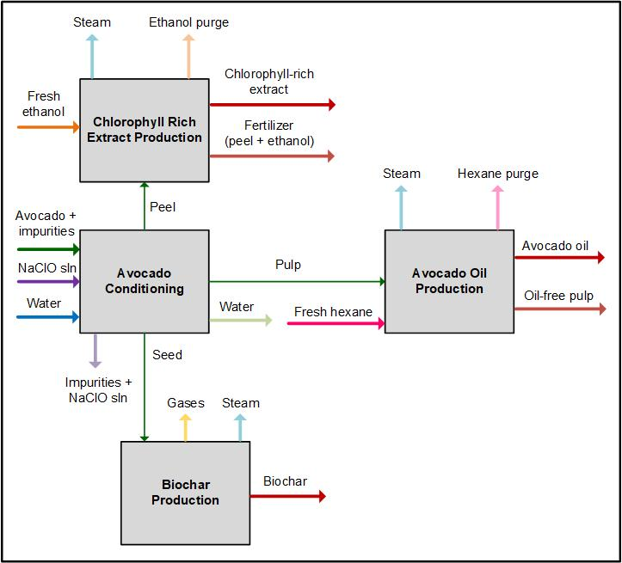

Figure 1: Process flow diagram of a thermal-based avocado (Laurus Persea L.) biorefinery.

In this sense, in the first stage of the process, focused on the conditioning of the avocado, 10,500 t/y of avocado enter (green stream), which is discarded from the total avocado production in the Montes de María region. In this section, the avocado, together with its impurities, is washed in the presence of water (blue stream) and NaClO (purple stream), generating impurities with NaClO in solution (violet stream). Subsequently, the avocado is peeled, separating the peel from the pulp and the seed; after this, the pulping process takes place, where the pulp is separated from the seed. Then, the avocado seed and the avocado peel are washed with water; in this way, impurities and traces of avocado pulp are removed. The residual water from these washes is mixed and goes through a centrifugation process, where the residual water (light green stream) is separated from the traces of avocado pulp. These traces of avocado pulp are mixed with the pulp generated in the pulping process and represent the input of the second stage of the process (thin green stream), referring to the production of avocado oil, where a homogenization process by grinding is started to facilitate the drying of the pulp. Subsequently, the pulp is dried to reduce the humidity, generating steam (light blue stream). Then, the oil is extracted by Soxhlet extraction in the presence of a mixture of fresh hexane (fuchsia stream) and recirculated hexane. Afterward, the oil is centrifuged to separate the pulp, producing a by-product, pulp without oil (light red stream) (Ariza et al., 2011). Next, distillation is carried out to separate the oil from the hexane, a part of the latter is purged (pink stream) and the other is condensed to re-enter the oil extraction stage. After distillation, the oil is refrigerated to prevent oxidation, producing 1,000.01 t/y of avocado oil (red stream).

Now, the seed (thin green stream), previously washed, enters the third stage of the process, referring to the production of biochar, where a grinding operation begins to reduce the size of the wet avocado seed. Subsequently, a drying process is carried out to reduce the humidity present, releasing steam (blue stream). Then, the grinding operation is carried out again to reduce the particle size of the dry seed and proceed to a sieving process, where the seeds that remain on the top of the sieve mesh, which does not comply with the particle size, are recirculated to the seed grinding section after drying. Next, the pyrolysis process of the avocado seed particles is carried out by thermal degradation of the biomass in an environment with a limited oxygen supply. Then, the thermally degraded avocado seed particles are condensed, generating gases (yellow stream) and producing 504.78 t/y of biochar (red stream) (Durak and Aysu, 2014). Finally, the peel (thin green stream), previously washed, enters the fourth stage of the process, concerning the production of a chlorophyll-rich extract, where a drying operation is started to reduce the humidity present, releasing steam (light blue stream). Then, the grinding operation is carried out to reduce the particle size of the dried peel and proceed to a chlorophyll extraction process in the presence of a mixture of fresh ethanol (orange stream) and recirculated ethanol. Then, the peel is separated with traces of ethanol, producing a by-product, fertilizer (light red stream). Next, evaporation is carried out to separate the chlorophyll-rich extract from the ethanol, a part of the latter is purged (pastel orange stream) and the other is condensed to re-enter the chlorophyll extraction stage. After evaporation, 31.32 t/y of chlorophyll-rich extract are produced (red stream) (Weemaes, 1999).

**2.2 Economics of scale analysis**

There are several indicators used to assess the profitability of a chemical process, which can be divided into two categories: techno-economic indicators and financial indicators. Techno-economic indicators are designed to measure the overall performance and profitability of a process, considering both internal operations and external factors, such as value generation efficiency, resource utilization, and return on investment. These indicators aim to reflect the outcome and the value created from the available resources. Among the economic indicators, some account for the time value of money, while others do not. One of the most important is Gross Profit (GP), which represents the process earnings before taxes. It can be calculated with or without the inclusion of asset depreciation (Depreciated Gross Profit, DGP), using Equation 1. From an economic standpoint, the process is more attractive the higher this value is. Profit After Tax (PAT) can also be calculated, which provides a more realistic measure of the net gain from the process. It is calculated using Equation 2, where the term (itr) corresponds to the tax rate set by the government for income derived from the process. Similarly, a higher PAT value indicates a more economically attractive process.

$$DGP=m_{p}C_{p}^{v}-TAC (1)$$

$$PAT=DGP\left(1-itr\right) (2)$$

$$NVOC= \frac{VOC}{m_{RM}}= \frac{AOC-FCH}{m_{RM}} (3)$$

$$NPV=\sum_{n}{{{AFC}_{n}(1+i)}^{-n} (4) }$$

$$PBP=\frac{FCI}{PAT} (5)$$

$$\%ROI=\frac{PAT}{TCI}x100\% (6)$$

On the other hand, if we want to determine the **Normalized Variable Operating Costs (NVOC)**, it is necessary to take the variable operating costs and divide them by the amount of product obtained, as shown in Equation 3. NVOC allows us to evaluate the resilience of processes in response to changes in costs. In addition, economics of scale analysis involves the use of indicators such as Net Present Value (NPV), Payback Period (PBP), and Return on Investment (ROI), as shown in Equations (4), (5), and (6), respectively. These indicators are used to assess changes in the process and the value of money over time (El-Halwagi, 2011).

3. Results and discussion

Based on the information obtained from the modeling and evaluation of the linear production chain of avocado oil, a proposal was made for the development of a product that utilizes the seed (biochar), the peel (chlorophyll-rich extract), and the generated residues. To this end, a biorefinery topology was modeled with an installed capacity of 10,500 t/year. This study assessed the economics of scale of the avocado biorefinery, considering the plant's commissioning in 2021, which allowed for an evaluation of the processes under scenarios of increased costs. Moreover, this type of analysis made it possible to determine the time required for the projects to begin generating profits.

Figure 2a shows the break-even point for the proposed topology, represented by the intersection of the lines, which does not exceed 3,000 t/year of avocado processing. This indicates that the process will not be significantly affected if processing capacity decreases, as the break-even point is well below the installed capacity of 10,500 t/year. The further the intersection point is from the installed capacity, the greater the resilience of the process.

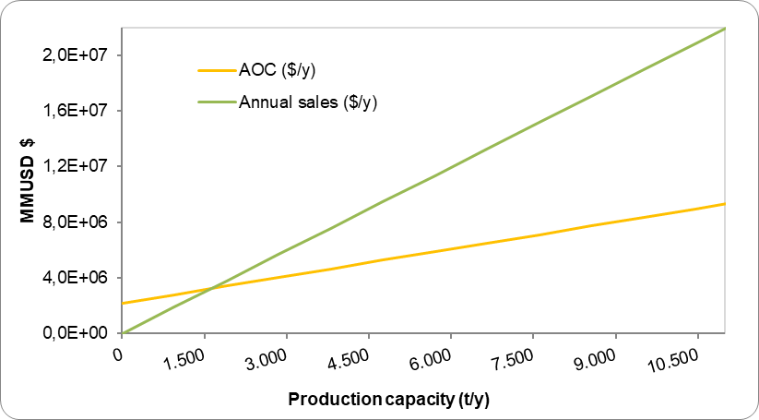 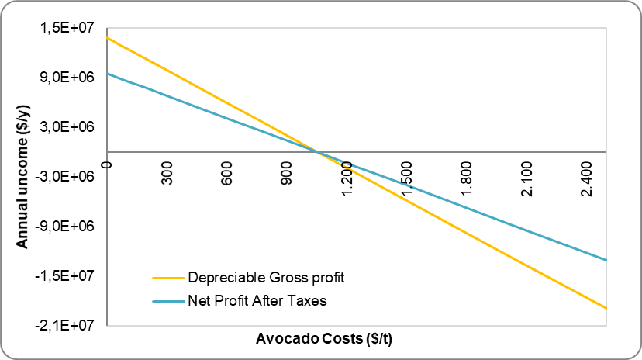

Figure 2: a) Resilience of Annual sales and Annual Operating costs of the avocado biorefinery, b) Annual income via sensitivity to changes in Raw material costs (avocado) in the biorefinery.

Figure 2b illustrates the behavior of the process in response to fluctuations in avocado price. According to the figure, the process presents a critical threshold for the topology at 1,100 USD/t. If the price of avocado were to double, the project could incur losses. However, since the avocados used in the biorefinery are discarded fruits not suitable for consumption, their price is not expected to increase significantly.

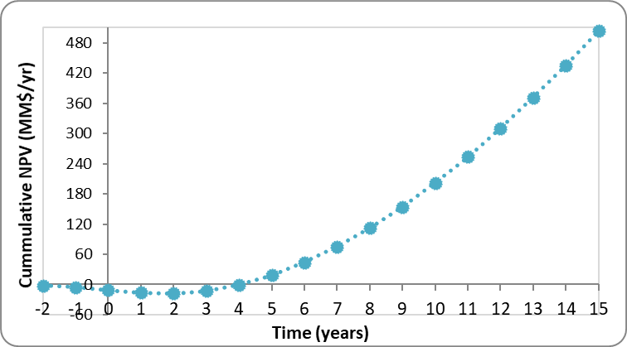 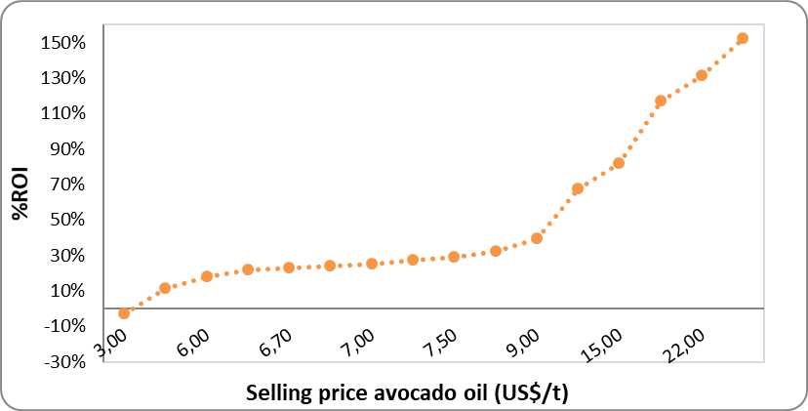

Figure 3: a) Net Present Value of the avocado biorefinery, b) Effect of avocado oil selling price on %ROI for the avocado biorefinery.

The biorefinery topology was analyzed considering a useful lifespan of 15 years. Within this period, a net present value (NPV) of 504.18 million USD was obtained, as shown in Figure 3a. Furthermore, it is observed that the process begins to generate profits by approximately the middle of the third year of operation (3.34 years). After this point, the initial investment can be recovered, considering the time value of money. This avocado biorefinery, aimed at the integral utilization of the fruit, is economically viable, as the benefits outweigh both the investment and the associated costs (Riveros & Leal, 2016).

The economics of scale analysis also evaluated the effect of avocado oil price (the main product) on return on investment (ROI), as shown in Figure 3b. It was found that negative returns on investment (-2.9%) begin to occur when the selling price of avocado oil is equal to or less than 3 USD/kg. For this analysis, a selling price of 15 USD/kg was considered. A directly proportional relationship is observed between the selling price and the ROI. Additionally, it can be noted that from 9 USD/kg onwards, the ROI increases at a faster rate.

Figure 4: a) Effect of ROI on NVOC normalized operating costs, b) Payback Period via sensitivity to changes in Normalized Annual Operating Costs (NVOC) in the biorefinery.

Figure 4a shows the relationship between return on investment and normalized variable operating costs (NVOC) to produce oil, biochar, chlorophyll, fertilizer, and defatted pulp. The NVOC of the process is 791.28 USD/t, with a critical value identified at 1,885 USD/t. The current NVOC is significantly below the critical threshold, indicating that the process is resilient to potential changes in operating costs. The maximum ROI for the topology is 140%, which would occur under the hypothetical condition of zero variable costs. Figure 4b illustrates the effect of operating costs (NVOC) on the payback period (PBP). When the NVOC equals the selling price of avocado oil, the gross profit before taxes becomes zero, and the PBP tends toward infinity. A stability zone for the NVOC is identified up to 1,250 USD/t; however, beyond 1,700 USD/t, the PBP begins to increase significantly.

**4. Conclusions**

The economics of scale analysis conducted on the avocado biorefinery indicates that the process is not significantly affected by changes in processing capacity, as the raw material depends on the harvest, which varies throughout the year. This variability can lead to fluctuations in production levels. However, it is important to note that the price of avocado is a sensitive variable in this case; if its value were to double, it could lead to losses. Therefore, the biorefinery uses discarded, overripe fruit that is not suitable for human consumption, with the expectation that its price will not increase significantly. When compared to other avocado utilization processes, it is evident that this process is more profitable than those that only make use of the seed and/or pulp. Although the increase in equipment results in higher operational expenses, it also boosts the production of various value-added products. Specifically, five products are produced from the seed, pulp, and skin of the avocado, making it an alternative for valorizing this type of agricultural waste. The economics of scale analysis provided insight into how the process behaves in response to variations in processing capacity, raw material price, sales price, and normalized operating costs.

Nomenclature

NaClO – Sodium Hypochlorite

GP – Gross Profit

DGP – Depreciated Gross Profit

PAT – Profit After Tax

itr – Tax rate set by the government for income derived from the process

TAC – Total Annualized Cost

VOC – Variable Operating Costs

AOC – Annualized Total Operating Costs

FCH – Fixed charges

NPV – Net Present Value

AFC – Annualized Fixed Costs

n – years

I – Inflation rate

PBP Payback Period

FCI – Fixed capital investment

TCI – Total Capital Investment

ROI – Return on Investment

NVOC – Normalized Variable Operating Costs

mi Ci^v – Product of product flow rate and selling price

kg – Kilogram

**Acknowledgments**

Authors thank the University of Cartagena and Colombian Ministry of Science, Technology and Innovation MINCIENCIAS through the projects “Sustainable Use of Avocado (Laurus Persea L) Produced in the Montes de María to obtain Value Added Products under the Biorefinery Concept in the Department of Bolívar” and “Evaluation of the sustainability of a cascade biorefinery topology for the use of Hass avocado seeds cultivated in the Amazon region”, Codes BPIN 2020000100325 and SIGP 100307.

**References**

Ariza J., Lopez F., Coyotl J., Ramos M., Diaz J., Martinez A., 2011, Effect of different extraction methods on the fatty acid profile in the avocado (Persea americana Mill. var. Hass) oil, Revista Venezolana de Ciencia y Tecnología de Alimentos, 2(2).

Durak H., Aysu T., 2014, Effect of pyrolysis temperature and catalyst on production of bio-oil and biochar from avocado seeds, Research on Chemical Intermediates, 41(11), 8067-8097.

El-Halwagi, M. (2011). *Sustainable Design Through Process Integration: Fundamentals and Applications to Industrial Pollution Prevention, Resource Conservation, and Profitability Enhancement.* Elsevier.

Herrera-Rodriguez T., Parejo-Palacio V., Gonzalez-Delgado A., 2022, Techno-economic Evaluation of Creole Avocado Biomass Valorization via Oil Production in North-Colombia, Chemical Engineering Transactions, 92, 409-414.

Herrera-Rodríguez T. C., Ramos-Olmos M., González-Delgado Á. D., 2024, A joint economic evaluation and FP2O techno-economic resilience approach for evaluation of suspension PVC production, Results in Engineering, 24, 103069.

Martinez-Hernandez E., Campbell G. M., Sadhukhan J., 2014, Economic and environmental impact marginal analysis of biorefinery products for policy targets. Journal of Cleaner Production, 74, 74–85.

Riveros Y., Leal L., 2016, Proyecto de preinversión para la creación de una planta productora y comercializadora de aceite de aguacate gourmet en la ciudad de Villavicencio, Universidad de los Llanos.

Rodríguez-Martínez B., Romaní A., Eibes G., Garrote G., Gullón B., del Río, P. G., 2022, Potential and prospects for utilization of avocado by-products in integrated biorefineries, Bioresource Technology, 364, 128034.

Sandoval T., González Chávez F., Poonia A., Iñiguez-Moreno M., Aguirre-Güitrón L., 2023, Avocado Waste Biorefinery: Towards Sustainable Development, Recycling, 8(5), 81.

Weemaes C., Ooms V., Van Loey A., Hendrickx M., 1999, Kinetics of Chlorophyll Degradation and Color Loss in Heated Broccoli Juice, Journal of Agricultural and Food Chemistry, 47(6), 2404-2409.