|  |  |
| --- | --- |
| cetlogo ***CHEMICAL ENGINEERING TRANSACTIONS***  ***VOL. XXX, 2025*** | A publication of  aidiclogo_grande |
| The Italian Association  of Chemical Engineering  Online at www.cetjournal.it |
| Guest Editors: David Bogle, Flavio Manenti, Piero Salatino  Copyright © 2025, AIDIC Servizi S.r.l. **ISBN** 979-12-81206-21-2; **ISSN** 2283-9216 | |

Hydrogen Generation through Cavitation-Based Water Splitting: Influence of Inlet Pressure

Mario Luisoa, Alessandro Ertob, Simeone Chianesea,\*, Dino Musmarraa

aDipartimento di Ingegneria, Università degli Studi della Campania “Luigi Vanvitelli”, Via Roma 29, 81031 Aversa, Italy

bDipartimento di Ingegneria Chimica, dei Materiali e della Produzione Industriale, Università degli Studi di Napoli “Federico II”, Piazzale V. Tecchio 80, 80125 Napoli, Italy

simeone.chianese@unicampania.it

Currently, hydrogen is considered a green, valid alternative to fossil fuels, and many efforts are being made to find sustainable processes for hydrogen generation. Water hydrodynamic cavitation is one of them; it consists of pressure variations in a water stream flowing through a constriction, such as an orifice or venturi. This phenomenon leads to the growth and collapse of microbubbles or cavities, generating high local temperature and pressure, creating the optimal condition for hydrogen generation due to water splitting.

Our research work is aimed at modelling and testing hydrodynamic cavitation-based hydrogen generation. For this purpose, cavitation simulations were carried out using Ansys Fluent 2025 to investigate a cavitation orifice reactor. The computational analysis was conducted on a pipe with a diameter of 30 mm, an orifice diameter of 2 mm, an orifice length of 2 mm and a total length of 14 mm. The effect of varying the pressure inlet was analysed, revealing that the vapour and low-pressure region expand with an increase in inlet pressure.

* 1. Introduction

In recent years, there has been growing concern over the unsustainable consumption of fossil fuels and the escalating issue of global warming, driven by rising global energy demand caused by ongoing population growth and energy-heavy lifestyles. In the 21st century, we are confronted with the challenge of meeting the increasing global energy needs while also mitigating the harmful effects of climate change. Fossil fuel-based energy systems, which have been essential for development, are proving unsustainable due to their finite supply and environmental consequences. Hydrogen, a versatile and key energy carrier, plays a critical role in the shift towards renewable energy, emerging as a viable and environmentally-friendly alternative to fossil fuels (Jeje et al. 2024). Many efforts are being made to find sustainable processes for hydrogen generation, such as electrolysis and the application of thermochemical cycles (Musmarra et al. 2021).

Water electrolysis is a well-known method of decomposing water into hydrogen and oxygen gas by applying electrical energy. Water molecules are electrochemically split into hydrogen and oxygen gases during electrolysis, a crucial process for sustainably producing hydrogen (El-Shafie 2023). Thermochemical water splitting cycles (TWSCs) are based on water decomposition through a series of chemical reactions using intermediate reactions and substances, which are all recycled during the process in such a way that the overall reaction is equivalent to the dissociation of the water molecule into hydrogen and oxygen (Safari and Dincer 2020). Although both technologies are recognized as viable approaches for sustainable hydrogen production, they exhibit inherent limitations. Electrolysis involves operational complexity and high energy consumption (Ozcan et al. 2023), whereas thermochemical cycles require elevated temperatures, posing challenges for practical implementation.

An alternative approach is offered by cavitation, a physical phenomenon characterized by the formation and subsequent collapse of vapor bubbles within a liquid due to pressure oscillations. During the compression phase, the rapid implosion of these bubbles leads to the formation of localized regions with extremely high temperatures and pressures, commonly referred to as "hot spots". These conditions lead to the dissociation of water molecules, forming hydrogen and oxygen gases.

Cavitation bubbles can be generated through either sonochemical or hydrodynamic means. In the former, pressure oscillations are induced via high-frequency ultrasound waves (typically >20 kHz), while in the latter, they are produced by a pressure drop associated with fluid flow through geometric restrictions, such as orifices or venturi structures (Carpenter et al. 2016). Recent studies have demonstrated the feasibility of hydrogen generation via ultrasound cavitation, showing that appreciable yields can be obtained under ambient conditions (Choi et al. 2023). However, current methods face notable limitations, including low energy efficiency, high operational costs, and difficulties in scaling up (Rashwan et al. 2019). Within this context, hydrodynamic cavitation presents a relatively unexplored and promising strategy for green hydrogen production, offering advantages such as higher energy efficiency (Capocelli et al. 2014) and enhanced scalability (Carpenter et al. 2016). The strength of hydrodynamic cavitation can be represented by the cavitation index, defined as:

|  |  |
| --- | --- |
| $$C=\frac{P_{1}-P_{v}}{P_{1}-P_{2}}$$ | (1) |

where P1 is the inlet pressure, Pv is the water vapour pressure, and P2 is the downstream pressure. The lower the cavitation index, the stronger the cavitation; in particular, a cavitation regime can occur if this parameter is lower or equal to 1.7 (Ebrahimi et al. 2017).

The present study aims to investigate the potential of hydrodynamic cavitation by utilizing Computational Fluid Dynamics (CFD) to simulate and analyze pressure distribution and water vapor fraction profiles within a specifically designed orifice-based cavitation reactor under water liquid flow.

* 1. Computational Method

The geometry employed in the cavitation CFD study is shown in Figure 2, with the corresponding dimensions detailed in Table 1.

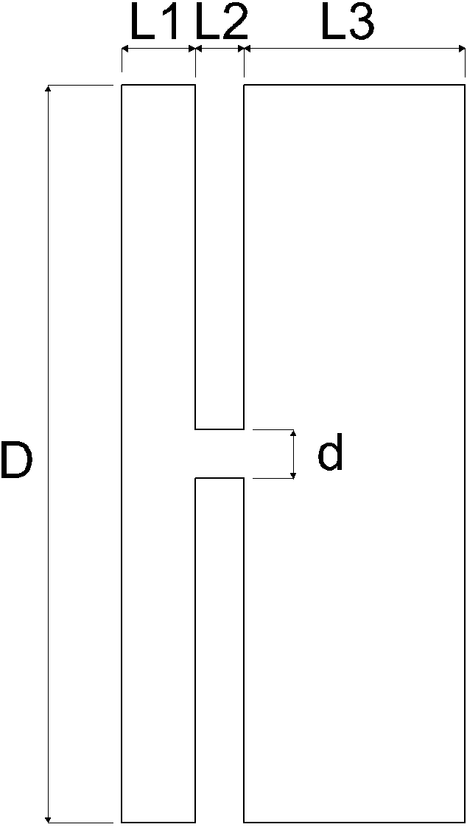

Figure 1. Orifice cavitation reactor geometry for CFD study

Table 1: Geometric characteristics of the cavitation orifice reactor

|  |  |  |  |  |
| --- | --- | --- | --- | --- |
| D (mm) | d (mm) | L1 (mm) | L2 (mm) | L3 (mm) |
| 30 | 2 | 3 | 2 | 9 |

Numerical simulations were performed using ANSYS Fluent 2025, conducting four two-dimensional (2D) fluid dynamic analyses by varying the inlet pressure values: (a) 200 kPag, (b) 400 kPag, (c) 600 kPag, and (d) 800 kPag. A constant downstream pressure of 12 kPag was maintained throughout.

The computational domain was discretized using a structured quadrilateral mesh consisting of 404,422 elements with a uniform element size of 0.03 mm. Mesh quality metrics, i.e. mean aspect ratio, skewness, and orthogonal quality, are summarized in Table 2, confirming the high quality of the generated mesh.

Table 2: Mesh quality parameters

|  |  |  |
| --- | --- | --- |
| Mean Aspect Ratio | Skewness | Orthogonal Quality |
| 1.00 | 5.26 x 10-4 | 1.00 |

The fluid dynamics were modeled by solving the incompressible Reynolds-Averaged Navier–Stokes (RANS) equations in a steady-state regime. The Renormalization Group (RNG) k–ε turbulence model with standard wall functions was adopted due to its balance between accuracy and numerical stability, particularly well-suited for simulating water flow through constrictions (De la Cruz-Ávila et al. 2024). Cavitation effects were captured using the Zwart Gerber Belamri model, with a vapor pressure of 3574 Pa and an initial bubble radius of 0.002 mm. This model was selected on the basis of a comprehensive literature review to ensure accurate prediction of cavitation phenomena (Kumar et al. 2020). The fluid properties were assumed constant, with liquid water having a dynamic viscosity of 0.001003 kg/(m·s) and a density of 998.2 kg/m³, while water vapor was defined with a viscosity of 1.26 x 10-6 kg/(m·s) and a density of 0.02558 kg/m³. The pressure–velocity coupling was handled using the Coupled algorithm. For spatial discretization, the gradient term was calculated using the Least Squares Cell-Based method, pressure using the PRESTO! scheme, the momentum, turbulent kinetic energy, and turbulent dissipation rate terms using the Second Order Upwind method. The First Order Upwind scheme was applied to the volume fraction calculation. Default under-relaxation factors were used, and the solution was initialized from the inlet boundary. Convergence was defined by achieving residuals below 10⁻⁶ to ensure solution accuracy.

* 1. Results and discussions

As previously mentioned, four simulations were conducted at varying inlet pressures: (a) 200 kPag, (b) 400 kPag, (c) 600 kPag, and (d) 800 kPag. These values were chosen to achieve cavitation indices (C) close to unity, a condition under which cavitation is likely to occur. The interdependencies among the cavitation index, inlet pressure, inlet power (EIN) and theoretical hydrogen molar flowrate requested to recover the input power (nH2,th.), are presented numerically in Table 3 and graphically in Figure 2. Input power quantifies the energy required to elevate the water flow pressure from atmospheric conditions to the specified inlet pressure, and is derived from the following formula:

|  |  |
| --- | --- |
| $$E_{IN}=\frac{Q×∆P}{η_{P}}$$ | (2) |

where Q is the water volumetric flow rate at the inlet, ΔP is the water pressure difference between the specified inlet pressure and the atmospheric pressure, and ηP is the pump overall efficiency, which is assumed to be equal to 0.7 for our estimation.

The theoretical hydrogen is defined as the molar flow rate of produced in the process which can generate a power equivalent to the input power through combustion; it is calculated as:

|  |  |
| --- | --- |
| $$n_{H2,th}=\frac{E_{IN}}{{HHV}_{H2}}$$ | (3) |

where HHVH2 is the high heating value of hydrogen, equal to 286 kJ/mol.

Table 3: Cavitation index (C), input power (EIN), theoretical hydrogen (nH2,th.) at selected inlet pressure values (P1)

|  |  |  |  |
| --- | --- | --- | --- |
| P1 (kPag) | C | EIN (kW) | nH2,th.(mmol/s) |
| 200 | 1.58 | 0.19 | 0.65 |
| 400 | 1.28 | 0.53 | 1.85 |
| 600 | 1.19 | 0.95 | 3.30 |
| 800 | 1.14 | 1.43 | 5.01 |

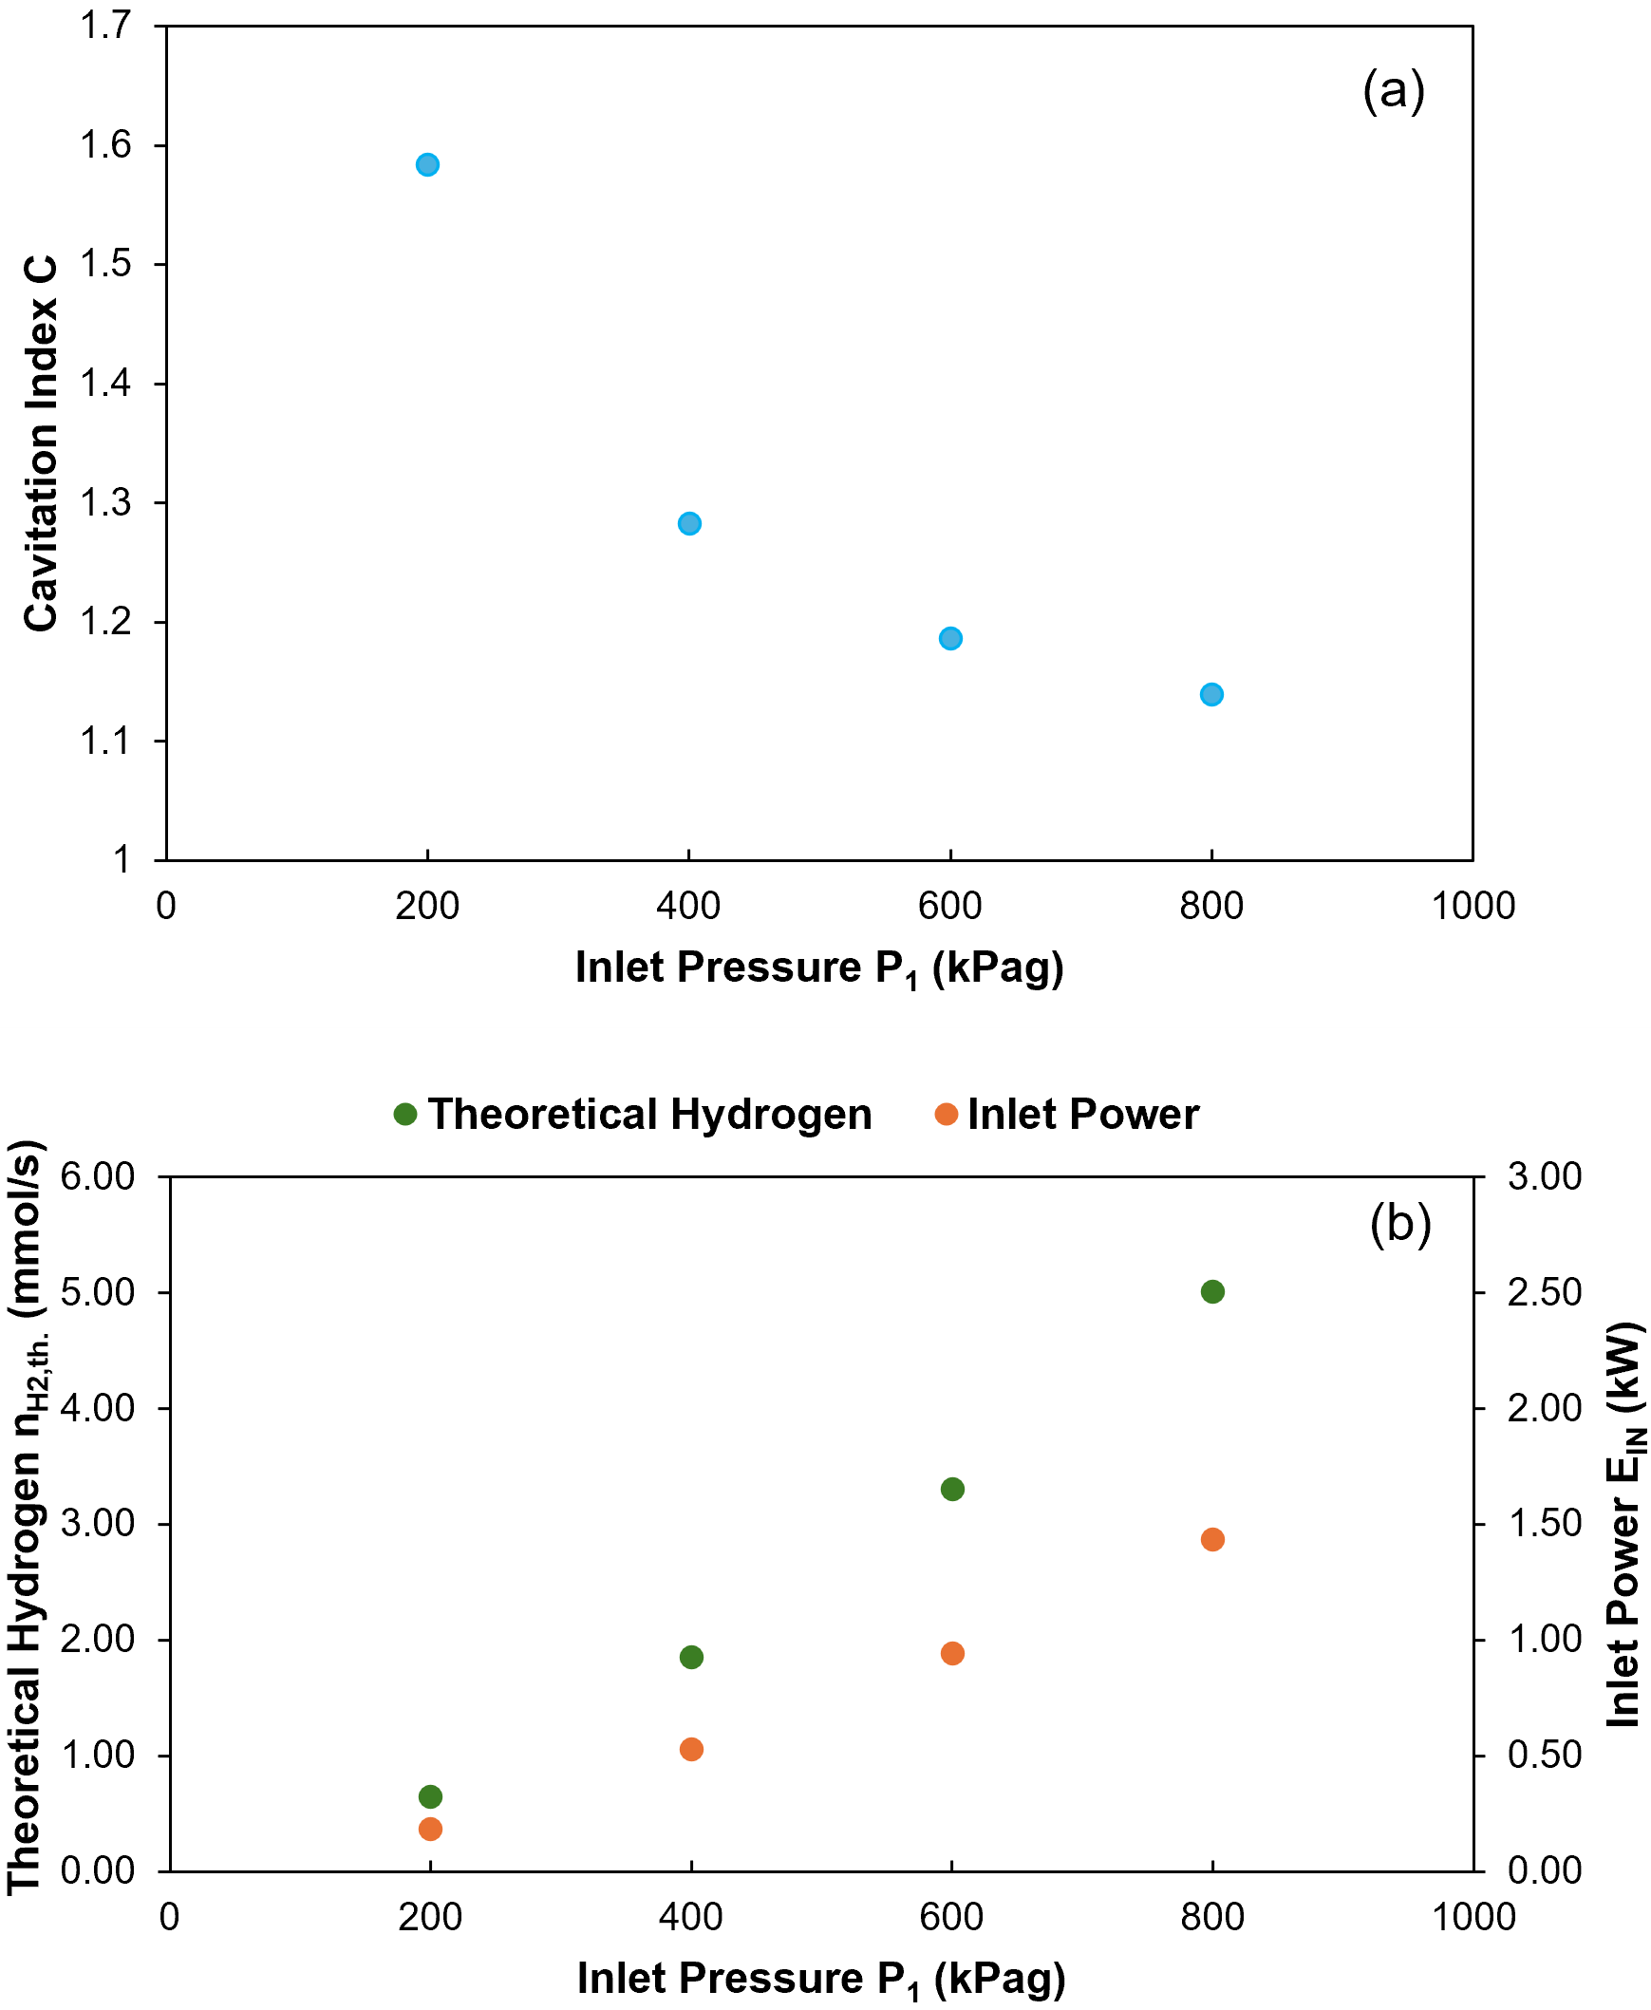

Figure 2. Cavitation index dependence on inlet pressure (a), inlet power and theoretical hydrogen as a function of inlet pressure (b).

From the analysis of Table 3 and Figure 2, a clear decreasing trend in the cavitation index with increasing inlet pressure is observed, accompanied by a notable increase in inlet power and a consequent rise in theoretical hydrogen. This trend indicates an intensification of the cavitation phenomenon as the upstream pressure increases. Simulation results, including pressure contours and water vapour volume fraction distributions for each inlet pressure, are shown in Figure 3. Examination of the vapor contours reveals that higher inlet pressures result in an expanded vapor region, with cavitation initiation occurring at inlet pressures equal to or exceeding 400 kPag. This behaviour is attributed to the increased pressure energy at the inlet, which promotes the formation and growth of vapor cavities. This result suggests that green hydrogen production may be enhanced by increasing inlet pressure, as it leads to a greater number of generated bubbles and intensified H₂O dissociation through stronger cavitation (Agarkoti et al. 2021). In terms of pressure distribution, a region of minimum pressure is observed at the throat, consistent with expectations based on the Venturi effect. This low-pressure zone is followed by a pressure recovery region where the pressure rises due to the geometric expansion of the channel. Additionally, Figure 3 shows that the extent of the low-pressure region increases with inlet pressure, further indicating the intensification of cavitation. These findings are consistent with recent studies in the literature (Ebrahimi et al. 2017).

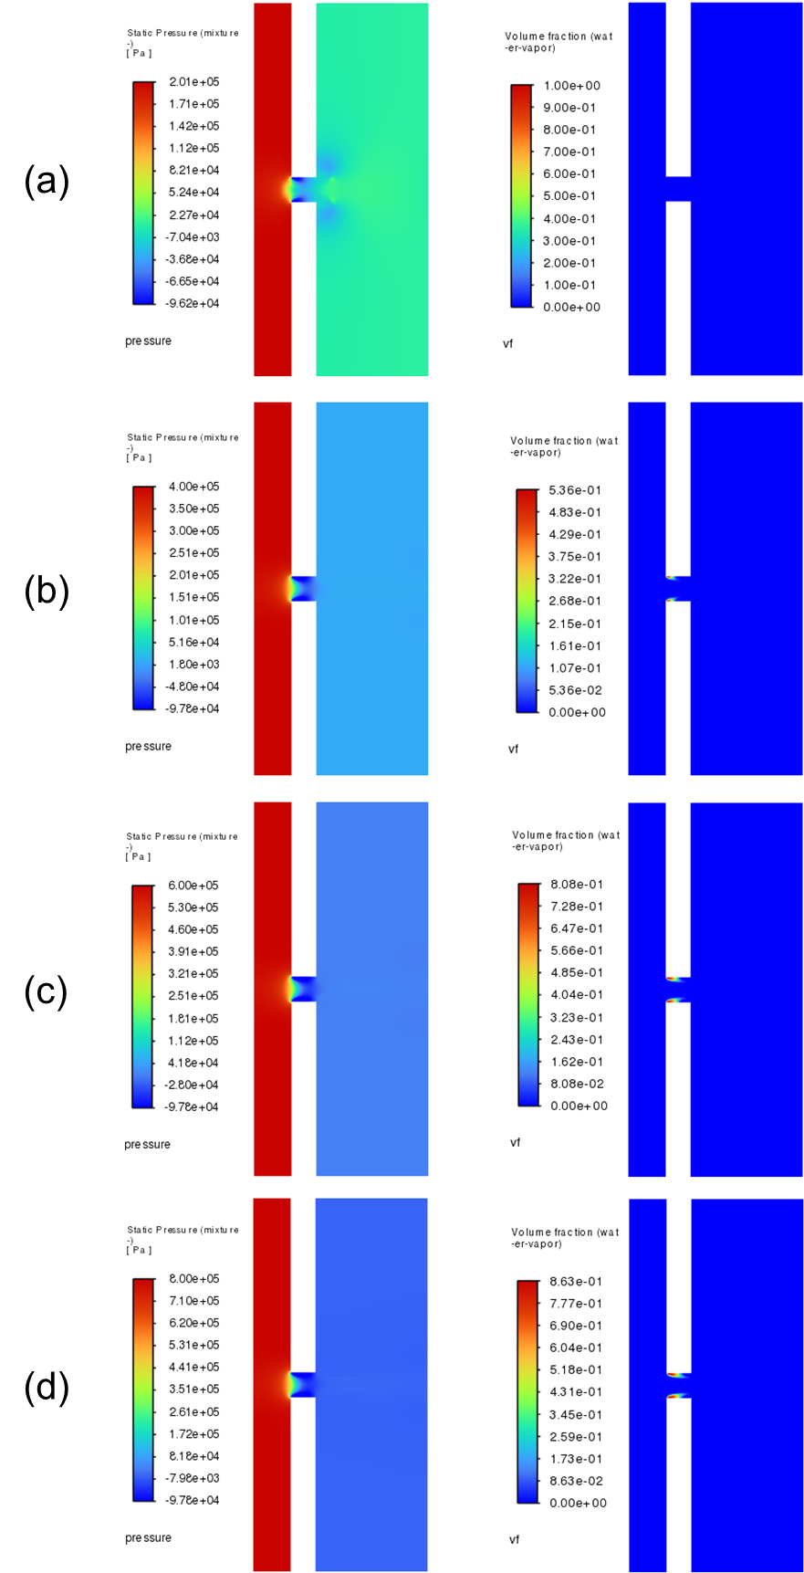

Figure 3. Distributions of the static pressure and vapour fraction through the orifice plate cavitation reactor.  
(a) P1 = 200 kPag, (b) P1 = 400 kPag, (c) P1 = 600 kPag, (d) P1 = 800 kPag.

* 1. Conclusions

In this study, a water cavitation orifice reactor was analyzed using a two-dimensional CFD approach, with a focus on evaluating the effect of varying inlet pressures: 200 kPag, 400 kPag, 600 kPag, and 800 kPag, while maintaining a constant outlet pressure of 12 kPag. The fluid dynamics of the system were modeled by solving the incompressible Reynolds-Averaged Navier–Stokes (RANS) equations under steady-state conditions. Turbulence was captured using the RNG k–ε model with standard wall functions, and cavitation behavior was described using the Zwart–Gerber–Belamri model. The results indicate that cavitation initiates at an inlet pressure of 400 kPag and becomes progressively more intense as the inlet pressure increases. Specifically, an expansion of both the low-pressure region and vapor bubble zone was observed with rising inlet pressure. These findings suggest favorable conditions for green hydrogen production and offer valuable insights for the further development of cavitation-based hydrogen generation technologies.

Nomenclature

C – cavitation index

CFD – Computational Fluid Dynamics

D – cavitation orifice reactor diameter

2D – two dimension

d – orifice diameter

EIN – Input power

HHVH2 – high heating value of hydrogen

L1 – cavitation orifice reactor entrance length

L2 – orifice length

L3 – cavitation orifice reactor outlet length

nH2,th. – theoretical hydrogen molar flowrate

P1 – inlet pressure

P2 – outlet pressure

Pv – water vapour pressure

Q – water inlet volumetric flowrate

RNG – Renormalization Group

RANS – Reynolds Averaged Navier Stokes

TWSCs – thermochemical water splitting cycles

ΔP – water pressure difference

ηP – pump overall efficiency

Acknowledgments

This work was supported by PhD program in Science and Engineering for the Environment and the Sustainability of Università degli Studi della Campania “Luigi Vanvitelli”.

References

Agarkoti C., Thanekar P.D., Gogate P.R., 2021, Cavitation based treatment of industrial wastewater: A critical review focusing on mechanisms, design aspects, operating conditions and application to real effluents, Journal of Environmental Management, 300, 113786.

Capocelli M., Prisciandaro M., Lancia A., Musmarra D., 2014, Comparison Between Hydrodynamic and Acoustic Cavitation in Microbial Cell Disruption, Chemical Engineering Transactions, 38, 13 – 18.

Carpenter J., Badve M., Rajoriya S., George S., Saharan V.K., Pandit A.B., 2016, Hydrodynamic cavitation: an emerging technology for the intensification of various chemical and physical processes in a chemical process industry, Reviews in Chemical Engineering, 1 – 36.

Choi J., Yoon S., Son Y, 2023, Effects of alcohols and dissolved gases on sonochemical generation of hydrogen in a 300 kHz sonoreactor, Ultrasonics Sonochemistry, 101, 106660.

De la Cruz-Ávila M., De León-Ruiz J.E., Carvajal-Mariscal I., Klapp J., 2024, CFD Turbulence Models Assessment for the Cavitation Phenomenon in a Rectangular Profile Venturi Tube, Fluids, 9, 71.

Ebrahimi B., He G., Tang Y., Franchek M., Liu D., Pickett J., Springett F., Franklin D., 2017, Characterization of high-pressure cavitating flow through a thick orifice plate in a pipe of constant cross section, International Journal of Thermal Sciences, 114, 229 – 240.

El-Shafie M., 2023, Hydrogen production by water electrolysis technologies: A review, Results in Engineering, 20, 101426.

Jeje S.M, Marazani T., Obiko J.O., Shongwe M.B., 2024, Advancing the hydrogen production economy: A comprehensive review of technologies, sustainability, and future prospects, International Journal of Hydrogen Energy, 78, 642 – 661.

Kumar A., Ghobadian A, Nouri J.M., 2020, Assessment of Cavitation Models for Compressible Flows Inside a Nozzle, Fluids, 5, 134.

Musmarra D., Karatza D., Konstantopoulos C., Chianese S., Diplas S., Svec P., Hristoforou E., 2021, Hydrogen production through water splitting at low temperature over Fe3O4 pellet: Effects of electric power, magnetic field, and temperature, Fuel Processing Technology, 211, 106606.

Ozcan H., El-Emam R.S., Celik S., Horri B.A., 2023, Recent advances, challenges, and prospects of electrochemical water-splitting technologies for net-zero transition, Cleaner Chemical Engineering, 8, 100115.

Rashwan S.S., Dincer I., Mohany A., Pollet B.G, 2019, The Sono-Hydro-Gen process (Ultrasound induced hydrogen production): Challenges and opportunities, International Journal of Hydrogen Energy, 44, 14500 – 14526.

Safari F., Dincer I., 2020, A review and comparative evaluation of thermochemical water splitting cycles for hydrogen production, Energy Conversion and Management, 205, 112182.