 CHEMICAL ENGINEERING TRANSACTIONS  VOL. xxx, 2025 | A publication of  
The Italian Association
of Chemical Engineering
Online at www.cetjournal.it

Guest Editors: David Bogle, Flavio Manenti, Piero Salatino
Copyright © 2025, AIDIC Servizi S.r.l.
ISBN 979-12-81206-21-2; ISSN 2283-9216

COMPARATIVE ANALYSIS OF “IN SITU” REMOVAL OF ETHANOL FROM FERMENTATION BROTH
Augusto S.C. Menezes,*, Artur S. Bispo, Gustavo S. Santos, Fernando L.P. Pessoa, Leonardo O.S. Santana
ªSENAI CIMATEC University, competence center for process intensification, Av. Orlando Gomes, 1845 - Piatã, Salvador - BA, 41650-010
ascdms@hotmail.com
The growing demand for sustainable energy has intensified the need for efficient bioethanol production. However, a key challenge in traditional fermentation is product inhibition, primarily caused by ethanol, which hinders yeast metabolism and limits glucose consumption. To overcome this, in situ ethanol removal methods have gained attention, enabling continuous fermentation and improving process efficiency. This study compares three major techniques: liquid-liquid extraction, gas stripping, and fermentation-pervaporation, analysing their sustainability and efficiency based on green chemistry principles and sustainable development goals. The findings emphasize the need for a comprehensive sustainability assessment to optimize energy use and minimize environmental impact.
  - Introduction
The detrimental effects of relying on fossil fuels are well-documented, and as a result, renewable energy sources are becoming increasingly important (Porsani et al, 2016). Transitioning to renewable energy is crucial for achieving sustainable development goals. In this context, bioethanol, which is ethanol produced by biomass, has emerged as a promising biofuel capable of replacing fossil-derived gasoline (Bispo et.al, 2020). Bioethanol is gaining importance as it can already be effectively integrated into the current fuel systems where 5–15% bioethanol/gasoline mixture does not require any modification of the current engines (Zentou et al, 2019). This biofuel is gaining space not only in the scientific community but also in the political and economic scenarios, and its role is expected to expand further in the future.
Despite its potential, bioethanol production via industrial fermentation suffers from some adverse factors, such as product inhibition caused by the ethanol, primary product of fermentation, and also a toxic component for yeast (Sonego et al, 2014). This leads to non-competitive inhibition of yeast metabolism, preventing the complete consumption of glucose. As a result, the fermentation process becomes less efficient, reducing the overall yield of bioethanol.
To overcome this limitation, in situ ethanol removal methods have been developed, which are techniques that allow ethanol to be extracted directly from the fermentation broth during the fermentation process itself, preventing the inhibition of yeast and improving process efficiency (Sonego et al, 2014). The most prominent methods include liquid-liquid extraction, which combines alcoholic fermentation and a separation unit operating via solvent extraction process (Zentou et al, 2019); gas stripping, which uses the CO₂ to remove components by the dissolution of the mixture into a gas passing through the fermentation broth (Zentou et al, 2019), and fermentation-pervaporation, which combines fermentation with membrane-based separation to selectively remove ethanol (Zentou et al, 2019).
This study aims to compare the three in situ ethanol removal methods in terms of their efficiency and sustainability. The comparison will be made using metrics from the fields of green engineering and green chemistry, which aim to optimize process efficiency while minimizing environmental impact (Lee, Marrocchi, 2024). By assessing the energy efficiency, ethanol removal selectiveness, and environmental footprint of each technique, this study seeks to identify the most effective and sustainable approach for bioethanol production.
  - Methodology
This review focused mainly on publications from 2014 to 2024, aiming to reflect recent advances in in situ ethanol removal methods and sustainability metrics. Additionally, earlier foundational studies were also included to support the analysis and strengthen the technical basis of the discussion. The main objective was to analyze research concerning in situ ethanol removal methods, integrating metrics grounded in the principles of green chemistry and green engineering for comparative evaluation. To ensure methodological rigor and a wide coverage of relevant studies, specific keywords were used during the literature search, including: “In situ ethanol removal”, “Gas stripping”, “Liquid–liquid extraction”, “Fermentation pervaporation”, “Green chemistry metrics”, “Green engineering metrics”, and “Sustainable bioprocessing”.
    - Comparative metrics
For the comparative analysis, six key metrics were selected based on the fields of green chemistry and green engineering:
Energy Consumption – The energy demand of a separation process directly influences its economic viability and environmental impact. Techniques requiring lower energy input lead to reduced operational costs and a smaller carbon footprint, making this a fundamental criterion for evaluating sustainable bioprocesses.
Selectivity – Selectivity reflects the ability of a separation method to preferentially remove ethanol while minimizing the loss of other valuable compounds. Greater selectivity reduces the need for additional downstream purification steps, enhancing resource utilization and overall process sustainability.
Environmental Impact – The environmental footprint of each technique is assessed through factors such as waste generation, chemical usage, and ecological consequences. Methods that avoid toxic solvents and minimize waste production are better aligned with green chemistry principles, easing the burden on wastewater treatment and environmental management.
Human Health Risk – The safety of the process for operators and the surrounding environment is critical, especially for large-scale applications. Techniques involving toxic chemicals or hazardous conditions present significant risks, making human health considerations a crucial evaluation metric.
Materials Efficiency – Material efficiency measures how effectively input materials are converted into the final product. It is an essential green engineering metric, as higher material efficiency correlates with reduced resource consumption and lower waste generation, contributing to both economic and environmental benefits.
Process Complexity – Process complexity is evaluated based on the level of control, equipment, and maintenance required. Systems with lower complexity are generally associated with lower operational costs and easier integration into existing production lines.
These comparative metrics are vital for systematically assessing the advantages and limitations of each in situ ethanol removal technique. By applying these sustainability-focused indicators, it becomes possible to identify the most efficient, economically feasible, and environmentally friendly approaches, ultimately supporting the advancement of sustainable bioethanol production technologies.
  - Literature Review
In several biochemical processes, like alcoholic fermentation, the accumulation of end-product and substrate in the broth can cause the inhibition effect and, making less efficient or even stop the fermentation process (Moulin et.al, 1980). Currently, there has been a growing interest in in situ fermentation/ product recovery techniques because these methods could be suitable for continuous and selective product recovery, and by that, reducing the energy demand and the costs of product recovery, achieving a more efficient fermentation (De Vrie et al, 2013). In this context, different in situ removal techniques have been developed to integrate fermentation processes like liquid-liquid extraction, gas stripping, and fermentation-pervaporation (Lemos et al, 2016).
Therefore, the selection of an in-situ product recovery technique would require comparable information on the energy demand and economics of the process (Outram, et al, 2017). And to make the comparison possible, it's essential to comprehend the functioning of the three techniques.
    - Operation of the in-situ ethanol removal techniques
- Liquid – Liquid Extraction
Liquid-liquid extraction (LLE) is a widely used technique in the processing industries. It takes advantage of the differences in the relative solubility of a compound between two immiscible phases. Generally, the chosen solvent is an organic liquid that does not mix with water. When applied to a fermentation broth, this allows the target compound to preferentially migrate from the aqueous phase into the organic phase (Outram, et al, 2017), and, in an in-situ system, like the one proposed by Minier & Coma (1981), the concentrated product would be recovered and both fermentation broth and solvent would be transferred to the fermenter. However, the in-situ liquid-liquid extraction method faces some challenges, such as solvent selection and its consequences. This technique can be applied either before or during fermentation, but it is not suitable for in situ application when the solvent has no biocompatibility (Park & Geng, 1992). The liquid - liquid ethanol extractor proposed by Minier & Coma (1981) is shown in figure 1. In this process, the continuous fermenter operates with pulsed flow across perforated plates to ensure effective agitation and aeration. It is simultaneously fed with fermentation medium and dodecanol, enabling ethanol production by immobilized cells and in-situ extraction. Heat exchangers regulate temperature, while multiple outlets along the column allow for phase separation and continuous processing. The numbers in the image represent, respectively, reactor (1), heat exchange (2), packing (3), pulse generator (4), outlets (5, 6, 7), air input (8), aqueous medium reservoir (9), dodecanol reservoir (10), metering pumps (11), heater (12).
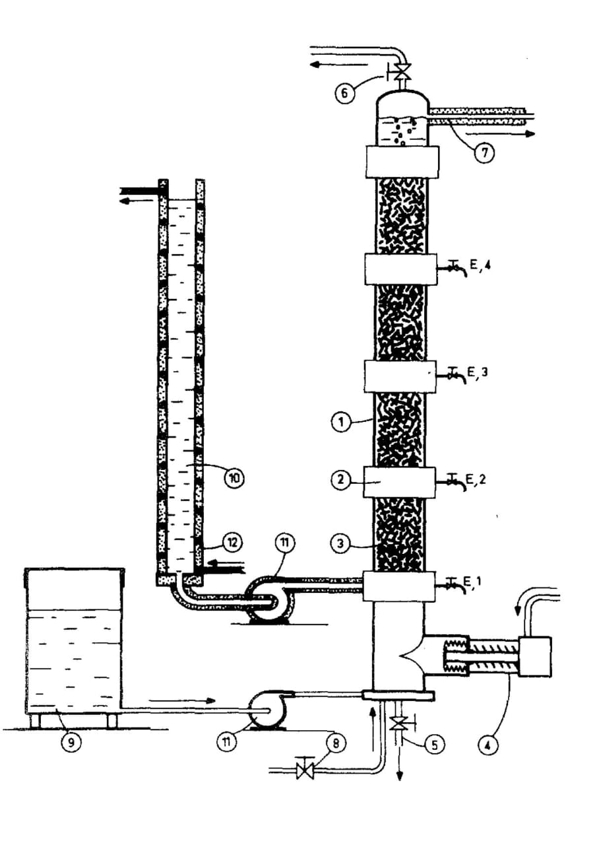
Figure 1 - Device for continuous extractive fermentation coupling liquid-liquid extraction and ethanol production by immobilized cells. Reproduced from Miner & Coma (1981)
- Gas Stripping
Among reactive extraction methods, stripping with carbon dioxide generated during fermentation has emerged as a promising approach to overcoming ethanol toxicity, which limits yeast performance in conventional fermentation processes (Bispo et al, 2020). In this process, an anaerobic gas, such as carbon dioxide or nitrogen, is recirculated through the bioreactor, causing the bioethanol to evaporate. The ethanol is then recovered from the gas stream using a condenser (Zentou et al, 2019). This technique is particularly appealing for large-scale production because offers advantages such as simplicity, it has the ability to remove volatile compounds in a pure form (free from non-volatile contaminants), it avoids the use of potentially toxic solvents, reducing the fermentation medium's temperature, and it is even able to use a 0-cost stripping gas (CO2) (Park & Geng, 1992). A bubble column bioreactor diagram is presented in figure 2. It shows an experimental model used by Almeida (2019). The system includes a CO₂ cylinder, a mass flowmeter to control the gas flow, the bioreactor itself, and a thermostatic bath that maintains the liquid at a constant temperature. Ethanol-containing solutions are treated by bubbling CO₂ through them, promoting ethanol removal over time. The process is monitored by regularly collecting liquid samples to measure ethanol concentration and mass.
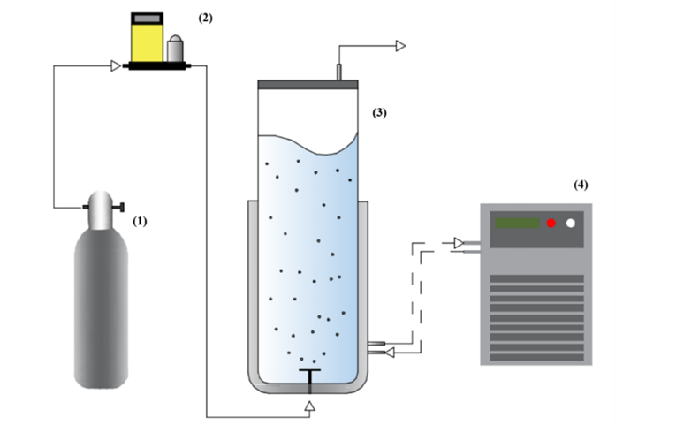
Figure 2. Experimental apparatus scheme. 1) CO₂ cylinder, 2) mass flowmeter, 3) bubble column bioreactor, and 4) thermostatic bath. Reproduced from Almeida (2019)
- Fermentation Pervaporation
Pervaporation is a membrane-based separation process that integrates evaporation and permeation through a semipermeable membrane. The ethanol in the fermentation broth dissolves into the membrane and, driven by a partial pressure gradient, permeates through the membrane, evaporates on the permeate side, and is then condensed and collected. Unlike distillation or evaporation, which rely on relative volatilities, pervaporation separates components based on their differing permeation rates through the membrane (Zentou et al, 2019). For pervaporation fouling is the biggest challenge leading to the loss of productivity, so the major decision to be made is the choice of membrane, as the ideal membrane should selectively allow the end product to be transferred while retaining the broth as well as it needs to be minimally fouling, so that it is not blocked by cells adhering to the membrane surface (Outram, et al, 2017). An example of the separation of an ethanol/water mixture is shown in figure 3.
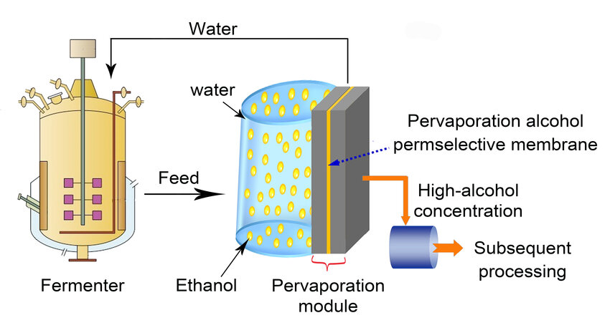
Figure 3. Pervaporation membrane separation technique applied to an ethanol/water mixture. Reproduced from Osman et al, (2024)
In this process, a selective membrane enables preferential ethanol permeation under a pressure gradient. Vaporization occurs on one side, followed by selective permeation and condensation on the other. This technique efficiently separates ethanol from water and is used in biofuel and chemical industries (Osman et al, 2024).

3.2 Green Chemistry and Green Engineering
The concept of GCP has been holistically developed for preventing chemical hazards, reducing environmental impact, and enhancing economic benefits since 1990s (Chen et al, 2020). Therefore, green chemistry and green engineering are research fields focused on optimizing process efficiency, minimizing environmental impact, reducing pollution, preventing accidents, maximizing energy efficiency, and ensuring resource sustainability (Lee & Marrocchi, 2024). To help achieving this, David Constable (2015) has categorized the principles of green chemistry and green engineering into three key areas: maximizing resource efficiency, eliminating, and minimizing hazardous and polluting substances, and adopting a holistic system design using life cycle thinking. These principles guide the development of more sustainable processes by not only focusing on the reduction of harmful environmental impacts but also promoting the efficient use of resources throughout the entire life cycle of a product or process. By integrating these principles, processes can be optimized while minimizing waste and energy consumption, contributing to long-term sustainability and environmental protection.
  - Results And Discussion
The comparison of the three in situ ethanol removal methods: liquid-liquid extraction, gas stripping, and pervaporation was conducted based on the operation of the methods, and on four key criteria aligned with green chemistry and green engineering principles: energy efficiency, selectivity, environmental impact, human health risk, materials efficiency, and process complexity. Table 1 summarizes these comparisons.
Table 1: Comparison of In Situ Ethanol Removal Methods
Comparative Metrics |  | Liquid – Liquid Extraction |  | Gas Stripping |  | Fermentation Pervaporation
Energy Consumption |  | Variable – Requires solvent separation and may require heating |  | Moderate – Requires continuous gas flow and condensation |  | High – Requires energy for vacuum and condensation
Selectivity |  | Variable/ High – Depends on the solvent’s affinity to ethanol |  | High – Remove volatile compounds in a pure form |  | High – Selective membrane ensures efficient ethanol separation
Environmental Impact |  | Variable/ High – Use of organic solvents may generate hazardous residues |  | Low – Uses recyclable inert gases, does not generate liquid waste |  | Low/ Moderate – Membrane wear may generate solid waste
Human Health Risk |  | Moderate/ High – May have the risk of exposure to toxic and flammable solvents |  | Low – No use of toxic substances. |  | Low – Does not involve a toxic compound, but requires proper membrane handling
Materials Efficiency |  | Moderate – Solvent losses and need for regeneration |  | High – Use of recyclable inert gases, low material loss. |  | High – High m with minimal waste
Process Complexity |  | Moderate – Requires control of phases (aqueous and organic) and solvent regeneration |  | Low – Simple bubble column Bioreactor |  | High – Requires fine control of vacuum and membrane maintenance

The comparative analysis reveals that each in situ ethanol removal method presents distinct advantages and challenges when evaluated through the principles of green chemistry and engineering.
From an analytical perspective, gas stripping offers a compelling balance: it combines moderate energy requirements with high selectivity for volatile compounds, a low environmental footprint, and significant material efficiency. These characteristics make it particularly attractive for large-scale industrial applications. Nonetheless, it is important to highlight that gas stripping's performance depends on precise process conditions, such as gas flow rate and fermentation temperature, which could influence ethanol removal efficiency and operational stability.
Pervaporation, on the other hand, stands out due to its high selectivity due to ethanol – specific membranes and its relatively low environmental impact. However, its practical implementation faces critical challenges, including higher energy demand, membrane fouling, and the need for vacuum and condensation systems. Research into more robust and selective membrane materials may address these limitations and enhance its industrial viability in the near future.
Liquid–liquid extraction remains an established technique with flexible design and integration potential, but it raises considerable concerns regarding environmental impact and human health due to solvent toxicity and possible emissions. Moreover, the requirement for solvent regeneration and phase separation adds operational complexity and increases costs. The future competitiveness of this technique largely depends on the development of greener, biocompatible solvents that align with sustainability goals.
Overall, gas stripping remains the most viable for industrial use, pervaporation holds future promise with further technological improvements, and liquid - liquid extraction may become more sustainable with the adoption of greener solvents.
  - Conclusion
Gas stripping stands out as the most sustainable method due to its low energy use, minimal environmental impact, and safety. Liquid-liquid extraction, though common, poses environmental and health concerns, while pervaporation shows strong future potential thanks to its high selectivity, despite current cost and durability limitations. Future research should focus on improving membrane performance for pervaporation, developing greener solvents for extraction, and optimizing gas stripping conditions for industrial scalability.

Acknowledgments
I would like to thank SENAI CIMATEC for their support, CNPq for the scientific initiation scholarship, and Professor Dr. Fernando L. P. Pessoa, as well as M.Sc. Leonardo O. S. Santana, M.Sc. Artur S. Bispo and M.Sc. Gustavo Santos for all their support and guidance.
References
Almeida, L.P., 2019, Evaluation of heat transfer in conventional and extractive alcoholic fermentations (Master’s Dissertation in Chemical Engineering) – Federal University of São Carlos, São Carlos, Brazil. (in Portuguese). Available at: repositorio.ufscar.br/handle/20.500.14289/11143.
Bispo, A., Santana, L., Garcês, L., Batista Nascimento, G., Souza, A., and Pessoa, F., 2020, Study on ethanol production from corn using temperature control and CO2 stripping. (in Portuguese). Available at: researchgate.net/publication/ESTUDO_DA_PRODUCAO_DE_ETANOL_A_PARTIR_DO_MILHO_UTILIZANDO_CONTROLE_DE_TEMPERATURA_E_STRIPPING_DE_CO2
Chen, T. L., Kim, H., Pan, S. Y., Tseng, P. C., Lin, Y. P., & Chiang, P. C. ,2020, Implementation of green chemistry principles in circular economy system towards sustainable development goals: Challenges and perspectives. Science of the Total Environment, 716, 136998.
Constable, D. J. C., 2015, Design principles for sustainable and green chemistry and engineering. American Chemical Society. Available at: acs.org/content/dam/acsorg/greenchemistry/resources/2015-gci-design-principles.pdf
de Vrije, T., Budde, M., van der Wal, H., Claassen, P. A., & López-Contreras, A. M., 2013, “In situ” removal of isopropanol, butanol and ethanol from fermentation broth by gas stripping. Bioresource technology, 137, 153-159.
Lee, J., & Marrocchi, A., 2024, Advances in green chemistry and engineering. Scientific Reports, 14(1), 3133.
Diego Andrade Lemos, 2016, Study on extractive ethanol fermentation using castor oil in bench-scale. In: Proceedings of the Brazilian Congress of Chemical Engineering – COBEQ 2016. (in Portuguese). Available at: proceedings.science/cobeq/cobeq-2016/papers/estudo-da-fermentacao-extrativa-de-etanol-com-oleo-de-mamona-em-escala-de-bancada
Minier, M., & Coma, G., 1981, Production of ethanol by coupling fermentation and solvent extraction. Biotechnology letters, 3, 405-408.
Moulin, G., Boze, H., & Galzy, P., 1980, Inhibition of alcoholic fermentation by substrate and ethanol. Biotechnology and bioengineering, 22(11), 2375-2381.
Osman, Ahmed & Nasr, Mahmoud & Farghali, Mohamed & S. Bakr, Sara & Eltaweil, Abdelazeem & Rashwan, Ahmed & El-Monaem, Eman., 2024, Machine learning for membrane design in energy production, gas separation, and water treatment: a review. Environmental Chemistry Letters. 22. 1-56. 10.1007/s10311-023-01695-y.
Outram, V., Lalander, C. A., Lee, J. G., Davies, E. T., & Harvey, A. P., 2017, Applied in situ product recovery in ABE fermentation. Biotechnology progress, 33(3), 563-579.
Park, C. H., & Geng, Q., 1992, Simultaneous fermentation and separation in the ethanol and ABE fermentation. Separation and Purification Methods, 21(2), 127-174.
Porsani, M. J. (coord.), 2022, Energy for Bahia in 2030. Salvador: Academy of Sciences of Bahia; Science, Technology and Innovation for the Development of Bahia. (in Portuguese). Available at: repositorio.ufba.br/handle/ri/35705
Sonego, J. L., Lemos, D. A., Rodriguez, G. Y., Cruz, A. J., & Badino, A. C., 2014, Extractive batch fermentation with CO2 stripping for ethanol production in a bubble column bioreactor: experimental and modeling. Energy & Fuels, 28(12), 7552-7559.
Zentou, H., Abidin, Z. Z., Yunus, R., Awang Biak, D. R., & Korelskiy, D., 2019, Overview of alternative ethanol removal techniques for enhancing bioethanol recovery from fermentation broth. Processes, 7(7), 458.

