|  |  |
| --- | --- |
| cetlogo ***CHEMICAL ENGINEERING TRANSACTIONS***  ***VOL. xxx, 2025*** | A publication of  aidiclogo_grande |
| The Italian Association  of Chemical Engineering  Online at www.cetjournal.it |
| Guest Editors: David Bogle, Flavio Manenti, Piero Salatino  Copyright © 2025, AIDIC Servizi S.r.l. **ISBN** 979-12-81206-21-2; **ISSN** 2283-9216 | |

Modelling of Lithium-Ion Battery Packs for the Prediction of their Thermal Degradation under Different C-Rates

Girolama Airò Farullaa, Luigi Gurrerib, Giuseppe Marsala c,\*, Davide Aloisiod

a CNR-ITAE: Istituto di Tecnologie Avanzate per l’Energia “Nicola Giordano”, Viale delle Scienze ed. 6, 90128, Palermo, Italy

b Dipartimento di Ingegneria Elettrica, Elettronica e Informatica, Università di Catania, Viale Andrea Doria 6, 95125, Catania, Italy

c CNR-INM: Istituto di Ingegneria del Mare, Via Ugo La Malfa 153, 90146, Palermo, Italy

d CNR-ITAE: Istituto di Tecnologie Avanzate per l’Energia “Nicola Giordano”, Salita Santa Lucia Sopra Contesse 5, 98126, Messina, Italy

giuseppe.marsala@cnr.it

This study aimed to develop a multi-physical model of Lithium-ion battery packs to assess their thermal performance and aging behaviour under various charge/discharge rates and environmental conditions, including ambient temperature and convective heat transfer coefficient. The Taguchi method was applied to identify the most critical operating conditions that influence the thermal degradation and assess the impact on battery capacity. The mathematical model was implemented in MATLAB/Simulink environment. The thermal performance and aging were evaluated based on the maximum temperature reached and the state of health, respectively. According to standard ISO 12405-2, the battery was considered to have reached the end of its life when its capacity declined to 80% of the initial value. The model predictions are consistent with expectations, demonstrating the capability to describe the problem's physics qualitatively. The results highlight the necessity of avoiding high ambient temperatures and excessive current rates to mitigate the risk of thermal runaway. Implementing appropriate thermal management systems, along with maintaining moderate charge/discharge rates, is recommended to extend the battery’s lifespan.

* 1. Introduction

Nowadays, Li-ion batteries (LiBs) are widely dominating the rechargeable battery market for electric storage and are considered the most promising technologies to be employed in electric vehicle (EV) applications as a secondary source of power (Zhao et al., 2022). Li-Bs perform poorly when operated under extreme temperatures, whether excessively high (T > 60 °C) or low (T < 5 °C). During the charging and discharging process, the battery temperature increases, even inducing the thermal runaway of the system (Zhang et al., 2024). Thermal runaway is a critical safety issue where exothermic reactions lead to uncontrollable temperature rise, potentially resulting in fire or explosion (Wang et al., 2024). The operative temperature is among the main factors affecting safety conditions and is strictly correlated to the cycle aging degradation mechanism (Yarimca and Cetkin, 2024). It refers to the gradual degradation of a battery's performance and capacity due to repeated charge and discharge cycles over time. It is usually quantified in terms of a reduction in the battery capacity (energy fade) or an increase in the internal resistance (power fade) (Bischof et al., 2024). Estimating the state of charge and understanding the aging process of LiBs are crucial for their widespread application in the market. That is why several studies have analysed aging phenomena. For instance, Cui et al. (2024) investigated the aging patterns and mechanisms of an 18650-type LiFePO4 battery based on experiments at 2C and different temperatures. The results showed that the cycle life improved by reducing the operating temperature.

Models that predict battery thermal degradation are powerful tools. However, the development of reliable models is quite challenging due to the need to capture the complex interplay of numerous thermal and electrochemical processes. Focusing on multiscale methodologies, Ali et al. (2023) provided a comprehensive overview of aging modelling methods. Empirical, semi-empirical, physics-based, and machine learning modelling are the most common approaches available in the literature to simulate battery aging. For example, Chen et al. (2024) proposed a novel electrochemical-thermal-aging effects coupled model to estimate the state of health under different temperature conditions. Compared to conventional analytical models frequently plagued by inaccuracies, machine learning methods can serve as a practical substitute for traditional models and offer a valuable means to analyse the battery behavior (Aloisio et al., 2021).

This study aims to develop a multi-physical model and investigate the thermal-electrical and aging performances of a commercial Li-ion battery pack under different conditions. Parametric simulations were conducted to evaluate the impact of ambient temperature, heat transfer coefficient, and high and fluctuating charge/discharge rates. The Taguchi approach was employed to minimise the simulation scenarios, identify the most influential factors for thermal degradation, and capture the interplay of electrical and thermal parameters in determining the proper functioning and capacity of the battery. Once the optimal conditions for ensuring thermal safety were determined, the aging process of the battery was examined.

* 1. Methodology

The simulated battery was a commercial Li-ion pack (37 V - 13 Ah, 18650 type, 10s6p) whose technical specifications were provided by the manufacturer. The model, implemented in the MATLAB/Simulink environment, can be divided into three sub-models: electric, thermal, and aging. The electric dynamic behaviour was modelled with an equivalent circuit based on Shepherd’s equation. The thermal behaviour was modelled with an electric equivalent model, and the power loss was estimated with Bernardi’s equation (Jindal et al., 2022). Battery aging due to cycling is analogous to material degradation due to cumulative stress; hence, the aging sub-model was derived from fatigue theory and equivalent cycle counting (Motapon et al., 2020). The modelling approach is depicted in Figure 1. A dynamic model with lumped parameters was implemented. The operating conditions, i.e., ambient temperature and charge/discharge current, along with the convective heat transfer coefficient, represent the model's input parameters. The electrical sub-model calculates the battery voltage and state of charge (SOC), the thermal sub-model predicts the cell temperature, and the aging sub-model estimates the maximum capacity, the aging factor and the state of health. The sub-models are linked by multiple interconnections (as illustrated in Figure 1). Therefore, an iterative procedure is applied for the computation.

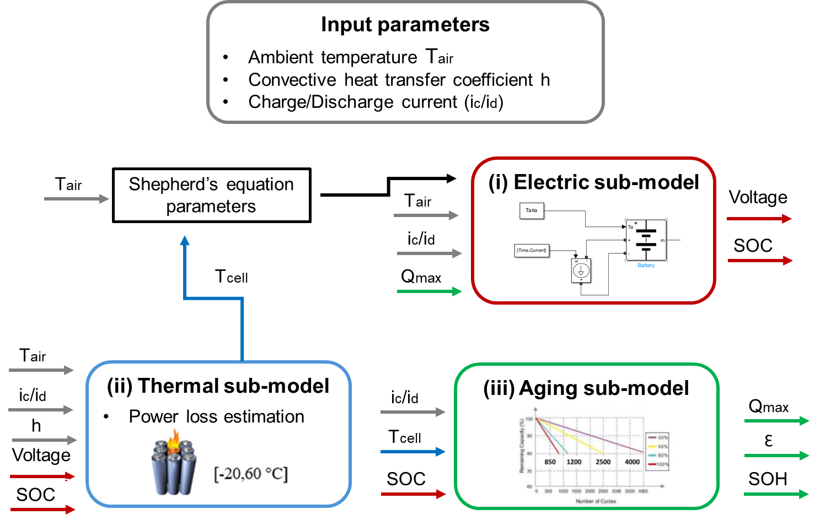

Figure 1*:* Modelling methodology implemented for the simulation of LiB packs.

The following reasonable assumptions were made according to previous studies:

• Peukert’s effect and self-discharge were neglected.

• The memory effect was neglected.

• Shepherd’s parameters were equal for charging and discharging.

• The model’s parameters were temperature- and aging-dependent.

• The specific heat capacity was independent of temperature.

• The temperature distribution was uniform.

• The dissipated thermal power was simulated as a distributed heat sink.

• Heat conduction from cell to cell was neglected (cells with the same temperature).

• The radiative heat transfer was neglected.

* + 1. Model equations

The electric behaviour of the battery was modelled with a Thevenin equivalent electric circuit consisting of a controlled voltage source and a resistor in series, representing the open circuit voltage (OCV) and the internal resistance of the battery (*R*), respectively:

|  |  |
| --- | --- |
| $$V_{bat}=OCV-iR$$ | (1) |

The OCV is given by a modified Shepherd’s equation (Hemi et al., 2019):

|  |  |
| --- | --- |
| $$\left\{\begin{aligned}\begin{aligned}Discharge \left(i>0\right): OCV=E_{0}-K\frac{Q}{Q-q}\left(i+q\right)+A exp\left(-B∙q\right)- C∙q \\ Charge \left(i<0\right): OCV=E_{0}-K\frac{Q}{q-0.1Q}i-K\frac{Q}{Q-q}q+A exp\left(-B∙q\right)- C∙q\end{aligned} \\ q=\int_{0}^{t}{i(t) dt}\end{aligned}\right.$$ | (2) |

where *i* is the current, $E_{0}$ is the thermodynamic voltage, *K* is the polarization constant, *Q* is the maximum battery’s capacity (which reduces cycle by cycle), *q* is the extracted capacity, *A* is the exponential zone amplitude, *B* is the exponential capacity, *C* is the nominal discharge curve slope, and *t* is the time. $E_{0}$, *K*, *A*, *B*, *C* were obtained by fitting the datasheet curves with the Levenberg-Marquardt algorithm. The state of charge was calculated as a function of the nominal battery’s capacity $Q_{nom}$ (Baccouche et al., 2018):

|  |  |
| --- | --- |
| $$SOC=1-\frac{q}{Q_{nom}}$$ | (3) |

In the thermal sub-model, the energy balance of the LiB packs was computed as (Incropera, 2015):

|  |  |
| --- | --- |
| $$mc\frac{dT}{dt}=P_{loss}-h S \left(T-T_{air}\right)$$ | (4) |

where *m* is the LiB pack mass, *c* is its specific heat capacity, *T* is the cell temperature, $P_{loss}$ is the thermal dissipation, *h* is the convective heat transfer coefficient, *S* is the external surface in contact with air, $T_{air}$ is the air temperature. The thermal dissipation, due to the complex phenomena resulting from electrochemical reactions taking place during charging/discharging cycles, was evaluated with Bernardi’s equation (Jindal et al., 2022):

|  |  |
| --- | --- |
| $$P_{loss}=i \left(OCV-V_{bat}\right)-iT\frac{dOCV}{dT}$$ | (5) |

The impact of cycle aging on capacity reduction (energy fade) was evaluated as (Motapon et al., 2020):

|  |  |
| --- | --- |
| $$Q\left(n\right)=Q_{BOL}-ε\left(n\right)\left(Q_{BOL}-Q_{EOL}\right)$$ | (6) |

where $Q_{BOL}$ and $Q_{EOL}$ are the maximum capacity at the beginning and end of life, respectively, *n* the number of transitions from charge to discharge and vice versa, and $ε$ is the aging factor, defined as:

|  |  |
| --- | --- |
| $$ε\left(n\right)=ε\left(n-1\right)+\frac{0.5\left(2-\frac{DOD\left(n\right)+DOD\left(n-2\right)}{DOD\left(n-1\right)}\right)}{N_{C_ref}}θ(n)$$ | (7) |

where, $DOD$ is the depth of discharge (%), $N_{C_ref}$ is the maximum number of cycles when the battery is subjected to repetitive charge/discharge cycles under the reference conditions, and $θ(n)$ is the stress factor.

|  |  |
| --- | --- |
| $$θ\left(n\right)={\left(\frac{DOD (n)}{DOD_ref}\right)}^{ξ}∙{\left(\frac{i_{d_ave} (n)}{i_{d_ref}}\right)}^{γ_{1}}∙{\left(\frac{i_{c_ave} (n)}{i_{c_ref}}\right)}^{γ_{2}}∙exp\left[-ψ \left(\frac{1}{T(n)}-\frac{1}{T_{ref}}\right)\right]$$ | (8) |

The subscripts *c* and *d* stand for charge and discharge, respectively. The aging parameters ( $ξ , ψ , γ_{1},γ_{2})$ were obtained by fitting the life cycle curves provided by the manufacturer. The state of health was calculated as:

|  |  |
| --- | --- |
|  | (9) |

* + 1. Design of simulations

The model contains parameters that characterize the specific behaviour of real batteries and whose values have been provisionally fixed based on open literature and pre-built Simulink packages. The minimum number of scenarios was identified through the Taguchi optimization algorithm (Airò Farulla et al., 2023). Its primary feature is the identification of an appropriate orthogonal array to evaluate how specific combinations of parameters affect performance. The examined parameters and their values are referred to as Factors (*F*) and Levels (*L*), respectively. The orthogonal array is designed to ensure that every level of each factor is tested at least once against all *L* levels of the other factors. This approach significantly decreases the number of simulations required, reducing it from *LF* to the number of rows in the array. The factors of the present simulation campaign were the main input parameters of the model, namely the air temperature, the heat transfer coefficient, the charge current and the discharge current. They were let to vary on three levels: 25, 35, and 45 °C for *Tair*; 5, 30 and 50 W/m2/K for *h*; 0.5 C, 1 C, and a time-dependent rate (~0.25 C on average) for the electric current (in both charge and discharge phases) (Leonardi et al., 2021). The selected array of simulations is reported in Table 1. The simulated time of battery operation was 100 h.

To measure quality and robustness, the signal-to-noise (S/N) ratio for the model outcome represented by the cell temperature was analysed. Hence, *the smaller the better* criterion was applied.

Table 1: Taguchi orthogonal array for the simulations with 4 factors and 3 levels.

|  |  |  |  |  |
| --- | --- | --- | --- | --- |
| **Simulation** | **Tair [°C]** | **h [W/m2/K]** | **ic [A]** | **id [A]** |
| 1 | 25 | 5 | 0.5 C | 0.5 C |
| 2 | 25 | 30 | 1 C | 1 C |
| 3 | 25 | 50 | Ic(t) | Id(t) |
| 4 | 35 | 5 | 1 C | Id(t) |
| 5 | 35 | 30 | Ic(t) | 0.5 C |
| 6 | 35 | 50 | 0.5 C | 1 C |
| 7 | 45 | 5 | ic(t) | 1 C |
| 8 | 45 | 30 | 0.5 C | id(t) |
| 9 | 45 | 50 | 1 C | 0.5 C |

* 1. Results and discussion

Table 2 reports the maximum temperature predicted by the model.

Table 2: Maximum temperature of the LiB pack [° C] predicted by the model in the nine simulations of the Taguchi orthogonal array.

|  |  |  |  |  |  |  |  |  |
| --- | --- | --- | --- | --- | --- | --- | --- | --- |
| 1 | 2 | 3 | 4 | 5 | 6 | 7 | 8 | 9 |
| 51.02 | 42.50 | 39.88 | 72.79 | 41.37 | 45.63 | 78.35 | 52.54 | 55.74 |

The simulation results reveal that cases 4 and 7 exceed the manufacturer’s safe temperature limits (–20 to 60 °C), reaching peak temperatures of ~72.8 °C and 78.4 °C, respectively. These scenarios are characterized by the minimum value of *h* and intermediate or maximum value of *Tair*, leading the battery to minimal levels of cooling and, thus, the highest thermal stresses. By contrast, case 3 yields the lowest cell temperature, hence representing the optimal condition for thermal safety and operating performance. This resulted from the most favourable working conditions of the cell, i.e., the minimum level of *Tair* and the maximum level of *h*. LiBs typically perform optimally and age minimally within a temperature range of 20–45 °C. Outside this range (T > 45 °C)—as in Cases 1, 6, 8, and 9, in addition to cases 4 and 7—the battery is subject to (i) elevated risks of thermal runaway and safety incidents, (ii) accelerated capacity fade, and (iii) increased self-discharge. Cases 2, 3, and 5 maintain cell temperatures below 45 °C and are therefore acceptable for the short time simulated (100 h). However, for extended operation, these scenarios could reach higher cell temperatures. In this case, the battery pack would benefit from active thermal management to ensure operations within the optimal range.

Figure 2 shows the S/N ratio for the maximum temperature (the lower the better). S/N decreases from –32.92 dB to –35.74 dB when the Tair level goes from 1 to 3. Since higher *Tair* levels correspond to a lower S/N ratio, Tair has a potential negative impact on signal quality. With *h* variation, the S/N sharply increases from –36.43 dB at level 1 to –33.10 dB at level 2, and then remains almost stable until level 3, suggesting that *h* initially leads to S/N improvement, but further increases do not have a positive additional effect. *Ic* has a non-monotonic effect on S/N, which initially decreases from –33.91 dB (level 1) to –34.9 dB (level 2), then increases to –34.08 dB (level 3). *Id* has a behaviour quite specular to *h*, though with milder variations, with the S/N ratio that sharply decreases from –33.80 dB to –34.54 dB when passing from level 1 to level 2, then decreases to –34.55 dB at level 3. Overall, *Tair* has the largest performance consistency and can be identified as the most influential factor (the S/N drops of 3 dB), and *h* has a similar impact on robustness, but the sensitivity of S/N to this factor is almost entirely concentrated between level 1 and level 2. The other two factors, i.e., *ic* and *id*, have a weaker overall effect (S/N total span of 1 dB) and poor response consistency. From the S/N results, the optimal settings of *Tair*, *h*, *ic*, and *id* to mitigate the maximum cell temperature should be L1, L2, L1 (or L3), and L1.

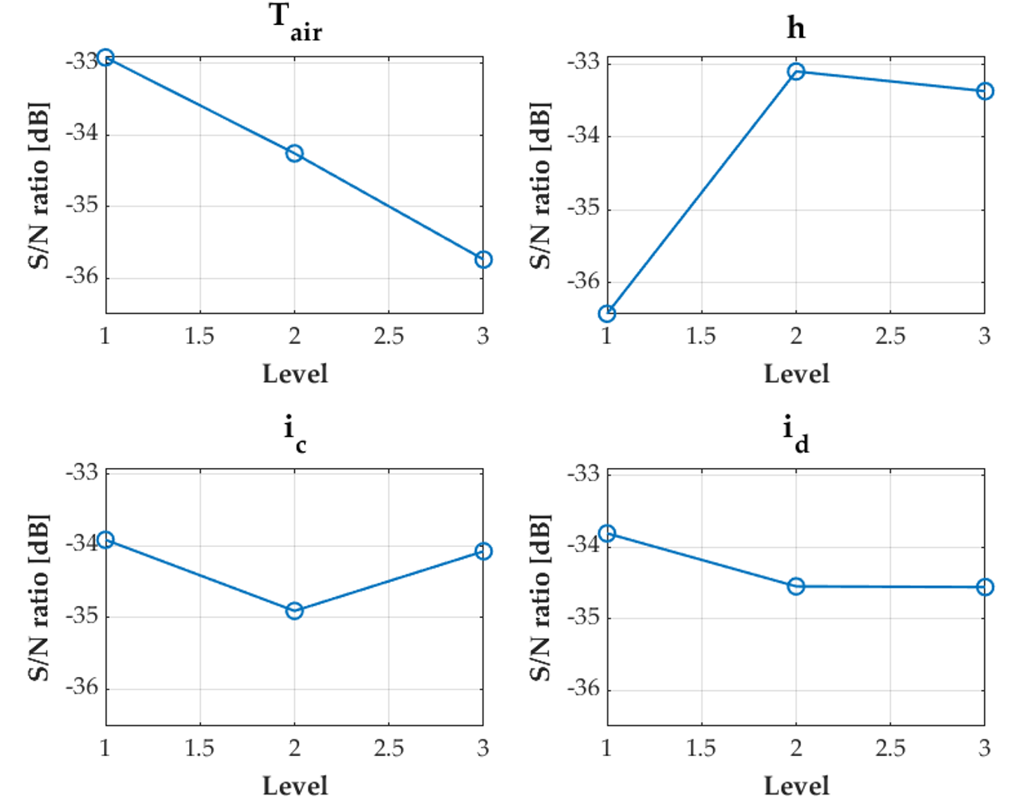

Figure 2: S/N ratio for the maximum temperature of the battery.

As depicted in Figure 3, the SOH decreases as the age (number of equivalent cycles) increases.

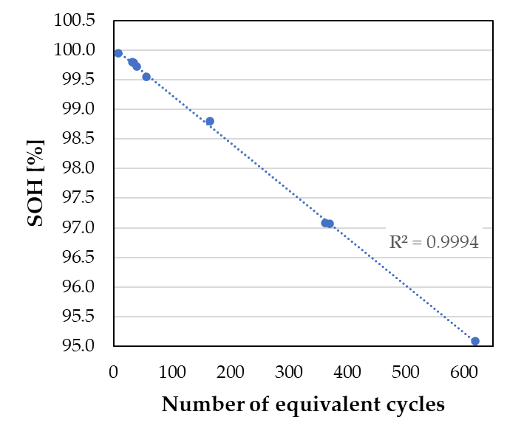

Figure 3: SOH of the battery correlated to the number of equivalent cycles.

Aging is strongly affected by the charging and discharging C-rates, which determine the cycle duration. Note that the simulated conditions refer to a fixed overall working time of 100 h, meaning that each case (which is set with a different combination of *ic* and *id*), corresponds to a different age. Therefore, a straightforward comparison among the simulated cases is much more complex than in terms of thermal performance. However, it can be highlighted that, aiming at preserving the battery’s life, the high values of current in case 2 should be avoided. In contrast, note that simulation 2 was identified as the most favourable in the thermal analysis to prevent the risk of thermal runaway. Therefore, the identification of the best scenario ensuring optimal battery performance requires a compromise between thermal and aging aspects.

* 1. Conclusions

A model for the simulation of LiB packs was developed to assess thermal and aging effects. An optimal design of simulation approach (Taguchi’s method) was deployed to investigate the combined effects of four parameters, namely air temperature (*Tair*), convective heat transfer coefficient (*h*), charge current (*ic*), and discharge current (*id*), which were varied in three levels. The results show that, out of an array of nine, two scenarios led the battery temperature beyond the threshold of safety (60 °C), five scenarios were beyond the upper limit of the optimal working temperature (45 °C), and four cases did not exhibit any risk of thermal runaway under the simulated time of 100 h. The most influential factors in the thermal performance were *Tair* and *h*, while the electric current played a minor role. However, the C-rate significantly affected the number of cycles (5 to 600) and thus the state of health (99.9% to 95.0%). Although a more comprehensive simulation campaign (e.g., with a fixed number of equivalent cycles) would provide more reliable insights, this preliminary analysis reveals that the simulated LiB pack likely necessitates a proper thermal management system to enhance the state of charge of the battery over its lifespan.

References

Airò Farulla G., Palomba V., Alosio D., Brunaccini G., Ferraro M., Frazzica A., Sergi F., 2023, Optimal design of lithium ion battery thermal management systems based on phase change material at high current and high environmental temperature, Thermal Science and Engineering Progress, 42, 101862.

Ali M.A., Da Silva C.M., Amon C.H., 2023, Multiscale Modelling Methodologies of Lithium-Ion Battery Aging: A Review of Most Recent Developments, Batteries, 9, 1–37.

Aloisio D., Campobello G., Leonardi S., Sergi F., Brunaccini G., Ferraro M., Antonucci V., Segreto A., Donato, N., 2021, Comparison of machine learning techniques for SoC and SoH evaluation from impedance data of an aged lithium ion battery, ACTA IMEKO, 10, 80.

Baccouche I., Jemmali S., Mlayah A., Manai B., Amara N.E. Ben, 2018, Implementation of an improved Coulomb-Counting Algorithm Based on a Piecewise SOC-OCV Relationship for SOC Estimation of Li-Ion Battery, International Journal of Renewable, 8, 178–187.

Bischof K., Flügel M., Hölzle M., Wohlfahrt-Mehrens M., Waldmann T., 2024, Aging Mechanism For Calendar Aging of Li-Ion Cells With Si/Graphite Anodes, Journal of The Electrochemical Society, 171, 010510.

Chen S., Zhang Q., Wang F., Wang D., He Z., 2024, An electrochemical-thermal-aging effects coupled model for lithium-ion batteries performance simulation and state of health estimation, Applied Thermal Engineering, 239, 122128.

Cui Y., Wang X., Zou S., Wang Q., Kang J., 2024, The aging pattern of lithium-ion batteries based on experiments at different temperatures, Journal of Physics Conference Series, 2788(1), 012042.

Hemi H., M’sirdi N.K., Naamane A., 2019, A new proposed shepherd model of a li-ion open circuit battery based on data fitting, International Conference on Integrated Modeling and Analysis in Applied Control and Automation-Imaaca, 83–92.

Incropera F.P., 2015, Incropera - EN - Fundamentals of Heat and Mass Transfer, Physiological Research.

Jindal P., Katiyar R., Bhattacharya J., 2022, Evaluation of accuracy for Bernardi equation in estimating heat generation rate for continuous and pulse-discharge protocols in LFP and NMC based Li-ion batteries, Applied Thermal Engineering, 201, 117794.

Leonardi S.G., Aloisio D., Brunaccini G., Stassi A., Ferraro M., Antonucci V., Sergi F., 2021, Investigation on the ageing mechanism for a lithium-ion cell under accelerated tests: The case of primary frequency regulation service, Journal of Energy Storage, 41, 102904.

Motapon S.N., Lachance E., Dessaint L.A., Al-Haddad K., 2020, A Generic cycle life model for lithium-ion batteries based on fatigue theory and equivalent cycle counting, IEEE Open Journal of the Industrial Electronics Society, 1, 207–217.

Wang G., Ping P., Kong D., Peng R., He X., Zhang Y., Dai X., Wen J., 2024, Advances and challenges in thermal runaway modeling of lithium-ion batteries, The Innovation, 5, 100624.

Yarimca G., Cetkin E., 2024, Review of Cell Level Battery (Calendar and Cycling) Aging Models: Electric Vehicles, Batteries, 10, 374.

Zhang L., Liu L., Terekhov A., Warnberg D., Zhao P., 2024, Thermal runaway of Li-ion battery with different aging histories, Process Safety and Environmental Protection, 185, 910–917.

Zhao G., Wang X., Negnevitsky M., 2022, Connecting battery technologies for electric vehicles from battery materials to management, iScience 25, 103744.