|  |  |
| --- | --- |
| cetlogo ***CHEMICAL ENGINEERING TRANSACTIONS***  ***VOL. xxx, 2025*** | A publication of  aidiclogo_grande |
| The Italian Association  of Chemical Engineering  Online at www.cetjournal.it |
| Guest Editors: David Bogle, Flavio Manenti, Piero Salatino  Copyright © 2025, AIDIC Servizi S.r.l. **ISBN** 979-12-81206-21-2; **ISSN** 2283-9216 | |

A novel semi-rigorous model for biomass pyrolysis and gasification

Filippo Bisottia,\*, Matteo Gilardia, Paolo de Carlib, Yann Mercierb, Bernd Wittgensa

a SINTEF Industry – Process Technology, Trondheim, 7465, Norway

b TERRAWATT SAS, 149, Avenue du Maine, 75014, Paris, France

Corresponding author: [filippo.bisotti@sintef.no](mailto:filippo.bisotti@sintef.no)

Biomass gasification is gaining interest as a promising route to valorise green waste and decarbonise syngas production. However, modelling gasification is challenging due to the intrinsic complexity of the system, with hundreds of chemicals and reactions involved. Current models in commercial process simulators are simplified: they are usually developed and tuned for a few operation points, often solely based on estimated yields or equilibrium conditions. Rigorous models can only be used to describe a wide range of feedstocks and operating conditions, as well as for the sizing of the gasification chamber. This work proposes a novel semi-rigorous model accounting for the multi-step nature of the gasification process. Four steps (pyrolysis, tar cracking, steam reforming of tars, and gas-phase secondary reactions) have been identified and modelled. Except for steam reforming of tars, all the other steps are modelled using kinetics in COFE V3.7, a CAPE-open license-free process simulator. The new model allows sizing the gasification chamber to achieve specific rates of lignin decomposition and syngas composition targets. The novel modelling approach accounts for all the most relevant endothermic and exothermic reactions involved in the gasification process to improve the reliability of the energy balance. Moreover, the proposed model also includes syngas combustion and quantifies the percentage of the produced syngas to be burnt for reaching auto-thermal operations.

* 1. Introduction

Biomass is an alternative carbon source and could phase out fossil fuels as part of the energy transition as well as the decarbonization strategy of the European Union (Millinger et al., 2025). However, this feedstock is rather complex due to seasonal availability and regional oscillations in quality and composition conversely to fossils. These features result in a more challenging modelling for its processing. For instance, pyrolysis and gasification generate a plethora of products and species (Gilardi et al., 2024). The status of modelling of thermochemical conversion of biomass into fuels, chemicals, and syngas is quite poor. Relevant works in the literature showed that stoichiometry and Gibbs reactors are implemented to mimic the gas and tar production and secondary gas-phase evolution reaction, respectively as in Kaushal and Tyagi (2017) and Han et al. (2017) to quote a couple of examples. The stoichiometry reactor is limited to defining reaction yields and distributing carbon (C), hydrogen (H), and oxygen (O) atoms within light gas (H2, COx, C1-3 hydrocarbons), char, and tar, e.g., phenols, aromatics, and other oxygenated molecules such as ketone, aldehydes, and carboxylic acids. Yields are often tuned over experimental data. This approach is not general as the feedstock (type of wood and/or biomass) and operating conditions affect the composition of gas and tar, and the distribution of light gas, tar, and char. These aspects are neglected in the current literature. The present work presents a semi-rigorous approach for the modelling of pyrolysis and gasification accounting for kinetics. The proposed approach has been initially developed within the Bio4Fuels project and later applied in the SEMPRE-BIO project. The new model will be validated to pilot plant data collected at the TERRAWATT pilot plant located in Bourges (France), as part of the EU-funded Horizon Europe SEMPRE-BIO project. For the validation, the model accuracy will be assessed regarding syngas composition, char production, and energy demand.

* 1. Process overview
     1. Process Block Flow Diagram (BFD)

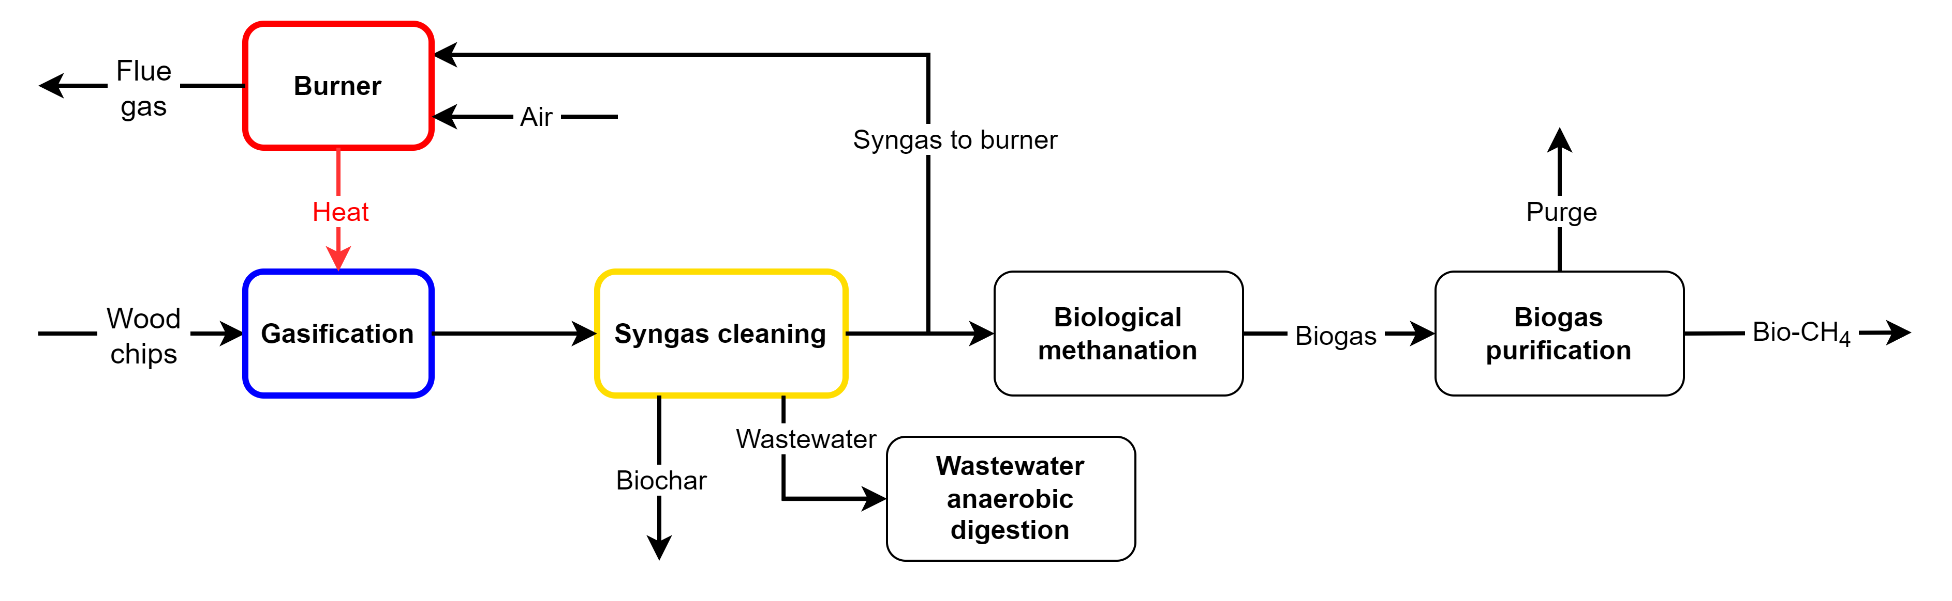Figure 1 reports the BFD of the global process of turning biomass into biogas. The concept includes a limited number of steps. The wood chips are gasified, and solid biochar is removed from the product mixture. The resulting biosyngas is cleaned and quenched to remove part of the moisture. The cleaned syngas is split: one fraction is conveyed to a burner to generate the heat to sustain the endothermic gasification. The remaining is fed to a biological methanation reactor, where thermophilic bacteria convert the syngas into biomethane. Biomethane leaves the reactor, but its purity does not meet the transport specs; hence, an additional purification step is considered. The present contribution focuses on the first part of the process, i.e., the gasification and energy balance to run the process under auto-thermal conditions. The proposed semi-rigorous model is used to estimate the syngas composition and fraction to be burnt to supply the heat for endothermic gasification.

Figure 1: BFD of the process. The same colours are used to identify subsections in Figure 2.

* + 1. Gasification flowsheet

Figure 2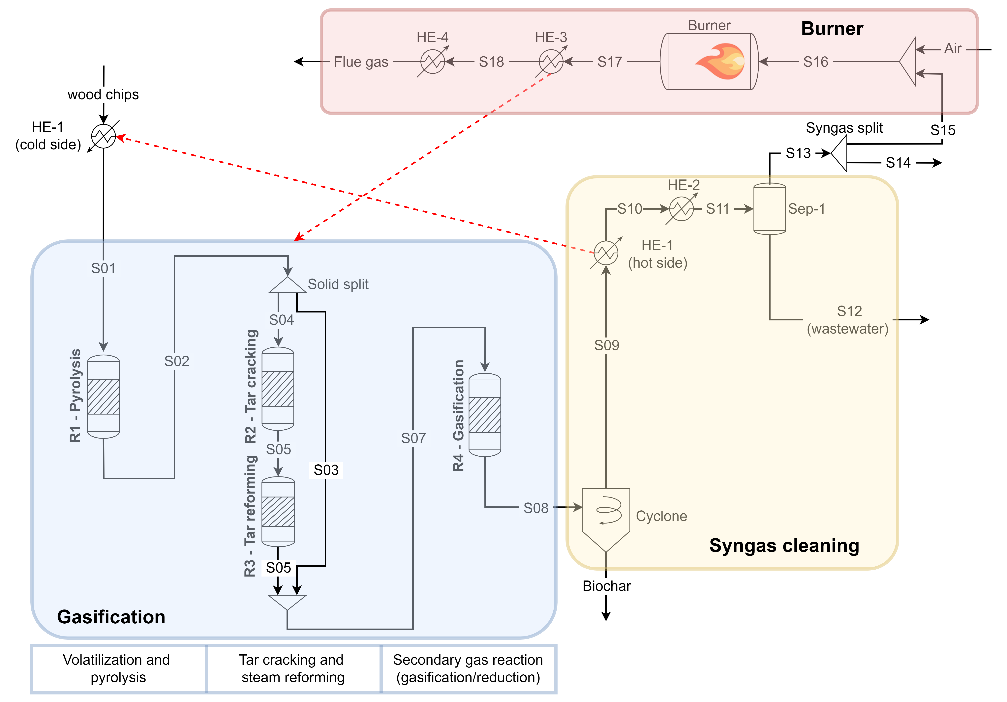 depicts the process flowsheet for the gasification process and the burner to supply the heat.

Figure 2: Flowsheet of the gasifier and burner: solid black line (material stream) and red dashed line (heat).

As shown, the gasification is not modelled as a single step, but as a series of reactive steps. The semi-rigorous model and assumptions are described in Section 3 since this section is meant to describe the flowsheet for the gasifier only. The wood chips are preheated in a screw system (HE-1) where the solid is contacted with the hot syngas (S09). This is an effective way to exchange heat between the solid and gas. The feedstock (S01) is fed to the gasification process. The solid is initially pyrolyzed (R1). Produced tars are cracked (R2) and then reformed with steam (R3). Steam is generated during the preheating, pyrolysis and cracking steps. The system considers separating the gas (S04) and the solid (S03), e.g., char and unreacted solid. This is clarified in Section 3. Secondary gas-phase reactions occur (R4) and the resulting syngas (S08) is conveyed to a cyclone to separate the biochar from the gas. As mentioned above, the hot bio-syngas is sent back to the solid screw feed system to preheat the solid (HE-1). The syngas is finally quenched (HE-2) and moisture is removed (S12). The cold syngas (S13) is split: one fraction (S14) is sent to the biological methanation (see Figure 1), the remaining part (S15) is mixed with air and burnt. The burners surround the gasification chamber and release the heat for gasification (HE-3). Combustion of part of the produced syngas covers the total energy demand for gasification. The flue gas leaves the gasification system (S18) and is chilled (HE-4) before conveying it to the stack.

* 1. Model assumptions and implementation

The flowsheet of the gasification section is implemented in COFE (CAPE-Open Flowsheet Environment) V3.7, a CAPE-Open license-free simulation software released by AmsterChem. Gasification occurs in four steps: (1) volatilization and pyrolysis, (2) tar cracking, (3) tar reforming, and (4) gas-phase secondary reactions that are commonly named “gasification” or “reduction” as shown in Figure 2. These steps occur in sequential reactors.

* + 1. Feedstock characterization

Biomass is characterized as approximate (cellulose, hemicellulose, and lignin) and elemental analyses (C, H, and O). The model neglects N and S, for now. Both are fundamental since the pyrolysis model (Section 3.2) considers different chemical paths for the biomass constituents. The elemental composition is considered to estimate the relative distribution of the lignin building blocks as proposed in Ranzi et al. (2014). TERRAWATT provided the approximate and elemental composition of wood waste available at the facility in Bourges. The pilot treats 150 kg/h of wood chips with a moisture content of 30 wt%, i.e., dry biomass is 105 kg/h.

* + 1. Biomass volatilization and pyrolysis (R1)

Biomass volatilization and pyrolysis are modelled based on the lumped kinetics proposed by Ranzi et al. (2014). Kinetic expressions are retrievable from the supplementary material of the same work. The lumped kinetic model reduces the number of reactions and chemical species in the system to be feasible for process simulators. The kinetics proposed by Ranzi et al. (2014) suggest different reactivity for cellulose, hemicellulose, and lignin: (1) cellulose is responsible for char production mainly, (2) hemicellulose releases alcohols and aldehydes, and (3) lignin degrades thermally and generates C5+ tars and other light molecules as well as char and other solid products. The reactor is size assuming fluidization of the bed, and the gas velocity guarantees the lift of the solid. The fluidization condition has been analyzed through a separate Python-based code. The pyrolysis chamber is run at 750°C, corresponding to the nominal operating conditions in TERRAWATT’s pilot. The temperature of the reactor is assumed uniform; hence, the next reactive steps also occur at the same temperature. This assumption is corroborated considering that fluidization keeps perfect mixing within the chamber. The resulting product mixture is sent to tar cracking.

* + 1. Tar cracking (R2) and reforming (R3)

Chen et al. (2021) published kinetics for tar cracking accounting for the same molecules proposed in Ranzi’s lumped model. Chemistry and kinetic expressions are reported in the same work. Remarkably, the proposed scheme considers small molecules as products of cracking: C1 (formaldehyde, methane), C2 (ethylene and acetylene), steam, and syngas constituents. Ranzi et al. (2017) published rather detailed kinetic models for tar cracking, where radicals are included. Implementing this kind of reactive system is impossible in process simulators due to propagation reactions of radicals which lead to a wide range of possible combinations reactions, i.e., exponential increment of the number of components to be defined, and exponential increase in computational time. The kinetic models in Chen et al. identify different reactivity for tar molecules: the smaller, the lower the reactivity. Acetone, glyoxal, and acetaldehyde are the most recalcitrant in increasing order of stability to thermal cracking decomposition, while C5+ molecules are sensitive to thermal degradation and rapidly turn into lighter molecules. The tar cracking section is designed to achieve 50% conversion of acetone, the least stable among the mentioned recalcitrant species.

The product mixture from tar cracking undergoes a reforming step. The reforming occurs owing to the steam released during both pyrolysis and cracking, as well as the water vaporized from the moisture of the biomass. The literature does not report any general and/or lumped model for reforming reactions of tar and its decomposition products. For this reason, an equilibrium reactor is considered to estimate the resulting equilibrium composition of the gas. The equilibrium reactor addresses the minimization of the Gibbs energy of the system based constrained to reforming reaction where residue tar and its derivates are consumed to release CO and H2, the water-gas shift reaction (RWGS) refines the H2/COx ratio.

* + 1. Secondary gas-phase reaction “gasification” (R4)

The secondary gas-phase reaction system includes water-gas shift (WGS) in Eq (1), steam methane reforming (SMR) in Eq (2), and char gasification in Eq (3). The kinetics for uncatalyzed reactions are retrieved from Chaurasia (2016), Gómez-Barea and Leckner (2010), and Groeneveld and van Swaaij (1980), respectively.

|  |  |  |
| --- | --- | --- |
| CO + H2O ⇄ CO2 + H2 | (WGS) | (1) |
| CH4 + H2O ⇄ CO + 3H2 | (SMR) | (2) |
| 2C + H2O + CO2 → 3CO + H2 | (char gasification) | (3) |

The kinetic for the char gasification is included though Groeneveld and van Swaaij experimentally observed that char gasification with steam and CO2 is spontaneous only above 1000°C. Later, Basu (2010) confirmed this result from a thermodynamic perspective and concluded that char gasification is activated only when the partial pressure of gasification agents, i.e., steam, CO2, O2/air are sufficiently high to facilitate their diffusion within the porous char. Therefore, the system is mass transfer controlled. The experimental evidence proves that char is inert to steam reforming and gasification at mild temperatures. For these reasons, solid char is “fictitiously” removed from the reaction environment (S03) and fed to gasification. Noteworthy, existing thermodynamic models in process simulators estimate complete char gasification above 600°C. Therefore, the flowsheet proposed in the literature must withdraw all formed char from pyrolysis and prevent its gasification in the Gibbs reactor, which is always implemented to mimic the secondary gas-phase reactor. The last consideration confirms that gasification is a complex system where thermodynamic constraints are interlinked to mass transfer and kinetic limitations. This corroborates the potential improvements offered by the proposed semi-rigorous approach compared to the existing models in process simulators.

* + 1. Syngas quenching and burner

The syngas quenching is carried out in two stages, namely HE-1 and HE-2 in . The first heat exchanger (HE-1) corresponds to the solid-gas counter current direct contact heat exchanger. The solid is fed at ambient temperature (25°C). Syngas enters at 750°C and the outlet temperature is set at 150°C to avoid condensation at 1.0 bar (abs) of the moisture which could increase the final moisture in the solid. The final temperature of the solid is calculated from the energy balance. The second heat exchanger reduces the temperature of the syngas to 40°C and the acid condense is purged. The model does not consider the presence of SOx and NOx from biogas thermochemical conversion. This is a potential limitation of the current semi-rigorous model though the mechanisms of formation of NH3, NOx, and SOx are still not fully understood yet and the literature is poor.

Part of the syngas is burnt to release and supply the heat to sustain endothermic gasification. The burner is designed as a conversion reactor where air is fed in excess. The system accounts for the complete combustion of CH4, CO, and H2 from the syngas to CO2 and H2O. The model considers the combustion of the traces of methanol, ethylene, and others. The mass flow of combustion air is tuned so that the residue oxygen in the gas after the combustion is ~3 vol% which is the normal oxygen content in flue gas in post-combustion carbon capture. In this way, the adiabatic temperature is ~1900°C and the flame irradiates heat to the gasification chamber (Quirino et al., 2021). The HE-3 mimic the heat released from the combustion and absorber by the gasification. The outlet temperature of the flue gas from the burner (S18 in Figure 2) is set at 850°C to guarantee a minimum pinch temperature of 100°C across the combustion and gasification chambers (the gasifier is run at 750°C), though this could be lower in large-scale natural reforming processes (Quirino et al., 2021). Remarkably, part of the combustion heat is wasted to increase further the temperature of the preheated solid (S01). Indeed, the direct contact heat exchanger (HE-1) is insufficient to raise the temperature of the solid up to ~550°C, when volatilization and pyrolysis reactions are activated. The syngas mass flow (S15) is calculated to satisfy the energy balance, i.e., the gasification is run at autothermal conditions.

* 1. Results and discussions
     1. Model pre-validation (using sensitive data)

The proposed semi-rigorous model has been compared to experimental data collected from an existing gasifier, whose owner and technology supplier are sensitive. The facility considered has an analogous layout and size of the unit designed for TERRAWATT and commissioned in Bourges. The data are sensitive and cannot be disclosed. This Section is limited to reporting the deviations of our semi-rigorous model against observations collected using similar woody biomass. The absolute (AE) and relative error (RE) are defined as follows:

|  |  |
| --- | --- |
|  | (4) |
| $RE [\%]=\frac{y_{i}^{model} -{ y}_{i}^{exp}}{{ y}_{i}^{exp}}⋅100$ | (5) |

where y is the generic variable of interest and superscripts “model” and “exp” refer to the semi-rigorous model and the corresponding measurements from the pilot, respectively. Table 1 gather three “features”: the order of magnitude of the measurements, the absolute (AE) and relative (RE) errors for the most relevant properties of the system. The first identifies the “size/scale” of the measurement. The AE refers to the accuracy and is given as an order of magnitude to avoid disclosing information; indeed, yexp = AE/RE. RE is a direct indicator of precision. The combination of these pieces provides an overview of the model's quality. The analysis focuses on the syngas dry composition through the most abundant species, residue tar, moisture content, and char production. Table 1 reports the global fraction of C1 to C3. Measurements report two species, i.e., ethane and propane, that are not considered in the semi-rigorous model and labelled as Not Available (NA). Neither Ranzi et al. (2014) nor Chen et al. (2021) considered those molecules in their models. However, they included the production of ethylene and acetylene. The mismatch between the molecules present in the model and actual measurements leads to an intrinsic imbalance in the system: atoms are distributed differently within available/considered molecules. Hence, it is worth considering the class of hydrocarbons C1 to C3 as a “lumped” class without accounting for their distribution. Table 1 shows how the semi-rigorous model is aligned with the expected syngas composition, especially for H2 and COx. Residual methane is underestimated, but the value is in the same order of magnitude as the measurements. The C1-3 fraction is predicted with an error of less than 10%. A similar conclusion holds for moisture. The formaldehyde content does not match the experimental observation, but the semi-rigorous model predicts the presence of other C1-2 oxygenated molecules in the syngas mixture not measured at the facility.

Table 1: Deviations in dry syngas composition at the outlet of the gasifier and other relevant variables

|  |  |  |  |
| --- | --- | --- | --- |
| **Dry composition [vol%]** | **Order of magnitude** | **AE (magnitude)** | **RE [%]** |
| CO | 101 % | 0.1% | -2.00 |
| CO2 | 101 % | 0.1 % | +3.42 |
| H2 | 101 % | 1.0% | +4.47 |
| CH4 | 100 % | 1.0% | -50.0 |
| C2H6 | 10-1 % | NA | NA |
| C2H4 | 100 % | 1.0 % | +77.1 |
| C2H2 | 10-1 % | 0.1% | +24.4 |
| C3H8 | 10-1 % | NA | NA |
| CH4O (formaldehyde) | 100 % | 1.0 % | +126 |
| Residue tar | 10-1 % | 0.1% | -58.2 |
| **Other variables** |  |  |  |
| Char production (kg/h) | 101 (kg/h) | 1.0 kg/h | -6.14 |
| Moisture (vol%) | 101 % | 1.0% | -8.45 |
| C1-3 (vol%) | 101 % | 1.0 % | -9.00 |

NA – Not Available

* + 1. Key Performance Indicators (KPIs) of the model and comparison with literature evidence

Our analysis includes additional KPIs which are relevant to qualify accuracy and predictivity of the model. The pyrolysis-specific energy (PySE), syngas lower- (LHV), and high-heating values (HHV) are considered. PySE refers to the total energy demand per unit dry biomass. Dry biomass is preferred because the moisture in the solid is variable and the latent heat of vaporization affects the energy demand, i.e., the process energy balance:

|  |  |
| --- | --- |
| $$PySE \left[\frac{MJ}{kg}\right]=\frac{Q_{pyrolysis}}{m_{dry biomass}}$$ | (6) |

The PySE is 1.78 MJ/kg and consistent with literature evidence (Daugaard and Brown, 2003). The LLH and HHV of the resulting syngas are 13.5 and 13.7 MJ/Nm3 and fit the reference range suggested in the literature, i.e., 10-15 MJ/Nm3 in Larson et al. (2021) for steam gasification of biomass in industrial applications. The system burns 35% of the syngas produced to keep auto-thermal operations, in line with tests at the pilot.

* 1. Conclusions

The present work showed an alternative to the current approach to the modelling of pyrolysis and gasification of biomass in commercial process simulators. The semi-rigorous model has been implemented in COFE V3.7 using kinetic models whenever possible, except for tar gasification, which has been simulated by considering equilibrium conditions due to the temperature in the chamber (750°C). The proposed model has been compared with pilot facility observations, and the outcomes for the dry syngas composition, moisture, and char production are well aligned with the data. Similarly, an additional analysis highlighted that the main KPIs, i.e., energy demand for pyrolysis and the LLH and HHV of the produced syngas, are consistent with experimental evidence and industrial reference values, confirming the validity of the new approach.

Acknowledgements

The present work received financial support from the EU Horizon Program through the project SEMPRE-BIO (GA 101084297). Filippo Bisotti, Matteo Gilardi, and Bernd Wittgens (SINTEF) are also grateful to the Bio4Fuels project (GA 257622), part of the FME program funded by the Research Council of Norway, and HYIELD (GA 101137792), funded by the Horizon Europe program.

References

P. Basu, 2010, Gasification Theory and Modelling of Gasifiers, in: P. Basu (Ed.), Biomass Gasification and Pyrolysis, Academic Press, Boston, 2010, 117–165.

Chaurasia A., 2016, Modelling, simulation and optimization of downdraft gasifier: Studies on chemical kinetics and operating conditions on the performance of the biomass gasification process, Energy, 116, 1065–1076

Chen T., Ku X., Li T., Karlsson B.S.A., Sjöblom J., Ström H., 2021, High-temperature pyrolysis modelling of a thermally thick biomass particle based on an MD-derived tar cracking model, Chemical Engineering Journal, 417, 127923

Daugaard D.E., Brown, R.C., 2003, Enthalpy for Pyrolysis for Several Types of Biomass, Energy & Fuels, 17, 934-939

Gilardi M., Bisotti F., Berglihn O.T., Rücker T., Brück T., Wittgens B., 2024, Modelling of Biomass-to-X: Challenges and Strategies, Chemical Engineering Transaction, 109, 271-276

Gómez-Barea A., Leckner B., 2013, Estimation of gas composition and char conversion in a fluidized bed biomass gasifier, Fuel,107, 419–431

Groeneveld M.J., van Swaaij W.P.M., 1980, Gasification of char particles with CO2 and H2O, Chemical Engineering Science, 35, 307–313

Han J., Liang Y., Hu J., Qin L., Street J., Lu Y., Yu F., 2017, Modelling downdraft biomass gasification process by restricting chemical reaction equilibrium with Aspen Plus, Energy Conversion and Management, 153, 641-648

Kaushal P., Tyagi R., 2017, Advanced simulation of biomass gasification in a fluidized bed reactor using ASPEN PLUS, Renewable Energy, 101, 629-636

Larsson A., Kuba M., Berdugo Vilches T., Seemann M., Hofbauer H., Thunmann H., 2021, Steam gasification of biomass – Typical gas quality and operational strategies derived from industrial-scale plants, Fuel Processing Technology, 212, 106609

Millinger M., Hedenus F., Zeyen E., Neumann F., Reichenberg L., Berndes G., 2025, Diversity of biomass usage pathways to achieve emissions targets in the European energy system, Nature Energy, 10, 226-242

Quirino P.P.S., Amaral A., Pontes K.V., Rossi F., Manenti F., 2021, Impact of kinetic models in the prediction accuracy of an industrial steam methane reforming unit, Computers & Chemical Engineering, 152, 107379

Ranzi E., Corbetta M., Manenti F., Pierucci S., 2014, Kinetic modelling of the thermal degradation and combustion of biomass, Chemical Engineering Science, 110, 2–12

Ranzi E., Debiagi P.E.A., Frassoldati A., 2017, Mathematical Modelling of Fast Biomass Pyrolysis and Bio-Oil Formation. Note II: Secondary Gas-Phase Reactions and Bio-Oil Formation, ACS Sustainable Chem. Eng., 5, 2882–2896