|  |  |
| --- | --- |
| cetlogo ***CHEMICAL ENGINEERING TRANSACTIONS***  ***VOL. , 2025*** | A publication of  aidiclogo_grande |
| The Italian Association  of Chemical Engineering  Online at www.cetjournal.it |
| Guest Editors:  Copyright © 2025, AIDIC Servizi S.r.l. **ISBN** 979-12-81206-XX-X; **ISSN** 2283-9216 | |

Hydrogen Refuelling Safety Dashboard: A Proposal Based on Incident Analysis and Expert Input

Joaquín Navajasa\*, Eulàlia Badiaa, Roser Salaa, José María Olavarrietab, Hitomi Satoc, Nicola Paltrinierid

aSocio-Technical Research Centre, Centro de Investigaciones Energéticas, Medioambientales y Tecnológicas (CIEMAT). Mòdul de Recerca A. Plaça del Coneixement s/n, Universitat Autònoma de Barcelona, 08193 Bellaterra, (Barcelona), Spain.

bCentro Nacional del Hidrógeno (CNH2), Prolongación Fernando el Santo, s/n.13500 Puertollano, (Ciudad Real), Spain.

cInstitute of Innovation for Future Society, Nagoya University. Furo-cho, Chikusa-ku, Nagoya, Japan.

dDepartment of Mechanical and Industrial Engineering, Norwegian University of Science and Technology (NTNU). , Richard Birkelands vei 2b, Trondheim 7034, Norway

joaquin.navajas@ciemat.es.com

The transition to sustainable energy sources has driven the development of hydrogen as a key energy carrier, particularly in the mobility sector. However, ensuring the safety of hydrogen refuelling stations (HRS) remains a critical challenge for their widespread adoption.

This study aims to develop a safety indicator dashboard for HRS by leveraging operational experience from incident data and expert insights. The research was conducted in two phases. Firstly, a systematic analysis of incidents reported in international hydrogen databases was performed to identify key contributing factors to accidents. Secondly, twenty-nine international experts from Japan, China, Germany, Norway, Spain, Poland and Turkey—specialists in hydrogen refuelling stations or hydrogen safety research—evaluated eighteen contributing factors through an online survey. The consultation gathered both quantitative and qualitative feedback to assess the relative importance and potential impact of each factor. The resulting indicators incorporate all critical aspects of HRS safety, including design, normal operation, maintenance and emergency situations.

The analysis of expert perspectives reveals a consistent understanding of key HRS safety issues across different countries, areas of expertise, years of experience and gender. The study's main outcome, the safety dashboard, provides a structured framework for monitoring and improving HRS safety, offering valuable guidance to policymakers, industry stakeholders and researchers.

* 1. Introduction

The establishment of safety indicators is of paramount importance for the management of complex, high-risk processes and systems. These indicators facilitate the continuous monitoring and evaluation of safety status, enabling the identification of potential failures or risks before they escalate into incidents. Moreover, the implementation of a safety dashboard provides a structured and systematic framework for the execution of preventive and corrective measures, ensuring compliance with safety standards and minimising the risk of major accidents (Paltrinieri et al., 2012).

There are various approaches and methodologies for the development of safety indicators. This study integrates elements from three relevant methodologies. Firstly, it draws on the step-by-step guide by the Health and Safety Executive (HSE, 2006), highlighting the necessity of incorporating both leading and lagging indicators as a form of dual assurance. Secondly, following the REWL method (Knut et al., 2012), this approach conceptualises a safety dashboard as a preventive tool designed to generate early warnings that mitigate the likelihood of severe accidents. Rather than serving solely as a data collection mechanism, the set of indicators is intended to actively contribute to the improvement of organisational safety. Thirdly, this study adopts the socio-technical perspective of the STAMP methodology (Leveson, 2012), seeking to go beyond the technical components of a system by incorporating human agency, organisational factors, and regulatory frameworks. Notably, a review of the existing literature on the current state and research advancements reveals a lack of studies specifically addressing the development of HRS performance indicators (Genovese and Fragiacomo, 2023).

* 1. Methodology

To develop the safety dashboard, two primary sources were utilized: A) a systematic review of incidents at HRS, which allowed for the identification of key contributing factors involved in the events, and B) the design and administration of a survey, which was assessed by an international panel of experts to evaluate the relevance and impact of these factors. The experts were selected by SUSHy project partners in each country based on their technical and/or regulatory experience with HRS and their active involvement in the sector. In Japan, a specialized market research firm carried out the identification process using equivalent criteria. Once selected, they provided a prioritized assessment based on their judgment, ensuring a comprehensive and expert-informed framework for the dashboard's construction.

The incident analysis followed a systematic process aimed at identifying the factors contributing to each event based on available data. This process was grounded in well-established analytical methodologies used in high-risk industries such as nuclear power and offshore operations. These methodologies were structured around a framework consisting of 10 potential contributing factors and 35 sub-factors, a set of rules applied by a team of analysts and pilot validation (Navajas et al., 2023). The contributing factors identified through the incident review served as the foundation for the survey, which utilized a 7-point Likert scale (1 to 7) to gather quantitative data on 18 critical safety factors, as well as on various equipment most prone to failure and likely to contribute to incidents. To arrive at these 18 factors, the original 35 sub-factors were streamlined using two main approaches: (1) eliminating sub-factors with very low prevalence in incidents (<1%), and (2) grouping closely related sub-factors into consolidated categories. For example, inspection and maintenance—intrinsically linked processes in HRS operations—were reorganized into planning and execution phases to create more meaningful assessment categories. Prior to survey administration, the content was reviewed by experts in the field. This expert review ensured the clarity, relevance, and comprehensiveness of the survey, helping to refine the instrument and enhance its validity for assessing safety at HRS. The stages for shaping the dashboard are shown in ***Figure 1***.



*Figure 1. Stages in the development of the safety dashboard*

Quantitative analyses were performed using SPSS 27. Independent t-tests and one-way ANOVAs were conducted to compare demographic variables across groups. Post hoc comparisons were carried out using Bonferroni correction to adjust for multiple comparisons. Statistical significance was set at p < 0.05. The demographics of the examined databases, identified events, and contributing factors are shown in Table 1, and the expert pool’s demographic information (N=29) by country, expertise field, and experience are presented in Table 2.

Table 1. Hydrogen databases and event information

|  |  |  |  |  |
| --- | --- | --- | --- | --- |
| Hydrogen Database | Events |  | Analysed events | 211 |
| ARIA | 4 |  | Events with contributing factors | 174 |
| H2 Tools | 13 |  | Identified contributing factors | 263 |
| HIAD 2.0 | 14 |  |  |  |
| KHK | 186 |  |  |  |

Table 2. Expert pool demographic data

|  |  |  |  |  |  |  |  |  |
| --- | --- | --- | --- | --- | --- | --- | --- | --- |
| Country | N. |  | Expertise field | N. |  | Years of experience | | N. |
| China | 1 |  | Academic | 8 |  | 5 or less | | 9 |
| Germany | 1 |  | Industry | 19 |  | from 6 to 10 | | 3 |
| Japan | 19 |  | Both Industry and academic | 1 |  | from 11 to 15 | | 6 |
| Norway | 3 |  | Others | 1 |  | from 16 to 20 | | 2 |
| Poland | 1 |  |  |  |  | more than 20 | | 9 |
| Spain | 3 |  |  |  |  |  | |  |
| Turkey | 1 |  |  |  |  |  |  | | |

To evaluate the instrument’s reliability, the Cronbach's alpha coefficient of the survey was calculated, yielding a value of 0.877. According to George and Mallery (2016), this value reflects 'good' internal consistency, suggesting that the obtained results are reliable.

Since the survey was designed based on an exhaustive review of incidents and validated by experts in the field, a factor analysis was not deemed necessary. This validation process ensures the validity of the items and their relationship with the construct of interest, guaranteeing that the dimensions of the instrument are adequately represented without the need for additional analyses. Additionally, given that the overall goal of the study is to build a set of indicators rather than validate a theoretical construct, factor analysis has been excluded.

* 1. Results

This section shows the results obtained at different stages of the dashboard development process. Specifically, it details the expert panel's assessment of the main factors identified in the incident review. A correspondence analysis of the two sources (experts and incidents) is also provided as a basis for selecting and developing operational indicators. Finally, this section introduces the dashboard, which comprises 10 critical indicators developed by the authors of the study, along with their nature (reactive / proactive) and an initial estimate of the time required for their measurement.

* + 1. Expert views

The survey analysis reveals that all assessed contributing factors received scores above 5 out of 7. The highest scores were recorded for item 1, "Compliance with specifications and standards (such as statutory codes, regulations, local codes, or bylaws)" (M=6.59), and item 10, "Adequate internal actions to prevent a follow-on accident" (M=6.52). In contrast, the factors with the lowest scores were item 16, "Human performance (e.g., during operation, inspection, or maintenance of the station)" (M=5.34), and item 5, "Adequate procedures for accepting and controlling design changes" (M=5.41).

Overall, the results indicate that the views on key hydrogen safety issues are consistent across different experts, regardless of variables such as country, field of expertise, age, and gender, with no statistically significant differences. The only statistically significant difference is observed in item 1, which pertains to "Compliance with specifications and standards (such as statutory codes, regulations, local codes, or bylaws)". Experts from Japan scored lower than those from other countries (M=6.42 vs. M=6.90), and female experts scored lower than their male counterparts did (M=6.00 vs. M=6.64).

The means of the 18 identified key safety issues for hydrogen development, categorized by country and expertise field, are shown in ***Figure 2***.

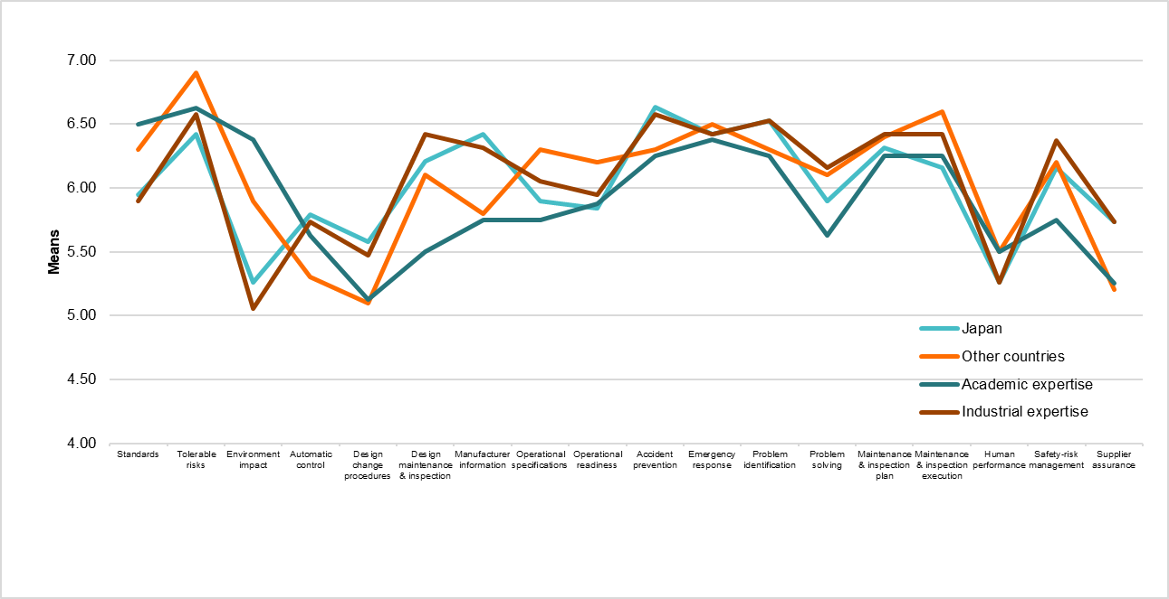

*Figure 2. Expert assessment of key hydrogen safety issues*

* + 1. Incident analysis outcomes versus experts’ views

The results for each contributing sub-factor are presented in Table 3, including the corresponding items’ evaluation by experts, the average scores assigned, and the degree of involvement in the reviewed incidents.

Table 3. Expert assessment and incident relevance of contributing sub-factors

|  |  |  |  |  |  |
| --- | --- | --- | --- | --- | --- |
| Contributing Factor | Sub-factor | Expert panel-rated item | Panel  Score  (1 to 7) | | Incidents relevance  (%) |
| Technical information | Supplier/manufacturer. communication | (7) Accurate information from manufacturers | 6.21 | 2.87 | |
| Data collection analysis | Problem Solving  Use of previous incident/accident info | (13) Successful problem solving  (12) Collection of relevant data for early problem identification | 5.97  6.45 | 1.1**5**  1.72 | |
| Operational Readiness | Verification operational readiness | (9) Effective operational verification prior to initiating refuelling activities | 5.97 | 5.17 | |
| Inspection & Maintenance | Planning Process  Execution | (14) Plan outlined (comprehensive evaluation and servicing of all relevant areas, equipment, and systems)  (15) Plan execution (no failures; on schedule; and according to the operational readiness of the hydrogen refuelling station) | 6.34  6.31 | 18.97  13.20 | |
| Supervision staff | Performance errors | (16) Human performance (operation, maintenance and inspection) | 5.34 | 18.97 | |
| Stabilisation & restoration | Prevention follow accident  Emergency action | (10) Adequate actions to prevent a follow-on accident  (11) Prompt and adequate external emergency response (fire-fighting) | 6.52  6.45 | 2.87  1.15 | |
| Management & risk policies | Risk management | (17) Risk management policy focused on the safety of the facility | 6.17 | 4.60 | |
| Concepts & requirement design | Goals and tolerable risks  Specification of requirements | (2) Goals and tolerable risks defined in the process of designing  (1) Compliance with specifications and standards (as statutory codes and regulations, local codes or bylaws) | 6.07  6.59 | 4.02  1.72 | |
| Design & development | Environment  Maintenance & Inspection Plan  Automatic control  Specification of operation  Design control change | (3) Environmental conditions affecting pieces, equipment or systems are minimized in the design (e.g., temperature, vibration, weight, or other physical conditions)  (6) The design establishes the basis for an appropriate maintenance and inspection plan  (4) Automatic control built into the design to ensure constant power flow operation  (8) Operational specifications for all phases of the installation  (5) Adequacy of procedures for accepting and controlling design changes. | 5.48  6.17  5.62  6.03  5.41 | | 20.69  9.20  2.30  8.50  4.60 |
| Failure by third part | Parts and equipment manufacturers | (18) Assurance quality program extends to overseeing suppliers (mostly parts and equipment manufacturers) | 5.65 | | 12.64 |

* + 1. Correspondence table

To analyse similarities and discrepancies in factor selection, a correspondence table was developed and visually represented. The intervals were chosen to ensure clear differentiation while maintaining practical interpretability. Cut-off points were set to balance interpretability with practicality. For Likert scores (all >5/7), intervals of 0.5 were used to show differences within high scores. Scores below 5.75 indicated low importance, scores between 5.75 and 6.25 showed moderate importance, and scores ≥6.25 indicated high importance, avoiding overly broad or empty categories. Incident frequencies were categorized into three groups: infrequent (<4%), moderate occurrence (4-12%), and high (>12%), based on the data distribution and operational priorities. This approach ensured balanced groupings (7-6-5 items per category) and prioritized practical information, highlighting key factors where expert visions and recurrence intersect. ***Figure 3*** presents the correspondences, and ***Figure 4*** illustrates experts’ opinions and incident frequency.

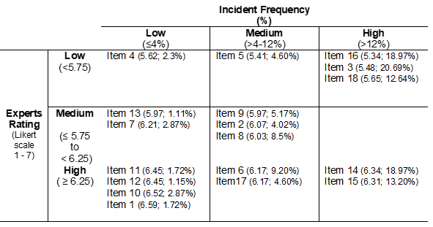

*Figure 3. Correspondence between expert vision and incidents review*

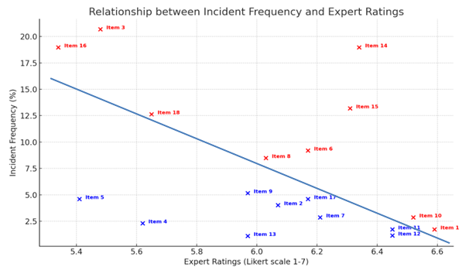

*Figure 4. Graphical representation of expert vision and incidents review*

* + 1. Dashboard proposal

The correspondence analysis has guided the selection of factors within the set of indicators; incorporating the five most frequently, occurring factors in incident reviews and the five most highly valued by experts. It is worth noting that some factors, despite discrepancies between expert assessments and incident reviews, have been included in the dashboard. The documentary review has highlighted critical factors that experts consider to be of low importance, such as human performance, environmental conditions in design, and contractor supervision processes. Similarly, two factors with low prevalence in incident reports but deemed highly critical by experts—regulatory compliance and the prevention of secondary accidents resulting from an event—have also been included. The result of the entire process is the dashboard proposal, as illustrated in Table 4.

Table 4. Dashboard proposal for the safety of a hydrogen refuelling station

|  |  |  |
| --- | --- | --- |
| **Scope** | **Items** | **Indicators** |
| Design [specifications and standards] | 1 | 1. Number of regulatory and/or legal non-compliances identified during official inspections or audits per quarter (lagging indicator) |
| Design [environmental conditions] | 3 | 1. Number of failures of components, equipment, and systems due to environmental conditions outside of design limits (quarterly / leading) |
| Operational specifications | 8 | 1. Percentage of effective operational readiness verifications completed during the normal operation, in accordance with the quality assurance plan (quarterly / lagging) |
| Maintenance and inspection plan | 6, 14, 15 | 1. Percentage of maintenance and inspection tasks completed on time, as compared to the timeline outlined in the annual plan (quarterly / leading) 2. Number of leak detections (H2 25% LEL, 1% concentration during HRS operation (quarterly / lagging) |
| Human performance | 16 | 1. Number of events due to human error (quarterly/lagging) 2. Percentage of employees trained in hydrogen-specific emergency procedures (annual /leading) |
| Overseeing suppliers | 18 | 1. Percentage of key supplier quality audits completed on time, as compared to the timeline outlined in the supply requirements (annual / leading) |
| Follow-on accident | 10 | 1. Number of secondary or follow-on incidents occurring after a primary incident (quarterly / lagging) 2. Percentage of corrective actions implemented on time after an incident (annual / leading) |

* 1. Conclusions

This study presents the development of a dashboard for monitoring hydrogen refuelling stations safety. Indicators were selected through two complementary methods: an analysis of past incidents to identify contributing factors and validation by a panel of 29 international experts, including 19 from Japan. The survey revealed strong expert consensus on hydrogen safety, with standards compliance and accident prevention rated highest, while human performance and design changes received lower scores. Correspondence analysis then guided the selection of key attributes for monitoring. These aspects include factors identified through both expert views and incident analysis, as well as factors considered highly relevant by experts despite their low occurrence in incident records. The final dashboard integrates 10 indicators, containing technological, organisational, regulatory, and human factors within a socio-constructionist risk management approach. Finally, it is important to note that this dashboard proposal is generic and potentially applicable to different types of HRS (700 bar, 350 bar, and LH2). Moreover, the proposed indicators and their measurement intervals should be further refined based on insights gained from a pilot implementation in a HRS. Initially a six-month trial with periodic measurements would allow for adjusting data collection frequencies and parameter values, helping ensure the indicators remain applicable and practically useful.

Nomenclature

ANOVA - Analysis of Variance

bar - Metric unit of pressure

H2 - Hydrogen

HRS - Hydrogen Refuelling Stations

HSE - Health and Safety Executive

LEL - Lower Explosive Limit

LH2 - Liquid Hydrogen

M - Mean

N - Total number of individuals

p - Statistical Probability Value

REWL - Replica-Exchange Wang-Landau Method

SPSS - Statistical Package for the Social Sciences

STAMP - Systems Theoretic Accident Model and Process

SUSHy - SUStainability and cost-reduction of Hydrogen stations through risk-based, multidisciplinary approaches

Acknowledgments

This work was supported by AEI Grant Number PCI2022-132997, Spain, through the European Interest Group (EIG) CONCERT-Japan platform (Grant Number 334340)

References

George, D., & Mallery, P. (2016). *IBM SPSS statistics 23 step by step : a simple guide and reference*. Routledge.

Health and Safety Executive (HSE). (2006). Developing process safety indicators: A step-by-step guide for chemical and major hazard industries. *Page*, 1–58. http://www.hse.gov.uk/pubns/priced/hsg254.pdf

Knut, O., Massaiu, S., & Kviseth Tinmannsvik, R. (2012). *Report Guideline for implementing the REWI*. 40. https://www.sintef.no/globalassets/upload/teknologi\_og\_samfunn/sikkerhet-og-palitelighet/sintef-a22026-guideline-for-implementing-the-rewi-method.pdf

Leveson, N. G. (2012). Stamp: An Accident Model Based on Systems Theory. In *Engineering a Safer World: Systems Thinking Applied to Safety* (p. 73).

Navajas, J., Badia, E., Sala, R., Sato, H., & Paltrinieri, N. (2023). Development of a Protocol for the Systematic Analysis of Events at Hydrogen Refuelling Stations. *Chemical Engineering Transactions*, *105*, 127–132. https://doi.org/10.3303/CET23105022

Paltrinieri, N., Dechy, N., Salzano, E., Wardman, M., & Cozzani, V. (2012). Lessons Learned from Toulouse and Buncefield Disasters: From Risk Analysis Failures to the Identification of Atypical Scenarios Through a Better Knowledge Management. *Risk Analysis*, *32*(8), 1404–1419. https://doi.org/10.1111/j.1539-6924.2011.01749.x

Genovese, M., & Fragiacomo, P. (2023b). Hydrogen refueling station: Overview of the technological status and research enhancement. Journal of Energy Storage, 61 (January), 106758. <https://doi.org/10.1016/j.est.2023.106758>