|  |  |
| --- | --- |
| cetlogo ***CHEMICAL ENGINEERING TRANSACTIONS***  ***VOL. xxx, 2025*** | A publication of  aidiclogo_grande |
| The Italian Association  of Chemical Engineering  Online at www.cetjournal.it |
| Guest Editors: David Bogle, Flavio Manenti, Piero Salatino  Copyright © 2025, AIDIC Servizi S.r.l. **ISBN** 979-12-81206-21-2; **ISSN** 2283-9216 | |

Glass Etched Titania Nanocrystals in a Semi-continuous Flatbed Reactor for UV-assisted Disinfection of Patulin in Apple Juice

Seteno K. O. Ntwampe, Morelle M. Ngandjou-Douanla

Department of Environmental and Occupational Studies, Faculty of Applied Sciences, Cape Peninsula University of Technology, Corner of Hanover and Tennant Street, Zonnebloem, Cape Town, 8000, South Africa.

\*NtwampeS@cput.ac.za

This study reports on patulin (PAT) disinfection for bentonite-clarified apple juice in a photocatalytic semi-continuous flatbed reactor (SCFR). In agricultural produce, several fungi (*Aspergillus* and *Penicillium* sp.) are known to be contributing sources of PAT and can occur in fresh and processed products. The regulation (EU) 2023/915 allows limits of 10 to 50 µg/kg in juices and beverages, including concentrates. The application of titanium dioxide (TiO2) nanocrystals etched on a flat glass was assessed in the degradation of PAT using photocatalysis (15/30V UV light source) on a 4-wheel UV panel-battery (power storage) system. TiO2 nanocrystals were synthesized from a mixture of titanium chloride (TiCl4) and ammonium hydroxide (NH4OH), with the glass being etched in acid to mobilize the TiO2 nanocrystals. The optical properties showed a polydisperse single-phase anatase structure with an average size of 100 nm. After treatment and SCFR operating in a fed-batch mode, 73% of PAT was removed in 160 min at UV 30 (300 nm) per processing cycle. The application of the process is aimed at small-scale co-operatives or farmers with fewer resources who can pre-treat their juices to produce PAT-free products.

* 1. Introduction

Due to climate change, the quality of agricultural produce, in particular, citrus fruit such as apples, has reduced, culminating in increased toxicants such as patulin (PAT, 4-hydroxy-4H-furo [3, 2c] pyran-2[6H]-one) produced as secondary metabolites on infected fruits by several fungi (moulds), i.e., *Penicillium*, *Aspergillus*, *Mucor*, and *Fusarium* sp. (Kharayat and Singh, 2018). Overall, climate-stressed agricultural produce is susceptible to colonization by these PAT-producing fungi, resulting in PAT-contaminated juice concentrate and product recalls (Isilow, 2021; Tapei Times, 2024). PAT's major ingestion route is through apple fruit and juices (WHO, 2023). It is a mycotoxin and a potential carcinogen with adverse clinical outcomes in humans when consumed, inducing vomiting and gastrointestinal problems in the short term, with long-term exposure resulting in geno/neurotoxicity, thus, its limit is set at 50 µg/Kg and stricter limits of 10 µg/Kg for baby, infants and young children and processed cereals (EU, 2023).

For the largest apple fruit, juice, and concentrate producers and exporters, such as the People's Republic of China (PRC) and the USA, among others, the integration of cooperatives and small-medium scale farmers (CSMSFs) in the apple fruit-juice/concentrate supply chain is advocated for. The CSMSFs supply commercially licensed producers and exporters (CLPE), albeit with some low-grade fruit and juices contaminated with fungi and their secondary metabolites such as PAT. This necessitates PAT treatment in the supplied products as reported elsewhere (Li et al., 2022), with UV/nanoparticle systems being developed (Huang and Peng, 2021).

But these systems are not in-field application friendly for CSMSFs, thus, a mobile, off-grid system must be developed for PAT treatment in apple juice. Therefore, this study reports on PAT disinfection for apple juice in a photocatalytic semi-continuous flatbed reactor (SCFR) for in-field application by CSMSFs.

* 1. Materials and methods

All reagents used in this study were of analytical grade standard and were sourced from Merck KGaA (Darmstadt, Germany), with the water used being distilled sterile water (sdH2O). Sample processing was done in duplicate.

* + 1. Semi-continuous flatbed reactor (SCFR) design, set-up, operation, and components synthesis

Clear polycarbonate sheets were used to construct the bottom part of the SCFR in such a way that the grey lid (cover) can accommodate 15 V/30 V fluorescent tubes (n = 2) on the cover of the reactor to allow for fair distribution of UV light within the reactor. The bottom exterior of the SCFR was covered in foil during the SCFR operation.

A wet chemistry method was used to synthesize TiO2 from TiCl4 in water (1 M) and NH4OH (32%) using a drop-wise approach under vigorous stirring. The complete methodology and TiO2 characterization are reported elsewhere (Ngandjou-Douanla et al., 2018).

For glass etching, a mixture of sdH2O (1000 mL), H2SO4 (250 mL) and NaF (50 g) were used, whereby the plain glass sheet was immersed in the solution for 48 h, with subsequent rinse (neutralization) using a solution (1000 mL) in which NaOH (22,23 g) and Na2CO3 (23,79 g) were added. The glass was allowed to air dry. Thereafter, a non-Newtonian viscous paste containing ground TiO2 nanocrystals (14.4 g), sdH2O (12 mL), ethanol (12 mL), acetylacetone (2 mL), acetic acid (2 mL), and Triton X-100 (6 mL), was prepared. A doctor blade technique was used to apply the paste on the etched glass in the following sequence: paste application > ambient temperature drying > sdH2O rinse > ambient temperature drying > SCFR operation.

The raw apple juice was clarified before processing using bentonite (10 g/1000 mL), culminating in a semi-clear apple juice. Figure 1 illustrates the SCFR design, set-up, component synthesis and the overall process designed.

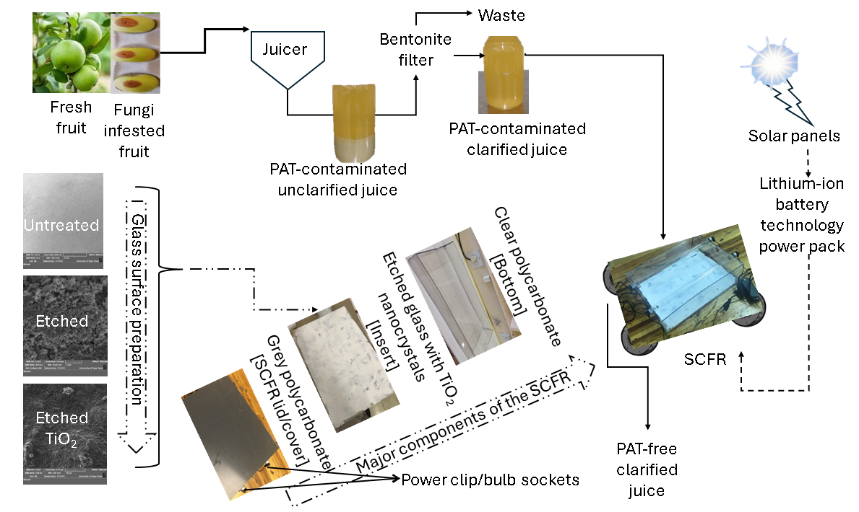

*Figure 1: SCFR PAT treatment components and process design*

For SCFR operation, a spiking approach was implemented with the final PAT concentration in the apple juice being 1,2 mg PAT/L. The SCFR conditioning phase was 30 min, i.e., a period between the supplying of PAT-contaminated apple juice and the start of irradiation, and intermittent sampling (4 mL sample volume) at phase 1: 10 min intervals (0 – 60 min), phase 2: 30 min intervals (60 – 120 min), and phase 3: 60 min intervals (120 – 180 min). Samples collected were centrifuged and filtered prior to further processing.

* + 1. Analytical methods and PAT removal efficiency

For PAT extraction, samples (n = 24, 330 mL) were processed through methanol (99.9%,10 mL) washed Supelco-Select HLB C18- SPE cartridges (500 mg solid phase, 12 mL tubes) which were rinsed with diluted methanol (10%, 3 mL) and Milli-Q water (10 mL). Samples (4 mL) with acetic acid buffer (0.5 mL) were subsequently processed via suction pressure-induced percolation (2-3 mL/min). Solid phase rinsing post-sample processing was done using hexane (5 mL), with subsequent PAT recovery, i.e., elution (n = 3 per cartridge), using different hexane-ethyl acetate-acetone mixtures (5 mL) with the ratios of 1:5:4 (mixture 1), 1:4:5 (mixture 2), 1:3:6 (mixture 3). To the collected eluates, acetic acid buffer (0.5 mL) was added, followed by nitrogen gas drying and reconstitution using 1 mL of acetic acid buffer under a vortex (3 min) for LC/MS/MS analysis (Lucci et al., 2017).

A LC/MS using a Luna® Omega polar C18 column (2.1 × 100 mm, 3.0 µm) at 40 ◦C and coupled with a triple quadruple linear ion trap MS, in a negative mode on an electrospray ionization (ESI) source using 10 µL sample injection volumes, was used. The mobile phase was constituted with NH4AC (5 mM) in Milli-Q water and 99.9% acetonitrile, with isocratic mode (0.3 mL/min), was implemented. Other parameters were a running time (4 min), LOD of 0.009 µg PAT/mL and a LOQ of 0.017 µg PAT/mL. Figure 2 illustrates the calibration and retention time of PAT during analysis.

PAT removal efficiency (%RE) was calculated using Eq. (1).

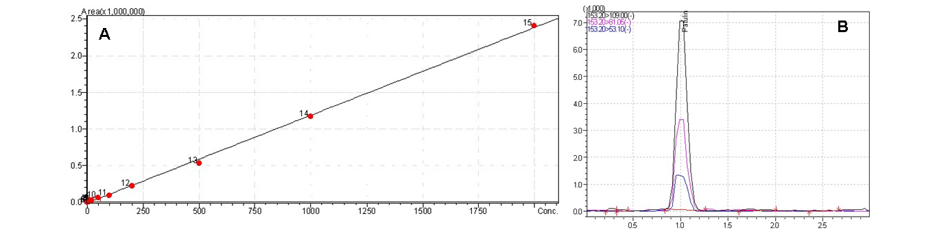

*Figure 2: PAT calibration curve (A) and the chromatogram indicating PAT retention time (B)*

|  |  |
| --- | --- |
|  | (1) |

* 1. Results and discussion

PAT and its masking in solid food, particularly apple-based beverages and food, as observed by SGS Digicomply, (2025), poses a risk to public health. Although, the identification of PAT-contaminated products can be achieved through Rapid Alert Systems, particularly for foodborne hazards such as mycotoxins of which PAT is a type, treatment at the source is always effective.

Although several reactor designs for PAT have been proposed, disinfection using UV/nanocrystal systems, provides a better approach compared to thermal and biological additives, which can result in the loss of nutritional value and sensory quality of the final product. In this study, an SCFR using UV/TiO2 was designed with the purpose of using it in-field by CSMSFs. Currently, CSMSFs employ rudimentary strategies to limit PAT contamination of their produce, i.e., by sorting and discarding rotting apples or removing the bruised, moldy areas before juicing. It was previously determined that UV irradiation didn’t have negative changes to key nutritional components of apple juice (Diao et al., 2018).

Covering the transparent part of the SCFR provided a reflective surface for improved irradiation efficacy, thus improving its performance. Aluminium foil, with its reflective surface, provides a barrier reducing the emission of light out of the system. Consequently, the light emitted from the light source can reflect into the system to allow for maximum photocatalytic reaction. Furthermore, by having a bentonite filtration system, the cloudy apple juice obtained was clarified to reduce particulate matter which can interfere with the PAT degradation as the particles can occupy the active sites of the nanocrystals.

Nanocrystal paste preparation immobilising on surfaces ensued by constructing systems for solar use in photocatalysis dye degradation systems. As etched glass had increased roughness on its surface, the shear thinning character of the TiO2 paste resulted in better embedment and ease of spreading. Figure 3 illustrates that the paste prepared was a non-Newtonian fluid, indicating increases in shear stress , result in thinning, allowing immobilization onto the etched glass.

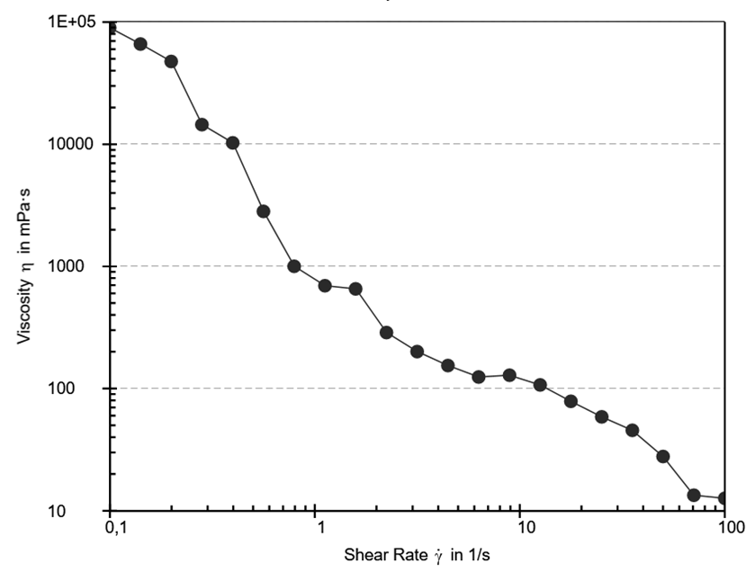

*Figure 3: Characteristics of the TiO2 paste synthesized*

Etched glass provides higher surface area and micro-cavities for fluid retention, benefiting fluids that can flow into and lock onto created pores or active sites.

The SCFR was subjected to a 30-minute initiation phase to enable optimal excitation of electron-hole pairs upon subsequent light exposure. Observingly, PAT degradation commenced rapidly, with significant reduction observed after 20 minutes, reaching peak efficiency at 160 minutes. Photocatalytic methods have shown potential for toxin breakdown, even in aqueous systems, with efficacy dependent on catalyst type, pH, and light intensity. PAT absorbs light in the 255–355 nm range, whereas microbial inactivation (e.g., spores) typically requires wavelengths below 255 nm (Ibarz et al., 2014). As illustrated in Figure 4, degradation rates increased exponentially between 10 and 20 minutes, likely due to heightened nanoparticle activation following the initiation phase. Furthermore, Figure 4 reveals that UV irradiation at 30 V achieved markedly greater PAT reduction compared to 15 V, suggesting that higher-intensity UV (30 V) is more effective. Consequently, this method is recommended for small-scale juice producers to mitigate PAT contamination.

****

*Figure 4: PAT degradation efficiency in the SCFR*

* 1. Conclusions

The SCFR-UV/TiO2 photocatalytic system exhibited high efficiency in degrading PAT when applied in a flat-bed reactor design. Notably, the immobilized TiO2 catalyst demonstrated reusability across multiple cycles without significant loss of activity, owing to its chemical stability, a cost-effective feature advantageous for small-scale juice operations. The study confirmed the viability of photocatalysis for PAT removal in apple juice, offering a scalable solution for other mycotoxin mitigation in beverages. These findings present a practical approach for juice producers, both medium and small, to address PAT contamination in apple juice effectively.

Acknowledgments

This study was sponsored by the National Research Foundation of South Africa - Research and Technology Fund 2015 RTF150410117042.

References

Diao, E., Chu, X., Hou, H., Dong, H., Gao, D., 2018, Improving the Safety of Apple Juice by UV irradiation. Journal of Food Measurement and Characterization, 12, 2005-2011. <https://doi.org/10.1007/s11694-018-9815-3>.

European Union, 2023, Regulation (EU) 2023/915 of 25 May 2023 laying down maximum levels for certain contaminants in food and repealing Regulation (EC) No 1881/2006. Official Journal of the European Union. 5.5.2023. L 119/113, https://eur-lex.europa.eu/legal-content/EN/TXT/?uri=CELEX%3A32023R0915 accessed 15.03.2025.

Hassan Isilow, 2021, South African Firm Recalls Contaminated Apple Juices from 7 countries, https://www.aa.com.tr/en/africa/south-african-firm-recalls-contaminated-apple-juices-from-7-countries/2392245 accessed 15.03.2025.

Huang, C., Peng, B., 2021, Photocatalytic Degradation of Patulin in Apple Juice Based on Nitrogen-doped Chitosan-TiO2 Nanocomposite Prepared by a New Approach. Lwt, 140, 110726. <https://doi.org/10.1016/j.lwt.2020.110726>.

Ibarz, R., Garvín, A., Falguera, V., Pagán, J., Garza, S., Ibarz, A., 2014, Modelling of Patulin Photo-degradation by a UV Multi-wavelength Emitting Lamp. Food Research International, 66, 158-166. <https://doi.org/10.1016/j.foodres.2014.09.006>.

Kharayat, B. S., Singh, Y., 2018, Mycotoxins in Foods: Mycotoxicoses, Detection, and Management. In A. M. Holban, A. M. Grumezescu (Eds.), Handbook of Food Bioengineering: Microbial Contamination and Food Degradation (pp. 395-421). Elsevier. <https://doi.org/10.1016/B978-0-12-811515-2.00013-5>.

Li, N., Cui, R., Zhang, F., Meng, X., Liu, B., 2022, Current Situation and Future Challenges of Patulin Reduction-A Review, Food Control, 138, 108996. <https://doi.org/10.1016/j.foodcont.2022.108996>.

Lucci, P., Moret, S., Bettin, S., Conte, L., 2017. Selective Solid‐phase Extraction using a Molecularly Imprinted Polymer for the Analysis of Patulin in Apple‐based Foods. Journal of Separation Science, 40(2), 458-465. <https://doi.org/10.1002/jssc.201601009>.

Ngandjou-Douanla, M. M., Ntwampe, S. K. O., Razanamahandry, L. C., Malenga, E., Fosso-Kankeu, E., Fölck, K., 2018, Impact of Solubilising Matrices for TiCl4 on the Formation of TiO2 Nanoparticles. 10th Int'l Conference on Advances in Science, Engineering, Technology and Healthcare, Nov. 19-20, 2018, Cape Town (South Africa). Pp 195-199, <https://doi.org/10.17758/EARES4.EAP1118249>.

Taipei Times, 2024, Turkish Apple Juice Seized at the Border, <https://www.taipeitimes.com/News/taiwan/archives/2024/01/04/2003811604 accessed 15.03.2025

World Health Organization, 2023, Mycotoxins, https://www.who.int/news-room/fact-sheets/detail/mycotoxins, accessed 15.03.2025.

SGS Digicomply, 2025, Patulin-related Contaminants have been Detected in Apple Juice Products. https://www.digicomply.com/food-safety-incidents/patulin-related-contaminants-has-been-detected-in-apple-juice-products accessed 15.03.2025.

Silwana, N., Calderón, B., Ntwampe, S.K.O., Fullana, A., 2020, Heterogeneous Fenton Degradation of Patulin in Apple Juice Using Carbon-Encapsulated Nano Zero-Valent Iron (CE-nZVI). Foods 2020, 9, 674. <https://doi.org/10.3390/foods9050674>.