 CHEMICAL ENGINEERING TRANSACTIONS  VOL. xxx, 2025 | A publication of  
The Italian Association
of Chemical Engineering
Online at www.cetjournal.it

Guest Editors: David Bogle, Flavio Manenti, Piero Salatino
Copyright © 2025, AIDIC Servizi S.r.l.
ISBN 979-12-81206-21-2; ISSN 2283-9216

Leveraging Untreated Mining Influenced Water Sludge (MIWS) for the Adsorption of Co(II) from Aqueous Solutions
Nokuthula N. Nchabelengª, Hlulani A. Makhubeleª, Caragh M. Jensenª, Evans M.N. Chirwaª, Hendrik G. Brink^{a,}*
ªDepartment of Chemical Engineering, University of Pretoria, Pretoria 0002, South Africa
deon.brink@up.ac.za
The transition towards net-zero carbon and renewable energy necessitates sustainable and cost-effective solutions for wastewater treatment. Heavy metal contamination, particularly Co(II), poses a significant environmental and health threat due to its persistence, bioaccumulation potential and toxicity. Addressing this challenge requires innovative approaches that align with circular economy principles. This study investigates the potential of mining influenced water sludge (MIWS) as an innovative, low-cost adsorbent for Co(II) removal, transforming a mining waste into a valuable resource for water purification. Batch adsorption experiments were conducted to optimize key adsorption parameters, including initial Co(II) concentration, solution pH and adsorbent dosage. A kinetic profile generated under optimal conditions gave insight into the time-dependent behaviour of the system – revealing possible mass transfer effects. SEM/EDX analyses confirmed the successful adsorption of Co(II) onto MIWS and demonstrated the material's structural stability. The results indicate that MIWS offers a sustainable alternative to conventional adsorbents, effectively reducing heavy metal pollution while repurposing mining waste. By integrating waste valorization into water treatment strategies, this approach not only minimizes environmental impacts but also contributes to the sustainable production of critical materials. These findings reinforce the viability of MIWS as a scalable and environmentally responsible solution for heavy metal remediation.
  - Introduction
The global drive toward a sustainable future necessitates efficient strategies for mitigating industrial pollution (Chowdhury et al., 2022). Cobalt(II) is released into the environment due to the occurrence of various anthropogenic activities. These include mining, battery manufacturing, and other industrial activities (Altunkaynak et al., 2022). This poses significant ecological and health-related risks due to its toxicity and bioaccumulation potential (Yang et al., 2023). When released into aquatic environments, heavy metals can persist in water bodies, leading to contamination of drinking water sources and disruption of aquatic ecosystems (Muedi et al., 2021). Prolonged exposure to cobalt can result in adverse health effects, including respiratory issues, cardiovascular diseases, and potential carcinogenic effects in humans (Abbas et al., 2014). Additionally, excessive cobalt concentrations in soil and water can negatively impact plant and microbial communities, further exacerbating environmental concerns (Rethinasabapathy et al., 2025).
Conventional water treatment methods such as chemical precipitation, ion exchange and membrane filtration have been employed to remove heavy metals, including Co(II), from wastewater (Worch, 2021). However, these techniques often suffer from high operational costs, complex maintenance, and secondary waste generation (Crini and Lichtfouse, 2019). Adsorption has emerged as a highly effective and economically viable alternative due to its simplicity, efficiency, and ability to remove low concentrations of contaminants (Bhaumik et al., 2013). The success of adsorption largely depends on the properties of the adsorbent material (Wankat, 2011). Conventional adsorbents are relatively costly and limit the potential applicability of the technology for large-scale applications (Worch, 2021).
In line with the principles of the circular economy and sustainable resource management, there is growing interest in utilizing waste-derived materials for water treatment. Mining influenced water sludge (MIWS) represents a promising low-cost alternative, leveraging mining waste for environmental remediation. This study evaluated the potential of MIWS as an efficient adsorbent for Co(II) removal, contributing to sustainable water treatment solutions. By optimizing adsorption parameters and analyzing kinetic behavior, this research provides insights into the feasibility of MIWS as a scalable and eco-friendly adsorbent, aligning with Sustainable Development Goals (SDGs) 6 and 12.
  - Materials and Methods
This section outlines the preparation and characterization of MIWS, along with the experimental procedures employed to evaluate its effectiveness in Co(II) adsorption.
    - Material preparation
The MIWS was prepared as in a previous study (Nchabeleng and Brink, 2024). Adsorbent particles with approximate diameter of 3 mm were selected to conduct the study. A 1,000 mg/L Co(II) stock solution was prepared by dissolving 4.94 g of Co(NO₃)₂.6H₂0 in distilled water in a 1,000 mL volumetric flask. Co(II) solutions required for the batch studies as well as the kinetics were prepared from this solution for uniformity.
    - Batch experiments
Batch studies were conducted to determine conditions promoting optimal adsorption in the MIWS-Co(II) adsorbent-adsorbate system. Each of the experiments were conducted in triplicate. In each instance, 50 mL Co(II) solutions were prepared for treatment. 0.1 M HNO₃ and 0.1 M NaOH solutions were prepared for pH adjustment. To determine the effect of pH on the efficacy of Co(II) adsorption in the system, aqueous solutions with pH from 2 to 10 were prepared. The effect of initial contaminant concentration was determined by preparing Co(II) solutions varying from 25 to 1000 mg/L. The optimal adsorbent dosage was determined by conducting studies in the range 0.0125 to 1 g of MIWS.
The experiments were conducted for 24 h. Samples drawn were centrifuged and analyzed using an AAnalyst 400, Atomic Absorption Spectrometer (AAS) (PerkinElmer, Waltham, MA, USA) to determine the residual Co(II) concentration. The removal efficiency was calculated by Eq(1) where C_{o} is the initial contaminant concentration and C_{e} is the equilibrium concentration, both measured in mg/L.
$$\% Removal= \frac{C_{o}-C_{e}}{C_{o}}×100$$ | (1)
    - Kinetic experiments
The time-dependent behavior of the MIWS-Co(II) adsorbent -adsorbate system was determined by conducting a kinetic experiment in triplicate under optimized conditions. Samples were withdrawn at set time intervals, centrifuged and analyzed with AAS to obtain a kinetic profile giving insight into the time required by the system to reach equilibrium.
    - Characterisation
A high-resolution Field Emission Gun – Scanning Electron Microscope (FEG-SEM, Zeiss Ultra Plus, Oberkochen, Germany) fitted with an Energy Dispersive X-ray Spectrometer (EDX) (Aztec version 3.0, Oxford Instruments) was utilised to confirm the adsorption of the target contaminant onto the material and to determine whether any change is observed in the material’s morphology post adsorption.
  - Results and Discussion
The SEM/EDX analysis provided critical insights into the fate of Co(II) post adsorption, as illustrated in Figure 1a to 1d, which display the pre-adsorption and post-adsorption results. The EDX spectrum confirmed the presence of Co(II) on the surface of the MIWS, demonstrating successful adsorption and validating the effectiveness of the material in capturing the metal ions from the solution.
Interestingly, a comparison of the SEM images before and after adsorption revealed minimal changes in the morphological structure of MIWS. This observation suggests that the adsorbent maintains its structural integrity during the adsorption process, which is a critical factor in evaluating material stability. The preserved morphology of MIWS indicates that it is a robust material capable of withstanding adsorption conditions without significant structural degradation. This stability enhances its potential for practical applications. Further studies on desorption and reusability could confirm the long-term effectiveness of MIWS as a sustainable adsorbent for Co(II) removal.

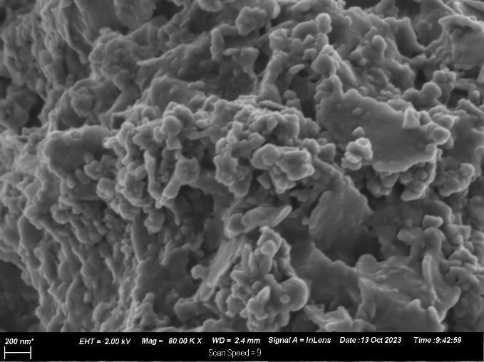  (a) | (b)
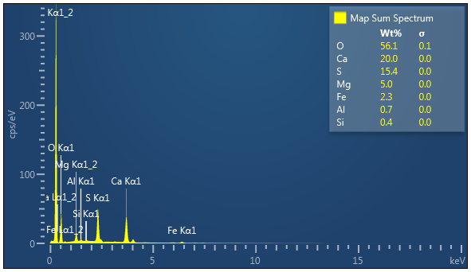  (c) | 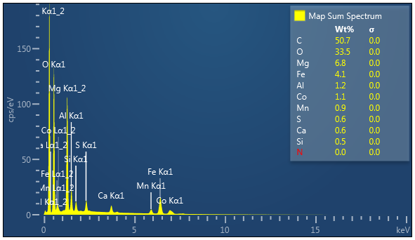  (d)
Figure 1: SEM graphs of MIWS: (a) before adsorption and (b) after adsorption, illustrating morphological changes. EDX spectra: (c) pre-adsorption and (d) post-adsorption, confirming the presence and distribution of Co(II) on the adsorbent surface
The pH of a solution is a critical parameter in the adsorption of metal ions such as Co(II) because it influences the surface charge of the adsorbent. At low pH values, the presence of excess H⁺ ions can compete with metal cations for adsorption sites, leading to lower adsorption efficiency. However, within the studied pH range of 2 – 10, it was observed that pH had no significant impact on the system’s behavior (Figure 2a).
Beyond a pH of approximately 7, Co(II) begins to precipitate altering the removal mechanism from pure adsorption to a combination of adsorption and precipitation. This effect has been reported in similar studies on metal adsorption, where a shift from ion exchange to hydroxide precipitation occurs at higher pH levels. To ensure that adsorption remained the primary mechanism, the inherent (unadjusted) pH of the solution – approximately 5 – was selected as the optimal pH for further experiments avoiding additional chemical requirements for pH adjustment.
The effect of initial Co(II) concentration on adsorption efficiency was investigated, as shown in Figure 2b. It was observed that as the initial concentration increased, the removal efficiency declined significantly, reducing to a third of its initial efficiency at the highest concentration tested. This trend is commonly observed in adsorption studies, as higher metal ion concentrations lead to a greater number of Co(II) ions competing for a finite number of adsorption sites. At lower concentrations, the available binding sites on the adsorbent surface are in excess, leading to higher removal efficiencies. However, as the concentration increases, saturation of adsorption sites occurs, reducing overall efficiency. The optimal concentration for effective removal was determined to be 100 mg/L, as beyond this, a substantial decrease in efficiency was observed.
The effect of adsorbent dosage was assessed within the range of 0.0125 to 1 g. It was observed that adsorption efficiency increased with dosage up to 0.5 g MIWS, beyond which no appreciable improvement was noted (Figure 2c). This plateau effect suggests that at higher dosages, excess adsorbent remains underutilized, as available adsorption sites outnumber the metal ions present in solution. Additionally, excessive adsorbent use could introduce economic and practical challenges in large-scale applications, making 0.5 g the optimal dose for further studies.
(a)
(b)
(c)
Figure 2: Key adsorption parameter optimisation results for (a) pH dependence of the system, (b) effect of Co(II) initial concentration and (c) MIWS adsorbent dosage

These findings indicate that the adsorption of Co(II) onto MIWS is influenced by initial concentration and adsorbent dosage, while pH within the studied range does not play a significant role. The results align with prior studies on Co(II) adsorption using low-cost adsorbents, reinforcing the potential of MIWS as a viable material for Co(II) removal from aqueous solutions (Altunkaynak et al., 2022). Further investigations into adsorption kinetics and thermodynamics could provide deeper insights into the underlying mechanisms governing this process.
The kinetic study conducted revealed that the adsorption system reached equilibrium within six hours, indicating a relatively moderate adsorption rate. The uptake of Co(II) followed a gradual adsorption kinetic profile, which suggests that multiple factors influenced the adsorption process, including surface interactions, pore diffusion, and potential mass transfer limitations (Figure 3). The initial rapid phase of adsorption can be attributed to the high availability of active binding sites on the MIWS surface, where Co(II) ions readily interact with functional groups present on the adsorbent (Van Veenhuyzen et al., 2021). As adsorption progresses, these sites become increasingly occupied, leading to a slower adsorption rate in the later stages. This behavior is characteristic of adsorption systems and is often described by kinetic models, where adsorption is initially diffusion-controlled, followed by reaction rate limited (Fogler, 2010).
The presence of mass transfer limitations is a likely contributor to the gradual adsorption profile observed. These limitations arise from the diffusion of Co(II) ions through both the liquid phase and within the porous structure of MIWS before reaching the active adsorption sites. External mass transfer resistance, which occurs at the boundary layer surrounding the adsorbent particles, could slow down the process, particularly at inadequate stirrer speeds (Nchabeleng and Brink, 2024). Internal diffusion within the pores of the adsorbent could also become a rate-limiting step, especially as surface sites become saturated and ion transport relies on diffusion deeper into the material (Wang and Guo, 2020). This aspect of the adsorption mechanism could be further explored through intraparticle diffusion modeling and mass transfer coefficient analysis to quantify these effects. Such insights would be valuable for optimizing the adsorption process conditions, particularly in scaling up the application of MIWS for Co(II) removal.

Figure 3: Kinetic profile of MIWS-Co(II) adsorbent-adsorbate system under optimised conditions
  - Conclusions and Recommendations
The findings of this study underscore the effectiveness of mining influenced water sludge (MIWS) as a promising low-cost and sustainable adsorbent for the removal of Cobalt(II) – Co(II) – from aqueous solutions. Given the increasing concerns surrounding heavy metal contamination in water systems, developing efficient and environmentally responsible remediation strategies is paramount. MIWS offers a dual advantage: it not only mitigates heavy metal pollution but also repurposes mining waste, aligning with circular economy principles and sustainable resource management.
Through a systematic optimization of adsorption parameters, it was determined that MIWS effectively removes Co(II) across a range of conditions, with adsorption efficiency influenced by initial contaminant concentration and adsorbent dosage, while pH played a negligible role within the studied range. The adsorption system exhibited a gradual kinetic profile, reaching equilibrium within six hours, indicating that mass transfer effects may influence the rate of adsorption. SEM/EDX analysis confirmed the successful uptake of Co(II) onto MIWS, demonstrating the material's structural integrity and highlighting its potential for multiple adsorption cycles.
These results reinforce the feasibility of MIWS as a viable alternative to conventional adsorbents. By transforming an industrial waste byproduct into a highly effective adsorption medium, this study contributes to the broader goal of developing sustainable water treatment technologies that balance economic feasibility with environmental responsibility.
Moving forward, additional studies on long-term performance, competitive adsorption in multi-contaminant systems, and real wastewater applications will further validate MIWS as a scalable and robust solution for Co(II) remediation. Gaining insight into adsorption mechanisms, kinetic modelling, regeneration and material stability will provide a strong foundation for future research.
The use of MIWS for Co(II) removal not only demonstrates technical feasibility but also aligns with global sustainability targets. This approach supports SDG 6 by improving water quality and SDG 12 through the valorization of mining waste, thus reinforcing the circular economy.
References

Abbas M., Kaddour S., Trari M., 2014, Kinetic and equilibrium studies of cobalt adsorption on apricot stone activated carbon, Journal of Industrial and Engineering Chemistry, 20, 745-751. doi:10.1016/j.jiec.2013.06.030.
Altunkaynak Y., Canpolat M., Yavuz Ö., 2022, Adsorption of cobalt (II) ions from aqueous solution using orange peel waste: equilibrium, kinetic and thermodynamic studies. Journal of the Iranian Chemical Society, 19, 2437-2448. doi:10.1007/s13738-021-02458-8.
Bhaumik M., Setshedi K., Maity A., Onyango M.S., 2013, Chromium(VI) removal from water using fixed bed column of polypyrrole/Fe₃O₄ nanocomposite, Separation and Purification Technology, 110, 11-19. doi:10.1016/j.seppur.2013.02.037.
Chowdhury I.R., Chowdhury S., Mazumder M.A.J., Al-Ahmed A., 2022, Removal of lead ions (Pb²⁺) from water and wastewater: a review on the low-cost adsorbents, Applied Water Science, 12, 185. doi:10.1007/s13201-022-01703-6.
Crini G., Lichtfouse E., 2019, Advantages and disadvantages of techniques used for wastewater treatment, Environmental Chemistry Letters, 17, 145-155. doi:10.1007/s10311-018-0785-9.
Fogler, H.S., 2010, Elements of Chemical Reaction Engineering, Pearson Education Inc, Massachusetts, USA.
Muedi K.L., Brink H.G., Masindi V., Maree J.P., 2021, Effective removal of arsenate from wastewater using aluminium enriched ferric oxide-hydroxide recovered from authentic acid mine drainage, Journal of Hazardous Materials, 414, 125491. doi:10.1016/j.jhazmat.2021.125491.
Nchabeleng N., Brink H., 2024, Untreated Mining Influenced Water Sludge (MIWS) for Lead Adsorption: Modelling Mass Transfer Effects, Chemical Engineering Transactions, 114, 511-516. doi:10.3303/CET24114086.
Rethinasabapathy M., Ghoreishian S.M., Kwak C.H., Han Y.-K., Roh C., Huh Y.S., 2025, Recent progress in advanced functional materials for adsorption and removal of cobalt from industrial and radioactive effluents, Coordination Chemistry Reviews, 527, 216401. doi:10.1016/j.ccr.2024.216401.
Van Veenhuyzen B., Tichapondwa S., Hörstmann C., Chirwa E., Brink H.G., 2021, High capacity Pb(II) adsorption characteristics onto raw- and chemically activated waste activated sludge, Journal of Hazardous Materials, 416. doi:10.1016/j.jhazmat.2021.125943.
Wang J., Guo X., 2020, Adsorption kinetic models: Physical meanings, applications, and solving methods, Journal of Hazardous Materials, 390, 122156. doi:10.1016/j.jhazmat.2020.122156.
Wankat P.C., 2011, Separation Process Engineering - Includes Mass Transfer Analysis, 3rd Edition, Pearson Education, Massachusetts, USA.
Worch E., 2021, Adsorption technology in water treatment : fundamentals, processes, and modeling, De Gruyter, Berlin, Germany.
Yang M.C., Rollins D.S., Huber D.L., Ou J.-T., Baptiste M.R., Zeppuhar A.N., Chen F., Taylor M.K., 2023, Carbonyl-rich porous organic polymers for cobalt adsorption from water, Journal of Materials Chemistry C, 11, 15541-15547. doi:10.1039/D3TC03320A.

