|  |  |
| --- | --- |
| cetlogo ***CHEMICAL ENGINEERING TRANSACTIONS***  ***VOL. xxx, 2025*** | A publication of  aidiclogo_grande |
| The Italian Association  of Chemical Engineering  Online at www.cetjournal.it |
| Guest Editors: David Bogle, Flavio Manenti, Piero Salatino  Copyright © 2025, AIDIC Servizi S.r.l. **ISBN** 979-12-81206-21-2; **ISSN** 2283-9216 | |

Exploring the Potential of Two-Stage Pyrolysis for Real Solid Plastic Waste Management

Letizia Marchettia,\*, Leonardo Tognottia, Federica Annunzib, Cristiano Nicolellaa

aDipartimento di Ingegneria Civile e Industriale, Università di Pisa, Largo Lucio Lazzarino 2, 56122, Pisa (PI), Italy

bConsorzio Polo Tecnologico Magona, via Magona, 57023, Cecina (LI), Italy

[letizia.marchetti@phd.unipi.it](mailto:letizia.marchetti@phd.unipi.it)

Solid plastic wastes management is pivotal for environmental sustainability, and it represents a challenge still nowadays because of the huge plastic production and its intrinsic non-degradability. Recycling technologies have gained more and more interest as they are alternative solutions to landfilling and incineration practices. Particularly, pyrolysis is a thermochemical treatment that converts plastic waste stream into solid, liquid, and gaseous co-products, breaking down the long polymeric chains in a high-temperature and non-oxygen environment. Furthermore, using a two-step technology, i.e., coupling an auxiliary cracking reactor to a pyrolysis one, it is possible to further upgrade the energy content of both liquid and gaseous fraction. The two-stage pyrolysis has been studied in depth as it represents a viable solution. However, while many studies are conducted on virgin polymers for better understanding the process, only a few experimental tests are performed on real plastic solid wastes for figuring out the effect of waste heterogeneity. Thus, this study aims to contribute to plastic waste management by investigating three samples of real plastic scraps, i.e., automotive shredder residue, light fraction and heavy fraction of polyolefin densification scrap. The experimental campaign provided a first waste characterization with TGA, DSC and elemental analysis, followed by laboratory-scale two-stage system pyrolysis experiments. The system successfully generated high-energy gas that mimics natural gas. The findings demonstrate the system's capability of handling different streams of waste and emphasize its future potential for large-scale and environmentally friendly waste recycling technologies.

* 1. Introduction

Plastic solid waste (PSW) management is one of the main challenges for environmental sustainability due to the high plastic production coupled with its non-degradable nature. In 2009, already more than 250·106 tons of PSW were registered to be produced every year in the European Union Countries (Al-Salem et al., 2009), while, in 2022, the worldwide plastic production is calculated to be 400·106 tons (Nayanathara Thathsarani Pilapitiya and Ratnayake, 2024). The significant progresses in recycling technologies brought to a lower amount of PSW treated in landfills, e.g., from 2012 to 2017 the percentage of PSW landfilled decreased from 32 % to 23 % (Eurostat, 2018), however this percentage requires further interventions as it is still relevant. Thus, recycling technologies, which emerged as promising options, need to be further investigated with particular attention to pyrolysis, a specific process capable of converting PSW in added-value products such as chemicals or fuels. Pyrolysis is a technology which uses high temperature in inert atmospheres bringing to the rapture of chemical bonds with low CO and CO2 emissions (Guastaferro et al., 2024). Gaseous and liquid products are potential energy sources as their heating value is comparable to those of fossil fuels, and it can be further enhanced through a second reactive stage, i.e., cracking reaction. Thus, the needed configuration incorporates a secondary cracking reactor to further break down the hydrocarbon chains of gas and liquid, improving their quality and allowing operational scalability. Indeed, the use of two independent sub-sequential reactors allows to higher energy gas and oil, without using extreme temperature or expensive catalysts.

Despite the large number of studies on two-stage pyrolysis, only a few have considered the variety of real industrial PSW. Indeed, real wastes are characterized by high heterogeneity that introduces challenging for recycling treatments. This study aims to address this research gap by investigating three different PSW streams: i.e., automotive shredder residue, and heavy and light fractions of scrap from densified polyolefin production process. These samples were characterized with thermogravimetric analysis (TGA), differential scanning calorimetry (DSC) and elemental analysis (CHN) to figure out their degrative behaviour in nitrogen, to determine the contained polymers, and to evaluate the carbon, hydrogen and nitrogen content. Once characterized, the PSW materials were subjected to the lab-scale two-stage batch pyrolysis setup which simulates a full-scale process, allowing the co-product yields evaluation. Moreover, each co-product was characterized for assessing the impact of feedstock variability on co-products quantity and quality. This work highlights the potential of two-stage pyrolysis as a sustainable waste management solution, offering insights for optimizing and scaling up thermochemical recycling processes.

* 1. Materials and methods

The entire experimental campaign was conducted on three different samples, i.e., sample 1 (S1), sample 2 (S2) and sample 3 (S3), which correspond to automotive shredder residue, and the light and heavy fractions of densified polyolefin production process scrap, respectively. Figure 1 depicts the three different samples before (left) and after (right) the shredding procedure, which reduces the characteristic dimension of PSW to 5 mm to enhance heat transfer during pyrolysis.

*Figure 1: Pictures of (a) sample 1, (b) sample 2, and (c) sample 3 before and after shredding procedure.*

Once shredded and dried, each sample underwent material characterization. Thermogravimetric analysis (TGA) in nitrogen (100 mL/min) was performed to investigate the thermal degradation behavior of real PSW materials in an inert environment. The samples were heated from 30 °C to 800°C at a rate of 10 °C/min and then kept at 800°C for 2 hours. Differential scanning calorimetry (DSC) analysis was carried out with a Mettler Toledo Star DSC 1/700 instrument under nitrogen flow (100 mL/min). The samples were heated from -20°C up to 300°C at a rate of 10 °C/min, cooled from 300 °C down to -20°C at 20°C/min, and heated again from -20 °C up to 300°C at 10°C/min. This analysis allowed for a qualitative identification of polymers contained in the samples. Elemental analysis (CHN) was performed coupling the LECO TruSpec CHN analyzer and the Elementar Vario Macro CHNS analyser, following the standard procedure UNI EN 15002:2015. After determining the C, H and N, the ash (A) content was assessed with the ASTM E1755–01 standard. The O content was calculated by difference and the low heating value (LHV) was estimated using Eq. (1) and Eq. (2) (Green and Perry, 2007).

|  |  |
| --- | --- |
| $$HHV=2.326[146.58C+568.78H+29.4S-6.58A(O+N)]$$ | (1) |
| $$LHV=(HHV-206H)$$ | (2) |

The three characterized samples were tested in a lab-scale batch setup, whose scheme and elemental block diagram are shown in Figure 2. The set-up simulates a two-stage pyrolysis process and consists of three main sections: i.e., reaction, separation, and analysis sections, as described in detail in a previous paper (Marchetti et al., 2024).

**

*Figure 2:* *Process scheme (a) and elemental block scheme (b) of the pyrolysis experimental setup with the measurement scheme performed (Marchetti et al., 2024).*

The reaction section includes a pyrolysis reactor and a cracking reactor operating at 500°C and 800°C, respectively. These reactors consist of two stainless steel tubes inserted in two independent electric furnaces, i.e., Carbolite TZF 12/65/550, and Carbolite MTF 12/38/250. The separation section has a condenser, where the cold utility is a mixture of ethanol and liquid carbon dioxide (-70°C). The analysis section includes a micro-GC for determining the gas composition. The entire process is conducted under a nitrogen flow rate of 300 mL/min, with each test processing 5 g of PSW, repeated three times to ensure result reliability. During the test, the material undergoes thermal decomposition, producing a solid fraction (solid 1) which remains in reactor 1, a vapor fraction and a gas fraction which are fed into reactor 2. In reactor 2, the cracking of gases and vapors occurs, leading to the formation of a new solid residue (solid 2), a gaseous fraction and a vapor fraction, which is condensed and collected in the separation system. The non-condensable fraction was collected in 5 L Tedlar Bag and analyzed via micro-GC. At the end of each test the mass of the four co-products (gas, oil, solid 1 and solid 2) was measured to determine the co-product yields, and the collected fractions were characterized. Specifically, the oil fraction and solid 1 were subjected to the same elemental analysis applied to the PSW samples.

* 1. Results
     1. Material characterization

In this paragraph the main results concerning the PSW samples characterization are collected starting from TGA graphs (Figure 3).

**

*Figure 3:* *Thermogravimetric analysis results of (a) sample 1, (b) sample 2, and (c) sample 3.*

In Figure 3, the degradation behaviour under nitrogen is shown for samples 1, 2 and 3 and each sample exhibits its highest mass reduction between 280°C and 540°C. No mass loss occurs before 280°C because the three samples were dried prior to analysis, as explained in Sec. 2. After 540 °C, degradation is almost complete, although slight variations are observed for samples 1 and 3. This behaviour may be attributed to many factors, such as the TGA operating conditions, the chemical structures of polymers, and their interactions with additives (NETZSCH). Therefore, it is difficult to figure out a specific cause; however, given that degradation is almost complete at 540°C, the pyrolysis temperature into the batch setup was set at 500°C. Furthermore, the final residue at 800°C is approximately 40 wt%, 7 wt%, and 25 wt% for samples 1, 2 and 3, respectively, highlighting the different behaviours of the samples in accordance with the intrinsic heterogeneity of real waste materials. These results are in line with the expectations, indeed, the automotive shredder residue (sample 1), also known as car fluff and composed of a mixture of plastic, rubber, glass, fabric, foam, paint residues, and other organic and inorganic compounds, has the highest residue. Similarly, the heavy fraction (sample 3) of densified polyolefin production scrap exhibits a higher residue than the light fraction due to its higher metallic content.

On the other hand, the DSC results allowed us to identify the main polymers contained into the tested samples.

*Figure 4: Differential scanning calorimetry results of (a) sample 1, (b) sample 2, and (c) sample 3.*

DSC revealed the presence of polyethylene (PE), polypropylene (PP), and polyethylene terephthalate (PET) in all PSW samples, while polyvinyl chloride (PVC) was detected only in samples 1 and 3. Specifically, LDPE exhibits a melting peak between 85 and 125 °C, HDPE between 130 and 140 °C, PP between 165 and 175 °C, and PET between 250 and 260 °C, in alignment with the thermal data provided in the Shimadzu Application Note T160, which characterizes PE and other polymers via DSC analysis (Kato, 2021). However, variations in peak intensities across the three samples reflected once again the inherent heterogeneity that poses a significant challenge in processing real wastes.

To better understand process efficiency, elemental analysis was performed to point out the C, H and N content, while O, A, and LHV were evaluated as described in Sec. 2; the results are collected in Table 1.

Table 1: Elemental analysis results and LHV of sample 1, sample 2 and sample 3.

|  |  |  |  |  |  |  |
| --- | --- | --- | --- | --- | --- | --- |
| Sample | C [% w/w] | H [% w/w] | N [% w/w] | O [% w/w] | A [% w/w] | LHV [MJ/kg] |
| S1 | 53 | 6 | 1 | 9 | 31 | 23 |
| S2 | 73 | 10 | 0 | 10 | 7 | 34 |
| S3 | 59 | 6 | 0 | 22 | 13 | 24 |

Consistent with TGA findings, sample 1 exhibited the highest ash content, whereas sample 2 has the lowest one and the highest carbon and hydrogen percentages. Consequently, the LHV was calculated to be 34 MJ/kg for sample 2, 23 MJ/kg for sample 1 and 24 MJ/kg for sample 3. These values underscore the importance of recycling PSW to employ its energy content.

* + 1. Co-product yields and characterization

In this section, the main results concerning the co-products are collected, starting with their yields (Figure 5).

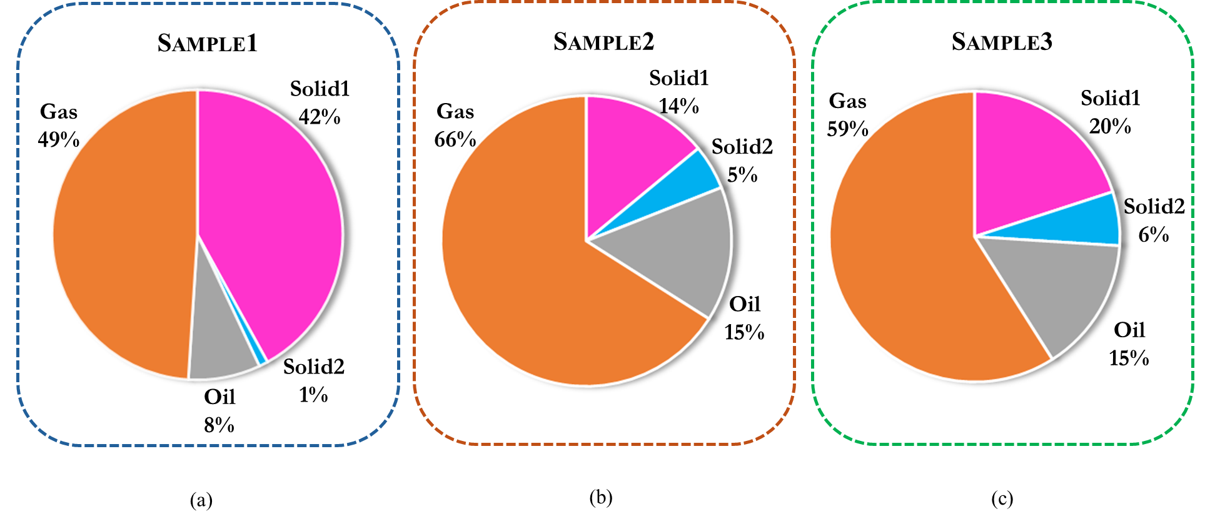

*Figure 5: Co-product yields from pyrolysis tests of (a) sample 1, (b) sample 2, and (c) sample 3.*

Figure 5 illustrates the co-product yields obtained from processing each sample into the batch setup. In detail, from left to right, the three charts represent the distribution of co-products resulting from the pyrolysis of samples 1, 2 and 3, respectively. Focusing on the gas fraction, depicted in orange, sample 2 exhibits the highest value, while sample 1 shows the lowest. A similar trend characterized the oil fraction (grey in Figure 5). Conversely, the solid co-products display a different pattern, i.e., the highest value is pointed out for sample 1, the middle value for sample 3, and the lowest one for sample 2. These findings aligned with waste characterization results, from which sample 2 demonstrated the highest content of C and H, and sample 1 had the greatest amount of inert material. Indeed, considering that the entire number of metals remains into the solid 1 without volatilizing, the sample with the highest A is also the sample that produces the highest solid 1. As well as the sample with the highest C and H is the sample that produces the highest hydrocarbons.

Beyond quantification, the co-products were also characterized. The gas volumetric composition is presented in Figure 6 for the three samples.

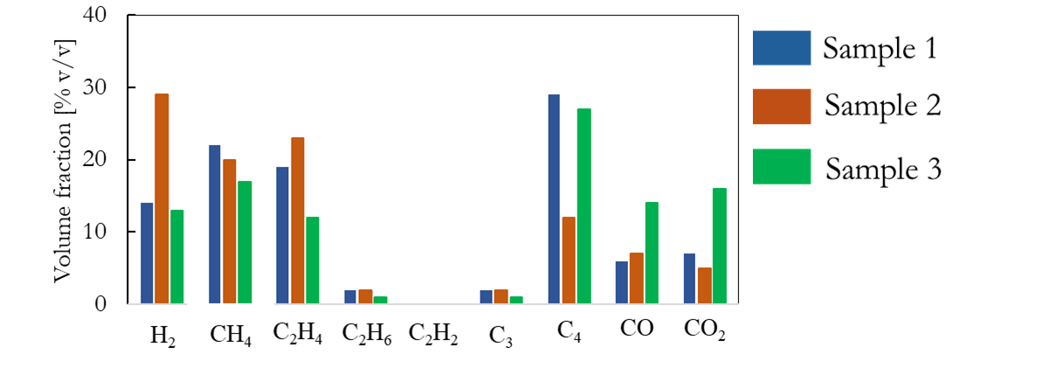

*Figure 6: Gas volumetric composition produced by sample 1, sample 2 and sample 3 pyrolysis.*

The analysis reveals that sample 2 produces the gas with the highest content of hydrogen and light hydrocarbons, calculated as the summatory of CH4, C2H4, C2H6, C2H2, and C3, while the pyrolysis gas from sample 1 has the most relevant content of heavy hydrocarbons (C4), and the highest amount of CO and CO2 are emitted from sample 3. Consequently, the gas LHV is higher for samples 1 and 2, at 40 and 41 MJ/kg, respectively, and lower for sample 3, at 32 MJ/kg. Despite the variation in LHV, pyrolysis gases produce from all the real PSW samples tested in this study exhibit a high energy content which make them suitable for being used to replace fossil fuels (Marchetti et al., 2024). Consequently, two important environmental issues can be solved, i.e., the plastic waste disposal, and the use of fossil fuels.

However, the process also produces a liquid and a solid phase, and their characterization data are summarized in Table 2.

Table 2: CHN results and LHVs of oil and solid 1 produced from sample 1, sample 2 and sample 3.

|  |  |  |  |  |  |  |
| --- | --- | --- | --- | --- | --- | --- |
| Sample | C [% w/w] | H [% w/w] | N [% w/w] | O [% w/w] | A [% w/w] | LHV [MJ/kg] |
|  | Oil Characterization | | | | | |
| S1 | 83 | 7 | 2 | 8 | 0 | 35 |
| S2 | 89 | 7 | 1 | 3 | 0 | 38 |
| S3 | 84 | 7 | 1 | 8 | 0 | 36 |
|  | Solid 1 Characterization | | | | | |
| S1 | 25 | 1 | 1 | 0 | 73 | 8 |
| S2 | 49 | 2 | 1 | 0 | 48 | 18 |
| S3 | 35 | 1 | 0 | 0 | 64 | 12 |

The pyrolysis oil analysis indicates that the carbon, hydrogen, and nitrogen content is comparatively stable for all the samples examined, with the highest LHV observed for sample 2. In particular, the LHVs measured are 35, 38, and 36 MJ/kg for oil from samples 1, 2, and 3, respectively. These findings imply that the resultant oil has great potential to be utilized as an alternative sustainable fuel compared to traditional fossil fuels. The solid residues, however, exhibit a significant variation in composition among the different samples. Solid from sample 1 contains a high inert component percentage and consequently a lower LHV, whereas solid from sample 2 presents a clean profile with a higher energy content. Although sample 2 seems to be best suited for pyrolysis, according to its initial characterization, because it yields higher quantities of oil and gas with higher LHVs, it should be mentioned here that samples 1 and 3 also yield beneficial products regardless of their varied initial composition and energy content. By examining the energy distribution, the percentage of original energy that the final co-products contain, it is apparent that approximately 75% of waste's original energy content is preserved in gas co-products in samples 1 and 2. In sample 3, this percentage is 66 % but still significant. The results indicate the flexibility and efficiency of the pyrolysis process. Despite the intrinsic heterogeneity and variable quality of the waste materials, the process achieves high energy recovery levels in every case. Specific consideration must be given to the presence of polyvinyl chloride (PVC), identified in samples 1 and 3 via DSC analysis. Although the amounts are limited, chlorine may redistribute across the solid, liquid, and gas phases. For potential scale-up, it will be important to assess its presence in pyrolysis products and, if necessary, implement removal systems such as NaOH scrubbers, as suggested in the literature (Marchetti et al., 2025).

* 1. Conclusions

The environmental challenges associated with PSW management need sustainable solutions. Among different treatment methods, pyrolysis has emerged as a promising alternative due to its low carbon emissions and its easy technology. However, while many studies have focused on virgin polymers, only a limited number have investigated real waste materials. This study aims to address this gap by testing three distinct real PSW samples. Specifically, the results confirm that the proposed two-stage pyrolysis process is effective in treating heterogeneous plastic waste streams, with a significant portion of the waste energy, between 66% and 75%, successfully recovered in the form of high-calorific pyro-gas. Despite the intrinsic variability of the real PSW samples, the process consistently produced valuable gas and liquid products, suggesting robustness and adaptability. These findings highlight the potential of the process as a sustainable and scalable alternative for plastic waste management, offering a pathway to energy recovery and fossil fuel displacement.

References

Al-Salem S.M., Lettieri P., Baeyens J., 2009, Recycling and recovery routes of plastic solid waste (PSW): a review, Waste Management, 29(10), 2625-2643.

European Union, Eurostat, 2018, Municipal waste statistics <ec.europa.eu/eurostat/statistics-explained/index.php/Municipal\_waste\_statistics> accessed 13.02.2025.

Green D.W., Perry R.H., 2007, Perry’s Chemical Engineers’ Handbook, 8th ed., McGraw-Hill, New York, USA.

Guastaferro M., Marchetti L., Vaccari M., Nicolella C., Tognotti L., 2024, Revitalizing plastic waste with pyrolysis: a UniSim Design© simulation case study for renewable energy production from car fluff, Computer Aided Chemical Engineering, 53, 1147-1152.

Kato H., 2021, Characterization of Polyethylene Materials by Thermal Analysis, Shimadzu Corporation, <www.shimadzu.com/an/sites/shimadzu.com.an/files/pim/pim\_document\_file/applications/application\_note/14058/an\_t160-en.pdf> accessed 13.02.2025.

Marchetti L., Guastaferro M., Annunzi F., Tognotti L., Nicolella C., Vaccari M., 2024, Two-stage thermal pyrolysis of plastic solid waste: set-up and operative conditions investigation for gaseous fuel production, Waste Management, 179, 77-86.

Marchetti L., Guastaferro M., Vaccari M., Annunzi F., Tognotti L., Nicolella C., 2025, Feasibility study of renewable recycled carbon fuel production via plastic waste pyrolysis, Journal of Cleaner Production, 495, 145035.

Nayanathara Thathsarani Pilapitiya P.G.C., Ratnayake A.S., 2024, The world of plastic waste: a review, Cleaner Materials, 11, 100220.

NETZSCH, Factors Influencing the DSC and TGA Measurement Results <analyzing-testing.netzsch.com/en/know-how/tips-tricks/tga/factors-influencing-the-dsc-and-tga-measurements-results-1> accessed 13.02.2025.