|  |  |
| --- | --- |
| cetlogo ***CHEMICAL ENGINEERING TRANSACTIONS***  ***VOL. xxx, 2025*** | A publication of  aidiclogo_grande |
| The Italian Association  of Chemical Engineering  Online at www.cetjournal.it |
| Guest Editors: David Bogle, Flavio Manenti, Piero Salatino  Copyright © 2025, AIDIC Servizi S.r.l. **ISBN** 979-12-81206-21-2; **ISSN** 2283-9216 | |

Open-source Automation of Aspen Plus simulation andLife Cycle Assessment for Carbon Capture: From Automation to Intelligent Scenario Optimization

Jonas Küng, Ada Robinson Medici, Michael Harasek, Stavros Papadokonstantakis\*

Institute of Chemical, Environmental and Bioscience Engineering, TU Wien, 1060 Wien, Austria

stavros.papadokonstantakis@tuwien.ac.at

Abstract

An open-source framework that couples Aspen Plus process simulations with the Python-based Brightway package to conduct Life Cycle Assessments (LCA) is presented. This work emphasizes openness, transparency, and extensibility, to lower adoption barriers in both academia and industry. We demonstrate the approach on a well-studied, solvent-based post-combustion carbon capture system using Monoethanolamine (MEA). A parameter sensitivity analysis on the flue gas CO₂ concentration (ranging from 8 to 11.8 vol%) generates a suite of automated Aspen Plus runs, whose outputs are transferred to Brightway. To validate the results, we conducted a ReCiPe 2016 impact assessments or midpoint indicators. The paper concludes by proposing strategies to scale the framework toward multi-parameter sensitivity analyses, uncertainty propagation, and an iterative feedback loop wherein LCA results guide subsequent Aspen Plus runs. This iterative approach bridges the knowledge gap between environmental analysts, who interpret LCA results, and process engineers, who manage Aspen simulations, by allowing either stakeholder group to initiate parameter adjustments. As a result, the process-LCA interaction becomes more agile, accelerating scenario exploration and converging on optimized, sustainable designs from both technical and environmental standpoints

**Keywords:** Life Cycle Assessment, Aspen Plus Simulation, Post-combustion Carbon Capture, Automation, Machine Learning

* 1. Introduction

Process Systems Engineering (PSE) is increasingly tasked with integrating sustainability metrics into early-stage process design and optimization. In this context, automation is increasingly recognized as a core requirement, where process optimization, control, and real-time decision-making are critical. Commercial simulators such as Aspen Plus provide rigorous models of thermodynamics and mass/energy balances but remain limited in their built-in automation capabilities. To date, Aspen Tech officially supports only the integration of MS Excel-VBA. This can result in laborious workarounds when linking Aspen Plus with other commercial software, also offering limited compatibility to third-party software. Recent efforts in automating LCA workflows underscore the need for systematic, reproducible, and transparent data exchanges between process simulators and LCA software (Wang et al., 2024).

.

For example, (Vaquerizo and Cocero, 2018) provide a methodology for connecting Aspen Plus and Ansys Fluent (for computational fluid dynamics, CFD), including a “C” language subroutine, MATLAB and MS Excel-VBA. This example shows that researchers have investigated the compatibility of Aspen Plus with various third-party applications such as MATLAB, Python, C++, etc. in recent time to simplify their workflows (Valverde et al., 2023). Despite these efforts, the program code is rarely made available, resulting in a lack of detailed documentation and making the reproduction and adaptation of the provided methodologies a trial-and-error process. Recent developments such as BIOSTEAM-LCA (Shi & Guest, 2020), an enhanced version of the BIOSTEAM biorefinery simulation platform (Cortes-Peña et al., 2020), allow simultaneous techno-economic and environmental impact assessments by embedding LCA calculations directly into biorefinery process models. However, these methodologies, while efficient for biorefinery processes, are not directly transferable to carbon capture applications.

The main objective of this study is to provide a reproducible and openly documented automation framework for Aspen Plus-LCA coupling, using the Brightway library. Our scope includes:

* Demonstrating how Python can programmatically adjust Aspen Plus parameters, run simulations, and retrieve mass and energy flows, reducing the manual effort required in bridging process simulation with LCA data generation.
* Analysing a cradle-to-gate LCA model in Brightway, allowing the use of any LCA method supported by Brightway.
* Demonstrating the framework’s effectiveness on a standard MEA-based post-combustion CO₂ capture process.
* Discussing future extension to a feedback-loop approach using machine learning (ML) for scenario optimization.
  1. Methodology

In the following, the generation of comprehensive data sets is discussed. Then, the PCCC process with MEA for showcasing the framework is briefly explained and its process conditions are specified, particularly those suited for automation. After defining the LCA scope, its implementation through the Brightway package is illustrated, resulting in the final framework.

* + 1. Systematical generation of data sets in process simulation

A prerequisite for using the framework is to provide a test schedule for the systematic generation of data points. Possible applications are diverse, such as parameter sensitivity analysis in traditional process design or data‑driven approaches, e. g. the development of machine learning models. For generalization, this is referred to herein as process conditions sampling (PCS). To conduct a systematical PCS, it is recommended to apply a Design of Experiment (DoE) method such as Stratified Sampling, Factorial Design or Latin Hypercube Sampling. In practice, applying these concepts is linked to defining a process operation point (base case) around which process parameters of interest are varied within a defined range. The choice of operating point is based on representing typical process operating conditions to ensure that the process behavior is adequately mapped. By repeating this procedure for multiple operating points, a more comprehensive mapping of the process performance can be achieved, which becomes particularly relevant in larger-scale sensitivity analyses or optimization scenarios. The range of values for the process parameters in the PCS depends on achieving a high number of feasible process simulations in the design space without deviating from the defined test schedule for the PCS. The described procedure is frequently used by researches (Zheng et al., 2022). However, it is rarely explained which DOE method was used. Sufficient transparency should be ensured to enable the quality of the data to be assessed.

* + 1. Process design and simulation

In this study, the developed framework is applied to a well-studied solvent-based PCCC process with MEA as a solvent, chosen to reflect the complexity of current research in PSE. Figure 1 illustrates the flowsheet, including the absorber, heat exchanger and stripper. Flue gas enters the absorber bottom and contacts an aqueous MEA solution in counterflow, where CO₂ transfers to the liquid phase. The CO₂-rich solvent is pumped to the stripper for heat-driven desorption. To supply heat, saturated steam is fed into the reboiler from an external utility. In the reboiler, the steam condenses, providing the energy needed to partially vaporize the lean solvent mixture, which then flows countercurrent to the rich solvent mixture in the stripper. while CO₂-rich gas is processed for storage or utilization. The regenerated solvent preheats incoming CO₂-rich solvent before cooling to absorber conditions (Wang et al., 2023).

A flowsheet is created in Aspen Plus V12.1 and a base case is defined, for which the specification of the flue gas and CO2 lean solvent are shown in Table *1*. Details for the thermodynamic models and equipment are provided by (Küng, 2024).

*Table 1: Base conditions for flue gas and CO2 lean solvent entering the absorber*

|  |  |  |  |
| --- | --- | --- | --- |
| Specifications | Flue gas | CO2 lean solvent |  |
| Flow rate/ circulation rate | 5000 m³/h | 19300 kg/h |  |
| Pressure | 112 kPa | 112 kPa |  |
| Temperature | 48 °C | 35 °C |  |
| Composition |  |  |  |
| MEA | - | 30.0 wt% |  |
| H2O | 11.3 vol% | 63.5 wt% |  |
| CO2 | 10.0 vol% | 6.5 wt% (= 0.3 mol CO2/mol MEA) |  |
| O2 | 3.8 vol% |  |  |
| N2 | 74,9 vol% |  |  |

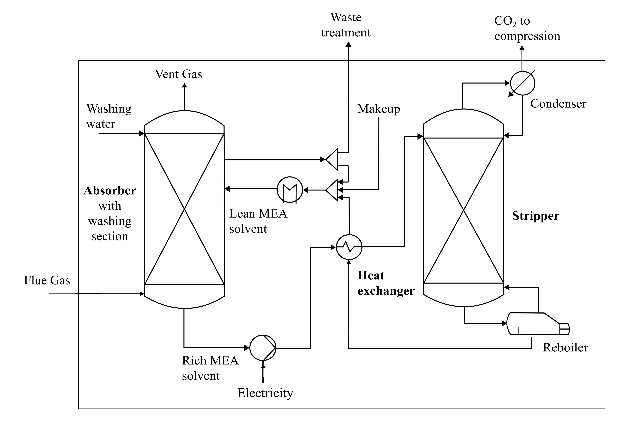

Figure 1: Flowsheet of a standard solvent-based post-combustion carbon capture process with MEA as a solvent, including the boundaries of the LCA.

For a stable and comparable process simulation suited for automation, the reboiler is specified by fixing the temperature to 121.5 °C and an initial setting for the reboiler duty. The latter is adjusted through a design specification to achieve the same CO2 removal efficiency of 95 % for all simulations. When performing the simulations, closing the cycle for each simulation is a tedious task, as the simulation is prone to convergence issues due to the present chemistry and circulating solvent. Instead of letting Aspen Plus automatically close the recycle with its default tear-stream procedure, which can cause convergence issues under certain conditions, we implemented a custom-made approach for tearing. Specifically, the CO2 lean solvent entering the absorber is selected as a “cutting point” and the composition of the corresponding tear streams is approximated to enable automation. For each simulation, it was aimed to limit the deviation of the component mass flows in the tear streams to < 0.1 %.

Since the CO₂ concentration in the flue gas is determined by the upstream process, it is a key parameter for ensuring process flexibility. For example, the CO₂ concentration in flue gas ranges from 3‑10 vol% for natural gas‑fired power plants (Ababneh et al., 2022) and from 10‑18 vol% for coal-fired power plants (Cheng et al., 2021). For this reason, a single parameter PCS for the flue gas CO2 concentration is conducted in the range of 8‑11.8 vol% according to Stratified Sampling. To ensure a similar composition of the tear streams and to keep the mass fraction of MEA constant at 30 wt%, the CO2 lean solvent loading is adjusted for each simulation. All other process parameters are kept constant, except for the makeup stream, respectively, drain stream for adjusting the water balance. The first simulation is performed manually to obtain a stable starting point. Then, the automated simulations are conducted, for which convergence is achieved if the increment is sufficiently small. To obtain an overview of the convergence of the simulations, status reports (success, warnings, errors) were implemented in the framework. The flue gas CO₂ concentration was varied from 8 to 11.8 vol% in increments of 0.2 vol%, so that each successive simulation was only marginally adjusted. This approach is a pragmatic, stratified stepping to ensure robust convergence between runs and reduce convergence failures. All 19 automated runs converged successfully (or with minor warnings), starting from one manually converged base case.

* + 1. LCA framework

Regarding the LCA boundaries, illustrated in Figure 1, a cradle-to-gate approach, covering the product’s life cycle from raw material extraction to plant exit but excluding product use and end-of-life, is selected. The functional unit is 1 tonne of treated CO2 with removal efficiency of 95 % and 99.5% purity, aligning with typical specifications for pipeline transport or utilization.

Excluded from the scope are CO2 emitters, flue gas purification, and CO2 storage/utilization. The focus lies on plant construction, MEA production, and operation, including key equipment such as columns, packings, pumps, compressors, and heat exchangers. Column and packing materials are modeled by a linear relationship to the column height. MEA losses due to leaks or entrainment are neglected, as are thermal and oxidative degradation, though future research plans to enhance the level of detail of the assessment.

A 30-year operational lifetime and natural gas combustion as a heat supply for the generation of low‑pressure (LP) steam is assumed. Water is needed for washing and cooling, with wastewater treatment considered depending on the mass balance.

For the LCIA, the ReCiPe 2016 method is applied using the cutoff approach, the egalitarian perspective, and long-term midpoint indicators. While midpoints are more related to environmental flows, endpoints are more straightforward for stakeholders to interpret in terms of environmental relevance. However, using endpoints introduces additional uncertainty when aggregating multiple midpoints. For these reasons, the midpoints are presented in this study.

* + 1. Python Interface

Given the lack of available coding documentation for accessing Aspen with Python, several unofficial and open‑source GitHub repositories (platform for sharing code) such as (ten Hagen, 2022) and (Wang, 2024) provide support. These interfaces are primarily built on the PyWin32 library, which enables the use of the Win32 API features in Python. It provides access to Windows' Component Object Model (COM), allowing Python to control Microsoft applications. After installing the PyWin32 library, an Aspen Plus simulation can be opened using the following code:



By using the built-in Variable Explorer in Aspen Plus, the inputs and outputs of a process simulation can be managed. For example, the flue gas CO2 concentration can be accessed by specifying its tree path in the Variable Explorer:



The GitHub repositories are extending this approach by various functionalities to achieve stable and customizable access to the simulation. With these instructions, an interface in Python for accessing Aspen Plus has been developed. For the given variation of the flue gas CO2 concentration, specified in an Excel file, the interface can modify the process parameter, conducting the simulation and extracting specific results required to populate the LCI. These data are divided into the main categories of material flows, natural resources, energy flows, equipment and infrastructure. For example, the equipment involves the amount and types of pumps, compressors, coolers, reboiler and condenser. The data is saved again in an Excel file for monitoring purposes and used directly in Brightway for LCA calculations.

* + 1. Brightway for LCA calculations

Brightway is an open-source Python library that implements a matrix-based LCA model. Its modular structure supports multiple projects and databases, each with “activities” (representing processes) and “exchanges” (inputs/outputs linking processes). However, Brightway modified this notation over the years, as many databases it builds on and utilises do not exhibit a clean separation between processes and products (Mutel, 2017).

In the present framework, an initial Brightway 2.5 project is created involving basic data on elementary flows and LCIA methods by utilizing biosphere data from the ecoinvent 3.9.1 database. Then, the ecoinvent cut‑off 3.9.1 database itself is implemented as a second database to receive complementary information to the process simulation results for populating the LCI. A third database is created, which consists of user-defined activities linked by exchanges, mapping the PCCC process. The exchanges represent the actual LCI and are populated by the process simulation results and/or the ecoinvent data, depending on the type of exchange. For example, to implement the reference unit of 1 tonne of CO2 captured, an activity “Production Absorption / Desorption” is defined as follows:



One specification required for this activity is the reboiler duty needed to capture the amount of CO2 for a certain process simulation. It can be defined by the following exchange:



The required reboiler duty is received from the process simulation in form of a pandas DataFrame (df\_EnergyFlow) and the background information for the heat supply is provided by the ecoinvent database (ecoinvent\_cutoff\_391).

To achieve an LCA calculation capable of automatically adjusting its LCI between simulation runs, this user‑defined database is re‑created for each run and populated with the results of the actual simulation. The final framework is illustrated in <https://github.com/AdaRobinsonMedici/AspenPlus-Brightway-LCA-Platform> and consists of the following main parts: (i) Test schedule for conducting an PCS, (ii) Python interface for modifying process parameters and extracting the results from Aspen Plus, (iii) Brightway for LCA calculation and ecoinvent database for providing information for the LCI.

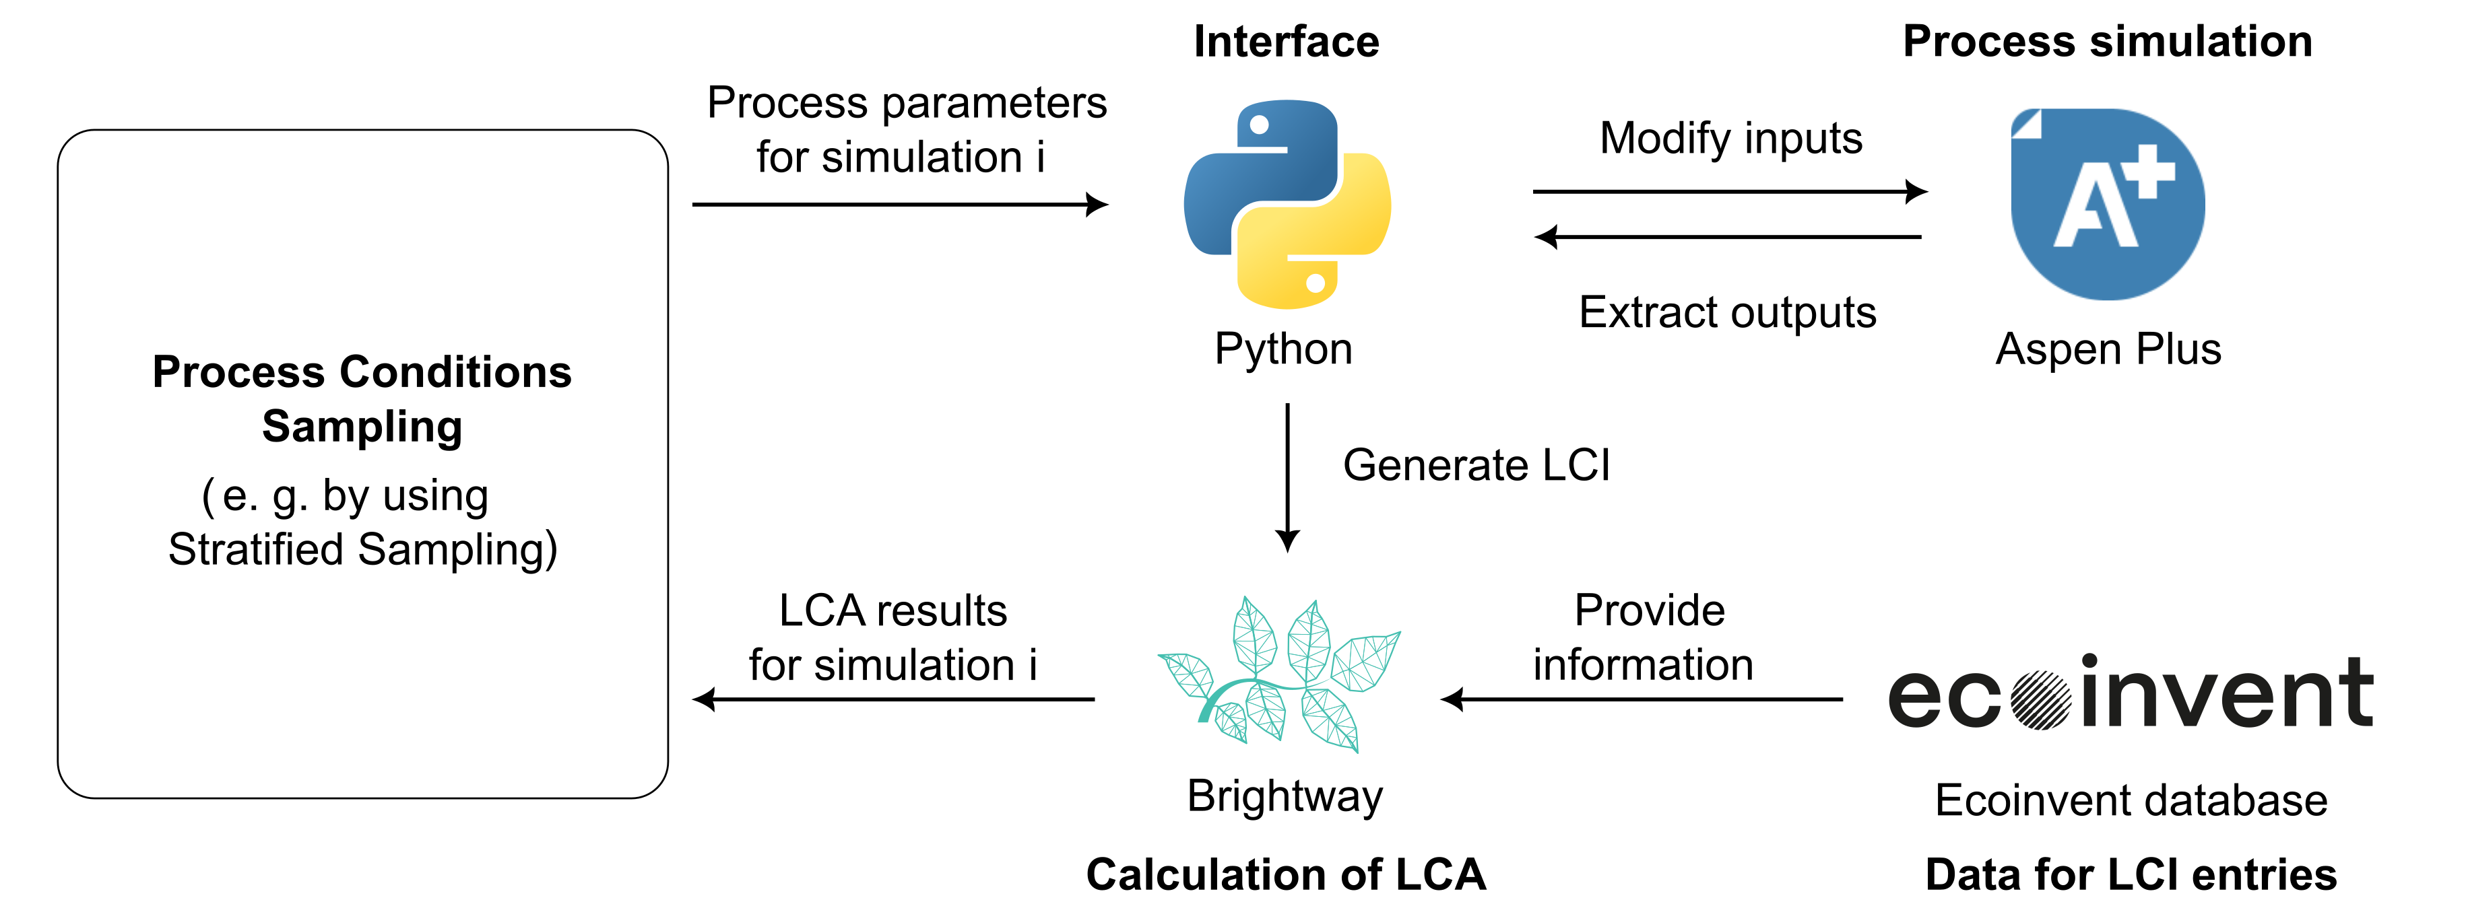

Figure 2: Interface developed in Python for conducting automated process simulations and connecting Aspen Plus with Brightway.

* 1. Results

Twenty process simulations were performed for flue-gas CO₂ concentrations ranging from 8 to 11.8 vol% (increment = 0.2); each run yielded ReCiPe 2016 impacts (i.e. Global Warming Potential (GWP), Terrestrial Acidification Potential (TAP), Human Toxicity Potential (HTPnc), Marine Ecotoxicity Potential (METP), Photochemical Oxidant Formation Potential (POFP), and Freshwater Ecotoxicity Potential (FETP)) computed via Brightway. Figure 3 shows these six midpoint indicators, each normalized to its own [0, 100%] range.

Although the primary focus of this work is on automating the workflow, rather than a comprehensive LCA study, we performed a brief validation of the LCA interface: for simulations 1, 10, 13 and 20, the same LCA calculations were repeated in SimaPro to check the validity of Brightway modeling results with another software, producing identical values for all ReCiPe 2016 impact categories. These findings confirm that the automated coupling reliably captures environmental metrics. Further refinements, such as multi-parameter sensitivity, uncertainty propagation, and process-tailored system boundaries, are planned to enhance the analysis and demonstrate the adaptability of the open-source framework.

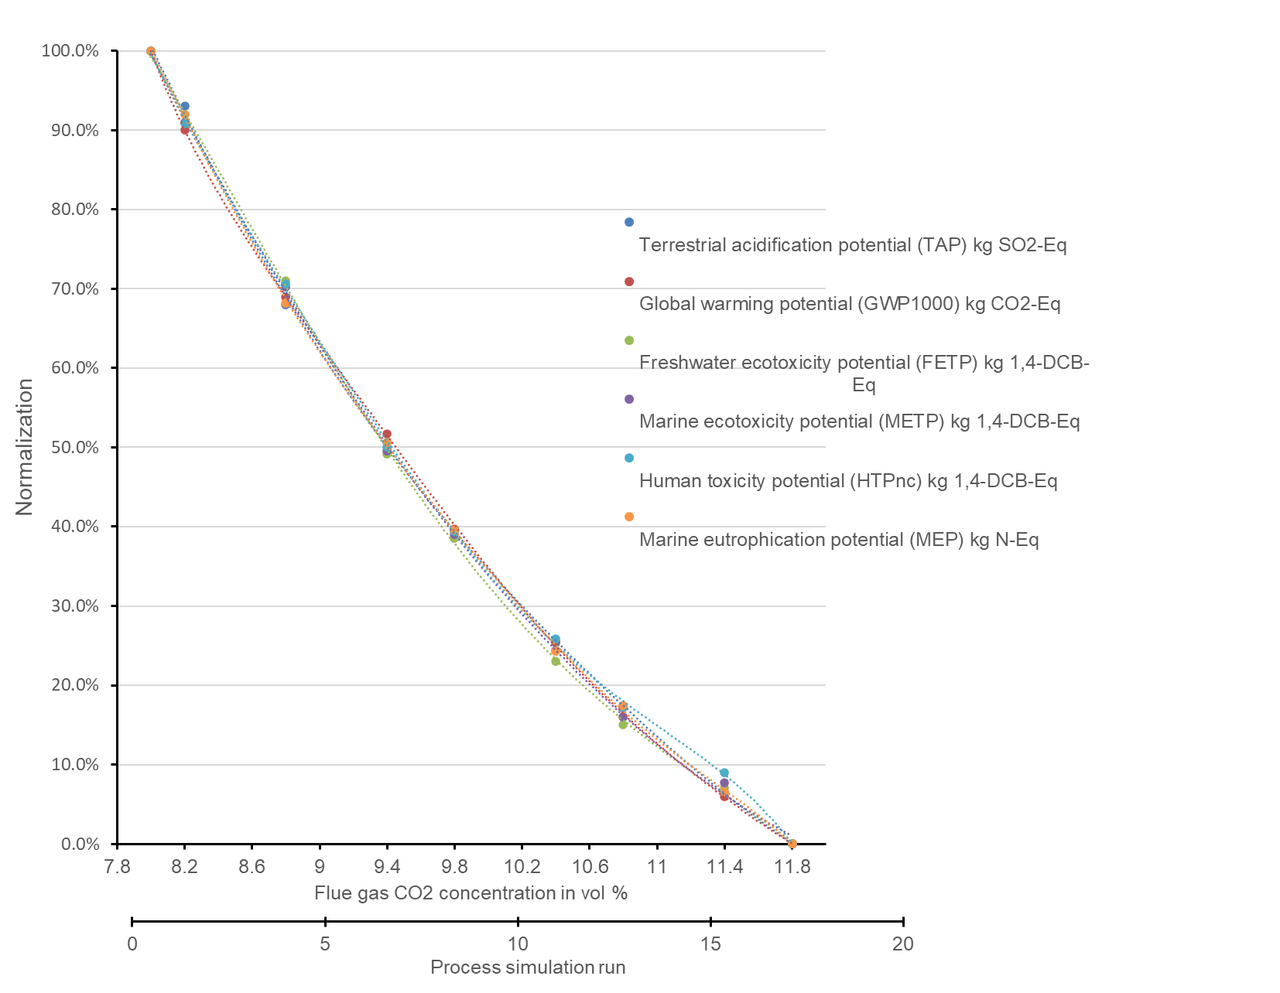

Figure 3: Selected indicators from the ReCiPe 2016 method, normalized by their minimum and maximum values.

* 1. Conclusions and Future Work

In this study, an open‑source framework for automating process simulations in Aspen Plus linked to LCA calculations in Brightway toolkit is presented. Its potential is showcased by an PCS for one key parameter of a PCCC process with MEA to capture the complexity of recent PSE research accurately. One Aspen Plus simulation typically requires about 15 minutes, while the corresponding LCA setup and execution in Brightway can take up to 45 minutes. Therefore, manually performing the 20 simulations and LCAs would require roughly 20 hours in total. In contrast, our automated framework needed only one manual run (1 hour total) to establish the base case and validate the procedure; the remaining 19 runs proceeded automatically in about 20 minutes. This drastically reduces the total time from 20 hours (manual) to roughly 1 hour + 20 minutes (hybrid manual-and-automated). The resulting workflow integrates environmental considerations at an early design stage and is applicable to a broad range of processes

Despite the successful demonstration, increased process complexity can pose challenges. Convergence robustness depends on the choice of Design of Experiments (DoE) methods and on carefully defining parameter ranges. Balancing the number of process parameters, their variation levels, and total simulations is crucial to reducing computational effort while maintaining insight into design trade-offs. Furthermore, planned refinements include modeling solvent degradation, incorporating multi-parameter and nested factorial experiments. From an LCA standpoint, Brightway’s built-in tools facilitate contribution and Monte-Carlo analyses, enabling uncertainty propagation and more thorough environmental trade-off evaluations. Once a direct link is established between process simulation and LCA, one can move beyond static sensitivity analyses. An iterative LCA-Process feedback loop scheme can adapt the next set of Aspen input parameters based on the LCA outcomes of the previous run. Mathematically, we can define an objective function (e.g., minimize GWP or a weighted sum of impact categories) and update the decision variables (e.g., flue gas composition, stripper setpoints, solvent properties) along a descending gradient or via more sophisticated heuristics. Such a scheme drastically reduces the number of runs needed to find more sustainable operating conditions, particularly if combined with partial surrogate modeling. Further, if the process exhibits strong non-linearities or discrete design decisions (e.g., number of column stages), specialized approaches (nested designs or evolutionary algorithms) may be required. In such a setup, LCA outputs inform re-tuned Aspen Plus runs, driving the system toward more sustainable operating conditions with fewer overall simulations.

Our repository and step-by-step approach lower the barrier for reproducible research, contrasting with many closed-source or ad hoc scripts in the literature. By providing all scripts and documentation openly, this framework aims to foster reproducible research and invites broader adoption and collaboration for further enhancements.

* 1. References

Ababneh, H., AlNouss, A. and Al-Muhtaseb, S.A. 2022. Carbon Capture from Post-Combustion Flue Gas Using a State-Of-The-Art, Anti-Sublimation, Solid–Vapor Separation Unit. *Processes*. **10**(11), p.2406.

Cheng, C.-Y., Kuo, C.-C., Yang, M.-W., Zhuang, Z.-Y., Lin, P.-W., Chen, Y.-F., Yang, H.-S. and Chou, C.-T. 2021. CO2 Capture from Flue Gas of a Coal-Fired Power Plant Using Three-Bed PSA Process. *Energies*. **14**(12), p.3582.

Cortes-Peña, Y., Kumar, D., Singh, V. and Guest, J.S. 2020. BioSTEAM: A Fast and Flexible Platform for the Design, Simulation, and Techno-Economic Analysis of Biorefineries under Uncertainty. ACS Sustainable Chemistry & Engineering. 8(8).

ten Hagen, R.W. 2022. AspenPlus Python Interface. [Accessed 3 February 2025]. Available from: https://github.com/YouMayCallMeJesus/AspenPlus-Python-Interface.

Küng, J. 2024. *Prediction of Environmental Performance in Absorption-based Carbon Capture: Addressing Process Enhancements and Data Uncertainties* [Online]. Wien. [Accessed 3 February 2025]. Available from: https://doi.org/10.34726/hss.2024.119741.

Mutel, C. 2017. Brightway: An open source framework for Life Cycle Assessment. *Journal of Open Source Software*. **2**(12), p.236.

P. Wang, A.J. Robinson, S. Papadokonstantakis, Prospective techno-economic andlife cycle assessment: a review across established and emerging carbon capture,storage and utilization (CCS/CCU) technologies, Front. Energy Res. 12-2024 (2024), https://doi.org/10.3389/fenrg.2024.1412770.

Shi, R. and Guest, J.S. 2020. BioSTEAM-LCA: An Integrated Modeling Framework for Agile Life Cycle Assessment of Biorefineries under Uncertainty. ACS Sustainable Chemistry & Engineering. 8(51).

Valverde, J., Ferro, V., Barbero-Sánchez, J. and Giroir-Fendler, A. 2023. Automation of Process Simulations with Aspen Plus.

Vaquerizo, L. and Cocero, M.J. 2018. CFD–Aspen Plus interconnection method. Improving thermodynamic modeling in computational fluid dynamic simulations. *Computers & Chemical Engineering*. **113**, pp.152–161.

Wang, N., Wang, D., Krook-Riekkola, A. and Ji, X. 2023. MEA-based CO2 capture: a study focuses on MEA concentrations and process parameters. *Frontiers in Energy Research*. **11**.

Wang, Z. 2024. Aspen-Plus-Automation. [Accessed 3 February 2025]. Available from: https://github.com/zwang1995/Aspen-Plus-Automation.

Zheng, H., Mirlekar, G. and Nord, L.O. 2022. Machine learning techniques for modeling chemical absorption in CO2 capture process. *Scandinavian Simulation Society*., pp.72–79.