 CHEMICAL ENGINEERING TRANSACTIONS  VOL. xxx, 2025 | A publication of  
The Italian Association
of Chemical Engineering
Online at www.cetjournal.it

Guest Editors: David Bogle, Flavio Manenti, Piero Salatino
Copyright © 2025, AIDIC Servizi S.r.l.
ISBN 979-12-81206-21-2; ISSN 2283-9216

Circularity of Water, Energy and Carbon Dioxide in the Production of Sustainable Aviation Fuel: A Case Study in Northern Europe
Maurizio Cenceª - Valeria Bernardiniª - Maria Valeria Erminiª - Fabio Franciaª - Alessandro Bettoniª - Luciano De Gaetanoª – Marco Vernaª – Luca Giuseppe Campanaª
ª TECHNIP ENERGIES ITALY Viale Castello della Magliana 68 00148 Roma ITALY
valeria.bernardini@ten.com maurizio.cence@ten.com mariavaleria.ermini@ten.com
To achieve sustainable development, we must emphasize “Energy Transition" across all human activities, with a particular focus on the decarbonization of the air transport sector that alone represented in 2024 approximately2,5% of global CO2 emissions.
Sustainable aviation fuels (SAFs) present a promising solution for decarbonizing air transport, and their use is expected to increase from 2% of global jet fuel demand in 2025 to 65% in 2050.
Theoretically, SAFs produced with renewable energy and green hydrogen can achieve nearly 100% emission reduction, significantly contributing to CO2 avoidance. However, effective and sustainable air transport decarbonization poses several challenges, such as reducing costs, enhancing supply chain efficiency, certifying new supply chains, and developing infrastructure for storage and distribution.
This analysis examines the sustainability and circularity of a SAF initiative in Northern Europe from carbon, environmental, energy, using a digital tool to compare various scenarios. The benefits of renewables, innovative design and circularity on water and gaseous effluents are shown for different grades of low-impact fuels.
Moreover, as transitioning to sustainable fuels requires significant investments in high-tech plants and infrastructure, the selected SAF design has been assessed for the accessibility of EU private and public funding opportunities in 2025-2030.
  - Introduction
According to the most recent energy Transition Literature, most emission cuts by 2050 will come from new fuels and aviation technologies, including liquid hydrogen fuel (EIA, 2025; AFDC, 2025).
eFuels are synthetic fuels like eGasoline, eDiesel, eKerosene, and eMethanol, produced from renewable sources or decarbonized electricity. They are made by generating Green Hydrogen through electrolysis, which is then combined with CO2 using processes like Fischer-Tropsch synthesis to create synthetic crude, later refined into various fuels. This Power-to-Liquid (PtL) process ensures climate neutrality. Among the eFuels, Sustainable Aviation Fuels (SAF) are jet fuels derived from renewable and biogenic sources, used in aircraft engines. SAF is crucial for decarbonizing aviation, especially for long-haul flights where alternatives like electric or hydrogen-powered flights are impractical (Prussi et al, 2021). SAF can be used in current engines, with tests showing 100% compatibility, though currently certified for up to 50% blends with conventional jet fuel.
The EU supports increasing eFuels in SAF blends until 2050., however, the transition to sustainable fuels requires substantial investments in high-tech plants. Recent challenges like the pandemic, energy crisis, and geopolitical conflicts have stressed the aviation sector, highlighting the need for policy and technological advancements across all transport segments to lower production costs and improve competitiveness.
To accelerate the decarbonization of the civil aviation sector, we need to focus on several key areas:
- Reduce costs.
- Improve the supply chain, regardless of its current state.
- Enhance the maturity level of technology.
- Develop and bring nascent supply chains to a commercial scale.
- Certify those supply chains that are currently uncertified.
- Establish storage and distribution infrastructure at airports, as well as infrastructure that connects production, distribution, and use.
- Coordinate and align the international regulatory framework with the European system, which is a complex but essential task.
The case study discusses these aspects, highlighting both advantages and drawbacks. Technological optimization can reduce raw material use and increase production efficiency, making it more competitive. Renewable energy is crucial, despite being energy-intensive, as it impacts only initial costs. Therefore, integrating green hydrogen and technology can significantly contribute to sustainable development in aviation
  - Methodology
In this study, the shortlisted configurations have been studied, analyzed and compared through a CEE&C Model (Ermini, et all, 2023). The CEE&C Model is a Life Cycle (LCA) Environmental Energy & Climate Footprint with associated Costs Model that can sustain a Decarbonization and Energy Transition Strategy.
Through CEE&C model, it is possible to show the primary contributors to the project GHG impact and to valorize the best ET solution in a Carbon Footprint Reduction Strategy. The model considers two different LCA boundaries in a wider Project to Context Decarbonization Assessment:
- Unit Boundary (such as Technology)
- System Boundary for decarbonization (such as ET Integration in an existing Industrial area and fossil fuel substitution)
Shortlisted options are assessed for preliminary Energy and Climate screening criteria designed to find the primary energy factors and greenhouse gas (GHG) contributors and is characterized by key Energy and CO2eq emission Indicators by Scope (Absolute and Intensity Key Performance Indicators, KPIs).
Environmental impact criteria are assessed by considering:
- Energy and Fuel streams by type and origin
- Feedstock consumption and circularity of by products
- Water and wastewater circularity.
The Output of the model is a set of KPIs including key Environmental, Energy and Carbon indicators by Absolute Avoidance, Intensity and Cradle-to-Grave, as well as the Levelized Cost of Carbon Abatement aligned to Literature (Malina et al. 2022), relevant and requested today by institutions and advisors to access to Climate Finance and Funding opportunities
  - Case Study Description
The case study considers a SAF Facility built in a Northern European country, near a port, providing a water supply source and easing commercial exchanges, and next to an existing Industrial District with potentiality to export carbon dioxide (CO2) from Plant processes to the facility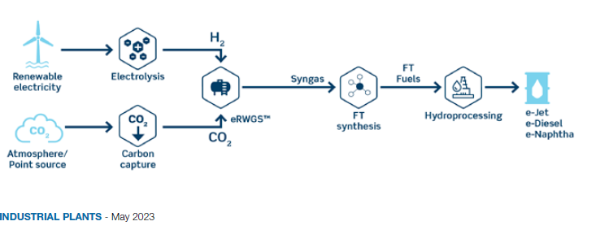
Figure 1 Schematic Process Block Description (De Gaetano, 2023 )

The Facility is set to produce eFuels, synthetic fuels derived through an electrical process (electrolysis) using water and carbon dioxide. About 80% of the output will be low-carbon Kero (SAF), which is more valuable and commercially helpful. Approximately 15% will be low-carbon Naphtha, with a small part being low-carbon fuel. The Facility will be a PtL (Power to Liquid for aviation) Plant, producing liquid hydrocarbons falling under the category of eSAF (Sustainable Aviation Fuel) for aviation. This has the dual advantage of easy transportation and distribution through existing networks (pipelines and refueling stations) currently used for fossil fuels.
The plant will combine commercially available resources and technologies (water, electrolysis, CO2 capture from biogas, Fischer-Tropsch reaction, steam reforming, and refining). Production will be improved in terms of energy consumption, recycling, and efficiency, producing eKerosene and eNaphtha (Collis, et all, 2022)
The plant feedstock is CO2 available from nearby Industrial District, plus the recycling of internally recovered CO2. It uses 46 m³ of treated wastewater per hour, available from nearby Industrial District. The plant's energy input is renewable electricity, producing 4.8 tons of hydrogen per hour via electrolysis. Hydrogen and CO2 are converted into syngas and long-chain hydrocarbons through RWGS and Fischer-Tropsch processes. Finished products like eKerosene are stored and shipped. Finally, combustion gases are recovered and reused, to prevent emissions. Desalinated Water or Treated wastewater is available from the nearby Industrial District. The Facility can be fed by Grid or by Offshore Wind Renewables
Two configurations have been analyzed to figure out the best environmental carbon and energy scheme.
- Base Case Low carbon kerosene Production with H2 via Electrolysis with Energy and Utilities from external grid and networks
- Optimized Scenario: SAF Production with Green H2 via Electrolysis with enhanced circularity and maximized reuse of energy by-products and wastewater.
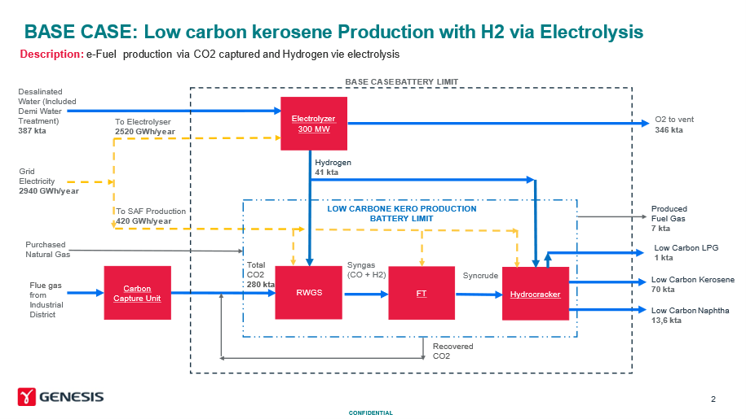
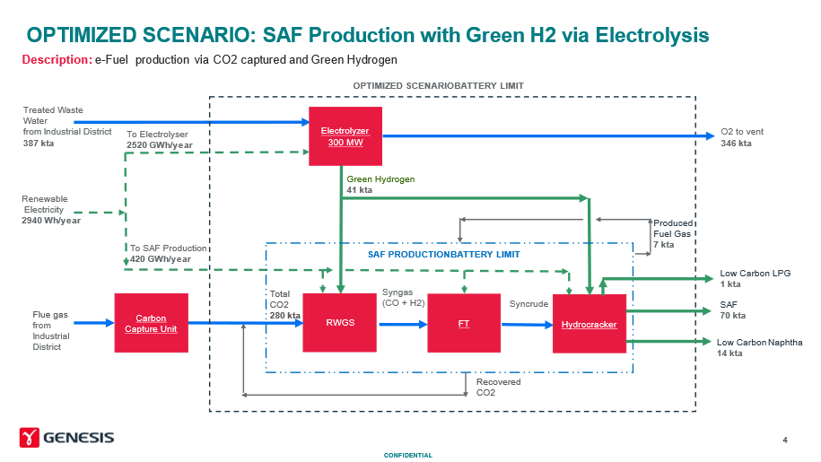
Figure 2 Schematic Base Case vs Optimized Scenario Description
Table 1: Input table to the CEE&C Analysis

 |  | Block 1 | Block 2 | Block 3 | Block 4 | Block 1 | Block 2 | Block 3 | Block 4
 |  | Electrolyzer | RWGS | FT | Hydrocracker | Electrolyzer | RWGS | FT | Hydrocracker
ENERGY
GRID Energy | GWh/y | 2520 | 420 |  |  | 0 | 0
REN Wind Farm Energy | GWh/y | 0 | 0 |  |  | 2520 | 420
Fuel Gas | Kta | 0 |  | 7 |  | 0 | 0
FEEDSTOCK
CO2 Intake | Kta |  | 280 |  |  |  | 280
H2 (produced by Block 1) | Kta | 41 |  |  |  | 0
Green H2 (produced by Block 1) | Kta | 0 |  |  |  | 41
CIRCULARITY
Desalinated Water | Kta | 387 |  |  |  | 0
Treated Waste Water | Kta | 0 |  |  |  | 387
Fuel Gas (recirculated as by-product) | Kta |  |  |  | 0 |  |  |  | 7

Table 2 Carbon Footprint Emission Factors

Emission Factors | Unit | CO2e | Source
GRID Energy | tCO2e / MWh | 0,272 | EIB 2023 EU 27 MV (medium voltage) grid
REN Wind Farm Energy | t CO2e/MWh | 0 | From External Source
H2 (produced by Block 1) | t CO2e / t | 3 | Internally produced
Green H2 (produced by Block 1) | t CO2e / t | 0 | by definition
Desalinated Water | t CO2e / t | 0,15 | UK DEFRA 2024
Treated Waste Water | t CO2e / t | 0 | Internally produced
Fuel Gas | t CO2e / t | 2,568 | UK DEFRA 2024
Fuel Gas (recirculated as by-product) | t CO2e / t | 0 | UK DEFRA 2024

5. Results

The first analysis is based on the GHG Protocol and European Bank for Investment Carbon Emission Project Assessment.
The first screening of the Carbon Footprint of the two configurations is in favor of the optimized scenario. indicates that the benefits of the proposed technology outweigh its drawbacks.:

Table 3 Carbon Impact Assessment- Left Base Case output, right Optimized Scenario
 |  |  | Base Case |  |  |  |  | Optimized Scenario
 |  |  | Block 1 | Block 2 | Block 3 | Block 4 |  | Block 1 | Block 2 | Block 3 | Block 4
Carbon Footprint |  |  | Electrolyzer | RWGS | FT | Hydrocracker |  | Electrolyzer | RWGS | FT | Hydrocracker
Scope 1 | Ton CO2e |  | 0 | 0 | 17.976 | 0 |  | 0 | 0 | 0 | 0
Scope 2 | Ton CO2e |  | 685.440 | 114.240 | 0 | 0 |  | 0 | 0 | 0 | 0
Scope 3 Feedstock | Ton CO2e |  | 58.050 | 0 | 0 | 0 |  | 0 | 0 | 0 | 0
TOTAL CO2e | Ton CO2e |  | 743.490 | 114.240 | 17.976 | 0 |  | 0 | 0 | 0 | 0
TOTAL CO2e | Ton CO2e |  | 875.706 |  |  |  |  | 0

In addition, the following KPIs have been built to define the comparison amongst the two scenarios with comparison of Carbon Intensity, Water Circularity and Renewable Energy Intensity of two Configurations

Table 4 Carbon Environmental and Energy Configurations Comparison- Left Base Case output, right Optimized Scenario

PRODUCTS |  | Base Case | Optimised Scenario
Design Capacity SAFs
SAF 1 KERO | Kta | 70 | 70
SAF 2 NAPHTHA | Kta | 13,6 | 13,6
SAF 3 LPG | Kta | 1 | 1
O2 ( by-product) | Kta | 346 | -
Fuel Gas (By- Product) | Kta | 7 | -
CO2e Intensity | t CO2e/ t | 10,136 | 0,000
Water Circularity | m3 / t | 0,005 | 0,000
Renewable Use | MWh/ t | 0,000 | 0,035

These benefits include low-impact fuel production, reuse of existing products and systems, clean energy usage, reduced environmental impact and waste, The resulting Carbon Emissions and Environmental KPI allows us to confirm design selection for the optimized scenario.
The case study shows that optimized technology selection is a significant step towards sustainable energy. Although innovative technologies face initial development challenges, perseverance, politics, and civil will find their success (Eyberg, et. all, 2024). While hydrogen technology is currently costly, it presents a vital opportunity to address climate issues and achieve sustainable development goals.
  - Conclusions
The urgency to combat global warming and climate change is intensifying, with many countries committing to net-zero emissions by 2050. This transition necessitates a significant reduction in coal, oil, and gas usage. eFuels, or synthetic fuels, are a critical component of the global energy shift from fossil fuels to renewables (solar, wind, geothermal, hydro). They can be used in existing engines and distribution systems and are especially important in applications where alternatives like electricity and hydrogen are currently not viable, such as aircraft engines.

eFuels have high energy density and can be transported at room temperature and pressure, overcoming issues related to the intermittent production and storage of renewables. The European Commission's plan to allow sales of new internal combustion engine cars running solely on eFuels after 2035 has sparked significant interest in their production. However, there are currently no industrial plants producing eFuels at scale.

The proposed optimized scenario aligns with the latest political trends, enabling the production of Sustainable Aviation Fuel (SAF) using green electricity. SAF is utilized in engines, contributing to the decarbonization of the transport sector. Additionally, the optimized scenario recycles waste from the adjacent Industrial District, including wastewater and flue gases. This approach reduces the volume of water effluent requiring disposal, thereby minimizing water losses. Furthermore, the discharge of flue gases into the atmosphere is decreased by incorporating a portion of these gases into SAF production.

For the selected option at the end of the Study it is foreseen the development of a Front-End Engineering and Design (FEED) and a more accurate Cost Estimate (CE) and to align with the country investors and financing institution. Similar studies with the CEE&C model results integrated with economic assessment, CAPEX and Annualized OPEX for the entire life duration of the facility can support climate ambitions, stakeholders’ needs and investors expectation in the geographical Decarbonization ambition and strategy.

Nomenclature
CEE&C – Carbon Energy Environmental & Cost Model
CTG – Product Carbon Footprint
ET – Energy Transition
GHG – Greenhouse Gas
KPI – Key Performance Indicators
LCA – Life Cycle Assessment
Acknowledgments
Maurizio Cence: Data curation, Formal analysis, Writing - original draft.
Valeria Bernardini: Conceptualization, Methodology, Supervision, Software, Validation, Writing – review.
Maria Valeria Ermini: Data curation, Formal analysis, Writing – review.
Fabio Francia: Formal analysis, Writing – review, Resources, Supervision, Project administration
Marco Verna: Formal analysis, Writing – review, Resources, Supervision, Project administration
Luciano de Gaetano: Resources, Supervision, Project administration.
Alessandro Bettoni: Resources, Supervision, Project administration
Luca Giuseppe Campana: Resources, Supervision, Project administration

The authors would like to thank Luciano de Gaetano, Marco Verna, Luca Giuseppe Campana and Alessandro Bettoni for the opportunity provided, the constant support and their thorough review of the results.
The authors would also like to acknowledge the significant work and effort undertaken by all the Technip Energies technology experts involved.

References
AFDC, 2025. US Alternative Fuels Data Center: Sustainable Aviation Fuel https://afdc.energy.gov/fuels/sustainable-aviation-fuel?utm=syndication
De Gaetano L., 2023 eFuels and their production, an immediate solution for the Energy Transition. Luciano De Gaetano, Project Director, Technip Energies Italy. Journal Impiantisica Italiana. Industrial Plants ANIMP
EIA, 2025. U.S. Energy Information Administration production capacity for sustainable aviation fuel to grow - U.S. Energy Information Administration (EIA) https://www.eia.gov/todayinenergy/detail.php?id=62504
EIB 2023, EIB Project Carbon Footprint Methodologies, Methodologies for the assessment of project greenhouse gas emissions and emission variations. Version 11.3 January 2023 EIB Project Carbon Footprint Methodologies
Ermini, M.V, Bernardini, V. Verna M., Campana L.G., Abdullaeva A., Fiorentino L., Florio G., 2023, A Project to Context Decarbonization Analysis (PCDA) to Select the Best Energy Transition Solution Fit for Funding, Chemical Engineering Transactions, 105, 19-24.https://doi.org/10.3303/CET23105004
Eyberg, et. all, 2024 Techno-economic assessment and comparison of Fischer–Tropsch and Methanol-to-Jet processes to produce sustainable aviation fuel via Power-to-Liquid, V Energy Conversion and Management, Volume 315, 2024, 118728, ISSN 0196-8904, https://doi.org/10.1016/j.enconman.2024.118728. https://www.sciencedirect.com/science/article/pii/S0196890424006691
Collis, J. Duch, K., Schomcker, R., 2022. Techno-economic assessment of jet fuel production using the Fischer-Tropsch process from steel mill gas. Front. Energy Res., Sec. Carbon Capture, Utilization and Storage Volume 10 - 2022 | https://doi.org/10.3389/fenrg.2022.1049229
Malina R., et all 2022 The Role of Sustainable Aviation Fuels in Decarbonizing Air Transport. World Bank Group. https://documents1.worldbank.org/curated/en/099845010172249006/pdf/P17486308a996a08b098a10d078d421c6a3.pdf
Prussi, M. et. all. 2021 CORSIA The first internationally adopted approach to calculate life cycle GHG emissions for aviation fuels.. Renewable and Sustainable Energy Reviews, Volume 150, 2021, 111398, ISSN 1364-0321, https://doi.org/10.1016/j.rser.2021.111398
UK DEFRA 2024, UK Government GHG Conversion Factors for Company Reporting, 2024. ghg-conversion-factors-2024-full_set__for_advanced_users__v1_1

