 CHEMICAL ENGINEERING TRANSACTIONS  VOL. xxx, 2025 | A publication of  
The Italian Association
of Chemical Engineering
Online at www.cetjournal.it

Guest Editors: David Bogle, Flavio Manenti, Piero Salatino
Copyright © 2025, AIDIC Servizi S.r.l.
ISBN 979-12-81206-21-2; ISSN 2283-9216

Pressure Risk Management in Accumulation and Transport Phases of Tanks Containing Hydrogen
Vincenzo Nastasiª, Giovanni Grilloneª, Andrea Tonti^{b}, Antonino Muratore^{c,}*
ªInail, UOT Palermo, Viale del Fante 58/D - 90146 Palermo, Italy
^{b}Inail, DIT, Via Ferruzzi 38/40 - 00143 Roma, Italy
^{c}Inail, UOT Como, Via Petrarca 4 - 22100 Como, Italy
a.muratore@inail.it
One of the main challenges facing in the hydrogen sector is related to the safe storage and transport of this product under pressure. Accidents involving pressure equipment that containing hydrogen almost always begin with a leak. The aim of the article, in the light of the authors’ institutional experience, is to manage the risk of pressure in the storage and transport phase of hydrogen in accordance with European legislation. This legislation concerns: a) PED directive, 2014/68/EU (Pressure Equipment Directive), for fixed installations; b) TPED Directive, 2010/35/EU (Transportable Pressure Equipment Directive) through compliance with the requirements set out in Directive 2008/68/EC and subsequent updates which incorporates the international agreements relating to the international transport of dangerous goods by road (ADR), the Regulation concerning the International Carriage of Dangerous Goods by Rail (RID) and the European Agreement concerning the International Carriage of Dangerous Goods by Inland Waterways (ADN). In Italy, in addition to the European legislation, Legislative Decree 81/08, Ministerial Decree 329/2004 and Ministerial Decree 11/04/2011 must also be taken into consideration during the exercise phase. Another aspect to be taken into consideration concerns hydrogen storage that falls under the European Directive 2012/18/EU (Seveso) on the control of major accidents involving hazardous substances.
- Physicochemical properties of hydrogen for safety and health purposes
From a safety point of view, hydrogen is no more or less dangerous than other gases, but it is different. This difference lies in its specific physicochemical properties. For a safe design, construction, and use of hydrogen storage tanks (fixed or transportable) that takes into account the risk of pressure, the main physicochemical characteristics must be taken into consideration:
- It is a colorless and odorless gas, not perceptible to the human senses, classified as "extremely flammable" by the legislation on dangerous substances. It is capable of forming potentially explosive mixtures with air. Unfortunately, compounds such as mercaptans (normally used as odorants to detect natural gas leaks) cannot be added to hydrogen systems as they would contaminate fuel cells. Hydrogen is neither toxic nor harmful, it has no physiological effect, but if inhaled in high concentrations it can cause asphyxia by replacing the oxygen in the air.
- It is the gas with the smallest and lightest molecule (density: 84 g/m³ at 15°C and 1 bar), it moves very quickly upwards and can penetrate materials normally impermeable to gases. Hydrogen is also very light in the liquid state (density: 70 g/l at -253°C and 1 bar); It evaporates quickly and forms about 845 liters of gas for every liter of liquid. The gas that has just evaporated, cold, has a density like that of air and spread horizontally, but as the temperature increases its density decreases and moves upwards.
- Flammability is the most important chemical property of hydrogen. Hydrogen reacts with all oxidizing agents, such as oxygen, chlorine, nitrous oxide etc., and in all cases the reactions are accompanied by a high heat development. In the presence of a source of ignition, reactions can become explosive, especially if they occur indoor where there is confinement. The energy required to ignite hydrogen in the air is very low (MIE = 0,019 mJ): about 1/10 of the amount needed for LPG (Liquefied Petroleum Gas), equal for example to that of a spark generated by the impact against an object of a particle of dust carried by hydrogen itself. The hydrogen flame is very hot and pale, in daylight it may not be visible. Therefore, the heat is not physically felt until direct contact with the flame occurs. A hydrogen fire can go undetected and will spread despite there being direct monitoring by people in areas where hydrogen can leak. The flammability limits in air are: 4.0%÷75.6% vol. %. Within the flammability range, hydrogen has a wider range of detonation in air than other fuels: between 18 and 59 vol. %. The hydrogen auto-ignition temperature is above 510°C.
- Hydrogen is generally a non-corrosive gas. However, some metallic materials, when they come into contact with hydrogen under certain conditions, can be subject to embrittlement and/or stress corrosion. The effect in both cases is the reduction of the ductility and tensile strength of the material.
The factors to consider are the following: - temperature, pressure, and contaminants of hydrogen; - type of metallic material and its structure (discontinuity, porosity, etc.); - distribution of stresses on the material. For this reason, compressed hydrogen steel is made of a special alloy (HY Responders, 2023).
- Hydrogen storage and transport
Hydrogen can be used in many industries such as: a) feedstock to produce chemicals and materials; b) fuel to generate energy and heat; c) fuel in the field of transport. One of the key challenges in the hydrogen sector is to store and transport it safely (Schiaroli et al., 2023), which is key to ensure its availability as an energy resource. First of all, hydrogen can be stored and transported as: 1) pressurized gas; 2) low temperature liquid (below its normal boiling point which occurs at – 252.8°C); 3) in the solid state, such as in metal hydrides. In this article authors will focus on storage and transport as highlighted in points 1) and 2). Below in Fig. 1, a simplified diagram of hydrogen production from renewable sources shows the hydrogen storage tanks (fixed and transportable):

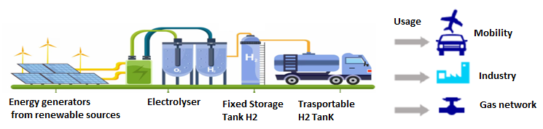
Figure 1: Diagram of hydrogen

Four types of containers have been developed and used for the transport and storage of hydrogen:
• Type I: metal container without and with metal welding
• Type II: seamless metal container wrapped in a composite resin fiber frame
• Type III: metal cladding completely wrapped with resin fiber composite
• Type IV: polymer coating fully wrapped with resin fiber composite.
In comparison with other economic sectors, like industry and agriculture, transportation is proved to be the major
contributor to greenhouse gas (GHG) emissions (Kazancoglu et al.,2021).
  - Hydrogen gas storage, GH₂
Currently, the most common way of storing hydrogen is as compressed gas (GH₂) in metal and composite cylinders at different pressures. The hydrogen compression process increases its volumetric density. Hydrogen for industrial or laboratory use is typically compressed at pressures of 15-20 MPa (150-200 bar).
In vehicles, hydrogen pressurized to 35-70 MPa is stored in on-board storage tanks. At refueling stations, hydrogen gas is pressurized (up to 100 MPa) in stages and stored in container. For example, three different pressure levels can be used in a filling station with gaseous storage: low pressure storage (in "cigar" tanks, P=4.5 MPa); medium pressure storage (in a group of cylinder assembly/cylinder, P=20-50 MPa) and high-pressure storage (in composite tanks/cylinders, P=70-100 MPa). The main concerns related to GH₂ are: • the large amount of energy required for compression; • the stress on container materials caused by repeated cycles from low to high pressures; • the inherent safety concerns for the use of such high pressures in tanks.
In this article, type I tanks will be considered, giving indications on their construction and safe use. Usually, hydrogen storage processes involve placing a compressor before the storage tank. With tanks (with welds) capable of storing hydrogen at 35 bar pressure (Fig. 2 A), for example, the user does not need to compress hydrogen before storing it; 35 bar, in fact, usually corresponds to the value of the pressure of the hydrogen leaving an electrolyzer. As a result, some hydrogen storage tanks can be placed directly between the electrolyzer, or any other hydrogen production system, and the machine that consumes or transport it. In this way, they allow the compressor to be eliminated from the system. Fig. 2 shows some examples of hydrogen storage tanks in stationary applications. Providing Type I tanks, welded in a system over 100 bar, can be improper: the more pressure rises, the thicker the wall of the tank must be, which brings with it more steel which becomes very long to weld, heavy and above all expensive. Keeping this in mind, for pressure over 70 bar authors opt for one-piece tanks (without welding) as shown in Fig. 2 B) and Fig. 2C).

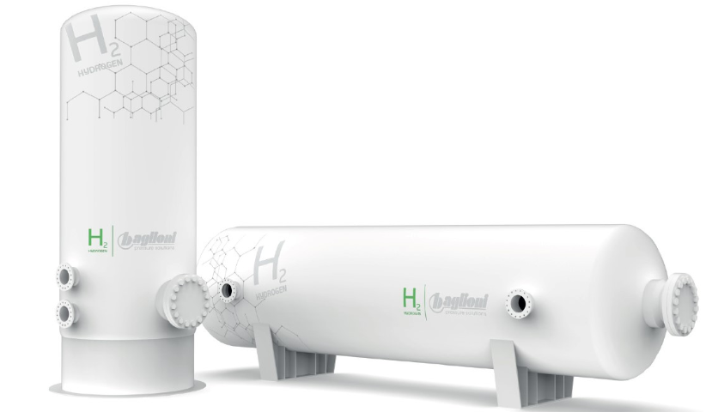  A) Welded tanks with designed pressure 35/70 bar | B) Seamless cylinders with design pressure 150/200 bar | C) Seamless cylinders with design pressure 200/500 bar
Fig. 2: Examples of hydrogen storage tanks

  - Storage and transport of liquefied hydrogen, LH₂
Storage tanks for LH₂ can hold more hydrogen than those for GH₂: the volumetric capacity of LH₂ is 0.070 kg/L versus 0.030 kg/L for GH₂ tanks at 70 MPa. One of the worst-case scenarios might be the catastrophic rupture of the LH₂ vessel (Ustolin et al., 2022). However, a considerable amount of energy is required for liquefaction (about 30% of the energy contained in hydrogen). Hydrogen can be liquefied for simplified transport or storage. All major industrial gas suppliers have cryogenic tankers. Fig. 3 A) shows an LH₂ storage diagram showing the main components. Fig. 3 B) shows a photo of an LH₂ tank with a special air vaporizer in order to deliver hydrogen gas.

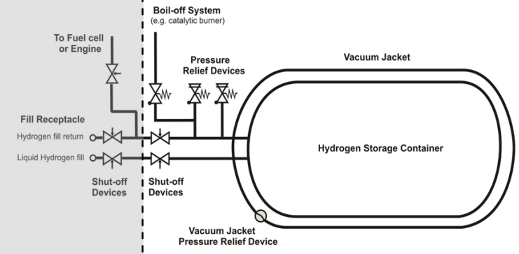  A) LH₂ storage scheme in which  The main components are highlighted | B) Fixed LH₂ tank with a special vaporizer | 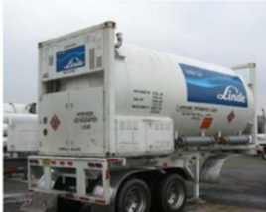  C) Example of a trailer for transporting LH₂ by road
Fig. 3: Examples of hydrogen tanks
- Pressure equipment and assemblies in fixed installations
It should be noted that almost always accidental events involving equipment or pressure assemblies that contain hydrogen begin with a loss of containment / release of H₂. Depending on the way in which the loss or release occurs, the equipment involved and the surrounding circumstances, the event evolves through three main phenomena: fire, explosion and release of H₂ (flammable substance). So, the first form of prevention is to avoid leaks from hydrogen containing equipment/assemblies. Therefore, it is essential that the integrity of the same is guaranteed, as well as that the safety and control devices are efficient and sufficient to perform their role. In addition, if hydrogen escapes through openings (e.g. safety valves, rupture discs, etc.) despite all precautions, the flow must be appropriately conveyed in order to avoid damage to people, structures and the environment. In Europe, those who manufacture pressure equipment/assemblies in fixed locations must follow the product directive 2014/68/EU (PED), which since 2016 replaces the old PED directive: 97/23/EC. This standard indicates what characteristics equipment or pressure assemblies operating at a pressure of more than 0.5 bar must possess in order to be able to mark them "CE" and introduce them into the European market.
The manufacturer is the main interlocutor of this directive, the one who has the task of making safe pressure equipment/assemblies. In addition, he has the burden of CE marking of the products manufactured and complete responsibility for design, construction and marketing. He must therefore ensure compliance with all the Essential Health and Safety Requirements that are imposed in the PED directive (Annex I). First of all, it is necessary to introduce the distinction between pressure equipment and assemblies: a) pressure equipment are: vessels, pipes, safety accessories and pressure accessories, including, where applicable elements attached to pressurized parts, such as flanges, fittings, sleeves, supports, movable fins; b) assemblies are: various elements of pressure equipment assembled by a manufacturer to form an integrated and functional whole. Generally, equipment and assemblies subjected to a maximum permissible related pressure PS greater than 0.5 bar fall within the scope of the PED. Equipment with a pressure equal to or less than 0.5 bar is excluded from the application of the regulation. After defining whether the equipment fall within the scope of Directive 2014/68/EU, the next step is the definition of the PED risk category to which it belongs with the tables in Annex II of the PED, taking into account: a) dimensions of the equipment (volume V for vessels, DN diameter for pipes); b) Maximum permissible pressure (PS); c) Type of fluid (group I, hazardous; hydrogen falls into this group as it is flammable) or group II (non-hazardous)). In general, can be found, pressure equipment with PED risk category: I, II, III and IV; passing from I to IV the risk increases. Considering the storage pressure, tanks or assemblies containing hydrogen are normally in PED risk category IV. The Risk Analysis that the manufacturer must carry out is based on the PED risk category to which it belongs. It is used to verify and track compliance with the Essential Safety Requirements set out in Annex I of the PED. The last step, before landing on the EU market, concerns the CE marking of the equipment and the possibility of resorting to the Notified Body (for PED risk classes from II to IV). The notification number processed by the Body shall be indicated on the certificate and on the plate affixed to the pressure equipment/assembly. Ultimately, in order to be able to place a pressure equipment/assembly on the European market, a manufacturer must: 1) CE marking pressure equipment / assembly with a special plate; 2) draw up the EU declaration according to Directive 2014/68/EU (PED); 3) draw up the "Operating Instructions" useful for safety purposes with regard; a) the assembly, including the assembly of the various pressure equipment; b) commissioning; c) use, d) maintenance and inspections by the user. It should be noted that the Technical File that is the basis of the three aforementioned elements must be kept by the manufacturer.
As regarding the commissioning of hydrogen tanks as well as the related internal controls and legal checks, in Italy everything is regulated by Legislative Decree 81/08, Ministerial Decree 329/2004 and Ministerial Decree 11/04/2011. For both liquid and gaseous hydrogen storage, in addition to maintenance and checks by employers, legal checks must also be carried out. As a first step pursuant to art. 6 of Ministerial Decree 329/04 for pressure equipment/assemblies, the employer/user must report the commissioning to INAIL. The INAIL competent for the territory will issue a special serial number for the equipment/assemblies. Finally, since these are equipment or pressure assemblies falling into PED risk category IV, containing a dangerous fluid (flammable such as hydrogen), they must be carried out at the request of the employer: an operation check every 2 years and an integrity check every 10 years.
- Transportable pressure equipment
Directive 2010/35/EU, TPED (which replaced the previous directive 1999/36/EC) establishes the rules and procedures to be followed for the certification of transportable pressure equipment. The application of the Directive is implemented through compliance with the requirements established in Directive 2008/68/EC and subsequent updates which makes its own: a) international agreements relating to the international transport of dangerous goods by road (United Nation, 2024, ADR), b) the regulation concerning the international carriage of dangerous goods by rail (RID); c) the European Agreement concerning the international carriage of dangerous goods by inland waterways (ADN). The European Directive 2010/35/EU (TPED) was implemented in Italy with the Legislative Decree. 78/2012. The fluids considered are compressed, liquefied or dissolved gases with characteristics: asphyxiating, oxidizing, flammable, toxic or corrosive, referred to in class 2 of the ADR. These include hydrogen which is a flammable product. When placing their transportable pressure equipment on the market, manufacturers shall ensure that it has been designed, manufactured and documented in accordance with the requirements set out in the Annexes to Directive 2008/68/EC and Directive 2010/35/EU. The manufacturer must therefore draw up for each piece of equipment or batch of equipment that falls within the scope of the TPED directive a technical file that must contain the documentation necessary to testify to the correct criteria of design, manufacture, qualifications of personnel, material, compliance of the essential safety requirements, etc. Where the conformity of transportable pressure equipment with the applicable requirements has been demonstrated by the conformity assessment procedure set out by the annexes of Directive 2008/68/EC and the TPED Directive, manufacturers shall affix the "π" mark. The different ADR procedures are shown below in table 1.
Table 1. Different ADR procedures
 | Procedures
Pressure receptacles 6.2 ADR |  |  | Tank-vehicles 6.8 ADR
 | Type examination and type approval certificate issue ADR 1.8.7.2
 | Supervision of manufacture ADR 1.8.7.3
 | Initial inspection and test ADR 1.8.7.4
 | Entry into service verification ADR 1.8.7.5
 | Periodic inspection 1.8.7.6
Description | Maximum water capacity |  | Gas Type
Cylinders | < 150 l | Compressed, Liquefied, Dissolved
Tubes | 150 ÷ 3000 l | Compressed, Liquefied, Dissolved
Barrels | 150 ÷ 3000 l | Compressed, Liquefied, Dissolved
Bundles of cylinders | < 3000 l  < 1500 l for toxic | Compressed, Liquefied, Dissolved
Cryogenic receptacles | < 1000 l | Refrigerated

What is represented in Table 1 refers to ADR but is similarly applicable to the corresponding chapters of the RID and the ADN. For compressed hydrogen (classification code 1F) the periodicity of the tests is 10 years for both cylinders, pipes, drums and packs of cylinders. This periodicity does not apply to pressure vessels made of composite material which normally has a maximum periodicity of 5 years (ADR part 4).
According to point 6.2.1.6 ADR, refillable pressure receptacles, other than cryogenic receptacles, shall be subjected to periodic inspections and test by a body authorized by the competent authority, in accordance with the following: a) Check of the external condition of the pressure receptacles and verification of the equipment and the external marks; b) Check of the internal condition of the pressure receptacles (e.g. internal inspection, verification of minimum wall thickness); c) Checking of the thread either: if there is evidence of corrosion or if the closures or other service equipment are removed; d) A hydraulic pressure test of the pressure receptacle shell, and, if necessary, verification of the characteristics of the material by suitable test.
Pursuant to 6.2.3.5.2. ADR closed cryogenic receptacles shall be subjected to periodic inspections and tests in accordance with the periodicity (at least every 10 years) defined in packing instruction P203 of 4.1.4.1 ADR, in accordance with the following: a) Check of the external condition of the pressure receptacle and verification of the service equipment and external marks; b) The leakproofness test. Closed cryogenic vessels must be equipped with at least one decompression device which must be tested at least every 5 years.
For stationary tanks (tank vehicles), detachable tanks and battery vehicles, they must be subject to periodic inspections at least every 6 years. While for tank containers, tank swap bodies and CGEM (multiple element gas containers) must be inspected at least every 5 years. These periodic inspections must include: - an examination of the internal and external condition; - a leak test of the tank with the equipment in accordance with point 6.8.2.4.3 ADR, as well as a verification of the proper functioning of each equipment; - a hydraulic pressure test. In addition, tanks and their equipment must undergo intermediate inspections at least every 3 years (or two and a half years for tank containers, tank swap bodies and MEGCs). These interim inspections must include a leak test of the tank with its equipment and a check that all the equipment is functioning properly. The tank must therefore be subjected to an effective internal pressure equal to the maximum service pressure.
- Hydrogen storage facilities covered by the Seveso Directive
When quantities of H₂ in storage exceed certain thresholds, the European Directive 2012/18/EU (Seveso) on the control of major accidents involving dangerous substances should be taken into account. A "major accident" is an event involving the release of hazardous substances that can cause serious damage to people, the environment or material property. Major accidents can include explosions, fires or uncontrolled releases of hazardous chemicals into the environment. In the case of quantities of H₂ exceeding 5 tons, reference must be made to the requirements of the Seveso directive for lower threshold deposits. While when the quantity of H₂ is greater than 50 tons, the obligations of the Seveso Directive are among those required for higher threshold deposits. In these cases, manufactures must identify, describe, analyse and characterise the accident sequences that can lead to a major incident. Each of the accident scenarios identified must be correlated with a summary of the events that may play a role in their triggering, with causes internal or external to the plant: a) operational causes; b) external causes, such as those connected with domino effects; c) natural causes, such as earthquakes (Giannelli et al., 2020) or floods (Muratore et al., 2022), (Muratore et al., 2024). All this is preceded by the carrying out of a preliminary analysis for the identification of the critical units of the H₂ storage plant that may be the initiators of major accidents. This legislation also has implications for the population living in the vicinity of these establishments. Plants subject to the Seveso Directive must: a) Send a Notification with detailed information on the plant and the hazardous substances stored therein; b) Draw up a "Safety Report" (for upper threshold establishments) documenting the safety assessments and measures taken to prevent and mitigate the risks of major accidents. c) Develop Internal Emergency Plans or procedures to respond quickly to any incidents. d) Collaborate with local authorities for the drafting of "External Emergency Plans" describing the actions to be taken in the event of an accident with impact outside the plant.
In addition, the operator of these establishment prepares and implements the policy of major accidents through suitable means and structures, as well as through a "Safety Management System" proportionate to the dangers of major accidents.
- Conclusions
One of the key challenges in the hydrogen sector is its safe storage and transport. The article, starting from the main physical-chemical characteristics of hydrogen, aims to give the essential indications for a design, construction, commissioning and safe use of hydrogen storage tanks (fixed or transportable) that takes into account the pressure risk in compliance with European directives and also with reference to Italian legislation. Only with organic management of the risk of pressure can hydrogen leaks and releases be avoided, which are sources of fires and explosions with serious impacts on workers and people who by chance could be near these storages, as well as serious economic damage to the plants. The work addresses the storage and transport of hydrogen as a pressurized gas (GH₂) and as a low-temperature liquid (LH₂). Finally, the article takes into consideration the hydrogen storage that falls under the European Directive 2012/18/EU (Seveso) on the control of major accidents involving dangerous substances when the quantity of H₂ is greater than certain quantities. It should be noted that this work derives from the institutional experience of the authors in the safety of fixed and transportable pressure equipment, with reference to the European Union standards that manufacturers and users must apply to place on the market and use the same equipment. Manufacturers, in order to place pressure vessels containing hydrogen on the market in the European Union, must comply with PED or TPED directives.
References
European Union, 2008, Directive 2008/68/EC of the European Parliament and of the Council of 24 September 2008 on the inland transport of dangerous goods, Official Journal of the European Union, N 260, 30.9.2008, p. 13–59.
European Union, 2010, Directive 2010/35/EU of the European Parliament and of the Council of 16 June 2010 on transportable pressure equipment and repealing Council Directives 76/767/EEC, 84/525/EEC, 84/526/EEC, 84/527/EEC and 1999/36/EC, Official Journal of the European Union, N 165 del 30.6.2010, p. 1–18.
European Union, 2012, Directive 2012/18/EU of the European Parliament and of the Council of 4 July 2012 on the control of major-accident hazards involving dangerous substances, amending and subsequently repealing Council Directive 96/82/EC (SEVESO III), Official Journal of the European Union, L197, p.1-37.
European Union, 2014, Directive 2014/68/EU of the European Parliament and of the Council of 15 May 2014 on the harmonization of the laws of the Member States relating to the making available on the market of pressure equipment (recast), Official Journal of the European Union, N. 189, 27.6.2014, p. 164–259.
Giannelli, G., Grillone, G., Muratore, A., Nastasi, V., Sferruzza, G., Earthquake Natech Risk: Index Method for critical Plants covered by Seveso III Directive. Proceedings of the 30th European Safety and Reliability Conference and 15th Probabilistic Safety Assessment and Management Conference, Venezia, Italy, 2-5 November 2020, ESREL2020-PSAM15 Organizers, pp. 3134-3140. Published by Research Publishing, Singapore. ISBN: 978-981-14-8593-0, DOI: 10.3850/978-981-14-8593-0_3785-cd.
HY Responders, 2023, European Train the Trainer Programme for Responders, Safety of liquid hydrogen, Level IV.
Kazancoglu Y, Ozbiltekin-Pala M., Ozkan-Ozen Y.D., 2021, Prediction and evaluation of greenhouse gas emissions for sustainable road transport within Europe, Sustainable Cities and Society, Vol 70, 102924.
Muratore A., Giannelli G., Nastasi V., Sferruzza G., Grillone G., Delle Site C., 2022, Flood risk identification and analysis for pressure equipment. Proceedings of 32nd European Safety and Reliability Conference, Dublin, Ireland, 28 August - 1 September 2022, ESREL2022 Organizers, pp. 885-890. Published by Research Publishing, Singapore. ISBN: 978-981-18-5183-4. DOI: 10.3850/978-981-18-5183-4_R17-03-059-cd.
Muratore A., Grillone G., Delle Site C., Giannelli G., Nastasi V., 2024, Natech Risk from Floods. Vulnerability of Critical Technical Systems Containing Hazardous Substances, Chemical Engineering Transactions, 111, 559-564 DOI:10.3303/CET24111094.
Schiaroli A., Scarponi G.E., Cozzani V., 2023, A Comparative Safety Assessment of Hydrogen Storage Tanks for Hydrogen-powered Buses, Chemical Engineering Transactions, 99, 151-156 DOI:10.3303/CET2399026.
United Nation, 2024, ADR – Agreement Concerning the International Carriage of Dangerous Goods by Road, Geneva.
Ustolin F., Giannini L., Pio G., Salzano E., Paltrinieri N., 2022, On the Mechanical Energy Involved in the Catastrophic Rupture of Liquid Hydrogen Tanks, Chemical Engineering Transactions, 91, 421-426 DOI:10.3303/CET2291071.

