 CHEMICAL ENGINEERING TRANSACTIONS  VOL. , 2023 | A publication of  
The Italian Association
of Chemical Engineering
Online at www.cetjournal.it

Guest Editors: David Bogle, Flavio Manenti, Piero Salatino
Copyright © 2023, AIDIC Servizi S.r.l.
ISBN 979-12-81206-04-5; ISSN 2283-9216

Evaluation and Mitigation of Carbon Footprint of Medical Inhalers
Tomasz R. Sosnowskiª, Daniel Wylezińskiª, Andrzej Emeryk^{b}
ªFaculty of Chemical and Process Engineering, Warsaw University of Technology, Waryńskiego 1, 00-645 Warsaw, Poland
^{b}Department of Pulmonary Diseases and Children Rheumatology, Medical University of Lublin, Gębali 6, 20-093 Lublin, Poland
tomasz.sosnowski@pw.edu.pl
Pressurized metered dose inhalers (pMDIs) contain propellants with high Global Warming Potential. This paper compares six pMDI products from the Polish market in terms of their contribution to environmental burden by analyzing the release and residuals of greenhouse gases during use and disposal. The results show that these similar medical products have markedly different carbon footprint values (12-22.5 kg CO₂e), which might be mitigated by certain measures involving technical and legal actions.

  - Introduction
The Kigali Amendment (2016) to Montreal Protocol defined new conditions on the use of certain liquid organic propellants (LOPs) in, so called, pressurized metered dose inhalers (pMDIs) which are commonly used aerosol drug delivery devices for the treatment of asthma and other inflammatory lung diseases (Pritchard, 2020; Emeryk et al., 2021). Although the amount of LOPs in single can is low, typically in the range of 10-20 g (Wyleziński, 2022), the total release of LOPs from pMDIs into the atmosphere leads to a measurable environmental burden. This is due to high values of the Global Warming Potential (GWP) value of LOPs and a massive number of pMDIs consumed. In Poland, pMDI inhalers account for 45% of all inhalers sold, Figure 1.

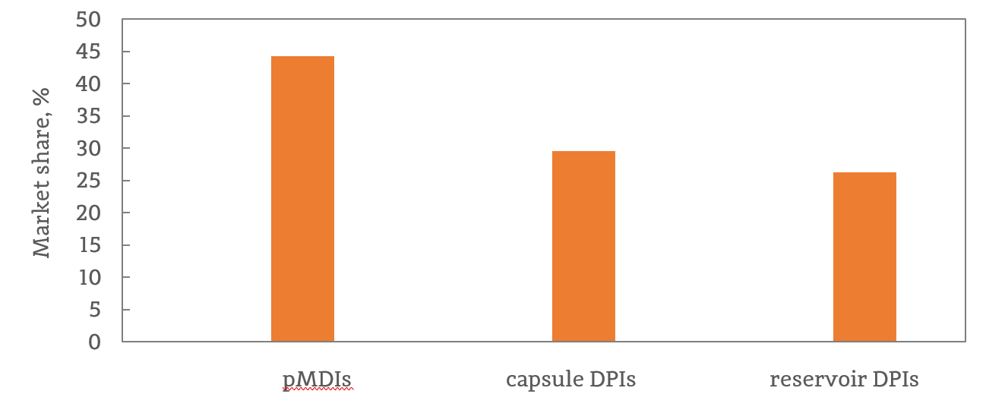
Figure 1. Market share of personal dosing inhalers in Poland (2019-2020). DPIs – dry powder inhalers. Data based on Emeryk et al. (2021).
The GWP value of the hydrofluoroalkane HFA134a, which is currently the most widely used LOP in pMDI is 1300 kg CO₂e. It might be noted though that novel propellants with lower GWP values are under development (Pritchard, 2020), although they must be thoroughly tested for safety for use as an ingredient in medical products.
A detailed discussion on the actual carbon footprint (CF) of pMDIs cannot be carried out without knowing specific figures for LOPs emission from such inhalers. This paper is focused on determining and comparing the propellant content and emission of six pMDIs commonly prescribed in Poland. These data are next used to calculate and compare the CFs of the inhalers.

  - Materials and Methods
LOP emissions from six pMDI products, labeled A-F (Table 1, Fig. 2) was tested over the lifetime of the inhalers using a gravimetric method. Each inhaler was weighed using AS 220/C/2 balance (Radwag, Poland) after releasing a series of 10 successive doses of the drug. The data were then converted to the mass released in a single dose and averaged. The content (and GWP) of the active pharmaceutical ingredients (API) contained in the products was neglected due to their low content compared to the LOP (up to 0.25 mg vs. above 50 mg of the propellent per dose, i.e., below 0.5% w/w). The estimations of CF were done using LCA analysis using openLCA® software (https://www.openlca.org/).

Table 1: Pressurized metered dose inhalers (pMDIs) studied. All contain HFA134a as a propellant.
Product code | API and dose per puff | Number of doses per can (declared)
A | Ciclesonide (160 μg) | 120
B | Fenoterol (50 μg) + ipratropium bromide (21 μg) | 200
C | Fenoterol (100 μg) | 200
D | Fluticasone (250 μg) | 120
E | Salmeterol (25 μg) + fluticasone (250 μg) | 120
F | Salbutamol (100 μg) | 200
API – active pharmaceutical ingredient

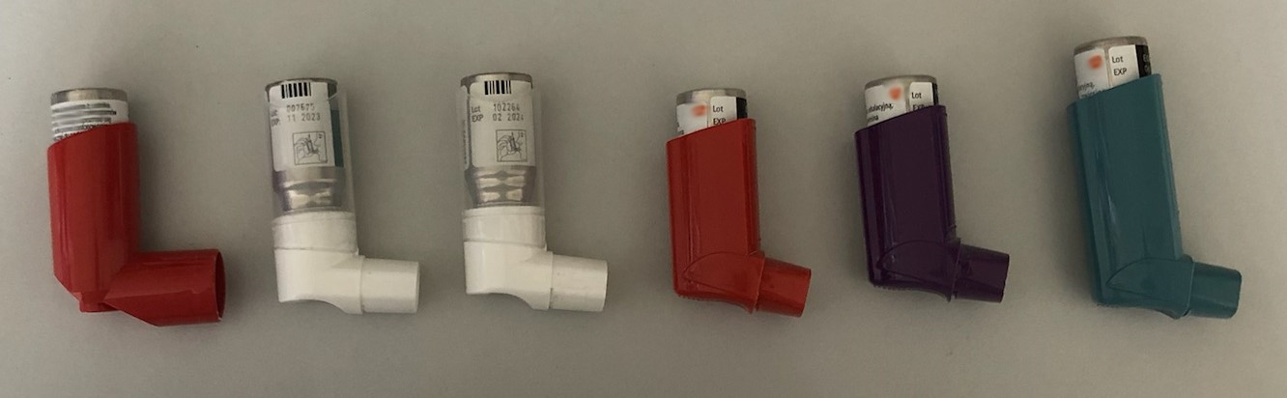

A B C D E F

Figure 2. pMDI inhalers tested

  - Results and Discussion
Table 2 shows the initial and the final weights of the inhalers after releasing the declared number of doses. The average LOP masses released per single dose shown in Figure 3 indicate that there are differences between the inhalers tested. Some pMDIs are much more environmentally friendly (e.g., B and C, with the LOP emission of approximately 50 mg/dose) that others (e.g., D, E and F - about 75 mg/dose). After calculating the carbon footprint for HFA134a as the propellant (GWP = 1300 kg CO₂e), values in the range of 65-97.5 g CO₂e per single drug dose emitted were obtained, i.e., 9.36-19,5 kg CO₂e for all doses declared for a given inhaler. It can be seen (Table 2) that all inhalers allowed the release of more doses than declared by the manufacturer, but a tail-off effect was observed for doses above the nominal dose number (Figure 4). This means that pMDIs still contain LOP (up to about 3 g) after releasing the declared number of doses. On the other hand, there is no direct correlation between the initial can contents, i.e., the number of nominal drug doses in a given product, and the mass of the “residual” propellant remaining after their release (Figure 5). This suggests that if the can after using the drug is not properly recycled, the residual propellant will form a waste with a measurable environmental burden.

Table 2: Pressurized metered dose inhalers (pMDIs) studied
Product code | Initial mass [g] | Mass after releasing the declared  number of doses [g] | Final mass after releasing all  available doses [g]
A | 25.229 | 18.152 | 16.255
B | 34.305 | 24.115 | 21.207
C | 34.033 | 24.037 | 21.251
D | 26.779 | 17.833 | 14.415
E | 31.259 | 22.682 | 20.491
F | 37.728 | 22.681 | 20.714

Figure 3. Emitted LOP mass per drug dose. Error bars denote standard deviation (n=3).

The emissions data can be used to further calculate the CF of pMDIs using LCA methodology, which also allows comparison of pMDI with other types of inhalers (Goulet et al. 2017). This can help to decide whether more environmentally friendly propellants should be developed, or whether pMDIs should be replaced by inhalers with a different operating principle (nebulizers, dry powder inhalers - DPIs, soft mist inhalers – SMI, and others) that allow the same drug doses to be delivered, but with a lower environmental impact expressed by CF.

Tail-off

Figure 4. Example of the relationship of emitted LOP mass per drug dose vs the dose number (product D).

Figure 5. The mass of residual LOP in the pMDIs (A-F) after the release of the nominal number of doses.

Estimates according to openLCA® methodology, which took into account the contents of the can, the aluminium can itself and the plastic actuator, showed that LOP emissions from the tested pMDIs account for 96-98% of the total CF of these medical products. However, also including the residual amount of the propellant remaining in the can, the carbon footprint values for the pMDIs (Figure 6) differ from those predicted based om LOP emissions during inhaler use, shown in Figure 2. The lowest CF was found for inhaler A (12 kg CO₂e; nominal content: 120 doses), and the highest for inhaler F (22.5 kg CO₂e; nominal content 200 doses). A large difference between 120-dose and 200-dose inhaler is evident here, although this is not a rule and the differences can be smaller (B, C, and F contain 200 doses, A, D and E contain 120 doses). This is due to the fact that amounts of remaining propellant in the containers are not equal.
The results show that there is room for improvement for reduction of CF of inhalers, such as by developing new propellants for drugs delivered with pMDIs. Works on pMDIs that use new propellants, for instance HFA-152a with GWP = 120 kg CO₂e, are in progress (Jeswani and Azapagic, 2019; Panigone et al., 2020), however that the process of propellant replacement is complex and expensive. This is dictated by the need to ensure good stability in the formulations of various drugs, but also the safety of inhaling the new propellant.

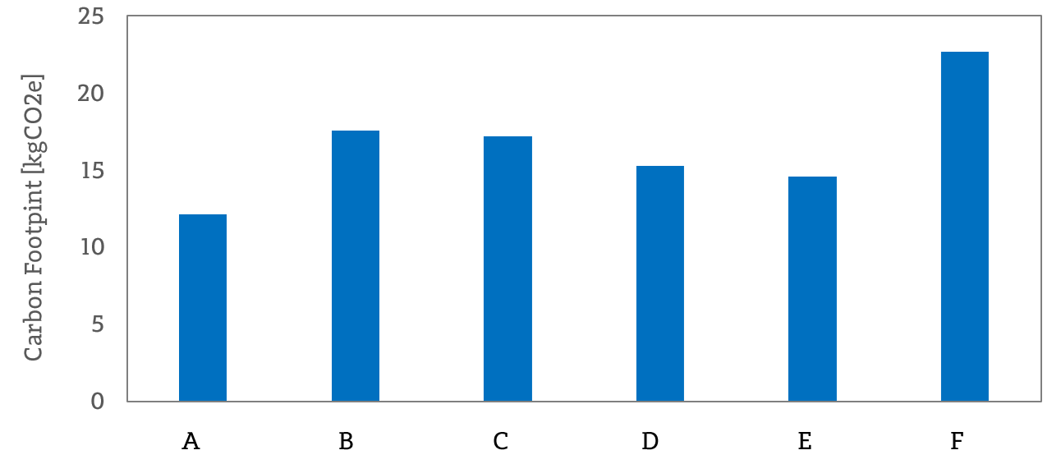

Figure 6. The total Carbon Footprint of studied inhalers (pMDIs: A-F) estimated by LCA approach.

Another option to reduce the carbon footprint of pMDIs is to replace them with other types of inhalers characterized by lower CF. Indeed, DPIs or nebulizers have been shown to have significantly lower CF (Janson et al., 2020; Goulet et al., 2017), but such swap is not always possible and may not be acceptable if it may be associated with worsening treatment outcomes. The economic cost of such a switch may also be significant for patients.
The most obvious strategy that can be proposed to reduce CF of pMDIs is to set up the recycling system for used cans (with a residual propellant) and plastic actuators, which will protect the environment from contamination by residual LOP contained in inhalers after their prescribed use. Such a modern and secure recycling system could benefit from cutting-edge data processing concepts, such as blockchain technology [Sosnowski and Sepczuk, 2023].

  - Conclusions
Quantitative analysis of carbon footprint of six pressurised metered dose inhalers (pMDIs) of pulmonary drugs commonly used in Poland showed that they differ in their high GWP LOP emissions (50 - 75 mg of HFA emitted per dose). There is also a difference in the residual propellant dose in the pressurized container after all claimed doses have been released (1.9 - 2.9 g of HFA). Converting these figures to the carbon footprint of inhalers leads to values of 9.4-19.5 kg CO₂e for all released doses and 12-22.5 kg CO₂e for the entire LOP contained in the product (including its residual content). This contributes to the environmental burden, given the widespread use of such inhalers. Mitigation of this burden should be done by replacing pMDIs with other types of inhalers (nebulizers, dry powder inhalers) whenever possible, but also by recycling used cans which usually contain the residual HFA gases. Developing drug formulations with new propellants with lower GWPs is also possible, but it requires a huge technical effort and thorough research on their safety in the inhalation treatment of respiratory diseases.

Nomenclature
DPI – dry powder inhaler
LCA – life cycle assessment
LOP - liquid organic propellant
HFA – hydrofluoroalkane
GWP – Global Warming Potential, kg CO₂e
CF – Carbon Footpring, kg CO₂e
pMDI – pressurized metered dose inhaler

Acknowledgment
Work was co-funded by NCN project No. 2018/29/B/ST8/00273.

References
Emeryk A., Sosnowski T.R., Kupczyk M., Śliwiński P., Zajdel-Całkowska J., Zielonka T.M., Mastalerz-Migas A., 2021, Impact of inhalers used in the treatment of respiratory diseases on global warming, Advances in Respiratory Medicine, 89, 427-438.
Goulet B., Olson L., Mayer B., 2017, A comparative Life Cycle Assessment between a metered dose inhaler and electric nebulizer, Sustainability, 9, 1725.
Janson C, Henderson R, Löfdahl M, et al., 2020, Carbon footprint impact of the choice of inhalers for asthma and COPD, Thorax, 75, 82–84
Jeswani H.K., Azapagic, A. 2019, Life cycle environmental impacts of inhalers. Journal of Cleaner Production, 237, 117733.
Kigali Amendment to Montreal Protocol, 2016, < https://treaties.un.org/doc/Publication/CN/2016/CN.872.2016-Eng.pdf> accessed 15.03.2023.
Panigone S, Sandri F, Ferri R, et al., 2020, Environmental impact of inhalers for respiratory diseases: decreasing the carbon footprint while preserving patient-tailored treatment, BMJ Open Respiratory Research 7, e000571.
Pritchard J.N., 2020, The climate is changing for metered-dose inhalers and action is needed, Drug Design, Development and Therapy, 14, 3043-3055.Wyleziński D. 2022, Carbon footprint of medical inhalers. BSc Eng. Thesis, Warsaw University of Technology (in Polish).
Sosnowski K., Sepczuk M., 2023, SURE: A smart failover blockchain-based solution for the recycling reuse process. Electronics, 12, 2201.

