|  |  |
| --- | --- |
| cetlogo ***CHEMICAL ENGINEERING TRANSACTIONS***  ***VOL. 96, 2022*** | A publication of  aidiclogo_grande |
| The Italian Association  of Chemical Engineering  Online at www.cetjournal.it |
| Guest Editors: David Bogle, Flavio Manenti, Piero Salatino  Copyright © 2022, AIDIC Servizi S.r.l. **ISBN** 978-88-95608-95-2; **ISSN** 2283-9216 | |

Motivating Students to Design Emission-free Processes

Daniel R. Lewina, Edwin Zondervanb

aChemical Engineering, Technion, I. I. T. Israel

bChemical engineering, University of Twente, Netherlands

Email for correspondence: dlewin@technion.ac.il

Each of us should work to save the planet from the impending ecological disaster to the best of our abilities. As chemical engineering educators, this means recruiting the young people in our care to apply their skills to the same endeavour. This contribution presents two examples of activities currently in progress at the Technion, Israel and at the University of Twente, Holland, to achieve this aim. The first example concerns the setup of a fast moving consumer goods supply chain, balancing profit with environmental impact. The second example concerns the sustainable production of methanol from concentrated carbon dioxide streams and renewable hydrogen. These two examples illustrate how students can be motivated to design emission-free processes and are intended to feed a further discussion how sustainability can be structurally integrated in the chemical engineering curriculum.

Emission-free, sustainability, chemical engineering curriculum, education.

* 1. Introduction

Our society is changing: the world population is not only increasing, but also demanding reliable, safe, and clean access to energy, food, water, and commodities. Humanity is getting wealthier and healthier, and the process industry plays a key role in satisfying society’s needs.

Today’s process industry is still large scale, inflexible, a major consumer of energy, and contributes to the emission of Greenhouse Gases (GHG) and other waste- and degraded streams. Although the process industry is designed for mass production, today’s society clamours for consumer centred, high quality, lasting and environmentally friendly products. Circular economy, energy transition and sustainability are high priority societal challenges, and a paradigm shift is required for tomorrow’s process-industry which will be decarbonized, circular and electrified.

To transform the industry, we should equip the next generation of chemical engineers during their training with the tools for developing sustainable processes and products. David Attenborough reportedly said: “Bringing nature into the classroom can kindle a fascination and passion for the diversity of life on earth and can motivate a sense of responsibility to safeguard it” (Attenborough, 2020). This work presents two examples of how students can be encouraged to design emission-free processes. The intention of this contribution is to activate a discussion on how sustainability can/should be structurally integrated in the chemical engineering curriculum.

* 1. Embedding sustainability in the curriculum

In 1992, it was clear that the challenge of transforming tertiary chemistry and chemical engineering education to assist with leadership development for what is called “sustainability” held important potential (Collins, 2017). Chemical engineering educators have an important role to arm our students with the tools to reverse the trend. This probably requires a change of thinking, from linear, profitability-driven economic considerations to circular economics, tempered by life cycle analysis. Over the years there has been a reasonable effort to integrate risk and safety (Jurgen. 2013) and sustainable enterprise resource planning (Chofreh et *al*., 2016) in the curriculum, making use of new tools such as augmented reality (Perry et *al*., 2010).

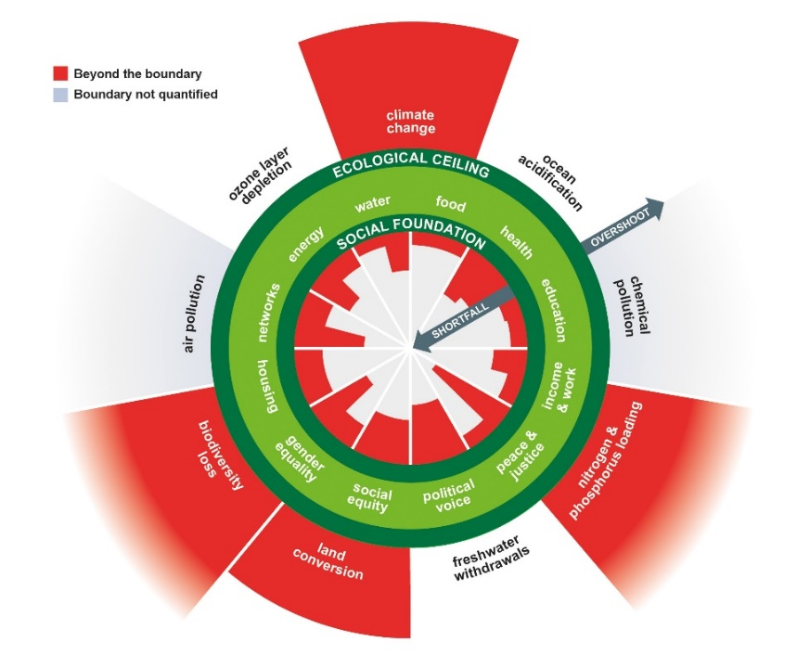It starts with creating awareness amongst students as to what sustainability actually is. One might follow Brundtland’s definition of sustainability, i.e., “meeting the needs of the present without compromising the ability of future generations to meet their own needs” (Brundtland, 1987). But, sustainability balances social development with ecological impacts. This can be visualized in the doughnut model proposed by Raworth (2017 (Figure 1). Everybody is entitled to a social foundation that includes education, housing, and health care, but also access to clean water, food, and energy.

*Figure 1:* Doughnut model ( Raworth, 2017)

During this social- and economic growth we will be reaching a ceiling rather soon (if not already reached), and by passing this ceiling all kinds of ecological impacts occur, from loss of biodiversity, up to climatological changes. Many of these social foundations are provided by the process industry and the process engineer is responsible for designing and operating processes and products in such way that they can be fully sustainable. There are many tools at hand to design for sustainability, such as green chemical engineering principles, Life Cycle Analysis (LCA), and eco- and carbon- foot printing. There have been several efforts to embed sustainability into the chemical engineering curriculum from week 1, as well as providing input on sustainability into the curriculum of the remaining engineering disciplines (Glassey and Haile, 2012). There is discussion whether “sustainability” is a discipline in itself uniting chemistry, physics, biology, hydrology, toxicology, modelling, and law (Boyle, 2004) that might motivate new course or even curriculum development. Alternatively, sustainability concepts could be integrated within the existing curriculum; for example, within conceptual process design- or process optimization courses. Below, some examples are provided.

* 1. Example activity from the University of Twente, the Netherlands

At the faculty of Science & Engineering of Twente University, undergraduate students enrolled in the “Process Engineering” track are required to execute an optimization project. In last year’s project, students had to set up the supply chain network model for a fast-moving consumer goods industry. The product that was produced, stored, moved, and distributed through this network were different ice-cream products. The client required an optimized design for economics, but at the same time wanted to project a “green” image, and thus, the task was to balance profitability with environmental impact. Students therefore had to setup an optimization model for bi-criterion optimization using the epsilon constraint method. It turns out that environmental impact can be reduced without affecting the costs too much.

**Case study** (Van Elzakker et *al.*, 2012). Fast Moving Consumer Goods (FMCG) are products that are produced in large quantities, with a lot of variations and a low margin. Typical examples of FMCG are shampoos, soups, or ice-creams. In this example the focus is on ice-cream production. Ice-cream can be produced in many assorted flavors, forms, and packaging. In other words, a FMCG company that produces ice-creams often has a large portfolio of different Stock Keeping Units (SKUs). All those units are produced and moved through logistic networks.



*Figure 2:* Topology of the FMGG supply chain

The topology of a small European supply chain with 10 suppliers, 4 factories, 4 warehouses, 10 distribution centers and 20 retailers is presented in Figure 2. Through this supply chain, 10 different SKUs are moved. The decision maker requires both the minimization of costs as well as the environmental impact of the supply chain. For that reason, life cycle assessment indicators are provided from the Eco-99 database. Only two main ingredients of ice-cream are considered, i.e., milk-based ingredients (milk and cream) and sugar. There are two alternatives for both ingredients as shown in Table 1.

Table 1: Eco-99 indicator metrics for raw materials

|  |  |  |  |  |
| --- | --- | --- | --- | --- |
|  | Non-organic milk | Organic milk | Beet sugar | Cane sugar |
| Environmental impact  [ECO-99 units/ton ingredient] | 24.0 | 17.9 | 8.0 | 9.2 |

There are also environmental data for the energy mix used for the production/cooling processes. Energy consumption in the production process is approximately 0.65 MJ/kg ice-cream and the environmental impact depends on the energy mix (by country). Table 2 shows the Eco-99 indicator values for different countries.

Table 2: Eco-99 indicator metrics for energy

|  |  |  |
| --- | --- | --- |
| Country | Environmental impact per kWh  [ECO-99 units/kWh] | Environmental impact per ton ice-cream  [ECO-99 units/ton product] |
| Austria | 0.018 | 3.25 |
| Belgium | 0.024 | 4.33 |
| Greece | 0.062 | 11.19 |
| Portugal | 0.018 | 3.25 |

Also, the environmental impact of the transport is included on a 40 ton truck with a 50% capacity load is 0.015 Eco 99 units/ton/km.

The e-constraint method is then used to create 26 points on a pareto-front. First a single objective is run, minimizing the cost. Then a second run is executed, fixing the cost at their optimum value (found in the first run) and minimizing the environmental impact. Then the environmental impact is minimized in a single optimization. This minimum value is now fixed, and the costs are once more minimized. From these four optimization runs the overall range of environmental and economic impact is found. Now for a set of 22 additional optimization runs where one objective (say economics) is fixed at different values between their minimum and maximum value, the graph as given in Figure 3 is generated.

*Figure 3:* Pareto trade-off contour between economics and environmental impact

The pareto contour shows that environmental impact can be reduced significantly without incurring additional costs, and vice versa.

* 1. Example activity from the Technion, Israel

The capstone process design course, and its integral design project, presents an opportunity for students to apply knowledge and skills acquired during their entire curriculum to the design of complete processes. Each year at the Technion’s Faculty of Chemical Engineering, the final year students are challenged with a design project for the production of a commodity chemical. Since 25% of the grade awarded for each submitted design depends on the Venture Profit (VP) achieved by each group, the student-engineers are motivated to apply best practices to achieve the most profitable design (Lewin and Barzilai, 2021).This year’s process design project, addressed by 12 groups of undergraduates at the Technion, was a process for the manufacture of methanol from concentrated waste CO2 and sustainably produced H2 (Dotan et *al.*, 2019). This was the first year that our project was motivated solely by “green chemistry.” The project tender includes economic penalties for gaseous and waste-water emissions, and typically leads to economic processes that eliminate emissions.

**Case study.** An environmentally-friendly process for the manufacture of methanol uses sustainable hydrogen from solar-powered electrolysis, and CO2 extracted from flue gas waste. The process proposed by an imaginary engineering company, EPL, is shown in Figure 4. The objective is to produce 100,000 metric tons/year of 99.5 mol % methanol. The design proposed by EPL achieves these objectives, but at a huge loss; their design has a large negative VP (-$11.2 M/year). In the EPL design, feed streams of pure hydrogen and CO2 containing 0.5% water at 2 bar are compressed to 80 bars using a multiple stage compressor, mixed with unreacted recycle gas, and then sent to a fired heater (H-100) to bring it to a temperature of 250oC, and is then fed to the reactor R-100, modelled as an equilibrium reactor. In the reactor, two equilibrium reactions take place:

|  |  |
| --- | --- |
|  | (1) |
|  | (2) |

In the EPL design, the primary reactor, R-100, equipped with 860 tubes packed with catalyst, is cooled by BFW (Boiler Feed Water). The hot, partially converted reactor effluent leaves R-100, undergoes cooling in two heat exchangers, E-102 (which is cooled using BFW at 11 bar) and E-103, from which the reactor effluents emerge at 30oC. This partially condensed stream is then separated by a flash vessel, V-100, whose gaseous effluent is purged and recycled using the last stage of the compressor, K-103. The liquid product from V-100 is reduced to 2 bar and then fed to a second flash vessel, V-101, which removes most of the light gases still left in the reactor product, before being separated into methanol, wastewater, and a small gas vent (light gases) in T-100.

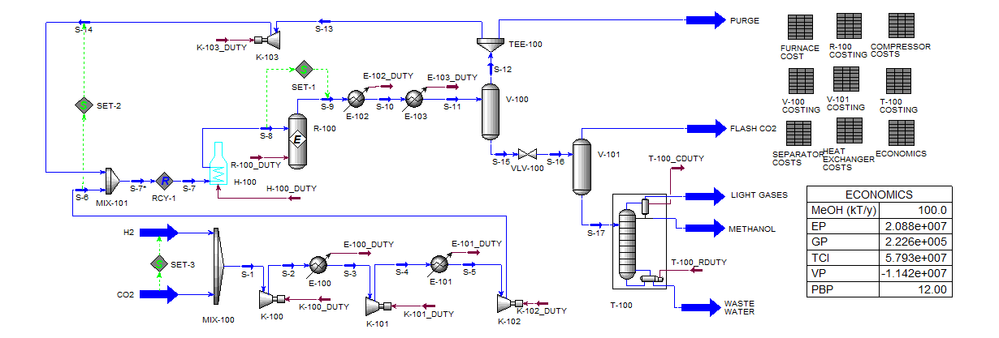

*Figure 4:* EPL design for the methanol process

**Features of successful student solutions.** The following modifications, suggested by student groups, has the most effect on the VP for this process:

* *Selecting appropriate synthesis loop pressure*. Increasing the operating pressure increases the methanol production rate in the reactor, which is limited by equilibrium conditions. However, as higher pressures will mean more expensive equipment costs, and particularly, the compressor costs and its operating expenses, one would expect there to be an optimum, intermediate operating pressure. Figure 5 shows the corrected VP for all submitted solutions as a function of the reactor feed pressure implemented, suggesting that there is indeed evidence of an optimum operating intermediate operating pressure.

*Figure 5: Correlation between selected reactor feed pressure and corrected VP for submitted solutions*

* *Elimination of purge stream, and recycling of all light gas vents*. In principle, the CO2 and H2 feed streams can be completely converted to methanol and water product streams, meaning that there is no need for either a gas purge stream from the synthesis loop, nor for light gas vents from the process, all of which can be recycled. Economically, the elimination of the purge stream is of greatest impact, with the elimination of vents principally reducing the environmental footprint (as well as reducing waste processing costs). The elimination of the purge stream requires the reduction of the H2/CO2 molar ratio from 3:1,since the recycled hydrogen that is not purged reduces the hydrogen demand of the process, and all submitted designs did this. All submitted designs eliminate at least the purge stream; design decisions regarding the rest of the waste streams have little effect on the VP.
* *Elimination of preheating furnace and smart energy management*. The preheating furnace can be eliminated by performing direct heat exchange between the reactor effluent and feed streams since the reaction is exothermic, and the reactor effluent is hotter than its feed. The reactor effluent and the diabatic reactor itself are hot streams that inherently provide heat sources that can be used elsewhere in the process, most significantly for preheating the reactor feed and for powering the column reboiler (or reboilers if the design consists of multiple columns). MER targeting and the Grand Composite Curve (GCC) enable the targeting of the minimum hot utility requirements of the process. Efficient energy recovery is one of the keys to profitable operation, and significantly impacts the environmental footprint.
* *Cost-effective compressor design*. The compressors are the most expensive equipment items. The installation cost of the compressors can be attenuated by appropriate selection of loop operating pressure. Economic design of the compressors is the most important key to profitable operation of this process.

The following design decision has little or conflicting effect on the profitability of the process:

* *CO2 conversion in the reactor*. As the reaction is limited by equilibrium, one would expect that an excess of hydrogen in the reactor feed will favour the conversion to methanol. However, CO2 conversion had little impact on the achieved VP most probably because of the reliance on high operating pressures to achieve it. Indeed, very high conversion, obtained by operating at high pressure leads to reduced VPs because of the incurred high equipment costs.

The lessons learned in this year’s project are that reduction of environmental footprint often runs hand in hand with increased profitability, with a sweet point possibly lying under the level of emissions mandated.

* 1. Conclusion

The two example projects discussed in this paper illustrate the potential of motivating chemical engineering undergraduates to engage in design activity that is aimed at attenuating the environmental footprint associated with process design and operations. The common themes are the trade-off between profitability and environmental impact, and the enthusiasm generated in students that are engaged in what they conceive to be “saving the world.” Contrary to the preconceptions of the students, reducing environmental impact and profitability do not necessary conflict – good engineering practice can provide designs that are both profitable and environmentally-friendly. In this regard, it is our recommendation that a significant percentage of project grades should depend on profitability and sustainability measures, which together will drive students to design economical and environmentally-friendly processes. More projects of this nature can be used regularly as part of the portfolio of challenges posed to students. We invite chemical engineering educators to participate in an open discussion about pooling resources and sharing experiences that we shall initiate during our presentation.

References

Attenborough, D. (2020). A life on our planet, *Ebury Press*.

Boyle, C. (2004). “Considerations on educating engineers in sustainability,” *International Journal of Sustainability in Higher Education*, 5 (2), 147-155.

Brundtland, G. (1987). Report of the World Commission on Environment and Development: Our Common Future. United Nations General Assembly Document A/42/427

Collins, T.J. (2017). “Review of the twenty-three-year evolution of the first university course in green chemistry: teaching future leaders how to create sustainable societies,” *Journal of Cleaner Production*, 140, 93-110.

Chofreh, A., Goni, F., Klemes, J.,(2016), “A masterplan for the implementation of sustainable enterprise resource planning systems: development of a roadmap”, *Chem. Engineering Transactions* (52), 1099-1104.

Dotan, H., Landman, A., Sheehan, S.W., Malviya, K.D., Shter, G., Grave, D.A., Arzi, Z., Yehudai, N., Halabi, M., Gal, N., Hadari, N., Cohen, C., Rothschild, A., and Grader, G.S. (2019). “Decoupled hydrogen and oxygen evolution by a two-step electrochemical–chemical cycle for efficient overall water splitting,” *Nature Energy*, 4, 786-795.

Glassey, J., Haile, S. (2012). “Sustainability in chemical engineering curriculum,” *International Journal of Sustainability in Higher Education*, 13 (4), 354-364

Jurgen, S., (2013), ´Process and plant safety research and education strategy to keep long term competences”, Chemical Engineering Transactions (31), pp. 421-426

Lewin, D.R. and Barzilai, A. “Teaching process design to chemical engineering undergraduates – an evolution.” (2021). *Chem. Eng. Educ*., 55(3), 157-172.

Perry, S., Bulatov, I., (2010), “The influence of new tools in virtual learning environments on the teaching and learning of process design in chemical engineering”, Chemical Engineerin Transactions (21), pp. 1051-1056.

Raworth, K., (2017). A doughnut for the Anthropocene: humanity’s compass in the 21st century, *Lancet Planet Health*, 1(2), E48-E49.

Van Elzakker, M.A.H., Zondervan, E., Raikar, N.B., Grossmann, I.E., Bongers, P.M.M. (2012). “Scheduling in the FMCG industry: An industrial case study, *Industrial and Engineering Chemistry Research*, 51 (22), 7800-7815.