|  |  |
| --- | --- |
| cetlogo ***CHEMICAL ENGINEERING TRANSACTIONS***  ***VOL. 96, 2022*** | A publication of  aidiclogo_grande |
| The Italian Association  of Chemical Engineering  Online at www.cetjournal.it |
| Guest Editors: David Bogle, Flavio Manenti, Piero Salatino  Copyright © 2022, AIDIC Servizi S.r.l. **ISBN** 978-88-95608-95-2; **ISSN** 2283-9216 | |

North Italian CCS Scenario for the Cement Industry

Alla Shogenovaa\*, Kazbulat Shogenova, Martina Marianib, Daniela Gastaldic and Guido Pellegrinod

aTallinn University of Technology, Ehitajate tee 5, 19086 Tallinn, Estonia

bSapienza University of Rome, Piazzalle Aldo Moro 5, 00185 Roma, Italy

cBuzzi Unicem S.p.A.,Via Monte Santo 10, 13039 Trino (VC), Italy

dItalcementi (ITC-HCG), Via Stezzano 87, 24126 Bergamo, Italy

\*alla.shogenova@taltech.ee

CO2 transport, storage and monitoring (TSM) cost for the Carbon Capture and Storage (CCS) scenario was estimated for Buzzi Unicem Vernasca Cement Plant (BUV СP) and HeidelbergCement Group Italcementi Calusco D'adda (HCICD) CP, located at 125 and 34 km via pipelines distance respectively from the Malossa storage site. Total emissions produced in 2020 by two CPs were 1.2 Mt CO2. About 1.1 Mt CO2 captured annually and 23 Mt during 20 years of the project duration could be transported and stored in the prospective for CO2 storage 83 m thick Upper Miocene Messinian Sergnano Gravel conglomerate Formation located at 1240 m depth in the Malossa structure. 3D geological static models of the storage reservoir in the Malossa structure (34 km2 area) were constructed using 18 wells and PETREL software.

Estimated TSM costs were the most economic for HCICD CP (4 €/t CO2 avoided), explained by the close location to the Malossa storage site and sharing of monitoring costs with BUV CP. TSM cost for BUV CP is higher (15.1 €/t CO2) explained by the longer pipeline distance (125 km) and the needed CO2 recompression. Total costs for the CCS scenario will depend on the final costs of Ca-looping CO2 capture at the BUV CP achieved by the CLEANKER project. The estimated maximum total CCS cost for BUV CP could be 73 €/t CO2 avoided, the maximum CCS cost for HCICD CP is 62 €/t CO2. These costs are already feasible considering 80-90 €/t CO2 price in EU ETS reached in 2021.

* 1. Introduction

The main objective of the CLEANKER project was to demonstrate new CO2 capture technology for the cement industry by developing an integrated Calcium Looping process and constructing a demonstration plant at the Buzzi Unicem Cement Plant (BUV СP) in Vernasca (Lombardy Region). The objective of this research was to make a techno-economic assessment of the CO2 transport and storage scenario in the vicinity of the demo plant at Vernasca Cement Plant (CP) and estimate the feasibility of the full value chain Carbon Capture and Storage (CCS) scenario.

Italy has good options for CO2 geological storage (CGS) in saline aquifers both onshore and offshore presented by siliciclastic rocks in 14 areas (Donda et al., 2011) and carbonate rocks in 8 areas (Civilie et al., 2013). Most of the Italian deep siliciclastic saline aquifers are suitable for CGS in various grain-size sands of the Pliocene age of different thicknesses intercalated with silty to clayey zones. The caprock sealing formations of at least 100 m thick usually consist of late Pliocene–Pleistocene clays (Donda et al., 2011). Regional estimations of geological parameters of carbonate reservoirs estimated for 8 areas and depleted oil and gas fields in Malossa-San-Bartolomeo (Civilie et al., 2013) and estimation of regional storage capacity in two Lombardy regions gave prospects for more detailed studies, which were later made for the Northern Italy (Colucci, 2016).

Recently ENI has run various studies and preliminary evaluations for CO2 injection and monitoring in the Cortemaggiore field (Piacenza) located only 30 km from the Vernasca CP. ENI has also analysed the legal and societal aspects linked to the storage site. The injection of 8000 tonnes of CO2 per year was planned over a three-year period, followed by two years of post-injection monitoring (Rütters et al., 2013). However, these plans were not realised, and the results of the feasibility study made by ENI are yet confidential. Considering these issues, for the CCS scenario modelling, we have selected a more distant CGS site available in the Lombardy Region.

Previous studies made in Italy for CGS have determined the potentially suitable reservoir rocks represented by upper Messinian Sergnano Gravel conglomerate formation sealed by primary cap rocks represented by a Pliocene Santerno clay formation. Primary cap rocks are covered by the Asti Sand formation and Quaternary alluvial deposits (Mancini et al., 2010). The Sergnano Gravel formation is the reservoir of almost all gas fields in the Po River plain, some of which are used now as gas storage fields (Marzorati and Maroli, 2012). CGS is not permitted in Italy in high-risk seismic areas and should be negotiated in case of available active mining or hydrocarbon leases and for natural environmental protected sites.

In this research, the CCS scenario was modelled for two cement plants, including BUV CP and HeidelbergCement Group Italcementi Calusco D'adda (HCICD) CP, which were planned to connect by pipelines with Malossa structure, selected for CGS. CO2 storage capacity of the structure, project duration, and technical and economic parameters was estimated for the TSM scenario. The feasibility of the full chain CCS scenario was estimated using the reference Ca-looping CO2 capture cost (De Lena et al, 2019) and costs planned to be achieved by the CLEANKER project.

* 1. Data and methods

All data for the CCS scenario were added to the CLEANKER ArcGIS database. CO2 emissions produced in 2020 and reported in EU ETS were applied (EU ETS, 2021). For the Malossa structure, selected for CGS, data for 18 old wells were available in a public database (ViDEPI, 2020). Wells were drilled to use the porous formations for the water disposal produced by the Malossa’s hydrocarbon field. In all the wells geophysical electric resistivity and spontaneous potential logs (SP) were made. Only in Malossa B well the sonic log was available, and porosity estimations using the Raymer time-average relation were reported earlier (Colucci et al., 2016). 2D and 3D static geological models were constructed and populated with porosity using PETREL Schlumberger software. The calculation of the thickness, area and average porosity of the structure was made in PETREL (Mariani, 2020). CO2 storage capacity was estimated using an approach described in Bachu et al., 2008 and proposed by the EUGeoCapacity project (Vangkilde-Pedersen et al., 2009). This method provides the estimation of the “effective storage capacity” based on the bulk volume, using the following equation:

$M{CO}_{2}=A*h*NG*φ*ρ{CO}_{2}*S_{Eff}$, (1)

where MCO2 is the effective storage capacity; h is the effective thickness; NG is the net to gross ratio. NG was estimated from ViDEPI database well logs as 50%, because of the high presence of clays in the reservoir; φ is the average porosity of the reservoir Formation; ρCO2 is CO2 density calculated at the reservoir pressure and temperature conditions. For the conservative estimates, SEff has been chosen 4%. For the optimistic approach, SEff was taken 10%, according to “the cartoon approach” described in (Vangkilde-Pedersen et al., 2009).

Building block datasets (EPRI, 2015) were used to estimate costs and performance for pipeline transportation and CGS. The costs of all CO2 storage and transport elements are calculated in total and for every CO2 producer, proportionally to their CO2 flow. The average cost per tonne of CO2 injected or avoided for the project duration (20 years) is calculated using formulas reported by EPRI, 2015 and updated for the CLEANKER project (Shogenova and Shogenov, 2020):

CAPEX/= , (€/t CO2), (2); /= , (€/t CO2) (3)

/= , (€/t CO2), (4); /= , (€/t CO2) (5)

COSTtotal/ $t_{{CO}_{2}}$ =CAPEX/tCO2 + OPEX/tCO2 + MVEX/tCO2 + ENERGEX/tCO2; (6)

Total Plant Cost (TPC) = BEC + Decom + interest; (7)

CCR (Capital Charge Rate) is taken as 8% and interest paid during construction is 1.5%. The annual fixed O&M (Operational and Maintenance cost) is assumed as 1% for pipelines, 2% for wells and 4% for the booster pumps and storage facilities. Annual onsite operating costs, including design, engineering, environmental assessment, project/site supervision, management, logistics fees and equipment/project contingencies, are taken 40% from BEC (Bare Erected Cost), and Decom (Decommissioning Cost) is 25% from BEC. It is considered that Decom occurs in the two years following the end of the project and may include costs for site remediation and equipment dismantling (EPRI, 2015).

* 1. CO2 Emission Sources

Vernasca Cement Plant (BUV CP) is owned by Buzzi Unicem, an international cement company working in 14 countries. In Italy, Buzzi Unicem is the second-largest industrial player in the country. BUV CP (Table 1) is located in a small village Mocomero in the province of Piacenza near Vernasca town, 110 km far from Milano.

Heidelberg Cement Group Italcementi Calusco D’Adda Cement Plant (HCICD CP) has been owned by the Italcementi Group since the 1920s. In 2016, Italcementi joined the German construction group HCG, becoming the world's second-largest cement producer. The plant is located in the town of Calusco d’Adda in Northern Italy, at the base of the Bergamasque Prealps, close to the Adda River, with nearby quarries of marly rock and limestone providing a supply of raw. HCICD CP is one of the largest cement plants in Europe (Table 1).

Table 1: Clinker and cement produced in 2018 and CO2 produced in 2018–2020 by cement plants

|  |  |  |  |  |  |  |  |
| --- | --- | --- | --- | --- | --- | --- | --- |
| Cement Plant | Company | Location | Clinker (kt) | Cement  (kt) | CO2 emiss | CO2 emissions (kt/yr)  2018 2019 2020 |  |
| Vernasca | Buzzi  Unicem | Emilia  Romagna | 575.5 | 786.1 |  | 445.4 504.9 521.8 |  |
| Italcementi  Calusco D’adda | Heidelberg Cement | Bergamo | 1097 | 955 |  | 903.6 818.9 688.2 |  |

**4. Malossa Storage Site**

The Malossa structure (MS) is located in the central part of the Po Valley in the Lombardy Region of Northern Italy. The Po Valley subsurface framework resulted from a Mesozoic extensional tectonic phase, followed mainly by the Tertiary collisional tectonic phase (Bello and Fantoni, 2002). The MS is located between seismic areas in Northern Italy. For CGS, the potential reservoir is represented by the Messinian Sergnano Gravel conglomerate Formation (SGF), and primary cap rocks by Santerno Clay deposited during the Pliocene. The SGF are made mostly of polygenic conglomerates with some interbeds of sand, clay and sandstone. The SGF has high permeability and porosity, and the salinity of water in the reservoir of about 20 g/l (kg/m3). The high permeability of SGF is confirmed by numerous injectivity tests. During the exploitation of the Malossa gas-condensate field, the Malossa A and Malossa B wells were used for the re-injection of production water from 1984 to 1991 with a flow rate of about 2000 m3/day (Colucci et al., 2016). In the Malossa structure, the SGF lays at a depth of 970–1483 m, the average depth from 18 wells is 1240 m, and the reservoir temperature is 40°C. SGF has a different thickness from a few meters in Malossa 11, 13, and 14 to 212 m in Malossa 2 and declined in Malossa 5 and 13 wells. The average thickness of 18 wells is 83 m. The porosity in the MS is 12.5-38% with an average of 26% and average permeability of 400 md (4\*10-13m2). 3D geological models of storage formation constructed in PETREL and populated with porosity data were used for CO2 storage capacity estimation (Figure 1). It is evident that the model is confined as a stratigraphic trap at the East and North borders. The Pliocene Santerno Clay Formation (SCF) is composed of clays with quartzitic sand interlayers with predominantly planktonic fossils, indicating an external platform depositional environment. In the Malossa site, the thickness of SCF is about 250–710 m, but it is only 62 m thick in Malossa A well. The average thickness of 18 wells in the Malossa structure is 403 m. The average porosity is 6% and permeability is 0.1 md (1\*10-16 m2). Secondary cap rocks are represented by Pleistocene Asti sands and Quaternary alluvial deposits with a total thickness of 685–1050 m, and an average of 837 m. The total CO2 storage capacity of the MS based on the conservative approach and average porosity, is 9.91 Mt, while the total CO2 storage capacity based on the optimistic approach is 24.8 Mt (Table 2). This average optimistic storage capacity will be enough for the storage of CO2 emissions produced by two studied cement plants for 20 years.

Table 2: Estimated CO2 storage capacity of the Sergano Gravel Reservoir Formation in the Malossa Structure

|  |  |  |  |  |
| --- | --- | --- | --- | --- |
| CO2 storage capacity, Mt | | | | |
| Optimistic |  | Conservative |  |  |
| Min  Max  Average | 11.9  37.6  24.8 | Min  Max  Average | 4.8  15.0  9.9 |  |



*Figure 1: 3-D model of the reservoir top and bottom of the Sergano gravel reservoir in the Malossa structure (Mariani, 2020)*

5. Techno-Economic Modelling of CCS Scenario

BUV and HCICD CPs produced about 1.2 Mt CO2 in 2020. It is possible to capture about 1.1 Mt CO2 annually and 23 Mt during 20 years of the project duration, considering the limited CO2 storage capacity of the Sergano Gravel Reservoir Formation with the estimated average optimistic capacity of 24.8 Mt CO2. Considering 5% of additional emissions produced during CCS operations, only 21.8 Mt of CO2 could be avoided during 20 years of the project (Tables 1, 3).

The planned CO2 pipeline routes will be constructed along available natural gas pipelines (if available), or roads (Figure 2). The pipelines will be designed using X70 steel and 1500 lb flange rating (rated to 25.5 MPa upper working pressure) with a maximum allowable working pressure of 15 MPa. The pipeline diameter was determined depending on the distance and flow rate of CO2 calculated for the specific scenario (EPRI, 2015). The annual flow rate for the pipelines from Vernasca and Calusco D'adda CPs is less than 1 Mt per year and the distance to the storage site is 125 and 34 km, respectively. Therefore, 220- and 180-mm diameter will be sufficient.

CO2 compression is included in the CPU unit for Ca-looping capture at the Vernasca plant with a pressure of 11 MPa, which is higher than the minimum pressure required for CO2 pipeline transport and injection (8 MPa). However, due to the estimated possible pressure drop of about 6 MPa, resulting in 5 MPa, during CO2 transportation from Vernasca (125 km), recompression will be needed for this CO2, which will be injected into the first planned injection well. For the CO2 transported for 34 km from HCG ICD to the second well the recompression is not applied, considering that after the calculated pressure drop (for about 2.7 MPa, resulting in 8.3 MPa) the final pressure will be enough for CO2 injection. CO2 injection costs include well drilling, storage site facilities, pumping and monitoring. In total two injection and two monitoring wells are planned for CO2 storage and monitoring. Coring and logging are included for all four wells.

CO2 TSM cost for this scenario is the most economic for HCICD CP, estimated as 4 €/t CO2 avoided, explained by close location to Malossa storage site and sharing of monitoring costs with BUV CP. About 34 km of pipelines along available natural gas pipelines will be constructed from HCICD. CO2 TSM cost for BUV CP is higher (15.1 €/t CO2) explained by the longer pipeline distance (125 km) and the needed CO2 recompression (Figure 2).

The total costs for the CCS scenario will depend on the final costs of Ca-looping CO2 capture at the BUV demo CP at the end of the CLEANKER project. At the present time, the reference Ca-looping capture cost is 58 €/t CO2 avoided (De Lena et al., 2019), but could be cheaper for the CLEANKER demonstration plant at BUV CP.

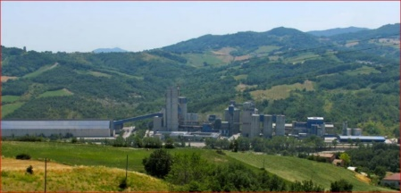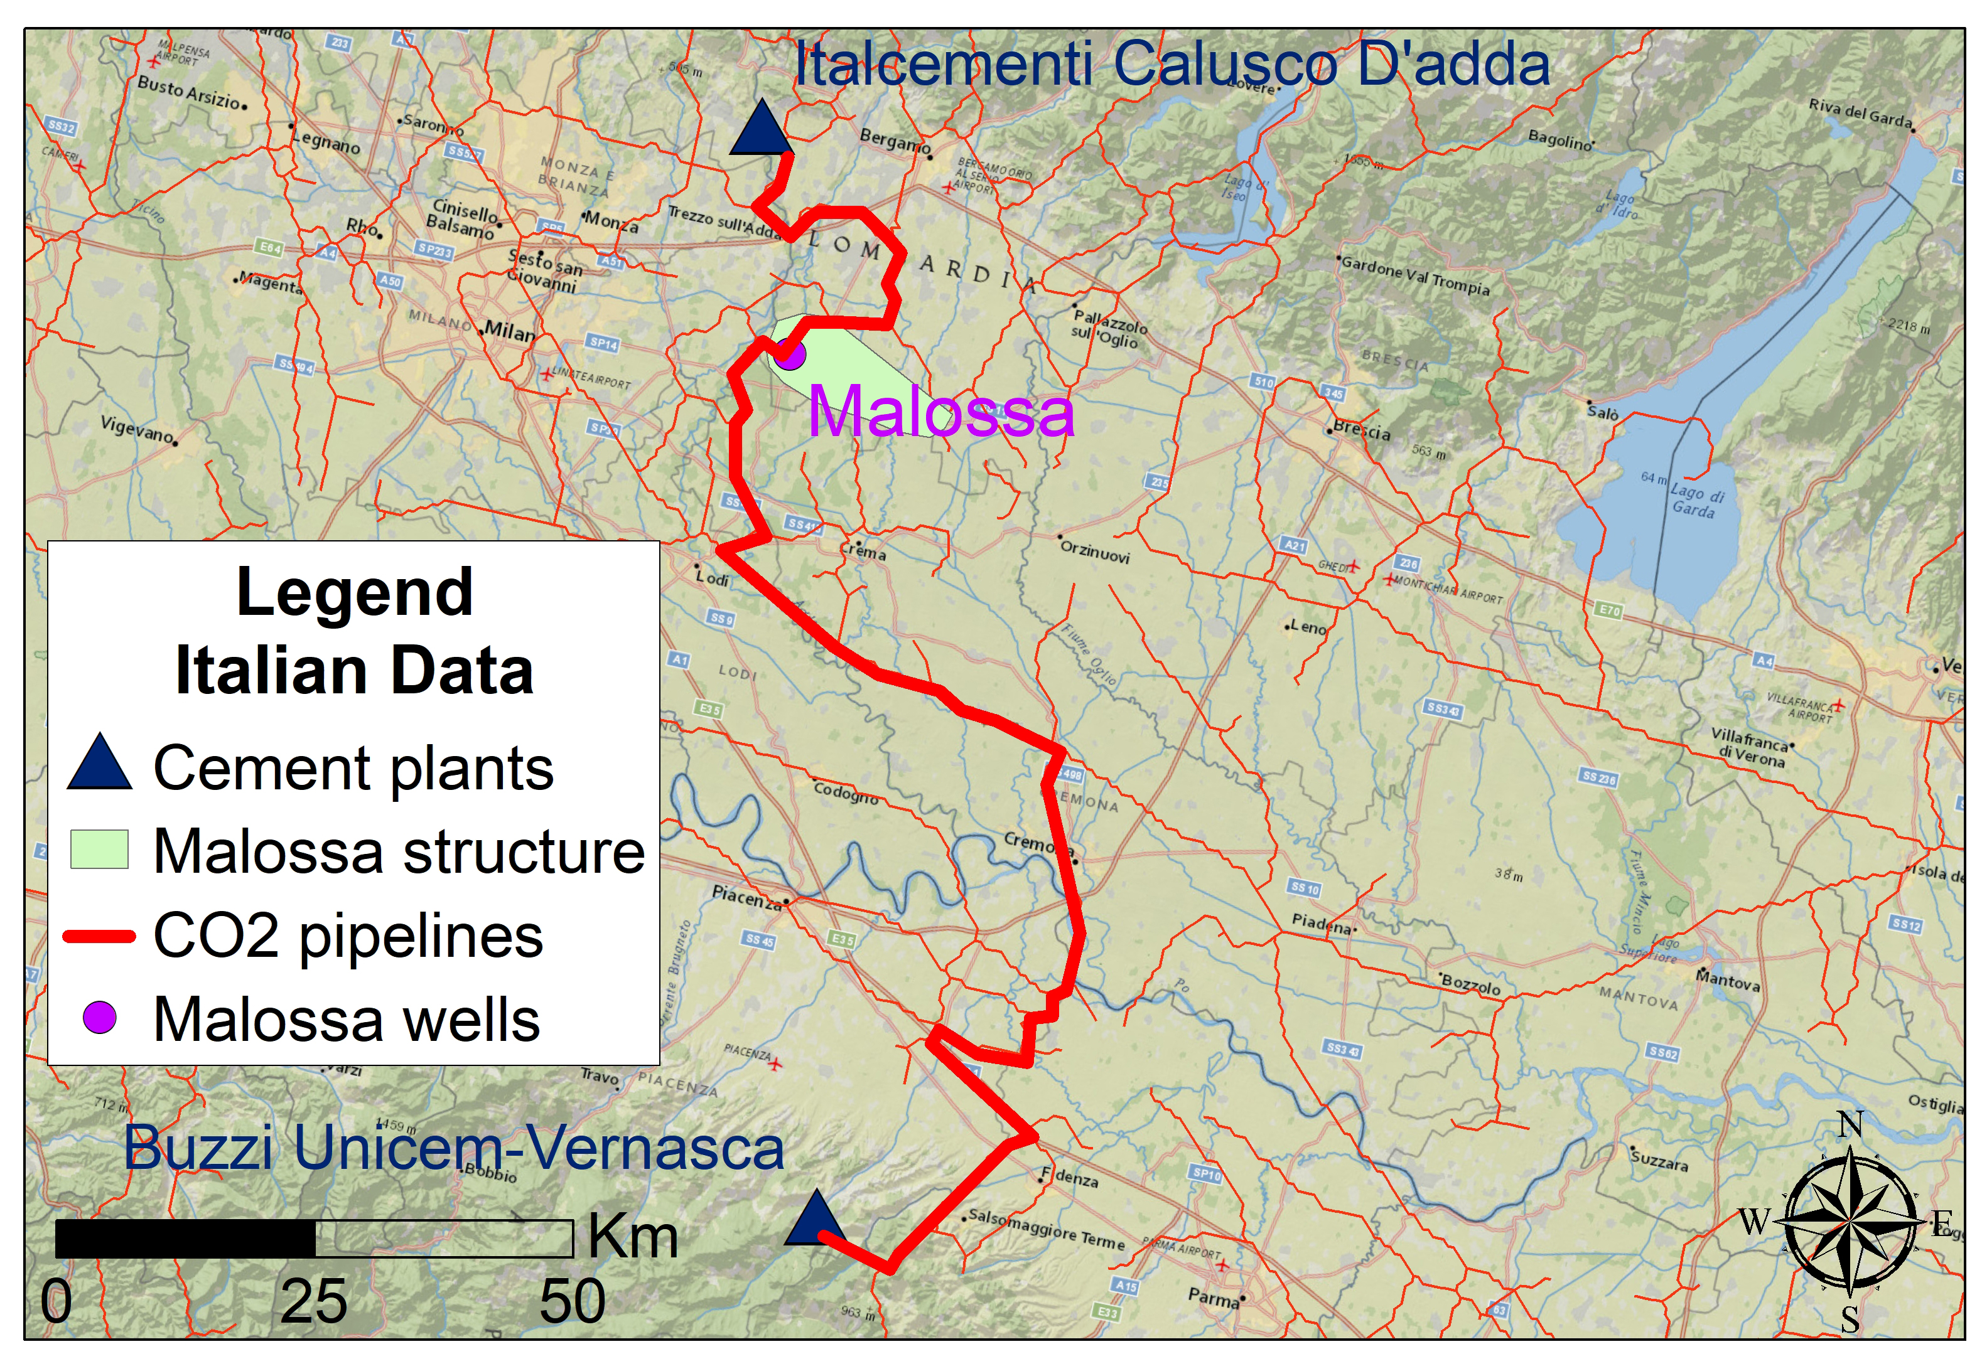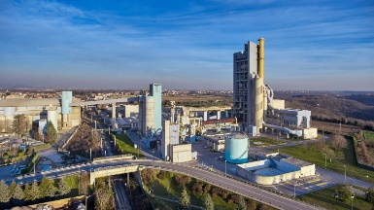

*Buzzi Unicem Vernasca Cement Plant*

*HCG Italcementi Calusco D’Adda Cement Plant*

125 km

**15 €/t CO2**

34 km

**4 €/t CO2**

**522 Kt/yr CO2**

**688 Kt/yr CO2**

*Figure 2: CO2 transport and storage scenario from Buzzi Unicem Vernasca and HCG Italcementi Calusco D'adda cement plants to Malossa storage site in Sergnano Gravel reservoir Formation*

*Table 3: Total costs for CO2 transport and storage for 20 years project in the Lombardy Region*

|  |  |  |  |
| --- | --- | --- | --- |
| Cement Plants | Vernasca | Calusco D’Adda | Total for 2 plants |
| CO2 injected per year, Mt | 0.50 | 0.65 | 1.15 |
| Total pipeline CAPEX, M€ | 34.96 | 6.87 | 41.83 |
| Total CAPEX for 4 wells, M€ | 5.71 | 5.71 | 11.41 |
| Booster CAPEX, M€ | 3.53 | - | 3.53 |
| Storage facilities CAPEX, M€ | 0.05 | 0.05 | 0.09 |
| BEC (for pipeline, wells  and storage facilities), M€ | 44.24 | 12.62 | 56.86 |
| Decommissioning cost (DC)  25% from TPC, M€ | 11.06 | 3.15 | 14.21 |
| Interest (1.5%) for 2 years of constriction | 1.33 | 0.38 | 1.71 |
| FOM (annual fixed O&M cost) M€ | 0.61 | 0.18 | 0.79 |
| TPC (Total Plant Cost), M€ | 57.23 | 16.34 | 73.56 |
| CAPEX, €/t CO2 injected | 10.46 | 2.28 | 5.81 |
| OPEX total (40% from BEC), M€ | 17.70 | 5.05 | 22.74 |
| OPEX, €/t CO2 injected | 2.86 | 0.62 | 1.58 |
| MVEX (annual monitoring and  verification cost), M€ | 0.50 | 0.56 | 1.06 |
| MVEX, €/t CO2 injected | 1.01 | 0.85 | 0.92 |
| COSTtotal, €/t CO2 injected | 14.32 | 3.75 | 8.31 |
| COSTtotal, €/t CO2 avoided | 15.1 | 3.95 | 8.74 |

The maximum total CCS cost for Vernasca CP could be 73 €/t CO2 avoided and will be feasible for CO2 price in EU ETS of about 75 €. However, if the Ca-looping capture cost is 40 €/t CO2 avoided could be reached, then the CCS scenario will be feasible starting from about 55 €/t CO2 in EU ETS.

6. Conclusions

Economic modelling of the CCS scenario for Northern Italy includes the two largest cement plants with a total of 1.2 Mt CO2 emissions produced in 2020. It is possible to capture, transport and store annually 23 Mt CO2 during 20 years of the project into the Malossa structure, considering the optimistic CO2 storage capacity of the Sergano Gravel Reservoir Formation (24 Mt). Considering 5% of additional emissions produced during CCS operations, only 21.8 Mt of CO2 could be avoided during 20 years of the project. This scenario demonstrates that a close location to the storage site (34 km) and sharing of storage infrastructure and monitoring costs with another plant could result in total low CO2 transport, storage and monitoring costs, which was reached in our scenario for Italcementi Calusco D'adda CP (4 €/t CO2 avoided). TSM costs are more expensive for Vernasca CP (15.1 €/t CO2) explained by a four times longer pipeline distance and thereafter needed CO2 recompression. To reach a more economic scenario for Vernasca CP, it is recommended to use the depleted gas field of the ENI company located in the Cortemaggiore field (Piacenza) located 30 km from the Vernasca CP and with good options for CO2 use for the enhanced gas recovery.

The total costs for the CCS scenario will depend on the final costs of Ca-looping CO2 capture at the Vernasca CP at the end of the CLEANKER project. Although the reference Ca-looping capture cost is 58 €/t CO2 avoided, it could be cheaper for the CLEANKER demo system at BUV CP. The maximum total CCS cost for Vernasca CP with the transport and storage into the Malossa site could be 73 €/t CO2 avoided, the maximum CCS cost for HCICD CP is 62 €/t CO2. These costs are already feasible now considering 80-90 €/t CO2 reached in EU ETS in 2021-2022. However, if the Ca-looping capture cost of about 40 €/t CO2 avoided will be reached at BUV CP, and storage will be made at the nearest available Cortemaggiore field, then the CCS scenario for BUV CP could be feasible starting from about 45 €/t CO2. The same total CCS cost could be reached for Italcementi Calusco D'adda with storage at the Malossa storage site if the capture cost is 40 €/t CO2. In this case, the lower TSM cost could be reached by prolonging the project up to 30 years instead of sharing the cost with Vernasca CP.

Acknowledgements

This study is supported by the CLEANKER project, which has received funding from the European Union's Horizon 2020 research and innovation programme under Grant Agreement n. 764816.

References

Bachu S., 2008, Comparison between Methodologies Recommended for Estimation of CO2 Storage Capacity in Geological Media by the CSLF Task Force on CO2 Storage Capacity Estimation and the USDOE Capacity and Fairways Subgroup of the Regional Carbon Sequestration Partnerships Program, Phase III (Report).

Bello M. and Fantoni R., 2002, Deep oil plays in Po Valley: Deformation and hydrocarbon generation in a deformed foreland. In Deformation history, fluid flow reconstruction and reservoir appraisal in foreland fold and thrust belts: American Association of Petroleum Geologists, Hedberg Conference, 1–4.

Civile D., Zecchin M., Forlin E., Donda F., Volpi V., Merson B., Persoglia S., 2013, CO2 geological storage in the Italian carbonate successions. International Journal of Greenhouse Gas Control, 19, 101–116.

Colucci F., Guandalini R., Macini P., Mesini E., Moia F., Savoca D., 2016, A feasibility study for CO2 geological storage in Northern Italy. International Journal of Greenhouse Gas Control, 55, 1–14.

De Lena E., Spinelli M., Gatti M., Scaccabarozzi R., Campanari S., Consonni S., Cinti G., Romano M. C., 2019. Techno-economic analysis of calcium looping processes for low CO2 emission cement plants. [International Journal of Greenhouse Gas Control](https://www.sciencedirect.com/science/journal/17505836), [Vol. 82](https://www.sciencedirect.com/science/journal/17505836/82/supp/C), 244–260.

Donda F., Volpi V., Persoglia S., Parushev D., 2011, CO2 storage potential of deep saline aquifers: the case of Italy. International Journal of Greenhouse Gas Control, 5, 327–335.

EPRI, 2015, Electric Power Research Institute, Inc. Australian Power Generation Technology Report.

EU ETS, 2021, EU Emission Trading System, <<http://ec.europa.eu/environment/ets/>> assessed 31.05.2021.

Mancini P., Mesini E., Moia F., Guandalini R., Savoca D., 2010, Assessing the underground CO2 storage potential in a highly populated and industrialized area: the case of Lombardia Region (Italy). In: SPE 133941, SPE Annual Tech.Conf. and Exhib., Florence, Italy.

Mariani M., 2020, North Italian CCS scenario for the cement industry, Sapienza University of Rome, Tallinn University of Technology, Master thesis, <<https://digikogu.taltech.ee/et/Item/c5aae902-34b9-4019-be83-15265cae348b>> assessed 30.03.2022.

Marzorati D. and Maroli R., 2012, Stoccaggio di gas naturale nel sottosuolo: aspettigeologici, dinamici e attività di monitoraggio. Atti del 1◦Congresso dell’Ordinedei Geologi di Basilicata, Ricerca, Sviluppo ed Utilizzo delle Fonti Fossili: IlRuolo del Geologo, Potenza, 353–361.

Rütters H. and the CGS Europe partners, 2013, State of play on CO2 geological storage in 28 European countries. CGS Europe report No. D2.10, 1–89.

Shogenova A. and Shogenov K., 2020, Definition of a methodology for the development of a techno-economic study for CO2 transport, storage and utilization, Deliverable D7.1 of the Horizon 2020 CLEANKER project.

Vangkilde-Pedersen T. and Kirk K. (Eds.), 2009, FP6 EU GeoCapacity Project, Assessing European Capacity for Geological Storage of Carbon Dioxide, Storage Capacity. D26, WP4 report Capacity standards and site selection criteria, <<http://www.geology.cz/geocapacity/publications>> assessed 30.04.2022.

ViDEPI, 2020, Visibility of petroleum exploration data in Italy, <<https://www.videpi.com/videpi/videpi.asp>> accessed 10.08.2020.