|  |  |
| --- | --- |
| cetlogo ***CHEMICAL ENGINEERING TRANSACTIONS***  ***VOL. 96, 2022*** | A publication of  aidiclogo_grande |
| The Italian Association  of Chemical Engineering  Online at www.cetjournal.it |
| Guest Editors: David Bogle, Flavio Manenti, Piero Salatino  Copyright © 2022, AIDIC Servizi S.r.l. **ISBN** 978-88-95608-95-2; **ISSN** 2283-9216 | |

Implementation and digitalization of a renewable hydrogen-based power system for social housing decarbonization

Víctor M. Maestre, Alfredo Ortiz, Inmaculada Ortiz\*

Chemical and Biomolecular Engineering Department, Universidad de Cantabria,Av. Los Castros 46, 39005, Santander, Spain

\* Corresponding author: [ortizi@unican.es](mailto:ortizi@unican.es)

The mitigation of greenhouse gases (GHG) triggered by the broad employment of fossil fuels requires a complete energy transition towards the utilization of renewable energy sources (RES), the increase in the efficiency of the systems, implementation of carbon, capture, storage, and utilization (CCSU) technologies to decarbonize the use of fossil fuels and switch to zero-emissions energy carriers. Thus, hydrogen has emerged as a clean and versatile energy carrier that ensures a higher RES penetration that is fundamental to achieving the required energy transition. In this context, the SUDOE ENERGY PUSH project combines RES, novel hydrogen technologies, building information modelling (BIM) methodology, and passive renovation to improve the energy efficiency of social housing in the regions of south-western Europe. In this context, the techno-economic feasibility of a combined renewable hydrogen-based system (RHS) to supply electricity to a residential building has been analyzed in three different locations across the SUDOE region (Spain, France and Portugal) where a pilot plant will be deployed. The evaluation has been carried out by means of HOMER Pro software, studying every configuration in terms of dimensions, energy mix, levelised cost of energy (LCOE), net present cost (NPC) and pollutant emissions. The work reflects a greater potential and competitiveness of an RHS located in Portugal as it is the location with the greatest RES potential and the highest electricity price.

* 1. Introduction

The anthropogenic contribution to the increase in GHG has triggered an unsustainable and urgent climate change situation. Therefore, governments, private companies, and stakeholders have been forced to define and implement a series of measures and policies to limit pollutants emissions (Foley and Olabi, 2017). The increase in energy requirements has negatively influenced the growth of GHG in the atmosphere, and thus, it has aggravated other problems such as energy poverty compromising the social well-being of most vulnerable citizens. The wide deployment of renewable energies (RES) is fundamental to achieve a sustainable climate situation and the required energy transition. However, despite the consistent increase of RES capacity worldwide, their contribution to the energy mix barely reaches 10% of the final energy consumed globally, and a six-fold increase is required to comply with the Paris agreement by 2050. To fight RES intermittency, energy storage systems (ESS) are key to foster systems reliability. In this regard, hydrogen has emerged as a very promising and feasible energy carrier representing an alternative to traditional ESS with important drawbacks related to their environmental impact and waste management (Staffell et al., 2019). Therefore, the hybridization of hydrogen technologies and RES is an important opportunity to decarbonize different economy sectors (Derempouka et al., 2022).

Now, RES share in energy use in buildings is 36% for both heat and power. This value needs to be increased at least up to 77% by 2050 to meet emission reduction targets (IRENA, 2018). The most employed RES in buildings are PV panels, solar thermal collectors (STC), biomass (Bio), geothermal (Geo), and heat pumps. The energy consumption in European buildings is responsible for 40% of the total energy consumed and 36% of GHG emissions (EU Comission, 2010). Furthermore, 75% of these buildings are older than 25 years and highly inefficient, contributing to over 90% of emissions associated to this sector. Therefore, efforts are focused on the renovation of old buildings to improve their energy efficiency. Recently, a proposal to renovate and prioritize energy efficiency has been raised by the European commission, where the new energy efficiency objective has been targeted in 32.5% for 2030 compared to 2007 benchmark (EU Commission, 2021). Thus, renewable hydrogen-based strategies (RHS) can represent a great opportunity to achieve low-carbon energy supply for buildings (Maestre et al., 2022). Thus, the coupling of RES with novel hydrogen technologies (Cipolletta et al., 2022) has been studied in the last years as a sustainable and low-carbon alternative for different kind of buildings: remote areas (Razmjoo et al., 2021), off-grid applications (Peláez-Peláez et al., 2021), homes and commercial buildings (Luta and Raji, 2019).

In this context, the main objective of the SUDOE ENERGY PUSH project is the increase of social housing efficiency to combat energy poverty in a sustainable way by combining renewable energy sources (RES) and hydrogen technologies in the SUDOE REGION (south-western countries of Europe). To assess the capabilities of RHS, three different locations from Spain, France and Portugal have been selected for the techno-economic assessment of these novel solutions for buildings decarbonization.

* 1. Methodology

During the last decade, multiple RHS have been studied for a variety applications in the framework of experimental studies and pilot projects. To evaluate the potential benefits of deploying these novel facilities in buildings, a techno-economic assessment has been carried out on three constructions considered in the application of the ENERGY PUSH project for the implementation of different pilot plants. These buildings consisting of 18 homes each are located in Bordeaux (France), Novales (Cantabria, Spain) and Vila Nova de Gaia (Portugal).

Final configurations depend on multiple factors. Climate zones and meteorological resources vary between locations as well as energy consumption in terms of daily average requirements, peak load and hourly distribution. To carry out the design and sizing of the RHS, HOMER Pro software has been employed. This tool examines different RHS components and performs a techno-economic optimization, sorting all viable configurations according to the least net present cost and levelized cost of energy. It uses NASA databases of global horizontal irradiation and average wind speeds to generate hourly distributions of photovoltaic (PV) and wind turbine (WT) production during a year. Hence, Figure 1 gathers the monthly PV production per installed kW and the monthly average wind speeds in the considered locations.

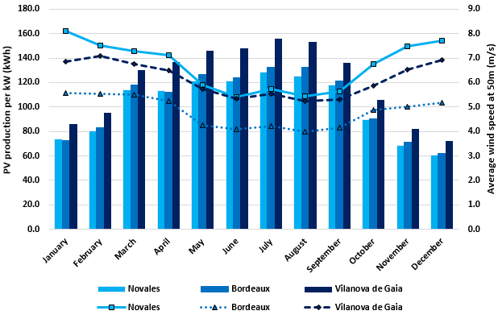

Figure 1: *PV production per kW (bars) and average wind speed at 50m (lines with markers) in different locations of SUDOE region.*

On the other hand, it is necessary to define the load demand of the building. This consumption could be either modelled in HOMER Pro or imported from previously collected information. In this case, the consumption of Novales has been built by compiling real hourly consumption data from the smart meter of a home during a whole year, while the buildings from Bordeaux and Vila Nova de Gaia have been modelled using yearly and monthly average demands respectively. Taking into account these initial hypotheses, the characteristics of the demand in the three locations are shown in Table 1.

Table 1: Summary of energy consumption per location.

|  |  |  |  |
| --- | --- | --- | --- |
| Description | Novales, Spain | Bordeaux, France | Vila Nova de Gaia, Portugal |
| Average consumption (kWh/day) | 94.38 | 82.16 | 85.95 |
| Average demand (kW) | 3.97 | 3.42 | 3.58 |
| Peak demand (kW) | 41.56 | 12.21 | 9.85 |
| Load factor a | 0.09 | 0.28 | 0.36 |

a Load factor calculated as the ratio between average demand and peak demand

The resulting configurations per location will consider the particularities of each country since they have different electricity mixes with different levels of carbon intensity and grid prices as reflected in Table 2.

*Table 2****:*** *Summary of electricity grid prices and carbon intensities per location.*

|  |  |  |  |
| --- | --- | --- | --- |
| Description | Novales, Spain | Bordeaux, France | Vila Nova de Gaia, Portugal |
| Electricity Price (US$/kWh) | 0.229 | 0.213 | 0.269 |
| Carbon intensity (gCO2/kWh) | 190 | 55 | 201 |

Moreover, the evaluation accounts the current technology readiness level (TRL), capital expenditures (CAPEX), operational expenditures (OPEX), maintenance costs and different levels of penetration of novel hybrid systems based on RES and hydrogen technologies. These prices are included in HOMER Pro along with equipment characteristics (lifetime, efficiency, etc.) for the optimization and are collected in Table 3 from international agencies and organisms. Simulations consider average prices within the ranges reported for each technology. For both converter and batteries we use the default values that appear in HOMER Pro software which are 300 US$/kW and 700 US$/kWh respectively. The use of WT has been dismissed, as they are not very commonly integrated into buildings in urban areas. Additionally, the size of batteries is limited and restricted to cover the peak load during an approximate time of one hour.

*Table 3****:*** *Summary of reported CAPEX prices by international agencies for main components of RHS.*

|  |  |
| --- | --- |
| Component | Reported CAPEX Prices (US$/kW) (Maestre et al., 2021) |
| Photovoltaic | 250 - 1,050 |
| Fuel Cell | 1,600 - 6,000 |
| Electrolyzer | 500 - 5,600 |
| Hydrogen tank | 700 – 1,000 US$/kg |

To assess the potential deployment of these technologies, three different scenarios shown in Figure 3 have been simulated during a period of 25 years:

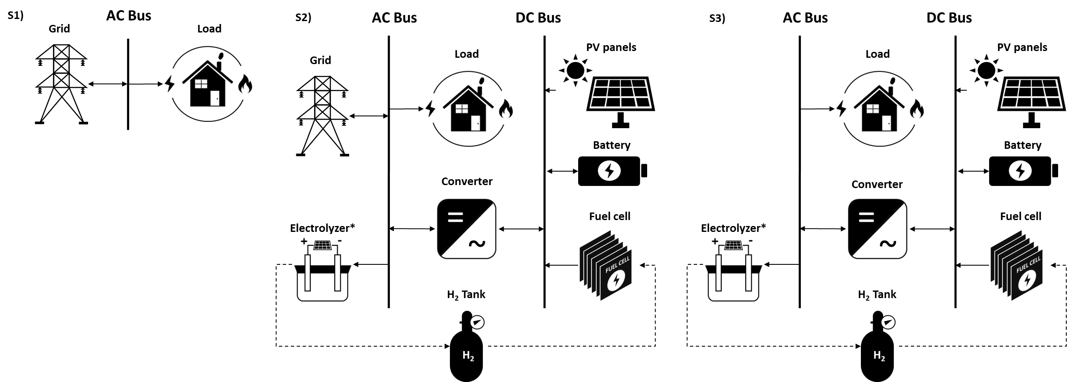

*Figure 3****:*** *Different configurations analyzed per location: grid-connected building, S2) grid-connected building and RHS, and S3) off-grid building with RHS. \* The electrolyzer has an internal AC/DC converter.*

* Scenario 1 (S1), grid-connected building: this scenario considers the current situation of the three buildings in the SUDOE region under study, which use electricity supplied by the grid.
* Scenario 2 (S2), grid-connected building and RHS: an intermediate solution for the improvement of energy efficiency and gradual decarbonization of the buildings studied is analyzed.
* Scenario 3 (S3), off-grid building with RHS: the potential for designing a decentralized energy supply system independent of the current power grid is evaluated.
  1. Results

The main results obtained through the simulation of the previously depicted scenarios are compared between them in terms of system configuration, dimensions, energy mix, net present cost, levelized cost of energy and greenhouse gases emissions.

* + 1. System configuration, dimensions and energy mix

The dimensions of the configuration obtained per location and scenario are gathered in Table 4. As S1 considers the current scenario where all the energy is purchased from the grid, the analysis only reflects the components and their size of S2 and S3:

*Table 4****:*** *System configuration and dimensions for scenarios 2 & 3..*

|  |  |  |  |  |
| --- | --- | --- | --- | --- |
| Scenario | Component | Novales, Spain | Bordeaux, France | Vila Nova de Gaia, Portugal |
| S2 | PV (kW) | 22.8 | 13.8 | 76.1 |
| S3 | PV (kW) | 117 | 113 | 92.8 |
| EL (kW) | 31 | 50 | 41 |
| FC (kW) | 20 | 7 | 10 |
| Bat (kWh) | 52 | 13 | 13 |
| H2 tank (kg) | 41 | 55 | 52 |

\* Abbreviations: PV (Photovoltaic panels), EL (Electrolyzer), FC (Fuel Cell), Bat (Battery).

The PV capacity installed in Vila Nova de Gaia is around 3 times more than the resulting capacity in Novales and 5 times more than in Bordeaux, which results in a lower dependence on the grid and a higher solar self-consumption. However, the dimensions of the PV panels are smaller for Vila Nova de Gaia in S3 because no solar surplus is sold to the grid, so less installed capacity is needed to cover the same load due to the higher solar radiation. As for the FC, it is shown that despite having a similar daily demand for the three locations, Novales has a system with a fuel cell twice the size or more due to the large peak load it has. In contrast, the electrolyzer and hydrogen tank are larger due to the smaller number of batteries installed. Additionally, the energy mixes of scenarios 2 and 3 are shown in Figure 4.

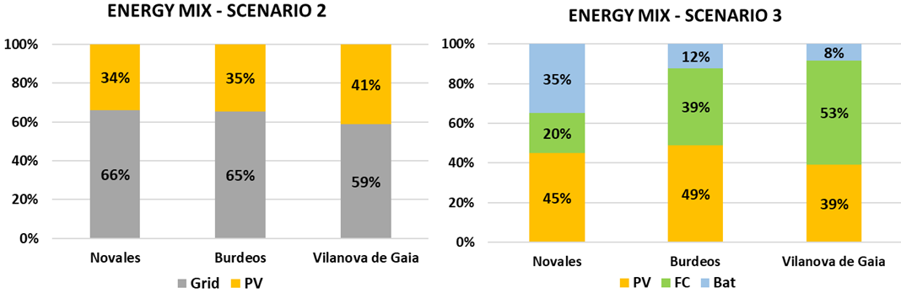

*Figure 4****:*** *Percentage of the load covered by component and location in scenarios 2 and 3.*

As mentioned above in S2, Vila Nova de Gaia has a large PV capacity installed which results in a greater economic benefit in terms of selling excess to the grid. With respect to S3, a great excess solar production is required for hydrogen generation and to charge the batteries. The remainder is energy excess and losses due to DC/AC conversion. However, it could be sold to the grid or can be reused to cover the thermal needs of the building and its inhabitants through electric heaters and hot water storage tanks. Finally, it can be seen that the FC has a greater contribution to cover the load in the locations with fewer batteries installed. Moreover, in Vila Nova de Gaia, the energy consumed by the load from the FC is greater than that provided by the PV panels due to the large hydrogen storage tank.

* + 1. Net present cost and levelized cost of energy

The economic evaluation of the different scenarios previously reported is performed in terms of net present cost (NPC), levelized cost of energy (LCOE) and the annual operating cost of each system. In addition, a new scenario is included, named S3.2, which considers that all the surplus energy obtained in the case of S3 is sold-back to the grid. In this regard, a sale price to the grid of 50% of the purchase price is considered (previously reported in Table 2). The results are collected in Table 5.

*Table 5****:*** *Net present cost, levelized cost of energy and operating cost per scenario and location.*

|  |  |  |  |  |
| --- | --- | --- | --- | --- |
| Scenario | Parameter | Novales, Spain | Bordeaux, France | Vila Nova de Gaia, Portugal |
| S1 | NPC (US$) | 101,977.80 | 82,570.87 | 109,084.00 |
| LCOE (US$/kWh) | 0.229 | 0.213 | 0.269 |
| Operating Costs (US$/kWh) | 7,888.43 | 6,387.22 | 8,438.13 |
| S2 | NPC (US$) | 92,116.25 | 73,842.95 | 64,874.06 |
| LCOE (US$/kWh) | 0.149 | 0.163 | 0.043 |
| Operating Costs (US$/kWh) | 5,661.38 | 4,828.22 | 145.37 |
| S3 | NPC (US$) | 414,176.80 | 412,123.10 | 352,294.40 |
| LCOE (US$/kWh) | 0.931 | 1.060 | 0.870 |
| Operating Costs (US$/kWh) | 14,321.03 | 15,125.84 | 12,364.42 |
| S3.2 | NPC (US$) | 161,002.47 | 199,732.21 | 149,135.01 |
| LCOE (US$/kWh) | 0.362 | 0.515 | 0.368 |
| Operating Costs (US$/kWh) | 5,572.39 | 5,885.54 | 4,811.06 |

The most economic scenario is S2, corresponding to a self-consumption installation with solar panels and without energy storage, particularly in the case of Vila Nova de Gaia. The effect of hydrogen and battery technologies on the NPC and LCOE of the system is appreciated in S3, being between 4 and 5 times higher than in S1. However, if solar surpluses are sold to the grid (S3.2), these values would be reduced by 50 to 60%. This new scenario reflects the potential of RHS in the medium term, taking into account their techno-economic development and the exponential growth of electricity prices in recent months. In fact, the LCOE obtained in Novales and Vila Nova de Gaia is comparable with grid prices in countries such as Germany.

* + 1. Greenhouse gases emissions

The energy consumption of buildings in the SUDOE region under study leads to a series of greenhouse gas emissions, including carbon dioxide (CO2), sulfur oxides (SOx) and nitrogen oxides (NOx). The use of renewable energies and new hydrogen technologies for the electricity supply of these buildings makes it possible to greatly reduce or eliminate these emissions. Table 6 shows the comparative emissions associated with each of the different scenarios according to their location.

*Table 6****:*** *Carbon dioxide, nitrogen and sulphur oxide emissions per scenario and location.*

|  |  |  |  |  |
| --- | --- | --- | --- | --- |
| Scenario | Gas emissions (kg/year) | Novales, Spain | Bordeaux, France | Vila Nova de Gaia, Portugal |
| S1 | CO2 | 6,545 | 1,649 | 6,305 |
| SOx | 28.2 | 7.1 | 27.3 |
| NOx | 13.8 | 3.5 | 13.5 |
| S2 | CO2 | 4,325 | 1,076 | 3,710 |
| SOx | 18.7 | 4.7 | 16.1 |
| NOx | 9.1 | 2.4 | 7.9 |
| S3 | CO2 | 0 | 0 | 0 |
| SOx | 0 | 0 | 0 |
| NOx | 0 | 0 | 0 |

Novales is the location with the highest emissions due to its higher energy consumption despite the fact that Portugal has the most carbon-intensive energy mix. With respect to the base case, Vila Nova de Gaia has the highest emissions reduction potential when combining both grid and hybrid system (around 59% with respect to S1) due to the higher potential for PV production in this location. Powering the buildings solely with the hybrid renewable-hydrogen system (S3) means the complete elimination of emissions in all locations.

* 1. Conclusions

The unsustainable climate change situation has prompted governments, policymakers, private companies and stakeholders to take measures and mitigate the exponentially growing GHG emissions. Particularly, energy use in buildings is responsible for almost 20% of total emissions globally. Moreover, most of the building stock in Europe is highly inefficient as it is older than 25 years. These buildings are responsible of around 92% of total emissions associated to this sector. On the other hand, energy requirements are continuously increasing; aggravating the energy poverty of must unfavorable inhabitants. In this regard, in the framework of SUDOE ENERGY PUSH project this study evaluates the techno-economic feasibility and the potential use of renewable hydrogen-based systems for buildings in three different locations of the SUDOE region.

The assessment reflects that the combination of the current grid connection and PV panels is already more economic than the current scenario of grid-connected buildings. This cost-competitiveness is reached for all the evaluated locations. Additionally, the regions with higher solar radiation (Vila Nova de Gaia in this case) are more appropriate to consider off-grid renewable hydrogen-based systems (RHS). These schemes are not as economic as the other scenarios, but the selling of energetic surpluses would make them affordable in the medium term. However, RHS report the highest savings in terms of pollutants as they enable the complete removal of GHG emissions. Besides, it is necessary to analyze their dimensions considering not only the power capacity, but also the surface required for their deployment.

Nomenclature

Bat – Battery

BIM – Building information modeling

CAPEX – Capital expenditures

CCSU – Carbon capture, storage and utilization

CO2 – Carbon dioxide

EL – Electrolyzer

ESS – Energy storage system

FC – Fuel Cell

GHG – Greenhouse gases

LCOE – Levelized cost of energy

NOx – Nitrogen oxides

NPC – Net present cost

OPEX – Operational expenditures

PV – Photovoltaic

RES – Renewable energy sources

RHS – Renewable hydrogen-based system

SOx – Sulfur oxides

TRL – Technology readiness level

WT – Wind turbine

Acknowledgments

This research is being supported by the Project ENERGY PUSH SOE3/P3/E0865, which is co-financed by the European Regional Development Fund (ERPF) in the framework of the INTERREG SUDOE Programme and the Spanish Ministry of Science, Innovation, and Universities (Projects: RTI2018-093310-B-I00 and PLEC2021- 007718).

References

BPIE, 2011, A Country-by-Country Review of the Energy Performance of Buildings <https://bpie.eu/wp-content/uploads/2015/10/HR\_EU\_B\_under\_microscope\_study.pdf> accessed 16.03.2022.

Cipolletta M., Moreno V., and Cozzani V., 2022, Green Hydrogen Production Routes: An Inherent Safety Assessment, Chemical Engineering Transactions, 90, 55–60.

Derempouka E., Skjold T., Njå O., and Haarstad H., 2022, The Role of Safety in the Framing of the Hydrogen Economy by Selected Groups of Stakeholders, Chemical Engineering Transactions, 90, 757-762.

EU Commission, 2010, Directive 2010/31/EU: Energy Performance of Buildings < https://eur-lex.europa.eu/LexUriServ/LexUriServ.do?uri=OJ:L:2010:153:0013:0035:EN:PDF> accessed 16.03.2022.

EU Commission, 2018, DIRECTIVE (EU) 2018/844: Amending Directive 2010/31/EU on the Energy Performance of Buildings and Directive 2012/27/EU on Energy Efficiency < https://eur-lex.europa.eu/legal-content/EN/TXT/PDF/?uri=CELEX:32018L0844&from=EN> accessed 16.03.2022.

EU Commission, 2021, Proposal for a Directive of the European Parliament and of the council on energy efficiency (recast) <<https://ec.europa.eu/info/sites/default/files/> proposal\_for\_a\_directive\_on\_energy\_efficiency\_recast.pdf> accessed 11.07.2022

Foley A., Olabi A.G., 2017, Renewable energy technology developments, trends and policy implications that can underpin the drive for global climate change, Renewable & Sustainable Energy Reviews, 68:1112–14.

IRENA, 2018, Global energy transformation: A Roadmap to 2050 <<https://www.irena.org/publications/> 2018/Apr/Global-Energy-Transition-A-Roadmap-to-2050> accessed 16.03.2022.

Luta D.N., Raji A.K., 2019, Optimal sizing of hybrid Fuel Cell-Supercapacitor storage system for off-Grid renewable applications, Energy, 166:530–40.

Maestre V.M., Ortiz A., Ortiz I., 2021, Challenges and prospects of renewable hydrogen-based strategies for full decarbonization of stationary power applications, Renewable & Sustainable Energy Reviews, 152:111628.

Maestre V.M., Ortiz A., Ortiz I., 2022, The role of hydrogen-based power systems in the energy transition of the residential sector, Journal of Chemical Technology & Biotechnology, 97:561–74.

Peláez S., Colmenar A., Pérez C., Rosales A.E., Rosales E., 2021, Techno-economic analysis of a heat and power combination system based on hybrid photovoltaic-fuel cell cystems using hydrogen as an energy vector, Energy, 224:120110.

Razmjoo A., Gakenia L., Vazari M.A., Marzband M., Davarpanah A., Denai M., 2021, A Technical Analysis Investigating Energy Sustainability Utilizing Reliable Renewable Energy Sources to Reduce CO2 Emissions in a High Potential Area, Renewable Energy*,* 164:46–57.

Stafell I., Scamman D., Velazquez A., Balcombe P., Dodds P.E., Ekins P., Shah N., Ward K.R., 2019, The role of hydrogen and fuel cells in the global energy eystem, Energy and Environmental Science, 12(2):463–91.