|  |  |
| --- | --- |
| cetlogo ***CHEMICAL ENGINEERING TRANSACTIONS***  ***VOL. 96, 2022*** | A publication of  aidiclogo_grande |
| The Italian Association  of Chemical Engineering  Online at www.cetjournal.it |
| Guest Editors: David Bogle, Flavio Manenti, Piero Salatino  Copyright © 2022, AIDIC Servizi S.r.l. **ISBN** 978-88-95608-95-2; **ISSN** 2283-9216 | |

Minimizing transport emissions for products delivery : accounting for uncertainty on industrial supply chains

Alessandro Di Pretoroa,\*, Stéphane Negnya, Ludovic Montastruca

aLaboratoire de Génie Chimique, Université de Toulouse, CNRS/INP/UPS, Toulouse, France

alessandro.dipretoro@ensiacet.fr

Transport represents almost a quarter of Europe's greenhouse gas emissions and it is the main cause of air pollution in cities. Therefore, the Commission's low-emission mobility strategy represents a key challenge towards a low-carbon, circular economy. Moreover, with the increasing price of transportation fuel, it is becoming a more and more relevant cost item in the industrial sector.

In the production sector, supply chains are usually optimized according to an established set of expected customers, this means that, when customers are not known, the outlined optimal solution could considerably underperform in terms of costs and transportation path. Accounting for uncertainties when designing a supply chain strategy could be then of critical importance to reduce the vehicle travel distances and, thus, the related emissions due to fuel consumption as well as to have more reliable expectations.

In this research work, the analysis of the optimal travel paths under uncertain customers’ location is addressed for a classical vehicle routing problem with delivery based on a methodology outlined in previous studies by the same authors. The approach exploits stochastic sampling generation to provide a probability distribution concerning the expected emissions and travel costs (travel equivalent distance in this case) for a given centralized factory location. In the selected case study, the uncertainty concerning both the customer locations and their expected demand are considered since these have been proved to be the most critical parameters. As indicator for the environmental impact the authors selected the Global Warming Potential.

The analysis shows that accounting for uncertainties during optimization of the supply chain design phase could provide a more reliable estimation of both travel distance and fuel consumption. Moreover, it allows to quantify the variance of these two in order to have an estimation of the maximum and minimum values. This approach is then worth to be extended to industrial cases and applications in order to be validated and become the standard methodology for a more low-carbon mobility strategy in the industrial sector.

* 1. Introduction

During the last years logistics has become one of the topics of major concern in the industrial domain due to the more and more constraining supply standards and the need to ensure products availability in critical conditions as well. However, the conventional approach for supply chain optimization has faced inconveniences related to the volatility of several factors such as demand, market price, number of customers and their geographical position and other unexpected events such as the COVID pandemic who drastically shook the entire industrial organization. In fact, during the last decades, uncertainty has been substantially affecting all production systems and it is a non-negligible aspect in the best practice of modern design procedures. For this reason, the need of coupling supply chain optimization and uncertainty of input parameters is now a priority of the Process Systems Engineering community. In this perspective digitalization could play an important role in terms of data to be treated and times required to have a reliable estimation according to the expected perturbations and demand fluctuation in a relatively short time.

Recent literature provides examples of supply chain analysis under uncertainty carried out by adapting the flexibility indexes used in process units design (Wang et al. 2016, Di Pretoro et al. 2021) as well as satisfactory reviews concerning the different optimization models employed to deal with it (Suryawanshi & Dutta, 2022). The approach based on flexibility (or resilience) indexes allows to quantify the additional costs correlated to a given expected perturbation and, from a qualitatively point of view, it shows how the optimal delivery paths change to minimize expenses under uncertainty. As a consequence, from an environmental perspective, minimizing the travel path corresponds not only to a reduction of fuel costs but also to mitigating the corresponding CO2 emissions. In fact, transport emissions represent almost a quarter of Europe’s greenhouse gas emissions and it is the main cause of cities air pollution (Transport Emissions EC, 2016). For this reason, the use of available technologies and methodologies for a reliable estimation of transport emissions in a supply chain system is of critical importance and allows to reconsider the decisions made with respect to nominal operating conditions so that the final outcome provides a double benefit both in terms of costs and sustainability.

In this research work both costs and emissions under uncertainty will be assessed but a different approach will be adopted and compared to the abovementioned ones; for uncertain customers location and demand, the travel path optimization is performed and the probability distribution of travel distance, costs and emissions is represented based on an iterative sampling strategy. The outcome will be then analysed and commented in order to draw useful conclusions in terms of average values and variance of the expected outcome.

Although the employed methodology is of general validity, the selection of a suitable case study was necessary to show some quantitative results. A more detailed description of the specific case study is then presented in the following section.

* 1. Case study

This research work addresses the case study of a centralized supply system over a rectangular geographical domain represented by a [10 x 20] grid. The depot location is fixed at the centre of the rectangle [5, 10] and the customers location is randomly generated over the region. In particular, for this research work, the results for 10 customers are discussed but the proposed methodology is nevertheless valid for any number of customers accounting for the fact that the corresponding computational time increases with a factorial trend. Figure 1 shows an example of customers distribution over the geographical domain where the black point 0 is the depot point while the light blue dots from 1 to 10 are the customers each on with the related product demand. The truck starts his travel at the point 0 with the full load and it should visit all customers by discharging the relative load (corresponding to the customer demand) before going back to the depot.

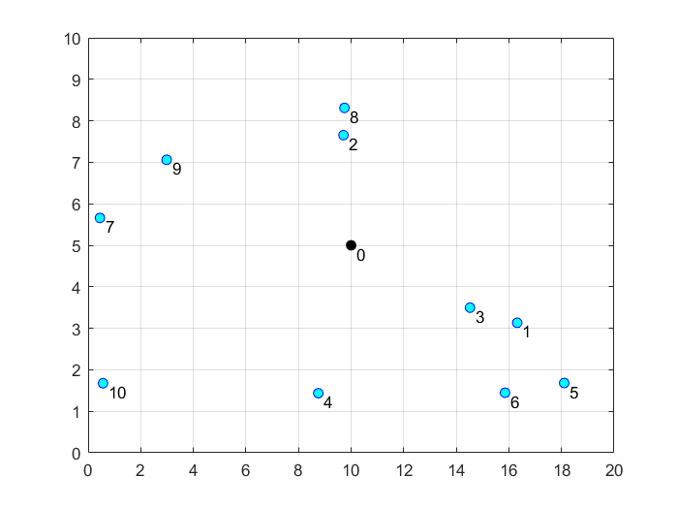

*Figure 1: Customers random location over the [10X20] domain (example for 10 customers).*

As concerns each customers demand, quantified by a load coefficient affecting the final objective function, it is randomly generated as well according to the same criteria proposed by Di Pretoro et al. (2022), i.e. the initial delivery total load weighs as much as the unloaded traveling distance if the cities were uniformly aligned over the interval. In short, this hypothesis can be resumed by the following equation:

|  |  |
| --- | --- |
| $$l_{tot}=\sum_{i=1}^{n}{l_{i}}=n⋅Δx$$ | (1) |

where *ltot* is the total initial load, *li* is the load corresponding to each city, *n* is the number of cities and *Δx* is the unit length of the grid. After each delivery the load corresponding to the last city is left and the weight of the following path on the objective function is reduced by a factor *li*.

As concerns the results analysis, to have values that can be compared to real units of measure, the grid unit length is considered equal to 1 km. For the economic assessment the value 0.078 €/ton/km (JRC technical report) is used while, for the environmental impact, the Global Warming Potential indicator was selected and the value 0.57 g CO2 eq/ton/km (The International Council on Clean Transportation) are used respectively. The following section presents the details concerning the optimization problem, the definition of the objective function as well as the way delivery loads affect the travel costs and emissions for the particular case study under analysis.

* 1. Methodology

In this research work the proposed approach for the solution of a single optimization run follows the one presented by Di Pretoro et al. (2021, 2022). Both customers location and related load are randomly generated and the former is normalized. Then, the traveling deliveryman problem for each simulation run is solved by minimizing the objective function:

|  |  |
| --- | --- |
| $$F_{obj}=\sum_{i=0,j≠i}^{n}{t_{ij}⋅(1+l_{j})}$$ | (2) |

where *tij* is the traveling path between the i-th and the j-th customers and *lj* is the load that the truck still carries with it when traveling towards the j-th customer after *j* iterations. From a mathematical point of view, the latter can be calculated as:

|  |  |
| --- | --- |
| $$l_{j}=l_{tot}-\sum_{i=0}^{j-1}{l_{i}}$$ | (3) |

Figure 2 shows the solution of the loaded [0 2 8 9 7 10 4 6 5 1 3 0] and unloaded [0 2 8 3 1 5 6 4 9 7 10 0] problem respectively for the same random customers distribution reported in Figure 1.

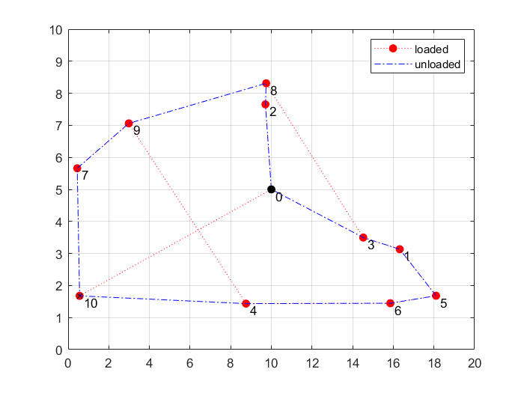

*Figure 2: Solution of the unloaded and loaded delivery optimization problem (example for 10 customers).*

As it can be noticed, the solutions of the problem with and without loads could be considerably different due to the fact that it might be convenient to deliver heavy loads first in order to reduce the corresponding fuel consumption for the remaining part of the travel. On the contrary, the unloaded optimization just refers to the travel distance between the cities.

The optimization problem is solved by enumeration since computational times for problems of this size are not a main issue. In case a higher number of customers is involved different solution approaches can be employed to reduce the computational time (Applegate et al. 2006) or a computer with higher performances can be used. It means that all possible paths are calculated along with the related cost function and the one corresponding to the lowest cost is selected. The algorithm is implemented in a Matlab 2021b script and the same software is use for the graphical representation and data treatment. Based on the abovementioned approach for the operations research optimization loop, results concerning the travel costs and travel emissions are collected as resumed in Table 1.

For output parameters collection an iterative sampling approach was used. This approach is based on the generation of a high number of samples and the representation of the results probability distribution. In particular, the definition of “high” number of samples can be seen as a quantity of runs sufficient to avoid particular cases and scattered results.

Table 1: Uncertain and output parameters.

|  |  |
| --- | --- |
| Uncertain parameters | Output parameters |
| Customer location | Total travel distance |
| Customer demand | Total travel costs |
|  | Total travel emissions |

This methodology allows to estimate the average value and variance of the variable of interest in case of input parameters uncertainty. The detailed analysis of the results for the three selected output parameters is presented in the next section.

* 1. Results

As previously anticipated, the simulation was performed for 1000 runs with random customer location and demand. The value was selected in order to have an almost continuous results distribution and not to obtain singular results. Of course, a higher number of runs would have provided a smoother result but at the cost of a higher computational time, therefore a compromise is needed. A single run for 10 customers takes 1.4 s of computational time. As already commented, this value depends on the optimization strategy for the operational research problem and, since in this case enumeration was selected, it corresponds to the longest time possible for this kind of problem.

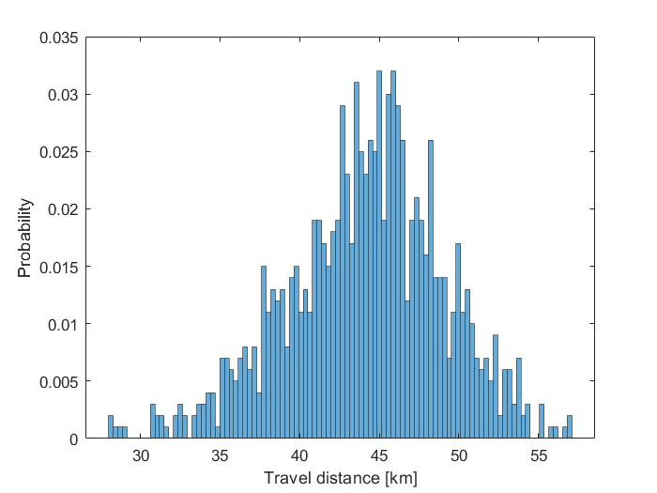

*Figure 3: Results for travel distance* probability distribution.

Figure 3 shows the results concerning the travel distance. This variable is related to distance only, i.e. the truck load is not considered. As it can be noticed, the distribution trend is similar to a normal distribution although it is slightly skewed towards the left. The characteristic values of the obtained dataset can be calculated: the average travel distance for this specific case study results to be equal to μ = 44.1 km with a variance σ = 24 km (i.e. σ = 4.9 km). As a consequence of these values, we can deduct that more than the 95 % of possible solutions under uncertainty fall within an approximation range of about 10 km, i.e. ± 17 % of the average value. The maximum and minimum values are respectively 27 and 58 km.

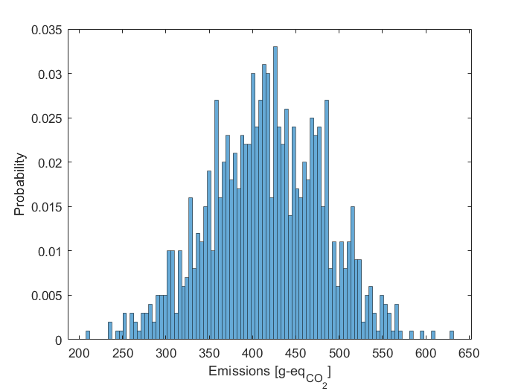

*Figure 4: Probability distribution for left) optimal costs and right) equivalent CO2 emissions.*

Of course, this outcome is strictly related to the specific case study but it shows that, for this particular set of parameters, the expected values could considerably vary with respect to the result obtained for calculations performed under nominal operating conditions only and the quantification of this variation is possible and can be correlated to the residual probability.

Figure 4 shows the results concerning the supply chain cost distributions related to a single route over the selected domain and the related emissions. First of all, it can be noticed that, with the exception of a scaling factor, the two trends are similar since they are both proportional to the value of the cost function. A second relevant remark is that these distributions are less regular than the one reported on Figure 3. This is due to the fact that more than one uncertain parameter, i.e. both position and demand, affect the cost function. Anyways, even in this case, the average value for costs and emissions can be assessed.

The average path costs result to be 569.4 € with a standard deviation equal to 89.74 €, the minimum and maximum values in this case are 325 € and 780 € by excluding the less significant points. As for the travel distance we can say that this value implies a range of ± 31.5 % where the 95 % of possible solution fall. On the other hand, emissions are on average 416 g CO2 - eq with a standard deviation equal to 65 g CO2 - eq, that corresponds to a range of ± 23.5 % within which the 95 % of possible solution could lie. The minimum and maximum values, removing the most unlikely points are 230 and 570 g CO2 - eq.

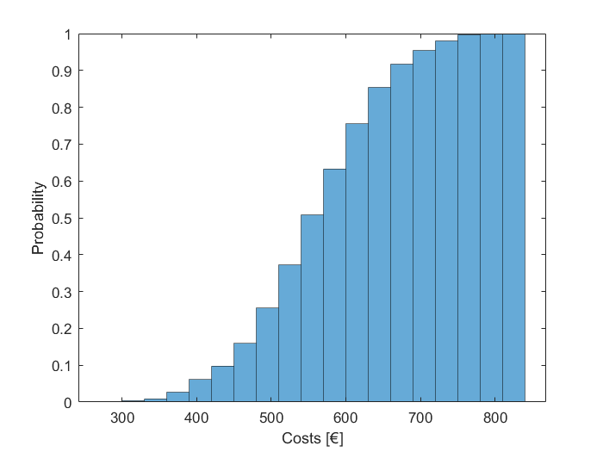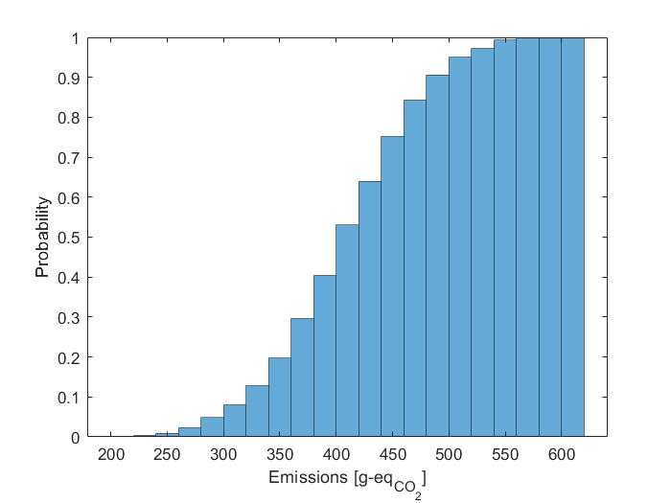

*Figure 5: Cumulative distribution for left) optimal costs and right) equivalent CO2 emissions.*

The results show how much the average value can differ from the effective distribution of the possible solutions under uncertainty. Finally, to have a more reliable representation, the cumulative distribution function can be analyzed as in the example reported in Figure 5 for the CO2 emissions.

* 1. Conclusions

This study shows that, whenever supply chain parameters, such as customers’ location or demand, are uncertain, a reliable estimation of costs and emissions is nevertheless possible. In particular, when the expected domain is defined and at least the depot location is known, it is possible to set up a stochastic approach based on iterative sampling to derive the probability distribution of the variables of interest. The advantage of the distribution is not only to detect the most probable value but also to estimate the standard deviation range within other cases affected by uncertain parameter deviation can fall. This approach indeed allows both to qualitatively assess how the optimal travel path minimizes distance, and thus emissions, and to quantify the corresponding advantage in terms of expenses and GWP. Furthermore, the cumulative distribution of the obtained results allows to quantify the percentage of neglected cases when a given value is kept during the design phase.

Besides the results obtained in this research work, that are strictly related to the selected uncertain and output parameters, the same procedure can be applied on different case study with reliable results and could be further exploited in future applications for more complex cases and integrated with more effective computational strategies in order to compensate the higher computational demand.

Nomenclature

li – load corresponding to the i-th customer, /

ltot – total initial load, /

tij – traveling distance between cities i and j, km

x, y – cartesian coordinates

Δx – domain discretization, km

μ – average value, km

σ – standard deviation, km

References

Applegate, D., Bixby, R., Chvatàl, V., Cook, W., 2006. The Traveling Salesman Problem: A Computational Study. Princeton University Press, Princeton; Oxford.

Di Pretoro A., Negny S., Montastruc L., 2021. Flexibility Analysis in Supply Chain Management: Application to the Traveling Salesman Problem. Computer Aided Chemical Engineering 50, 1721-1726.

Di Pretoro A., Negny S., Montastruc L., 2022. The Traveling Deliveryman Problem under Uncertainty: Fundamentals for Flexible Supply Chains. Computers & Chemical Engineering, 160, 107730.

JRC technical report “Estimating road transport costs between EU regions” retrieved at <https://joint-research-centre.ec.europa.eu/system/files/2020-05/jrc114409.pdf> accessed 26.05.2022

Suryawanshi P., Dutta P., 2022. Optimization Models for Supply Chains under Risk, Uncertainty, and Resilience: A State-of-the-Art Review and Future Research Directions. Transportation Research Part E: Logistics and Transportation Review 157, 102553.

The International Council on Clean Transportation <https://theicct.org/publication/co2-emissions-from-trucks-in-the-eu-an-analysis-of-the-heavy-duty-co2-standards-baseline-data/>

Transport emissions, European Commission, retrieved at <https://ec.europa.eu/clima/eu-action/transport-emissions_en> accessed 13.03.2022 .

Wang. H., Mastragostino, R., Swartz, C.L.E. 2016. Flexibility analysis of process supply chain networks. Comput. Chem. Eng. 84, 409-421.