Roneta Chaliulina ¹*, Jose-Luis Galvez-Martos ², Ammar Elhoweris ¹, Jonathan Mwanda ¹, Yousef Al-Horr ¹
¹Gulf Organisation for Research and Development, Doha, Qatar
²Systems Analysis Unit, IMDEA Energy, Avda. Ramón de la Sagra 3, E-28935, Móstoles, Madrid, Spain
*Corresponding author
T: +974 30386209, email: r.chaliulina@gord.qa

Utilization of CO₂ in the development of carbon-negative construction materials

Rising ambitions to cut greenhouse gas emissions is presenting the construction industry with a near-impossible task, as it is facing the largest wave of urban growth in human history. Accounting for almost a tenth of all anthropogenic CO2 emissions, it is in a dire need to accelerate the transition to a carbon-neutral economy.

Motivated by the environmental concerns, a construction material has been developed which may be classed as an eco-efficient gypsum plaster alternative. Based on Mg carbonate as the main precursor, the material embodies around 30% CO₂ by weight and exhibits a superior mechanical strength and environmental profile to traditional gypsum plaster-based products. Utilizing captured CO₂ and other wastes, including desalination brine and cement kiln dust, the potential has been demonstrated to be both, economically viable and carbon negative for production in the global construction industry.

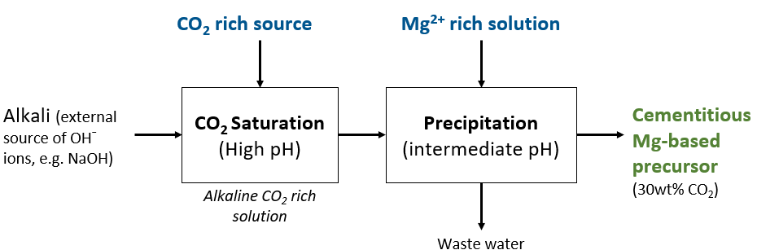

Figure 1: GORD Developed CO2 Capture and Mineralization Process.

