|  |  |
| --- | --- |
| cetlogo ***CHEMICAL ENGINEERING TRANSACTIONS***  ***VOL. 96, 2022*** | A publication of  aidiclogo_grande |
| The Italian Association  of Chemical Engineering  Online at www.cetjournal.it |
| Guest Editors: David Bogle, Flavio Manenti, Piero Salatino  Copyright © 2022, AIDIC Servizi S.r.l. **ISBN** 978-88-95608-95-2; **ISSN** 2283-9216 | |

COMPARATIVE LCA ANALYSIS FOR REPLACEMENT OF MATERIALS TO REDUCE ENVIRONMENTAL IMPACT

Zieminska-Stolarska A\*a., Pietrzak Mb., Zbicinnki Ia.

aFaculty of Process and Envronmental Engineeering, Lodz University of Technology, Wolczanska 215, 90-924 Lodz, Poland

bFaculty of Chemistry, Lodz University of Technology, Zeromskiego 116, 90-953 Lodz, Poland

aleksandra.zieminska-stolarska@p.lodz.pl

The paper presents examples of LCA application to reduce environmental impact by replacement of conventional materials in chemical, biochemical, construction and electrical industry. Examples of replacement of talc-reinforced polypropylene composite by lightweight composite, using of natural aggregates versus recycled aggregates coming from reinforce concrete demolition, replacing of carbon black with graphene in tire production, production of asphalt mixtures, change of metal contacts for perovskite/silicon (Si) tandem structure of solar cell, etc. are described showing reduction of environmental load in impact categories or carbon footprint.

The full case study of LCA of analysis to replace Indium, a material extensively used as Transparent Conductive Oxide (TCO) compound for opto-electronic industry is presented. Several alternative materials for indium-tin-oxide (ITO) replacement as pure zinc oxide (ZnO) or doped with aluminum (Al) either boron (B) and tin oxide (SnO2), deposited by different techniques: physical vapor deposition (PVD), chemical vapor deposition (CVD) and atomic layer deposition (ALD) were extensively tested. ReCiPe Endpoint H/A method was applied to end up life cycle analysis with single score. In case of all layers deposited by CVD and ALD techniques the main impact is related to electricity or nitrogen consumption and the impact produced by the material is of minor significance. The results show that replacement of ITO by ZnO in TCO layer deposition process is an optimal strategy to minimize environmental impact keeping required opto-electrical properties for the economic and safe manufacturing of optoelectronic components. Environmental impact of analysed TCOs strongly depends on deposition technologies; for the layers deposited by CVD and ALD techniques the main impact is related to energy or nitrogen consumption whereas for PVD to energy and material of TCO.

* 1. Introduction

Demand for indium has grown since the 1970s with considerable expansion and diversification in consumption since 1990s. (Werner, Mudd, and Jowitt 2015). The fast electronic development and advent of flat-panel display notably raised commercial significance of indium (Ciacci et al., 2019; Frenzel et al., 2017; Lokanc, Eggert, Redlinger, 2015). Approximately 90% of the annual indium consumption account to transparent conducting oxide films (TCOs) in the form of indium tin oxides (ITOs)- (In)-doped SnO2 (O’Neill 2010). Today, ITOs are technologically entrenched in the commercial manufacture of components like flat panels displays, liquid crystal displays (LCDs), light emitting diodes (LEDs), touch screens and photovoltaic cells (Mohamed et al., 2009; Lu et al., 2015). These cumulative markets having multiplied by a factor of 4 in 5 years (www.inrep.eu). Indium has been classified by the European Commission as one of the critical raw material (CRM) with a high supply-risk and high economic importance to which reliable and unhindered access is a concern for European industry and value chains (European Commission 2020, Bobba et al., 2020). High-tech products, including electric and electronic equipment, green energy technologies contain substantial amounts of CRM. Although the amount of CRM per product is very low, the large number of products manufactured makes the total amount significant. There is therefore a need to find alternative solutions to replace CRM in concrete applications, or to diversify the supply of raw materials sources. Substitution of CRMs can also increase the recyclability of waste products, allowing for more efficient processes and reduce environmental impact. As demand of photovoltaics and flat-panel displays continues to increase, the availability of ITO can be alarming in the future. Furthermore, economic aspect is also driven force to development indium-free materials for TCO commercial application (Yu et al. 2016; Minami, 2005). Alongside ITO, satisfactory performance as TCO was shown by fluorine (F)- doped SnO2, aluminium (Al)- doped ZnO and gallium (Ga)- doped ZnO (Dalapati et al., 2021). However, different multilayer and nano-based materials are also extensively considered to meet requirements of TCOs (Gong, Lu, Ye, 2011; Yu et al., 2016; Kim et al., 2019). As the usefulness of TCO thin films depends on their optical and electrical properties, both parameters should be considered together with an environmental stability, abrasion resistance, electron work function, and compatibility with substrate and other components of a given device, as appropriate for the application. The availability of the raw materials and the economics of the deposition method are also significant factors in choosing the most appropriate TCO material (Afre et al., 2018).

The objective of this study is to identify and evaluate environmental impact of commercially acceptable indium-free TCOs, proposed in the frame of INREP project (www.inrep.eu). The new developed TCOs materials are potentially dedicated to high efficient PV cells, GaN based LEDs, organic LEDs and touch-screen monitor. Different materials and processes was evaluated by Life Cycle Assessment (LCA) methodology to provide information on possible environmental and safety impact of the developed solutions.

* 1. Materials and methods

Extensive literature screening revealed that the most suitable methodology for life cycle assessment of TCO’s layer deposition process is SimaPro® (Ziemińska-Stolarska, Barecka, Zbiciński, 2017). The software enables measurement of the environmental impacts of products and services across all life cycle stages and identification of hotspots in every link of the supply chain. For the reported analysis, ReCiPe method was selected and EcoInvent database due to availability of environmental impact coefficients for majority of compounds considered in the analysis.

* + 1. Life Cycle Assessment Analysis

LCA analysis can be performed with different calculation techniques and a broad variety of approaches. However there is no standard methodology, or even no legally accepted guidelines facilitating the choice of LCA method. The only aspect which can be systematically verified is accordance with the ISO 14040 and 14044 standards (Klöpffer, Grahl, 2014). The first steps for setting an inventory analysis are the definition of the functional unit and scope of the analysis. Since the main goal of the INREP project was to develop and bring to the market efficient Indium- free TCOs, the functional unit of analysis is related to a piece of such layer, exactly 1 cm2 of a TCO layer. The functional unit is a measure of a performance of a system. The purpose of the functional unit is to provide reference to which all inputs and outputs are related. One of the most important part in goal and scope is definition of system boundaries. Decision must be made which unit processes and activities will be included in the studies. For the presented work “gate to gate” approach was selected and inventory tables were prepared for deposition technologies. The inventory analysis consists of collection of detailed data for the different TCO materials and deposition techniques (physical/chemical vapor deposition, atomic layer deposition). The data was collected for lab-scale devices operated by different project partners providing a critique from a commercial perspective. Based on the obtained data, additional mass and energy balances were calculated and subsequently all impacts on environment were quantified. Additionally, impact of transport of raw materials was assessed: transport by ferry from China to Europe (Marseille) and further by lorry to the target production place. Within the scope of INREP project, different promising deposition technique and material candidates for ITO replacement were analyzed and benchmarked against the state-of-the art ITO layer applied by physical vapor deposition (PVD) technique of sputtering. Crucial in LCA analysis is the availability of impact coefficients in the selected database.

In case of PVD processes and related source of ITO, ZnO or ZnO doped with Al such data was available, what ensured exact analysis without need for further assumptions. Resulting process trees for ITO and ZnO layers, showing different stages of the deposition process and related impacts are shown in Figure 1 a and b.

For the ITO layer, majority of environmental impact comes from raw materials usage. Indium doped tin oxide used for the layer accounts for 60.9 % of the total impact. Therefore, in order to reduce environmental load ITO should be replaced. Based on results of LCA analysis, ZnO seems to be a promising alternative for ITO: its total environmental impact is 42 % lower (2.29x10-6 Eco-points for ITO vs. 1.32x10-6 for ZnO layer) circa one half lower (3.5x10-6 Eco-points for ITO vs. 1.55x10-6 for ZnO coating). The impact related to the material usage is of minor importance and accounts only for 2.04 % of the total LCA score, whereas the majority of impact is related to the electricity consumption. The results for ZnO layer doped with aluminum are very similar to the score for ZnO layer, due to minor amount of Al used. From the environmental point of view, the major difference between the PVD and ALD technique is related to the source of ZnO and Al doping deposited on the layer. In case of ALD liquid precursors are used, such as for e.g. diethyl zinc, which participate in reactions leading to ZnO and Al2O3 formation. Naturally, a number of volatile by-products is generated and present in the exhaust gases. These gases are further scrubbed before the final gas disposal. In order to provide as accurate analysis as possible, the amount of waste gases purified in the scrubber was quantified and subsequently the environmental impact of waste generated from scrubbing process was modelled.

The main challenge of LCA analysis for ALD technique is the use of complex precursors, which are not available in the EcoInvent database. In such case, the two following LCA procedures can be applied: the missing compounds can be replaced by the compounds which have a similar environmental impact or, alternatively, the missing compounds can be synthesized using the substrates required for compound production. Such an approach gives a simplified picture of the environmental impact, but still this is the most accepted procedure to be performed in case of lack of data. In order to determine sensitivity and accuracy of applied LCA methodology, calculations for both methods - compound replacement and compound synthesis were carried out. Sensitivity analysis of LCA calculations showed that for compounds replacement and synthesis, similar values of single score were obtained which proves accuracy of applied methods for substitution of missing data.

The process tree for ZnO:Al layer, ALD technique indicate that the main contributions are related to electricity consumption and nitrogen usage. Impact related to the deposited material is of minor importance.

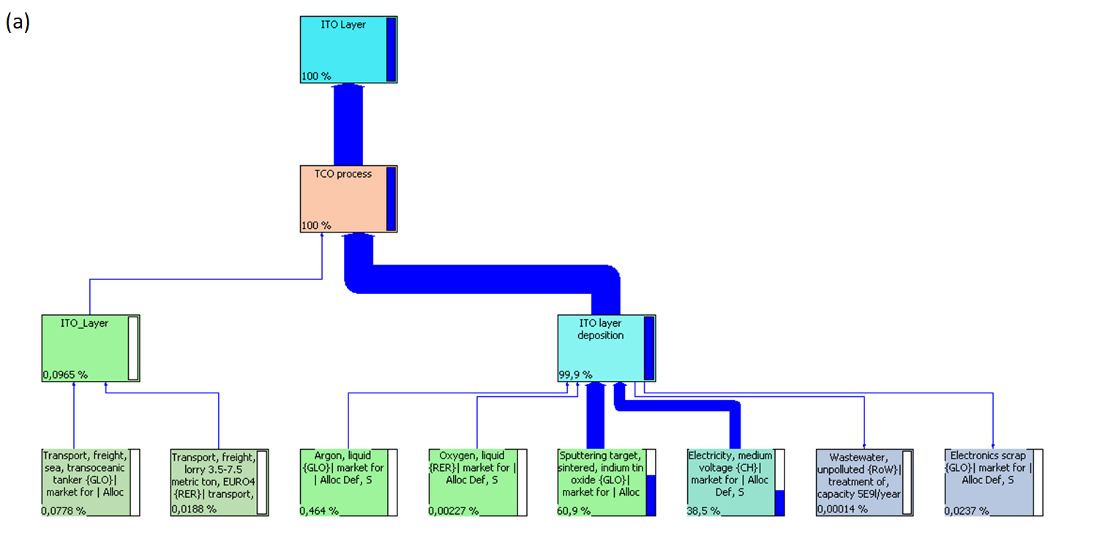

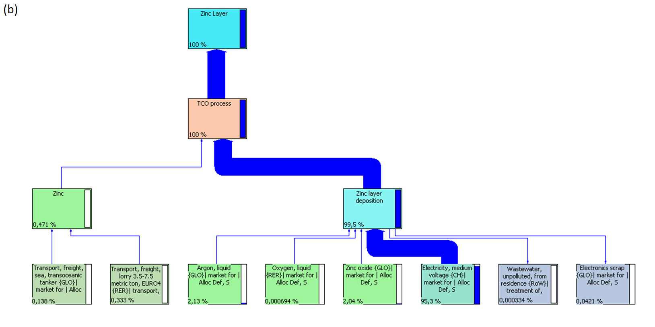

*Figure 1:* *Process tree for a) ITO and b) ZnO coating deposited by PVD technique.*

LCA analysis for CVD deposition of ZnO with Boron doping was carried out. For CVD technique of ZnO:B deposition, all the data necessary for LCA calculations, except diethylzinc (DEZ) were available in the EcoInvent database. Trimethylborate was selected as the most adequate replacement for actually used diethylzinc.

In the case of ZnO-based layers, deposited by different techniques, electricity consumption proved to be the key contributor to environmental impact. However, the LCA calculations were based on data gathered from lab scale devices, which usually are less energy efficient than industrial scale ones. Therefore, it is essential to validate how the results of analysis would change with energy efficiency of the process. LCA analysis was recalculated for each case, assuming that the energy consumption for the deposition process was reduced by 10, 20, 50 and 100 %. With higher energy efficiency, ZnO layer deposited by PVD process has even lower environmental impact that the ITO layer. The CVD and ALD techniques are characterized by higher energy consumption than the PVD process; consequently improvement of energy efficiency for CVD& ALD has a more significant impact on the LCA results.

* 1. Results

Results for all analyzed cases are summarized in Table 1. For the PVD technique, replacement of ITO by ZnO/ ZnO:Al reduces environmental load by half. ZnO / ZnO:Al layer deposited by PVD seems to be the best option for ITO replacement. The results obtained for the ZnO:Al layer deposited by CVD and ALD techniques cannot be directly bench marked towards the ITO layer deposited by PVD, since differences in deposition technologies result in significant difference in the single score for each technique. However, in case of all layers deposited by CVD and ALD techniques the main impact is related to electricity or nitrogen consumption and the impact produced by the material is of minor significance. Hence, that proves that ZnO has a low environmental impact and is an appropriate replacement for ITO in all cases.

Table 1: Summary of LCA results

|  |  |  |  |
| --- | --- | --- | --- |
| No. | Compound | Deposition Techniques | Main impact [%] |
| 1 | ITO reference case | PVD | ITO 60.9 |
| 2 | ZnO | PVD | Electricity 95.3 |
| 3 | ZnO:Al | PVD | Electricity 95 |
| 4 | SnO2 | PVD | Tin dioxide 90.0 |
| 5 | ZnO:B | CVD | Electricity 84.1 |
| 6 | ZnO:Al | ALD (spatial) | Nitrogen 99.5 |
| 7 | ZnO:Al | ALD (batch) | Nitrogen 98.1 |

* 1. Conclusions

Replacement of ITO by ZnO proved to be a promising strategy towards minimization of the environmental impact of the TCO layer deposition process. The impact was, approximately 50 % lower for ZnO than for ITO deposited by sputtering. The ZnO consumption is responsible for a minor part of the environmental impact (ca. 1 %). However, the results for SnO2 layer are less promising, due to the high environmental impact of the SnO2 raw material. LCA analyses were also calculated for Boron doped ZnO (ZnO:B) deposited by means of PE-CVD (plasma enhanced chemical vapour deposition). In this case one of the chemical compounds needed to make the layer, Diethylzinc (DEZ), was not present in the EcoInvent database. Trimethylborate was selected instead as the most adequate replacement. Analysis of the LCA results shows that energy consumption is a decisive factor affecting the environmental impact for CVD production of ZnO:B: 84.1 % of the total environmental score is due to electricity usage versus only about 9 % for the material usage. In presented work Electricity was chosen for the Switzerland, where electricity is mainly generated by hydropower (59.9%), nuclear power (33.5%) and conventional thermal power plants (2.3%, non-renewable). Different locations (markets) can generate even higher inputs due to the predominantly use of energy from non-renewable sources. The total score for CVD process is higher than for all cases in PVD technique. LCA analyses of AZO coatings applied by either conventional or spatial atomic layer deposition revealed a score significantly higher than that of the PVD and PE-CVD AZO coatings. This was due to high nitrogen and/or electricity usage. This result is strongly influenced by the operation of the scale and experimental nature of the equipment for which the data has been collected, exaggerating the outcome. Nevertheless, crucial is, that the impact related to the deposited material is minor, what proves that ZnO coatings enable to reduce the final environmental load. Obtained LCA results support further process improvement and help to determine possibilities of environmental impact minimization.

Acknowledgments

This project has received funding from the European Union’s Horizon 2020 research and innovation programme under grant agreement No 641864.

References

Afre R. A., Sharma N., Sharon M., Sharon M., 2018, Transparent Conducting Oxide Films for Various Applications: A Review. Reviews on Advanced Materials Science 53 (1): 79–89.

Bobba S., Carrara S., Huisman J., Mathieux F., Pavel C., 2020, Critical Raw Materials for Strategic Technologies and Sectors in the EU - a Foresight Study. European Commission.

Ciacci L., Werner T.T., Vassura I., Passarini F., 2019, Backlighting the European Indium Recycling Potentials, Journal of Industrial Ecology 23 (2): 426–437.

Commission, European. 2020. “Critical Raw Materials Resilience: Charting a Path towards Greater Security and Sustainability.” COM(2020) 474 Final.

Dalapati G., Sharma H., Guchhait A., Bamola P., Zhuk S., Liu Q.N., Gopalan S., et al. 2021, Critical Review on SnO2 for Transparent Conductor and Electron Transport Layer: Impact on Dopants and Functionalization of SnO2 on Photovoltaic and Energy Storage Devices. Journal of Materials Chemistry A.

Frenzel M., Mikolajczak C., Reuter M.A., Gutzmer J., 2017, Quantifying the Relative Availability of High-Tech by-Product Metals – The Cases of Gallium, Germanium and Indium. Resources Policy 52 (April). Elsevier Ltd: 327–335.

Gong L., Lu J., Ye Z., 2011, Conductive Ga Doped ZnO/Cu/Ga Doped ZnO Thin Films Prepared by Magnetron Sputtering at Room Temperature for Flexible Electronics. Thin Solid Films 519 (11). Elsevier B.V.

ISO. 2006. “ISO 14044:2006.” Environmental Management - Life Cycle Assessement - Requirements and Guidelines, ISO 14044, International Organization for Standardization.

Kim S., Jeong H., Choi S.H., Park J.T., 2019, Electrical Conductivity Measurement of Transparent Conductive Films Based on Carbon Nanoparticles. Coatings 9 (8): 1–12.

Klöpffer W., Grahl B., 2014, Life Cycle Assessment (LCA): A Guide to Best Practice. Life Cycle Assessment (LCA): A Guide to Best Practice.

Lokanc, Martin, Roderick Eggert, and Michael Redlinger. 2015, The Availability of Indium: The Present, Medium Term, and Long Term. National Renewable Energy Laboratory.

Lu Y., Poole J.E., Aytug T., Meyer H.M., Ozcan S., 2015, Tunable Morphologies of Indium Tin Oxide Nanostructures Using Nanocellulose Templates. RSC Advances.

Minami T., 2005, Transparent Conducting Oxide Semiconductors for Transparent Electrodes. Semiconductor Science and Technology.

Mohamed S. H., El-Hossary F.M., Gamal G.A.,Kahlid M.M., 2009, Properties of Indium Tin Oxide Thin Films Deposited on Polymer Substrates. Acta Physica Polonica A.

O’Neill B., 2010, Indium Market Forces, a Commercial Perspective.” Conference Record of the IEEE Photovoltaic Specialists Conference, 556–559.

Werner T. T., Mudd G. M., and Jowitt S. M., 2015, Indium: Key Issues in Assessing Mineral Resources and Long-Term Supply from Recycling. Transactions of the Institutions of Mining and Metallurgy, Section B: Applied Earth Science 124 (4): 213–226.

Young W. G., Hartung W. H., Crossley F.S., 1936, Reduction of Aldehydes with Aluminum Isopropoxide. Journal of the American Chemical Society.

Yu, S., Li L., Lyu X.,Zhang W., 2016, Preparation and Investigation of Nano-Thick FTO/Ag/FTO Multilayer Transparent Electrodes with High Figure of Merit. Scientific Reports 6 (February). Nature Publishing Group, 1–8.

Ziemińska-Stolarska A., Barecka M., Zbiciński I., 2017, Effect of Replacement of Tin Doped Indium Oxide (ITO) by ZnO: Analysis of Environmental Impact Categories.E3S Web of Conferences 19, 1–4.

http://www.inrep.eu/