|  |  |
| --- | --- |
| cetlogo ***CHEMICAL ENGINEERING TRANSACTIONS***  ***VOL. 96, 2022*** | A publication of  aidiclogo_grande |
| The Italian Association  of Chemical Engineering  Online at www.cetjournal.it |
| Guest Editors: David Bogle, Flavio Manenti, Piero Salatino  Copyright © 2022, AIDIC Servizi S.r.l. **ISBN** 978-88-95608-95-2; **ISSN** 2283-9216 | |

Forecast of Carbon Consumption of a Blast Furnace Using Extreme Learning Machine and Probabilistic Reasoning

Wandercleiton Cardosoa,\*, Renzo di Felicea

aUniversità degli Studi di Genova

wandercleiton.cardoso@dicca.unige.it

**Abstract:** Blast furnaces are chemical metallurgical reactors for the production of pig iron and slag. The raw materials used (metallic feedstock) are sinter, granulated ore and pellets. The main fuel is metallurgical coke. Considering the existing difficulties in the field of simulation of complex processes, the application of solutions based on neural networks has gained space due to its diversity of application and increase in the reliability of responses. The Extreme Learning Machine is a way to train an artificial neural network (ANN) with only one hidden layer. The database used for numerical simulation corresponds to 3.5 years of reactor operation. Big Data contains 94875 pieces of information divided into 75 variables. The input of the ELM neural network is composed of 72 variables and the output of 3 variables. The selected output variables were coke rate, PCI rate and fuel rate. Artificial neural networks using extreme learning machines and using Big Data are able to predict fuel consumption based on the parameters of the reduction process in blast furnaces, and this can be verified by the accuracy of the model.

* 1. Introduction

Blast furnaces are chemical metallurgical reactors for the production of pig iron and slag. Pig iron is obtained in a liquid state and consists of iron (92 to 95%), carbon (3 to 4.5%) and impurities such as sulphur, phosphorus and silica. The raw materials used (metallic feedstock) are sinter, granulated ore and pellets. The main fuel is metallurgical coke. All these materials are loaded through the upper part of the reactor, with hot air blown into the lower section. The injected hot air gasifiers the coke and produces CO reducing gas and a large amount of heat that rises upwards in counter current to the descent of the charge, providing heating, reduction and melting of the metallic charge. Pulverized coal is used as an additional fuel, which is blown in together with hot air (Itman et al., 2014; Cardoso et al., 2021; Cardoso et al., 2021d; Kina et al., 2021).

The preheated air with a temperature of about 1200°C is blown through the blast tuyeres of the blast furnace and comes into contact with the coke in the raceway area. The contact of the oxygen in the air with the carbon of the coke heated to 1500°C first leads to a reaction that produces carbon dioxide (CO2). This highly exothermic reaction generates a large amount of heat for the process. The carbon dioxide immediately reacts with the carbon in the coke to form carbon monoxide (CO), according to the loss-of-solution or Boudouard reaction (C + CO2 2CO), which is very endothermic (Itman et al., 2013; Arif et. al, 2021; Cardoso et. al, 2021a; Cardoso et. al, 2022a; Cardoso et. al, 2022b; Cardoso et. al, 2022c; Kellouche et. al, 2021).

The moisture contained in the injected air reacts with the carbon in the coke to produce the reducing gases CO and H2. Although these reactions are endothermic, i.e. proceed under heat absorption, the exit of the reducing gases from the duct effectively results in a high heat input into the process, producing flame temperatures in excess of 2000°C. On the rest of the way through the furnace, the rising gas gives off heat to the descending metal layers and leaves the furnace with temperatures in the order of 100 to 150°C (Kurunov, 2019; Cardoso et. al, 2022d; Cardoso et. al, 2022e; Cardoso et. al, 2022f; Kina et al., 2021).

Due to the different heat requirements for a number of chemical reactions taking place at different levels in the furnace, the temperature profile takes on a characteristic shape: an upper preheating zone (0-800ºC) separated from a lower melting zone (900-1500ºC) and a vertical thermal reserve zone whose temperature is in the range of 800-1000ºC. The thermal reserve zone, where there is little heat exchange between gas and solids, occupies 40-50% of the total height of the furnace (David et. al, 2016; Liang et. al, 2020; Cardoso et. al, 2021b; Cardoso et. al, 2022g; Kina et al., 2021). The nature of the counter current process allows a highly reducing gas (high content of CO) to contact the metallic mineral wustite, which has the lowest oxygen potential of the iron oxides, and then hematite and magnetite in the upper zone to be reduced by a gas with a lower reduction potential. Since CO2 is the end product of carbon combustion, the more oxygen that is removed, the more complete the utilisation of the thermal and chemical energy of the carbon. These reactions are called indirect reduction, and the overall reaction is slightly exothermic. If some of the wustite remains unreduced, it is further reduced by direct reduction in the range where temperatures exceed 1000°C (Su et. al, 2018, Cardoso et. al, 2021c; Liu et. al, 2021).

The high temperature ramp gas generated in the combustion zone (the tuyeres region) causes heating of the charge, decomposition reactions and reduction of oxides during its ascent in the blast furnace. As a result, the temperature of the gas gradually decreases while its chemical composition changes (Cardoso et. al, 2022).

First, near the charge level, the charge undergoes moisture evaporation and preheating. When the charge decreases, the reduction of iron oxides takes place. In the softening and melting zone, in the area of the lower vat and the belly, begins the softening and melting of the charge, which develops to the crucible (Ducic, 2020).

The pig iron (hot metal) and slag that are in the crucible are removed at controlled intervals through the running holes. In the area of the tuyeres, the coke gradually decreases in size as it burns. Together with the fusion of the materials that make up the charge, this causes the level in the blast furnace to drop, so that a new charge has to be conveyed at the top (Arif et. al, 2021).

Coke is considered the permeabilizer of the blast furnace charge. This role cannot be assumed by any other fuel, as coke is the only material capable of maintaining the permeability of the bed to the ascending gas, as well as that of the descending liquid slag and hot metal. Coke remains solid under the high-temperature conditions prevailing in the oven and maintains levels of resistance to the different stresses it undergoes inside the oven. This allows it to maintain a suitable size and size distribution for good permeability, without which the manufacture of pig iron in a blast furnace would be impossible (Lyalyuk et. al, 2018).

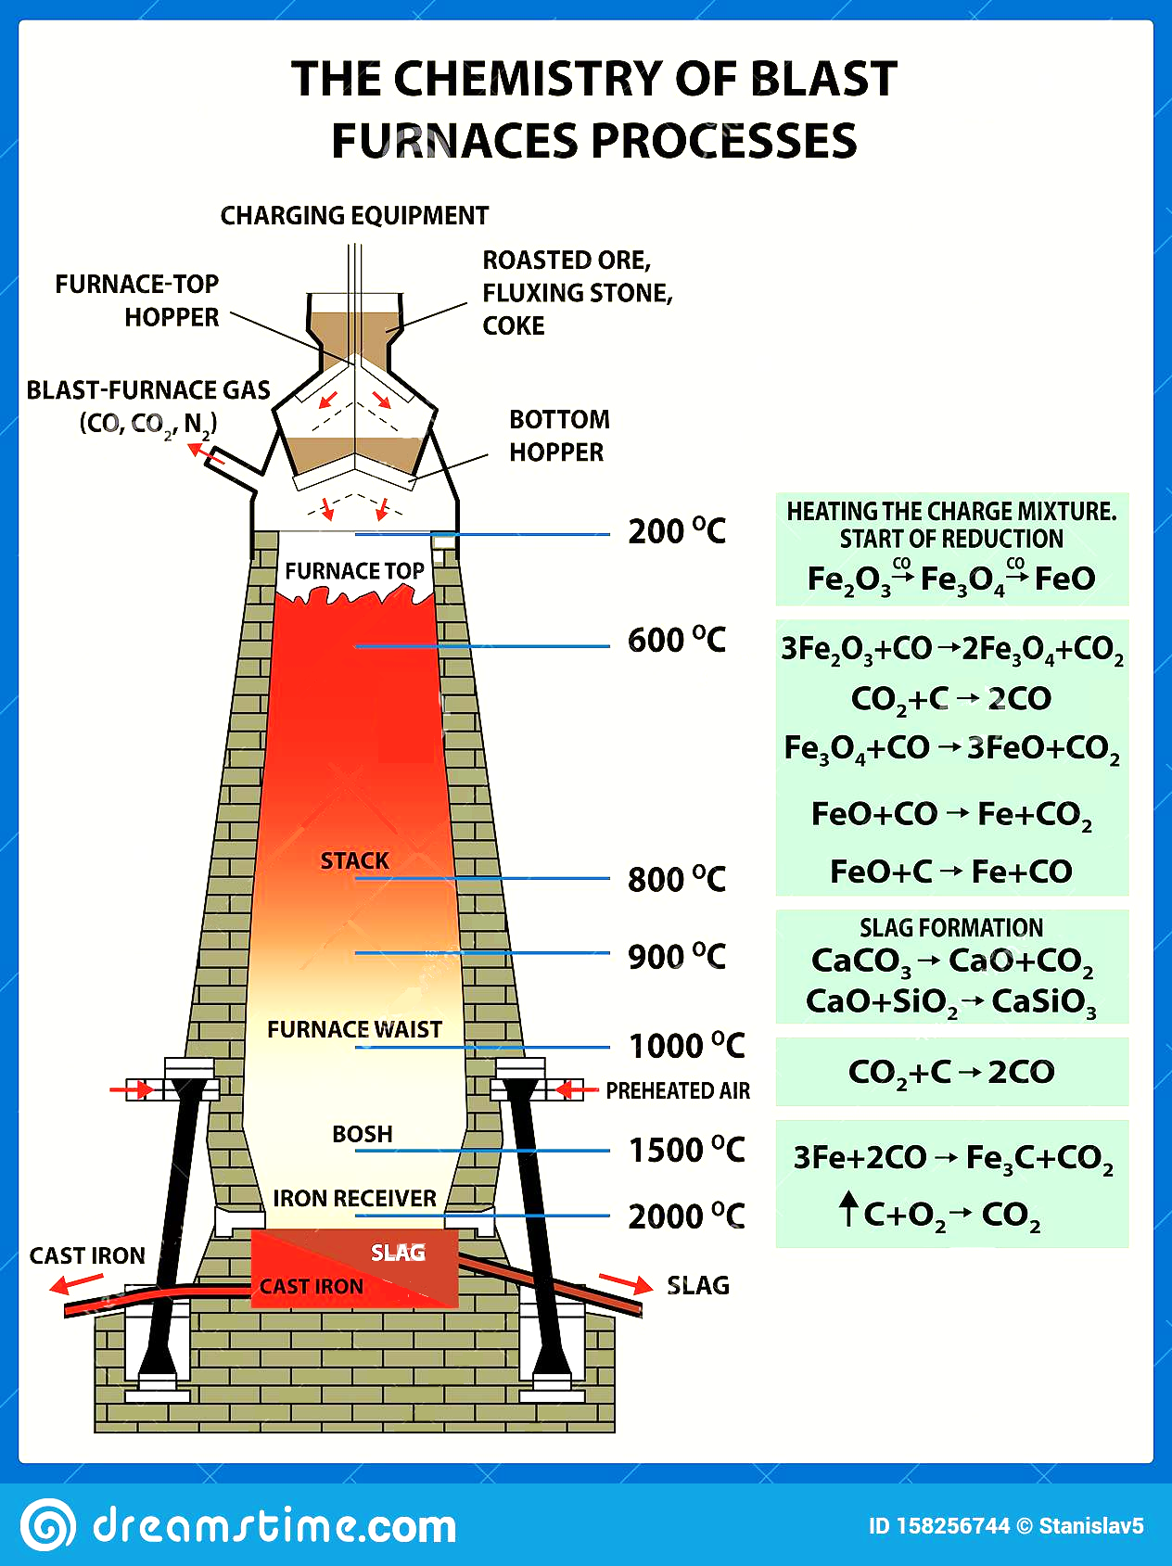However, the thermal and chemical roles can be played, in part, by other liquid fuels (petroleum fuel oil and coal tar), gaseous with high calorific value (reducing gas, natural gas, and coke oven gas) or solids (mainly, mineral coal), injected through the tuyeres of the kiln. Thus, these auxiliary fuels also participate as sources of heat and reducing gas for the process. Figure 1 illustrates the working principle of a blast furnace (Lyalyuk et. al, 2017).

*Figure 1: Blast furnace* working principle

In the field of technology and modelling, in addition to predicting the effects of changes in production parameters, several blast furnace simulation models have been developed with the aim of improving production conditions, including two- and three-dimensional models that allow progress and detailed information on fluid flow and mass and heat balances within the blast furnace (Wong et. al, 2016).

Considering the existing difficulties in the field of simulation of complex processes, the application of solutions based on neural networks has gained space due to its diversity of application and increase in the reliability of responses, since the neural network receives new data in the operating process/training without necessarily drawing conclusions about values or types of interaction between raw materials for the use of neural models.

The Extreme Learning Machine, an algorithm proposed by Huang et al. (2004) and Huang et al. (2006), is then another way of training an artificial neural network (ANN) with only one hidden layer. The working principle of ELM is the same as that of ANN, however, the training methodology of ELM is not based on gradient descent.

Thus, the algorithm escapes the main shortcomings of backpropagation: slow convergence and convergence to local minima. The extreme learning machines used in this work have an architecture similar to multi-layer neural networks (MultiLayer Perceptron), with only one intermediate layer, as shown in Figure 2.

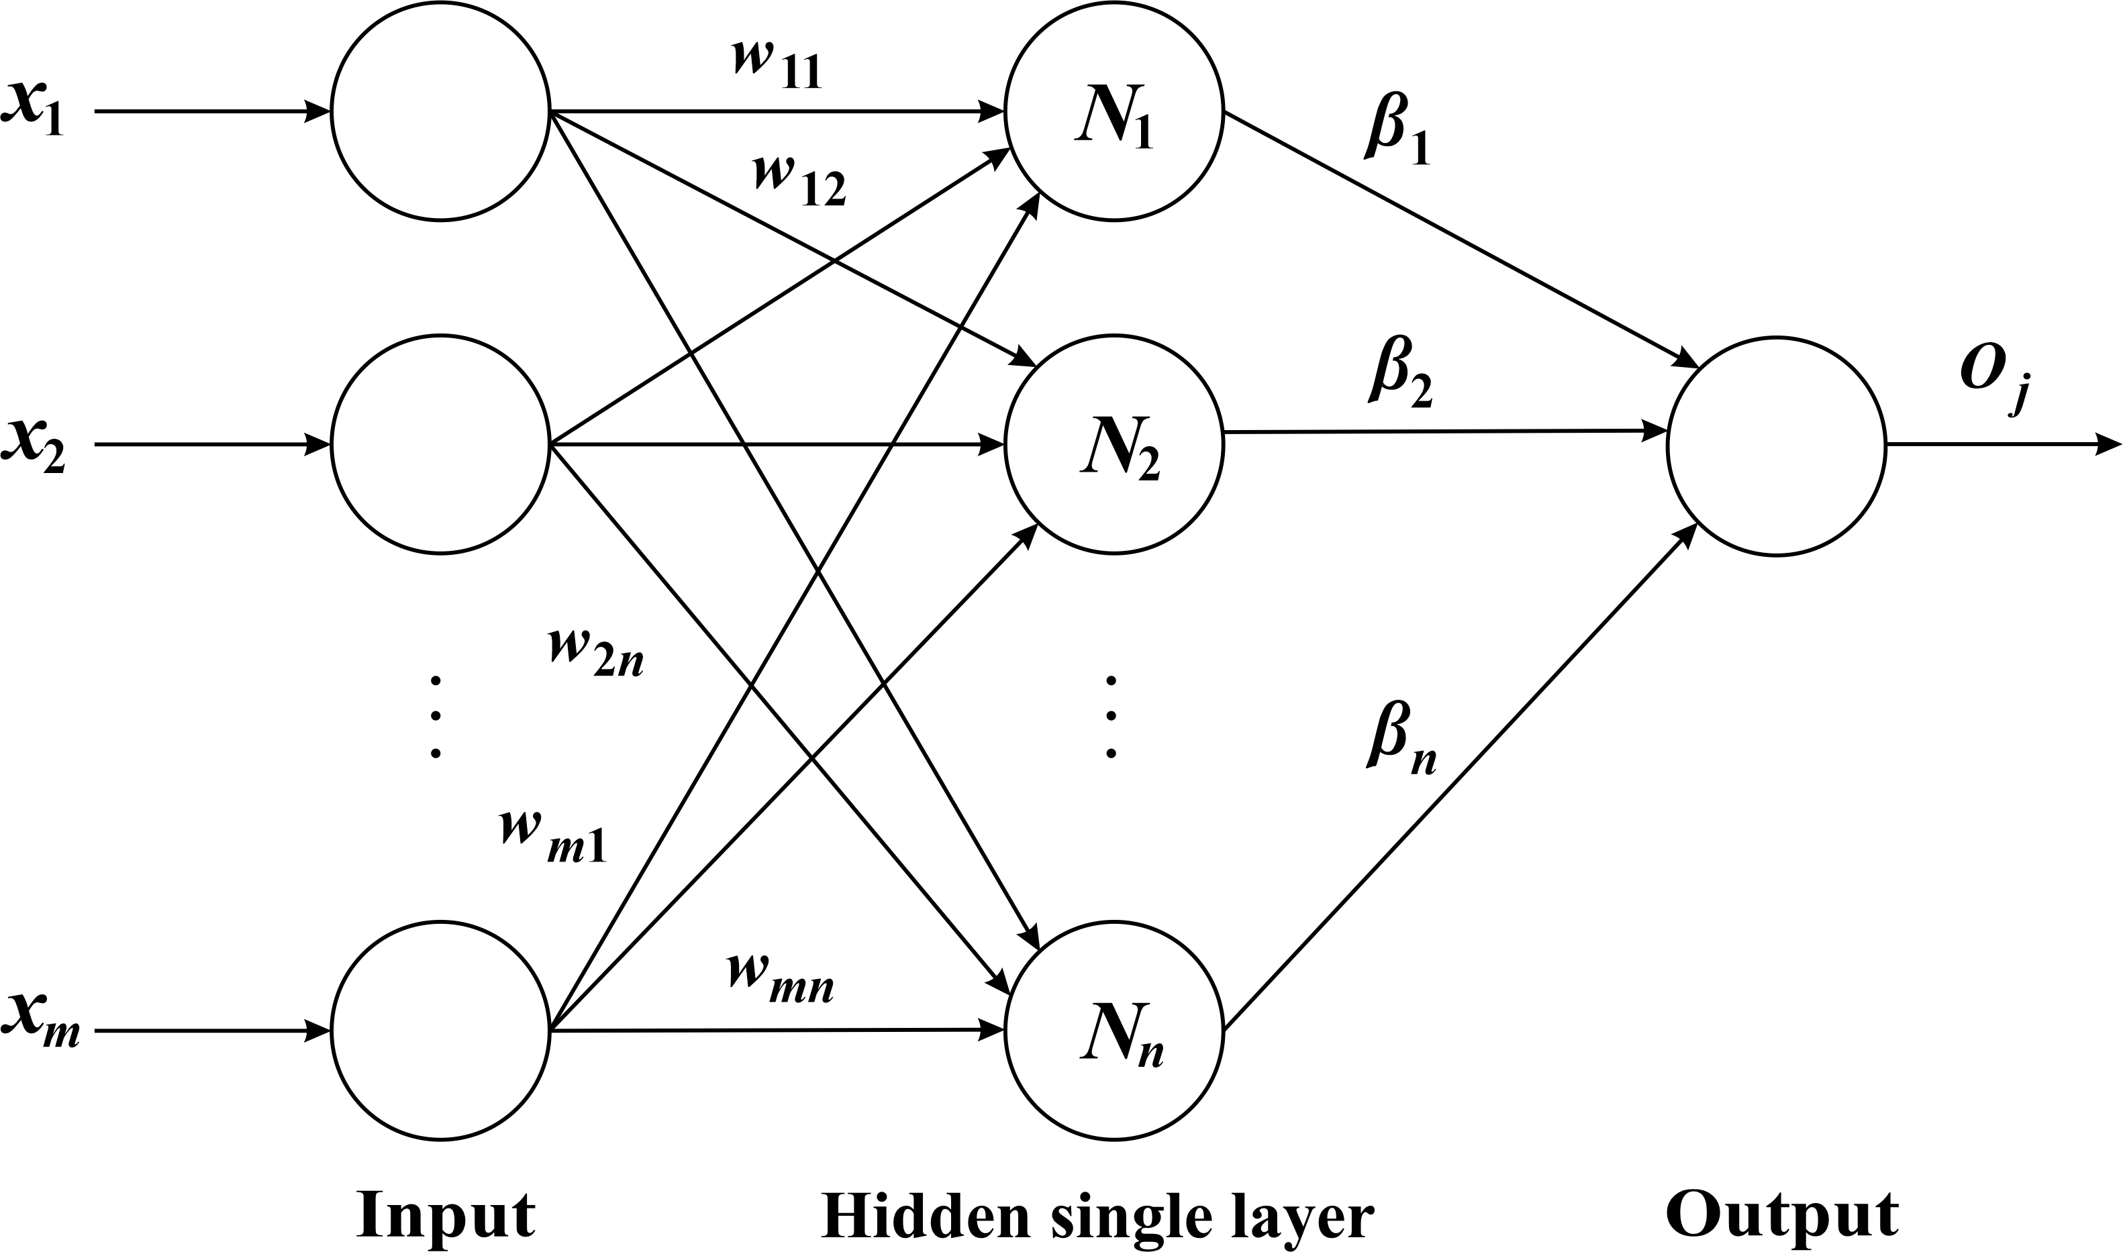

*Figure 2:* Artificial neural network using the extreme learning machine principle

The goal of this work is to numerically simulate an artificial neural network with 25 neurons in the hidden layer using the extreme learning machine methodology.

* 1. Research Method

The database used for numerical simulation corresponds to 3.5 years of reactor operation. Big Data contains 94.875 pieces of information divided into 75 variables. The input of the ELM neural network is composed of 72 variables and the output of 3 variables. The selected output variables were coke rate, PCI rate and fuel rate.

The artificial neural network has a similar structure to Figure 2 with an architecture based on an extreme learning machine, a simple layer, 25 neurons in the hidden layer, using the Levenberg-Marquardt training algorithm, and a sigmoid activation function. Figure 3 shows more details of the architecture.



*Figure 3: Architecture of a*rtificial neural network using the extreme learning machine principle

Considering the information in the work of Cardoso and Felice (2021), 85% of the database should be used to train a neural network based on an extreme learning machine and the remaining 15% will be used to test the predictive ability of the model. Cross-validation is a step that occurs after testing and using an additional database. At this stage, the predictive ability of the model is tested again. Table 1 illustrates the splitting of the database.

Table 1: Division of samples

|  |  |
| --- | --- |
| Step | Samples |
| Training | 935 |
| Testing | 165 |
| Cross-validation | 165 |

The method used to evaluate the quality of the neural network model was the RMSE (root mean square error). Small values close to zero indicate better predictive capacity of the model. Pearson's mathematical correlation coefficient (R) was also used to validate the mathematical models. The RMSE mathematical equation is presented in Eq(1) and Pearson's mathematical correlation coefficient is presented in Eq(2).

$$RMSE=\sqrt{\frac{1}{n}\sum_{i=1}^{n}{{\left(C_{neural }-C_{real }\right)}^{2}} } (1)$$

$$R=\sqrt{{\left[\sum_{i=1}^{n}{{\left(C_{neural }-C_{real }\right)}^{2}}\right]}/{\left[\sum_{i=1}^{n}{{\left(C_{real }-C_{neural }\right)}^{2}}\right]}} (2)$$

Descriptive statistics describe the database using measures such as mean, median, standard deviation, maximum, minimum, skewness, and kurtosis. Table 2 illustrates the statistics of the output variables (coke rate, PCI rate, and fuel rate) used in the Extreme Learning Machine.

Table 2: Output variables

|  |  |  |  |  |  |  |  |  |
| --- | --- | --- | --- | --- | --- | --- | --- | --- |
| Variables | Unit | Mean | Std\_Dev | Minimum | Median | Maximum | Skewness | Kurtosis |
| Coke rate | kg/ton | 312.9 | 24.4 | 272.1 | 310.8 | 489.0 | 2.7 | 12.9 |
| PCI rate | kg/ton | 179.9 | 19.3 | 128.5 | 179.9 | 222.5 | -0.1 | -0.5 |
| Fuel rate | kg/ton | 492.8 | 19.5 | 464.4 | 490.3 | 668.9 | 4.9 | 33.7 |

* 1. Results and discussions

Table 3 presents the results of the descriptive statistics between the extreme learning machine (ELM) and the values available in Big Data. Table 4 illustrates the obtained RMSE values. It is important to note that the RMSE values are not considered high due to the high magnitude of the variables. Figures 4 to 6 illustrate the ELM results using a scatterplot of the output variables compared to big data values.

Table 3: Descriptive statistics of output variables

|  |  |  |  |  |  |  |  |  |  |
| --- | --- | --- | --- | --- | --- | --- | --- | --- | --- |
| Source | Variables | Unit | Mean | Std\_Dev | Minimum | Median | Maximum | Skewness | Kurtosis |
| Big Data | Coke rate | kg/ton | 312.9 | 24.4 | 272.1 | 310.8 | 489.0 | 2.7 | 12.9 |
| ELM | 314.8 | 24.0 | 272.1 | 312.3 | 496.1 | 2.7 | 14.1 |
| Big Data | PCI rate | kg/ton | 179.9 | 19.3 | 128.5 | 179.9 | 222.5 | -0.1 | -0.5 |
| ELM | 179.9 | 18.6 | 128.5 | 179.9 | 223.1 | -0.2 | -0.5 |
| Big Data | Fuel rate | kg/ton | 492.8 | 19.5 | 464.4 | 490.3 | 668.9 | 4.9 | 33.7 |
| ELM | 494.7 | 19.8 | 460.8 | 492.6 | 675.7 | 4.6 | 31.4 |

Table 4: Root Mean Square Error (RMSE)

|  |  |  |  |
| --- | --- | --- | --- |
| Step | Coke rate | PCI rate | Fuel rate |
| Overall | 4.494 | 2.412 | 4.874 |
| Training | 4.499 | 2.249 | 5.062 |
| Testing | 4.481 | 2.756 | 4.405 |
| Cross-validation | 4.491 | 2.472 | 4.780 |

*Figure 4:* Coke rate scatter diagram between ELM results and Big Data

*Figure 5:* PCI rate scatter diagram between ELM results and Big Data

*Figure 6:* Fuel rate scatter diagram between ELM results and Big Data

The analysis of Table 3 proves that the extreme learning machine has achieved excellent results, as the values are similar to those of Big Data. The values obtained for the RMSE in Table 4 were relatively low considering the size of the variables. In Figure 4, the coke rate shows a mathematical correlation of 0.9706, while in Figure 5, the PCI rate shows a mathematical correlation of 0.9544. The fuel rate (Figure 6) is the sum of the coke rate and the PCI rate and shows a mathematical correlation of 0.9484. This again proves the excellent learning ability of the artificial neural network based on an extreme learning machine.

* 1. Conclusions

Regarding simulation methods for predicting process variables, the increasing development of computational capacity leading to cheaper and more powerful equipment is driving the development of more complex algorithms with better results, such as artificial neural networks using extreme learning machines.

Artificial neural networks using extreme learning machines and using Big Data are able to predict fuel consumption based on the parameters of the reduction process in blast furnaces, and this can be verified by the accuracy of the model.

References

Arif M. S., Ahmad I., 2021, Artificial Intelligence Based Prediction of Exergetic Efficiency of a Blast Furnace. Computer Aided Chemical Engineering, 50, 1047-1052.

Cardoso W., di Felice R., 2021, Prediction of silicon content in the hot metal using Bayesian networks and probabilistic reasoning. International Journal of Advances in Intelligent Informatics, 07, 268-281.

Cardoso W., Barros, D., Baptista, R., di Felice R., 2021a, Mathematical Modelling to Control the Chemical Composition of Blast Furnace Slag Using Artificial Neural Networks and Empirical Correlation. IOP Conference Series: Materials Science and Engineering, 1203, 032096.

Cardoso W., di Felice R., Baptista, R., 2021b, Artificial Neural Networks for Modelling and Controlling the Variables of a Blast Furnace. In IEEE 6th International Forum on Research and Technology for Society and Industry (RTSI)*,* 148-152.

Cardoso W., di Felice R., Baptista, R., 2021c, Mathematical modelling of a solid oxide fuel cell operating on biogas. Bulletin of Electrical Engineering and Informatics, 10, 2929-2942.

Cardoso, W., Di Felice, R. 2021d. Prediction of Silicon Content in the Hot Metal Using Bayesian Networks and Probabilistic Reasoning. International journal of advances in intelligent informatics, 07, 268–281.

Cardoso W., di Felice R., Baptista, R., 2022, Artificial neural network for predicting silicon content in the hot metal produced in a blast furnace fuelled by metallurgical coke. Materials Research, 25, 20210439.

Cardoso, W, Di Felice, R., 2022a, A Novel Committee Machine to Predict the Quantity of Impurities in Hot Metal Produced in Blast Furnace. Computers & chemical engineering 163, 107814.

Cardoso, W., Di Felice, R., Baptista, R., 2022b, A Critical Overview of Development and Innovations in Biogas Upgrading. In: Proceedings of the 7th Brazilian Technology Symposium (BTSym’21). Smart Innovation, Systems and Technologies, Springer, 295, 42-50.

Cardoso, W., Di Felice, R., Baptista, R., 2022c, Artificial Neural Network-Based Committee Machine for Predicting the Slag Quality of a Blast Furnace Fed with Metallurgical Coke. In: Proceedings of the 7th Brazilian Technology Symposium (BTSym’21). Smart Innovation, Systems and Technologies, Springer, 295, 66-73.

Cardoso, W., Di Felice, R., Baptista, R., Machado, T., Galdino, A., 2022d, Evaluation of the use of blast furnace slag as an additive in mortars. REM - International Engineering Journal, 75, 215-224

Cardoso, W., Di Felice, R., Baptista, R., 2022e, Mathematical Modelling to Predict Fuel Consumption in a Blast Furnace Using Artificial Neural Networks. In: International Conference on Intelligent Emerging Methods of Artificial Intelligence & Cloud Computing. Smart Innovation, Systems and Technologies, Springer International Publishing, 273, 01-10.

Cardoso, W., Di Felice, R., Santos, B. N., Schitine, A. N., Machado, T. A. P., Galdino, A. G. S., Dixini, P. V. M., 2022f, Modeling of Artificial Neural Networks for Silicon Prediction in the Cast Iron Production Process. IAES international journal of artificial intelligence. 11, 530–538.

Cardoso, W., Machado, T., Baptista, R., Galdino, A., Pinto, F., Luz, T., 2022g, Industrial Technological Process for Welding AISI 301 Stainless Steel: Focus on Microstructural Control. In: Proceedings of the 7th Brazilian Technology Symposium (BTSym’21). Smart Innovation, Systems and Technologies, 295(2), 34-41, 2022.

David S. F., David F. F., Machado M. L. P., 2016, Artificial neural network model for predict of silicon content in hot metal blast furnace. Materials Science Forum, 869, 572–577.

Ducic N., Jovicic A., Manasijevic S., Radisa R., Cojbasic Z., Savković B., 2020, Application of Machine Learning in the Control of Metal Melting Production Process. Applied Sciences, 10, 6048-6063.

Huang G.B., Zhu Q.Y., Siew, C.K., 2004, Extreme learning machine: a new learning scheme of feedforward neural networks. IEEE International Joint Conference on Neural Networks, 02, 985–990.

Huang G.B., Zhu Q.Y., Siew, C.K., 2006, Extreme learning machine: theory and applications. Neurocomputing, 70, 489–501.

Itman, A., Silva, R. V., Cardoso, W. S., Casteletti, L. C.: Effect of Niobium in the Phase Transformation and Corrosion Resistance of One Austenitic-Ferritic Stainless Steel. Materials research, 17(4), 801–806, 2014.

Itman, André, Cardoso, W. S., Gontijo, L. C., Silva, R. V., Casteletti, L. C.: Austenitic-Ferritic Stainless-Steel Containing Niobium.Revista da Escola de Minas: REM, 66(4) 467–471, 2013.

Kellouche Y., Boukhatem B., Ghrici M., Rebouh R., Zidol A., 2021, Neural network model for predicting the carbonation depth of slag concrete. Asian Journal of Civil Engineering, 22, 1401-1414.

Kina C., Turk K., Atalay E., Donmez I., Tanyildizi H., 2021, Comparison of extreme learning machine and deep learning model in the estimation of the fresh properties of hybrid fiber-reinforced SCC. Neural Computing and Applications, 33, 11641-11659.

Kurunov I. F., 2019, Ways of Improving Blast Furnace Smelting Efficiency with Injection of Coal-Dust Fuel and Natural Gas. Metallurgist, 61, 736–744.

Liang W., Wang G., Ning X., Zhang J., Li Y., Jiang C., Zhang N., 2020, Application of BP neural network to the prediction of coal ash melting characteristic temperature. Fuel, 260, 116324.

Liu Y., Wang Y., Chen L., Zhao J., Wang W., Liu Q., 2021, Incremental Bayesian broad learning system and its industrial application. Artificial Intelligence Review, 54, 1202-1214.

Lyalyuk V. P., Sokolova V. P., Kassim D. A., Lyakhova I. A., 2018, Influence of the Stability of Coke Quality on Its Consumption in the Blast Furnace. Coke and Chemistry, 618.

Lyalyuk V. P., Tarakanov A. K., Kassim D. A., Otorvin P. I., Pinchuk D. V., 2017, Blast-furnace operation with pulverized-coal injection and with chunk anthracite. Steel in Translation, 47.

Su X., Zhang S., Yin Y., Xiao W., 2018, Prediction model of permeability index for blast furnace based on the improved multi-layer extreme learning machine and wavelet transform, Journal of the Franklin Institute, 355, 1663-1691.

Wong P. K., Zhong J., Yang Z., Vong C. M., 2016, Sparse Bayesian extreme learning committee machine for engine simultaneous fault diagnosis. Neurocomputing, 174, 331-343.