CHEMICAL ENGINEERING TRANSACTIONS  VOL. 96, 2022 | A publication of
The Italian Association
of Chemical Engineering
Online at www.cetjournal.it

Guest Editors: David Bogle, Flavio Manenti, Piero Salatino
Copyright © 2022, AIDIC Servizi S.r.l.
ISBN 978-88-95608-95-2; ISSN 2283-9216

Development of an innovative XPS food tray containing up to 50 % post-consumer recycled plastic, fully recyclable and with a lower environmental impact
Andrea La Piccirella
Versalis SpA, Via Taliercio, 14 - 46100 Mantova (MN) - Italy
andrea.la.piccirella@versalis.eni.com
In the context of mechanical recycling of post-consumer plastic waste, food-contact is a rather complicated
target, both from a technical and regulatory point of view. Versalis (Eni) has launched a new product for
food packaging called Versalis Revive® PS Air F, made of 75 % recycled polystyrene obtained from domestic
separate waste collection. With this material, through an important collaborative effort that involved all
the players in the food supply chain coordinated by Versalis (Eni), an innovative fully recyclable R-XPS food
tray was developed, made with an internal layer containing Versalis Revive® PS Air F and two external
layers of virgin polystyrene. This structure, called A-B-A functional barrier, guarantees food-contact in
compliance with European Regulations (EC) No. 282/2008 and (EU) No. 10/2011.
  - Introduction
    - The “SUP” Directive: driving force and challenge
The introduction of the EU regulatory package on the circular economy has strengthened the concepts of waste hierarchy, prevention, reuse and EPR systems for a truly Circular Economy.
This regulatory package includes Directive (EU) 2019/904 (so called “SUP” Directive) which concerns packaging. Some of the major innovations introduced concern plastic packaging, in particular:
- a recycling target is set for plastic packaging waste: 50 % by 2025 and 55 % by 2030;
- the phasing out of single-use plastics is programmed, introducing restrictions on placing on the market for the following products: cotton bud sticks, cutlery (forks, knives, spoons, chopsticks), plates, straws, beverage stirrers, sticks to be attached to and to support balloons, food containers, beverage containers and cups made of expanded polystyrene for immediate consumption, either on-the-spot or take-away.
Looking at Polystyrene (PS) demand for applications, packaging represents almost half of the volumes (see Figure 1). It follows that PS packaging is strongly impacted by the “SUP” Directive and that in order to achieve the European recycling targets it is necessary to create a value chain that allows to bring polystyrene waste back into food applications.
To date, in fact, PS that ends up in domestic separate collection (coming for the most part from food packaging), so called post-consumer r-PS (PC r-PS), is only “downcycled” in applications such as hangers or frames (typically black or dark).
Expandable Polystyrene (XPS) trays are widely used in the food sector as containers mainly for meat and fish, but also fruits.
The ultimate purpose of the project described in this document is to introduce PC r-PS in the XPS trays for the first time, to reduce the environmental impact of XPS trays, obtain a more circular package and create an economically sustainable PS recycling chain.

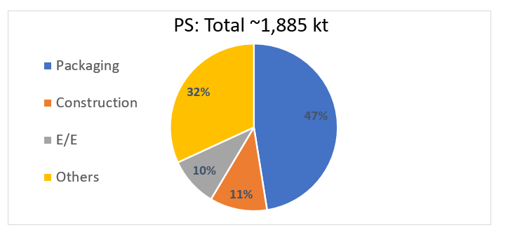
Figure 1: Breakdown of applications for PS (EU Market) (“Post-Consumer PS and EPS Plastics Waste - Generation and Recycling Opportunities in selected European Countries” – Conversio Final Report for Plastics Europe, 2018)
    - Use of recycled material in food application: Normative references
Within the general regulatory framework for Food Contact Materials (FCMs), the specific regulatory references for the use of recycled plastic materials in food applications are European Regulations (EC) No. 282/2008 and (EU) No. 10/2011.
Regulation (EC) No. 282/2008 regulates the use of recycled plastic for food applications. It does not apply to items where recycled plastic is used behind a functional barrier.
In the Regulation are contained the conditions for European Food Safety Authority (EFSA) recycling process authorization (100 % recycled plastic use):
- recycled plastic must come mainly from material originally intended for food ("closed and controlled chain", with different percentage depending on the plastic, e.g. 95 % for PET);
- "it must be demonstrated by a challenge test, or by other appropriate scientific data, that the process is capable of reducing any contamination of the plastic input to a concentration that does not represent a risk to human health";
The Regulation is currently under examination for changes to also include the concept of functional barrier.
EU Regulation No. 10/2011 regulates food contact for all plastics (including multilayer and therefore with any recycled core), regulating the use of the barrier layer and indicating lists of authorized substances with their specific migration limits (SML).
Unauthorized substances can be used behind the functional barrier, but under the following stringent conditions:
- They must not be carcinogenic, mutagenic, toxic for reproduction (CMR) or in nanoform;
- migration must be < 0.01 mg/kg (10 ppb), to be demonstrated through specific migration tests with food simulants under the worst foreseeable conditions of use of the package.
In the Regulation are also reported the detailed conditions for migration tests in food simulants.
  - Use of recycled material in food application with functional barrier: the “PET experience”
Talking about the reuse of recycled plastics in food, the main danger arises from secondary contamination of waste and possible harmful practices before entering the recycling loop. The packaging may have been mixed with materials unsuitable for contact with food or diverted from its original destination (e.g. to clean the brushes). Currently, only recycled polyethylene terephthalate (r-PET) is authorized for contact with food by EFSA. Other polymers (including polystyrene) could be authorized for direct contact with food if the absence of CMR substances is demonstrated and if the risk of transfer of Non-Intentionally Added Substances (NIAS) to food is lower than the previously defined acceptable thresholds by EFSA. The risk of food contamination by recycled materials can be reduced if a barrier layer, called functional, because it is not absolute, separates the recycled material from the food.
In PET packaging it has therefore become common practice to use type A-B-A structures in which A is the functional barrier of virgin PET and B is the core of Post-Consumer r-PET (PC r-PET) in the middle.
The possible migration mechanisms of NIAS to the food are:
- spontaneous diffusion (volatile substances): in this case direct contact between packaging and food is not necessary;
- direct contact (non-volatile / semi-volatile substances soluble in the contact phase) (see Figure 2).
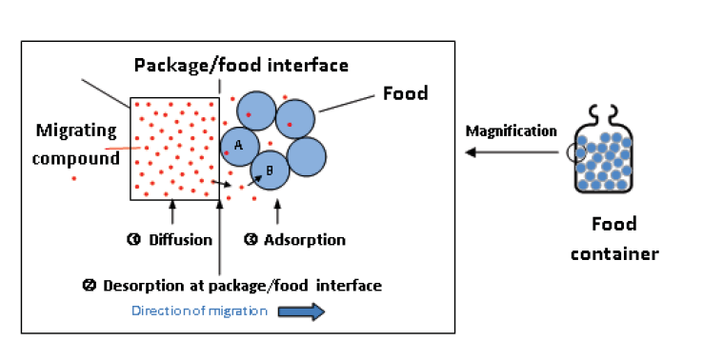
Figure 2: Diffusion/migration mechanisms (Lee D. S. et al., 2008)

The diffusion of NIAS migrant within the polymer depends on polymer chain mobility, migrant dimension, molecular weight, solubility and temperature (Lee D.S. et al, 2008).
All these parameters can be modeled to define the specific migration of analytically identified NIAS or model molecules and through modeling it is therefore possible to define the necessary thickness of the barrier layer in the conditions of application of the packaging (depending mainly on temperature and shelf-time). For references (Franz R. et al., 2009; Piringer O. et al., 1998).
The evaluation scheme used to design the functional barrier for PET food packaging included the following steps:
- determination of NIAS in PC r-PET;
- prediction of NIAS diffusivity by modeling;
- design of the thickness of the functional barrier;
- challenge test with surrogate molecules;
- migration test with food simulants.
In the EFSA Scientific Opinion document approving the mechanical recycling process for PC r-PET in contact with food, the contamination data of bottles from domestic collection are reported (Franz R. et al., 2004), thus determining the Reference Contamination Level (RCL). Furthermore, the criteria of the assessment scheme and the modeling for the surrogate contaminants to determine the Critical Concentration according to the identified exposure scenario (adults, toddlers or infants) are also exhaustively summarized.
  - Application of the “PET experience” to XPS trays
The evaluation scheme used to design the functional barrier for XPS trays is the same already tested for PET.
The supply chain that worked on this project consists of:
- Corepla which collects and selects PS packaging through the selection centers of its network;
- Forever Plast which treats the collected containers and transforms them into PC r-PS;
- Versalis which creates a compound between PC r-PS (75 %) and virgin PS (25 %, called booster), creating the product Versalis Revive® PS Air F - Series Forever with better properties than pure recycled thanks to the booster, a stable quality and a guaranteed chemical composition;
- XPS trays producers belonging to the Pro Food Italia Group that transform the Versalis Revive® PS Air F - Series Forever material into packaging for contact with food.
Fraunhofer Institute for Process Engineering and Packaging (IVV) provided technical and analytical support for analysis of NIAS in PC r-PS, definition of the diffusion modeling, challenge test.
    - Analysis of NIAS in post-consumer recycled PS
The first step was to characterize the NIAS present in PC r-PS.
The analyses were conducted by the Fraunhofer Institute for Process Engineering and Packaging (IVV), through headspace chromatography for volatiles and with extraction for medium-low volatiles.
At the end of the evaluation, it was possible to determine the NIAS present in the PC r-PS (thus also excluding the presence of CMR substances) with the relative maximum concentration thresholds, useful for defining the RCL which are:
- 10 mg/kg (10 ppm) for volatile NIAS;
- 100 mg/kg (100 ppm) for low to medium volatile NIAS.
    - Diffusion modeling and design of functional barrier thickness
The Fraunhofer Institute has therefore carried out a predictive study of the functional barrier properties of PS in A-B-A structure for NIAS with different molecular weights.
The diffusion model includes some assumptions:
- the density of the structure was considered 1.04 g/cm³ (typical of compact rigid PS) for both layer A and layer B;
- the diffusion analysis was done assuming the conditions of 6 °C and 25 °C for 365 days;
- B layer was considered to be made up of 100 % contaminated material;
- the concentration of contaminants in layer B for each contaminant substance (surrogate) was considered 10 mg/kg (10 ppm), based on RCL determined by the NIAS analyses on PC r-PS (see Paragraph 3.1);
- the migration limit for contaminants was considered 0.01 mg/kg (0.01 ppm) as indicated by EU Regulation No. 10/2011.
The conclusions of the study using the diffusion model are:
- a 30 µm layer of virgin PS is suitable to guarantee a functional barrier to the contamination coming from PC r-PS;
- according to the diffusion model, the protection of the functional barrier of 30 µm is effective for at least 365 days with storage at 6 °C and at least 50 days for storage at 25 °C (see Figure 3).

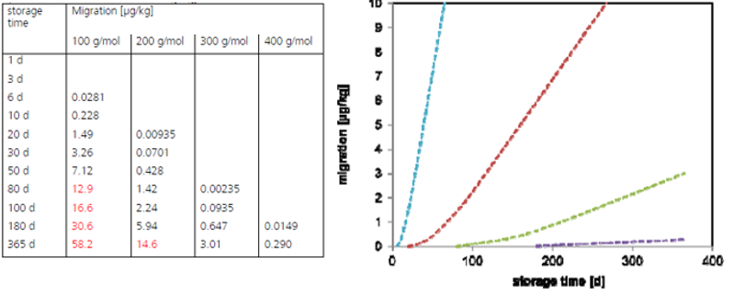
Migrations (µg/kg)
Storage time (days)
Figure 3: Calculation of migration for contaminants at different molecular weight for different storage times at 25 °C for a functional barrier of 30 µm

The results obtained can be adapted to the XPS trays, considering some aspects related to the peculiar nature of the process and of the expanded product:
- the density of an XPS extruded sheet can be considered 0.06 g/cm³ (average industrial data) and not 1.04 g/cm³. The lower density proportionally reduces the amount of material and potential contaminants in layer B per unit of surface in contact with the food. The quantity of substances that can migrate through the barrier layer is drastically reduced by more than a factor of 15;
- the amount of PC r-PS that will be used to produce layer B will be a maximum of 50 % and not 100 % as described in the diffusion model, mainly due to color issues.
Therefore, the following reduction coefficients can be applied to the migration value obtained from the diffusional model available for compact rigid materials:

Density Coefficient = foam density / rigid density = 0.06 g/cm³ / 1.04 g/cm³ = 0.05769 Eq(1)

Recycled Content Coeff. = real max recycled content / recycled content modeled = 50 / 100 = 0.5 Eq(2)

So, the final reduction coefficient to be applied to the diffusion results will therefore be:

Final Reduction Coeff. = Density Coeff. x Recycled Content Coeff. = 0.05769 x 0.5 = 0.028845 Eq(3)

Furthermore, the design of the barrier layer must also take into consideration the fact that with the thermoforming of the A-B-A sheet there is a thinning of the thicknesses due to stretching phenomena.
To then ensure that the A-B-A structure is maintained over the entire surface of the tray, a spreadsheet was developed that allows to determine what the starting thickness of layer A must be to ensure a certain thickness after thermoforming (see Figure 4). This system was then verified by asking an external accredited laboratory to perform stratigraphy on the trays, to verify that starting from a known thickness of the layers, the distribution of the thicknesses on the finished product provided for in the spreadsheet was reached.

- (b)
Figure 4: Scheme of the A-B-A structure on the sheet (a) and on the final thermoformed trays (b) as reported in the developed spreadsheet

    - Challenge Test
At this stage the scheme has been validated through the Challenge Test.
The virgin PS granule was artificially over contaminated with typical surrogates (see Table 1). The contamination level will then be normalized to an initial concentration of 100 mg/kg, applying a safety factor of 10 with respect to the real initial concentration value of the contaminants detected by the analyses on PC r-PS.
The contaminated material was then used to produce a sheet of XPS protected by 2 layers of virgin material (A-B-A structure) and then thermoformed into trays.
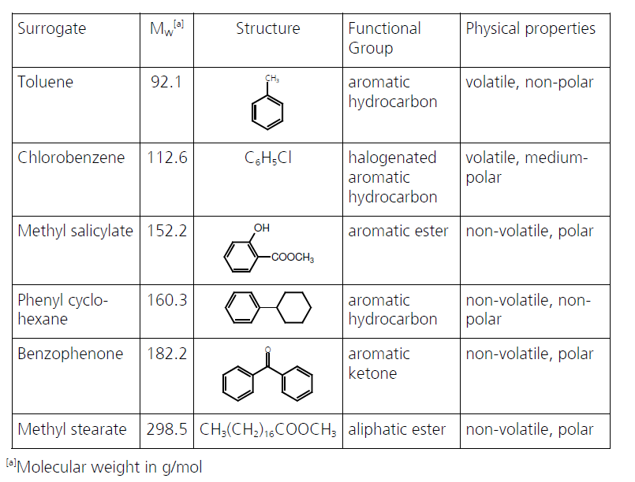
Table 1: Surrogates used in Challenge Test

    - Migration test with food simulants
The trays obtained with A-B-A structure were subjected to migration tests at accredited laboratories.
Migration tests were conducted at 60 °C for 10 days. These conditions are provided by EU Regulation No. 10/2011 for applications that require contact with food for more than 6 months at room temperature. In this way it was also included the standard period of pre-use (storage) of the trays.
The results show that there is no migration of contaminants into food simulants and therefore that the functional barrier in the A-B-A structure is effective in blocking any contaminants from the use of PC r-PS.
    - Validation of the evaluation scheme
At this stage the scheme was validated through the collaboration of the entire supply chain.
To ensure the compliance of the recycled material for the application, the Versalis Revive® PS Air F - Series Forever product is subjected to the following monitoring system on each production batch:
- analysis of volatile NIAS according to the UNI/TS 11788 method;
- analysis of low-medium volatile NIAS (internal method).
These analyses ensure that any NIAS remains within the concentrations defined as RCLs for volatiles and non-volatiles and therefore the effectiveness of the designed functional barrier.
  - Conclusions
Using the evaluation scheme already used for PET, it was possible to develop a product containing 75 % of PC r-PS that can be used in the XPS tray application with a functional barrier.
It has therefore been shown that it is possible to make an innovative XPS tray suitable for contact with food containing up to 50 % of PC r-PS. The tray must be made with an A-B-A structure where A are layers of virgin PS with a thickness of at least 30 µm each and B is an expanded structure containing a maximum of 50 % of PC r-PS.
The XPS tray is also fully recyclable because it does not contain other types of polymers and can be recycled in existing sorting and mechanical recycling plants.
Furthermore, the use of PC r-PS replacing virgin PS also brings a lower environmental impact to the innovative XPS trays respect to traditional ones. Comparing the production of PS from fossil feedstock to the production of PS from post-consumer waste feedstock through mechanical recycling, PC r-PS emits over 1500 kg less of CO₂ (-60 %) (data from Styrenics Circular Solutions LCA Study). Therefore, incorporating 50 % of PC r-PS in the XPS tray, leads to a 30 % reduction in terms of GWP (kg CO₂ eq.).
Nomenclature
EPR - Extended Producer Responsibility
“SUP” Directive – Single-Use Plastics Directive

PS - Polystyrene
r-PS – Recycled Polystyrene
PC r-PS – Post-Consumer Recycled Polystyrene
FCMs – Food Contact Materials
CMR Substances – Carcinogenic, Mutagenic, or toxic for Reproduction
SML – Specific Migration Limit
PET - Polyethylene Terephthalate
r-PET – Recycled Polyethylene Terephthalate
PC r-PET – Post-Consumer Recycled PET
EFSA – European Food Safety Authority
NIAS - Non-Intentionally Added Substances
RCL – Reference Contamination Level
XPS - Expanded Polystyrene
HIPS - High Impact Polystyrene
GPPS – General Purpose Polystyrene
Acknowledgments
Thanks to Corepla, Forever Plast, Fraunhofer Institute for Process Engineering and Packaging (IVV) and Pro Food Italia for the collaboration.
References
Commission Regulation (EC) No. 282/2008 on recycled plastic materials and articles intended to come into contact with foods and amending Regulation (EC) No 2023/2006
Commission Regulation (EU) No. 10/2011 on plastic materials and articles intended to come into contact with food
Directive (EU) 2019/904 of the European Parliament and of the Council of 5 June 2019 on the reduction of the impact of certain plastic products on the environment
Franz R., Bayer F., Welle F., 2004, EU-Project FAIR-CT98-4318 "Recyclability" Project: "Programme on the Recyclability of Food Packaging Materials with Respect to Food Safety Considerations - Polyethylene Terephthalate (PET), Paper & Board and Plastics Covered by Functional Barriers".
Franz R., Huber M., Piringer O., 2009, Presentation and experimental verification of a physico‐mathematical model describing the migration across functional barrier layers into foodstuffs
Lee D.S., Yam K.L., Piergiovanni L., 2008, Food Packaging Science and Technology
Piringer O., Franz R., Huber M., Begley T. H., McNeal T. P., 1998, Migration from Food Packaging Containing a Functional Barrier: Mathematical and Experimental Evaluation
“Post-Consumer PS and EPS Plastics Waste - Generation and Recycling Opportunities in selected European Countries” – Conversio Final Report for Plastics Europe, 2018
Scientific Opinion on the criteria to be used for safety evaluation of a mechanical recycling process to produce recycled PET intended to be used for manufacture of materials and articles in contact with food (EFSA Journal 2011;9(7):2184)
Styrenics Circular Solutions Event, Move to zero. Zero waste. Zero CO₂. Powered by styrenics., 30 June 2021 (https://styrenics-circular-solutions.com/life-cycle-analysis.html)
Welle F., 2013, Twenty years of PET bottle to bottle recycling—An overview

