CHEMICAL ENGINEERING TRANSACTIONS  VOL. 96, 2022 | A publication of
The Italian Association
of Chemical Engineering
Online at www.cetjournal.it

Guest Editors: David Bogle, Flavio Manenti, Piero Salatino
Copyright © 2022, AIDIC Servizi S.r.l.
ISBN 978-88-95608-95-2; ISSN 2283-9216

HOOP® ‐ Advanced chemical recycling technology for mixed plastics
Fabio Adelfi
Versalis (Eni), Via Taliercio 14, 46100 Mantova
fabio.adelfi@versalis.eni.com
HOOP® is the advanced chemical recycling technology via pyrolysis of mixed plastics developed by Versalis.
With this technology it is possible to recover as raw material the fraction of mixed plastic waste that cannot
be mechanically recycled and is sent to waste‐to‐energy or landfill. With this technology it is possible to
convert the mixed plastic waste into a raw material to be used as feedstock in the production cycles of the
chemical industry replacing the traditional raw material based on fossil sources to produce new plastic
exactly equivalent to the virgin one and suitable for any application (e.g. food contact, high tech, etc.). In this
way the plastic cycle is theoretically endless.
HOOP® technology foresees two‐step pyrolysis with separate reactors with an advanced reactor heating
system that makes the temperature extremely homogeneous throughout the reactor. The operating
conditions are continuously tuned on the basis of "online" monitoring of the composition of the input
material made with spectroscopic techniques, making the system flexible on the characteristics of the plastic
material fed and maximizing the yield and quality of the produced oil in all conditions. The result is a material
recovery above 80 %.
Versalis will build a first plant with 6,000 ton/y capacity at the Mantova site, with the aim of a subsequent
scale‐up in its national production sites.
  - Introduction
In 2020, more than 29,000,000 tons of post-consumer plastic waste were collected in the EU27+3. The implementation of recycling processes, mainly mechanical, has made it possible to achieve important objectives: from 2006 to 2020 the amount of post-consumer plastic waste collected has increased by about 20% and the share destined for recycling has doubled (from 4.7 x 10⁶ to 10.2 x 10⁶ tons per year). Still, over 23% of the collected plastic waste was sent to landfill and more than 40% was sent to energy recovery operations. (Source Plastics Europe “the Fact”). This is not only a source of CO₂ emissions but also a waste of valuable resources.
One of the main reasons is related to the specific composition of the plastic products. In fact, modern trends and market needs lead to the production of products specifically designed for the desired application. Many of these are made up of heterogeneous and colored materials, some have additives to improve their performances, or are characterized by complex structures, such as multilayer, to meet specific food storage or hygiene requirements. Therefore, the specific structure of these materials generally makes them difficult to rework efficiently while maintaining good quality. Mechanical recycling is therefore hampered, and, in fact, the recycled material can no longer be used in original applications but is downgraded to lower quality industrial applications. In addition, even for items that are easy to identify and separate (e.g. PET bottles and HDPE flacons), the number of “recycles” that can be done is limited due to the decrease in characteristics that each recycling step determines.

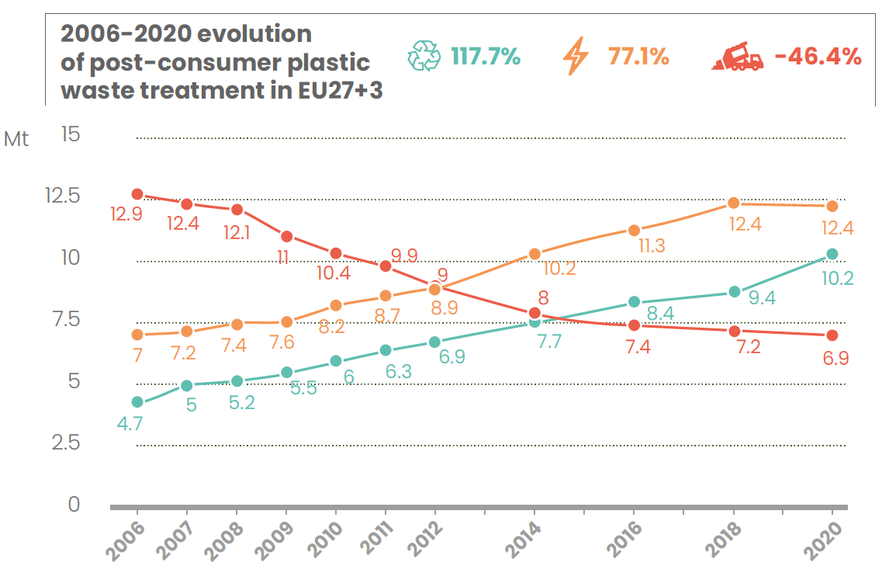
Figure 1. Evolution of post-consumer plastic waste in EU27+3
For this reason, it is essential to develop other recycling technologies that complement mechanical recycling in order to fill the gap in the recycling loop and change the way we approach plastic recycling.
Chemical recycling includes those technologies that aim to convert plastic waste into chemicals. These are processes in which the chemical structure of the polymer is modified and converted into chemical constituent elements, including monomers, which are then reused as raw material in chemical processes for the production of new polymers, equivalent to those produced from fossil raw materials.
These processes currently exist on a pilot or demonstration scale and require further research and development efforts for industrial scale scale-up and subsequent commercialization (Cefic Position Paper: Introducing chemical recycling: Plastic waste becoming a resource, 2020).
Versalis has developed an innovative technology to transform non-mechanically recyclable mixed plastic waste. Hoop® is an advanced pyrolysis technology that converts mixed plastic waste in a raw material to be used for the production of new virgin polymers suitable for each application and with characteristics identical to those that come from fossil sources.
  - Technology development
Hoop® project is part of the research and development activities that Versalis is carrying out on recycling of post-consumer plastic waste.
The conversion of plastics into liquids through the pyrolysis process consists of thermal decomposition of the material in an oxygen-free environment. Plastics waste contains various types of polymers that can degrade forming a wide spectrum of products: monomers, a mixture of waxy materials, paraffins olefins and aromatics. Depending on the starting polymers and the operating conditions of the decomposition, it is possible to obtain mixtures of compounds that can be both in the state liquid or gaseous at ambient conditions.
Pyrolysis is a process governed by kinetics and therefore very dependent on the technological solutions that are used. The main parameter that controls the pyrolysis of plastic materials is the temperature. It can be “low” (< 400 ° C) or “high” (> 600 ° C). The operating pressure is usually “low” (slightly above the atmospheric pressure). The pyrolysis processes of plastics provide two families of products: carbonized solid material and volatile material, which, cooled to ambient conditions, forms liquids, waxes and non-condensable.
The pyrolysis processes are carried out with different technologies. However, there are two aspects that characterize all the technologies for converting plastics into liquids:
- The quality / characteristic of the raw material;
- The conditions / methods of heat exchange that allow the chemical reactions (cracking).
The first aspect has a substantial impact on the entire process, it determines its technological choices, product quality and, ultimately, costs.
The second aspect, on the other hand, has an impact on the technological choices and on the operation. The process is governed by heat exchange, an efficient conversion of plastics into liquid requires an efficient and controlled heat exchange. The problem is that plastic materials are not suitable for heat exchange since they are insulating materials and therefore the process is complex, especially in terms of temperature homogeneity.
These two aspects are the elements that most characterize the different technologies of conversion of plastics to liquids that have been developed over the years.
The development of Hoop® Technology started with the selection of an existing technology to be further developed and upgraded. Twenty different processes have been preliminary assessed in order to evaluate the different technologies according to a list of criteria:
- Accepted quality of the feedstock;
- Type of operation;
- Type of process;
- Type of main reactor;
- Products and byproducts yield;
- Technology Readiness Level (TRL);
- Operated size.
The table 1 below, summarizes the results of such preliminary assessment:
Table 1: Preliminary assessment of pyrolysis technologies
Pyrolysis Technology Assessment
Feedstock quality  (# of Technology provider) | Unsorted  1 | Limited Sorting  2 | Sorted  17
Operation | Batchwise | Semi-batch | Continuous
 | 0 | 5 | 15
Process | Thermal | Catalytic | Other
 | 10 | 9 | 1
Reactor | Mobile | Fixed | Other
 | 13 | 2 | 5
TRL | < 5 | 5 to 8 | > 6
 | 1 | 19 | 0
Size Operated | < 10 t/d | 10÷20 t/d | > 20 t/d
 | 4 | 4 | 4

Among these technologies, six have been selected with the aim of creating a representative sample of the technology panel, by placing attention to include, among the technologies chosen, the greatest possible variety
of the main features.
A «feasibility study level» design has been developed per each of the shortlisted technology provider. The boundary conditions and the final purpose was the same.
The comparison of the results of the feasibility allowed to define a ranking in the technologies.

Based on the detailed analysis of the panel of pyrolysis technology there was an evidence that the technology originally developed by the Italian company “Servizi di Ricerche e Sviluppo“ (SRS), to convert a pre-sorted raw material derived from rich polyolefins mixed plastic waste in diesel fuel for motor vehicles, is the best option in terms of:
- Cost of the oil produced;
- Carbon footprint;
- Oil quality;
- Development potential in terms of:
  - Management of a wide variety of raw materials;
  - Improvement of the yield and quality of the oil and gas produced;
  - Possibility of process improvement.

Starting from this know-how, made available by SRS, Versalis is developing and customizing a new technology (Versalis Hoop® technology) that aims to recycle mixed plastic waste to produce liquid and gaseous hydrocarbons that can be used as raw material in the production cycles of monomers or other chemical intermediates (i.e. feedstock for Steam Cracking plants in place of or mixed with virgin naphtha).
The development activities started with a first phase of implementation of improvements of the original SRS technology, followed by the design phase of the first DEMO plant of the new Versalis Hoop® technology, which will be built by Versalis at the Mantova industrial site (installed capacity of approximately 6 kton/y of mixed waste as input).
To support and to guide the technology development, Versalis has carried out an in-depth program of experimental and analytical tests in the laboratories of the Versalis research center in Mantova.
The first step was the implementation of a lab scale pyrolysis reactor that reproduced the experimental results shared by SRS with reference to the running performed on the SRS pilot plant.

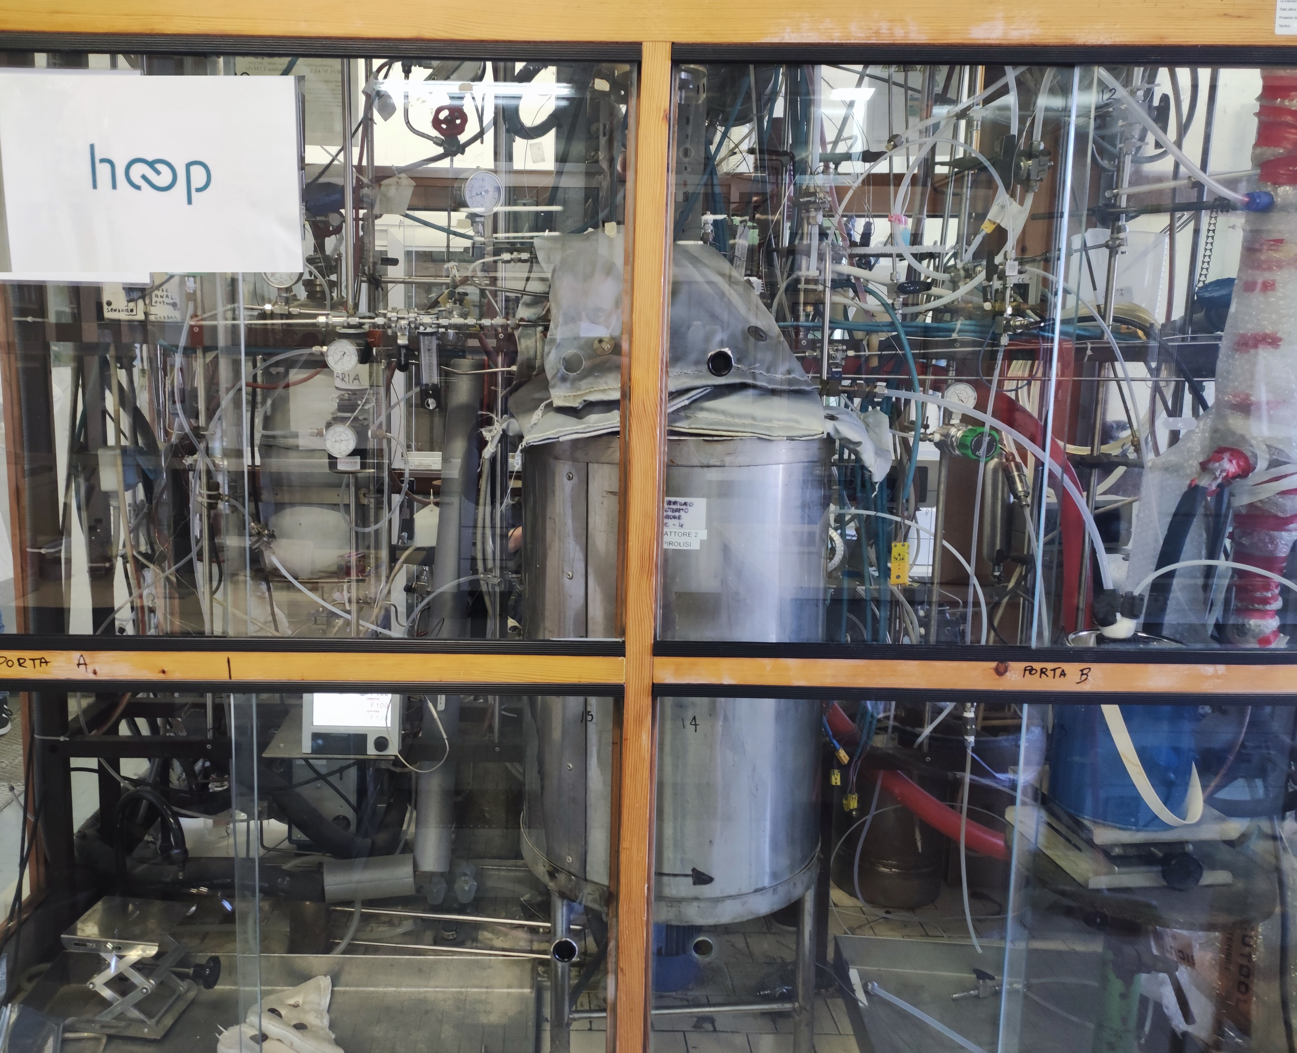
Figure 2. Hoop® lab-scale pyrolysis reactor
Once the implementation of such laboratory apparatus, capable of reproducing exactly the results of the pilot plant based on the original SRS technology, was finalized, it was possible to evaluate the effects of the improvements to be implemented in the new Versalis Hoop® technology (e.g. variation of operating conditions, introduction of catalysts, etc.) as well as the variation of the raw material fed to the pyrolysis. The different raw material has been classified according to a set of main parameters.

According to the evaluation of such parameters it is possible to tune the operating condition of the pyrolysis process in order to reach in every condition the best results in terms of yield and quality.
As example, in Figure 3 and Figure 4 below, is shown the effect of the tuning of the process parameters on products yield and r-oil composition for two different raw materials. “Relative quality (a.u.)” refers to an internal parameter which takes into account the chemical composition of the r-oil (based of PONA distribution) and provides a direct estimate of the goodness of such product for subsequent usage (e.g. co-feeding to steam cracking). According to such experimental results it has been possible to improve the overall process as detailed in the following paragraph.

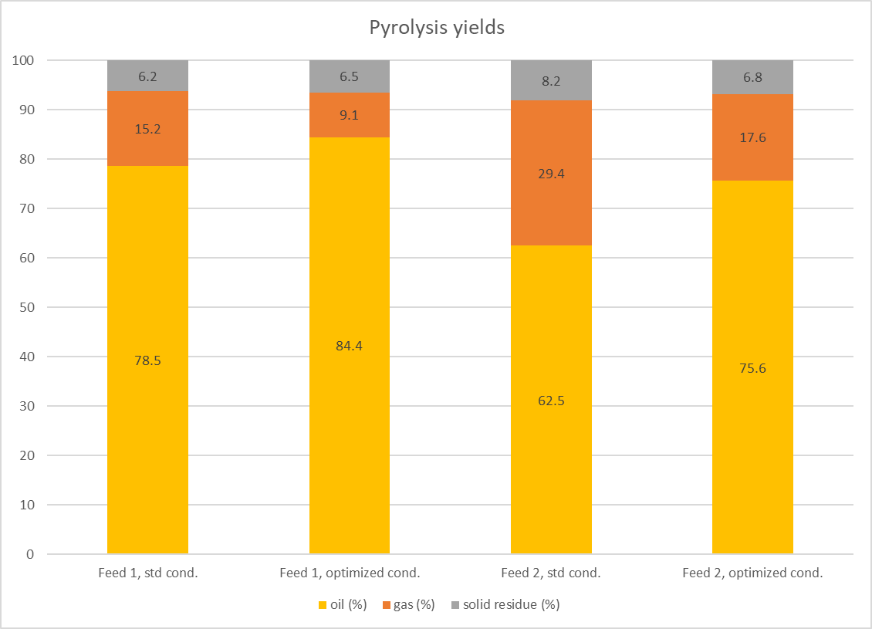
Figure 3. Effect of variation of process condition on yield
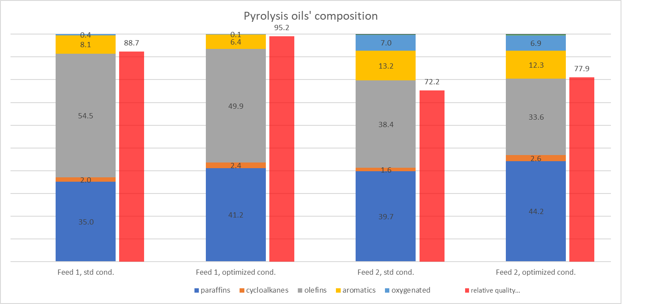
Figure 4: Effect of variation of process condition on r-oil composition and quality
  - Hoop® Technology
Chemical recycling via pyrolysis is a process that is divided into 2 phases: preparation and pyrolysis.
Preparation: The mixed plastic waste (Plasmix) is subjected to a sorting, grinding and compaction treatment with the aim of removing any non-plastic materials and PVC. The material is also compacted to give a homogeneous physical shape, suitable for feeding to the pyrolysis plant.
Pyrolysis: The plastic material is heated in the reactors at a temperature between 300° C and 500° C in absence of oxygen. As shown in Figure 4, there are three flows outgoing from the plant:
- liquid product (r-oil): it will be fed as feedstock to steam cracking plant;
- gaseous product (r-gas): it will be fed as feedstock to steam cracking plant;
- solid co-product (r-char): product with a high carbon content that can be used as a raw material in various industrial processes or as a fuel.

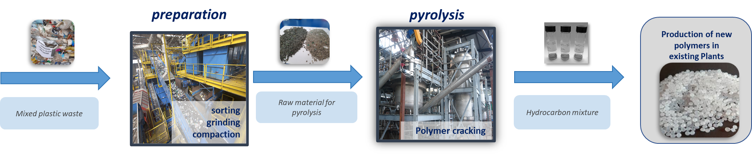
Figure 5. Chemical recycling via pyrolysis
The HOOP® technology is characterized by a pyrolysis in two steps with separate reactors, the second step allows a "finishing" of the reaction in temperature conditions different from those of the first step.
This technology uses an advanced reactor heating system that makes the temperature extremely homogeneous: temperature and pressure are continuously tuned on the basis of "online" monitoring of the composition of the input material. This monitoring of the raw material is carried out continuously with spectroscopic techniques which represent a Versalis know-how, already successfully applied in its polymers production plants.
The real-time control of the input to the reactors and the precise control of the reaction temperature and pressure make the system flexible on the characteristics of the plastic material fed, maximizing the yield and quality of the produced r-oil in all conditions.
The pyrolysis oil leaving the reactors is subjected to a purification and treatment process to further improve its quality.
The result is a material recovery, as r-oil, above 80%. The quality of the products is similar to that of traditional feedstocks from fossil sources and therefore suitable for feeding them to steam cracking plants for the subsequent production of polymers that are completely equivalent to those produced from fossil sources.

The maximum recovery of material leads the maximum amount of carbon that remains in the cycle in the form of a product and is not released into the atmosphere as CO₂ in the incineration processes. It is estimated that with chemical recycling it is possible to avoid the release into the atmosphere of about 1.5 tons of CO₂ per ton of recycled plastic waste compared to the current waste-to-energy destiny.

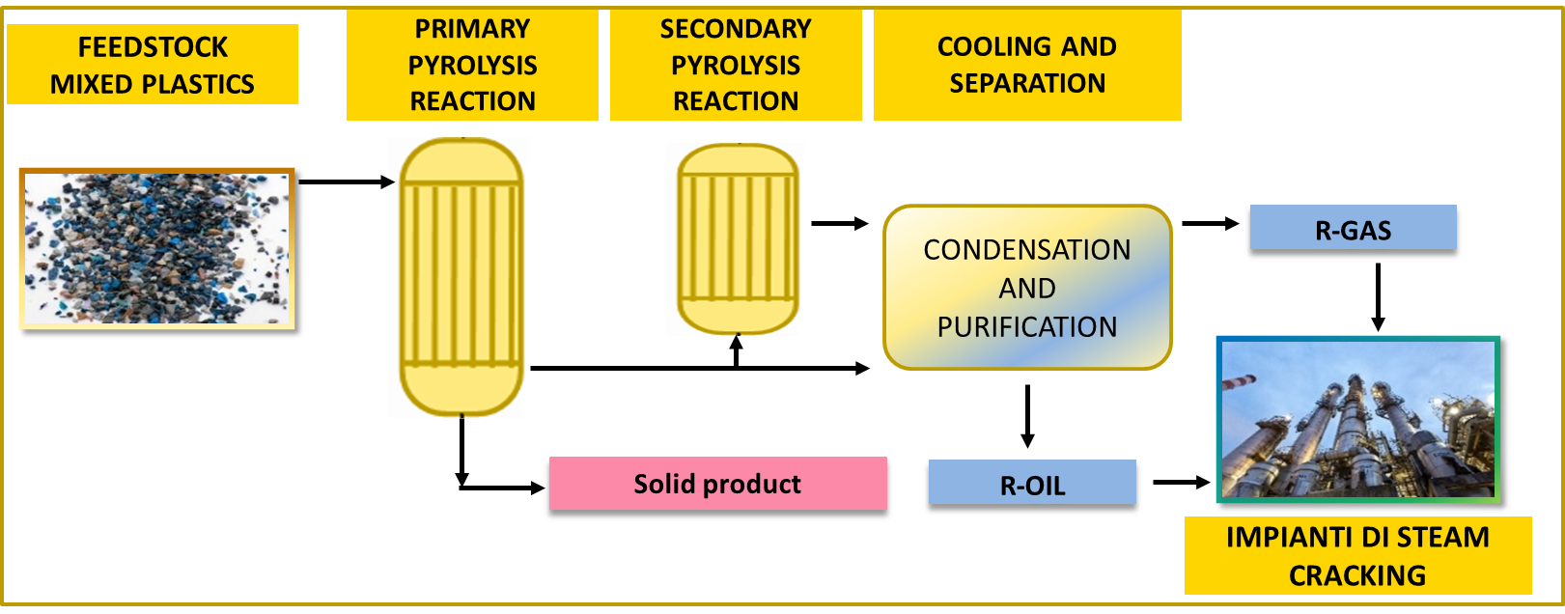
STEAM CRACKING PLANT
Figure 6. Simplified process scheme
  - Industrial development
Versalis is starting the construction of a demonstration plant with 6,000 tons / year of plastic material processed. This demonstration plant will allow to build-up technological and operational experience of the process, which will then be replicated on an industrial scale.
This technology has the characteristic of being modular, allowing in fact the replicability both on a high scale (40 ÷ 150 kt / year), creating a plant physically connected to a steam cracking plant and thus optimizing the interconnection with the user plants and the yield in the final products (since it also allows the recovery as material of part of the gaseous products), both on a smaller scale (10 ÷ 30 kt / year) and "distributed", by creating small-scale plants physically connected to the waste collection and treatment plants distributed throughout the territory, optimizing the interconnection with the feedstock preparatory plants.
  - Conclusions
The European Commission recognizes the need for higher recycling rates in its Circular Economy Action Plan adopted under the Green Deal, according to which all Member States must achieve 55 % recycling of packaging plastic waste by 2030 (The EU’s Circular Economy Action Plan, 2020).
Mixed plastic waste (Plasmix) represents about 50 % of post-consumer packaging plastic waste collected and is currently subjected to energy recovery through waste-to-energy and fuel production, or sent to landfills, since there are currently no recycling techniques for this fraction of waste.
In Versalis' strategy, the development of innovative technologies for the recycling of polymers is a fundamental step in terms of sustainability. The adoption of a circular model allows to close the life cycle of plastic products, to save fossil resources, to minimize the environmental impact and to maximize the sustainability of processes and products, with a consequent reduction in GHG emissions.
HOOP® is an advanced chemical recycling technology developed by Versalis to convert mixed plastic waste into a raw material to be used as feedstock in the production cycles of the chemical industry replacing the traditional raw material based on fossil sources to produce new plastic.
With this process it is possible to enhance plastic products even once they have reached the end of their life, in line with the principles of the circular economy, generating new products with the same quality as virgin plastic from fossil sources and suitable for any application (e.g. food contact, high tech, etc.). This project will allow the recycling of plastic materials that cannot be mechanically recycled reducing the plastics industry's dependence on fossil resources, as well as reducing the amount of urban waste sent to waste-to-energy or disposal.

  - References
Plastics Europe “the Fact”, 2021.
Cefic Position Paper “Introducing chemical recycling: Plastic waste becoming a resource”,2020.
The EU’s Circular Economy Action Plan, 2020

