CHEMICAL ENGINEERING TRANSACTIONS  VOL. 96, 2022 | A publication of
The Italian Association
of Chemical Engineering
Online at www.cetjournal.it

Guest Editors: David Bogle, Flavio Manenti, Piero Salatino
Copyright © 2022, AIDIC Servizi S.r.l.
ISBN 978-88-95608-95-2; ISSN 2283-9216

Study on a Thermal Management System for Proton Exchange Membrane Fuel Cell Technologies
Sheilla C. Lima^{a,}*, Edilailsa J. Melo^{b}, Rogerio A. A. Meloª, José I. S. Silvaª
ª Institute of Science and Technology, Federal University of Jequitinhonha and Mucuri Valleys, Diamantina - MG, Brazil
^{b} Faculty of Chemical Engineering, State University of Campinas, Campinas - SP, Brazil
* sheillalima.dtna@gmail.com
Fuel cells are capable of converting the chemical energy of a fuel and an oxidant into electrical energy and water vapor. In the scientific field, fuel cells provide an increasing production of energy and, consequently, there is an increase in waste heat. As a result, studies involving thermal management systems are receiving increased attention. Therefore, in this work, a fuel cell cooling system was studied using a proton exchange membrane, whose category has potential for vehicular applications and stationary units. In this work, a schematic representation of the proposed system was elaborated, then a thermal simulation of the fuel cell subjected to a cooling system was performed, finally an analysis of the heat flow as a function of the cell temperature was performed. As a result of implementing the proposed cooling system, the fuel cell reached a maximum temperature of 114.26°C, showing that the system needs to be optimized. In addition, a linear variation of the heat flux as a function of temperature was observed.
  - Introduction
In academia and industry, technologies capable of promoting energy production through clean and/or less polluting sources have been sought. In this line of research, there is the fuel cell that is capable of converting chemical energy, from a fuel and an oxidant, into electrical energy and water vapor (Vargas et al., 2006). One of the most promising technologies is the proton exchange membrane fuel cell (PEMFC). Researchers studied PEMFC as this technology has potential for automotive applications and stationary power systems (Vargas et al., 2006; Shah, 2007).
PEMFC is an electrochemical energy generator (Zhao et al., 2015). The basic working principle of a PEMFC (Figure 1) is as follows: free electrons (released with the oxidation of hydrogen gas at the anode) flow from the anode to the cathode and, therefore, combine with the protons and dioxygen; the cycle is completed when protons (produced with the oxidation of hydrogen gas at the anode) flow from the anode to the cathode (Garrity, Klausner and Mei, 2007). It should be noted that while electrons are transported through an external circuit, protons are transported through an electrolyte membrane (Garrity, Klausner and Mei, 2007).
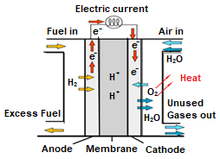
Figure 1: PEMFC Operating Principle (Basualdo, Feroldi and Outbib, 2011).
Among the advantages of this fuel cell category are high efficiency, high power density, low operating temperature and fast start-up (Zhao et al., 2015; Park et al., 2021). Whereas, the disadvantages of PEMFC are related to water management problems and carbon monoxide poisoning of electrodes (Faghri and Guo, 2005). While, the durability of PEMFC is subject to the operating conditions (Park et al., 2021). Among the factors that influence operating conditions is the thermal management system.
Proper temperature management is critical to system performance and lifespan. The proper operating temperature of this battery is between 60°C to 80°C (Bargal et al., 2020). At higher temperatures, electrocatalytic activity is favored (Zhao et al., 2015), however, when this temperature is exceeded, there is degradation of the catalyst and membrane (Han, Park and Yu, 2015).
To control the temperature of a PEMFC, the following cooling methods can be used: forced ventilation, liquid cooling, cooling with dissipation surfaces, phase change cooling (Asensio et al., 2018). Where liquid cooling has advantages over air cooling, since the liquid has greater thermal conductivity than air. While phase change cooling has advantages over liquid cooling (Asensio et al., 2018). However, when PEMFC is incorporated into a CHP (Combined Heat and Power) system, the liquid cooling system is more suitable than the phase shift system, as it has greater cooling capacity and greater control flexibility (Asensio et al., 2018).
The coolant used in liquid cooling is usually deionized water or antifreeze coolant (Zhang and Kandlikar, 2012). Still, there are alternative fluids under study, such as nanofluids. These, in turn, must have high thermal conductivity, low electrical conductivity, low freezing point, low viscosity, must be non-explosive, non-toxic and non-flammable (Bargal et al., 2020).
It should be noted that the fuel cell thermal management system is under development. In the literature, there are research on modeling, simulation and experiments on new thermal management systems. Also, there are studies on new refrigerant fluids, as already mentioned. However, there are still few references associated with the subject. Thus, this work is a contribution in the scientific field with regard to technologies belonging to the theme.
In this study, a cooling system for a PEMFC was discussed in order to verify the behavior of the fuel cell in operation, subjected to a cooling system and, also, to verify the heat flux dissipated by the cell as a function of temperature.
  - Methodology
In this work, a basic liquid cooling system for a PEMFC was designed and a computer simulation of this system was performed. First, the boundary conditions were specified, based on information available in the literature. Then, the cooling system of a PEMFC was modeled. Finally, the thermofluid dynamics simulation of the system was carried out.
    - Specifications
In this section, the specifications of the proposed system are informed (Table 1).
Table 1: Proposed System Specifications (Bargal et al., 2020. Adapted).
Specifications | Data
Initial Operating Temperature | 40 °C
Heat Generation in the Cell | 3 MW/m³
Cell Area | 157 x 150 mm²
Cell Thickness | 1.7 mm
Cell Material | Nafion
Flow Channel Model | Multi-Pass Serpentine
Refrigerant Fluid | Deionized Water
    - Modeling
The cooling system proposed in this work is composed of a reservoir, used as a deposit of deionized water; a centrifugal pump, responsible for the circulation of the refrigerant; a radiator, to make the heat dissipation of the coolant; and a cooler, which transfers heat to the fuel cell. This thermal management system is schematically represented in Figure 2.
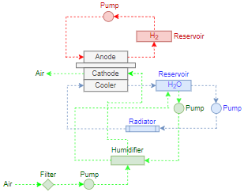
Figure 2: Schematic Representation of the Proposed System.
The cooler developed in this work consists of a bipolar plate, with a flow channel in the form of a multi-pass serpentine (Figure 3). The flow channel has a cross-sectional area of 1x1 mm², a distance from each other of 5 mm and occupies an area of 157x150 mm².
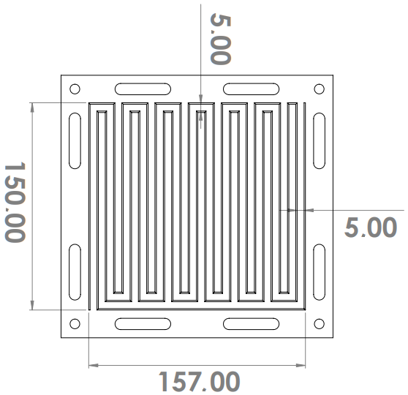
Figure 3: Front View of the Bipolar Plate.
The bipolar board (Figure 3) will be connected to PEMFC. A series of plates and cells will be successively connected, forming the set presented by Soupremanien et al. (2012), as shown in Figure 4. The composition of the system presented by Soupremanien et al. (2012), fits the system proposed in this work.
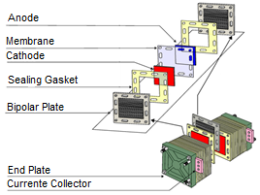
Figure 4: Refrigeration System Connected to a PEMFC (Soupremanien et al. 2012).
    - Estimates and Considerations
To perform the simulation of this system, it is necessary to resort to the heat and mass transfer equations. However, first, it is necessary to define the conditions of the system under study. In this way, based on the article by Zhao et al. (2015), the following conditions were considered for this system:
- Anode, cathode and membrane temperatures are the same.
- The coolant temperature at the radiator outlet is equal to the coolant temperature at the inlet of the PEMFC stack.
- The coolant temperature at the outlet of the PEMFC stack is equal to the coolant temperature at the radiator inlet.
- The inlet gas temperatures at the cathode and anode are equal to the inlet temperature of the refrigerant.
- The outlet gas temperatures at the cathode and anode are equal to the outlet temperature of the refrigerant.
- The radiator inlet air temperature is equal to the ambient temperature.
- The mass flow is constant.
- The system is ideal.
2.3.1 Heat Transfer Fee
In this work, heat transfer will be taken as an element of study. The basic heat transfer rate equation is described below:
$$\dot{Q}=C∙∆T$$ | (1)
$$\dot{Q}=(\dot{m}∙c_{p})∙\left(T^{hot}-T^{cold}\right)$$ | (2)
2.3.2 Cooler
The coolant temperature at the inlet of the cooler $\left(T_{coolant,cooler}^{in}\right)$ is the “cold temperature” $\left(T^{cold}\right)$, since, the working fluid has already been preceded by the heat dissipation in the radiator. Meanwhile, the temperature of the coolant at the outlet of the cooler $\left(T_{coolant, cooler}^{out}\right)$ is the “hot temperature” $\left(T^{hot}\right)$, because the fluid passed through the PEMFC at a higher temperature. Thus, considering the cooler as a control volume, the heat dissipated by the refrigerant is:
$${\dot{Q}}_{coolant, cooler}={\dot{m}}_{coolant}∙c_{p_{coolant}}∙\left(T_{coolant, cooler}^{out}-T_{coolant,cooler}^{in}\right)$$ | (3)
Also, it should be noted that the temperature of the refrigerant at the inlet of the cooler $\left(T_{coolant,cooler}^{in}\right)$ is equivalent to the temperature of the coolant at the radiator outlet $\left(T_{coolant, radiator}^{out}\right)$. Meanwhile, the temperature of the coolant at the outlet of the cooler $\left(T_{coolant, cooler}^{out}\right)$ is equivalent to the coolant temperature at the radiator inlet $\left(T_{coolant, radiator}^{in}\right)$. Thus, one has to:
$$T_{coolant, cooler}^{in}=T_{coolant,radiator}^{out}$$ | (4)
and
$$T_{coolant, cooler}^{out}=T_{coolant,radiator}^{in}$$ | (5)
2.3.3 Radiator
In the radiator, the coolant temperature at the radiator inlet $\left(T_{coolant, radiator}^{in}\right)$ is equal to “hot temperature” $\left(T^{hot}\right)$, since, the working fluid was preceded by the cooler. Meanwhile, the coolant temperature at the radiator outlet $\left(T_{coolant, radiator}^{out}\right)$ is equal to “cold temperature” $\left(T^{cold}\right)$, as there was heat dissipation when passing through the radiator.
Considering the radiator as a control volume, the equation that represents the heat transfer rate in the radiator is presented below, as Campos (2010).
$${\dot{Q}}_{coolant, radiator}=C_{minimum,radiator}∙ε_{radiator}∙{∆T}_{maximum,radiator}$$ | (6)
Where, it is known that:
$${∆T}_{maximum,radiator}=T_{coolant,radiator}^{in}-T_{air,radiator}^{in}$$ | (7)
and
$$ε_{radiator}=1-exp\left\{\left[exp\left(-{NTU}^{0.78}∙C_{r}\right)-1\right]∙\frac{{NTU}^{0.22}}{C_{r}}\right\}$$ | (8)
Still, one has to:
$$C_{r}=\frac{C_{minimum, radiator}}{C_{maximum,radiator}}$$ | (9)
and
$$NTU=A_{coolant}∙\frac{U_{radiator}}{C_{minimum,radiator}}$$ | (10)
2.3.4 Pump
Considering that there is no heat generation or heat dissipation in the pump, we have that:
$${\dot{Q}}_{coolant,pump}=0$$ | (11)
2.3.5 Reservoir
Considering that there is no heat generation or heat dissipation in the reservoir, we have that:
$${\dot{Q}}_{coolant,reservoir}=0$$ | (12)
  - Results and Discussion
In this section, the results and discussion of the simulations performed will be presented. It should be noted that results were obtained that indicate that there must be an optimization of the system, through subsequent studies.
3.1 Fuel Cell
To carry out the simulation, it was considered that the thickness of the flow channel is infinitesimally small and the material of the flow channel has high thermal conductivity. Therefore, we have a PEMFC connected directly to the refrigerant fluid flow.
Under these conditions, the information in Figure 5 results, where the PEMFC has a maximum temperature of 114.26 °C. Knowing that this cell must operate between 60 °C and 80 °C, the flow channel must be optimized so that the ideal temperature is reached.
Still, it should be noted that there was a large temperature variation when modifying the dimensions related to the flow channel. It is necessary to carry out a more in-depth study on this subject.
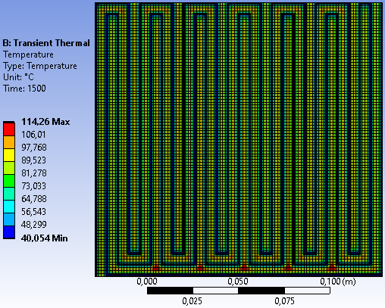
Figure 5: Fuel Cell Simulation.
3.2 Cooler
To know the dissipated heat flux it is necessary to know the temperatures of the system under study. In this section, the coolant temperature has been set to 40 °C as it can be determined according to the efficiency of the refrigeration system. Meanwhile, the cell temperature varies from 60 °C to 80 °C. Thus, different values were found for heat flux as a function of cell temperature. (Figure 6).

Figure 6: Simulation of Heat Flow as a Function of Temperature.
  - Conclusions
In this study, a model of a refrigeration system was defined, where a reservoir for the refrigerant, a centrifugal pump, a radiator and a cooler were used. Also, a simulation of a PEMFC connected directly to the flow of a refrigerant was carried out. With the simulation, it was observed that there were temperature variations along the cell and that in certain regions of the cell a maximum temperature of 114.26 °C was reached, exceeding the appropriate temperature limit. One variable that changes with the efficiency of the refrigeration system is the cell temperature. This temperature varies linearly with the heat dissipated. This behavior, in turn, can be observed in this work.
Nomenclature
$A_{coolant}$ – Total heat exchange area on the coolant side, m²
$c_{p}$ – Specific heat, kJ/kg.K
$c_{p_{coolant}}$ – Specific heat of refrigerant, kJ/kg.K
$C$ – Thermal capacity, kW/K
$C_{maximum,radiator}$ – Minimum heat capacity, kW/K
$C_{minimum,radiator}$ – Maximum heat capacity, kW/K
$C_{r}$ – Ratio of heat capacity rates, -
$\dot{m}$ – Mass flow, kg/s
${\dot{m}}_{coolant}$ – Mass flow of refrigerant, kg/s
$NTU$ – Heat transfer units, -
$\dot{Q}$– Heat, kW
${\dot{Q}}_{coolant, cooler}$ – Heat dissipated by the refrigerant in the cooler, kW
${\dot{Q}}_{coolant,pump}$ – Heat dissipated by the coolant in the pump, kW
${\dot{Q}}_{coolant,reservoir}$ – Heat dissipated by the coolant in the reservoir, kW
${\dot{Q}}_{coolant, radiator}$ – Heat dissipated by the coolant in the radiator, kW
$∆T$ – Temperature difference, K
${∆T}_{maximum,radiator}$ – Maximum temperature difference in radiator, K
$T^{cold}$ – Cold temperature, K
$T^{hot}$ – Hot temperature, K
$T_{air,radiator}^{in}$ – Radiator inlet air temperature, K
$T_{coolant,cooler}^{in}$ – Coolant temperature at the inlet of the cooler, K
$T_{coolant,radiator}^{in}$ – Coolant temperature at radiator inlet, K
$T_{coolant, cooler}^{out}$ – Coolant temperature at the outlet of the cooler, K
$T_{ coolant,radiator}^{out}$ – Coolant temperature at radiator outlet, K
$U_{radiator}$ – Overall radiator heat transfer coefficient, kW/m².K
$ε_{radiator}$ – Effectiveness, -

Acknowledgments
The authors would like to thank the ICT of the UFVJM and FAPEMIG.
References
Asensio, F. J. et al. (2018) ‘Model for Optimal Management of the Cooling System of a Fuel Cell-Based Combined Heat and Power System for Developing Optimization Control Strategies’, Applied Energy, 211, pp. 413–430. doi: https://doi.org/10.1016/j.apenergy.2017.11.066.
Bargal, M. H. S. et al. (2020) ‘Liquid Cooling Techniques in Proton Exchange Membrane Fuel Cell Stacks: A Detailed Survey’, Alexandria Engineering Journal, 59, pp. 635–655. doi: https://doi.org/10.1016/j.aej.2020.02.005.
Basualdo, M. S., Feroldi, D. and Outbib, R. (2011) PEM Fuel Cells with Bio-Ethanol Processor Systems: A Multidisciplinary Study of Modelling, Simulation, Fault Diagnosis and Advanced Control. Springer.
Campos, E. R. V. (2010) Effectiveness Modeling the Use of Nanofluids in the Cooling System of Internal Combustion Engines. Pontifícia Universidade Católica do Rio de Janeiro. doi: https://doi.org/10.17771/PUCRio.acad.15694.
Faghri, A. and Guo, Z. (2005) ‘Challenges and Opportunities of Thermal Management Issues Related to Fuel Cell Technology and Modeling’, International Journal of Heat and Mass Transfer, 48(19–20), pp. 3891–3920. doi: 10.1016/j.ijheatmasstransfer.2005.04.014.
Garrity, P. T., Klausner, J. F. and Mei, R. (2007) ‘A Flow Boiling Microchannel Evaporator Plate for Fuel Cell Thermal Management’, Heat Transfer Engineering, 28, pp. 877–884. doi: http://dx.doi.org/10.1080/01457630701378333.
Han, J., Park, J. and Yu, S. (2015) ‘ScienceDirect Control Strategy of Cooling System for the Optimization of Parasitic Power of Automotive Fuel Cell System’, International Journal of Hydrogen Energy, 40, pp. 13549–13557. doi: http://dx.doi.org/10.1016/j.ijhydene.2015.08.067.
Park, J. Y. et al. (2021) ‘Investigation of Thermal Management System to Improve Reliability of Polymer Electrolyte Membrane Fuel Cell’, Energy, pp. 1–42. doi: https://doi.org/10.1016/j.energy.2020.119062.
Shah, R. K. (2007) ‘Introduction to Fuel Cells’, Recent Trends in Fuel Cell Science and Technology, pp. 1–9. doi: http://dx.doi.org/10.1007/978-0-387-68815-2_1.
Soupremanien, U. et al. (2012) ‘Tools for Designing the Cooling System of a Proton Exchange Membrane Fuel Cell’, Applied Thermal Engineering, 40, pp. 161–173. doi: 10.1016/j.applthermaleng.2012.02.008.
Vargas, R. A. et al. (2006) ‘A Look at Fuel Cell Technology’, pp. 1–13. Available at: https://www.ipen.br/biblioteca/2006/eventos/15436.pdf.
Zhang, G. and Kandlikar, S. G. (2012) ‘A Critical Review of Cooling Techniques in Proton Exchange Membrane Fuel Cell Stacks’, International Journal of Hydrogen Energy, 37, pp. 2412–2429. doi: 10.1016/j.ijhydene.2011.11.010.
Zhao, X. et al. (2015) ‘Thermal Management System Modeling of a Water-Cooled Proton Exchange Membrane Fuel Cell’, International Journal of Hydrogen Energy, 40(7), pp. 3048–3056. doi: 10.1016/j.ijhydene.2014.12.026.

