|  |  |
| --- | --- |
| cetlogo ***CHEMICAL ENGINEERING TRANSACTIONS***  ***VOL. 96, 2022*** | A publication of  aidiclogo_grande |
| The Italian Association  of Chemical Engineering  Online at www.cetjournal.it |
| Guest Editors: David Bogle, Flavio Manenti, Piero Salatino  Copyright © 2022, AIDIC Servizi S.r.l. **ISBN** 978-88-95608-95-2; **ISSN** 2283-9216 | |

Investigation of a possible process for hydrogen odorization in pure hydrogen and in natural gas – hydrogen mixture systems

Elisa Zanellaa,\*, Mariangela Longhia, Piersilvio Marcolinb, Giovanni Camardab, Carlo Pirolaa

aUniversità degli Studi di Milano, Dipartimento di Chimica – via Golgi, 19, 20133 Milano (MI), Italy

b Regas srl - Via Redipuglia, 70, 24047 Treviglio (BG), Italy

elisa.zanella@unimi.it

One of the most important goals of this century is the exploitation of hydrogen as green energy carrier. Due to its storage and transportation problem, a concrete and immediate solution is the exploitation of the gas pipelines now used for natural gas. In this regard, safety is of paramount importance; indeed, like natural gas, hydrogen is an odourless and colourless flammable gas. To solve this problem a system of hydrogen odorization is to implement. This work is aimed at the investigation of a possible process for hydrogen odorization, focused on pure hydrogen and natural gas-hydrogen mixtures systems, to simulate a possible real gas pipeline. The odorization system considered in this work is called INGRID, developed by Regas Srl, a partner company for this project. Starting from INGRID’s specifications, a simulation model was then developed using AVEVA's PRO II software on the basis of the thermodynamic liquid-vapor equilibria of the mixture. As odorant, tetrahydrothiophene (THT) was taken into consideration, thanks to the fact that this is the most used odorant and so more experimental data are available in the literature. This system has proved to be effective in the odorization of both pure hydrogen and hydrogen-natural gas mixture.

* 1. Introduction

One of the most important goals of this century is the production of energy through sustainable processes. Today, most of the energy is produced using non-renewable energy sources such as fossil fuels, that led to significant climate change, mainly related to carbon dioxide emissions (Rajeshwar et al., 2008). In addition, these non-renewable resources are running out and they will no longer be able to meet the world's energy demand (U.S. EIA, 2019). Therefore, it is necessary to find new sustainable ways of producing, carrying and storing energy (Jankuj et al., 2022). In this respect, a very promising energy carrier is hydrogen, which presents a green combustion, thanks to which no pollutants are produced and the only by-product is water, and a very high gravimetric energy density, more than three times higher than that of petrol (Pareek et al., 2020). These characteristics make hydrogen an excellent green fuel. However, to achieve a real energy transition its production method must be taken into consideration. Indeed, nowadays the main ones still use fossil fuels and consequently produce CO2 as the main by-product (“Grey or blue hydrogen”). Only the hydrogen entirely produced from renewable sources thanks to the use of electrolysers can be considered "Green hydrogen”. At the same time, hydrogen is characterized by both low volumetric energy density and high flammability and so its use is mainly limited by storage and transport problems (Zanella et al., 2022). A concrete and immediate solution for its transportation problem is the exploitation of the gas pipelines now used for natural gas, starting from natural gas/hydrogen mixtures in a ratio of 90/10 or 80/20. In this regard, safety is of paramount importance; indeed, like natural gas, hydrogen is an odourless and colourless flammable gas. To solve this problem a system of hydrogen odorization is to implement. Until now there are no data in literature on the odorization of hydrogen, so the work presented in this article has been based on what is already known about the odorization of natural gas.

Natural gas odorization process consists in adding compounds that allow an easy detection of leaks inside the pipelines giving at the gaseous mixture the characteristic “gas” smell. The most important characteristics that an odorant must have are: a strong and recognizable odour even in presence of minimal quantities (few ppm level), high miscibility with the gas, chemical stability under transport conditions, both towards the gas and the piping components, high vapor pressure to prevent condensation from forming in the pipes due to high pressure and low toxicity and cost (Tenkrat, D. et al., 2010).

The choice of the odorant is determined not only by the availability of odorants, but also by the properties of the gas to be smelled and by the structure of the pipeline, such as the properties of the soil and the material of which it is made. Initially the odour was caused by the refinery by-products present inside the gas, subsequently replaced by low molecular weight chemical species such as mercaptans and sulphides. However, the sulphur species produce oxides which are released into the atmosphere so new types of odorants, based on acrylate mixtures, have been introduced (Graf, 2007).

The most used odorants are: sulphur containing compounds, tetrahydrothiophene (THT), dimethyl sulphide (DMS) and ter-butyl mercaptan (TBM), and non-sulphur containing compounds, methacrylate (MA), ethyl acrylate (EA) and ethyl-methyl-pyrazine (EMP) (Tenkrat, D. et al., 2010). These molecules are largely used as odorants for methane, but their behaviour for hydrogen or methane/hydrogen mixtures has been scarcely investigated.

In this work, a preliminary study on the odorization process of hydrogen and methane-hydrogen mixtures has been done. Starting from INGRID, an automatic odorant injection system developed by Regas Srl, a partner company for this project that supplies control systems for natural gas odorization and distribution plants, and its specifications, a simulation model was then developed using AVEVA's PRO II process simulation software on the basis of the thermodynamic liquid-vapor equilibria of the mixture. INGRID is a by-pass injection odorization system in which the liquid odorant is added in small amount into the gas pipeline. INGRID is able to ensure the correct odor ratio and homogeneity with single injections as small as possible, reducing the risk of over odorization, thanks to advanced closed-loop control algorithm that is able to auto-adjust injector operations according to the actual amount of odorant needed, enabling the system to react quickly to sudden changes in working conditions such as flow, pressure, temperature, etc. (Regas srl internal information). In addition to the by-pass system, the main flow of gas can be throttled generating a pressure gap, which allows a partial flow of gas to enter the odorant tank and become saturated. At the end the odorized gas returns to the main stream. This system is named lapping odorization system and start to work when the previous one has some technical issues. In this way the odorization process is always granted (Fink, 2015) (Negaresh et al., 2018) (Figure 1).

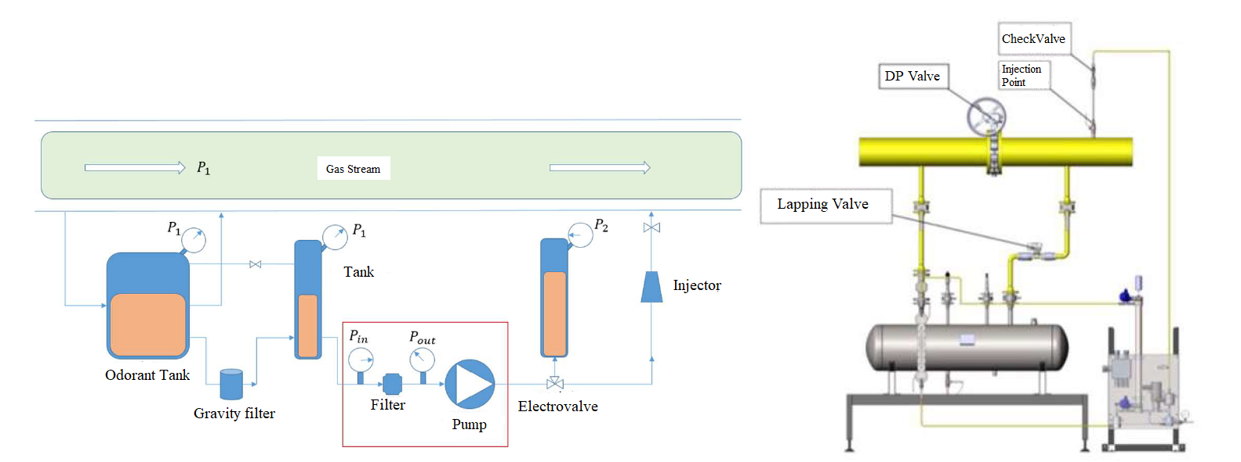

Figure 1: A schematic representation of INGRID odorization system designed by Regas srl.

The aim of this work is the study of the lapping odorization system to maximize the efficiency of the plant. In particular, a primary study on the methane odorization was done. The experimental vapor-liquid equilibria data found in the literature were compared with the data provided by Regas srl and the data calculated with PRO II considering the system as ideal or not.

Through the selected model it was possible to calculate the gas flow necessary to odorize the pure gas or the gas mixture in all the operative scenarios. Pure methane, pure hydrogen and methane-hydrogen mixture were considered as possible gas to be odorized. In particular mixture of methane/hydrogen in ratio 90/10 and 80/20, were used to simulate a possible real future application. As odorant, tetrahydrothiophene (THT) was taken into consideration, thanks to the fact that this is the most used odorant and so more experimental data are available in the literature.

* 1. Methodology

It was decided to start from the optimization of the odorization of methane with tetrahydrothiophene (THT). The first step was to check the vapour pressures of methane and THT calculated by our simulation versus the corresponding ones detected experimentally (Yaws, 2015) (Hubbard W.N. et al., 1952). After checking the consistency of the data calculated on the PRO II software, the liquid-vapor equilibria of methane-THT and hydrogen-THT were studied. The investigation for the binary mixture was carried out and the correct thermodynamic approach for the simulation of the experimental data in PRO II was sought. In particular, two different thermodynamic approaches were taken into consideration, the ideal model (IDEAL) and the Soave-Redlich-Kwong model (SRK), and they were compared to experimental data find in literature (Ghanem et al., 1998). The Soave-Redlich-Kwong model (SRK) turned out to be the most performing one.

For the simulation of the liquid-vapour equilibria data, the following setup on Pro II was employed (Figure 2)

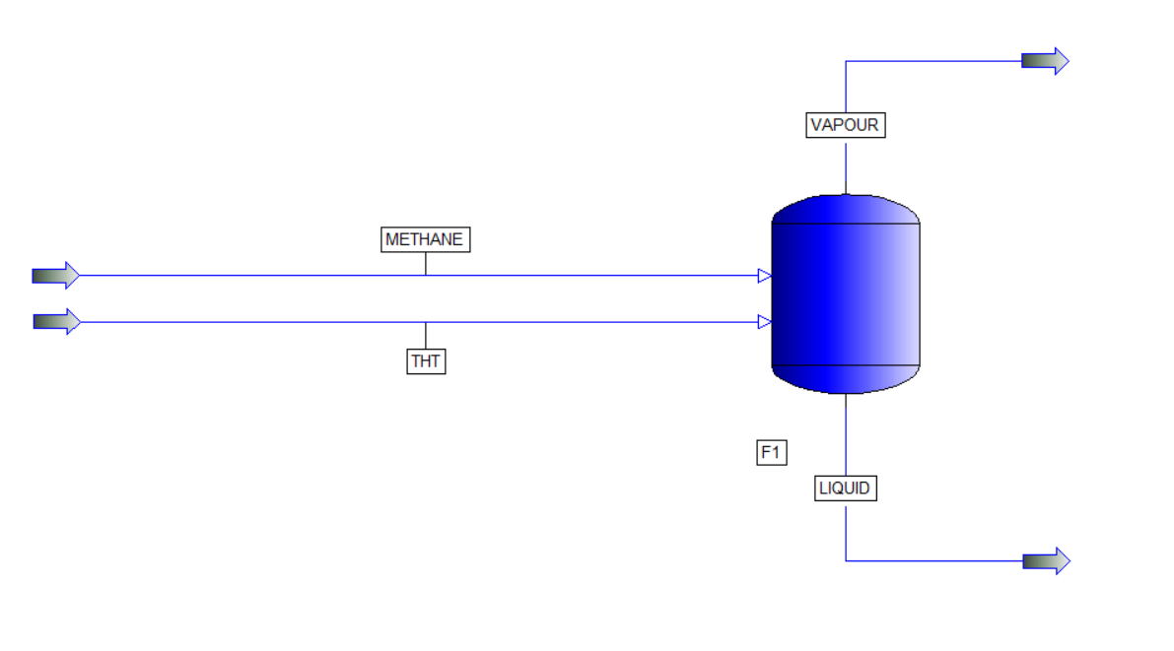

Figure 2: Simulated plant use in PRO II to study the liquid-vapour equilibria.

After the model validation, the study of the odorization of pure hydrogen and hydrogen-methane mixtures with THT has been brought forward. Since there are no literature data relating hydrogen odorization, the same thermodynamic model of the simulations described below has been employed, that is SRK model.

Finally, the industrial process of odorization by lapping has been simulated and studied, going to investigate the minimum flow of gas necessary to obtain the desired concentration of odorant in the final stream.

The industrial plant consists of a main stream where the major flow of gas can be throttled generating a pressure gap, which allows a partial flow of gas to enter a tank, where the liquid odorant is held. Here, the gas is odorized, thanks to the vapour-liquid equilibria; then it returns to the main stream.

On the basis of the above considerations, the scheme of the simulated plant is reported in Figure 3.

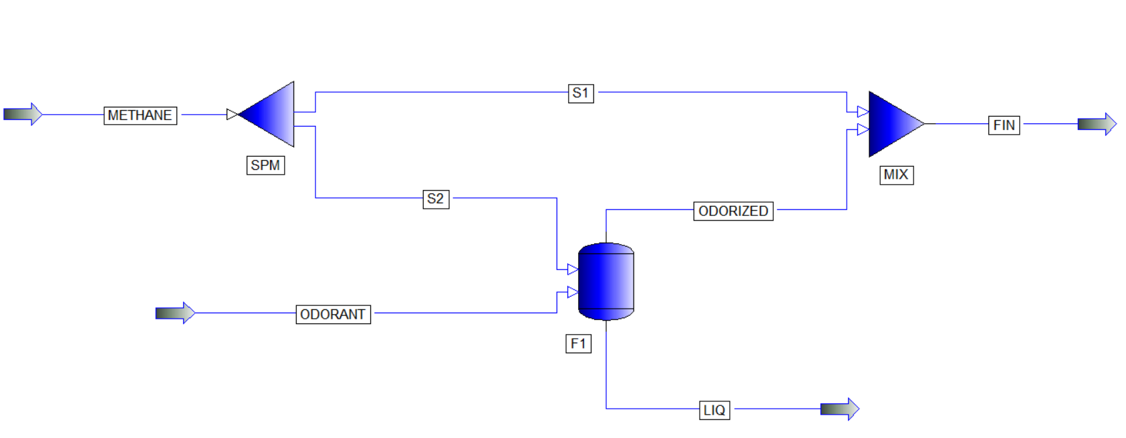

Figure 3: Simulated plant use in PRO II to study the odorization process.

The flow of gas to be odorized passes through a splitter that divides it into two parts, a main flow (S1) and a secondary flow (S2). S2 and a second stream (ODORANT), containing the liquid odorant, reach a flash. In the latter, the odorization of the gas occurs thanks to the liquid-vapour equilibria that forms between the incoming gas and the odorant. Then, through a stream (ODORIZED), the odorized gas reaches a mixer that converges the two gas stream (S1 and ODORIZED) in the final stream (FIN). The concentrations of odorant are monitored in the latest stream (FIN).

The working methodology identified is the same for the various simulations.

As a first step, the change in the concentration of odorant as a function of the gas flow in the secondary stream (FIN) has been monitored. Specifically, a "Case of study" was devised with 50 cycles, the flow of the stream S2 has been changed starting from 60 NL/h with an increase of 2 NL/h. Then the vapour phase (y) of THT has been monitored in the final stream FIN. Since the concentration of odorant varies in a linear way with respect to the flow rate, it was possible to calculate the flow rate necessary to have a quantity of odorant that complies with the legal limits (32 mg/L for THT). Going to repeat the same operation at different temperatures, it was possible to describe a flow profile such as to make the odorization as efficient as possible to the various working conditions. Preliminary tests were carried out with a pressure of 2 bar and a temperature range from 273.15 to 313.15 K. Final simulations were carried out at a pressure of 4 bar, the most common pressure for INGRID, and temperatures from 258.15 to 328.15 K, simulating the ambient temperature. Indeed, INGRID does not work with a temperature control system. The initial stream rate is 10,000 NL/h. In this way, the minimum flow rate to odorized under different conditions was obtained.

At this point, hydrogen odorization process was investigated. The working methodology is the same of methane. The initial stream flow rate is 10,000 NL/h and 60 NL/h after the splitter (S2). In this case, the simulation was carried out directly at 4 bar.

Regarding hydrogen-methane mixtures, it was decided to test two different combinations: methane/hydrogen 90/10 and 80/20.

* 1. Results and discussion

As regards the study of the vapour pressures of methane and tetrahydrothiophene (THT), the data obtained from two different equations were compared. The first equation is a Van’t hoff, used by the PRO II software with database parameters reported in Table 1. The second one is an Antoine equation, with the parameters reported in Table 2.

|  |  |
| --- | --- |
| $log P=C_{1}+\frac{C_{2}}{T}+C_{3}\ln\left(T\right)+C_{4}T^{C_{5}}+C_{6}T^{3}+C_{7}T^{6}+\frac{C_{8}}{T^{2}}+\frac{C_{9}}{T^{4}}+C_{10}T^{2}$ | (1) |

Table 1: Van’t hoff coefficients for the two different compounds.

|  |  |  |  |  |  |  |  |  |
| --- | --- | --- | --- | --- | --- | --- | --- | --- |
| Compound | C1 | C2 | C3 | C4 | C5 | C6-10 | References | |
| Methane | 39.205 | -1,324.4 | -3.4366 | 3.1019e-05 | 2 | 0 | PRO II\_2021: SIMSCI database | |
| THT | 74.588 | -6,863 | -7.7478 | 4.217e-06 | 2 | 0 | PRO II\_2021: SIMSCI database | |
| $log P=A-\frac{B}{T+C}$ | | | | | | | | | (2) |

Table 2: Antoine coefficients for the two different compounds.

|  |  |  |  |  |
| --- | --- | --- | --- | --- |
| Compound | A | B | C | References |
| Methane | 6.84377 | 435.4534 | 271.361 | (Yaws, 2015) |
| THT | 6.99540 | 1,401.939 | 219.607 | (Hubbard W.N. et al., 1952) |

As shown in Figure 4, a good overlap has been obtained between the data calculated with these equations and, in the case of THT, also with experimental data (Hubbard W.N. et al., 1952).

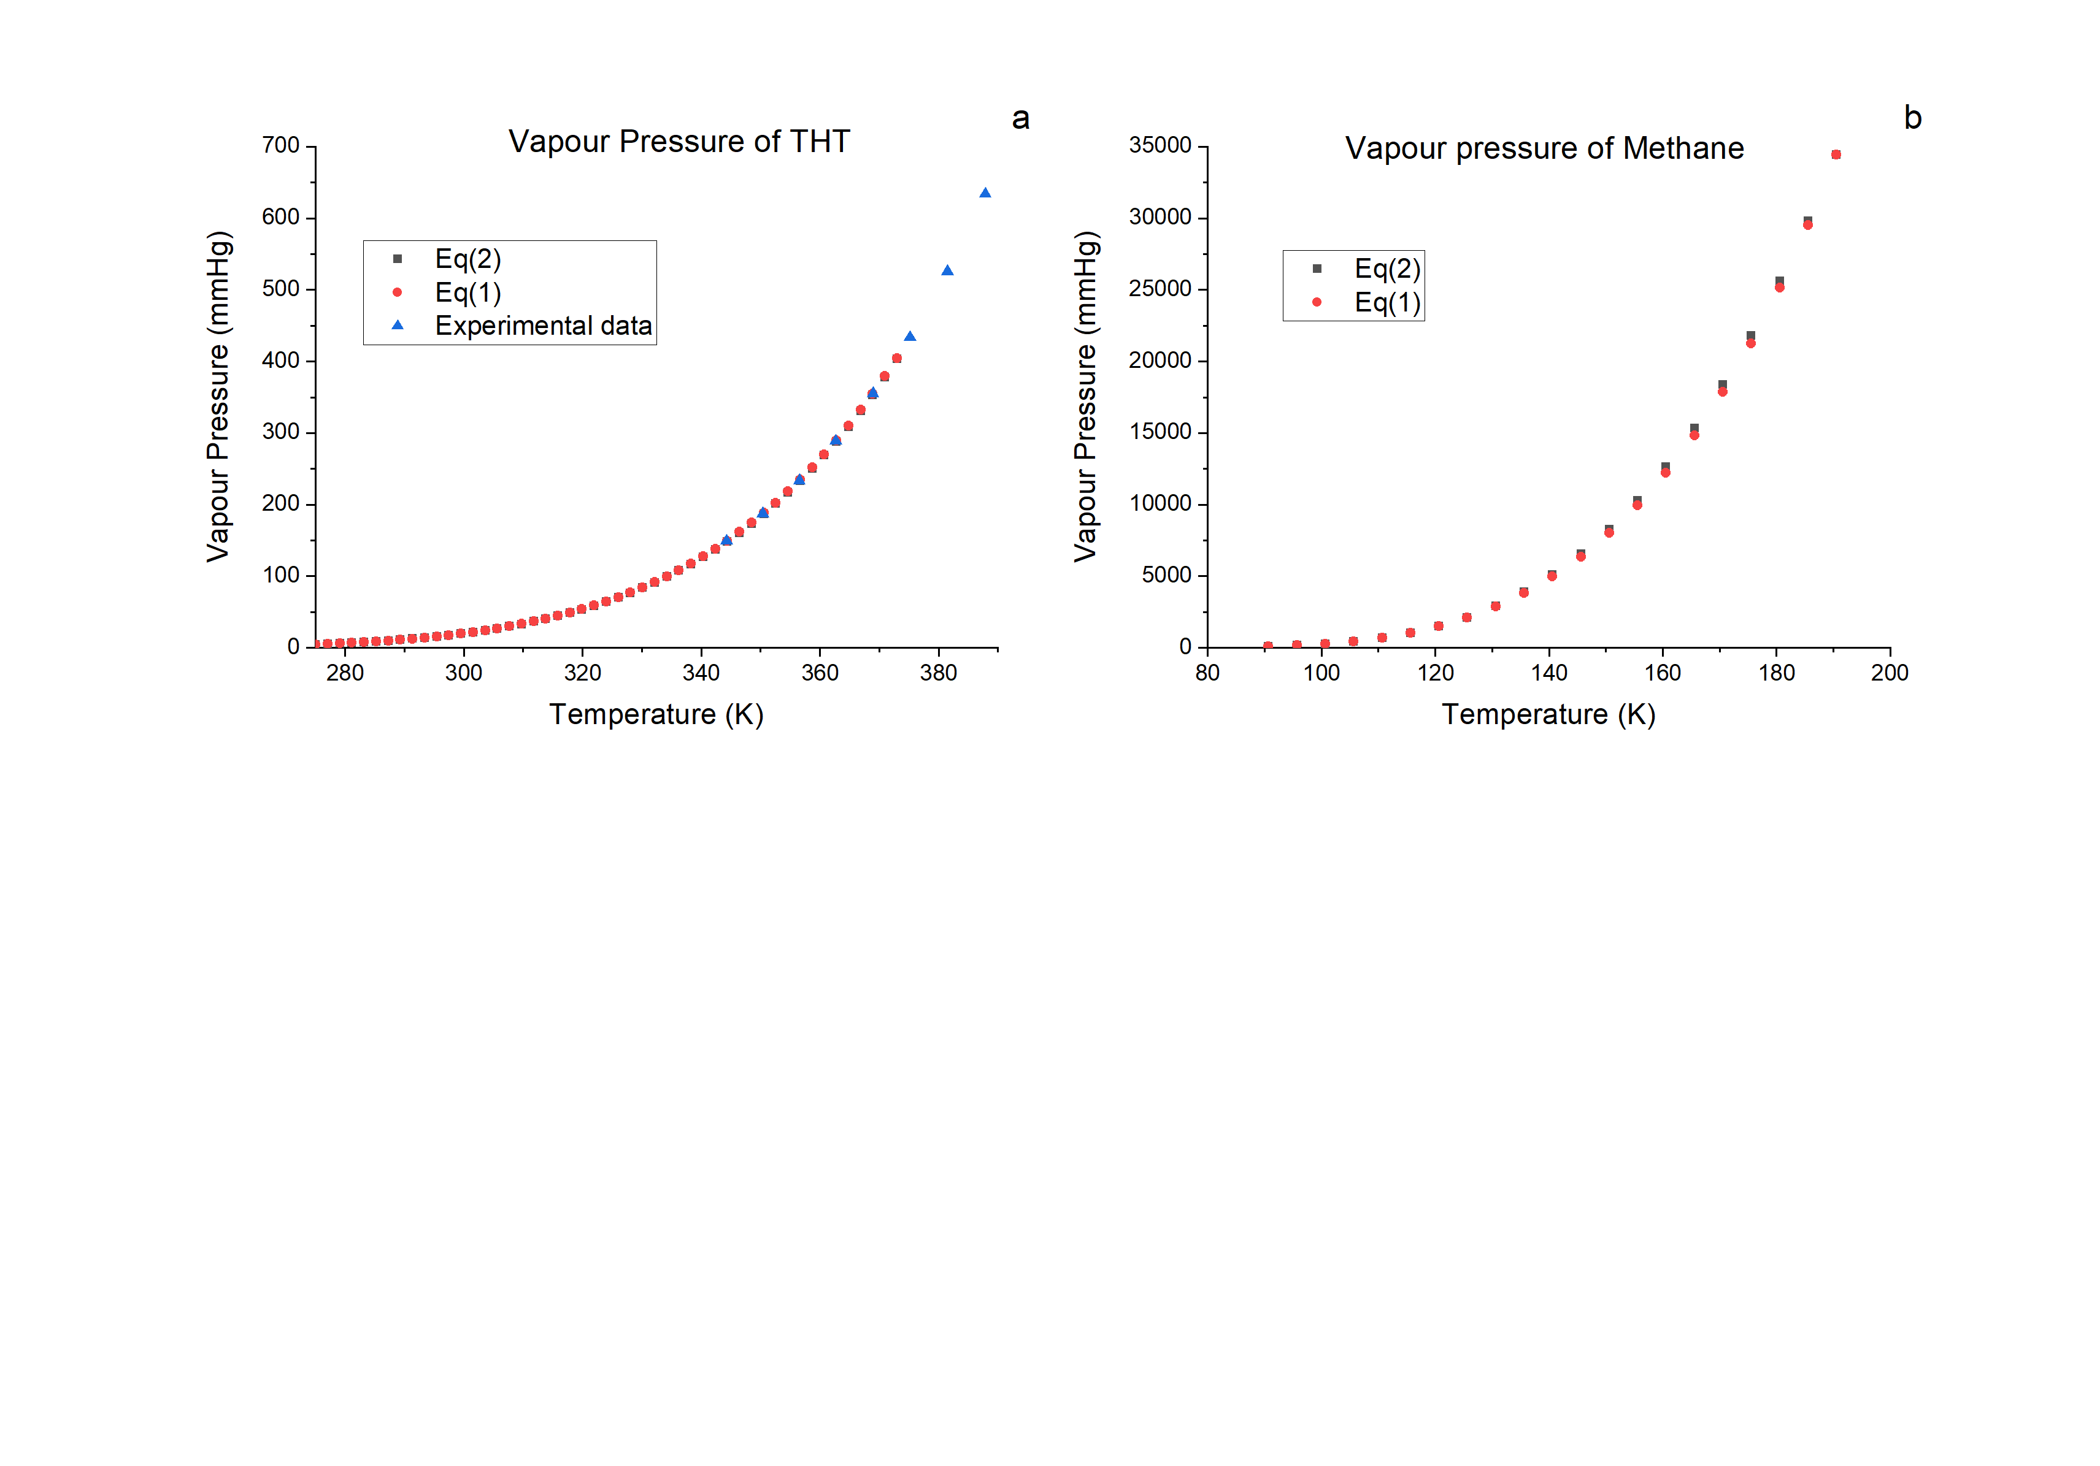

Figure 4: Comparison between the simulated and the calculated data related to vapour pressure of tetrahydrothiophene (THT) (a) and methane (b).

After checking the consistency of the data calculated on the PRO II software, the liquid-vapor equilibria were taken into consideration. Starting from liquid-vapour equilibria data of methane-THT binary mixture available in the literature (Ghanem et al., 1998), it was possible to compare the difference between two different models, i.e. the ideal model (IDEAL) and the Soave-Redlich-Kwong model (SRK). Clearly SRK is most suitable for the correct representation of the system but the aim of our work is the quantification of the real gas behaviour.

When the Ideal method (IDEAL) is selected, equilibrium K-values are computed as $k_{i}=p°_{i}/P$, where P is the system pressure.

The Soave-Redlich-Kwong equation of state (SRK) Eq(3) is a modification of the Redlich-Kwong equation of state (which is based on the van der Waals equation).

|  |  |
| --- | --- |
| $P=\frac{RT}{V-b}-\frac{a\left(T\right)}{V\left(V+b\right)}$ | (3) |

As can be seen in Figure 5 the Soave-Redlich-Kwong (SRK) model approximates better the experimental data. Indeed, working at higher pressures than 1 atm, the SRK model takes into consideration the deviation from the ideality of the gas employed by working with the fugacity coefficient. Therefore, this model was used to study the odorization of methane with THT. Since there are no literature data relating hydrogen odorization, the same thermodynamic model has been employed also for hydrogen odorization.

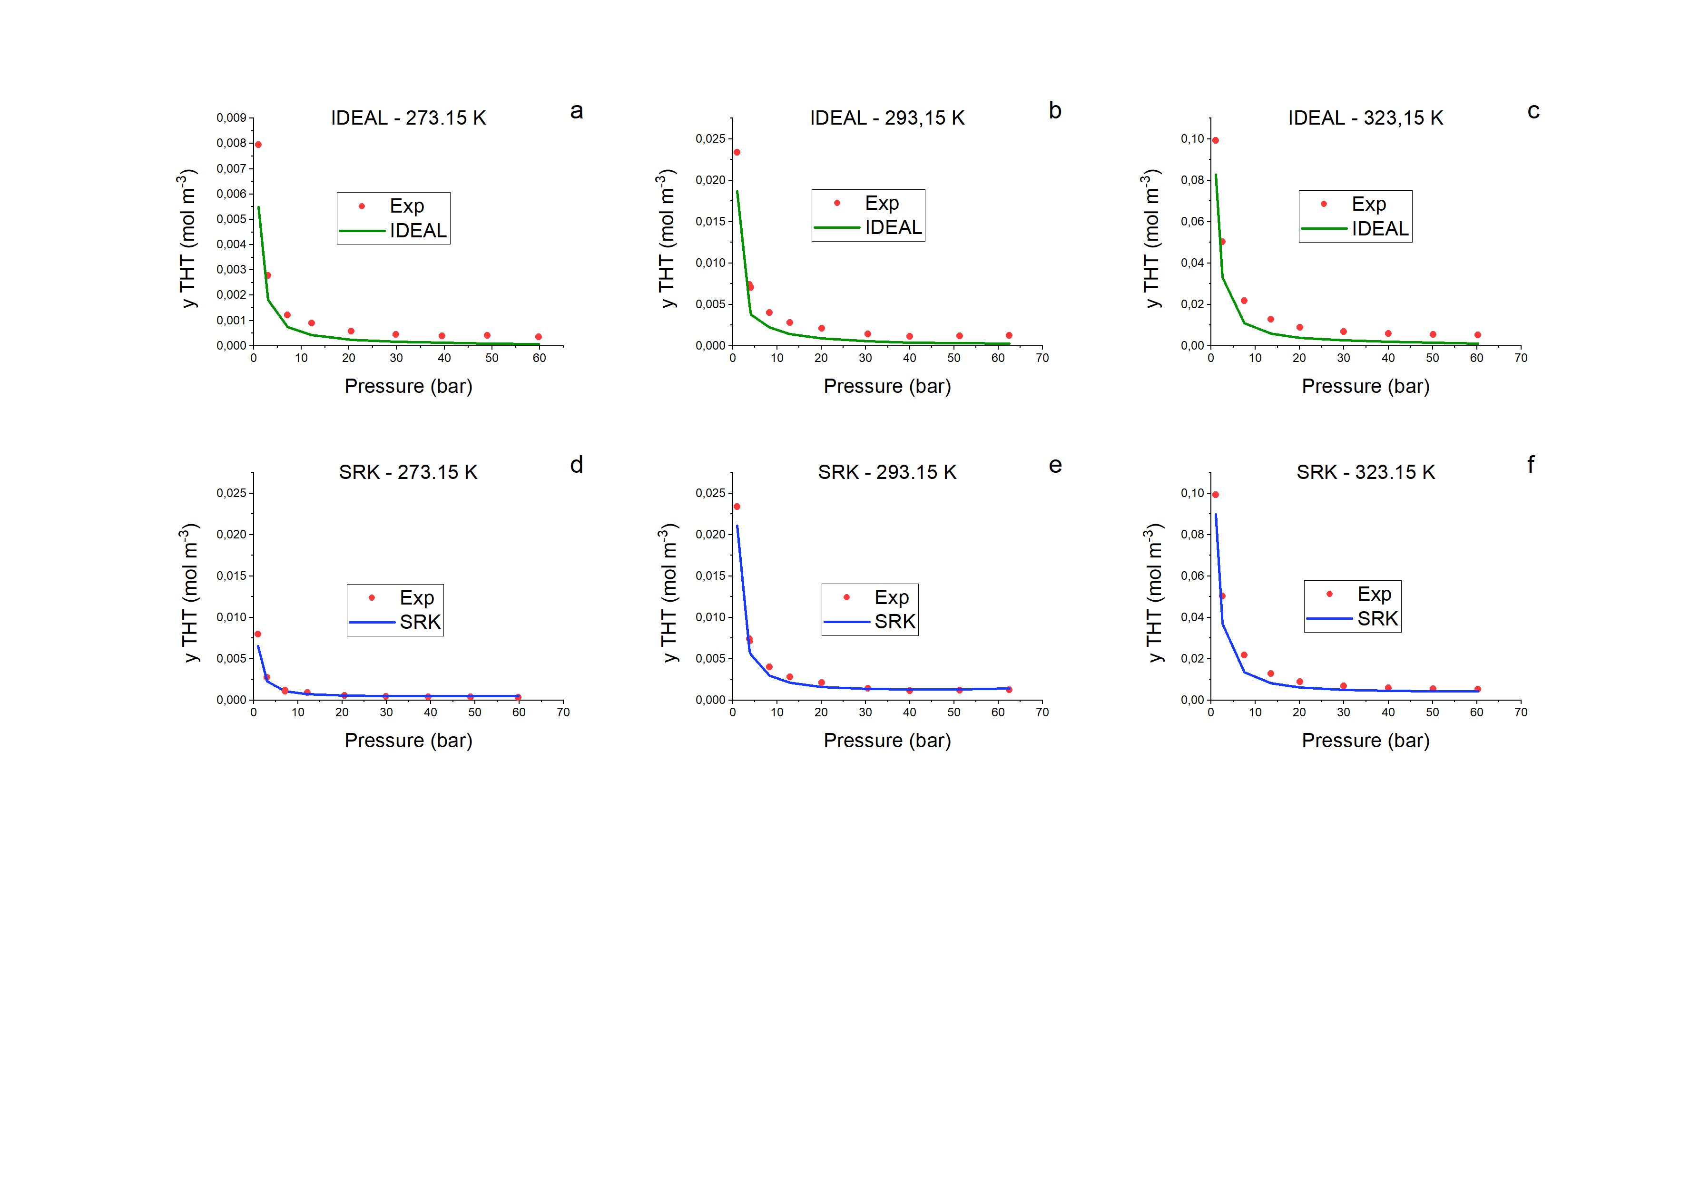

Figure 5: Comparison between the experimental data of methane-THT liquid-vapour equilibria and those simulated on PRO II with different model and at different temperature: IDEAL (a-c) and SRK (d-f).

Finally, the industrial process of odorization has been simulated. Starting from the procedure described in the previous section, in Figure 6 the four gas flow vs temperature profiles are shown.

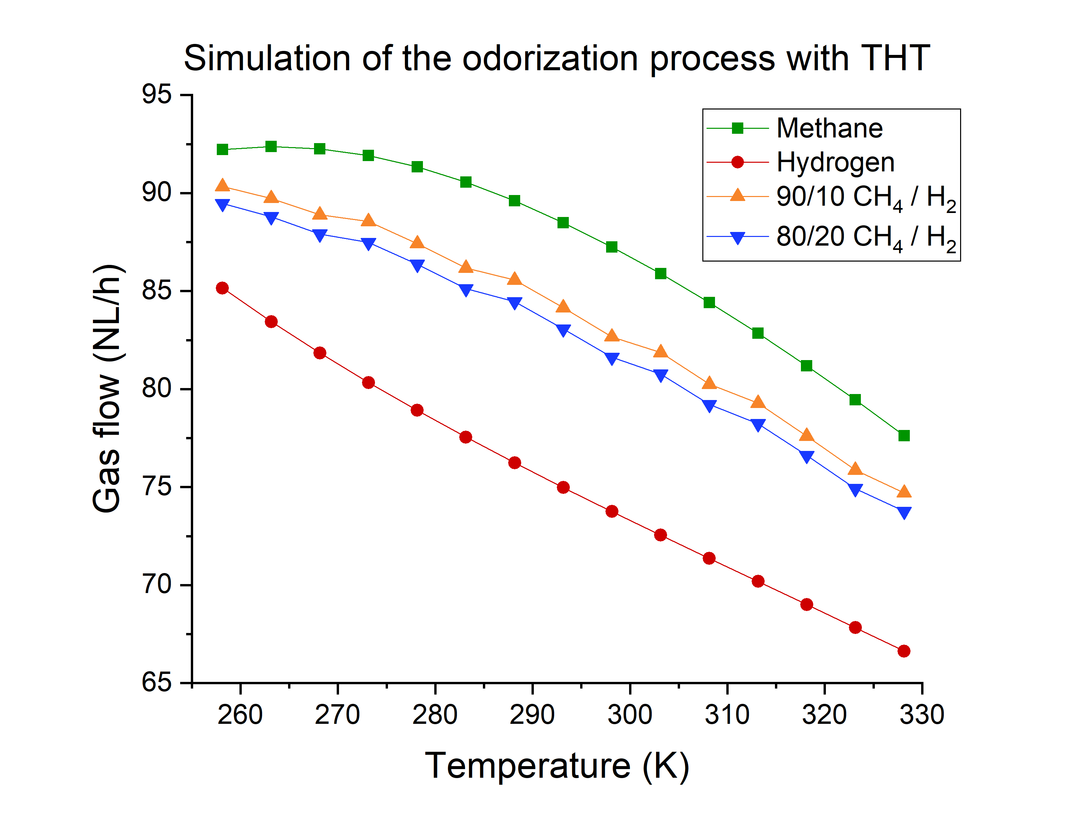

Figure 6: Comparison between the gas flow vs temperature profiles of odorization process of the different gas mixtures.

The aim of this study was to investigate the minimum flow of gas necessary to obtain the desired concentration of odorant in the final stream. The mixtures of gas taken into consideration are the following: pure methane, pure hydrogen and the binary mixture of methane-hydrogen in ratio 90/10 and 80/20. As can be seen in the figure above, as the temperature rises a lower gas flow is necessary. This behaviour can be explained knowing that as the temperature rises a higher amount of tetrahydrothiophene (THT) in vapour phase is present (see Figure 5) and consequently a lower flow in S2 stream has to be set.

* 1. Conclusions

Starting from INGRID’s specification, it was possible to simulate a preliminary study on the odorization process of hydrogen and methane-hydrogen mixtures. The first step was the study and optimization of the methane odorization process. The vapour pressures of methane and THT were checked. The thermodynamic model was validated, confirming the need to consider the system as real by SRK model. The lapping odorization system was successfully simulated and the results demonstrated a difference in the secondary flow depending on the pure gas considered (methane or hydrogen) or their mixtures to reach the desired concentration of THT in the final gas stream.

References

Fink J. (2015) Petroleum Engineer’s Guide to Oil Field Chemicals and Fluids (Second Edition), “Chapter 15 - Odorization.”, 455–75, Gulf Professional Publishing.

Ghanem G., Tagand G., Loiseleur H., Ingrain D. and Jose J. (1998) Détermination de la solubilité du tetrahydrothiophene (THT) liquid dans les principaux constituents du gaz naturel (CH4, CO2 et N2) au moyen d’un dispositive dynamique avec analyse chromatographique en ligne de la phase vapeur, J. Chem. Phys, 95, 927-946.

Graf F., Kröger K. and Reimert R. (2007) Sulfur-Free Odorization with Gasodor S-Free - A Review of the Accompanying Research and Development Activities, Energy & Fuels, 21 (6), 3322-3333, DOI: 10.1021/ef700406x

Hubbard W.N., Finke H.L., Scott D.W, McCullough J.P., Katz C., Gross M.E., Messerly J.F., Pennington R.E. and Guy Waddington (1952) Thiacyclopentane: Heat Capacity, Heats of Fusion and Vaporization, Vapor Pressure, Entropy, Heat of Formation and Thermodynamic Functions, Contribution No. 31 from the Thermodynamics Laboratory, Petroleum Experiment Station, Bureau of Mines.

Jankuj V., Spitzer S.H., Krietsch A., Štroch P., Bernatík A., 2022, Safety of alternative energy sources: A review, Chemical Engineering Transactions, 90, 115-120.

Negaresh M., Mohammadreza F. and Nasir M. (2018) Modeling and Control of Natural Gas Bypass Odorizer., Journal of Natural Gas Science and Engineering 50: 339–50.

Pareek A., Dom R., Gupta J., Chandran J., Adepu V. and Borse P.H. (2020) Insights into Renewable Hydrogen Energy: Recent Advances and Prospects., Materials Science for Energy Technologies, 3, 319–27.

Rajeshwar K., McConnell R., Harrison K. and Licht S. (2008) Renewable Energy and the Hydrogen Economy BT - Solar Hydrogen Generation: Toward a Renewable Energy Future, edited by Krishnan Rajeshwar, Robert McConnell and Stuart Licht, 1–18. New York, NY: Springer New York.

Regas srl. n.d. “Ingrid - Odorant Injection System.” www.regasenergy.com/products/gas-odorization/ingrid-odorant-injection-system/.

Tenkrat, D., Hlincik, T., Prokes, O. (2010) 'Natural Gas Odorization', in P. Potocnik (ed.) Natural Gas, IntechOpen, London. 10.5772/9825.

U.S. Energy Information Administration’s (EIA) (2019) “International Energy Outlook 2019.”

Yaws C. (2015) The Yaws Handbook of Vapor Pressure – Antoine Coefficients, 2nd edition, Gulf Professional Publishing.

Zanella E., Pirola C., Loghi M., Camarda G., Marcolin P. (2022) Idrogeno: Produzione e Compressione. Una Scommessa Energetica per Il Futuro, La Chimica e l’Industria Online, 2, 88–90.