|  |  |
| --- | --- |
| cetlogo ***CHEMICAL ENGINEERING TRANSACTIONS***  ***VOL. 96, 2022*** | A publication of  aidiclogo_grande |
| The Italian Association  of Chemical Engineering  Online at www.cetjournal.it |
| Guest Editors: David Bogle, Flavio Manenti, Piero Salatino  Copyright © 2022, AIDIC Servizi S.r.l. **ISBN** 978-88-95608-95-2; **ISSN** 2283-9216 | |

Flowsheet Model and Simulation of Produced Slag in Electric Steelmaking to Improve Resource Management and Circular Production

Alice Petrucciania,\*, Antonella Zaccaraa, Ismael Matinoa, Valentina Collaa, María Ferrerb

a Scuola Superiore Sant’Anna, TeCIP Institute – ICT-COISP, Via Moruzzi 1, 56124, Pisa, Italy

b Sidenor I+D

alice.petrucciani@santannapisa.it

The steel industry is one of the most energy-intensive sectors, as it requires a great amount of resources and produces a considerable quantity of by-products, with not negligible environmental impact. Therefore, the main challenge of steelworks consists in improving sustainability and reducing carbon footprint of the production process, by ensuring the required quality of final products. In this context, the reuse and recycling of by-products can play a key role in preventing their landfilling and waste of valuable products, reducing the exploitation of primary raw materials, decreasing CO2 emissions, and supporting the implementation of the Circular Economy concept. In particular, one of the main by-products is slag, which can be used as a potentially valuable source of secondary raw materials, leading to a substantial reduction of natural resources usage and related costs.

This paper concerns part of the work developed inside the EU-funded project entitled “Optimising slag reuse and recycling in electric steelmaking at optimum metallurgical performance through on-line characterization devices and intelligent decision support system – iSlag”. The main focus of this project is the valorisation of slags produced in the electric steelmaking route, by defining good practices, investigating new recycling paths, and promoting industrial symbiosis solutions. In this paper, the adaptation and the improvement of a previously developed Aspen Plus® simulation model are presented to obtain an accurate prediction of slag features. In particular, the model estimates amount and composition of slags produced in the primary and the secondary steelmaking processes, and it allows simulating different case scenarios including usual and unusual conditions, for instance, process operating conditions, raw materials compositions, steel families to be produced. In addition to slag features, product compositions and environmental and energy impacts can be monitored with the model.

* 1. Introduction

In recent years, resource and energy-intensive industries are undergoing a profound renovation: efficiency, sustainability, circularity, and mitigation of environmental impact have become priorities along with productivity and product quality. The steel industry fits into this scenario, being a resource- and energy-intensive sector, which produces significant volumes of by-products and significantly contributes to greenhouse gas emissions.

The steel production processes generate different types of by-products, and, in particular, slags represent about 90% by mass of all by-products (World Steel Association, 2021). The improvement of slags re-use and recycling, inside and outside the steelmaking cycle, is an important goal to reduce the environmental impact and achieve economic benefits. Moreover, it is in line with the concept of Circular Economy (CE), which is an absolute priority for the whole European industry.

The different types of steelmaking slags (blast furnace slag, basic oxygen furnace slag, electric arc furnace slag, and ladle furnace slag) can be exploited in different sectors depending on their characteristics. The slags are used in the construction sector, for instance, in the production of eco-friendly permeable brick (Liu et al., 2020), as aggregate in concrete (Dong et al., 2021), or in hot mix asphalt road construction (Kumar and Varma, 2021). Further potential slags usages concern treatment of municipal wastewater, such as for phosphorus removal (Roychand et al., 2020). A good overview of several applications for slags recycling and reuse is provided by Fisher and Barron (2019).

In order to assess the feasibility of recycling slags in the most economical and environmentally friendly way, continuous monitoring and knowledge of its chemical composition and of its produced amount are essential. In general, steelworks focus mainly on monitoring the steel quality in the liquid stage, while characterization of liquid and solid slags is less regular.

The common procedure of slag characterization is based on pointwise and discontinuous analyses that are not suitable for allowing optimization of slag management to increase its recycling and reuse. On the other side, the current online available measurement systems in Electric Arc Furnace (EAF) are mostly indirect and cannot offer direct and accurate information on slag composition. Pauna et al. (2019) present optical emission spectroscopy with plasma diagnostics online evaluation of slag composition. An underdevelopment technology exploits electrical conductivity/impedance measurements for rapid online valuation of chemical properties of liquid slag (Zhang et al., 2011). Moreover, slag can be monitored through camera-based techniques coupled to ad-hoc image processing software; on this topic, Patra et al. (2019) present the InfraRed cameras-based method to identify slag presence in the tapping stream. Finally, laser-induced breakdown spectroscopy (LIBS) is also becoming of interest for slag analysis (Wang et al., 2016). To forecast slag amount and composition, dynamic slag balance models were developed, as reported by Harada et al. (2013), but the most challenging task is the acquisition of reliable data to be used in the models. Other techniques that are gaining interest in the EAF steelmaking field are data-driven models, monitoring, and control approaches based on Artificial Intelligence methods as reported by Hay et al. (2019), which describes the implementation of several models to estimate molten bath and slag compositions.

The model presented in this paper focuses on the electric steel production, and it was developed starting from a previous Aspen Plus®-based flowsheet model aimed at estimating the energy and environmental impacts of EAF steelmaking. Data provided by a European steelwork were used for model development, tuning, and validation. Its novelty and potential lie in the possibility of obtaining a precise prediction of amount and composition of both EAF and Ladle Furnace (LF) slags by exploiting as inputs data that are well known and commonly available in the process. This model improves the functionalities of the previous one by enabling simulations focused on the effects on slags of various and even uncommon process conditions to support analysis and classification of potential recycling paths.

The current work is developed within the EU-funded project “iSlag”, which aims at jointly exploiting novel fast slag characterization systems and advanced modelling tools for optimal slag reuse and recycling to reduce environmental impact of the EAF steelmaking and slag disposal costs, and maximize revenues from slag utilization. In particular, within the project, an intelligent decision support system (DSS) will be developed, which will support operational and management practices to maximise slag reuse and encourage the implementation of the CE concept in the daily work of electric steelworks.

The rest of the paper is structured as follows: Section 2 presents the developed model; Section 3 describes obtained validation and test results; finally, Section 4 provides concluding remarks.

* 1. Flowsheet model of EAF-steelmaking route

The considered flowsheet model was developed by using Aspen Plus® V11 software, and derives from deep improvement and adaptation of a previous simulation model, which was developed during the RFCS project entitled “Environmental impact evaluation and effective management of resources in the EAF steelmaking - EIRES” (Matino, et al., 2016). The first version of the model was part of an integrated evaluation tool including also water and exhaust gases treatments, which reproduces the entire EAF steelmaking process in a sort of digital twin. The goal of the overall EIRES tool was the evaluation of the environmental impact of the EAF process for studying possibilities for enhancing its sustainability (Matino et al., 2016). The model allowed analyses of process behaviour in common and uncommon scenarios, and preliminary evaluation of the effect and the feasibility of possible modifications in the production cycle or of standard practices (Matino et al., 2018).

The core objective of the updated model is an accurate forecast of amount and composition of EAF and LF slags based on the operating conditions and produced steel. Moreover, the model allows monitoring the liquid metal amount and compositions and estimates the energy impacts (i.e. electrical energy exploited in EAF and LF), by considering a broader range of phenomena with respect to its first version. Three steps have been followed for model development:

* Analysis of the considered real industrial production process and knowledge acquisition;
* Data collection, analysis, clustering, and acquisition of missing/useful information from literature;
* Model adaptation, tuning, and refining according to plant specifications and requirements.

The model was adapted to reproduce all the different steps and involved phenomena of the considered production process. The main sections of the model are:

* EAF charge and melting;
* Additions in the EAF, slagging and tapping;
* Additions before secondary metallurgy and transportation of the ladle;
* LF treatment;
* Vacuum Degassing (VD) treatment and final stages of secondary metallurgy;
* Receipt of steel in tundish and starting of continuous casting.

Model adaptation started by increasing the included chemical species, interactions, and reactions. Then, input streams (i.e. scraps, Fe-alloys, and further additions) were updated in terms of types and compositions considering industrial data. Therefore, the model flowsheet was upgraded section by section. Each section takes into account the sum of effects in terms of mass and energy flows and balances, and chemical and physical equilibria and transformations. Furthermore, each “process unit” (e.g., EAF, LF, VD) is represented by the combination of different sub-units to reproduce the various involved phenomena (e.g., melting, oxidation, tapping, refining, degassing, etc.). The inputs of each unit are well-known process parameters, including charge streams and process conditions such as mass/volume of charges/injections, Fe-alloys or further additions, temperatures, and pressures. All of them are available before starting the single heat production (or simulation).

As reported above, the first flowsheet part is related to “EAF charge and melting”, in which the charge of basket with solid scraps and further solid feeds (e.g. dolomitic lime) is simplified by mixing in a single step (generally more baskets are charged in sequence) a series of input streams. The charge is melted by applying different energy sources, such as electric energy, combustion of natural gas, chemical energy from potential addition of coke, and exothermic reactions (e.g. oxidations). The expected temperature at tapping (set by the user) is guaranteed by the computation of the required electric energy, which is the result of energy balances considering all the mentioned energy streams and including also energy losses.

After melting, “EAF addition, slagging, and tapping” are simulated. Figure 1 shows the related part of the flowsheet model; which is one of the main model parts whose update was fundamental for improving the accuracy of EAF slag simulation. Coal (generally used for foamy slag formation), scorifying materials, and deoxidizing agents are supplied. A significant number of reactions (more numerous than in the first version of the model) were included in this section for simulating the formation of slag, including foaming with the decarbonisation reaction, deoxidation, and subsequent desulphurization of the bath. Exothermic and endothermic nature of the reactions is considered for contributing to energy balances. Then, the separation of slag and fumes from molten bath is simulated including the related energy losses; this step ends with the separation of liquid metal from EAF slag and with an estimate of eventual slag entrainment.

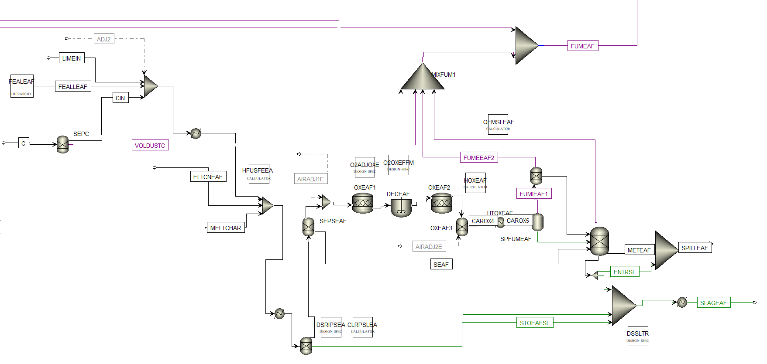

Figure 1: Flowsheet section of EAF additions, slagging and tapping – Aspen Plus interface where the lines are the streams and the blocks represent the plant components

Before secondary metallurgy, the additions introduced during tapping, the related heat losses (e.g. for their melting) and the cooling of melting bath for ladle transportation are considered.

Secondary metallurgy aims at achieving the desired steel composition and temperature. Deoxidation, desulphuration, and refining processes of steel and slags are simulated together with the addition of inert gases generally used for stirring purposes or for improving steel bath degassing. For modelling purposes and considering the available data, LF processes are included in the model in a single step (Figure 2), although generally LF is followed by VD and by final LF stages. Control of the Nitrogen content and reduction of hydrogen and sulphur in steel in VD is simulated through a “flash unit” and an ad-hoc “calculator blocks” including a literature function, which correlates the N2 and H2 removal to the injected Ar (Mapelli and Nicodemi, 2011).

Finally, slag is separated from liquid steel. Otherwise from the real process, where LF slag remains floating on the steel that is tapped from the bottom of the ladle, in the model, LF slag separation is done in different steps and then all the slag contributions are mixed. After separation from LF slag, the steel flows into the tundish for continuous casting. The model computes the energy losses before steel solidification.

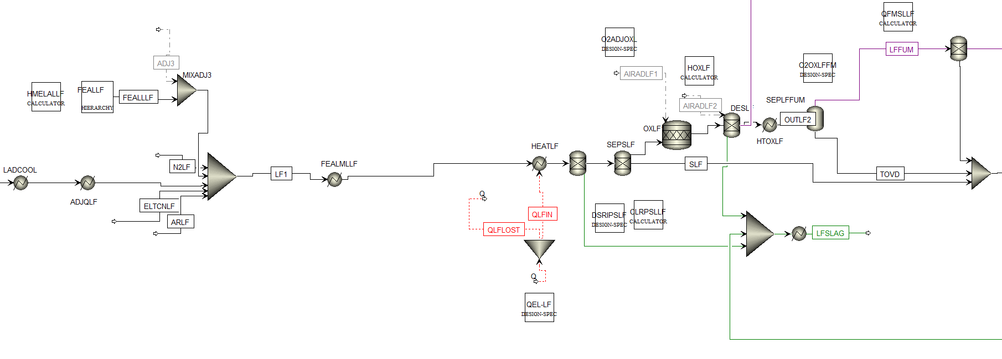

Figure 2: Flowsheet section of LF treatment - Aspen Plus interface where the lines are the streams and the blocks represent the plant components

* 1. Results related to the validation and tests of the model

Model tuning to obtain suitable accuracy was carried out by exploiting several internal parameters, tuning factors, adjustment streams and ad-hoc unit blocks. An example of adjustment stream is the estimate of the amount of parasite air inlet to simulate the not-tight closure of EAF and LF, and the air inlet during charging or during ladle transportation. This aspect is crucial to ensure the consistency of model results (e.g. tapped steel and formed slag amount and compositions) with the provided data. To ensure model robustness, tuning and validation were carried out for 8 steel families that group all steel grades produced by the considered steelworks. Initially, the “average heat” of the considered family was simulated and simulation results were compared to real average data. The model is considered validated when the difference between simulated and real data is acceptable for the expected model application, which means that real processes and balances are well reproduced. Afterwards, each validated family-model was tested by simulating some random single production heats of the same steel family and deviations concerning real data were evaluated. Due to the model final usage for improving slag knowledge and consequent management, in both validation and test phases particular attention was paid to model accuracy in simulating slags amount and composition.

The results for validation and test related to one of the simulated families are reported in Figure 3. In particular, the figure compares real and simulated composition and amount of produced EAF and LF slags for both model validation and simulation of a test heat. The model provides good results in terms of calculation of amount and composition of generated slags. Concerning the LF slag amount, as shown by the histograms reported in Figures 3a and 3b, only a range of the amount of produced LF slag is known from industrial data. Therefore, the comparison of these values cannot be very accurate; however, simulated values belong to the same ranges as the real ones.

During both validation and tests, the main difference between real and simulated values is represented by the concentration of the minor compounds in the slags (“others” in the figures). These compounds are not properly specified in the industrial analyses, while in the simulation of the reported family they correspond mainly to Nickel and Molybdenum oxides. Similar results were obtained for the other steel families.

The differences between real values and simulation results can be connected to the variable scrap composition and the difficulties linked to their characterization. To improve the accuracy of the simulation it is possible to frequently update the scrap composition, if known. Moreover, the knowledge of missing information, such as minor compounds contents in slag or exact quantity of produced LF slags can further improve model accuracy, as it would allow a whole check of the mass balances by decreasing the number of assumptions.

|  |  |
| --- | --- |
| **a** | **b** |
| **c** | **d** |
| **e** | **f** |

Figure 3: Exemplar model results concerning EAF and LF slags for one of the considered steel families

* 1. Conclusions

A flowsheet-based model estimating amount and chemical composition of slags produced during EAF-based steelmaking is described, which exploits as inputs process and product variables and parameters that are normally available in standard operating practice. The model behaviour is quite robust and the simulation results fit well with real data from production. The accuracy of the different sections of the model are deeply related to quantity and quality of the data that are used for its customization, configuration, and validation. The developed model is very useful for investigations targeting improved slag valorisation. In the future, the model will be used as is for off-line investigation, and will be the basis for the development of black-box AI-based models to be integrated in a DSS supporting optimal management and improved slag recycling and reuse.

Acknowledgments

The work described in the present paper was developed within the project entitled “Optimising slag reuse and recycling in electric steelmaking at optimum metallurgical performance through on-line characterization devices and intelligent decision support system - iSlag” (G.A. 899164) co-funded by the Research Fund for Coal and Steel of the European Union, which is gratefully acknowledged. The sole responsibility of the issues treated in the present paper lies with the authors; the Union is not responsible for any use that may be made of the information contained therein.

References

Dong Q., Wang G., Chen X., Tan J., Gu X, 2021, Recycling of steel slag aggregate in portland cement concrete: An overview, Journal of Cleaner Production, 282, 124447.

Fisher L. V., Barron, A. R., 2019, The recycling and reuse of steelmaking slags-A review, Resources, Conservation and Recycling, 146, 244-255.

Harada A., Maruoka N., Shibata H., Kitamura S. Y., 2013, A kinetic model to predict the compositions of metal, slag and inclusions during ladle refining: Part 1. Basic concept and application., ISIJ international, 53(12), 2110-2117.

Hay T., Reimann A., Echterhof T., 2019, Improving the Modeling of Slag and Steel Bath Chemistry in an Electric Arc Furnace Process Model, Metallurgical and Materials Transactions B, 50(5), 2377-2388.

Kumar H., Varma S., 2021, A review on utilization of steel slag in hot mix asphalt, International Journal of Pavement Research and Technology, 14(2), 232-242.

Liu J., Li C., Lin C. W., Han L., Ning T., Wu J., Gui H., Luo Z., Liu T.; Lu A., 2020, Use of steel slag and quartz sand‐tailing for the preparation of an eco‐friendly permeable brick. Journal of Applied Ceramic Technology, 17(1), 94-104.

Mapelli W., Nicodemi C., 2011. Siderurgia. Milano, AIM.

Matino I., Alcamisi E., Colla V., Baragioli S., Moni P., 2016, Process modelling and simulation of electric arc furnace steelmaking to allow prognostic evaluations of process environmental and energy impacts, Matériaux & Techniques, 104(1).

Matino I., Colla, V., Baragiola S., 2018, Internal Slags Reuse in an Electric Steelmaking Route and Process Sustainability: Simulation of Different Scenarios Through the EIRES Monitoring Tool., Waste and Biomass Valorization, 9, 2481–2491.

Matino I., Colla V., Colucci V., Lamia P., Baragiola S., Di Cecca C., 2016, Improving sustainability of electric steelworks through process simulations., Chemical Engineering Transactions, 52, 763-768.

Patra P., Sarkar A., Tiwari A., 2019, Infrared-based slag monitoring and detection system based on computer vision for basic oxygen furnace. Ironmaking & Steelmaking, 46(7), 692-697.

Pauna H., Aula M., Fabritius T., Klung J., Seehausen J., Huttula M., June 2019, Development of process control for industrial electric arc furnaces with optical emission spectroscopy. Düsseldorf, Germany, s.n.

Roychand R., Pramanik B. K., Zhang G., Setunge, S., 2020, Recycling steel slag from municipal wastewater treatment plants into concrete applications-A step towards circular economy, Resources, Conservation and Recycling, 152, 104533.

Wang Z., Deguchi Y., Shiou F., Yan J., Liu J., 2016, Application of laser-induced breakdown spectroscopy to real-time elemental monitoring of iron and steel making process, ISIJ International, 56(5), 723-735.

World Steel Association, 2021. Steel industry co-products. <https://worldsteel.org/wp-content/uploads/Fact-sheet-Steel-industry-co-products.pdf> accessed 11.04.2022.

Zhang G. H., Yan B. J., Chou K. C., Li F. S., 2011, Relation between viscosity and electrical conductivity of silicate melts, Metallurgical and Materials Transactions B, 42(2), 261-264.