CHEMICAL ENGINEERING TRANSACTIONS  VOL. 96, 2022 | A publication of
The Italian Association
of Chemical Engineering
Online at www.cetjournal.it

Guest Editors: David Bogle, Flavio Manenti, Piero Salatino
Copyright © 2022, AIDIC Servizi S.r.l.
ISBN 978-88-95608-95-2; ISSN 2283-9216

Techno-economic modelling of carbon dioxide utilisation pathways at refineries for the production of methanol
Federico d’Amore*, Andrea Nava, Paolo Colbertaldo, Carlo G. Visconti, Matteo C. Romano
Department of Energy, Politecnico di Milano, Via Lambruschini 4A, 20156 Milan, Italy
federico.damore@polimi.it
The decarbonisation of carbon-intensive sectors is a fundamental task for the achievement of future environmental goals. Within the challenge of industrial decarbonisation, oil refining represents a hard-to-abate sector, considering that it is characterised by CO₂ emissions deriving from multiple units and at different levels of concentration and flow rate. Therefore, pathways for the separation and conversion of such CO₂ into products (e.g., synthetic fuels) may cover an important role in the reduction of CO₂ emissions from refineries.
The objective of this study is the technical design and economic evaluation of a conversion pathway for the production of CO₂ and green H₂-based e-Fuel methanol (i.e., based on conventional electrolysis), as juxtaposed to an alternative process concept based on electrified reforming er-Fuel methanol. Such plants are modelled in terms of mass and energy balances in Aspen Plus® software to produce methanol. Then, an economic assessment is carried out to highlight the best design configurations and compare the production costs.
Optimal plants configurations are determined by fine-tuning the level of light products recycles, to minimise the feed of green H₂ and maximise the performance indicators. Results demonstrate how the er-Fuel configuration allows better conversion efficiencies and lower production costs, in the order of 30-40 % reduction with respect to the e-Fuel design.
  - Introduction
Climate change due to the anthropogenic emissions of greenhouse gases, particularly CO₂, is a complex and multifaceted issue to be tackled in the next decades (IPCC, 2018). The decarbonisation of highly carbon-intensive industry sectors (e.g., iron and steel, oil refining, cement) is of paramount importance to achieve future goals within the framework of this global environmental challenge (d’Amore et al., 2021). As in 2019 in Europe the 23.9 % of CO₂ emissions derived from industry-related processes and operations (EEA, 2021), and considering that oil refining represents an hard-to-abate sector due to its multitude of emitting units (IEAGHG, 2017), carbon capture and utilisation (CCU) technologies may play an important role in the decarbonisation of these sites (Dieterich et al., 2020; Hepburn et al., 2019). This consideration reflects in the growing scientific and industrial interest in CCU-derived e-products (i.e., e-Fuels) (Chehade et al., 2019), meaning by this term the production of synthetic fuels via combining green H₂ (i.e., produced through water electrolysis fed with renewable electricity) and captured CO₂ (either from concentrated sources or by direct air capture - DAC). Methanol (MeOH) is among the most investigated e-products (Wulf et al., 2020), considering that it can be deployed both as a liquid fuel and as a platform chemical.
Different studies have questioned the role of CCU in mitigating climate change (Mac Dowell et al., 2017) and the effective net CO₂ avoidance of e-Fuel conversion pathways (Ueckerdt et al., 2021). Firstly, as e-Fuels are meant to be used in combustion processes and would release their carbon content once burned, their production should make use of ‘carbon neutral-to-negative carbon’, i.e. separated from the atmosphere (i.e., DAC) or of biogenic origin (Gabrielli et al., 2020). In case fossil carbon is used in the production of an e-fuel, a net zero value chain should include a negative emission process, involving geologic storage of CO₂ from air (DACCS) or of biogenic origin (bio-energy with carbon capture and storage - BECCS). Secondly, e-Fuels production is based on processes with significant electric consumptions (Blanco et al., 2018), to which most of the production cost is associated. Hence, direct electrification or processes with lower electricity demand should be preferred when possible (Al-Qahtani et al., 2020).
The objective of this study is the techno-economic design of different conversion pathways for the production of e-Fuels (i.e., the conventional process concept based on green H₂) or er-Fuels (i.e., an alternative process concept based on electrified reforming) for the exploitation of the carbon content of a refinery fuel gas and its conversion into e-MeOH or er-MeOH, respectively. Fuel gas is a blend of light hydrocarbons typically produced at different units within a refinery and currently employed as fuel to provide utility heat upon combustion in boilers and furnaces, resulting in the generation of up to 60 % of the overall CO₂ emissions of the plant (IEAGHG, 2017). Based on the quantitative results obtained, the ultimate goal of the paper is to discuss the following fundamental questions: (i) what are the conditions that make e-MeOH production the preferable option to decarbonise refineries? And (ii) what is the potential of the alternative process concept (i.e., er-MeOH) in reducing CO₂ emissions in refineries?
  - Plants design
This study addresses the conversion into e-Fuel or er-Fuel of the carbon content of a refinery fuel gas, the characteristics of which are reported in Table 1. In the e-MeOH plant, the fuel gas (stream #1, Figure 1a) is burned to generate process heat for the refinery. The resulting CO₂ in the fuel gas is separated by means of a monoethanolamine-based (MEA) capture system (specific reboiler duty of 3.7 MJ/kg of captured CO₂ and carbon capture rate of 95 %). In line with the refinery electrification perspective, the MEA heat requirement is fulfilled through an electric heat pump with coefficient of performance (COP) of 2 (and in part from steam recovered from the plant, as detailed later on). The captured CO₂ (#3) is compressed through a 5-stage inter-cooled compressor to 92 bar and mixed with H₂, this (#4) produced at 30 bar through a low-temperature electrolyser (with power-to-H₂ efficiency of 70 %) and then compressed to 92 bar. The H₂ flow rate is set so as to obtain an H₂/CO₂ molar ratio of 3.05 at the inlet of the subsequent MeOH synthesis. The compressed mix of H₂ and CO₂ (#5) is mixed with an internal recycle of light products (#14) and sent to the MeOH reactor (#7). MeOH synthesis is modelled at chemical equilibrium at a nominal pressure of 90 bar and temperature of 240°C. The products stream (#8) is cooled to 40°C and undergoes a flash separation between light gases (#10) and wet MeOH (#15), then it is purified by separating H₂O and recycled products (#13). A purge stream (0.5 % in mass) is included to allow some plant flexibility in off-design operation, and exploited to generate steam in a boiler (90 % efficiency) to cover part of the reboiler duty of the CO₂ capture system.
In the er-MeOH plant, fuel gas combustion is replaced by electric boilers and furnaces with unitary electricity-to-heat efficiency. The refinery fuel gas (stream #1, Figure 1b) is pre-heated to 240°C and mixed with steam, to obtain a steam-to-carbon ratio of 3.5 at the inlet of the subsequent reforming section. The resulting stream (#3) is preheated to 490°C, sent to an adiabatic pre-reformer and to an electrified reformer operated with exit temperature and pressure of 890°C and 25 bar. The resulting syngas (#6) is mixed with external CO₂ (#8) (12.8 t/h to obtain CO/CO₂ molar ratio of 1.11 and module of 2.05 at subsequent MeOH synthesis inlet), which is assumed to derive from a generic external flue gas and captured from other sources through a MEA system as in the e-MeOH plant. Subsequent compression and MeOH synthesis sections are designed as in the e-MeOH option. A purge stream of off-gas products (2.5 % in mass) is extracted to avoid the accumulation of inert species (e.g., CH₄) at the inlet of the synthesis section, and exploited to generate steam in a boiler, covering part of the thermal requirement of the CO₂ capture system.

Table 1. Fuel gas properties and composition (left), and summary of process features and assumptions (right).
Mass flowrate |  | 36050 | kg/h |  | Pre-reformer | Temperature in | 620 | °C
Lower heating value |  | 46.84 | MJ/kg |  | Reformer | Steam-to-carbon | 3.5 | -
Molar mass |  | 26.29 | kg/kmol |  | Reformer | Temperature out | 890 | °C
Thermal content |  | 469 | MW |  | Reformer | Pressure | 25 | bar
Molar fractions | H₂ | 26.34 | % |  | MeOH synt. | Temperature out | 240 | °C
 | CH₄ | 19.55 | % |  | MeOH synt. | Pressure | 90 | bar
 | C₂H₆ | 15.02 | % |  | MeOH synt. | Recycle e-MeOH | 99.5 | %
 | C₂H₄ | 5.56 | % |  | MeOH synt. | Recycle er-MeOH | 97.5 | %
 | C₃H₈ | 11.83 | % |  | CO₂ capture | MEA reboiler duty | 3.7 | MJ/kg
 | C₃H₆ | 7.41 | % |  | CO₂ capture | Capture efficiency | 95 | %
 | C₄H₁₀ | 7.61 | % |  | CO₂ capture | Heat pump COP | 2 | -
 | C₄H₈ | 0.51 | % |  | Electrolysis | Spec. consumpt. | 47.6 | kWh/kg
 | C₅H₁₂ | 1.44 | % |  | Electrolysis | H₂ pressure out | 30 | bar
 | C₆H₁₄ | 1.95 | % |  | Compressor | Isentropic efficien. | 80 | %
 | N₂ | 2.78 | % |  | Compressor | Mech-electr. effic. | 94 | %
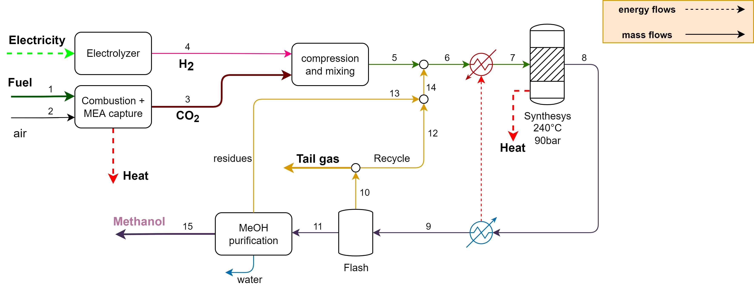
(a)

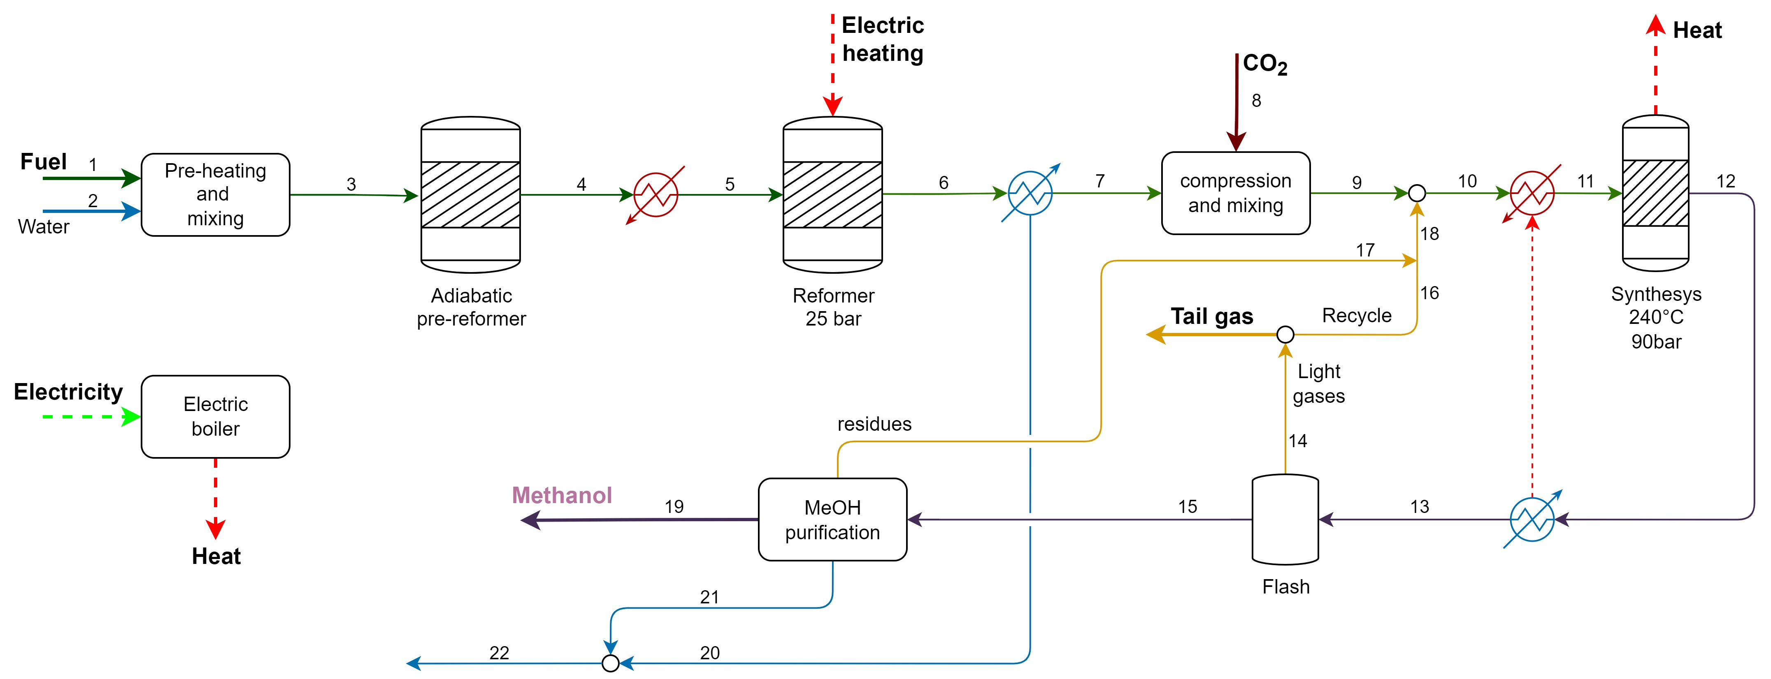
(b)

Figure 1. Plant schemes of: (a) e-MeOH; and (b) er-MeOH.
  - Economic assumptions and key performance indicators
This study assumes an operation rate of the plants of 8400 h/year and an annualisation rate AF of 8.67 %/year (corresponding to a discount rate of 8 % over 25 years). Costs are reported in €²⁰¹⁸ and updated with CEPCI indexes when needed. Material and installation costs are taken from the literature and scaled by using appropriate cost functions, following the methodology proposed by Spinelli et al. (2018). The investment costs of the process units are summed up to obtain the total direct plant cost TDPC [M€], and increased by the contributions of engineering and procurement (14 % of TDPC) and contingencies and owner costs (15 % of TDPC) to obtain the total plant cost TPC [M€]:
$$TPC=TDPC∙(1+0.14+0.15)$$ |  | (1)
The TPC from Eq.(1) is annualised into the yearly total plant cost TPC_{a} [M€/year]:
$${TPC}_{a}=TPC∙AF$$ |  | (2)
The operating costs are given by a fixed contribution of operation and maintenance (2.5 % of TPC), by insurance costs (2 % of TPC), by the costs of electricity, and by the potential revenues from steam export:
$${TC}_{a}=TPC_{a}+TPC∙\left(0.025+0.02\right)+c_{el}∙E_{el}-c_{steam}∙Q_{steam}$$ |  | (3)
being c_{el} (equal to 40 or 100 €/MWh_{el}) and E_{el} [MWh_{el}/year] the cost of electricity and the electric demand of the plant, respectively. The terms c_{steam} [€/MWh_{th}] and Q_{steam} [MWh_{th}/year] of Eq.(3) are the price of steam and the net steam thermal energy export. In particular, the price of steam c_{steam} is determined by comparison with its production cost through natural gas combustion (with unitary cost of 6 €/GJ) in a conventional boiler with 90 % efficiency, thus obtaining 24.8 €/MWh_{th} of steam export.
Focussing on performance indicators, the overall energy efficiency of plants η_{en} [%] is here defined as the ratio between the thermal power output in the products (i.e., MeOH - P_{MeOH,LHV} [MW], useful heat output - Q_{u} [MW], steam export - Q_{steam} [MW]) and the consumptions (i.e., fuel gas - P_{FG,LHV} [MW], electricity - P_{el} [MW]):
$$η_{en}=\frac{P_{MeOH,LHV}+Q_{u}+Q_{steam}}{P_{FG,LHV}+P_{el}}$$ |  | (4)
Given the MeOH power output (P_{MeOH,LHV}) and the consumption of the plant (i.e., electricity P_{el} and fuel gas P_{FG,LHV}), it is also possible to define the power-to-MeOH (η_{PtMeOH} [%]) and the fuel gas-to-MeOH (η_{FtMeOH} [%]) efficiencies, as:
$$η_{PtMeOH}=\frac{P_{MeOH,LHV}}{P_{el}}$$ |  | (5)
$$η_{FtMeOH}=\frac{P_{MeOH,LHV}}{P_{FG,LHV}}$$ |  | (6)
Considering the yearly energy output of MeOH E_{MeOH} [GJ/year], the MeOH production cost TC_{MeOH} [€/GJ] is:
$${TC}_{MeOH}=\frac{{TC}_{a}}{E_{MeOH}}$$ |  | (7)
A sensitivity analysis on the off-gas recycle revealed that both e-MeOH and er-MeOH plants exhibit a monotonic increase of energy efficiency and carbon efficiency, and therefore a decrease in MeOH production cost, alongside a raise in internal recycle. Hence, the internal recycle is here maximised to optimise the techno-economic performance of the plants. In particular, e-MeOH is designed with a limited purge of 0.5 % in mass, while er-MeOH with a purge of 2.5 % in mass, and both plants involve a direct recycle of the remaining off-gas at the inlet of the synthesis section.
  - Results
The previously described e-MeOH and er-MeOH plants were simulated in Aspen Plus® software, by using the Peng-Robinson equation of state. Reactors were calculated at chemical equilibrium. The results from the technical analysis are reported in Table 2 in terms of mass and energy balances, and key performance indicators. The electricity consumption is dominated by electrolysis in the e-MeOH plant (90 % of total demand) and by electric heat (74 %) and electric reforming (24 %) in the er-MeOH option. Electric energy consumption for CO₂ capture constitutes a small contribution in both plants: 8 % in e-MeOH and well below 1 % in er-MeOH. Overall, e-MeOH exhibits an electric energy consumption of 716.1 MW (corresponding to 480 kWh/GJ of MeOH), against 570.1 MW (corresponding to 355 kWh/GJ of MeOH) in the er-MeOH case (i.e., -20 %). The resulting carbon efficiency is always higher than 90 %, with the er-MeOH plant slightly penalised by the unconverted CH₄ in the reformer. On the other hand, er-MeOH entails better performance indicators with respect to the e-MeOH option, with +22 % in overall energy efficiency, +35 % in electric power-to-MeOH efficiency, and +8 % in fuel gas-to-MeOH efficiency. Overall, the er-MeOH plant has higher MeOH output (+7.6 %), as it exploits also external CO₂ to regulate the syngas composition, and lower electric consumptions compared to the e-MeOH one, with the latter being particularly penalised by electrolyser losses (195 MW) and other losses (156 MW).
The economic analysis (Figure 2) highlights that the TDPC of the e-MeOH plant is dominated by the cost of the electrolyser (55 % of TDPC), followed by CO₂ capture (16 %) and MeOH synthesis (13 %), while the cost breakdown in the er-MeOH case highlights the significant contributions of electric heating (31 %), MeOH synthesis (28 %), and electric reforming (22 %). As a result, the TDPC of the er-MeOH plant (321.6 M€) is about half of that of the e-MeOH configuration (712.5 M€) (Figure 2a). Even in an optimistic scenario with a unitary cost of 40 €/MWh, electricity would be the major contributor to annualised costs in both e-MeOH (65 % of TC_{a}) and er-MeOH (80 %), where the er-MeOH configuration still exhibits lower total annualised costs therefore, lower MeOH production costs (between -34 % and -39 %) with respect to the e-MeOH plant (Figure 2b). For an electricity price of 40 €/MWh, the MeOH production cost would result equal to 30.5 €/GJ (e-MeOH) and 18.6 €/GJ (er-MeOH), these increasing up to 60.0 €/GJ (e-MeOH) and 39.9 €/GJ (er-MeOH) for the more realistic 100 €/MWh scenario.

Table 2. Mass and energy balances, and performance of e-MeOH and er-MeOH plants.
 | e-MeOH | er-MeOH
Energy balance
Input
Fuel gas | 469.1 | 469.1 | MW
Electricity | 716.1 | 570.1 | MW
- Electrolyser | 648.0 | - | MW
- Boilers/furnaces | - | 420.0 | MW
- Reformer | - | 134.0 | MW
- CO₂ capture comp. | 59.1 | 1.34 | MW
- Others | 9.0 | 14.7 | MW
Output
Electrolyser losses | 194.9 | - | MW
MeOH | 414.6 | 446.2 | MW
Thermal power output | 420.0 | 420.0 | MW
Steam export | - | 24.6 | MW
Other losses | 147.5 | 148.4 | MW
Mass balance
Input
Fuel gas | 36050 | 36050 | kg/h
Combustion air | 605755 | - | kg/h
External CO₂ | - | 12797 | kg/h
H₂O | - | 34723 | kg/h
Output
MeOH | 70713 | 76106 | kg/h
H₂O | 13607 | - | kg/h
Performance
Single pass MeOH yield | 66.7 % | 45.1 %
Global MeOH yield | 99.7 % | 97.0 %
Carbon efficiency | 94.8 % | 90.7 %
Key performance indicators
Energy efficiency | 70.4 % | 85.7 %
Power-to-MeOH efficiency | 57.9 % | 78.3 %
Fuel gas-to-MeOH efficiency | 88.4 % | 95.1 %

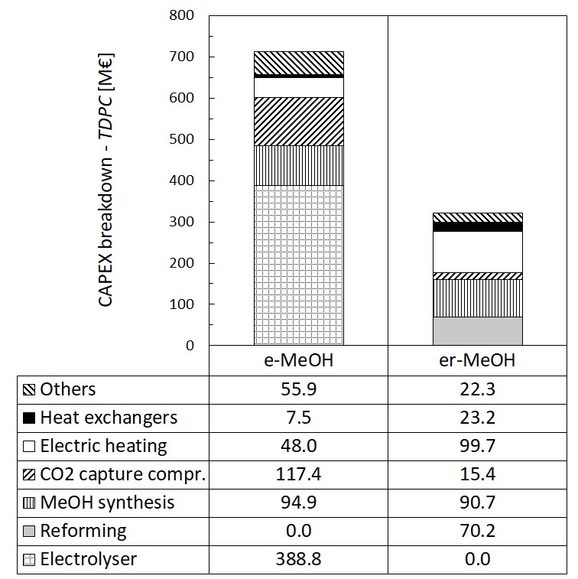 | 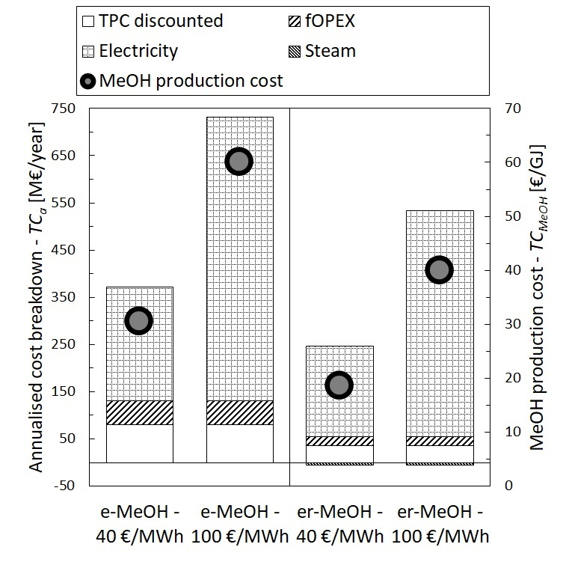
(a) | (b)
Figure 2. Economic results: (a) TDPC [M€]; and (b) annualised cost (TPC discounted, fixed variable costs - fOPEX, cost of electricity, steam export) [M€/year] and MeOH production cost [€/GJ of MeOH].
  - Conclusions
This study proposed a techno-economic assessment of different design configurations for the conversion of a refinery fuel gas into methanol (MeOH). In particular, two conversion pathways were here investigated: a conventional e-Fuel (i.e., e-MeOH) plant based on green H₂ from low-temperature electrolysis and CO₂ captured from the flue gas stream deriving from the combustion of the fuel gas; an alternative er-Fuel (i.e., er-MeOH) process concept, based on the electric reforming of the fuel gas and subsequent synthesis of the obtained syngas.
On the one hand, both plants exhibited a carbon efficiency higher than 90 %. On the flip side, the technical assessment revealed the higher energy efficiency (+22 %), electric power-to-MeOH efficiency (+35 %), and fuel gas-to-MeOH efficiency (+8 %) of the er-MeOH plant, compared to the e-MeOH one. This outcome was mainly due to the higher electric power consumption of the e-MeOH option with respect to the er-MeOH alternative (+20 %). Furthermore, the economic assessment highlighted the higher production cost (between +30 % and +40 %) of the e-MeOH plant (between 30.5 and 60.0 €/GJ of MeOH) with respect to the er-MeOH one (between 18.6 and 39.9 €/GJ of MeOH).
All things considered, the e-Fuel process design was characterised by a worse techno-economic performance compared to the er-Fuel alternative scheme, and this outcome highlights how the e-Fuel conversion pathway should not be the preferred one to exploit and utilise the carbon content of a fossil fuel stream. The implementation of co-electrolysis could bring in some benefits in the e-Fuel configuration, and this could constitute a future development of this study.

References

Al-Qahtani A., González-Garay A., Bernardi A., Galán-Martín Á., Pozo C., Mac Dowell N., Chachuat, B., Guillén-Gosálbez, G., 2020, Electricity grid decarbonisation or green methanol fuel? A life-cycle modelling and analysis of today′s transportation-power nexus, Appl. Energy, 265, 114718.
Blanco H., Nijs W., Ruf J., Faaij A., 2018, Potential for hydrogen and Power-to-Liquid in a low-carbon EU energy system using cost optimization, Appl. Energy, 232, 617–639.
Chehade Z., Mansilla C., Lucchese P., Hilliard S., Proost J., 2019, Review and analysis of demonstration projects on power-to-X pathways in the world, Int. J. Hydrogen Energy, 44, 27637–27655.
d’Amore F., Romano M.C., Bezzo F., 2021, Optimal design of European supply chains for carbon capture and storage from industrial emission sources including pipe and ship transport., Int. J. Greenh. Gas Control, 109, 103372.
Dieterich V., Buttler A., Hanel A., Spliethoff H., Fendt S., 2020, Power-to-liquid via synthesis of methanol, DME or Fischer–Tropsch-fuels: a review, Energy Environ. Sci., 13, 3207–3252.
EEA, 2021, Greenhouse gases data viewer <https://www.eea.europa.eu/data-and-maps/data/data-viewers/greenhouse-gases-viewer> accessed 13.04.2022.
Gabrielli P., Gazzani M., Mazzotti M., 2020, The Role of Carbon Capture and Utilization, Carbon Capture and Storage, and Biomass to Enable a Net-Zero-CO₂ Emissions Chemical Industry, Ind. Eng. Chem. Res., 59, 7033–7045.
Hepburn C., Adlen E., Beddington J., Carter E.A., Fuss S., Mac Dowell N., Minx J.C., Smith P., Williams C.K., 2019, The technological and economic prospects for CO₂ utilization and removal, Nature, 575, 87–97.
IEAGHG, 2017, Understanding the cost of retrofitting CO₂ capture in an integrated oil refinery, 2017, <https://ieaghg.org/publications/technical-reports/reports-list/10-technical-reviews/819-2017-tr8-understanding-the-cost-of-retrofitting-co2-capture-in-an-integrated-oil-refinery> accessed 13.04.2022.
IPCC, 2018, Global warming of 1.5°C <https://www.ipcc.ch/site/assets/uploads/sites/2/2019/06/SR15_Full_Report_High_Res.pdf> accessed 13.04.2022.
Mac Dowell N., Fennell P.S., Shah N., Maitland G.C., 2017, The role of CO₂ capture and utilization in mitigating climate change, Nat. Clim. Chang., 7, 243–249.
Spinelli M., Campanari S., Consonni S., Romano M.C., Kreutz T., Ghezel-Ayagh H., Jolly S., 2018, Molten Carbonate Fuel Cells for Retrofitting Postcombustion CO₂ Capture in Coal and Natural Gas Power Plants, J. Electrochem. Energy Convers. Storage, 15, 1–15.
Ueckerdt F., Bauer C., Dirnaichner A., Everall J., Sacchi R., Luderer G., 2021, Potential and risks of hydrogen-based e-fuels in climate change mitigation, Nat. Clim. Chang, 11, 384–393.
Wulf C., Zapp P., Schreiber A., 2020, Review of Power-to-X Demonstration Projects in Europe, Front. Energy Res., 8, 1–12.

