CHEMICAL ENGINEERING TRANSACTIONS  VOL. | A publication of
The Italian Association
of Chemical Engineering
Online at www.cetjournal.it
Guest Editors:
Copyright © AIDIC Servizi S.r.l.
ISBN 978-88-95608-xx-x ISSN 2283-9216

Adsorption of N₂O using Fe-13X zeolites – A possibility to make a Process Intensification by using Microwaves for the Regeneration step
Mariaconcetta Pierro^{a*}, Eugenio Meloniª, Marco Martinoª, Pluton Pullumbi^{b}, Federico Brandani^{b}, Vincenzo Palmaª
ªDepartment of Industrial Engineering, University of Salerno, Via Giovanni Paolo II 132, 84084 Fisciano (SA), Italy
^{b}Air Liquide, Paris Innovation Campus,1 Chemin de la Porte des Loges, Les Loges en Josas 78350, France
*mpierro@unisa.it
Nitrous oxide is an effective greenhouse gas, which also greatly contributes to the depletion of the stratospheric ozone. Among the most common abatement methods, the capture of N₂O by adsorption and the consequent reutilization appears as the best technique. In this work, the adsorption – regeneration cycle of N₂O on 13X zeolites has been intensified by electrification of the process. More in detail, the regeneration step has been conducted in an innovative way, by employing a microwave heating. For the adsorption step, a concentrated stream consisting of 40 %vol N₂O has been used, while the regeneration one was carried out using a stream of 100 %vol Ar and a power of 500 W for microwave heating. Each complete adsorption – regeneration cycle has been repeated several times, considering both wet and dry conditions for the gas mixture to be adsorbed, to prove the repeatability of the process. The results of the tests revealed that microwaves allowed to regenerate the solid adsorbent bed, by obtaining a significant reduction in the purge gas consumption and a recovery of 100 %. Therefore, employing a microwave-assisted regeneration step led to a process intensification, with respect to a conventional Temperature Swing Regeneration.
  - Introduction
Humans have a strong impact on climate changes, and in particular on Earth's temperature raising, through activities such as industrial production, burning fossil fuels, deforestation and cattle breeding.
Nitrous oxide (N₂O) is a colorless and toxic gas, naturally present both on Earth’s terrestrial and aquatic ecosystems. N₂O takes part in the nitrogen cycle through the two biochemical processes of nitrification and denitrification, which are regulated by several factors, both environmental and biological, including temperature, water and oxygen levels, acidity, and substrate availability (Butterbach-Bahl et al., 2013). During the last years, monitoring the amount of N₂O in the atmosphere has become necessary too, since it significantly contributes to the greenhouse effect, having a Global Warming Potential of about 265 times than CO₂, and to the thinning of the stratospheric ozone layer (Prather et al., 2015). Moreover, N₂O concentration is undergoing an even more sudden increase. With a growth rate of about 2 percent per decade (Tian et al., 2020), the concentration of N₂O in the atmosphere reached 335 ppb in 2021 (NOAA Report, 2021). The anthropogenic activities having the greatest impact on N₂O concentration are the massive use of nitrogen-based fertilizers, the burning of fossil fuels, and the production of nitric and adipic acid. So, the abatement of N₂O from industrial waste gases could be a starting point through which the negative impact of N₂O on the environment can be limited. The main processes used to remove N₂O from flue gas are adsorption and catalytic decomposition. With respect to catalytic decomposition, which requires temperatures above 400 °C and expensive metal oxides (Denisova et al., 2019), adsorption is the most promising technique, being a simple process, which requires low costs and low energy consumption (Kloutse et al., 2020), and allows to obtain N₂O with high purity. Indeed, it can be interesting to re-use the captured N₂O in several ways, i.e., as a selective and worth oxidant for the sustainable production of fine and intermediate chemicals, such as phenol or methanol.
Most of the studies available in the literature aim to identify the most suitable adsorbent, thus developing increasingly performing materials in certain ranges of temperature and pressure. To purify highly concentrated streams (> 30 %vol N₂O), that is the case of adipic acid flue gas, and also the case investigated in this work, it is better to use a mesoporous solid adsorbent. This result was carried out from the study of Peng et al. (2009), which examined the adsorption of N₂O on three types of activated carbons with different pore sizes. Also, carbon nanotubes (CNT), both intrinsic and Pd-doped, have been studied by Yoosefian (2017) as adsorbents for N₂O; the study revealed a too much strong interaction between Pd-CNT and the chemisorbed N₂O, thus resulting in an application not suitable for a continuous adsorption-desorption cycle. In many studies has been explored the possibility of utilizing zeolites as adsorbents for removing N₂O. Wu et al. (2019) compared adsorption isotherms of nitrous oxide on 5A zeolite, 13X zeolite, activated carbon (AC), ZSM-5, and silica gel, obtaining that 5A and 13X zeolite possessed a higher adsorbed amount of N₂O at lower adsorption pressure, while AC had the best adsorption capacity at the higher one. Zhang et al. (2011) and Guillemot et al. (2015) found that ZSM-5 has a good adsorption capacity, especially if cation-exchanged. Instead, in the work of Saha et al. (2010), 4A and 13X zeolite resulted to be very similar in the interaction with N₂O. In addition to the choice of a good adsorbent, the subsequent regeneration step has to be fast and cost-effective, in order to have an efficient adsorption-desorption cycle. Moreover, in recent literature studies (Kamaruddin et al. 2018), the use of electromagnetic fields as an alternative to the Joule effect for a more efficient heating has been developing. In this work, the 13X zeolites were selected as adsorbents because they combine their great adsorption capacity and fast adsorption-desorption kinetics towards N₂O with the possibility to be heated through MW-irradiation, due to their electro-thermal features (Haidar et al., 1986). In particular, 13X type zeolites has a low Si/Al ratio (1÷1.5), corresponding to a high number of compensating cations. Since cations are not chemically bound to the framework, they can move to new positions under the influence of an external electric field, for example induced by MW. The cation-hopping between exchangeable sites allows to obtain dielectric losses, that are the cause of the heating through microwave irradiation (Gracia et al., 2013). Furthermore, the peculiarity of the supplied 13X zeolites is that they are Fe-exchanged, and many literary studies prove that the presence of iron gives a stronger interaction between N₂O and zeolites, so that the adsorption process is favoured (Wang et al., 2010 and Wood et al., 2002).
  - Materials and methods
    - Adsorbent
The solid adsorbent used in this work were the 13X zeolites, supplied by the French company Air Liquide. They were in the form of spheres with an average diameter of 2–3 mm. The physical properties of the Fe-13X zeolites are shown in Table 1.
Table 1. Physical properties of the Fe-13X zeolites.
Density | 660 kg/m³
Bed void | 0.35
Spheres porosity | 0.60
Thermal conductivity (k_{T}) | 0.20 W/(m·K)
Specific heat (c_{p}) | 850 J/(kg·K)
    - Experimental plant
The experimental plant used to carry out the adsorption-desorption tests can be divided into three sections, which are respectively feeding, adsorption, and analysis (Figure 1). The feeding section was conceived to carry out the tests both in dry and wet conditions. The gases pass through a moisture trap and then are fed by using a mass flow controller (MFC) into a tee connection, in which they are mixed. In the case of wet tests, the water is supplied by passing the feeding mixture through a bubbler, in which it is saturated in moisture (100 % RH).
In the adsorption section, the gas mixture can be sent to the adsorber or to the analysis section, by means of a three-way electro valve. On the bottom of the adsorber, the magnetron for the generation of microwaves (MWs) is placed, and it is managed by a PID controller. Two temperature probes (TS2 by Optocon-Weidmann), specially designed to be inert to the action of the electric field, have been placed at 0.3 mm from the inlet and from the outlet section of the bed respectively. The adsorber, made of stainless steel, has a particular configuration. It has an external and an internal chamber: the gas enters from the top of the external chamber and then passes through the adsorbent bed by entering from the bottom of the internal one. The internal chamber has a narrower region, in which the zeolites bed is put: this feature allows the system to have the electromagnetic field concentrated in this zone (Meloni et al., 2021) and so to have high efficiency in heating. The analysis section includes the mass spectrometer, which analyses the composition of the outlet mixture, and the computer, for the acquisition of temperatures and compositions, through specific software (respectively Fotemp and QUADSTAR 422).
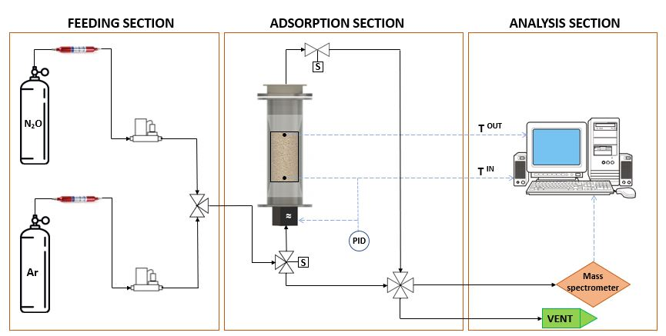
Figure 1. Experimental plant scheme.
    - Experimental tests and characterizations
The adsorber has been filled with 160 g of 13X zeolites, which remained the same for all tests. The pressure of the adsorber was constantly atmospheric during the experimental tests. Dry and wet tests have been carried out under the operative conditions shown in Table 2 below.
Table 2. Operative conditions.
 | ADSORPTION | DESORPTION
Flow rate | 1.25 NL/min | 0.35 NL/min
Composition
(dry) | 40 %vol N₂O  60 %vol Ar | 100 %vol Ar
(wet) | 39.3 %vol N₂O  59 %vol Ar  1.7 %vol H₂O | 100 %vol Ar
MW power | Off | 500 W
The fresh and spent (i.e., after wet tests) samples have been characterized in terms of BET analysis and SEM imaging. The NOVAtouch sorptometer, which uses BET method, by means of adsorption-desorption of N₂ at 77 K, defined the specific surface area (SSA), the pore radius, and the microporous volume. Subsequent imaging analysis was carried out by means of a Philips XL30 Scanning Electron Microscope (SEM).
  - Results and discussion
    - Dry adsorption-desorption tests
Before the N₂O adsorption and desorption tests, the adsorbent bed of zeolites was subjected to a preliminary heating process at 350 °C in presence of Ar, to remove any impurity in the porosities of the solid. Three consecutive dry adsorption-desorption cycles have been carried out, achieving the results shown in Figure 2. The composition of the system has been registered every 10 minutes. The three tests gave back superimposable results, index of total regeneration of the solid with the innovative MWs regeneration technique. The total amount of adsorbed N₂O, determined through a mass balance on the system, was found to be 29.3 g. Moreover, the equivalence between the adsorbed and the desorbed amount of N₂O, observed in all three tests, is a further confirmation of the complete regeneration of the adsorbent by means of MWs heating.
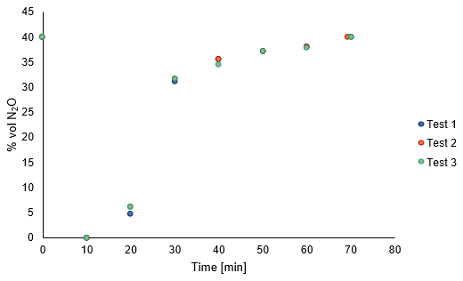
Figure 2. Results of the three dry adsorption – desorption tests.
    - Wet adsorption – desorption tests
In order to verify the behaviour of the adsorbent bed even in presence of humidity, which is a usual condition for the industrial flue gas, three consecutive wet tests have been carried out. As it is known, water can affect the zeolite’s adsorbent capacity, because it could establish both superficial and intra-pore bonds with the zeolite’s structure (Stanciakova et al., 2021). In particular, the gas mixture has been brought to a saturation condition, i.e., 100 % RH, to evaluate the worst possible situation. From the results of the wet tests, it was reported that the adsorbent capacity towards N₂O after introducing water has fallen to 24.8 g, corresponding to a loss of 15 % with respect to the dry one. This shows that water is able to be adsorbed simultaneously with N₂O on zeolites. After the aforementioned three wet tests, two dry adsorption-desorption cycles have been carried out, the second of which has been used to show the repeatability of the results, which has been confirmed. The adsorbent capacity of the 13X zeolites in dry conditions, after their exposure to humidity, was found to be 27 g, corresponding to a loss of adsorbent capacity of about 8 %, compared to the fresh sample.
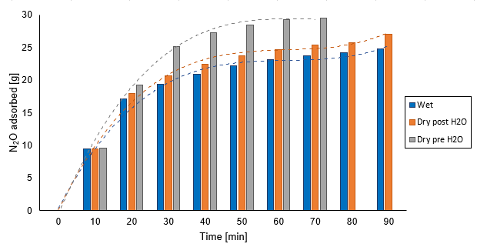
Figure 3. Comparison between wet and dry adsorption kinetics.
It was not possible to retrieve the initial adsorbent capacity since the required temperature to desorb the chemisorbed water is about 400 °C. This temperature couldn’t be achieved because starting from 360 °C the structure of the used zeolites begins to damage, as declared by the supplier. In Figure 3, a comparison between the first dry tests, the wet ones and the last dry ones has been made. For each set of tests, an average value of the amount of N₂O adsorbed versus time has been considered and then diagrammed: the dashed curves in the diagram represent the adsorption kinetics. The addition of water has brought the curve of the adsorption kinetics of N₂O (Dry pre H₂O) to change in its shape (Wet), and this trend is maintained also in the subsequent Dry post H₂O tests, thus indicating that the presence of chemisorbed water in the structure brought to change not only the total amount adsorbed, but also the kinetic with which N₂O is adsorbed. However, the behaviour of the adsorbent in presence of humidity deviates a it differs slightly from what it has in dry conditions.
    - BET and SEM results
The results of the characterizations revealed that water did not entail significant changes in the structure of zeolites. From the BET analysis, the fresh and spent samples had both a pore radius of 1.90 nm and a specific surface area (SSA) of 400 m²/g. A slight difference can be detected in the microporous volume, which was 15 mm³/g for the fresh sample and 13 mm³/g for the sample after the wet tests, probably due to the presence of the chemisorbed water. Even from the SEM imaging, the fresh and spent samples have the same particle size and distribution, as can be seen in Figure 4. These results are evidence of the fact that by undergoing consecutive adsorption and desorption cycles, the 13X zeolites’ structure remains untouched.
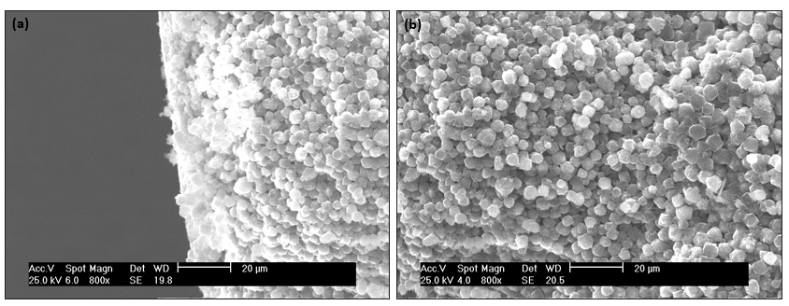
Figure 4. SEM image of fresh (a) and spent samples (b).
    - Comparison with a traditional TSR process
The results obtained both from wet and dry tests have been compared with a recent work regarding the traditional Temperature Swing Regeneration (TSR) process, focusing the attention on the purge gas consumption and on the percentage recovery of N₂O. The MW-assisted TSR process has led to selective heating of the adsorbent, thus resulting in the so-called volumetric heating (Das S. et al, 2009). This way of heating, in which the electromagnetic energy is transformed into thermal energy directly inside the solid, based on the solid’s dielectric and thermal properties, allowed to use a reduced amount of purge gas, which is usually used as a medium to heat the solid (by means of convection and conduction mechanisms). Our work, compared with those of Jiang et al. (2020), achieved a significant reduction of purge gas consumption, of 99.2 %, and a recovery of 100 % of the adsorbed N₂O, with respect to 90 %. So, the microwave-assisted regeneration step led to a process intensification with respect to a conventional TSR.
  - Conclusions
This work represents a study on the possibility of intensifying the regeneration step, after having adsorbed N₂O, through electrification of the process using MWs. For the tests, both in dry and wet conditions, a volume fraction of 40 %vol of N₂O has been used, to study the capacity of the adsorbent at the highest nitrous oxide concentration in industrial flue gas (> 30 %vol in adipic acid plants). The used adsorbent, the Fe-13X zeolites, has been carefully chosen, by combining the best adsorption-desorption and the best electro–thermal features, to optimize the process as much as possible. The results showed that the MWs heating allowed to completely regenerate the solid, since the adsorbed and desorbed amount coincide, and without damaging the Fe-13X zeolite’s structure because consecutive tests gave back the same result. This new regeneration technique brought to a reduction in the purge gas consumption up to 99.2%, compared to a traditional TSR process. Also, the effect of water on the whole adsorption-desorption cycle has been evaluated. The introduction of water in the system brought only a partial loss in the adsorbent capacity, with no changes neither in the structure nor in the particle size or distribution of the solid adsorbent. In conclusion, the reduction of gas consumption, linked to the innovative way of heating, together with the total regeneration of the solid after each adsorption-desorption cycle, represents a real process intensification. Moreover, the results revealed that the combination of Fe-13X zeolites with the MW-assisted regeneration can be used also in presence of water in the feeding gas.

References
Butterbach-Bahl K., Baggs E. M., Dannenmann M., Kiese R., Zechmeister-Boltenstern S., 2013, Nitrous oxide emissions from soils: how well do we understand the processes and their controls? Philosophical Transactions of the Royal Society B, 368, 20130122.
Das S., Mukhopadhyay A.K., Datta S., Basu D., 2009, Prospects of microwave processing: An overview, Bulletin of Materials Science, 32, 1–13.
Denisovа K.O., Ilyin A.A., Rumyantsev R.N., A. P. Ilyin R.P., Volkova A.V., 2019, Nitrous Oxide: Production, Application, and Protection of the Environment, Russian Journal of General Chemistry, 89, 6, 1338–1346.
Gracia J., Escuin M., Mallada R., Navascues N., Santamaría J., 2013, Heating of zeolites under microwave irradiation: a density functional theory approach to the ion movements responsible of the dielectric loss in Na, K, and Ca A-Zeolites, Journal of Physical Chemistry C, 117, 15659–15666.
Guillemot M., Castel B., 2015, Workplace Nitrous Oxide Sampling: Alternative Adsorbents, Industrial & Engineering Chemistry Research, 2015, 54, 7760−7765.
Halidar A.R., Jonscher A.K., 1986, The Dielectric Properties of Zeolites in Variable Temperature and Humidity, Journal of the Chemical Society, Faraday Transactions 1,82, 3535-3551.
Jiang N., Shen Y., Liu B., Zhang D., Tang Z., Li G., Fu B., 2020, CO₂ capture from dry flue gas by means of VPSA, TSA and TVSA, Journal of CO₂ Utilization, 35, 153–168.
Kamaruddin M.J., Hamid S.R.A., Othman S.I.A. et al., 2018, The Effects of Conventional and Microwave Heating: Techniques on Extraction Yield of Orthosiphon Stamineus Leaves, Chemical Engineering Transactions, 63, 601-606.
Kloutse F.A., Gauthier W., Hourri A., Natarajan S., Benard P., Chahine R., 2020, Study of competitive adsorption of the N2O-CO2-CH4-N2 quaternary mixture on CuBTC, Separation and Purification Technology 235, 116211.
Meloni E., Martino M., Pullumbi P., Brandani F., Palma V., 2021, Intensification of TSA processes using a microwave-assisted regeneration step, Chemical Engineering and Processing - Process Intensification, 160, 108291.
NOAA’s Earth System Research Laboratory, Global Monitoring Division, 2021, Trends in Atmospheric Nitrous Oxide.
Peng Y., Zhang F., Xu C., Xiao Q., Zhong Y., Zhu W, 2009, Adsorption of Nitrous Oxide on Activated Carbons, Journal of Chemical & Engineering Data, 54, 3079−3081.
Prather M.J., Juno H., DeLuca N.M., Jackman C.H., Oman L.D., Douglass A.R., Fleming E.L., Strahan S.E., Steenrod S.D., Søvde O.A., Isaksen I.S.A., Froidevaux L., Funke B., 2015, Measuring and modeling the lifetime of nitrous oxide including its variability. JGR Atmospheres 120, 5693–5705.
Saha D., S. Deng, “Adsorption Equilibrium, Kinetics, and Enthalpy of N2O on Zeolite 4A and 13X”, J. Chem. Eng. Data 2010, 55, 3312–3317.
Stanciakova K. and Weckhuysen B.M., 2021, Water–active site interactions in zeolites and their relevance in catalysis, Review, Trends in Chemistry, 3, 456-468.
Tian H., Xu R., Canadell J.G. et al., 2020, A comprehensive quantification of global nitrous oxide sources and sinks, Nature, 586, 248–256.
Wang Y., Lei Z., Chen B., Guo Q., Liu N., 2010, Adsorption of NO and N₂O on Fe-BEA and H-BEA zeolites, Applied Surface Science, 256, 4042–4047.
Wood B.R., Reimer J.A., Bell A.T., 2002, Studies of N₂O Adsorption and Decomposition on Fe–ZSM-5, Journal of Catalysis 209, 151–158.
Wu T., Shen Y., Feng L., Tang Z., Zhang D., 2019, Adsorption Properties of N₂O on Zeolite 5A, 13X, Activated Carbon, ZSM-5, and Silica Gel, Journal of Chemical & Engineering Data, 64, 3473−3482.
Yoosefian M., 2017, Powerful greenhouse gas nitrous oxide adsorption onto intrinsic and Pd doped Single walled carbon nanotube, Applied Surface Science, 392, 225–230.
Zhang B., Lu Y.A., He H., Wang J.G., Zhang C.B., Yu Y.B., Xue L., 2011, Experimental and density functional theory study of the adsorption of N2O on ion-exchanged ZSM-5: Part II. The adsorption of N2O on main-group ion-exchanged ZSM-5, Journal of Environmental Sciences, 23, 681–686.

