|  |  |
| --- | --- |
| cetlogo ***CHEMICAL ENGINEERING TRANSACTIONS***  ***VOL. 96, 2022*** | A publication of  aidiclogo_grande |
| The Italian Association  of Chemical Engineering  Online at www.cetjournal.it |
| Guest Editors:  Copyright © AIDIC Servizi S.r.l. **ISBN** 978-88-95608-xx-x **ISSN** 2283-9216 | |

Non-conventional Energy from Biogas recovered from Wastewater Sludge

Candy M. Corsino Cortez, Katherin L. Delgado Pantoja, Carlos Castañeda Olivera, Elmer Benites-Alfaro

Universidad César Vallejo, Av. Alfredo Mendiola 6232, Lima 15314, Perú

Corresponding: ebenitesa@ucv.edu.pe

The energy crisis due to the depletion of fossil fuels and the negative environmental impacts they produce, require the search for more environmentally friendly energy sources. The research evaluated the electric energy obtained from biogas generated by wastewater sludge from a wastewater treatment plant (WWTP). An anaerobic biodigester was used in the process of obtaining the biogas. The wastewater was evaluated taking into account the parameters of pH, humidity and percentage of organic matter, data that also allowed determining the daily load. After 42 days, the biogas concentration was evaluated, reaching concentrations of 57.7 % methane (CH4), 33 % carbon dioxide (CO2) and 10 ppm hydrogen sulphide (H2S), presenting adequate characteristics to generate electricity using a 1300 W four-stroke generator set, with a 3.0 HP, 3.0 rpm, single cylinder capacity. The mechanism consists of placing a gas mixer in the carburettor whose function is to mix the biogas and air in the correct proportions. As a result, a useful energy of 0.100 KW-h was obtained with LED bulbs of 110 W. A test was also carried out with incandescent bulbs of 100 W where a useful energy of 0.056 KW-h was obtained. It can be established that a yield of 2.421 % was reached in function to the total and useful energy registered with the LED bulbs. From the above mentioned, it is established that the biogas obtained can be a non-conventional energy source, under the concept of sustainability.

* 1. Introduction

The energy crisis due to the depletion of fossil fuels produces negative impacts on the environment, which is why efficient options for sustainable development are being sought. Being in Latin America where the consumption of renewable energy is 30 % compared to 5.7 % of OECD countries (Organization for Economic Cooperation and Development). Likewise, Pelkmans L. (2018) in the publication: IEA Bioenergy Countries Report - Update 2018, Bioenergy policies and status of implementation, mention that countries such as the Korean government will expand its share of renewable generation in total electricity production from 7 % to 20 % by 2030. In such sense, it is important to indicate that there is a concern in the management of organic waste and its application to generate energy, so refers Bucura F., Marin F., Miricioiu M., Saros G., Zaharioiu A. and Constantinescu M. (2018) in the publication: Energy potential of geothermal gas and sewage sludge biogas. A laboratory stage investigation: they mention that we should pay more attention to reusable waste, since, it can be used as an efficient and sustainable energy source. Another potential source of green energy could be gas from anaerobic digestion as wastewater sludge from urban WWTPs. If for many EU countries such a solution is no longer a novelty, in Romania, waste management is still in its initial phase. In this context, Peru has not yet made the appropriate investment and the maximum use of sewage sludge as a potential for biogas production and its application in pilot plants to generate its own electricity as other EU countries are doing, where they are already obtaining favourable results with 17,400 biogas plants producing more than 61 TW-h of electricity until 2018.

* 1. Methodology
     1. Sewage sludge acquisition and evaluation

For the analysis, a sample of 500 g was acquired according to the regulations for the reuse of sludge generated in the WWTP. The parameters of pH, humidity and percentage of organic matter were analyzed to determine the daily load of the biodigester, see Table 1.

Table 1: Sludge sample parameters

|  |  |
| --- | --- |
| Parameter | Value |
| pH | 6.68 |
| Humidity (% in weight) | 92.6 |
| Organic material (% in weight) | 7.4 |

* + 1. Biodigester load:

The process of anaerobic digestion by microbial communities of sludge was carried out in an IBC tank biodigester made up of three pipes, one for feeding, another for gas outlet and the last for biol outlet. The loading process that is used is the semi-continuous system, this consists of the initial load having to be a large amount of material and while the volume of the gas is reduced, more material is added. In the initial load, the inoculum of cattle manure was used to optimize the microbial activity, the daily load of sludge with water is carried out once the methane production has stabilized, taking into account the retention time of 35 days.

The calculations of load, concentration, quantity, inoculum, mixture and daily load of the biodigester are shown below:

Determination of sludge loading:

Useful volume load -> liquid phase ........................ (1)

Real volume of the biodigester= 1000 L

Useful volume = 80% real volume

Useful volume = 800 L.

Loading concentration:

Quantity of solid matter (SM) = Useful volume \* %SM ..................................... (2)

SM quantity = 800 \* 0.05 (considering 5%, Guevara (1996))

Quantity of SM = 40 kg

(SM: solid matter)

Sludge quantity for the biodigester:

Considering SM % of WWTP sludge with a value of 7.4 %................................... (3)

(WWTP: Residual water treatment plant)

Quantity of WWTP sludge= 40 kg \* 100%/ 7.4 %.

Quantity of WWTP sludge = 540.54 kg

Inoculum concentration:( According to Palomino (2007), between 10% and 15% of inoculum of the useful volume of the reactor can be added)

Inoculum = 10% de Useful volume .................................. (4)

Inoculum = 800 \* 10

Inoculum = 80 kg of fresh cow manure.

Sludge + inoculum mixture

(540.54 kg sludge + 80 kg inoculum + 324 L water) was added for a total of 800 L tank volume of the intermediate bulk container (IBC), before entering the tank it was homogenized with an industrial mixer to ensure good contact of the substrate with the microbial activity.

Daily load

For the calculation of the daily load, the retention time is taken into account, where a retention time (TR) of 35 days was considered, the load was made once the methane production is stable, according to Verbero (1991):

Qd \* TR = V ............................... (5)

V: Volume of the liquid phase biodigester

If, TR=35 days and V=800 L

In (5): Qd \*35 days = 800 L

Then: Qd= 800/35=22.8 L /day Daily loading of sludge-water mixture (L / day).

* + 1. Biogas production

The production of biogas depends on the food supplied to the biodigester (Gomez C., Bosco F., Ruggeri B, 2020), the biogas generated was detected by witnessing the bubbling in the relief valve indicating the formation of gases 28 days after the first load and then measured by means of a gasometer, obtaining a flow of 0.063 m3 per day, as shown in Table 2, projected at 1 month.

See Figure 1 for the bag containing the biogas generated.

*Table 2: Biogas production*

|  |  |  |  |  |  |
| --- | --- | --- | --- | --- | --- |
| Time | 1h | 1 day | 2 days | 1 Week | 1 month |
| Volume (m3) | 0.015 | 0.063 | 0.112-0.223 | 0.572 | 2.288 |

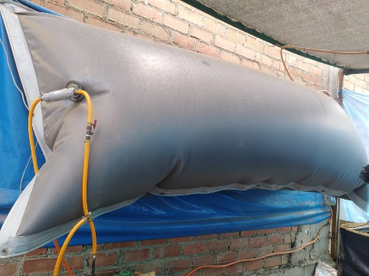

Figure 1: Biogas obtained under anaerobic conditions with sludge

* + 1. **Conversion of the gasoline engine to biogas**

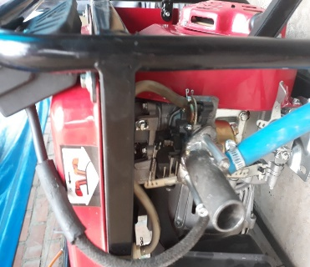For the conversion, the biogas concentration was evaluated with the Multitec® 540 equipment, which measures the mixture of gases produced during biological processes. Concentrations of 57.7% methane (CH4), 33% carbon dioxide (CO2) and 10 ppm of hydrogen sulfides (H2S) were found, thus presenting the appropriate characteristics to generate electricity. For this, a four-stroke electric generator (gas station), 3.0 HP, single-cylinder, with a rotation speed of 3000 rpm, maximum output power 1500 watts, with a 25 mm diameter carburetor was used. The mechanism consists of placing a gas mixer at the carburetor inlet whose function is to mix the biogas and the air appropriately. To start up the generator set, a little gasoline was used to activate the spark ignition, to then closed the gasoline tap and opened the biogas tap at an angle of 45º. Figure 2 shows the converter mixer equipment at the carburetor inlet of a generator set.

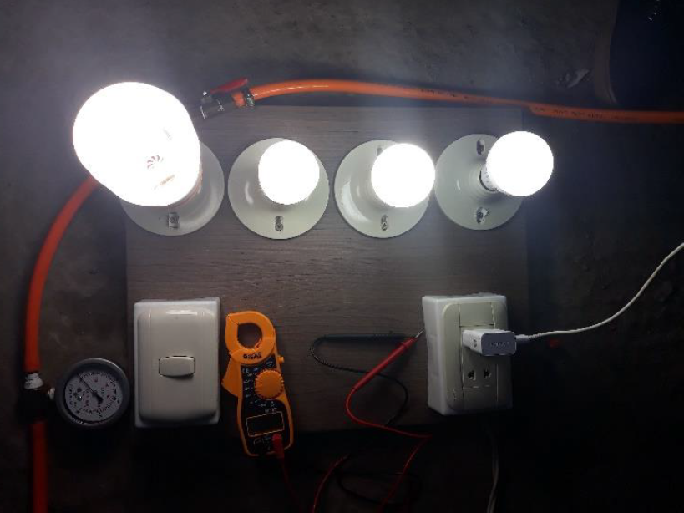

*Figure 2: Mixer (generator biogas conversion) at the carburetor inlet*

*Figure 3: LED light bulbs powered by biogas energy*

2.5. Energy measurement

The energy generated was measured in situ with an ammeter clamp, both voltage and intensity in a time of 3600 s; according to Melegari et all. (2012), the calorific value is calculated according to the chemical composition of biogas, with 60 % CH4 corresponding to a lower calorific value (ICP) of 4229.98 Kcal.kg-1 and density 1.2143 kg.m-3, in the research the methane CH4 produced was 57.7 %.

Calculating the calorific value

|  |  |
| --- | --- |
| 4229,98 Kcal.kg-1 60 % ……………………… (6)  X 57.7 % | (6) |

X= 4067.831 Kcal.kg-1

Convertion a KJ/ m3

|  |  |
| --- | --- |
| 4067.831 Kcal x 1,214 Kg x 4,187 KJ = 20676,858 KJ/m3  Kg m3 Kcal | (7) |

Total energy

|  |  |
| --- | --- |
| ET= 0.720 x 20676.858 x 2.777 x 10-4 Wh\*J-1 | (8) |
|  |  |

ET= 4.134 KW-h

Useful energy

|  |  |
| --- | --- |
| EU= 218 x 0.46 x 1 | (9) |
| EU=100.28 x 1 KW-h  1000 |  |
| EU=0.100 KW-h |  |

**Yield**

|  |  |
| --- | --- |
| R=0.100 KW-h x1 00  4.13 KW-h | (10) |
| R= 2.421 % |  |

* 1. Results and discussion
     1. Composition of gases generated in biogas

Figure 2, shows that the highest methane production was 59.0 %, according to the publication of Osinergmin, (2017) mentions that, for the application of energy from biogas, methane should range between 50 to 70 %, then what was obtained is locating the concentration within the indicated range. Likewise, according to FAO, (2011) in its biogas manual indicates that Carbon Dioxide (CO2) ranges from 30 to 45%, whose maximum value obtained in the laboratory results was 33%, registering a favorable value for biogas production and its application in the generation of electricity.

Figure 2: Concentration of methane (CH4) and carbon dioxide (CO2)

* + 1. Energy produced and used in LED light bulbs

Table 3 presents the power obtained in the generator and the result of the power of LED light bulbs in the time they remained on until the electric charge generated with a certain amount of biogas was exhausted.

*Table 3: Power of Energy produced and use in LED bulbs*

|  |  |  |  |  |  |
| --- | --- | --- | --- | --- | --- |
| Volume of  spent biogas  in generator (m3) | Voltage protruding from generator (V) | electric current to the generator output (A) | Power (W) | Power of light bulbs (W) | Maximum permanence time of the light bulbs on (s) |
| 0.18 | 218.00 | 0.22 | 47.96 | 50.00 | 900 |
| 0.36 | 218.00 | 0.30 | 65.40 | 70.00 | 1800 |
| 0.54 | 218.00 | 0.38 | 82.84 | 90.00 | 2700 |
| 0.72 | 218.00 | 0.46 | 100.28 | 110.00 | 3600 |

* + 1. Calorific power and performance

As a result, a power of 0.100 KW-h was obtained with 110 W LED light bulbs (Figure 3) and for testing with 100 W incandescent bulbs, a power of 0.056 KW-h was obtained. The performance obtained based on the maximum value of the test with LED light bulbs for 110 W, taking into account the expenditure of 0.720 m3 of biogas volume to obtain 4.134 Kw-h of total energy with 0.100 Kw-h of useful energy, is found the value of 2.418 % (Table 4); This value represents a low performance due to the low outlet pressure of the gasholder and probably due to the design of the mixer, which is still being investigated.

Table 4: Performance in energy production for LED light bulbs

|  |  |  |  |  |
| --- | --- | --- | --- | --- |
| Time  (s) | Volume  (m3) | Total energy  (KW-h) | Useful energy  (KW-h) | Yield  (%) |
| 900 | 0.180 | 1.003 | 0.011 | 1.064 |
| 1800 | 0.360 | 2.067 | 0.032 | 1.548 |
| 2700 | 0.540 | 3.100 | 0.062 | 2.000 |
| 3600 | 0.720 | 4.134 | 0.100 | 2.418 |

Regarding the production of biogas from the sewage sludge of the Ancon District, depending on the temperature, the first methane indexes were recorded at 28 days with 12.4 % and at 42 days with 57.7 %, with a total volume of 2 m3 of biogas; a result similar to that achieved by Castro et al. (2020) which was 58 % methane at 60 days. It must be taken into account in the operation as indicated by Dos Santos S., Morrais S. and Van Handel A., (2018), who indicate that the climatic factor and the age of the sludge are the main variables that will serve to relate the production of biogas considering it efficient for the application in the electric generator.

For the measurement of the electric power, we worked with a parallel circuit of LED bulbs and a generator set to then place the mixer that fulfilled the function of the homogeneous entry of biogas and oxygen, to generate electric power that resulted with a power of 0.100 KW, in contrast the research of Llanos M., Quipuzco L. and García J., (2019) found the effective power applied to a biogas engine was 0.501 KW, presenting higher power in relation to the present research; this may happen due to the influence of the type of biomass, the pressure and the type of mixer that was used for the generation of electricity. The energy yield obtained was 2,418 % in terms of total energy and calculated useful energy (see Table 3). In spite of having obtained a low yield, it was possible to generate electricity from an ecological renewable fuel such as biogas, being a starting point to continue with the research in order to improve the yield.

* 1. Conclusion

The result of this study made it possible to demonstrate that the wastewater sludge from the San Pedro de Ancón WWTP has sufficient characteristics to be a usable resource to generate electricity. The biogas obtained presented a methane composition of 57.75 %, enough to convert it to electrical energy, obtaining with an electric generator motor the level of 100.28 W-h of power using 0.720 m3 and with a useful energy of 0.100 KW-h and a total energy of 4.13 Kw-h. It was verified after two tests that the power of the electrical energy with 110 W LED light bulbs registered a power of 100.28 W and for 100 W incandescent light bulbs a power of 56.42 W was registered demonstrating effectiveness with less loss of energy power to LED light bulbs. Therefore, it is feasible to take advantage of energy from WWTP residual sludge, constituting a method and alternative to continue optimizing for future scaling in obtaining renewable energy to be used for various energy uses, especially domestic.

Acknowledgments

Our thanks to the Universidad César Vallejo with its Investiga UCV program, for supporting the dissemination of this research work and to the GITA-UCV- LN research group of the School of Environmental Engineering.

References

Abdel M., Said N. and Negm A., 2018, Potential energy from residual biomass of rice straw and sewage sludge in Egypt, 22, 818-825.

Alves A., Mambeli R., Tiag, G., Silva I. and Martuscelli E., 2018, Analysis of biogas produced by the anaerobic digestion of sludge generated at wastewater treatment plants in the South of Minas Gerais, Brazil as a potential energy source. Journal Ciudades y Sociedad Sostenible, 41,139-153.

Bucura, F., Ionete, R., Marín, F., Miricioiu, M., Saros, G., Zaharioiu, A., Constantinescu, M., 2018, energy potential of geothermal gas and sewage sludge biogas. A laboratory stage investigation. Progress of Cryogenics & Isotopes Separation, 2(1), 97-108.

Caceres F., 2015, Generación de energía eléctrica con un motor de combustión interna usando biodiesel de aceite de piñón, master Thesis, Universidad Nacional Agraria la Molina, Lima.

Castro Ch., Flores J., Avosta E., Castañeda C., Benites E., 2022, Water Treatment Plant Sludge as a Source of Clean Energy: Biogas, CET Journal, 92. https:// doi .org/ 10.3303 / CET2292125.

De Souza C., Da Silva M. and Goncalves E., 2018, Construction of Biodigesters to Optimize the Production of Biogas from Anaerobic Co-Digestion of Food Waste and Sewage, Energies, 11(4), 870- 875,

Gomez C., Bosco F., Ruggeri B, 2020, The Role of Microbial Community Engineering (MCE) in the Water-Energy-Food-Waste (WEFW) Nexus, CET Journal, 79 (79), https://doi.org/10.3303/CET2079067.

Guevara A., 1996, Fundamentos básicos para el diseño de biodigestores anaeróbicos rurales. Centro panamericano de ingeniería sanitaria y ciencias del ambiente. Lima.

Guven H., Evren M., Kaan R., Ozgun H., Isik I. and Oztruk I., 2019, Potential for energy recovery from the anaerobic digestion of excess sludge from high-speed activated sludge systems that jointly treat municipal wastewater and food waste. Journal Energy,172,1027-1036.

LLanos M., Quipuzco L. y Garcia J., 2019, Evaluación del desempeño de un motor de combustión interna a gasolina convertido a biogás. RedBioLAC, 50, 221—225.

Melegari, S., Camargo, C. y Ferreira, R., 2012, Fontes renováveis: agroenergia, Editora da Universidade Estadual do Oeste do Paraná. pp.49.

Moreira W., Gottardo M., Pavan P., Belli P., Bolzonella D., 2016, Energetic and performance aspects of the thermophilic mono-phase and biphasic anaerobic digestion of activated sludge residues. Renewable Energy, 86, 1324-1331.

Organización de las naciones unidas para la alimentación y la agricultura (FAO), 2011, Manual del biogás. Chile.

Orozco J., Carmon, F., Botero R. y Hernandez C.,2004, Utilización de biogás para uso en motores de cuatro tiempos, Manual, Universidad Earth, Costa Rica.

Organismo Supervisor de la Inversión en Energía y Minería, Osinergmin, 2017, La industria de la energía renovable en el Perú: 10 años de contribuciones a la mitigación del cambio climático, 1ra edición. Lima, Perú.

Parra D., Botero M. y Botero J., 2019, Biomasa residual pecuaria: revisión sobre la digestión anaerobia como método de producción de energía y otros subproductos. Revistas UIS Ingenierías, 18(1), 149-160.

Pelkmans L. 2018, IEA Bioenergy Countries Report- Update 2018, Bioenergy policies and status of implementation, Edition © OECD/IEA, US.

Rathaur R., Dhawane S., Ganguly A., Mandal M., Haider G., 2018, Methanogenesis of organic wastes and their blend in batch anaerobic digester: Experimental and kinetic study. Process Safety and Environmental Protection, 113, 413-423.

Santos I., Barros R., Tiago G., 2016, Electricity generation from biogas of anaerobic wastewater treatment Plants in Brazil: An assessment of feasibility and potential, Journal of Cleaner Production, 126, 504-514.

Sinopoli C., Mansilla F., Onfriu, C. y Dell J, 2015, Uso de biogás en motores, Uni. Nacional de Lujan. Argentina.

Velasquez J., Venturini O., Silva E., 2018, Technical evaluation of mono-digestion and co-digestion systems for the production of biogas from anaerobic digestion in Brazil, Renewable Energy, 86, 1324-1331.

Wang X., Ren Q., LI L., LI S. y LU Q. 2015, TG-MS Analysis of nitrogen transformation during combustion of biomass with municipal sewage sludge, Journal of Thermal Analysis and Calorimetry, 123, 2061–2068